S60 3.0
Stereo Widening Utility
Design Document

Team name | Author
S60 Apps MM PD Audio | Jeffery Wang

Change history:

Version | Date | Status | Comments
1.0 | 10.07.2006 | Approved

Table of contents:

1. Document control 5
1.1 References 5
1.2 Documentation conventions 5
1.3 Abbreviations 5
1.4 Definitions 5
2. General 6
2.1 Introduction 6
2.2 Use cases 7
2.2.1 Create Preset 7
2.2.2 Modify Preset 7
2.2.3 Delete Preset 8
2.2.4 Reset Preset 8
2.2.5 Apply Preset 8
2.2.6 Get Preset 9
2.2.7 Disable Stereo Widening 9
2.3 Services required 9
2.3.1 From the Symbian OS subsystems 9
2.3.2 From the Domestic OS subsystems 9
2.3.3 From HW 9
2.4 Services provided 9
2.4.1 UI 9
2.4.2 SW IF 10
3. UI control hierarchy 11
3.1 Framework 11
4. Design 12
4.1 Class diagrams 12
4.2 Class descriptions 13
4.2.1 Stereo Widening Utility 14
4.2.2 Flag definitions 21
4.3 Operations 21
4.3.1 CreatePresetL 21
4.3.2 ApplyPresetL 22
4.3.3 ResetPresetL 23
4.3.4 DeletePresetL 24
4.3.5 DisableStereoWideningL 25
4.3.6 GetPresetL 26
4.3.7 ModifyPresetL 26
4.3.8 Presets 27
4.3.9 Stereo Widening 28
4.3.10 NumberOfPreDefinedPresets 28
5. Variation 30
6. System resource usage 31
6.1 Memory consumption 31
6.2 Task allocation 31
6.3 Timers 31
7. Security 32
7.1 Capabilities of this component 32
7.2 Input and output validation 32
7.3 Environmental assumptions 32
7.4 Additional enforcements 32
8. Exception handling 33
9. Usage 34
9.1 Building 34
9.2 User's guide 34

Document control

References
- ECom Architecture Overview | http://www.symbian.com/
- Multimedia Framework Architectural Description | A Symbian document
- MMF Controller Framework Design Document | A Symbian document
- MMF DevSound API SGL.GT0137.513 | A Symbian document
- S60 Effects API Specification Document

Documentation conventions
Code is shown with the Courier New font.

Abbreviations
MMF | Multimedia framework
API | Application Program Interface
DLL | Dynamic Link Library
HW | Hardware
ID | Identifier

Definitions
ECom | Symbian OS Common Object Model. This is a Symbian GT (General Technology) component that allows for the dynamic registry of libraries. The libraries must be built in conformance with the ECom specifications. ECom libraries can be pluggable to any framework. MMF relies on the ECom for registering and loading the pluggable components. See reference document [1] for details.

General
Stereo Widening Utility allows applications to create and modify Stereo Widening settings for the Stereo Widening audio effect. This can be used by applications to save audio presets for the audio stream. There are also some predefined presets, which can be applied to the audio stream.

Introduction
Stereo Widening Utility is used by multimedia applications to be able to apply audio Stereo Widening effects to the audio stream.
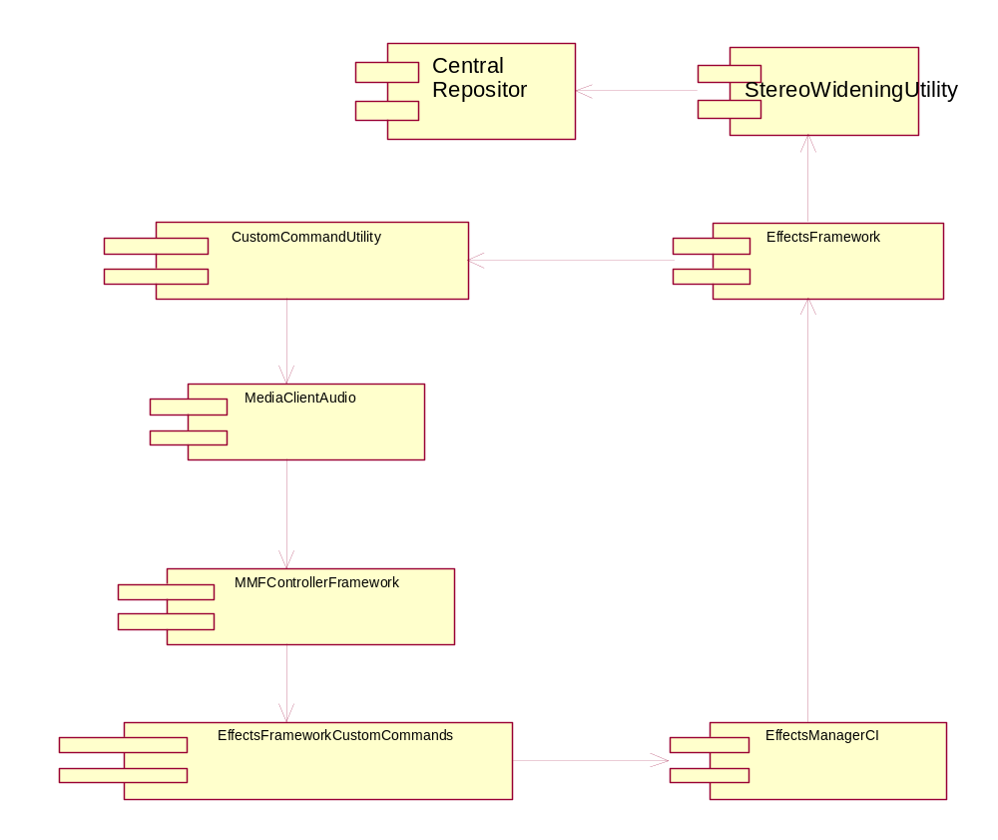
Figure 2.1 Component framework

Use cases
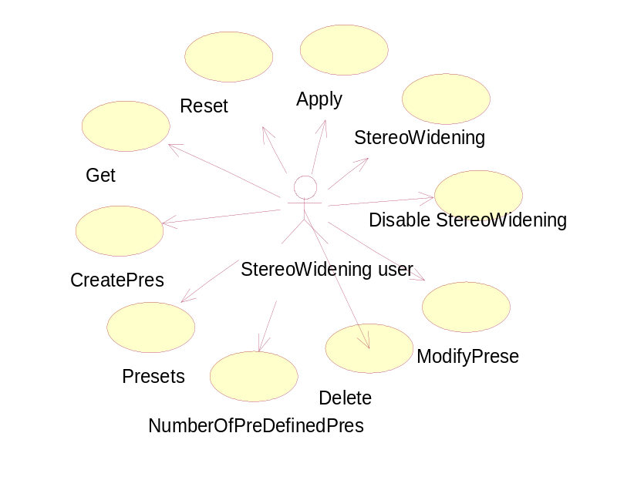
Figure 2.2 Use case diagram

Create Preset
Summary | An application such as Music Player is trying to create audio Stereo Widening settings and save the preset in Central Repository for future use.
Actor(s) | The application that is trying to create the preset.
Frequency | When the application has the Stereo Widening settings for the preset that is being created.
Preconditions | There should be a Stereo Widening object populated with the settings.
Description | When the application tries to create the preset, it saves the name and the Stereo Widening settings in Central Repository.
Exceptions | Deleting the Audio Player Utility object will delete the audio Stereo Widening Utility and cancel the Create Preset request.
Postconditions

Modify Preset
Summary | An application such as Music Player is trying to modify audio Stereo Widening settings and save the preset in Central Repository for future use.
Actor(s) | The application that is trying to modify the preset.
Frequency | When the application has the Stereo Widening settings for the preset that is being modified.
Preconditions | There should be a Stereo Widening object populated with the settings.
Description | When the application tries to modify the preset, it saves the name and the Stereo Widening settings in Central Repository.
Exceptions | Deleting the Audio Player Utility object will delete the audio Stereo Widening Utility and cancel the Modify Preset request.
Postconditions

Delete Preset
Summary | An application such as Music Player is trying to delete audio Stereo Widening settings and save the changes in Central Repository for future use.
Actor(s) | The application that is trying to delete the preset.
Frequency | When the application has the index of the preset in the array.
Preconditions | There should be an array of the names of the current presets in Central Repository.
Description | When the application tries to delete the preset, Stereo Widening Utility checks whether the preset is a pre-defined or user-defined preset. If it is a pre-defined preset, then Stereo Widening Utility returns KErrNotSupported. If the preset is a user-defined one, it deletes the preset from Central Repository and updates the array.
Exceptions | Deleting the Audio Player Utility object will delete the audio Stereo Widening Utility and cancel the Delete Preset request.
Postconditions

Reset Preset
Summary | An application such as Music Player is trying to reset audio Stereo Widening settings and restore the preset from the initialization file to Central Repository for future use.
Actor(s) | The application that is trying to reset the preset.
Frequency | When the application has the index of the preset in the array.
Preconditions | There should be an array of the names of the current presets in Central Repository.
Description | When the application tries to reset the preset, Stereo Widening Utility checks whether the preset is a pre-defined or user-defined preset. If it is a pre-defined preset, then Stereo Widening Utility resets the preset from the initialization file. If the preset is a user-defined one, it deletes the preset from Central Repository and updates the array.
Exceptions | Deleting the Audio Player Utility object will delete the audio Stereo Widening Utility and cancel the Reset Preset request.
Postconditions

Apply Preset
Summary | An application such as Music Player is trying to apply an audio Stereo Widening preset to the audio stream.
Actor(s) | The application that is trying to apply the preset.
Frequency | When the application has the index of the preset in the array.
Preconditions | There should be an array of the names of the current presets in Central Repository.
Description | When the application tries to apply the preset, Stereo Widening Utility reads the Stereo Widening settings for the given preset and applies the settings to the Stereo Widening object.
Exceptions | Deleting the Audio Player Utility object will delete the audio Stereo Widening Utility and cancel the Apply Preset request.
Postconditions

Get Preset
Summary | An application such as Music Player is trying to get the audio Stereo Widening settings for a particular preset.
Actor(s) | The application that is trying to get a preset Stereo Widening.
Frequency
Preconditions | There should be a Stereo Widening object in Central Repository.
Description | When trying to get a particular preset for modification, it has to be retrieved from Central Repository and the Stereo Widening settings have to be stored in the Stereo Widening object.
Exceptions | Deleting the Audio Player Utility object will delete the audio Stereo Widening Utility and cancel the Get Preset request.
Postconditions

Disable Stereo Widening
Summary | An application such as Music Player is trying to disable the audio Stereo Widening effect for the audio stream.
Actor(s) | The application that is trying to disable Stereo Widening.
Frequency
Preconditions | There should be a preset, which is enabled.
Description | Sending commands to disable Stereo Widening. When the function is called and Stereo Widening is already in the Disabled state, it will not do anything.
Exceptions | Deleting the Audio Player Utility object will delete the audio Stereo Widening Utility and cancel the Disable Stereo Widening request.
Postconditions

Services required

From the Symbian OS subsystems
Services of the Symbian OS plug-in infrastructure (ECom) are required. In addition, the MMF including the MMF Controller Framework is required.

From the Domestic OS subsystems
This component has no interfaces to the Domestic OS side subsystems.

From HW
This component has no direct HW interfaces.

Services provided

UI
This component is not a UI component.

SW IF
Audio Stereo Widening Utility provides a way for applications to maintain presets for audio streams. It allows applications to create new presets or apply existing presets to the audio stream.

UI control hierarchy

Framework
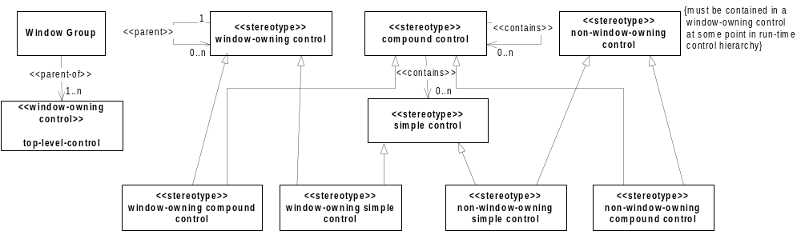
Figure 3.3 Control metamodel

Design

Class diagrams
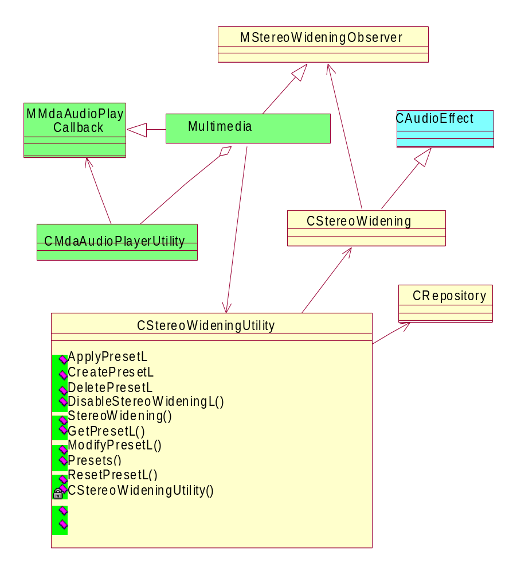
Figure 4.4 Stereo Widening Utility class diagram

Class descriptions
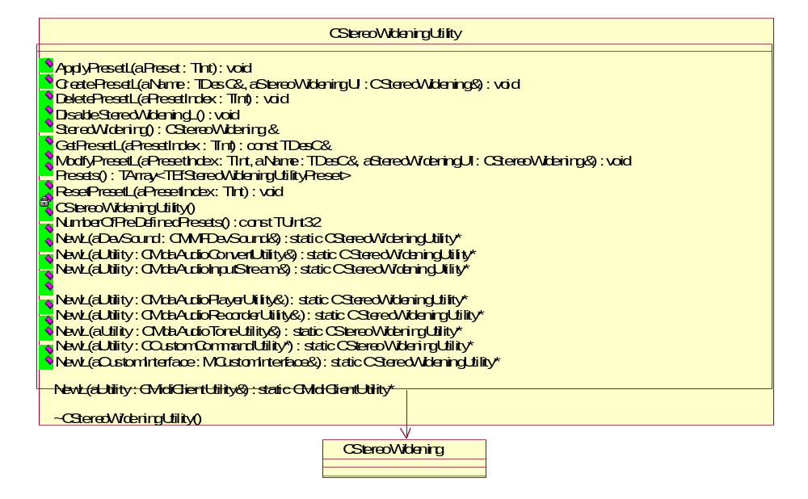
Figure 4.5 Stereo Widening Utility class description
Class | Description | Header file
CStereoWidening  Utility | This is the base call, which will create a Stereo Widening Utility object to be used by the client. | StereoWideningUtility.h
CStereoWidening | The audio Stereo Widening effect class. Stereo Widening Utility creates this object with the audio stream. | StereoWideningBase.h
CentralRepository | A Central Repository class. Stereo Widening Utility creates Central Repository and initiates the data from the given initialization file. | CentralRepository.h
MStereoWidening  Observer | This is the observer for the Stereo Widening effect. This has to be implemented by the client that creates Stereo Widening Utility. | MStereoWideningObserver.h
CtempStereoWidening | This is a CStereoWidening subclass used for transferring data between the client and Stereo Widening Utility. | TempStereoWidening.h

Stereo Widening Utility
Stereo Widening Utility enables the audio client to use preset values stored in Central Repository for use with the Stereo Widening effect.
Headers:
StereoWideningUtility.h
Library:
StereoWideningUtility.dll
Methods:

NewL – Factory Methods
CStereoWideningUtility* NewL(CMMFDevSound& aDevSound);

A static constructor that creates an audio Stereo Widening utility object.
Arguments:
CMMFDevSound& aDevSound: The DevSound associated with this effect.
Returns:
A pointer to CStereoWideningUtility.
Error handling:
This method will leave with these typical leave codes:
- KErrNoMemory: Unable to instantiate due to memory errors.
- KErrNotSupported: The effect is not supported.

CStereoWideningUtility* NewL(CMdaAudioConvertUtility& aUtility);

A static constructor that creates an audio Stereo Widening utility object.
Arguments:
CMdaAudioConvertUtility& aUtility: The convert utility that is to be associated with this effect.
Returns:
A pointer to CStereoWideningUtility.
Error handling:
This method will leave with these typical leave codes:
- KErrNoMemory: Unable to instantiate due to memory errors.
- KErrNotSupported: The effect is not supported.

CStereoWideningUtility* NewL(CMdaAudioInputStream& aUtility);

A static constructor that creates an audio Stereo Widening utility object.
Arguments:
CMdaAudioInputStream& aUtility: The input stream utility that is to be associated with this effect.
Returns:
A pointer to CStereoWideningUtility.
Error handling:
This method will leave with these typical leave codes:
- KErrNoMemory: Unable to instantiate due to memory errors.
- KErrNotSupported: The effect is not supported.

CStereoWideningUtility* NewL(CMdaAudioOutputStream& aUtility);

A static constructor that creates an audio Stereo Widening utility object.
Arguments:
CMdaAudioOutputStream& aUtility: The output stream utility that is to be associated with this effect.
Returns:
A pointer to CStereoWideningUtility.
Error handling:
This method will leave with these typical leave codes:
- KErrNoMemory: Unable to instantiate due to memory errors.
- KErrNotSupported: The effect is not supported.

CStereoWideningUtility* NewL(CMdaAudioPlayerUtility& aUtility);

A static constructor that creates an audio Stereo Widening utility object.
Arguments:
CMdaAudioPlayerUtility& aUtility: The play utility that is to be associated with this effect.
Returns:
A pointer to CStereoWideningUtility.
Error handling:
This method will leave with these typical leave codes:
- KErrNoMemory: Unable to instantiate due to memory errors.
- KErrNotSupported: The effect is not supported.

CStereoWideningUtility* NewL(CMdaAudioRecordUtility& aUtility);

A static constructor that creates an audio Stereo Widening utility object.
Arguments:
CMdaAudioRecordUtility& aUtility: The record utility that is to be associated with this effect.
Returns:
A pointer to CStereoWideningUtility.
Error handling:
This method will leave with these typical leave codes:
- KErrNoMemory: Unable to instantiate due to memory errors.
- KErrNotSupported: The effect is not supported.

CStereoWideningUtility* NewL(CMdaAudioToneUtility& aUtility);

A static constructor that creates an audio Stereo Widening utility object.
Arguments:
CMdaAudioToneUtility& aUtility: The tone utility that is to be associated with this effect.
Returns:
A pointer to CStereoWideningUtility.
Error handling:
This method will leave with these typical leave codes:
- KErrNoMemory: Unable to instantiate due to memory errors.
- KErrNotSupported: The effect is not supported.

CStereoWideningUtility* NewL(MCustomCommand& aUtility);

A static constructor that creates an audio Stereo Widening utility object.
Arguments:
MCustomCommand& aUtility: A utility that implements the MCustomCommand interface that is to be associated with this effect.
Returns:
A pointer to CStereoWideningUtility.
Error handling:
This method will leave with these typical leave codes:
- KErrNoMemory: Unable to instantiate due to memory errors.
- KErrNotSupported: The effect is not supported.

CStereoWideningUtility* NewL(MCustomInterface& aCustomInterface);

A static constructor that creates an audio Stereo Widening utility object.
Arguments:
MCustomInterface& aCustomInterface: A utility that implements the MCustomInterface interface that is to be associated with this effect.
Returns:
A pointer to CStereoWideningUtility.
Error handling:
This method will leave with these typical leave codes:
- KErrNoMemory: Unable to instantiate due to memory errors.
- KErrNotSupported: The effect is not supported.

CStereoWideningUtility* NewL(CMidiClientUtility& aUtility);

A static constructor that creates a CMidiClientUtility object.
Arguments:
CMidiClientUtility& aUtility: A utility that is to be associated with this effect.
Returns:
A pointer to CStereoWideningUtility.
Error handling:
This method will leave with these typical leave codes:
- KErrNoMemory: Unable to instantiate due to memory errors.
- KErrNotSupported: The effect is not supported.

ApplyPresetL
void ApplyPresetL(TInt aPresetIndex);

Used to apply preset values.
Arguments:
TInt aPresetIndex: The index of the preset to apply. The index is the index into the array of presets retrieved with the method Presets().
Returns:
None.
Error handling:
This method will leave with these typical leave codes:
- KErrArgument: The argument value is out of range or invalid.

CreatePresetL
void CreatePresetL(TDesC& aName, CStereoWidening& aStereoWidening);

Creates a user-defined preset with the specified Stereo Widening settings.
Arguments:
- TDesC& aName: The name of the user-defined preset.
- CStereoWidening& aStereoWidening: A Stereo Widening object configured to the values to be used in creating the user-defined preset.
Returns:
An updated list of presets is returned if the operation is successful.
Error handling:
This method will leave with these typical leave codes:
- KErrArgument: The argument value is out of range or invalid.
- KErrNoMemory: An out of memory error was encountered.

DeletePresetL
void DeletePresetL(TInt aPresetIndex);

Deletes the specified user-defined preset.
Arguments:
TInt aPresetIndex: The index into the preset array retrieved with the method Presets().
Returns:
None.
Error handling:
This method will leave with these typical leave codes:
- KErrArgument: The argument value is out of range or invalid.

DisableStereoWideningL
void DisableStereoWideningL();

Disables the Stereo Widening effect.
Arguments:
None.
Returns:
None.

StereoWidening
CStereoWidening& StereoWidening();

Gets an audio Stereo Widening object.
Arguments:
None.
Returns:
A reference to the audio Stereo Widening object.

GetPresetL
void GetPresetL(TInt aPresetIndex);

Resets the specified preset.
Arguments:
TInt aPresetIndex: The index of the preset to be retrieved. The index is the index into the array of presets retrieved with the method Presets().
Note: If the preset index points to a preset that cannot be obtained, the method will leave with KErrArgument.
Returns:
None.
Error handling:
This method will leave with these typical leave codes:
- KErrNotFound: The argument value is out of range or invalid.

ModifyPresetL
void ModifyPresetL(TInt aPresetIndex, TDesC& aName, CStereoWidening& aStereoWidening);

Modifies a user-defined preset with the specified Stereo Widening settings.
Arguments:
- TInt aPresetIndex: The index into the preset array retrieved with method Presets().
- TDesC& aName: The name of the preset to be used in modification.
- CStereoWidening& aStereoWidening: A Stereo Widening object configured to the values to be used in modifying the preset.

Returns:
None.
Error handling:
This method will leave with these typical leave codes:
- KErrArgument: The argument value is out of range or invalid.
- KErrNoMemory: An out of memory error was encountered.

NumberOfPreDefinedPresets
TUint32 NumberOfPreDefinePresets() const;

Gets the number of predefined presets.
Arguments:
None.
Returns:
The number of predefined presets.

Presets
TArray< TEfStereoWideningUtilityPreset> Presets();

Gets a list of the presets.
Arguments:
None.
Returns:
An array of all the presets (pre-defined and user-defined). The pre-defined presets are in the beginning of the list.

ResetPresetL
void ResetPresetL(TInt aPresetIndex);

Resets the specified preset.
Arguments:
TInt aPresetIndex: The index of the preset to reset. The index is the index into the array of presets retrieved with the method Presets().
Note: If the preset index points to a preset that cannot be reset, the method will leave with KErrArgument.
Returns:
None.
Error handling:
This method will leave with these typical leave codes:
- KErrArgument: The argument value is out of range or invalid.

Flag definitions
The Audio Effects feature can be included in build using the __AUDIO_EFFECTS_API flag in bldvariant.hrh.

Flag | Description
__AUDIO_EFFECTS_API | If this is set in bldvariant.hrh, Audio Effects is available. The adaptation layer needs to use the same flag.

Operations

CreatePresetL
Operation | CreatePresetL
Preconditions | Stereo Widening Utility must be present.
Description | An application such as Music Player is trying to create audio Stereo Widening settings and save the preset in Central Repository for future use.
Inputs | TDesC& aName, CStereoWidening& aStereoWidening
Modifies | Creates the preset in Central Repository.
Outputs | The preset in Central Repository.
Postconditions | The preset aName is created in Central Repository.
Related To
Related Event | Happens when the client creates a new preset.
Exceptions

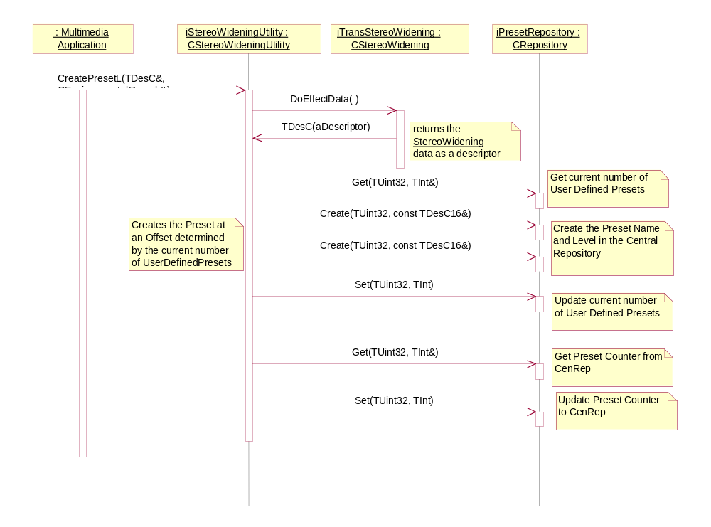
Figure 4.6 CreatePresetL

ApplyPresetL
Operation | ApplyPresetL
Preconditions | Stereo Widening Utility must be present.
Description | An application such as Music Player is trying to apply audio Stereo Widening settings and save the preset in Central Repository for future use.
Inputs | TInt aPresetIndex
Modifies | Applies the preset to the Stereo Widening effect.
Outputs
Postconditions | The Stereo Widening effect is loaded with the preset.
Related To
Related Event | Happens when the client applies a new preset to the Stereo Widening.
Exceptions

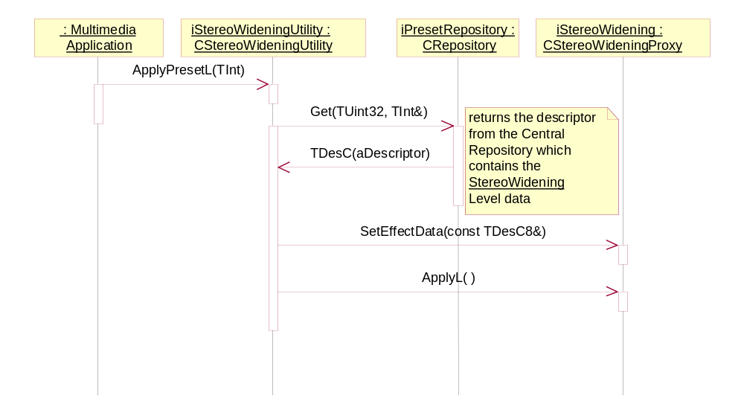
Figure 4.7 ApplyPresetL

ResetPresetL
Operation | ResetPresetL
Preconditions | Stereo Widening Utility must be present.
Description | An application such as Music Player is trying to reset the audio Stereo Widening settings of Central Repository.
Inputs | TInt aPresetIndex
Modifies | Resets the preset in Central Repository.
Outputs | The preset is restored from the INI file in Central Repository.
Postconditions | The preset is restored in Central Repository.
Related To
Related Event | Happens when the client resets the preset settings.
Exceptions

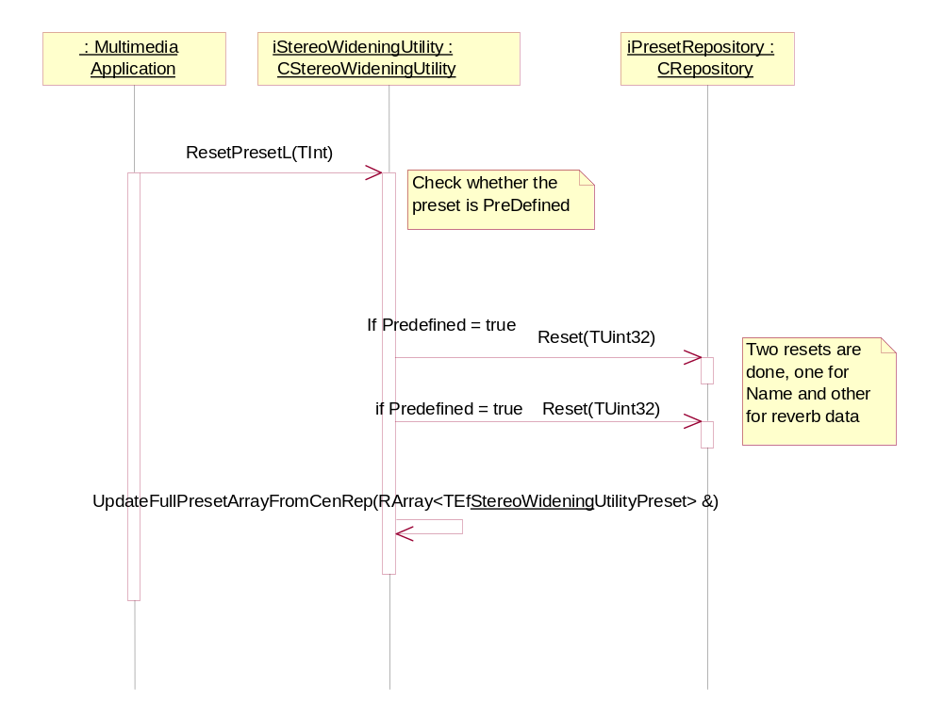
Figure 4.8 ResetPresetL

DeletePresetL
Operation | DeletePresetL
Preconditions | Stereo Widening Utility must be present.
Description | An application such as Music Player is trying to delete a user-defined audio Stereo Widening setting from Central Repository.
Inputs | TInt aPresetIndex
Modifies | Deletes the preset from Central Repository.
Outputs | The preset is deleted from the INI file in Central Repository.
Postconditions | The preset is deleted in Central Repository.
Related To
Related Event | Happens when the client deletes the preset settings.
Exceptions

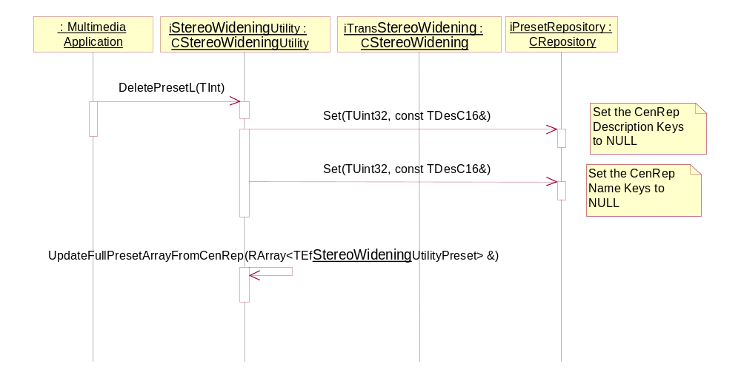
Figure 4.9 DeletePresetL

DisableStereoWideningL
Operation | DisableStereoWideningL
Preconditions | Stereo Widening Utility must be present.
Description | An application such as Music Player is trying to disable the Stereo Widening effect.
Inputs
Modifies | Disables the Stereo Widening effect.
Outputs | The Stereo Widening effect is disabled.
Postconditions | The Stereo Widening effect is disabled.
Related To
Related Event | Happens when the client disables the preset settings.
Exceptions

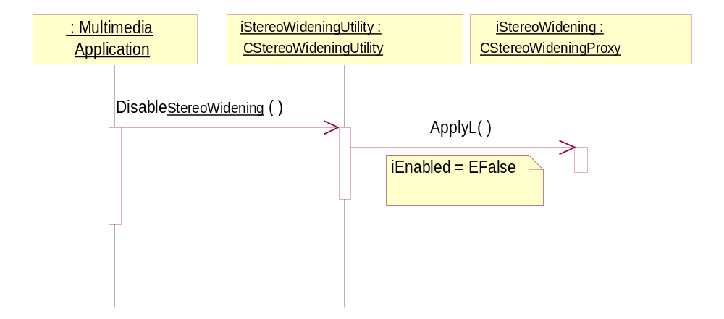
Figure 4.10 DisableStereoWideningL

GetPresetL
Operation | GetPresetL
Preconditions | Stereo Widening Utility must be present.
Description | An application such as Music Player is trying to retrieve audio Stereo Widening settings from Central Repository.
Inputs | TInt aPresetIndex
Modifies | Retrieves the preset from Central Repository.
Outputs | Returns the name of the given preset to the client.
Postconditions | The preset aName is returned to the client.
Related To
Related Event | Happens when the client retrieves a preset.
Exceptions

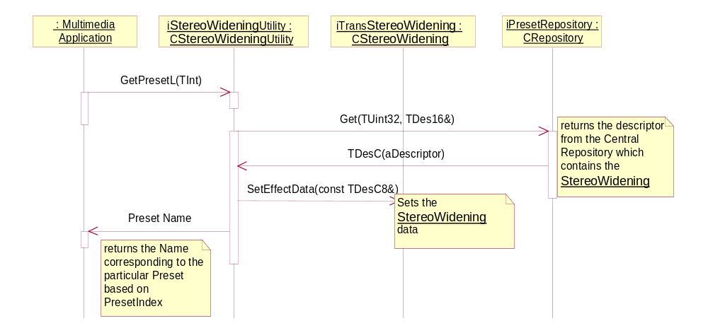
Figure 4.11 GetPresetL

ModifyPresetL
Operation | ModifyPresetL
Preconditions | Stereo Widening Utility must be present.
Description | An application such as Music Player is trying to modify audio Stereo Widening settings and save the preset in Central Repository for future use.
Inputs | TInt aPresetIndex, TDesC& aName, CStereoWidening& aStereoWidening
Modifies | Modifies the preset in Central Repository.
Outputs | The modified preset in Central Repository.
Postconditions | The preset aName is modified in Central Repository.
Related To
Related Event | Happens when the client modifies an existing preset.
Exceptions

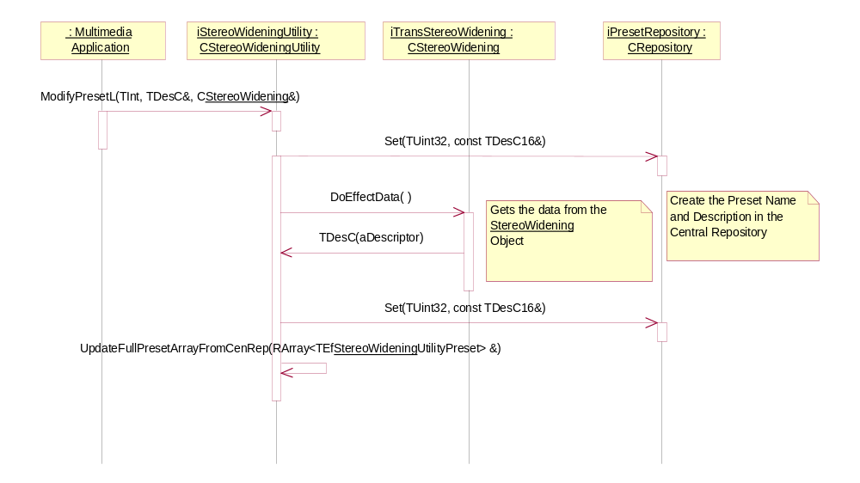
Figure 4.12 ModifyPresetL

Presets
Operation | Presets
Preconditions | Stereo Widening Utility must be present.
Description | An application such as Music Player is trying to retrieve a list of the presets in Central Repository.
Inputs
Modifies | The preset array returned to the client.
Outputs | The preset array with a list of the presets is returned to the client.
Postconditions
Related To
Related Event | Happens when the client retrieves a list of the presets.
Exceptions

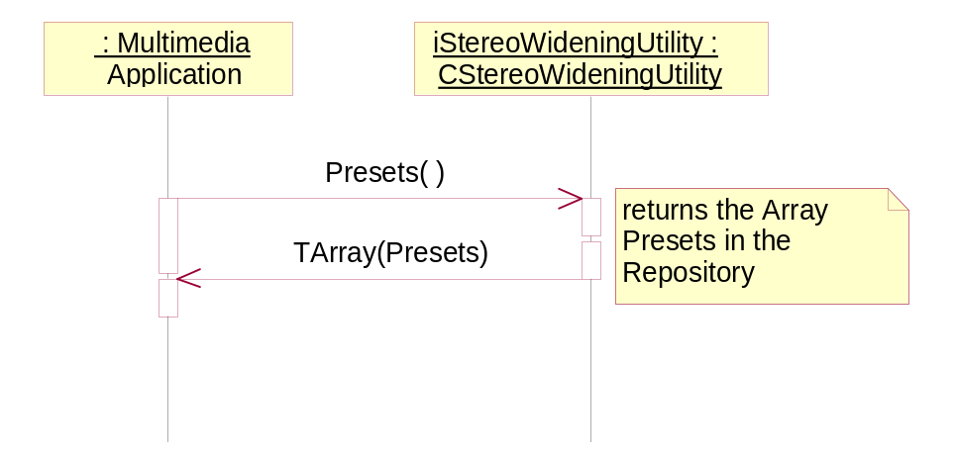
Figure 4.13 Presets

Stereo Widening
Operation | Stereo Widening
Preconditions | Stereo Widening Utility must be present.
Description | An application such as Music Player is trying to retrieve a Stereo Widening object associated with a preset.
Inputs
Modifies | A Stereo Widening object is returned to the client.
Outputs
Postconditions
Related To | Retrieving a preset from Central Repository.
Related Event
Exceptions

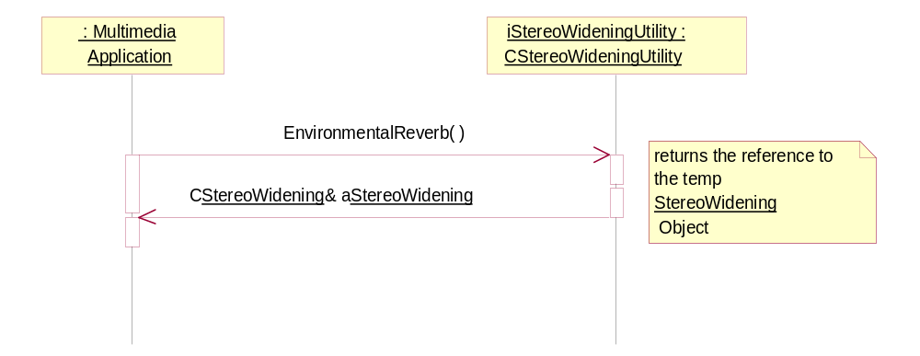
Figure 4.14 Stereo Widening

NumberOfPreDefinedPresets
Operation | NumberOfPreDefinedPresets
Preconditions | Stereo Widening Utility must be present.
Description | An application such as Music Player is trying to retrieve the number of pre-defined presets in Central Repository.
Inputs
Modifies
Outputs | The number of pre-defined presets in Central Repository.
Postconditions
Related To
Related Event
Exceptions

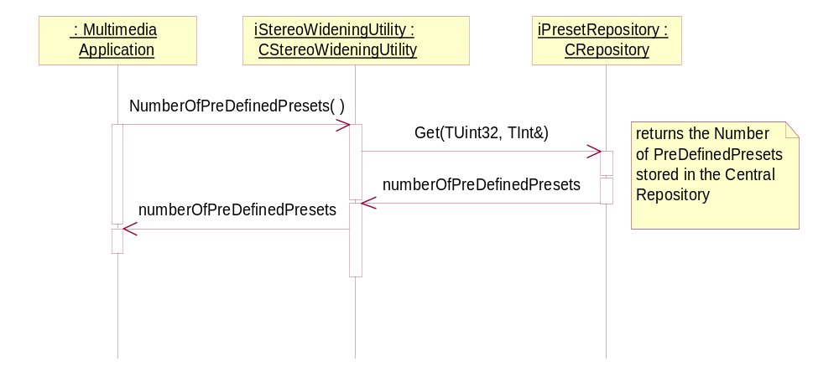
Figure 4.15 NumberOfPreDefinedPresets

Variation
Stereo Widening Utility uses __AUDIO_EFFECTS_API as a feature flag. It is also dependent on the adaptation layer (DevSound) to provide information about the Stereo Widening effect using the custom interface.

System resource usage
This component does not have any resource files.

Memory consumption
Memory/Build | Consumption
WINSCS URel | 60 Kb
ARMV5 URel | 4 Kb

Task allocation
The Stereo Widening Utility object is owned by the application that uses it and runs it in its process.

Timers
This component does not use any timers.

Security

Capabilities of this component
Capability | Justification
ReadUserData | This capability is used when reading settings from Central Repository
WriteUserData | This capability is used when writing settings to Central Repository

Input and output validation
This component does not require or make any validation for data.

Environmental assumptions
This component does not make any assumptions about its environment.

Additional enforcements
This component does not have any additional security enforcements.

Exception handling
The leave mechanism of the Symbian OS environment is used to handle memory exhaustion.

Usage

Building
Stereo Widening Utility is a part of Audio Enhancements. You can build it from the group folder (\StereoWideningUtility\group\) using abld build armv5. This API can only be used if the adaptation layer (DevSound) provides a custom interface.

User's guide
This application is not used by other components.

