S60
Audio Enhancements
Adaptation Guide

Team name | Author
MM Audio | Vasudevan Ramachandraiah

Change history:

Version | Date | Status | Comments
5.0 | 03.07.2008 | Approved | Updated to support DevSound initialization with FourCC
4.0 | 25.04.2007 | Approved | Updated ‘3.0’ references to ‘since 3.0’  Removed 3.0 references from filename, title and document header.  Added DevSound API documentation for Custom Interface  Added Requirement for supporting Uid 0x10206593 and Added Process and Thread Priorities
3.0 | 23.01.2006 | Approved | Added DevSound API documentation (SetVolumeRamp).
2.0 | 09.01.2006 | Approved | Added DevSound custom interface framework design.  Added comments about client capabilities usage.
1.0 | 25.02.2005 | Approved

Table of contents:

1. Document control 6
1.1 Documentation conventions 6
1.2 Abbreviations 6
1.3 Definitions 6
2. General 7
2.1 Introduction 7
3. Custom command utility 8
4. Custom interface utility 11
4.1 Proxy custom interface utility 12
4.1.1 Custom interface proxy factory 12
4.1.2 Custom interface builder 12
4.1.2.1 Message handler factory 13
4.1.3 Example custom interface 14
4.1.4 Custom interface custom command parser creation 15
4.1.5 Creation sequence 15
4.1.6 Creating a custom interface sequence 16
4.1.7 Generic proxy custom interface usage sequence 17
5. Custom interface framework in S60 release DevSound 18
5.1 Proxy custom interface utility 18
5.2 Custom interface proxy factory 18
5.3 Custom interface builder 19
5.4 Message handler factory 19
5.5 Class diagram 19
5.6 Example custom interface 20
5.7 Sequence diagrams 22
5.7.1 Custom interface custom command parser and custom interface builder creation 22
5.7.2 Custom interface creation 22
5.7.2.1 Requesting a handle to the custom interface builder 23
5.7.2.2 Returning a handle to the custom interface builder 24
5.7.2.3 Request for creating the CExampleCIMessageHandler message handler 24
5.7.2.4 Returning a handle to the CExampleCIMessageHandler message handler 25
5.7.2.5 Creating and returning the CExampleCIProxy proxy object to the client 25
5.7.3 Calling methods on the CExampleCI object by the client 26
5.8 Collaboration diagram 27
6. DevSound API Documentation 29
6.1 SetVolume 29
6.2 Volume 29
6.3 SetVolumeRamp 29
6.3.1 Usage 30
6.4 SetToneRepeats 30
6.5 Pause 30
6.6 Stop 31
6.7 Samples Played 31
6.8 SetConfigL 31
6.9 CustomInterface 32
7. Added DevSound Control Custom Interface 33
7.1 SetHardwareAwareness 33
7.2 PauseAndFlush 33
7.3 Resuming from True Pause 34
7.3.1.1 BufferToBeFilled() callback before calling Pause() and resuming. 34
7.3.1.2 BufferToBeFilled() callback after calling Pause() and resuming. 35
7.3.1.3 Race condition while resuming. 35
7.3.1.4 Race condition handling while resuming. 36
8. Platform Security 37
9. Support for Uid 0x10206593 38
9.1 S60 Release 5.0.1 38
10. Process and Thread priorities 40

Document control

Documentation conventions
Code is shown with the Courier New font.

Abbreviations

CC | Custom Command
CI | Custom Interface
MMF | Multimedia Framework

Definitions

Custom command | An expansion mechanism for MMF Controllers and their utilities for adding functionality beyond what is directly specified in the APIs. Custom commands are message-based.
Custom interface | An expansion mechanism for CMMFDevSound for adding functionality beyond what is directly specified in the API. Custom interfaces are class-based.

General

Introduction
This document is a How-To guide for the new audio features since S60 release 3.0. This document is intended for groups doing adaptation along with those who are writing MMF Controllers for audio. The intent is to give details on what S60 expects from the adaptation and how adaptation plugs into the new features.

Custom command utility
Custom commands are the mechanism that the MMF uses for communicating between the client MDA client utilities and the controllers, which run on their own thread that the MMF creates when creating the controller. Each of the standard MDA client utilities defines custom command methods in their APIs, which allow extensions to the API without changing the APIs or breaking binary compatibility. Many of the new audio enhancements, such as effects, routing, and resource notification, need to use custom commands for communicating between the client and DevSound, which is in the controller thread. Unfortunately, the custom commands are not defined by an M class, so this means that specific code needs to be written for each of the enhancements to work with each client utility. To reduce this work, S60 includes a new interface called MCustomCommand, which defines the custom command methods, and CCustomCommandUtility, which provides an adapter for each of the MDA client utilities that have custom commands so that it appears that they implement the MCustomCommand interface even though they do not. This allows the audio enhancement code to be generically associated with any of the MDA client utilities that use custom commands. Figure 3.1 shows the class diagram of CCustomCommandUtility:

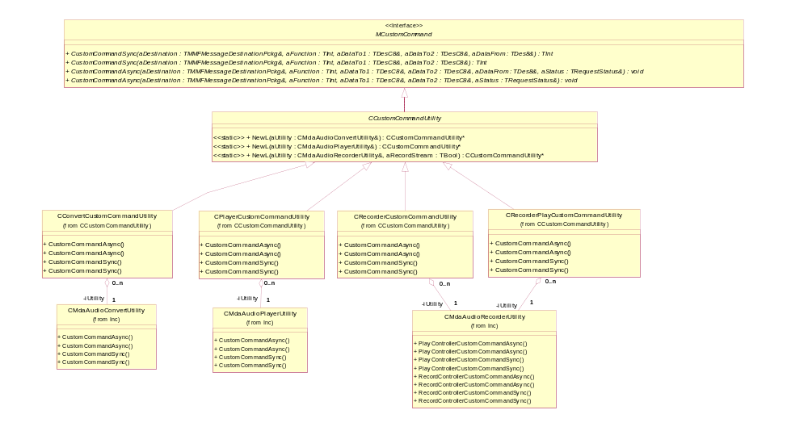
Figure 3.1 Custom command utility class diagram
In this utility, only MCustomCommand and CCustomCommandUtility are visible. All of the CCustomCommandUtility subclasses are private nested classes of CCustomCommandUtility. The NewL methods of CCustomCommandUtility create the appropriate subclass, which interfaces to the specified utility. These utilities are very thin. Their basic operation is shown in Figure 3.2.
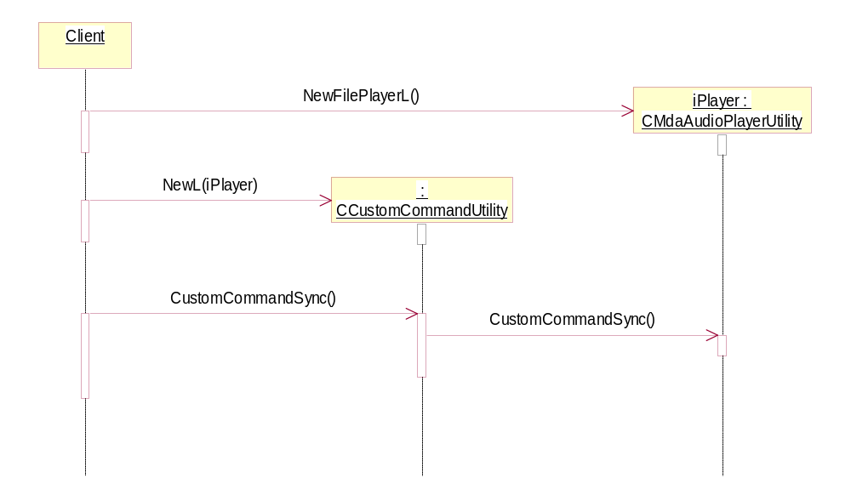
Figure 3.2 Normal custom command utility sequence
Since the custom command utility implements the MCustomCommand interface, a reference to a specific custom command utility can be passed to any class that is dependent on only the interface. This allows these classes to only be dependent on the MCustomCommand interface and not each specific MDA client utility.
The one complicated utility is CMdaAudioRecorderUtility. The record utility actually has two controllers and therefore two sets of custom command methods: one for the stream that is recording and a second for the optional playback stream. As a result, there are two versions of the custom command utility associated with CMdaAudioRecorderUtility. A client specifies which stream the custom command utility is to be associated with by using a second parameter. This parameter is a TBool, where ETrue indicates that the custom command utility is to be associated with the record stream and EFalse indicates that it is to be associated with the playback stream. Figure 3.3 shows the use of CMdaAudioRecorderUtility.
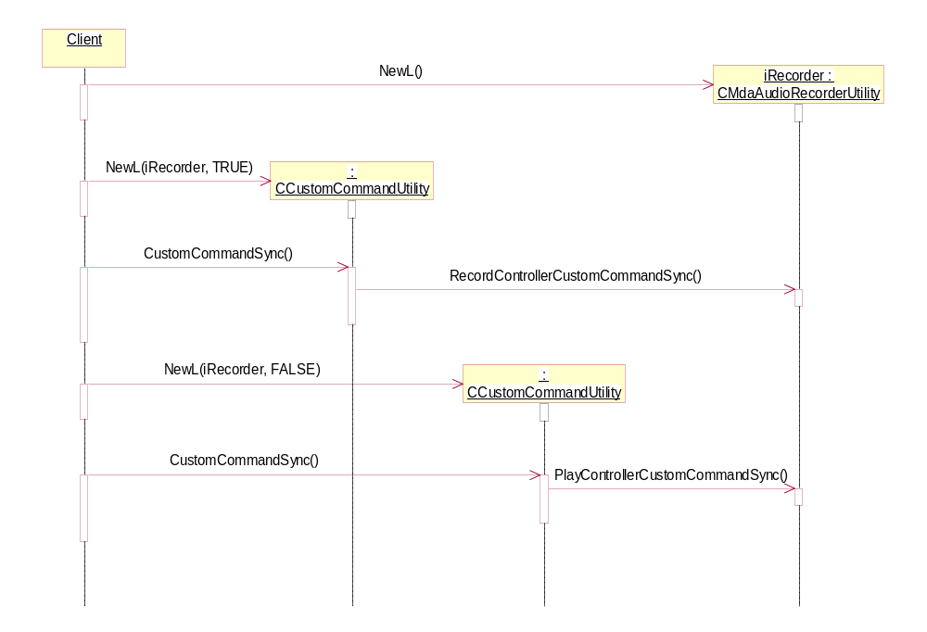
Figure 3.3 CMdaAudioRecorderUtility sequences
Note that it is possible to have multiple custom command utilities for the same MDA client utility at the same time.

Custom interface utility
DevSound does not use custom commands like the controllers. Instead, it has its own extension mechanism called custom interfaces. Custom interfaces are not message-based like custom commands. Instead, they are class-based. Like custom commands, there is no generic interface for accessing custom interfaces. So, like for custom commands, S60 includes a generic interface called MCustomInterface for accessing custom interfaces, and a utility for providing adaptors to MMF objects that provide custom interfaces, so that it appears that they use the interface. The utility is called CCustomInterfaceUtility and its class diagram is shown in Figure 4.4.

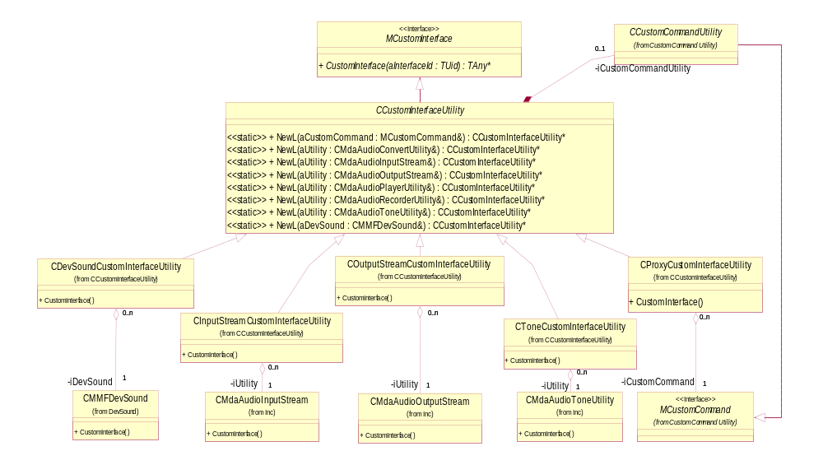
Figure 4.4 Custom interface utility class diagram
The custom interface utility works just like the custom command utility for CMMFDevSound, CMdaAudioInputStream, CAudioOutputStream, and CMdaAudioToneUtility. Note that the input stream, output stream and tone utilities do not currently have the custom interface method.
In addition to being a simple adaptor to MDA and MMF utilities that have the custom interface method, the custom interface utility also provides an adaptor for the MDA client utilities that use custom commands, so that it seems like they have the custom interfaces methods. This allows custom interfaces to be used with these MDA client utilities. CProxyCustomInterfaceUtility provides this feature.

Proxy custom interface utility
The proxy custom interface utility allows custom interfaces to be used with the MDA client utilities that implement the MCustomCommand interface (see Chapter 3). The proxy custom interface utility class diagram is shown in Figure 4.5.
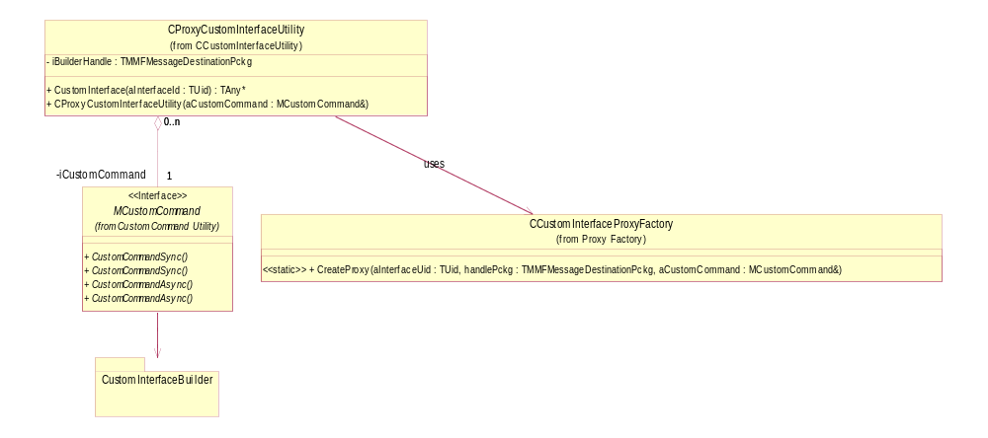
Figure 4.5 Proxy custom interface utility class diagram
The proxy custom interface utility uses CCustomInterfaceProxyFactory to build a proxy for the requested custom interface. It uses custom commands to communicate with the custom interface builder, which is in the controller thread.

Custom interface proxy factory
This factory builds proxies for custom interfaces. It exists in its own DLL. A reference version of this factory is provided in S60 that builds all of the custom interfaces defined by S60. However, it is up to the adaptation to replace this factory with its own version that builds all of the proxies that are supported by a specific product.

Custom interface builder
The custom interface builder receives messages from the proxy custom interface utility and uses DevSound to build the specified custom interface. It also builds a message handler to be associated with the custom interface and the proxy that was build by the proxy factory. The custom interface builder’s class diagram is shown in Figure 4.6.
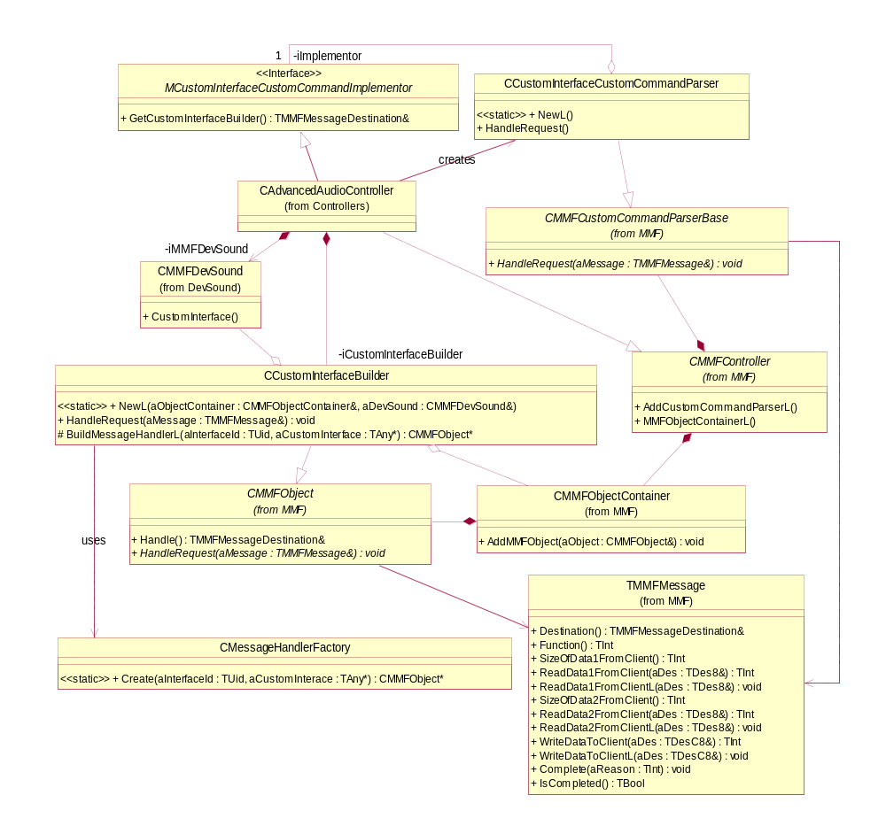
Figure 4.6 Custom interface builder class diagram

Message handler factory
Like the custom interface proxy factory, the message handler factory builds message handlers for custom interfaces that will be associated with the real custom interface and the custom interface proxy. This factory exists in its own DLL. A reference version of this factory is provided in S60 that builds all of the message handlers for custom interfaces provided by S60. It is up to the adaptation to replace this reference implementation with one that builds message handlers for the custom interfaces supported by a specific product.

Example custom interface
Each custom interface that can be used over a thread boundary looks as shown in Figure 4.7 below.

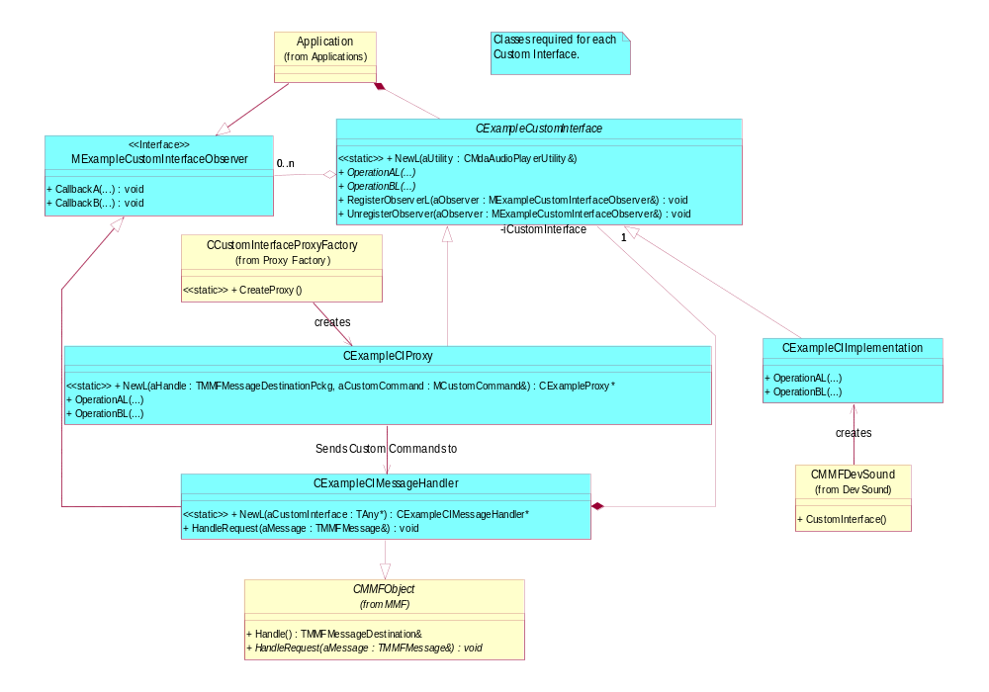
Figure 4.7 Example custom interface
Each custom interface has a generic definition class used by clients, a proxy that turns operations into custom commands, a message handler that receives the custom commands and turns them into calls into the actual custom interface, and the actual custom interface implementation.
Custom interfaces can have observers that work with this framework. The message handler registers itself as an observer to the real custom interface. When an observer method is called, the message handler sends the data back by completing an outstanding asynchronous custom command that the proxy keeps sending to the message handler.

Custom interface custom command parser creation
Figure 4.8 shows the creation of the custom command parser needed for the custom interface utility.

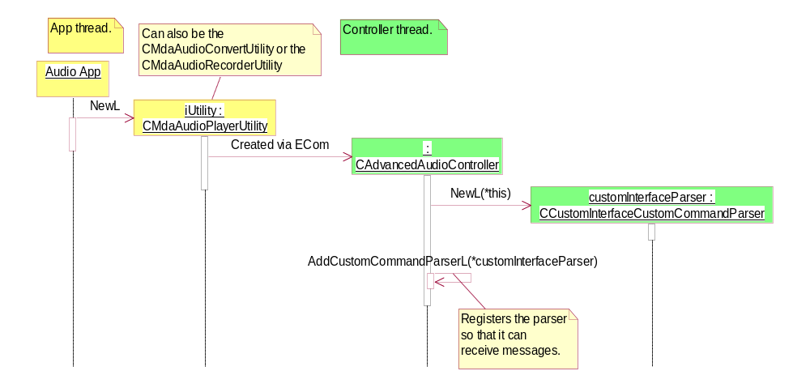
Figure 4.8 Custom interface custom command parser creation sequence

Creation sequence
Figure 4.9 and Figure 4.10 show the creation sequence for the proxy custom interface utility.

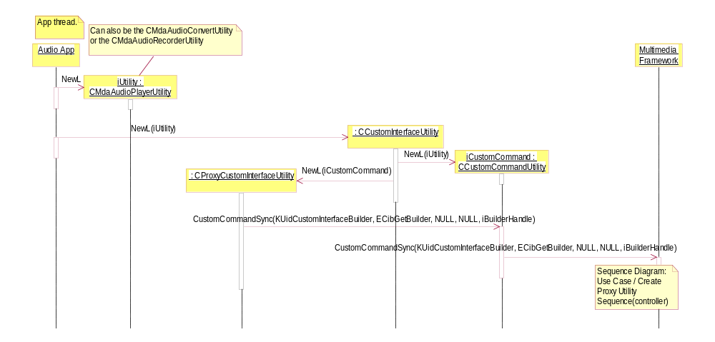
Figure 4.9 Proxy Custom Interface Utility creation sequence on the application thread
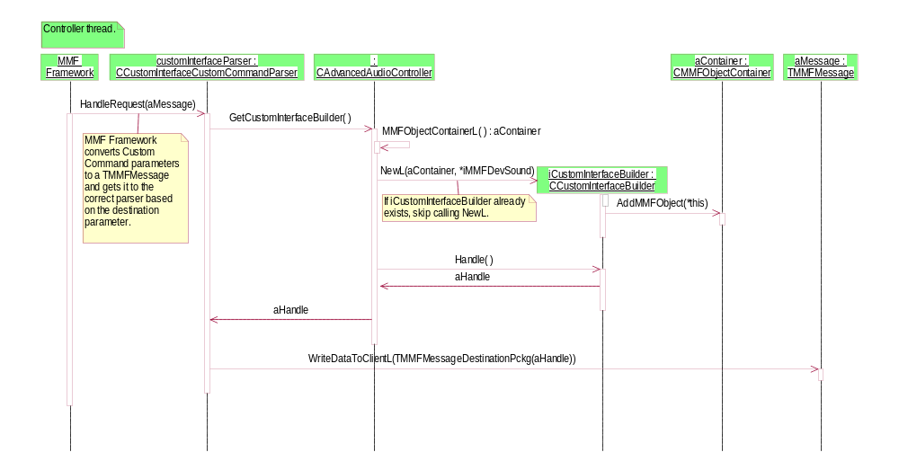
Figure 4.10 Proxy custom interface utility creation sequence continued on the controller thread

Creating a custom interface sequence
Figure 4.11 and Figure 4.12 show how a custom interface is created with the proxy custom interface utility.

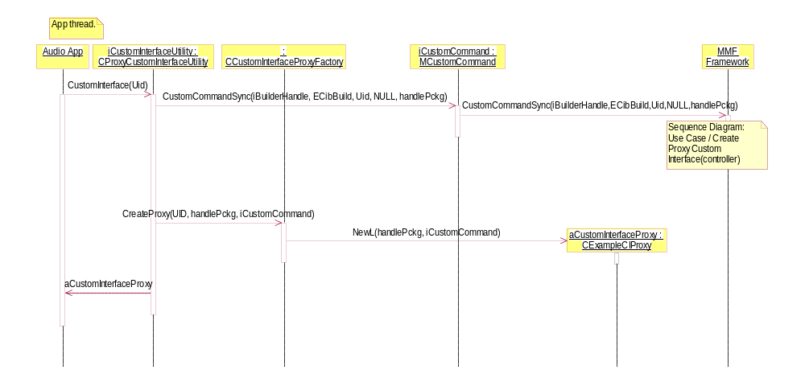
Figure 4.11 Creating a custom interface sequence on the application thread
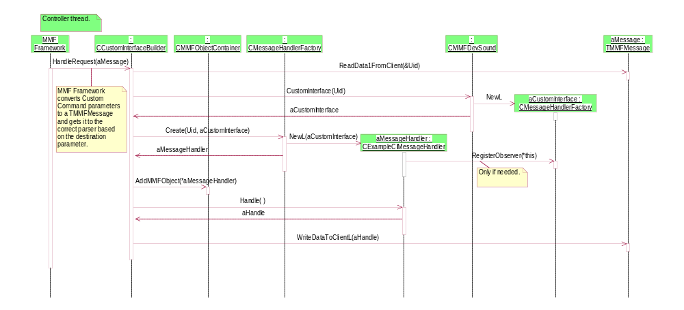
Figure 4.12 Creating a custom interface sequence continued on the controller thread

Generic proxy custom interface usage sequence
Figure 4.13 shows how an operation on a proxy custom interface works generally.

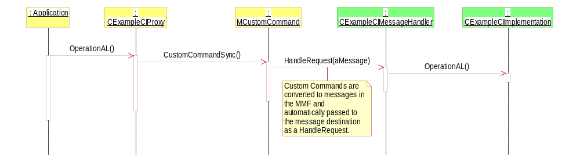
Figure 4.13 Using a custom interface sequence

Custom interface framework in S60 release DevSound
The DevSound MMF component since S60 release 3.0 is implemented as client/server, which includes:
- The DevSound client, an instance of CMMFDevSound, created and running in the controller thread.
- The DevSound server (one instance per DevSound client), created and running in a different process serving DevSound client’s requests.

The DevSound client, CMMFDevSound, is a thin proxy implementation. When a client makes any request, it forwards the requests to the server and returns the result back to its client/observer.
The actual DevSound custom interface implementation exists on the server side. In order to allow clients to have access to the custom interface implemented by the DevSound server, DevSound provides a framework similar to that of a controller.
A custom interface implementation (e.g. CExampleCI) has a generic class definition used by the clients (controllers). When the client creates a custom interface class instance, the instance requests a pointer reference to the custom interface through CDevSoundCustomInterfaceUtlity. Now a message handler is created in the DevSound server process that has a reference to the actual custom interface implementation, and a new proxy is created on the client side and a reference to it is returned to the client (controller). When the client makes a method call on the proxy, it converts the message to an IPC command and sends it to the message handler in the DevSound server. The message handler receives the command and turns it into a call on the actual custom interface implementation.
Note: When custom interface message handler objects are created by passing a reference to the custom interface implementation, the message handlers own the custom interface implementation from then on, and delete the custom interface implementation in its destructor.
Note: Custom interface proxy objects use the DevSound proxy for sending messages to the custom interface message handlers. Once the DevSound client is deleted, the DevSound proxy also gets deleted. Application developers should make sure that the custom interface instance(s) are deleted before the DevSound client (based on which custom interfaces instances are created) is deleted.

Proxy custom interface utility
The DevSound client uses this class to get a reference to the custom interface proxy object. The proxy custom interface utility, using RMMFDevSoundProxy, sends IPC commands to the custom interface builder via CMMFDevSoundSession, to create a message handler for the requested custom interface. It then uses CCustomInterfaceProxyFactory to build a proxy for the requested custom interface.

Custom interface proxy factory
The proxy custom interface utility uses this class to create custom interface proxy objects. The purpose of this factory is to create proxy objects for the custom interfaces (e.g. CExampleCIProxy). The proxies are created in the controller thread.
The adaptation should replace this DLL with a version that builds proxies for the custom interfaces that are supported by a specific product. When a new custom interface is implemented, this DLL needs to be modified to create and return the proxy object based on the UID.

Custom interface builder
This is a utility object used by the DevSound server to manage custom interface message handlers. The custom interface builder receives IPC commands from the proxy custom interface utility to create and destroy message handlers. It uses CMMFDevSoundSession to get a reference/access to the actual custom interface implementation.
Note: CMMFDevSoundSession::CustomInterface(TUid aInterfaceUid) is a non-leaving function. The adaptation has to TRAP all leaving function calls (such as NewLs) within this function and return a NULL pointer in case of the following:
- Failure in finding the custom interface with the implementation UID aInterfaceUid.
- Failure in creating the requested object.

Message handler factory
The custom interface builder uses this class to create custom interface message handler objects. This factory builds message handlers for the custom interfaces (e.g. CExampleCIMessageHandler) that will be associated with the actual custom interface implementation.
The adaptation should replace this DLL with a version that builds message handlers for the custom interfaces that are supported by a specific product. When a custom interface is implemented, this DLL needs to be modified to create and return the message handler object based on the UID.

Class diagram
The class diagram including the custom interface framework is shown in Figure 5.14.
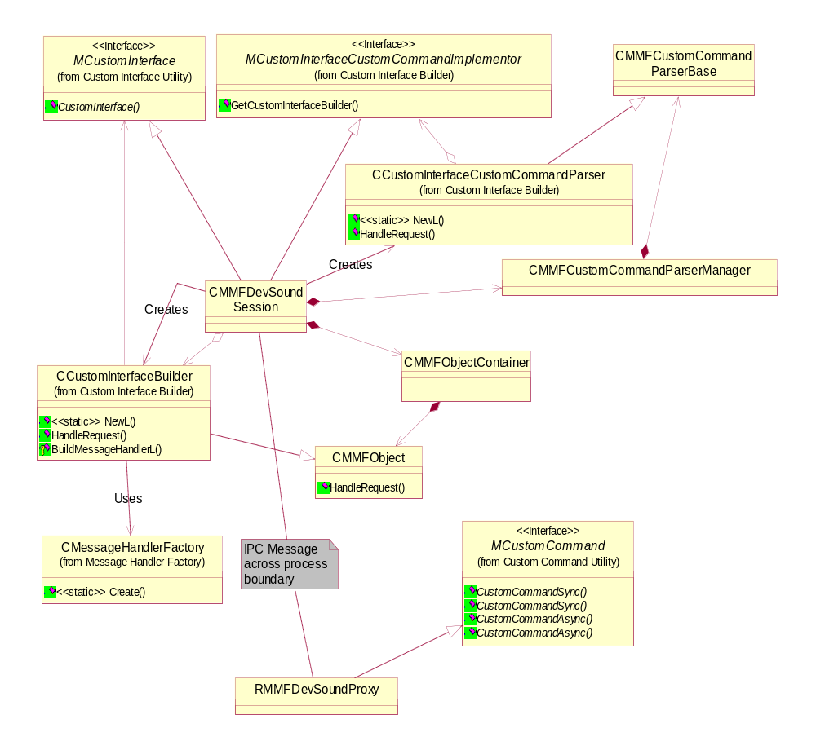
Figure 5.14 Class diagram

Example custom interface
Each custom interface has a class definition used by the clients (controllers), a proxy that converts operations into IPC commands, a message handler that converts IPC commands into operations and calls on the actual custom interface implementation.
A custom interface that is used over a process boundary looks as shown in Figure 5.15. The class diagram looks exactly similar to Figure 4.7.
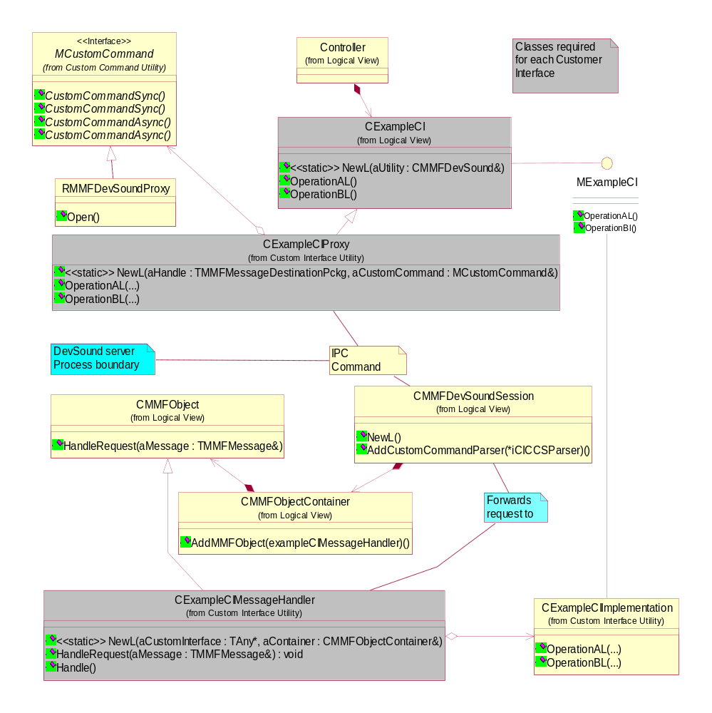
Figure 5.15 Custom interface used over a process boundary

Sequence diagrams

Custom interface custom command parser and custom interface builder creation
Figure 5.16 shows the creation of the custom interface custom command parser and the custom interface builder needed by the proxy custom interface utility to get a handle to the custom interface builder.
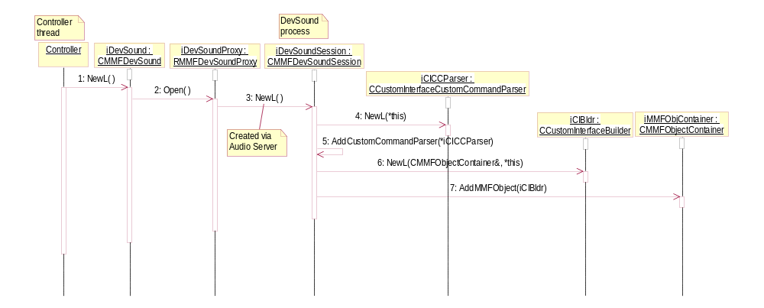
Figure 5.16 Creation of the custom interface custom command parser and the custom interface builder

Custom interface creation
Creating a custom interface on the controller thread involves the following steps:
- Getting a handle to the custom interface builder.
- Sending a command to the custom interface builder to create a message handler and getting a handle to the newly created message handler.
- Creating and returning a proxy that associates with the server side message handler to the client.

Each step is explained by taking an example of creating CExampleCI.
The example custom interface has:
- CExampleCI.dll
Clients/controllers create an instance of this class by passing a reference to the CMMFDevSound instance. The class interface also defines all the functions implemented by CExampleCIImplementation (which is the actual custom interface implementation on the DevSound server side). These functions are defined to be pure virtual.
- CExampleCIMessageHandler.dll
The purpose of this class is to interpret the IPC messages it receives and call the operations on to actual custom interface implementation. An instance of this class is created by the message handler factory when the proxy custom interface utility sends a message to the custom interface builder to build the message handler.
- CExampleCIProxy.dll
This is a subclass of CExampleCI and implements all the functions that are defined as virtual in CExampleCI. The purpose of this class is to package an operation into an IPC command and send it to the message handler. After the message handler is created and a handle to it is returned, the proxy custom interface utility makes a request to the custom interface proxy factory to create an instance of this class. The proxy custom interface utility passes the message handler’s handle to the constructor of the proxy, CExampleCIProxy.

Requesting a handle to the custom interface builder
Figure 5.17 shows the sequence diagram for creating the example custom interface that results in a request for a handle to the custom interface builder for the proxy custom interface utility.

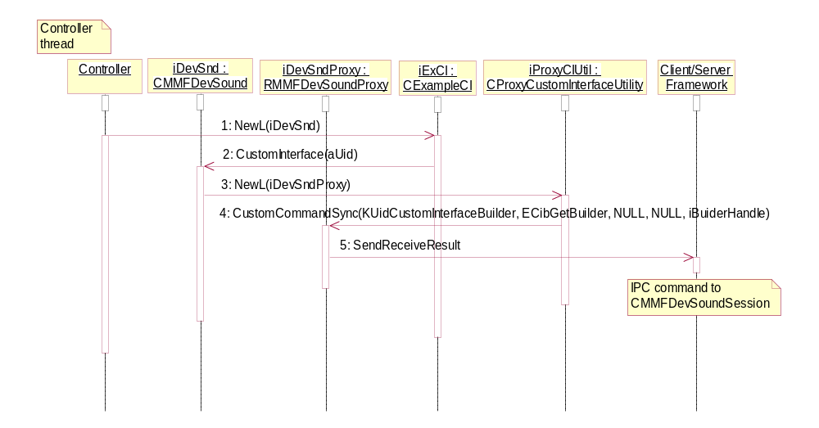
Figure 5.17 Requesting a handle to the custom interface builder

Returning a handle to the custom interface builder
Figure 5.18 shows the sequence diagram of the DevSound server returning the custom interface builder’s handle to the proxy custom interface utility.

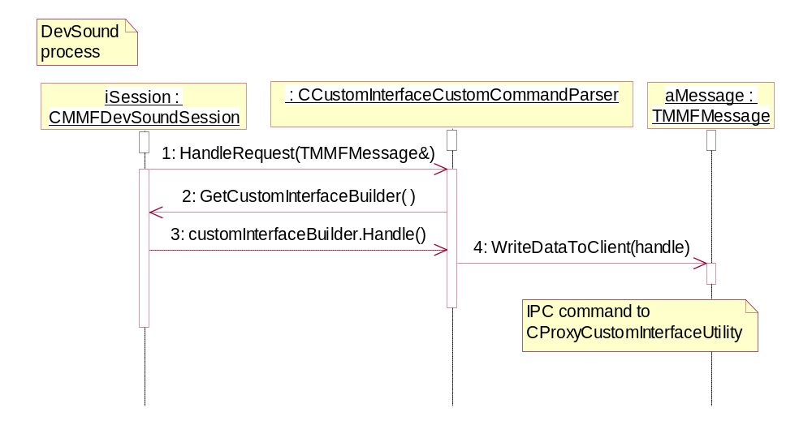
Figure 5.18 Returning a handle to the custom interface builder

Request for creating the CExampleCIMessageHandler message handler
Figure 5.19 shows the sequence diagram of the proxy custom interface utility requesting the custom interface builder to create the message handler, CExampleCIMessageHandler, and to return a handle to it.

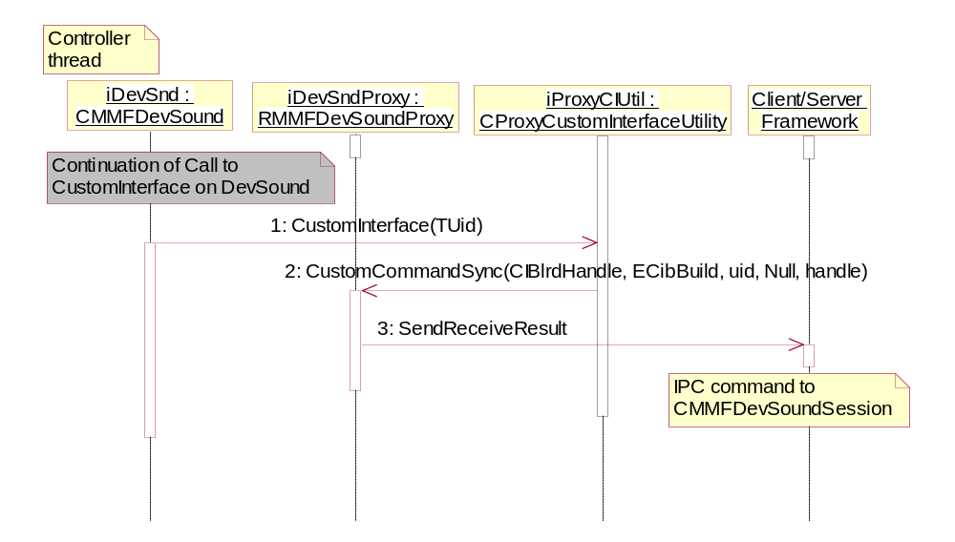
Figure 5.19 Request for creating the CExampleCIMessageHandler message handler

Returning a handle to the CExampleCIMessageHandler message handler
Figure 5.20 shows the sequence diagram of the DevSound server returning the message handler’s (CExampleCIMessageHandler) handle to the proxy custom interface utility.

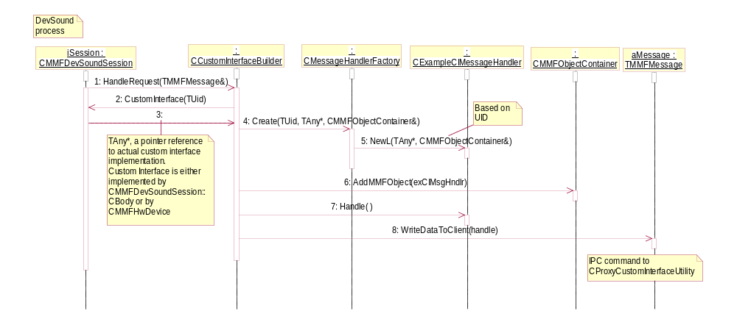
Figure 5.20 Returning a handle to the CExampleCIMessageHandler message handler

Creating and returning the CExampleCIProxy proxy object to the client
Figure 5.21 shows the sequence diagram of the proxy custom interface utility creating and returning the CExampleCIProxy proxy object to the client (controller).

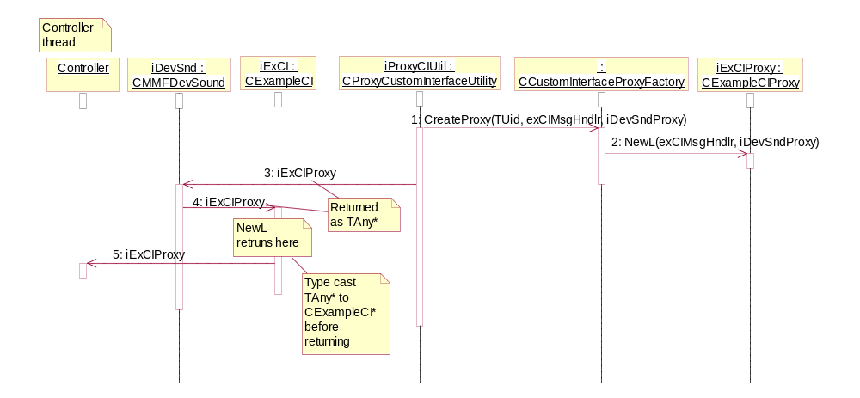
Figure 5.21 Creating and returning the CExampleCIProxy proxy object to the client

Calling methods on the CExampleCI object by the client
Figure 5.22 shows the sequence diagram of clients (or controllers) calling methods on CExampleCI.

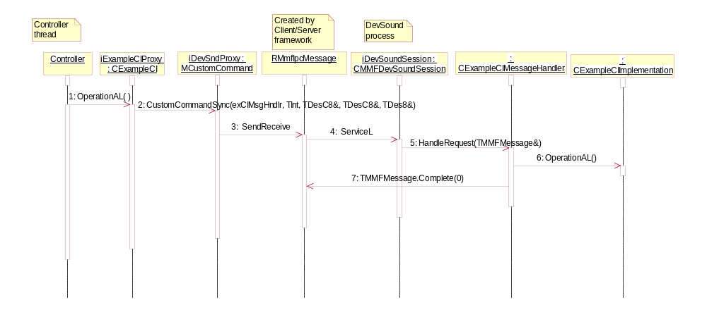
Figure 5.22 Calling methods on the CExampleCI object by the client

Collaboration diagram

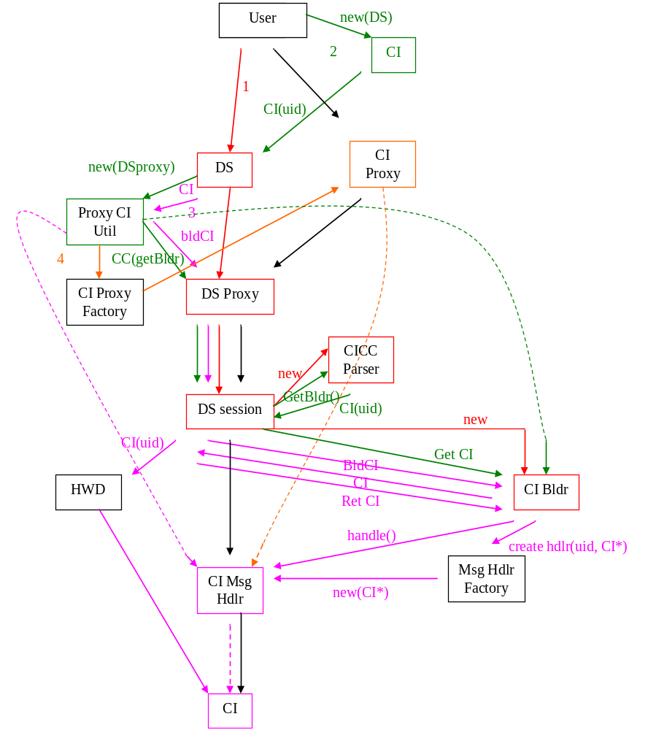
Figure 5.23 Collaboration diagram
- Create DevSound -> Create DSproxy -> Create Session -> Create CICC parser
- Create Custom Interface ->Create Proxy CI Util -> Get CIBldr handle for Proxy CI Util
- Bld CI -> Bld Msg Hdlr -> return Msg Hdlr hdl to Proxy CI Util
- Bld CI Proxy and give it handle to Msg Hdlr
(black arrows show custom inteface method call)
In Figure 5.23, the steps are the following:
- Create DevSound.
- Create DS Proxy.
- Create a session.
- Create the CICC parser.
- Create the custom interface.
- Create Proxy CI Util.
- Get the CIBldr handle for Proxy CI Util.
- Build CI.
- Build Message Handler.
- Return the Message Handler handle to Proxy CI Util.
- Build CI Proxy and give its handle to Message Handler.

In the figure, the black arrows show custom interface method calls.

DevSound API Documentation

SetVolume
Changes the playback volume to a specified value. Audio Adaptation changes the volume only on the audio stream owned by this DevSound instance.
Volume changes are taken into effect immediately. If DevSound is not playing audio, this volume is used by Audio Adaptation to configure audio stream when the client calls CMMFDevSound::PlayInitL (or one of the Tone Play APIs). If DevSound is currently playing audio (digital/tone), Audio Adaptation changes the volume on the audio stream immediately.

Volume
Returns an integer representing the current volume. The current volume is defined by the most recent CMMFDevSound::SetVolume call by client.

SetVolumeRamp
Defines the period (Time ‘T’) over which the volume level is to rise smoothly from volume level one to the normal volume level when the client calls CMMFDevSound::PlayInitL (or one of the Tone Play APIs). After duration ‘T’, the audio is played at normal volume level for the full duration of playback. This applies both for digital audio and tone.

Parameters:
const TTimeIntervalMicroSeconds &aVolumeRampTime | Time period over which the volume level rises smoothly from level one to the normal level.

Normal volume is the volume level set by the client with the most recent SetVolume() before CMMFDevSound::PlayInitL OR if no SetVolume() call has been made previously, the default volume level is considered to be the normal volume.
When DevSound goes to Stopped state (e.g. if the user calls Stop on DevSound OR playback is completed), any ongoing ramping (if there is any) is aborted. When the user calls PlayInitL (or one of the Tone Play APIs) again, ramping is restarted from volume level one to the normal volume. Except if the clip is played with alert priority/preference (KAudioPrefIncomingCall, KAudioPrefIncomingCallLine2, KAudioPrefRingFilePreview, KAudioPrefRingFilePreviewVibra, KAudioPrefIncomingPocCall, KAudioPrefAlarmClock, KAudioPrefCalendarAlarm), ramping is resumed during the next PlayInitL.
The SetVolumeRamp call made on DevSound when it is in playing state has no effect on the ongoing playback. Volume ramping is taken into effect in the subsequent PlayInitL requests (or one of the Tone Play APIs).
A zero value resets the duration (if there is any) and results in audio to be played at normal volume level for the subsequent PlayInitL requests (or one of the Tone Play APIs). A value, which is longer than the duration of the clip means that the sample never reaches its normal volume level. Except if the clip is repetitively played with alert priority/preference (KAudioPrefIncomingCall, KAudioPrefIncomingCallLine2, KAudioPrefRingFilePreview, KAudioPrefRingFilePreviewVibra, , KAudioPrefIncomingPocCall, , KAudioPrefAlarmClock, KAudioPrefCalendarAlarm), ramping is resumed during the next PlayInitL and the clip will reach its normal volume level after ramping duration.
If the client calls SetVolume in the middle of ramping (after time delta < ramp duration ‘T’) ramping is aborted and the volume level is set to the new level specified by the client.
Volume ramping is relative to the time it has begun that continues until volume limit is reached in the duration specified. If the client does not provide data (i.e. holds on to buffer give to it in BufferToBeFilled() callback and does not call PlayData()) ramping continues silently. When the client gives data by calling PlayData(), there will be a jump in the volume level.

Usage
A client wishing to use this API for volume ramping has to use it in the following sequence:

// Code snippet
DevSound::SetVolume()
DevSound::SetVolumeRamp(T) // Time ‘T’
DevSound::PlayInitL()

Note: The order of calling SetVolume/SetVolumeRamp does not matter as long as they are called before PlayInitL.

SetToneRepeats
SetToneRepeats defines the number of times the tone is to be repeated during the tone playback operation. A period of silence can follow each playing of a tone. The tone playing can be repeated indefinitely. This API is supported only during tone playing.

Parameters
TInt aRepeatCount | The number of times the tone, together with the trailing silence, is to be repeated. If this is set to KMdaRepeatForever, then the tone, together with the trailing silence, is repeated indefinitely or until Stop is called or the playback is pre-empted.
const TTimeIntervalMicroSeconds &aRepeatTrailingSilence | An interval of silence which is played after each tone.

The SetToneRepeats call made on DevSound when it is playing a tone has no effect on the ongoing playback. The repeat attribute is taken into account in the subsequent tone play requests. Once the value is set, it exists for the life time of the DevSound instance (like volume).
A zero value causes the tone to be played once when the client calls Tone Play APIs. The value one causes the tone to be played twice with an interval of silence specified by the user, and so on. When client calls a Tone Play API, the tone playback is considered to be complete only when Audio Adaptation has played the tone completely (repeatedly if required, based on tone repeats attributes set by the client) ToneFinished callback with KErrNone is sent to the observer.
When using tone repeats, ramping extends to cover the repeats, if the duration of tone sample is shorter than ramp time. The repeat trailing silence is considered as playing tone with mute and volume is ramped for that duration also.

Pause
Not supported for tones.
Synchronous operation that causes the codec to be stopped and deleted, data buffers in adaptation that not played is flushed. To resume playback, client has to call PlayInitL.
No PlayError callback will occur if client calls this function.
Historically the Pause() method was implemented as a stop, meaning buffers passed into the DevSound interface were not maintained, due to early hardware adaptations associated with s60. This behavior has been continuously carried forward, creating the problem of not being able to provide a pause where the buffers are maintained.
When Pause() is called, any ongoing ramping (if there was any) is aborted. When client resumes playback by calling PlayInitL(), volume ramping starts from level 1.
When DevSound is initialized for recording mode and if this function is called while recording, it should send all buffered data (audio data captured before Pause was called but not sent to observer yet) to client and should send a buffer with zero length and last buffer flag set, to the client via BufferToBeEmptied() observer callback.

Stop
Synchronous operation.
For tones, this will immediately stop playing tones.
For digital audio playback this function causes the codec to be stopped and deleted, data buffers in adaptation that not played is flushed.
No PlayError callback will occur if client calls this function.
Historically with hardware accelerated codec, Stop() command on the DevSound interface was implemented to delete the hardware codec and associated resources with that particular instance. This behavior has also been carried forward, creating the problem of introduced latency due to codec deletion and recreation in a seeking use case.
For digital audio recording this function causes the codec to be stopped and deleted, the data buffers captured before this function was called are discarded.

Samples Played
Returns the number of samples played so far. This is valid only for digital audio playback. Samples played will reset to zero when PlayInitL is called, except the case where PlayInitL is called to resume from Paused state. Samples Played will also be reset to zero if DevSound is re-initialized. Samples Played will be maintained even after PlayError.

SetConfigL
Configure CMMFDevSound object with the settings in aConfig. This function is used to set sampling rate, encoding and mono/stereo.
Not supported for tones.
For digital audio playback and recording, sampling rate and mono/stereo specifies the attributes of the audio stream (owned by this DevSound instance) that is connected to the audio device (Mixer).
This does not specify the attributes of audio data (encoded/plain) given by client to this instance of CMMFDevSound via PlayData().
If the audio stream owned by DevSound instance does not connect to audio device (Mixer), there is no need to call this API. However sampling rate and mono/stereo configuration information can be used to configure the next component (which ever happens to receive the data from this DevSound instance).
BufferSize and Encoded in the configuration parameters are ignored.
This function leaves with KErrNotReady if DevSound is not in the initialized state. This function should be called after a client has received MDevSoundObserver::InitializeComplete with error code KErrNone. Preferably before calling PlayInitL/RecordInitL. This function may leave with KErrAlreadyExists if called in the middle of playback/recording or when DevSound is paused based on whether the actual implementation supports dynamic configuration.
If DevSound is not configured by calling this function, then default configuration will be applied for playback/recording stream. Current configuration can be obtained by calling Config().

CustomInterface
Creates and returns pointer to an instance of Custom Interface identified by the specified input parameter. If no implementation is found or if there was any error creating the custom interface object, NULL is returned.
Custom Interfaces can be broadly classified into two categories:
Custom Interface with Continuous lifespan
Custom Interface with Discontinuous lifespan
Custom Interface with Discontinuous lifespan is the custom interface objects that can only be created once the DevSound instance is initialized successfully. The custom interface objects that are created will be valid until the DevSound instance is re-initialized/deleted. The entire codec configuration Custom Interfaces fall under this category.
Custom Interface with Continuous lifespan is the custom interface objects that have the lifespan matching with the lifespan of the DevSound instance. Objects can be created once the DevSound is instantiated and once they are created, they will be valid as long as the DevSound instance exists (unless explicitly deleted by the client). All the effects and routing custom interfaces fall under this category.
CustomInterface is a factory function. Objects returned by this function are owned by the client of DevSound instance upon which this function was called. The client is responsible for deleting the object once the custom interface object is no longer needed or becomes invalid.
If client needs custom interface objects that belong to Custom Interface with Discontinuous lifespan category, beyond re-initialization of DevSound instance, it should delete the custom interface objects first, re-initialize DevSound instance, and then re-create needed custom interfaces objects.
Custom Interface objects creation and deletion should match the following sequence:
- Create DevSound instance
- Create one or more Custom Interface with Continuous lifespan objects
- Initialize DevSound instance
- Create one or more Custom Interface with Discontinuous lifespan objects.
- Access DevSound API and/or Custom Interface API.
- Delete all Custom Interface objects
- Delete DevSound instance.

Optionally client can re-initialize DevSound instance after step 6 above and repeat sequence from 3 - 7.
As a general rule:
The client should request Custom Interface once per UID per DevSound initialization cycle.
- Once the Custom Interface is no longer needed, the client should delete it.

Added DevSound Control Custom Interface
The AddedDevSoundControl Custom Interface (CI) was created to modify the default behavior of both Pause and Stop during digital audio playback.
The API is intended only for Helix engine and should not to be used by other clients.
This custom interface enables pause that maintain buffers and provide a way to stop the codec and empty buffers without codec deletion. As a side effect of this change in behavior, the usage of this custom interface also affects samples played.
MAddedDevSoundControl is the interface implementing the custom interface. This is the class intended to be called by the client of the DevSound desiring to use the custom interface. If this interface is utilized and the SetHwAwareness() method is passed ETrue then the DevSound interface will alter its behavior for the Stop and Pause methods.
In the case where the hardware awareness flag is set EFalse or the MAddedDevsoundControl class is not used:
- The CMMFDevSound::Pause() causes the codec to be stopped and deleted, so buffers are flushed in the nominal case.
- The MAddedDevSoundControl::PauseAndFlush() is not enabled
In the case where the hardware awareness flag is set ETrue:
- The CMMFDevSound::Pause() when called will pause the codec with the all buffers sent to the CMMFDevSound::PlayData() will remain intact
- The MAddedDevSoundControl::PauseAndFlush() will be enabled for calling. Calling the MAddedDevSoundControl::PauseAndFlush() will stop the codec and buffers will be flushed flush so any data sent to DevSound that has not played out will be removed, but not delete the task. The CMMFDevSound::Stop() will still stop and delete the task as before.
- Samples played will not reset to zero when transitioning from paused state to playing state when next PlayInitL is called.
- Ramping is preserved when Pause()/PauseAndFlush() is called. It will be applied when playback is resumed. However since ramping is relative to the time it began, if the client takes longer time to resume playback, there will be a jump in the volume level. See SetVolumeRamp for more information.
The both methods can return error codes when there is no support for this API if it is ever needed to port to another architecture.

SetHardwareAwareness
This method will enable/disable hardware awareness attribute for desired CMMFDevSound::Pause behavior and will also enable/disable MAddedDevSoundControl::PauseAndFlush().

PauseAndFlush
This method can only be called when DevSound is in playing paused state and hardware awareness is set to true.
This method call will result in codec flushing (discarding) any buffered data sent to it via CMMFDevSound::PlayData()which is not decoded and/or rendered
Samples played will reset to zero when next PlayInitL is called.
Returns KErrInUse if DevSound is not in paused state. KErrNotSupported if feature is not supported. KErrNone if any buffered data is flushed successfully.

Resuming from True Pause
True Pause is the term used to describe the state when hardware awareness flag is set to ETrue and Pause() is called. Client’s should call PlayInitL() to resume from pause. If client has a buffer received before or after calling Pause(), it should call PlayData() before calling PlayInitL(). The following cases illustrate the sequence of operations and how resuming is done.

BufferToBeFilled() callback before calling Pause() and resuming.
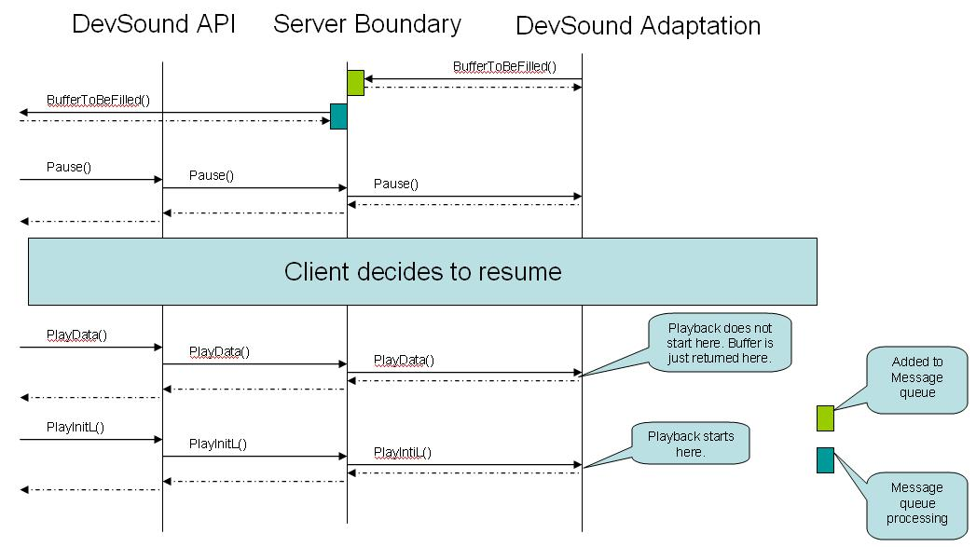

BufferToBeFilled() callback after calling Pause() and resuming.
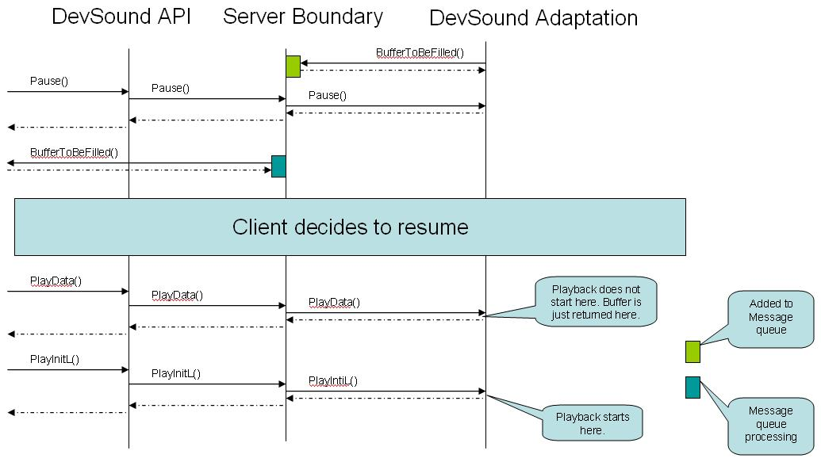

Race condition while resuming.
Platform Secure a.k.a PlatSec implementation of DevSound, since S60 release 3.0, consists of a process boundary between DevSound API, which client application uses, and the Adaptation implementation accessing hardware resources to service clients’ requests. Data and control commands are sent via Client/Server IPC message. Asynchronous events from Adaptation are sent to client via message queue. In pause/resume use case, there may be a case where client and server may go out of sync because of this. This is illustrated in the following diagram.
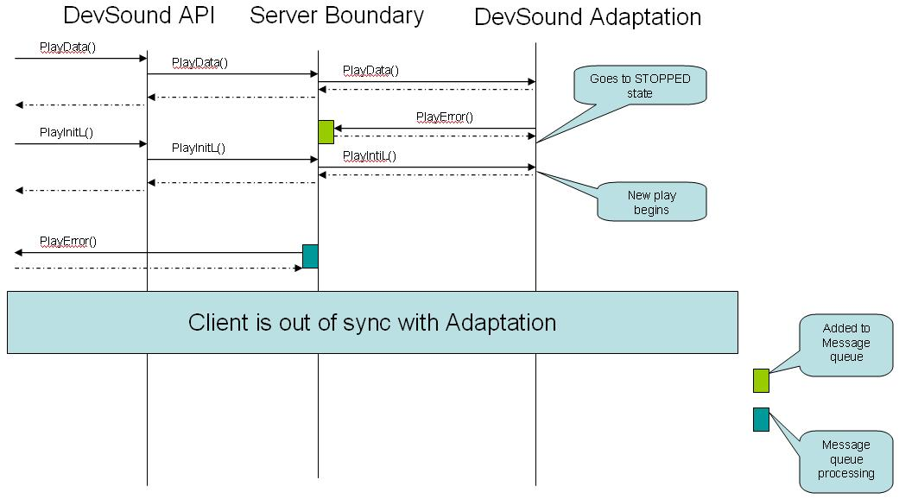

Race condition handling while resuming.
The following diagram proposes one possible solution to handle the race condition.
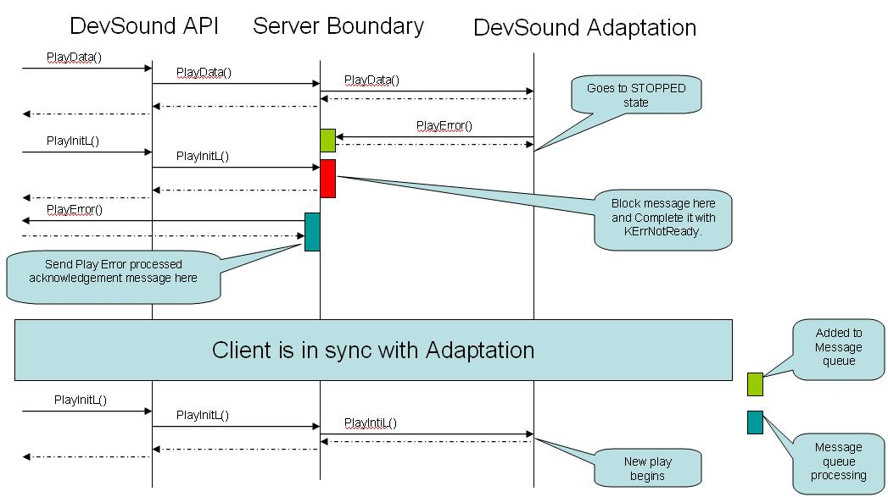

Platform Security
The DevSound server does not mandate its client to have any capabilities for using the APIs (MMF DevSound API and Custom Interface APIs) it provides. A client with no capabilities can still access and call these APIs.
The DevSound server passes the following client information to the adaptation:
- MultimediaDD capability (if the client application has it)
- Protected Server capability (if the client application has it)
- User Environment capability (if the client application has it)
- Secure ID
- Vendor ID

Note: If the client application does not have MultimediaDD, Protected Server or User Environment capabilities, the None capability is passed to the adaptation.
The DevSound server delegates the responsibility of enforcing Platform Security to the Adaptation subsystem. When a client application makes a MMF DevSound API or Custom Interface API call, the API call is always forwarded to the Adaptation subsystem across the process boundary. It is the adaptation that will decide whether or not to service the API call based on the client information given to it by the DevSound server.
Adaptation should enforce at least the following rules:
- The Adaptation subsystem should only allow clients with the User Environment capability to record audio from the microphone.
- The Adaptation subsystem should only allow clients with the MultimediaDD capability to use higher priority and preference values. If any application without the MultimediaDD capability tries to use higher priority and preference values, the Adaptation subsystem should ignore those values and use the default values for priority and preference for that client. This will prevent downloaded applications from pre-empting/denying critical system audio.
- The Adaptation subsystem should guarantee that system applications (Telephony and ringing tones) with a known Secure ID and Vendor ID always have a higher precedence over other applications while resolving the audio policy.
- If an application (including third party applications) is using the system audio for playback or recording with any priority (the default priority in case of untrusted applications or a higher priority in cases of applications with MultimediaDD), the Adaptation subsystem should prevent the key clicks audio (tone) from playing.

Support for Uid 0x10206593
The Adaptation subsystem should support initializing DevSound with uid 0x10206593 for mode EMMFStatePlaying and EMMFStateRecording. This is needed by S60 Telephony application engine. The Telephony application engine as part of its initialization during device boot up:
- Creates an instance of DevSound, initializes it with uid 0x10206593 and mode EMMFStatePlaying for controlling downlink volume.
- Creates an instance of DevSound, initializes it with uid 0x10206593 and mode EMMFStateRecording for controlling uplink gain (Muting and un-muting).
After the device is booted up, when Telephony application needs to use audio device (for establishing a call), it will call PlayInitL and RecordInitL on DevSound instances created for downlink volume control and uplink gain control respectively. This is to only signal Audio Policy that telephony application is in the process of establishing a call and not to request permission to establish call. The phone engine then proceeds with establishing the voice call. The DevSound instances will return empty buffer to the phone engine and these buffers are not used for call audio handling.
During call, all volume control messages goes to DevSound instance created for downlink volume control and all microphone control messages (mute/un mute) goes to DevSound instance created for uplink gain control.
When the call is terminated, the Telephony application engine will call Stop on both instances to signal Adaptation subsystem to release audio resources including policy.

Policy server denying requests for PlayInitL and RecordInitL will not stop telephony engine from establishing call. Also Policy server pre-empting DevSound instances that were initialized with uid 0x10206593, in the middle of call do not have any effect on the call. To make sure Policy Server enforces policy rules for other clients, it should consider these two instances of DevSound with highest priority and always grant permission for PlayInitL and RecordInitL requests and never pre-empt them.

When C/S call audio becomes active, Adaptation should automatically change the default output to EPrivate. (For C/S call audio, Adaptation should use the routing value set by Telephony application through TAR API).
To determine C/S call activation, Adaptation relies on the DevSound instance (with HwDevice ID 0x10206593) that is associated with downlink telephony audio, receiving a PlayInitL call.

S60 Release 5.0.1
Starting from S60 Release 5.0.1, Platform telephony applications will rely on Adaptation subsystem supporting initializing DevSound with FourCC code instead of UID 0x10206593. Apart from the initialization, the rest of the DevSound behavior explained in the previous section [9] are still need to match.
The FourCC ('M','O','D','M') is defined in the header S60FourCC.h.
So the Telephony application engine as part of its initialization during device boot up:
- Creates an instance of DevSound, initializes it with FourCC 0x4D444F4D (as opposed to UID 0x10206593) and mode EMMFStatePlaying for controlling downlink volume.
- Creates an instance of DevSound, initializes it with FourCC 0x4D444F4D (as opposed to UID 0x10206593) and mode EMMFStateRecording for controlling uplink gain (Muting and un-muting).
The CMMFDevSound API used to initialize the above mentioned instances is:
InitializeL(MDevSoundObserver& aDevSoundObserver, TFourCC aDesiredFourCC, TMMFState aMode)

Note: In releases previous to 5.0.1, the CMMFDevSound API used to initialize DevSound instances for controlling uplink and/or downlink gain and/or volume is:
InitializeL(MDevSoundObserver& aDevSoundObserver, TUid aHWDev, TMMFState aMode)

Process and Thread priorities
Some of the advanced applications like VOIP etc which by nature are real-time communication applications use DevSound for audio data capture and rendering. These applications demand a low latency and a very high performance audio service from DevSound Server framework.
To provide audio services with as very little interruption from other processes and threads as possible, the MMF Audio Server process priority is set to high. The MMF Audio Server also changes the priority of DevSound Server threads it creates to real-time priority (EPriorityRealTime) level. At the Operating System thread scheduler level, this value is treated differently than other threads with lesser priority. The value set by MMF Audio Server causes the absolute priority of the DevSound Server thread to be just less than the priority of the kernel.
It is recommended that any additional serves and threads created by Adaptation subsystem should also be set to the same level.

