S60 3.0
Telephony Audio Routing
Adaptation Guide

Team name | Author
MM Audio | Don Mitrani

Change history:

Version | Date | Status | Comments
1.0 | 23.11.2005 | Approved

Table of contents:

1. Telephony Audio Routing Manager API 4
2. API methods 5
2.1 OutputChanged 5
2.2 OutputChangeRequestCompleted 5
2.3 AvailableOutputsChanged 6
3. MTelephonyAudioRoutingPolicyObserver class 7

Telephony Audio Routing Manager API
Telephony Audio Routing Manager API provides an interface for the Adaptation system to communicate audio output changes to Telephony Audio Routing Server. When initializing the Audio subsystem during the system startup, Adaptation instantiates CTelephonyAudioRoutingManager by calling NewL() and passing to the factory function a list of the audio outputs available and a reference to the MTelephonyAudioRoutingPolicyObserver observer. During the instantiation, Telephony Audio Routing Server is started and a session to it is created within NewL(). If any of the steps fail, NewL() leaves with an error code.
When the CTelephonyAudioRoutingManager instance is deleted, Telephony Audio Routing Server is terminated.
Adaptation has to make sure that the Telephony Audio Routing Manager instance is created from within the MMF Audio Server process. It also has to make sure that the Telephony Audio Routing Manager instance is created before telephony applications try to create a session to Telephony Audio Routing Server in the startup sequence.
Telephony Routing API is available when Accessory Framework is used.
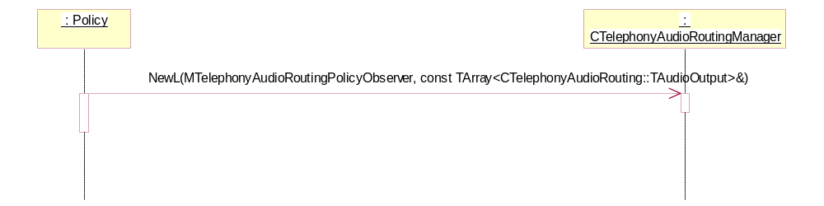
Figure 1.1 CTelephonyAudioRoutingManager creation sequence

API methods

OutputChanged
Adaptation uses the OutputChanged method to notify Telephony Audio Routing Server about changes in the current output. Telephony Audio Routing Server communicates the changes to the telephony applications registered with it.
All the routing decisions for telephony audio are made by the Telephony application. The only automatic routing that can happen which is not triggered by the Telephony application is audio switching between a Bluetooth accessory and the phone through a long key press by the user. This function will be called by Adaptation only if:
- In-call audio is routed from the device to a Bluetooth audio accessory by the user through a long key press (audio is automatically routed by the Audio subsystem).
- In call audio is currently routed to a Bluetooth audio accessory and the audio link between the device and the Bluetooth audio accessory is destroyed by the user through a long key press. Audio is not routed anywhere and the Bluetooth audio accessory is still a valid output.

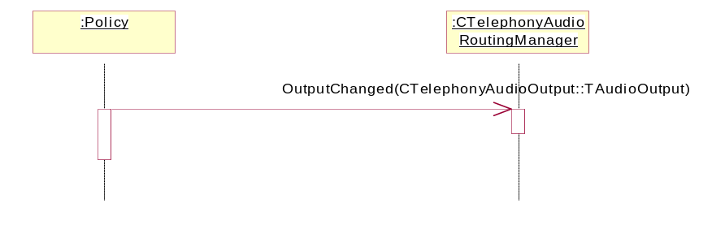
Figure 2.2 OutputChanged

OutputChangeRequestCompleted
Adaptation uses the OutputChangeRequestCompleted method to notify Telephony Audio Routing Server that the call to MTelephonyAudioRoutingPolicyObserver::OutputChangeRequested has been serviced. If the output requested by the client is set, aError will be KErrNone. If for some reason the output requested by the client is not set, Adaptation should call this with the current output and the reason for not setting the requested output.
Adaptation has to make sure it calls this function for each OutputChangeRequested request it received from the client.
The client application will not consider the request to be completed until it receives this signal from Adaptation. Adaptation has to make sure the requests from clients are serviced very quickly.
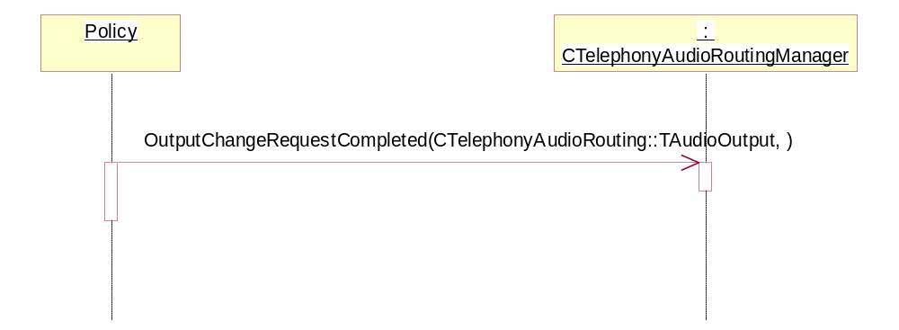
Figure 2.3 OutputChangeRequestCompleted

AvailableOutputsChanged
Adaptation uses the AvailableOutputsChanged method to notify Telephony Audio Routing Server about changes in the list of the available outputs that the telephony applications can use. This is then communicated to all the telephony applications that are clients of Telephony Audio Routing Server.
Adaptation has to call this function as soon as the list changes.
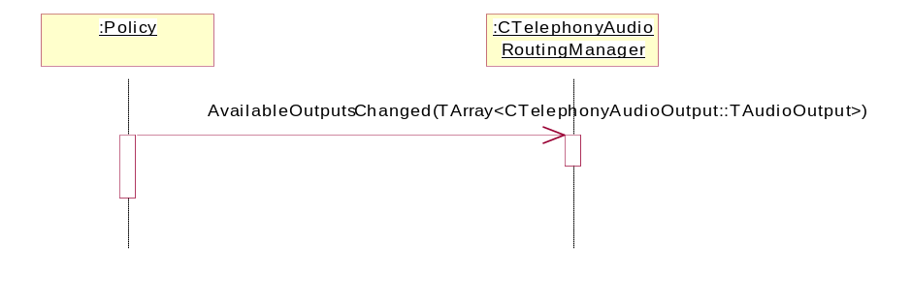
Figure 2.4 AvailableOutputsChanged

MTelephonyAudioRoutingPolicyObserver class
This is the interface that is used by Telephony Audio Routing Server to provide notifications to Adaptation about any current output change requests made by the telephony applications. The Adaptation component receives clients’ requests to change output by inheriting from MTelephonyAudioRoutingPolicyObserver and implementing the OutputChangeRequested pure virtual function.
The method OutputChangeRequested is called when a telephony application requests Telephony Audio Routing Server to change the current output. Adaptation needs to make sure that the change requests are handled in the order they are received. On servicing the request, Adaptation should call the OutputChanged method of Telephony Audio Routing Manager API.
Telephony Audio Routing Server makes sure a client cannot request to activate an unavailable output. There might still be some cases where by the time the message reaches MTelephonyAudioRoutingPolicyObserver the output requested by the application might not be valid (e.g. the user has just disconnected HS/BT). In such cases, Adaptation has to call OutputChangeRequestCompleted with the current output and the error code KErrHardwareNotAvailable.
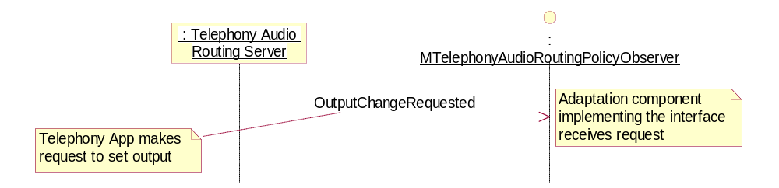
Figure 3.5 MTelephonyAudioRoutingPolicyObserver class

