S60 5.1
Audio Policy Mixing Table
Specification Document

Team name | Author
D RD S60 CSU MW MM & Secur Services US | Vasudevan Ramachandraiah

Change history:

Version | Date | Status | Comments
2.0 | 17.12.2008 | Approved | - Added emergency call preference and priority  - Added UPnP preference and priority  - Added VoIP preference and priority  - Editorial changes
1.0 | 26.10.2007 | Approved

Table of contents:

1. Document Control 4
1.1 References 4
1.2 Definitions 4
2. Purpose 5
2.1 Scope 5
3. Introduction 6
4. Categories 7
5. Mixing rules 9
6. Profile Settings and Preference mappings 10

Document Control

References

- S60 Audio Policy Implementation Guideline
- S60 Audio Policy Mixing Table User’s Guide

Definitions

Audio Policy | A logical component in Audio Adaptation that controls access to device audio resources.

Purpose
The purpose of this document is to define standard S60 release 5.1 mixing rules to be used by Audio Policy. The intended audiences for this document are the licensees who implement Audio and Audio Policy Adaptation for S60.

Scope
This document defines the S60 release 5.1 wide mixing rules. The actual description audio behavior (Routing, Effects, Vibra, and so on) associated with category is outside the scope of this document.

Introduction
Mixing rules are evaluated when some application starts audio activity (playback or recording) and there is already some other audio activity ongoing in the device.
The evaluation process includes comparing the incoming request against all other currently active audio clients. A new incoming request is presented by a row of the mixing table. The incoming request is then compared to all other current audio activity, presented by the columns of the mixing table (see reference document [2]).

Categories
The preference/priority values (see reference document [1]) are grouped into various categories as depicted in Figure 4.1.
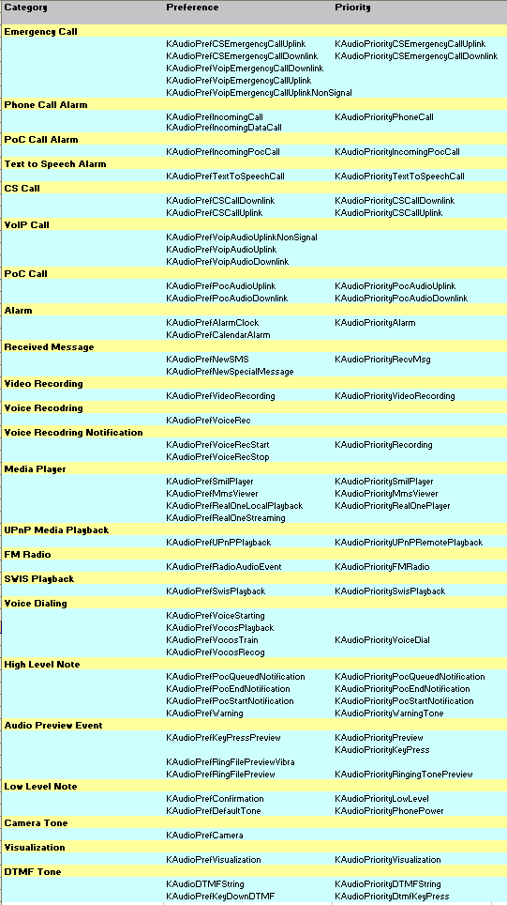
Figure 4.1 Categories of preference/priority values

Mixing rules
The default mixing rules for S60 release 5.1 are depicted in Figure 5.2:
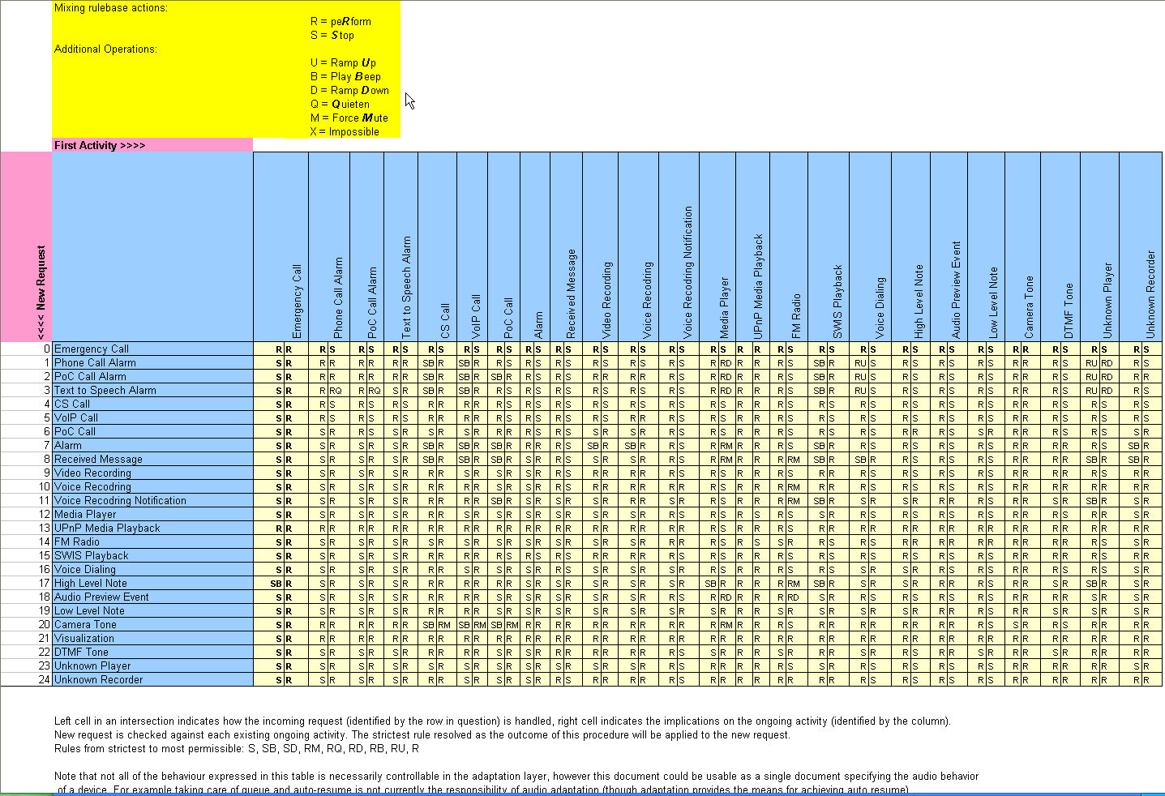
Figure 5.2 Default mixing rules for S60 release 5.1

Profile Settings and Preference mappings
Figure 6.3 depicts how Preference values are mapped to Profile Setting attributes.
An x value means that request to play audio with preference is considered for further rules evaluation only if the profile attribute/profile configuration is enabled.
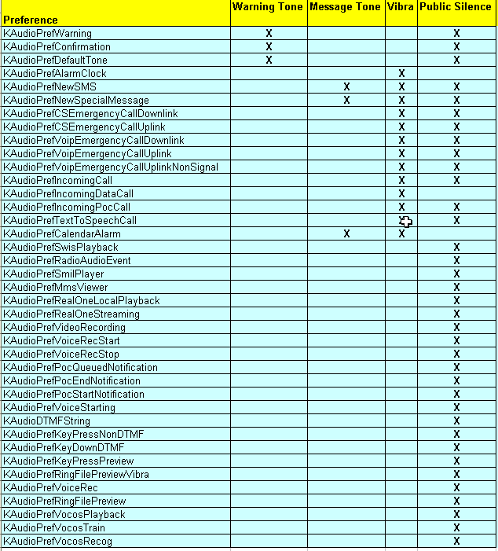
Figure 6.3 How Preference values are mapped to Profile Setting attributes

