S60 3.x
Audio Routing API
Specification Document

Team name | Author
MM Audio | Barry Woodward

Change history:

Version | Date | Status | Comments
4.0 | 11.04.2007 | Approved | - Release validity changed to 3.x  - Updated the AudioInput and AudioOutput Class with Supported APIs in S60 3.2  - Added description for SetAudioOutputL when C/S call is activated.  - Added description about EOutputToSpeaker in SetAudioInputL function.  - Added description to SetAudioInputL function.  - Added default input device selection rules and updated SetAudioOutputL documentation.  - Updated Doc after review of supported API  - Added BT Routing sequence diagram.
3.0 | 09.01.2006 | Approved | Updated based on modified Telephony Audio Routing API.
2.0 | 14.06.2005 | Approved | - Added CTelephonyAudioRouting class.  - Added clarifications and corrections.
1.0 | 01.03.2005 | Approved

Table of contents:
1. Document control 4
1.1 References 4
1.2 Documentation conventions 4
1.3 Abbreviations 4
2. Purpose 5
2.1 List of the required interfaces 5
2.2 Constraints 5
3. Technical specification 6
3.1 Type of the interface 6
3.2 Interface class structure 6
3.2.1 Input 6
3.2.2 Output 7
3.3 Usage 9
3.3.1 Protocol 9
3.3.1.1 Input 9
3.3.1.2 Output 9
3.3.2 Error handling 10
3.4 Example 10
3.4.1 Code examples 10
3.4.2 Sequence diagrams 12
3.4.2.1 Application initiated routing scenario 12
3.4.2.2 Non application initiated routing scenarios 13
3.5 Detailed description 15
3.5.1 Input 15
3.5.1.1 CAudioInput class 15
3.5.2 Output 17
3.5.2.1 CAudioOutput class 17
3.5.2.2 MAudioOutputObserver Class 22
3.5.2.3 CTelephonyAudioRouting class 22
3.5.2.4 MTelephonyAudioRoutingObserver class 24
3.5.3 Code architecture 25
4. Index 26
4.1 List of constants and enumerations 26
4.1.1 TAudioInputPreference enumeration 26
4.1.2 TAudioOutputPreference enumeration 26
4.1.3 TAudioOutput enumeration 26

Document control

References
- S60 Effects API Specification Document

Documentation conventions
Code is shown with the Courier New font.

Abbreviations
API | Application Program Interface
DLL | Dynamic Link Library
HW | Hardware
ID | Identifier
MB | Millibel
MMF | Multimedia Framework
SWIS | See-What-I-See
VoIP | Voice-over-IP

Purpose
This document describes the client interface for Audio Routing in S60 release 3.x. These APIs are associated with the audio that is controlled by the MDA utility that is used to construct the routing object. The interface is intended for the use of MMS, FM Radio, Line-In Recorder, and the Phone application, and it is provided as a substitute for the functionality provided by DOS Server in earlier releases.

List of the required interfaces
CAudioInput requires the client to have an instance of one of the following:
- CMMFDevSound
- CMdaAudioRecorderUtility
- MCustomCommand
- MCustomInterface
- CMdaAudioInputStream
- CVideoRecorderUtility

CAudioOutput requires an instance of one of the following:
- CMMFDevSound
- CMdaAudioPlayerUtiltiy
- CMdaAudioRecorderUtility
- MCustomCommand
- CMidiClientUtility
- MCustomInterface
- CMdaAudioToneUtility
- CDrmAudioPlayerUtility
- CVideoPlayerUtility
- CMdaAudioOutputStream

CTelephonyAudioRouting requires the client to be one of the following:
- The Phone application
- Video Telephony
- SWIS
- VoIP

Constraints
This interface is available from S60 release 3.0 onwards. This API is intended only for the use of MMS, FM Radio, Line-In Recorder, and the Phone application.

Technical specification

Type of the interface
This API provides a method call interface. A callback mechanism is also provided for output routing notification.

Interface class structure

Input
Input routing is provided using the CAudioInput API.
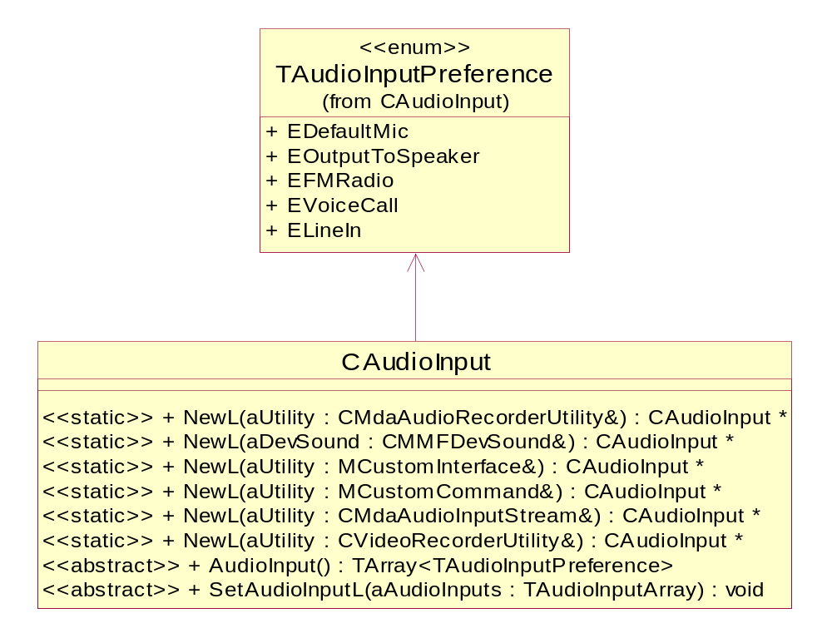
Figure 3.1 CAudioInput API class structure
Table 3.1 below defines the expected priority order (from the highest to the lowest) of basic input device types. The exact availability of input devices is product-specific. For instance a device might have FM Tuner but might not support recording from it, in such case FM Radio will not be a valid input source. When selecting the audio input, the Audio subsystem determines which devices are available and chooses the one with the highest priority to maintain the S60 application behavior consistency.
Table 3.1 Default input device selection rules
Input devices
Telephony audio (If call is in progress)
FM Radio (If FM Tuner is available, device supports recording from tuner and FM Radio is playing)
Default microphone

Output
Figure 3.2 shows the audio output routing system context.
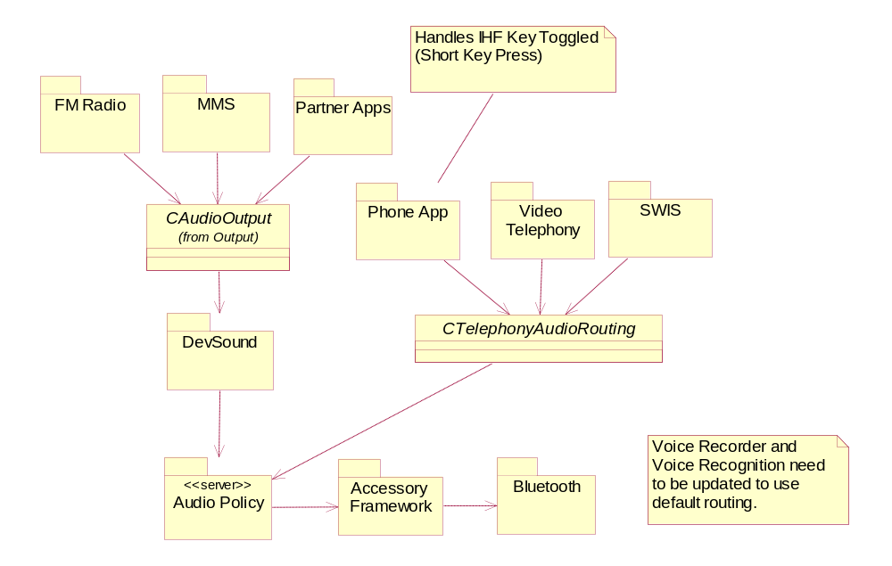
Figure 3.2 Audio output routing system context
Two audio output routing interfaces are provided. The CAudioOutput API is used by FM Radio, MMS, and partner applications for general audio routing.
The CTelephonyAudioRouting API is provided for telephony applications only because they have the highest priority and unique requirements.
By default, non-telephony routing will be to a public device when a headset is not connected and to a private device if a headset is connected. The default routing will automatically switch between private/public when accessories are attached and detached. Most applications should be able to use the default routing.
Table 3.2 below defines the expected priority order (from the highest to the lowest) of basic device types. The exact ordering of specific devices is product-specific. When selecting the audio output, the Audio subsystem determines which devices are available and chooses the one with the highest priority based on the current mode (public or private). When a higher priority accessory is connected, the output routing is switched automatically by the Audio subsystem. If a lower priority accessory is connected, the routing is not changed automatically.
Table 3.2 Default telephony routing device rules
Private | Public
Bluetooth (when activated by the user or the UI) | Bluetooth (when activated by the user or the UI)
Wired headset | IHF (loudspeaker)
Earpiece

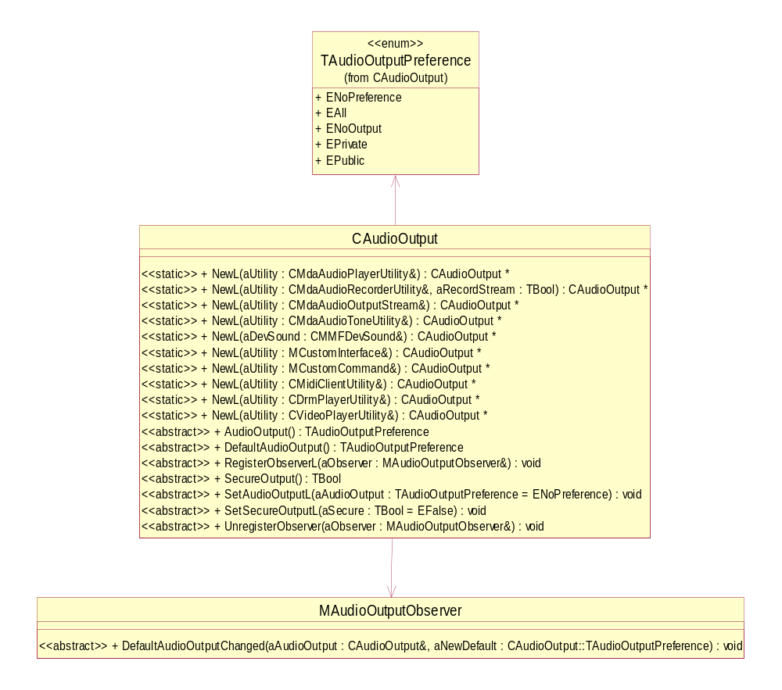
Figure 3.3 CAudioOutput API class structure
When telephony applications use the CTelephonyAudioRouting API, audio routing is always decided by and initiated by the telephony application. The only automatic switching of audio is between a Bluetooth headset and the device during a long key press event initiated by the user on the Bluetooth device.

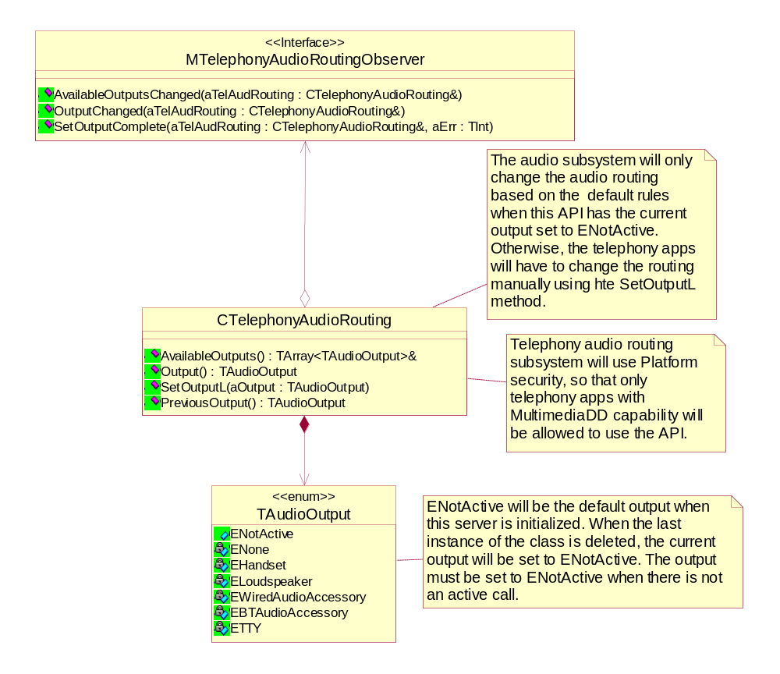
Figure 3.4 CTelephonyAudioRouting API class structure

Usage

Protocol

Input
The client first instantiates CAudioInput by calling the appropriate NewL() method. It can then set an audio input by calling SetAudioInput() and get the current input by calling AudioInput().

Output

CAudioOutput
The client first instantiates CAudioOutput by calling the appropriate NewL() method. It can then use any of the other API methods. The client may also register for notifications when the default output is changed by inheriting from MAudioOutputObserver and implementing the DefaultAudioOutputChanged() method.

CTelephonyAudioRouting
The client first instantiates CTelephonyAudioRouting by calling NewL(). It can then use any of the other API methods. The client will receive change notifications by inheriting from MTelephonyAudioRoutingObserver and implementing the AvailableOutputsChanged(), OutputChanged(), and SetOutputComplete() pure virtual methods.
The Audio subsystem changes the audio routing based on the default rules when the current output is set to ENotActive. When the current output is not ENotActive, the telephony applications have to change the routing manually using the SetOutputL() method.
The current output is ENotActive upon the construction of the first instance of CTelephonyAudioRouting in the system. The current output for the subsequent instances is the active output set by any telephony application client at any given point in time. The telephony application’s client is responsible for ensuring that the current output is set to ENotActive when not in an active call. Upon the destruction of the last instance of CTelephonyAudioRouting, the output is set to ENotActive.

Error handling
When using these APIs to override the default audio routing, it is possible that there may be a conflict in the audio routing resources. If there is a conflict, any audio that cannot be played will be given KErrRoutingConflict through the associated MDA utility.
When telephony applications use the CTelephonyAudioRouting API for configuring output, the client-side API implementation does most of the error checking before sending the request to the Audio subsystem. Any run time errors result in clients getting an error code in the MTelephonyAudioRoutingObserver::SetOutputComplete callback if SetOutputL() were to fail.

Example

Code examples
// Input Example

// Create CAudioInput
CAudioInput* audioInput = CAudioInput::NewL( *theRecordUtility );
RArray<CAudioInput::TAudioInputPreference> inputArray;
inputArray.Append( CAudioInput::EdefaultMic );
// Set Audio Input
audioInput->SetAudioInputL( inputArray.Array( ) );
// Get Audio Input
CAudioInput::TAudioInputArray currentInputs = audioInput->AudioInput( );

// Output Example

// class definition
class COutputRoutingClient : public CBase, MAudioOutputObserver
{
.
.
.
void DefaultAudioOutputChanged( CAudioOutput* aAudioOutput,
CAudioOutput::TAudioOutputPreference aNewDefault );

.
.
.
};

// Implementation
void COutputRoutingClient::Method1()
{
// Create CAudioOutput
CAudioOutput* audioOutput = CAudioOutput::NewL( *iPlayerUtility );
// Register for default output notification
audioOutput->RegisterObserver( *this );
// set secure output
audioOutput->SetSecureOutput( );
}

void COutputRoutingClient::DefaultAudioOutputChanged(CAudioOutput* aAudioOutput,
CAudioOutput::TAudioOutputPreference aNewDefault )
{
// Handle default change notification
}

// Telephony Output Example

// class definition
class CTelephonyApplication : public CBase, MTelephonyAudioRoutingObserver
{
.
.
.
void AvailableOutputsChanged(CTelephonyAudioRouting& aTelephonyAudioRouting);
void OutputChanged(CTelephonyAudioRouting& aTelephonyAudioRouting);
void SetOutputComplete(CTelephonyAudioRouting& aTelephonyAudioRouting, TInt aError);
.
.
.
}

// Implementation
void CTelephonyApplication::Method1()
{
.
.
.
// Create CTelephonyApplication
CTelephonyAudioRouting* audioRouting = CTelephonyAudioRouting::NewL(*this);
// get available outputs
outputArray = audioRouting->AvailableOutputs();
// set output
audioRouting->SetOutputL(output);
}

void CTelephonyApplication::AvailableOutputsChanged(
CTelephonyAudioRouting& aTelephonyAudioRouting)
{
//Handle available outputs changed
}
void CTelephonyApplication::OutputChanged(
CTelephonyAudioRouting& aTelephonyAudioRouting)
{
//Handle output changed
}

void CTelephonyApplication::SetOutputComplete(
CTelephonyAudioRouting& aTelephonyAudioRouting, TInt aError)
{
//Handle set output complete
}

Sequence diagrams

Application initiated routing scenario
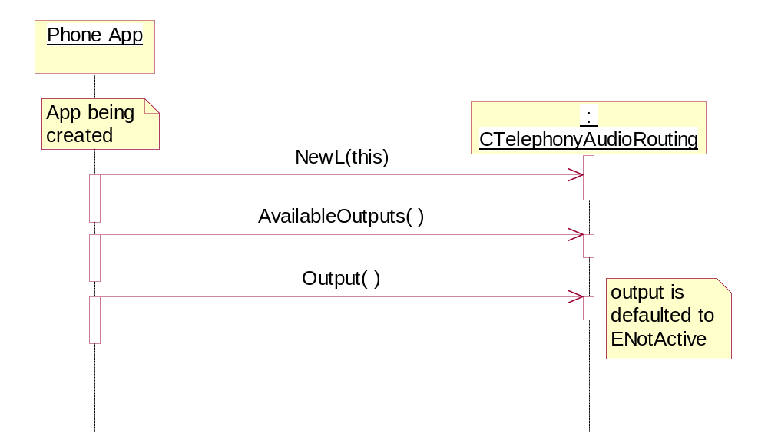
Figure 3.5 CTelephonyAudioRouting creation sequence

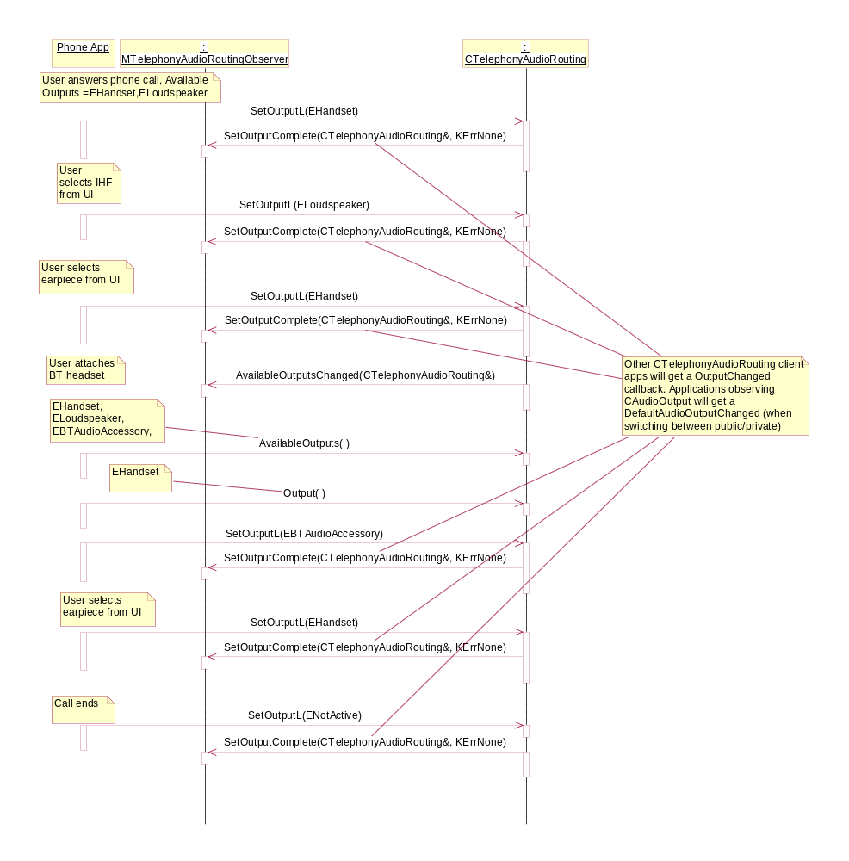
Figure 3.6 Answering a phone call sequence

Non application initiated routing scenarios
Pre-condition: The phone is in call state and BT Audio Accessory is one of the available outputs. The telephony audio is routed to one of the available outputs other than BT Audio Accessory.
The user presses the key on the BT Audio Accessory long enough which signals the Adaptation subsystem to automatically route telephony audio from the current output to BT Audio Accessory.
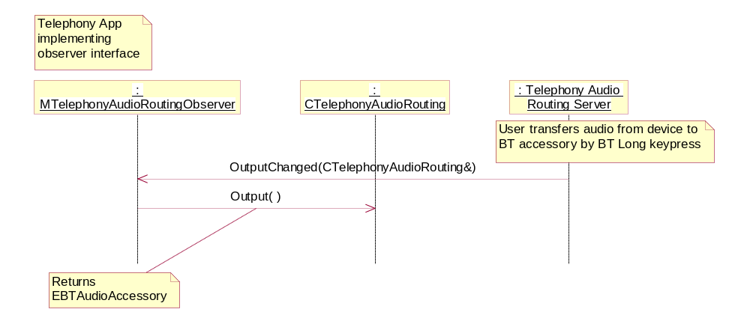
Figure 3.7 Audio Routing using BT Audio Accessory Long key press
Pre-condition: The phone is in call state and telephony audio is routed to BT Audio Accessory.
The user presses the key on the BT Audio Accessory long enough which signals the Adaptation subsystem to destroy the audio link between the device and BT Audio Accessory. Audio is not automatically routed anywhere by the Adaptation subsystem.
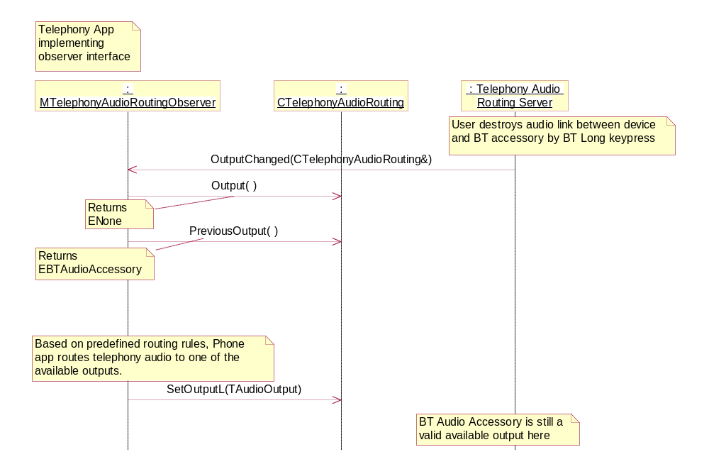
Figure 3.8 Audio Link destroyed using BT Audio Accessory Long key press

Detailed description

Input

CAudioInput class
The CAudioInput class is used by an audio application to inform the Audio subsystem which audio streams it wants to record or capture.
This is an optional feature. If it is not supported on a platform, the NewL method will leave with KErrNotSupported or return a NULL pointer. Even if the interface is supported, any method in the interface may leave with KErrNotSupported. It is the audio application’s responsibility to be able to handle this error when using this class.

NewL
A static constructor that creates an audio input object.
Since:
S60 3.0
Parameters:
MCustomCommand& aUtility: An MDA or MMF utility that implements the custom command interface that controls the recording audio stream that will be affected by this object.
Returns:
CAudioInput*

NewL
A static constructor that creates an audio input object.
Since:
S60 3.0
Parameters:
CMdaAudioRecorderUtility& aUtility: The MDA audio recorder utility that controls the recording audio stream that will be affected by this object.
Returns:
CAudioInput*

NewL
A static constructor that creates an audio input object.
Since:
S60 3.0
Parameters:
CMMFDevSound& aDevSound: The DevSound that controls the recording audio stream that will be affected by this object.
Returns:
CAudioInput*

NewL
A static constructor that creates an audio input object.
Since:
S60 3.2
Parameters:
MCustomInterface& aCustomInterface: The Custom Interface Object that controls the recording audio stream that will be affected by this object.
Returns:
CAudioInput*

NewL
A static constructor that creates an audio input object.
Since:
S60 3.2
Parameters:
CMdaAudioInputStream& aInputStream: The Input Stream Object that controls the recording audio stream that will be affected by this object.
Returns:
CAudioInput*

NewL
A static constructor that creates an audio input object.
Since:
S60 3.2
Parameters:
CVideoRecorderUtility& aUtility: The Video Recorder Utility that controls the recording audio stream that will be affected by this object.
Returns:
CAudioInput*

AudioInput
This method returns the exact values that the user wrote using the SetAudioInputL method. If SetAudioInputL was never used, then enumeration with zero elements is returned.
Parameters:
None.
Returns:
TArray<TAudioInputPreference> aAudioInputs

SetAudioInputL
This method allows an audio application to specify which audio streams it wants to record or capture. The recording stream in this section refers to the stream belonging to the recorder utility that is associated with this instance of CAudioInput.
- If all the inputs specified in the parameter are not valid for the device, the Audio subsystem returns MDevSoundObserver::RecordError(KErrorHardwareNotAvailable) for the DevSound stream for which the client application is trying to set the Audio Input.
- If one or more inputs specified in the parameter are valid, the audio data of recording stream contains the resultant of audio mixed from input types in the parameter list. There might be hardware limitations of streams that can be mixed from different input types. In such a case the Audio subsystem, from the parameter list, selects the input device with the highest priority and tries to find the compatible stream that can be mixed starting with the next highest priority in the list. In case of devices that do not appear to have default priority (EOutputToSpeaker and ELineIn), the order in which they appear in the list is considered. So at a minimum level, the application is always guaranteed to get input from the highest priority input.
- If the selected as input type is only EOutputToSpeaker, Adaptation does not return silent audio frames to the recording stream when no input signal is detected. Adaptation holds on to the partially filled buffer (if any) and appends data to it as and when input signal is detected. Once the buffer is full, Adaptation sends the data buffer to the recording stream. If the user sends the stop command to the recording stream before any partial buffer is filled, Adaptation flags the buffer as last buffer and sends the buffer to recording stream after receiving stop command.
Parameters:
TArray<TAudioInputPreference> aAudioInputs: This array contains all of the audio streams that the application wants to record or capture. If this is NULL, the Audio subsystem records what it determines to be the default audio stream.
Returns:
void

Output

CAudioOutput class
The CAudioOutput class is used by an audio application to inform the Audio subsystem of limitations on where the audio can be routed for output when playing. This class should only be used if the default audio routing is not sufficient for the audio client.
This is an optional feature. If it is not supported on a platform, the NewL method will leave with KerrNotSupported or return a NULL pointer. Even if the interface is supported, any method in the interface may leave with KerrNotSupported. It is the audio application’s responsibility to be able to handle this error when using this class.

NewL
A static constructor that creates an audio output object.
Since:
S60 3.0
Parameters:
MCustomCommand& aUtility: An MDA or MMF utility that implements the custom command interface that controls the playing audio stream that will be affected by this object.
Returns:
CAudioOutput*

NewL
A static constructor that creates an audio output object.
Since:
S60 3.0
Parameters:
CMdaAudioPlayerUtility& aUtility: The MDA audio player utility that controls the playing audio stream that will be affected by this object.
Returns:
CAudioOutput*

NewL
A static constructor that creates an audio output object.
Since:
S60 3.0
Parameters:
CMdaAudioRecorderUtility& aUtility: The MDA audio recorder utility that controls the playing audio stream that will be affected by this object.
Returns:
CAudioOutput*

NewL
A static constructor that creates an audio output object.
Since:
S60 3.2
Parameters:
CMdaAudioOutputStream& aUtility: The audio output stream that controls the playing audio stream that will be affected by this object.
Returns:
CAudioOutput*

NewL
A static constructor that creates an audio output object.
Since:
S60 3.2
Parameters:
CMdaAudioToneUtility& aUtility: The tone utility that controls the playing audio stream that will be affected by this object.
Returns:
CAudioOutput*

NewL
A static constructor that creates an audio output object.
Since:
S60 3.0
Parameters:
CMMFDevSound& aDevSound: The DevSound instance that controls the playing audio stream that will be affected by this object.
Returns:
CAudioOutput*

NewL
A static constructor that creates an audio output object.
Since:
S60 3.1
Parameters:
CDrmPlayerUtility& aUtility: The Drm player utility that controls the playing audio stream that will be affected by this object.
Returns:
CAudioOutput*

NewL
A static constructor that creates an audio output object.
Since:
S60 3.1
Parameters:
CMidiClientUtility& aUtility: The MidiClient utility that controls the playing audio stream that will be affected by this object.
Returns:
CAudioOutput*

NewL
A static constructor that creates an audio output object.
Since:
S60 3.2
Parameters:
CVideoPlayerUtility& aUtility: The Video Player utility that controls the playing audio stream that will be affected by this object.
Returns:
CAudioOutput*

NewL
A static constructor that creates an audio output object.
Since:
S60 3.0
Parameters:
MCustomInterface& aUtility: The Custom Interface that controls the playing audio stream that will be affected by this object.
Returns:
CAudioOutput*

AudioOutput
Returns the audio output value that was set by the SetAudioOutputL method.
Parameters:
None.
Returns:
TAudioOutputPreference

DefaultAudioOutput
Returns the current audio output that is being used when the preference is set to ENoPreference. This will never return ENoPreference.
Parameters:
None.
Returns:
TAudioOutputPreference

RegisterObserverL
Allows clients to register to be updated when the default audio output changes.
Parameters:
MAudioOutputObserver& aObserver: The observer that is being registered.
Returns:
void

SecureOutput
Returns the secure output value that was set by the SetSecureOutputL method.
Parameters:
None.
Returns:
TBool

SetAudioOutputL
This method allows an audio application to specify how its audio may be routed. The routing is communicated by setting a preference of the type of output.
This method may leave with KErrNotSupported any time it is used. If this method is supported, it should always work when called before starting the playback. However, it is optional for it to work while playback is in progress. In this latter case, the method leaves with KErrNotSupported. If this happens, the application should always stop the audio and then optionally call SetAudioOutput and start the audio again.
Due to limited hardware resources, some products may not allow different audio to be played in different speakers at the same time. In such cases the following things happen:
- Routing Conflict: The two types of conflicts are: ENoOutput with any other preference, or Private with Public or EAll. Selecting Public and EAll at the same time is not a conflict. When a conflict is detected, the Audio subsystem will give the error KErrRoutingConflict to the conflicting clients based on their priority.
- Audio Routing: When the application chooses EAll, based on current state of the device and based on current ongoing activity, the Audio subsystem is free to choose where audio (e.g. alert tone or system beep) is routed. If it cannot be routed at all (if such a case ever happens), then the Audio subsystem gives KErrRoutingConflict to the application requesting this operation.
- If earpiece is/was active when some audio client requests EAll (especially if the audio is non-user-initiated), it might be harmful for the user to have the audio routed to IHF (his/her ear most likely being close to the device), so in this case it might be best if the EAll was routed to earpiece (and possible accessory) and not IHF. The user should be able to hear the audio of EAll from earpiece also since it is being used anyway. If EAll is requested after a very short period since the last stream that was routed to earpiece was deactivated it might be good to rise the volume of the audio that is routed to IHF smoothly.

The primary reason for this setting is to get audio to go to the Loudspeaker when the headsets are connected.
Parameters:
TAudioOutputPreference aAudioOutput: Used to specify the audio output preference. By default, the preference is ENoPreference.
Returns:
void

SetSecureOutputL
This method is used to indicate that audio must be played through secure outputs only. Non-secure outputs are anything high-quality digital (such as files) or high quality Bluetooth. This method must be called with the parameter set to ETrue if the data is DRM-protected. If the data was DRM-decoded outside MMF, then it is the audio client’s responsibility to make this call; otherwise it is the audio controller’s responsibility.
Parameters:
TBool secure: Set to ETrue if audio must be played through secure outputs only, otherwise EFalse. By default, this is set to EFalse.
Returns:
void

UnregisterObserver
Indicates that the specified observer no longer wants to be updated when the default audio output changes.
Parameters:
MAudioOutputObserver& aObserver: The observer that is being unregistered.
Returns:
void

MAudioOutputObserver Class
The interface that is used by the CAudioOutput class to provide notifications to the registered clients when the default audio output changes. The default audio output is what the routing setting is when the client selects ENoPreference as the audio output setting.

DefaultAudioOutputChanged
Called when the default audio output changes.
Parameters:
- CAudioOutput* aAudioOutput: The CAudioOutput object with which the MAudioOutputObserver object is registered.
- TAudioOutputPreference aNewDefault: The new value of the default audio output. This will never be ENoPreference.
Returns:
void

CTelephonyAudioRouting class
The CTelephonyAudioRouting class is only used by telephony applications to inform the Audio subsystem on where audio can be routed for telephony output. The output must be set by the telephony applications to ENotActive when not in an active call. During an active call, the interface can be used to route the audio to the earpiece, loudspeaker, wired audio accessory (for e.g. headset, loopset, etc), Bluetooth or TTY device using the EHandset, ELoudspeaker, EWiredAudioAccessory, EBTAudioAccessory, or ETTY output types respectively.

NewL
A static constructor used by the client to create an instance of CTelephonyAudioRouting.
If the server is not created by the Audio subsystem, this function leaves with KErrNotReady. If the client application does not have the MultimediaDD capability, this leaves with KErrPermissionDenied.
Parameters:
MTelephonyAudioRoutingObserver& aObserver: Reference to the audio routing observer.
Returns:
void

AvailableOutputs
Returns a reference to an array of the outputs currently available in the hardware configuration where telephony audio can be routed.
The array contains a list of the following outputs depending on whether the output is available or not at the time of the query:
- EHandset
- ELoudspeaker
- EWiredAudioAccessory,
- EBTAudioAccessory
- ETTY

Audio can be routed to any of the available outputs in the list.
Returns:
TArray<TAudioOutput>&

Output
Returns the active output that is configured by the telephony application client to play audio.
The possible values are:
- ENotActive: If output has not been set or one of the telephony applications has called SetOutputL(ENotActive) successfully.
- ENone: If active output becomes unavailable (e.g. IHF/BT where audio is currently routed is disconnected) or the user has switched audio between the Bluetooth accessory and the device by pressing a key long on the Bluetooth device and active output has not been set.
- EHandset, ELoudspeaker, EWiredAudioAccessory, EBTAudioAccessory or ETTY depending on the last successful SetOutputL() call.

Returns:
TAudioOutput

SetOutputL
Sends an asynchronous request to the Audio subsystem to configure the active output to play telephony audio. This request is completed only when the application receives the MTelephonyAudioRoutingObserver::SetOutputComplete callback.
If MTelephonyAudioRoutingObserver::SetOutputComplete receives KErrNone, the aOutput requested by this application is configured by the Audio subsystem. Otherwise there was an error configuring aOutput and the application should call CTelephonyAudioRouting::Output to get the active output.
The function leaves with:
- Any of the system wide error code in case of a failure to send the request.
- KErrArgument when the parameter is ENone.
- KErrHardwareNotAvailable if aOutput is not in the list of the available outputs.

Parameters:
TAudioOutput aOutput: The output that needs to be configured by the Audio subsystem.
Returns:
void

PreviousOutput
Returns the second last output that was successfully configured to play telephony audio.
The possible values are:
- ENotActive : If output had not been set or one of the telephony applications had previously called SetOutputL(ENotActive) successfully.
- EHandset, ELoudspeaker, EWiredAudioAccessory, EBTAudioAccessory or ETTY depending on the second last successful SetOutputL() call.

Note: ENone will never be returned since telephony applications cannot call SetOutputL(ENone).
Returns:
TAudioOutput

MTelephonyAudioRoutingObserver class
The interface that is used by the CTelephonyAudioRouting class to provide notifications to clients when the list of the available outputs changes, when the current output changes, and when a set output operation completes.

AvailableOutputsChanged
This method is called by CTelephonyAudioRouting when the list of the available outputs changes. The applications has to call CTelephonyAudioRouting::AvailableOutputs() to get the updated list.
Parameters:
CTelephonyAudioRouting& aTelephonyAudioRouting: A reference to the object triggering this callback.
Returns:
void

OutputChanged
This method is called by CTelephonyAudioRouting when the current output changes. The applications has to call CTelephonyAudioRouting::Output() to get the current active output.
The application gets this callback only when the change in the output is due to some other application's SetOutputL call or when the active output becomes invalid or when the user switches audio using a long key press from the Bluetooth device.
Parameters:
CTelephonyAudioRouting& aTelephonyAudioRouting: A reference to the object triggering this callback.
Returns:
void

SetOutputComplete
This method is called by CTelephonyAudioRouting when the asynchronous call to SetOutputL() completes.
Parameters:
- CTelephonyAudioRouting& aTelephonyAudioRouting: A reference to the object triggering this callback.
- Tint: The returned error code. KErrNone if the output requested by the application is set, else a system-wide error code.

Returns:
void

Code architecture
Input:
- Include: CAudioInput.h
- Link against: AudioInput.lib

Output:
- Include: CAudioOutput.h
- Link against: AudioOutput.lib

Telephony output:
- Include: TelephonyAudioRouting.h
- Link against: TelephonyAudioRouting.lib

Index

List of constants and enumerations

TAudioInputPreference enumeration
This enumeration defines the audio streams that can be selected as inputs for recording.
Attributes:
- EDefaultMic: Refers to the microphone associated with the currently active speaker (see Section 3.5.1.1).
- EOutputToSpeaker: Refers to the audio currently being sent to the currently active speaker (see Section 3.5.1.1).
- EFMRadio: Refers to the audio of the currently tuned FM radio station.
- EVoiceCall: Refers to the audio stream associated with the current phone call.
- ELineIn: Refers to the audio being received from the LineIn connection (if available).

TAudioOutputPreference enumeration
This enumeration defines the preferences that an audio application can use for controlling where its audio output will be played.
Attributes:
- ENoPreference: Used to indicate that the playing audio can be routed to any speaker. This is the default value for audio.
- EAll: Used to indicate that the playing audio should be routed to all speakers.
- ENoOutput: Used to indicate that the playing audio should not be routed to any output.
- EPrivate: Used to indicate that the playing audio should be routed to the default private speaker. A private speaker is one that can only be heard by one person.
- EPublic: Used to indicate that the playing audio should be routed to the default public speaker. A public speaker is one that can be heard by multiple people.

TAudioOutput enumeration
This enumeration defines the devices that can be used by telephony applications for routing audio output.
Attributes:
- ENotActive: When set as the output device, this value indicates to the Audio subsystem that the default routing rules should be used. The telephony applications should set output to this when not in an active call.
- ENone: When the current active output becomes invalid (the active accessory is disconnected) or the user has switched audio between the Bluetooth accessory and the device by pressing a key long on the Bluetooth device and the telephony application has not called CTelephonyAudioRouting::SetOutputL, this will be the current output.
- EHandset: When set as the output device, this value indicates to the Audio subsystem that the earpiece should be used as the output device.
- ELoudspeaker: When set as the output device, this value indicates to the Audio subsystem that the loudspeaker should be used as the output device.
- EWiredAudioAccessory: When set as the output device, this value indicates to the Audio subsystem that the wired accessory should be used as the output device.
- EBTAudioAccessory: When set as the output device, this value indicates to the Audio subsystem that the Bluetooth device should be used as the output device.
- ETTY: When set as the output device, this value indicates to the audio subsystem that the TTY device should be used as the output device.

