S60 3.0
Audio Visualization API
Specification Document

Team name | Author
MM Audio | Don Mitrani

Change history:

Version | Date | Status | Comments
1.0 | 09.11.2005 | Approved

Table of contents:

1. Document control 4
1.1 References 4
1.2 Documentation conventions 4
1.3 Abbreviations 4
2. Purpose 5
2.1 List of the required interfaces 5
2.2 Constraints 5
3. Technical specification 6
3.1 Type of the interface 6
3.2 Interface class structure 6
3.3 Usage 6
3.3.1 Protocol 6
3.3.2 Error handling 6
3.4 Example 7
3.4.1 Code examples 7
3.5 Detailed description 7
3.5.1 CVisualization class 7
3.5.1.1 NewL 8
3.5.1.2 DataRate 8
3.5.1.3 DataRateRange 8
3.5.1.4 EnableFrequencyData 8
3.5.1.5 EnableWaveformData 8
3.5.1.6 FrequencyBandCount 9
3.5.1.7 FrequencyBandCountRange 9
3.5.1.8 IsFrequencyDataEnabled 9
3.5.1.9 IsWaveformDataEnabled 9
3.5.1.10 SamplingRate 9
3.5.1.11 SetDataRateL 10
3.5.1.12 SetFrequencyBandCount 10
3.5.1.13 SetWaveFormDataLength 10
3.5.1.14 StartL 10
3.5.1.15 StopL 10
3.5.1.16 WaveformDataLength 11
3.5.1.17 WaveformDataLengthRange 11
3.5.2 MVisualizationObserver class 11
3.5.2.1 DataChanged 11
3.5.2.2 DataRateChanged 11
3.5.2.3 FrequencyBandCountChanged 12
3.5.2.4 VisualizationPreempted 12
3.5.2.5 VisualizationResumed 12
3.5.2.6 VisualizationStarted 12
3.5.2.7 VisualizationStopped 12
3.5.2.8 WaveformDataLengthChanged 13
3.5.3 TVisualizationData 13
3.5.4 Code architecture 13

Document control

References
- Series 60 Effects API Specification Document

Documentation conventions
Code is shown with the Courier New font.

Abbreviations
API | Application Program Interface
DLL | Dynamic Link Library
HW | Hardware
ID | Identifier
MMF | Multimedia Framework

Purpose
This document describes the client interface for controlling audio visualization in S60 release 3.0.

List of the required interfaces
None.

Constraints
This interface is available from S60 release 3.0 onwards.

Technical specification

Type of the interface
This API provides a method call interface. A callback mechanism is also provided for notifications.

Interface class structure
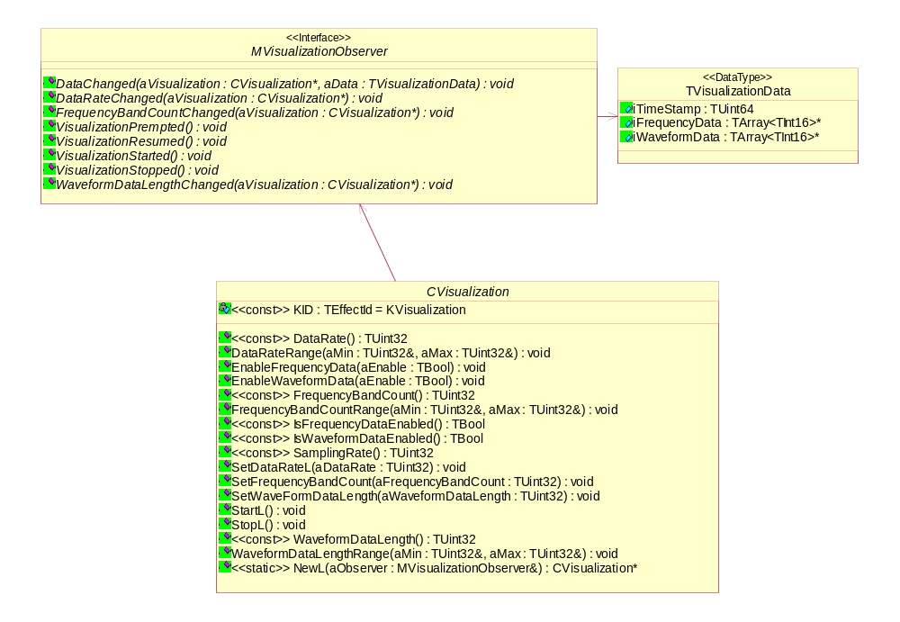
Figure 3.1 CVisualization API class structure

Usage

Protocol
The CVisualization object is created by calling NewL(). When the object has been created, any of the methods provided by the API may be called. Callbacks from asynchronous operations are provided by the MVisualizationObserver abstract class, which should be realized by the audio application.

Error handling
The visualization may be preempted if an application with a higher priority also requests visualization. In this case, the VisualizationPreempted() callback is called on the client.

Example

Code examples
// Example
// class definition
class CVisualizationClient : public CBase, MVisualizationObserver
{
.
.
.
void DataChanged(CVisualization* aVisualization, TVisualizationData aData);
void DataRateChanged(CVisualization* aVisualization);
void FrequencyBandCountChanged(CVisualization* aVisualization);
void VisualizationPreempted();
void VisualizationResumed();
void VisualizationStarted();
void VisualizationStopped();
void WaveformDataLengthChanged(CVisualization* aVisualization);
.
.
.
};

// Create CVisualization
CVisualization * viz = CVisualization::NewL( *this );

//get data rate
TUint32 theDataRate = viz->DataRate(); //in Hz

//set data rate
viz->SetDataRate(KDataRate);

// enable waveform data
viz->EnableWaveformData(ETrue);

//get sampling rate
TUint32 theSamplingRate = viz->SamplingRate();

//start
viz->StartL();

//stop
viz->StopL();

Detailed description

CVisualization class
The CVisualization class is used by an audio application to control audio visualization.
This is an optional feature. If it is not supported on a platform, the NewL method will leave with KerrNotSupported or return a NULL pointer. It is the audio application’s responsibility to be able to handle this error when using this class.

NewL
A static constructor that creates an audio input object.
Parameters:
MVisualizationObserver& aObserver: The audio application should inherit from MVisualizationObserver and pass in its this pointer for notification.
Returns:
CVisualization*

DataRate
Returns the data rate in Hz.
Parameters:
None.
Returns:
TUint32

DataRateRange
Returns the upper and lower limits of the supported data rate range.
Parameters:
- TUint32& aMin: The lower limit of the data rate range.
- TUint32& aMax: The upper limit of the data rate range.

Returns:
void

EnableFrequencyData
Allows the audio application to enable or disable frequency data.
Parameters:
TBool aBool: ETrue to enable frequency data, EFalse to disable frequency data.
Returns:
void

EnableWaveformData
Allows the audio application to enable or disable waveform data.
Parameters:
TBool aBool: ETrue to enable waveform data, EFalse to disable waveform data.
Returns:
void

FrequencyBandCount
Returns the frequency band count.
Parameters:
None.
Returns:
TUint32

FrequencyBandCountRange
Returns the frequency band count range.
Parameters:
- TUint32& aMin: The lower limit of the frequency band count range.
- TUint32& aMax: The upper limit of the frequency band count range.

Returns:
void

IsFrequencyDataEnabled
Returns ETrue if frequency data is enabled, EFalse if it is disabled.
Parameters:
None.
Returns:
TBool

IsWaveformDataEnabled
Returns ETrue if waveform data is enabled, EFalse if it is disabled.
Parameters:
None.
Returns:
TBool

SamplingRate
Returns the sampling rate.
Parameters:
None.
Returns:
TUint32

SetDataRateL
Sets the data rate. Results in a call to MVisualizationObserver::DataRateChanged().
Parameters:
TUint32 aDataRate: The data rate.
Returns:
void

SetFrequencyBandCount
Sets the frequency band count. Results in a call to MVisualizationObserver::FrequencyBandCountChanged().
Parameters:
TUint32 aFrequencyBandCount: The frequency band count.
Returns:
void

SetWaveFormDataLength
Sets the waveform data length. Results in a call to MVisualizationObserver::WaveformDataLengthChanged().
Parameters:
TUint32 aWaveformDataLength: The waveform data length in samples.
Returns:
void

StartL
Starts visualization. Results in a call to MVisualizationObserver::VisualizationStarted().
Parameters:
None.
Returns:
void

StopL
Stops visualization. Results in a call to MVisualizationObserver::VisualizationStopped().
Parameters:
None.
Returns:
void

WaveformDataLength
Returns the waveform data length in samples.
Parameters:
None.
Returns:
TUint32

WaveformDataLengthRange
Returns the waveform data length range in samples.
Parameters:
- TUint32& aMin: The lower limit of the waveform data length range.
- TUint32& aMax: The upper limit of the waveform data length range.

Returns:
TUint32

MVisualizationObserver class
The interface that is used by the CVisualization class to provide notifications to registered clients when data changes, when an asynchronous set completes, or when visualization is preempted, resumed, started, or stopped. This class must be implemented by the audio application using the CVisualization interface.

DataChanged
Called when the visualization data changes.
Parameters:
- CVisualization* aVisualization: The CVisualization object with which the MVisualizationObserver object is registered.
- TVisualizationData aData: The new value of the data object.

Returns:
void

DataRateChanged
Called when the visualization data rate changes.
Parameters:
CVisualization* aVisualization: The CVisualization object with which the MVisualizationObserver object is registered.
Returns:
void

FrequencyBandCountChanged
Called when the frequency band count changes.
Parameters:
CVisualization* aVisualization: The CVisualization object with which the MVisualizationObserver object is registered.
Returns:
void

VisualizationPreempted
Called when visualization is preempted.
Parameters:
None.
Returns:
void

VisualizationResumed
Called when visualization resumes.
Parameters:
None.
Returns:
void

VisualizationStarted
Called when visualization is started.
Parameters:
None.
Returns:
void

VisualizationStopped
Called when visualization is stopped.
Parameters:
None.
Returns:
void

WaveformDataLengthChanged
Called when the waveform data length changes.
Parameters:
CVisualization* aVisualization: The CVisualization object with which the MVisualizationObserver object is registered.
Returns:
void

TVisualizationData
- TUint64 iTimeStamp: The time stamp of the current visualization data.
- TArray<TInt16>* iFrequencyData: An array of the frequency data.
- TArray<TInt16>* iWaveformData: An array of the waveform data.

Code architecture
- Include: Visualization.h
- Link against: Visualization.lib

