S60 3.x
Display Posting
API Specification Document

Team name | Author
Multimedia | Jeff Niemann

Change history:

Version | Date | Status | Comments
1.0 | 16.02.2007 | Approved

Table of contents:

1. Document control 4
1.1 References 4
2. Introduction 5
3. Display posting 7
3.1 CPostingSurfaceFactory 7
3.2 CPostingSurface Methods 7
3.3 TPostingFormat 8
3.4 TRotationType 8
3.5 TPostingBuffering 8
3.6 TPostingUsageHint 9
3.7 TPostingCapab 9
3.8 TBufferType 10
3.9 TPostingSourceParams 10
3.10 TPostingParams 11
3.11 TPostingBuff 12
3.12 GetCapabilities 13
3.13 FormatSupported 13
3.14 Initialize CPostingSurface instance 13
3.15 Destroy 14
3.16 Destroy 14
3.17 WaitForNextBuffer 14
3.18 CancelBuffer 14
3.19 NextBuffer 14
3.20 PostBuffer 14
3.21 SetPostingParameters 14
3.22 SetClipRegion 15
4. FAQ 16
4.1 What happens if dialog pops on top of the posting surface? 16
4.2 What happens if the DSA is lost for the whole posting surface on internal display? 16
4.3 What if Symbian comes up with generic pluggable display support? 16
5. Use Cases – Scaling 17
5.1 Scale frame to fit output rectangle, maintaining aspect ratio 17
5.2 Rotate frame, then scale to fit output rectangle, maintaining aspect ratio 17
5.3 Scale to fit output rectangle, ignoring aspect ratio 18
5.4 Scaling is not supporting 19
6. Color formats 20

Document control

References
- MSL 1.0 Video Common Elements API Specification version 1.06, SGL.GT0162.163, John Turner, Symbian 2003 | A Symbian document
- The polymorphic interface DLL | http://www.symbian.com/developer/techlib/v9.1docs/doc_source/guide/base-subsystem-guide/n10086/dynamicallyloadinglinklibraries/polymorphicinterfacedll.guide.html

Introduction
S60 Display Posting API allows the application to use display controller advanced features. Advanced features include posting YUV color format bitmaps to display, controlling HW scaling and rotation functions and handling cases where the surface must be simultaneously displayed on two screens with different properties (LCD and TV-out for example).
External display (such as TV-out) may be of higher resolution than the internal display. Some HW specific display controller may be able to route image stream efficiently to multiple displays from a single source.
When using this API it is assumed that Direct Screen Access (DSA) region for relevant portion of the main device display is reserved. Streamed external displays do not have DSA as they are handled automatically (through display cloning or sourcing the image or video data directly to the display).
The use case for this API is more in the platform adaptation rather than providing generic support for pluggable display devices.
This document is valid from S60 release 3.1 onwards.
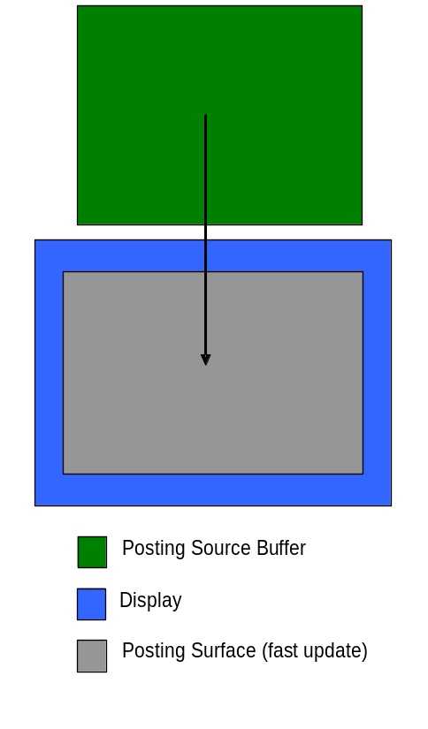
Figure 2.1 Definitions
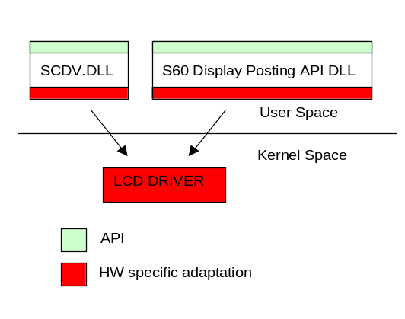
Figure 2.2 High level SW view

Display posting
This API is similar to ATID (Anti-Tearing Image Display) in Symbian, but it is extended to support efficient image streaming and n-buffering.

CPostingSurfaceFactory
/** CPostingSurfaceFactory
*
* CPostingSurfaceFactory implementation dll and library file must be named
* "PostingSurfaceFactory.dll" and "PostingSurfaceFactory.lib" respectively.
*/
class CPostingSurfaceFactory : public CBase
{
public:
/**
* Creates object for user and reserves posting for that
* If all success method returns pointer to the object
* @param aDisplay is TPostingDisplay Enum value indicating which display
* to work on
* @return new PostingSurface If there isn't enough memory returns NULL
*/
virtual CPostingSurface* NewPostingSurfaceL( TInt aDisplay);
/**
* Object Destructor
*/
virtual ~CPostingSurfaceFactory();
};

enum TPostingDisplay
{
EMainDisplay = 0x00000000,
ESecondaryDisplay = 0x00000001,
};

CPostingSurfaceFactory implementation is a polymorphic DLL. The DLL and library file must be named PostingSurfaceFactory.dll and PostingSurfaceFactory.lib respectively. As is customary with a polymorphic DLL, the CPostingSurfaceFactory DLL exports a single function with no arguments (often referred to as an “Install” method) that creates a concrete instance of the CPostingSufaceFactory implementation.
More details on polymorphic DLLs can be found in reference document [2].
Display enumerations can be extended as needed. The TPostingDisplay enumerations correspond to the value returned from:

CWsScreenDevice* screenDevice=CCoeEnv::Static()->ScreenDevice()
screenDevice->GetScreenNumber();

GetScreenNumber() returns the screen number (primary screen is 0, secondary 1).

CPostingSurface Methods
public:
virtual ~CPostingSurface();

virtual TBool FormatSupported(TPostingFormat aFormat) = 0;
virtual void InitializeL(const TPostingSourceParams& aSource,
const TPostingParams& aDest) = 0;
virtual void GetCapabilities(TPostingCapab& aCaps) = 0;

virtual void Destroy(TRequestStatus& aComplete) = 0;
virtual void Destroy() = 0;

virtual TInt WaitForNextBuffer(TRequestStatus& aComplete) = 0;
virtual TPostingBuff* NextBuffer() = 0;
virtual TInt CancelBuffer() = 0;
virtual TInt PostBuffer(TPostingBuff* aBuffer) = 0;

virtual TInt SetPostingParameters(const TPostingParams& aParams) = 0;
virtual TInt SetClipRegion(const TRegion& aClipRegion) = 0;

TPostingFormat
enum TPostingFormat
{
ERgb16bit565Le
ERgb24bit888Le
ERgb32bit888Le
EYuv422LeBt709Range0
EYuv422LeBt709Range1
EYuv422BeBt709Range0
EYuv422BeBt709Range1
EYuv422LeBt601Range0
EYuv422LeBt601Range1
EYuv422BeBt601Range0
EYuv422BeBt601Range1
EYuv420PlanarBt601Range0
EYuv420PlanarBt601Range1
EYuv420PlanarBt709Range0
EYuv420PlanarBt709Range1
EYuvPlatformDependent
};

Specifies the data format. Also sampling pattern, data layout and YUV-RGB conversion coefficients for YUV data. See Chapter 6 for information about the formats.

TRotationType
enum TRotationType
{
ENoRotation = 0x00000000, //0Deg
ERotate90ClockWise = 0x00000001, //90Deg
ERotate180 = 0x00000002, //180Deg
ERotate90AntiClockWise = 0x00000004, //270Deg
};

Rotation types as defined in [MDF Video Common Elements]. Settings indicate rotation relative to the current UI orientation. E.g. if TRotationType = 0 then the posting surface appears in the same orientation than the UI, regardless of the current display orientation.

TPostingBuffering
enum TPostingBuffering
{
ESingleBuffering = 0x00000004,
EDoubleBuffering = 0x00000001,
ETripleBuffering = 0x00000002,
EProgressiveFrames = 0x00000010,
EInterlacedFrames = 0x00000020,
EDisAllowFrameSkip = 0x00000100,
EAllowFrameSkip = 0x00000200,
EInternalBuffers = 0x00001000,
};

Bitmask value describing how the display posting is done and how the frames should be handled. If progressive frames method is used it means that the content is updated to the buffers the whole frame at a time (default).
If interlaced frames method is used it means that the content is updated to the buffers in field based manner where a frame consists of two fields.
In frame skipping mode, a frame that is waiting to be displayed may be skipped if a new ready buffer is posted. This mode guarantees that most up-to-date buffer is always displayed. New buffers may be taken from the front of the display buffer chain or from the middle of the display chain.
If frame skipping is not enabled, it is guaranteed that frame skipping is not done in any situation. In this mode, free buffers are always taken from the front of the display chain whenever display subsystem gets a VSYNC pulse.
Internal buffers are used, meaning the posting buffers are allocated by the display driver.

TPostingUsageHint
enum TPostingUsageHint
{
EGeneric = 0x00000001,
E3D = 0x00000002,
EVideoPlayback = 0x00000004,
EVideoCapture = 0x00000008,
EViewfinder = 0x00000010,
EStillImage = 0x00000011,
EVendorSpecific = 0x80000000,
};

Tells the intended usage of the posting surface. The display driver uses these hints to prioritize the HW usage and route content. Vendor specific meanings may be added to the end of the enum space.

TPostingCapab
class TPostingCapab
{
public:
inline TPostingCapab();
public:
///Maximum buffer size in bytes
TUint iMaxSourceSize;
///Hw limits for source size, normally cannot allocated whole this size
TSize iMaxPixelSize;
///Bit mask of supported rotations
TUint iSupportedRotations;
///ETrue when horizontal mirroring is supported
TBool iSupportsMirroring;
///ETrue when rational scales is supported
TBool iSupportsScaling;
///ETrue when brightness tuning is supported
TBool iSupportsBrightnessControl;
///ETrue when contrast tuning is supported
TBool iSupportsContrastControl;
///Bitmask (TPostingBuffering)
TUint iSupportedPostingBuffering;
///Bitmask (TBufferType)
TUint iSupportedBufferTypes;
};

Describes the posting buffer size restrictions and processing capabilities.

TBufferType
enum TBufferType
{
EBufferTypeInvalid = 0x00000000,//Initialisation value, do not use
EStandardBuffer = 0x00000001,//Direct address
EChunkBuffer = 0x00000002,//RChunk handle
};

Standard buffer is most efficient. Only use the Chunk buffer when the client explicitly must share the frame buffer across process boundaries.
NB: Every implementation must support the EStandardBuffer buffer type. EChunkBuffer support is optional.

TPostingSourceParams
class TPostingSourceParams
{
public:
inline TPostingSourceParams();
public:
///Buffering usage mode (TPostingBuffering)
TUint iPostingBuffering;
///Type of request
TBufferType iBufferType;
///Purpose of buffer (TPostingUsageHint)
TUint iPostingUsage;
///Source resolution. Values must be even.
TSize iSourceImageSize;
///Source's pixel format
TPostingFormat iPostingFormat;
///Source pixel aspect ratio (width),
/// Scaling factor = Numerator/Denominator. Tv only.
TUint16 iPixelAspectRatioNum;
///Source pixel aspect ratio (width)
TUint16 iPixelAspectRatioDenom;
///ETrue when copy protection enabled
TBool iContentCopyRestricted;
};

Describes the source content and buffering parameters. These values are fixed in the initialization phase.
- iPostingBuffering is a bitmask describing required buffering.
- iBufferType indicates the type of buffer requested.
- iPostingUsage gives a hint to display routing about the application using this API.
- iImageSize defines the size of the source image in pixels.
- iPostingFormat specifies the data format for the frame in the input buffer
- iPixelAspectRatioNum and iPixelAspectRatioDenom define the pixel aspect ratio of the content as iPixelAspectRatioNum/iPixelAspectRatioDenom, where the values are positive integers and relatively prime. The value should be 1/1 for standard applications using square pixels.
- iContentCopyRestricted tells if the content has copy protection restrictions. Depending on the external display, image may not be displayed.

TPostingParams
class TPostingParams
{
public:
inline TPostingParams();
public:
/** Size and position of the rectangle on phone's display. Even.
Ui-orientation parameters. Does not affect Tv-out. */
TRect iDisplayedRect;
///Output size in pixels, defines scaling
TRect iScaleToRect
/** Required cropping for the content before applying other
processing. Even. This is <= iSourceImageSize. This is Tv-out crop
too. */
TRect iInputCrop;
///ETrue when horizontal mirroring. Does not affect Tv-out.
TBool iMirror;
/** Orientation of content compared to symbian videobuffer. Does not
affect Tv-out. */
TRotationType iRotation;
///Brightness value on screen, [-100,100]%, may be ignored by the driver
TInt16 iBrightness;
///Contrast value on screen, [-100,100]%
TInt16 iContrast;
/// Defined background color.
TRgb iBackGround;
};

Specifies window properties and required processing types for the posting buffer before it can be displayed on the screen.
- iInputCrop defines the required cropping for the content before applying other processing.
- iDisplayedRect defines the size and position of the posting window on the screen. Any area of this rectangle not covered by iScaleToRect must be filled in with iBackground color.
- iScaleToRect defines the rectangle that should be filled by the video frame once cropping, mirroring and rotating has be performed. This rectangle is specified as relative to iDisplayedRect. As such, the point (0, 0) in iScaleToRect corresponds to the upper left corner of iScaleToRect. This also means that iScaleToRect must not extend beyond the bounds of iDisplayedRect. See Chapter 5 for more details.
- The iBrightness and iContrast parameters take effect only when YUV posting format is used. The value range is [-100 … 100], with –100 corresponding to minimum setting, 100 to maximum setting, and 0 to no change in contrast and brightness.
- iBackground is a pixel to be used for filling in the portion of the iDisplayedRect that, as a result of scaling, rotating, etc. is not covered by the output frame.

Note: the order of operations is – 1. Input cropping, 2. Mirroring, 3. Rotation, 4. Scaling.
If the resulting image rectangle from the scaling, mirroring, and rotation operations does not match the posting surface dimensions, the display posting implementation must fill those areas with the designated background color.

TPostingBuff
class TPostingBuff
{
public:
///@return EBufferTypeInvalid or EChunkBuffer (iType)
IMPORT_C virtual TBufferType GetType();
///@return Direct address of buffer (0,0) (iBuffer)
IMPORT_C virtual TAny* GetBuffer();
///@return buffer size in pixels
IMPORT_C virtual TSize GetSize();
///@return scanline length in bytes (width*bytes_per_pixel + some_offset)
IMPORT_C virtual TUint GetStride();
protected:
///Hidden constructor, user should never use this
IMPORT_C TPostingBuff();
protected:
///Type of this TPostingBuff
TBufferType iType;
///Pointer to buffer
TAny* iBuffer;
///Size of frame in pixels
TSize iSize;
/// scanline length in bytes (width*bytes_per_pixel + some_offset)
TUint iStride;
};

class TPostingBufferChunk : public TPostingBuff
{
public:
///@return Handle to DChunk (iChunk)
IMPORT_C virtual RChunk GetChunk();
///@return buffer start address offset in chunk, (iOffsetInChunk)
IMPORT_C virtual TUint GetOffsetInChunk();
protected:
///Hidden constructor
IMPORT_C TPostingBufferChunk();
protected:
///Handle to DChunk
RChunk iChunk;
///Offset in chunk, to first pixel
TUint iOffsetInChunk;
};

Additional information about the chunk buffer.
- iChunk Chunk buffer
- iOffsetInChunk Indicates the location within the chunk to write frame data (in bytes)
- iStride scanline length in bytes (width*bytes_per_pixel + some_offset)

Normally, the standard posting buffer should be requested by the client as it is likely to be the more efficient implementation.
However, the chunk buffer if the client application must pass the buffer across a process boundary. RChunk is selected as the buffer abstraction in this case, as it is the only “future proof” way to pass data like this. RChunk regions are allocated in kernel side (as DChunks) and passed to this API.
RChunk buffers have the following organization. For any given chunk buffer, pixels outside of the usage region are not allowed. Only bytes between: [rchunk_base + iOffsetInChunk, rchunk_base + iOffsetInChunk + iStride * iSize.height-1] may be used.
Also, if the iStride is different from bytes_per_pixel * width, pixels in any scanline between [scanline_base + bytes_per_pixel * width, scanline_base + iStride –1] may not be used.
scanline_base = rchunk_base + iOffsetInChunk + iStride * y. True for y < iSize.height
If iOffsetInChunk = 0 and iSize.width = iStride, contiguous buffer.
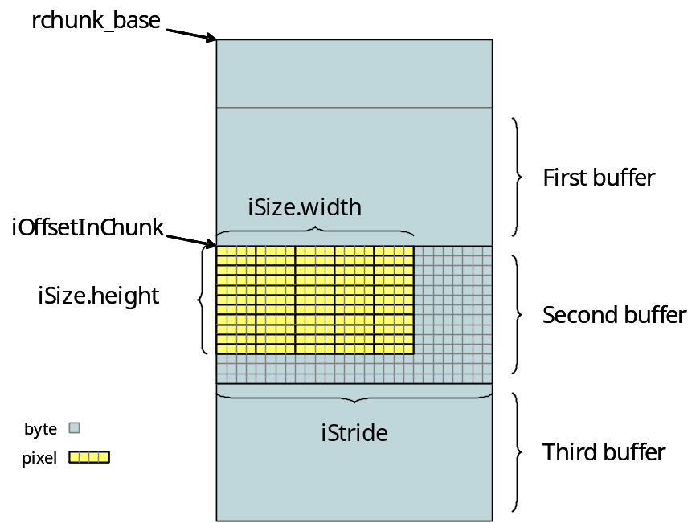
Figure 3.3 Example buffer layout

GetCapabilities
virtual void GetCapabilities(TPostingCapab& aCaps) = 0;

Fills the TPostingCapabilities structure.

FormatSupported
virtual TBool FormatSupported(TPostingFormat aFormat) = 0;

Queries the underlying implementation about its capability to process the proposed input format.
The return value “false” indicates that the format is not supported.
If for example the application can support multiple RGB formats or YUV formats, it may want to use the format that is most optimal for the HW. Generally it is assumed that at least the RGB formats are supported.
Note: the image quality of the formats should be evident (less bits means worse quality).

Initialize CPostingSurface instance
virtual void InitializeL(const TPostingSourceParams& aSource,
const TPostingParams& aDest) = 0;

Leave with error code:
KErrAlreadyInUse | CPostingSurface instance has already been initialized.
KErrNotSupported | Invalid TPostingSourceParams setting.

Destroy
virtual void Destroy(TRequestStatus& aComplete) = 0;

Destroy
virtual void Destroy() = 0;

A convenience function that destroys the posting surface and waits until all buffers are freed. This should take at maximum the length of the slowest display refresh period (e.g., 1/50 seconds).

WaitForNextBuffer
virtual TInt WaitForNextBuffer(TRequestStatus& aComplete) = 0;

Starts a wait for the next free buffer, see description for skip vs. non-skip modes in section 3.5.
Note: it is allowed for an application to wait and acquire two or more buffers before actually posting the buffers. However, only one wait for the next free buffer can be active at the time. KErrInUse is returned if multiple waits are used.

CancelBuffer
virtual TInt CancelBuffer() = 0;

Cancels the wait for the next free buffer.

NextBuffer
virtual TPostingBuff* NextBuffer() = 0;

Gets the free buffer (must have been waited for before calling this). See description for skip vs. non-skip modes in section 3.5.
The client code can check the iType member of TPostingBuffer and cast the pointer to the appropriate type.

PostBuffer
virtual TInt PostBuffer(TPostingBuff* aBuffer) = 0;

Posts buffer previously claimed from the API.

SetPostingParameters
virtual TInt SetPostingParameters(const TPostingParams& aParams) = 0;

This function can be used to change window properties and processing to be done for the posting buffer before it is displayed on the screen. Parameters take effect upon next buffer posting. Setting stays in effect until posting parameters are set again.

SetClipRegion
virtual TInt SetClipRegion(const TRegion& aClipRegion) = 0;

This function can be used to directly pass the DSA region of the internal display down to this API if DSA region is clipped in some way. Some implementations may support none; some may support only one or few clipping regions. In those cases the return value should be set to KErrNotSupported. If clipping region is supported, no image is drawn outside of the clipping region.
If aClipRegion is set to an empty region, then the posting is not active for the internal display. However, if display posting is still done, external display may get updated. Default: no clipping is done, but internal display is enabled.

FAQ

What happens if dialog pops on top of the posting surface?
See Section 3.22.

What happens if the DSA is lost for the whole posting surface on internal display?
Clipping region can be set to NULL. This disables updates to the internal display. Updates to external display may still be active.

What if Symbian comes up with generic pluggable display support?
This API deals with routing same source data to multiple displays. In that sense, this API is not really a pluggable display API. In case that in future Symbian OS versions there is support for pluggable displays, this API should only be used when the application has fullscreen access to the external display (DSA). This API assumes that it has full control of the external display.

Use Cases – Scaling

Scale frame to fit output rectangle, maintaining aspect ratio
The first use case has the DP API client wishing to scale the video frame to fill the output rectangle, while maintaining the original aspect ratio. Also, the client wishes to center the frame within the output window. First, the client determines the axis that limits scaling. In this example the horizontal axis is the limiting factor, so it determines the scale factor of the “scale to” rectangle.
If iScaleToRect does not completely cover iDisplayRect, the display posting implementation fills in the uncovered area with the iBackground color.
iScaleToRect is computed as indicated in Figure 5.4. Again, it is important to remember that those formulas apply to the case where the horizontal axis is the limiting factor and the output frame is to be centered.
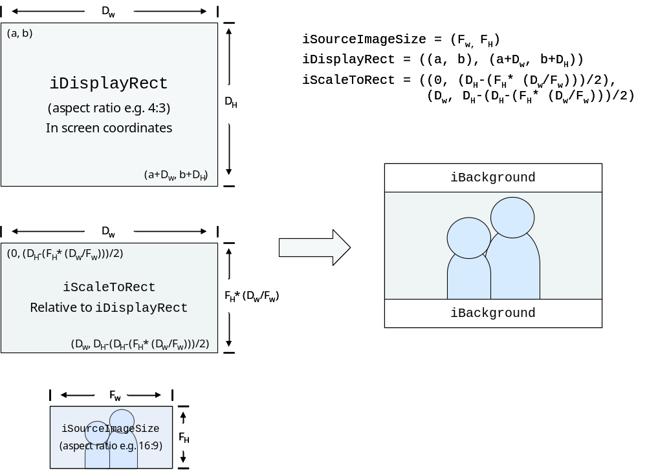
Figure 5.4 Scale frame to fit output rectangle, maintaining aspect ratio

Rotate frame, then scale to fit output rectangle, maintaining aspect ratio
This use case depicts the scenario where the frame is rotated prior to scaling and where the aspect ratio is to be maintained. The rotation of the frame must be taken into account when computing iScaleToRect.
Again, note, the limiting axis in this use case is the vertical.
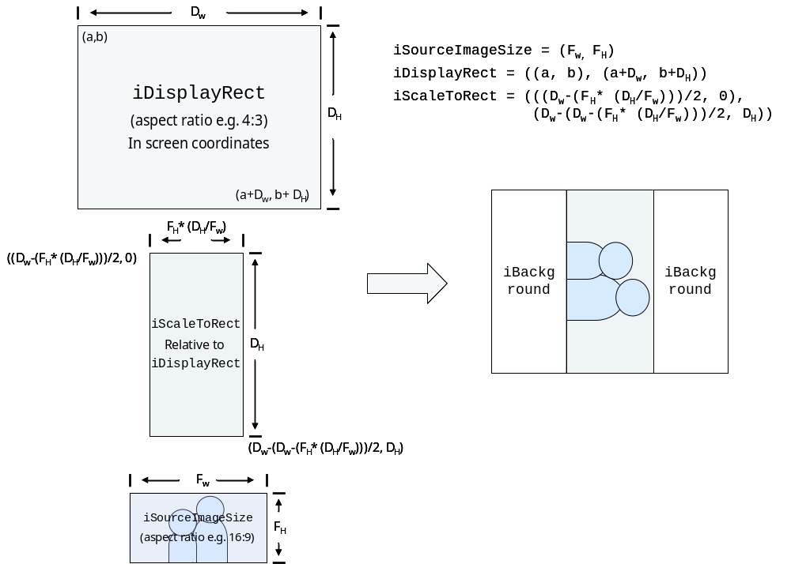
Figure 5.5 Rotate frame, then scale to fit output rectangle, maintaining aspect ratio

Scale to fit output rectangle, ignoring aspect ratio
This use case is the simplest from a client calculation point of view. It describes the case where the video frame is intended to fill the entire output rectangle regardless of aspect ratio. In this case iScaleToRect is simply a rectangle whose upper left coordinate is (0,0) and its lower right is the width and length of iDisplayRect. This results in an output where the frame covers the output rectangle exactly and no iBackground color is shown.
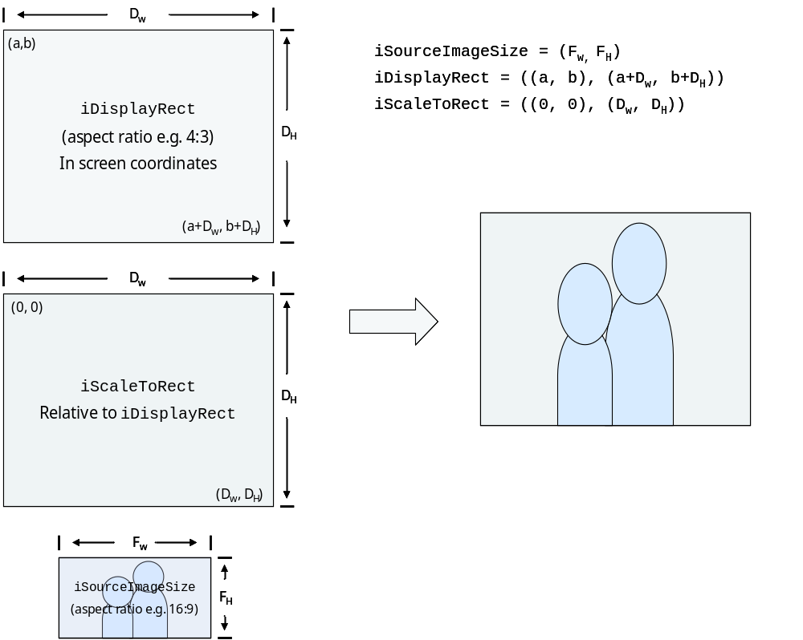
Figure 5.6 Scale to fit output rectangle, ignoring aspect ratio

Scaling is not supporting
All rectangles should be same size.

Color formats
Table 6.3 lists the current and most of the potential color formats to be used with Display Posting API.
NOTE: The “DevVideo” column in the table reflects the intent of the enumeration and not necessarily the name. According to the MDF specification, the YUV enumeration labels are backward with respect to “endianness”. I.e., EYuvDataInterleavedBE maps to the EYuv422Le… formats on Display Posting API.
What does the column “Sampling” mean?
RGB 4:4:4 means that all the components (R, G and B) have equal horizontal and vertical sampling. YUV 4:2:2 means that the vertical sampling of the chroma components (U and V) is equal to luma (Y), but horizontal chroma subsampling period is two samples of luma. YUV 4:2:0 means that both horizontal and vertical chroma subsampling periods are two samples of luma.
What do the data layout (“Byte order” and “Bits [95…0]”) columns mean?
E.g., byte order “gb₀ rg₀ gb₁ rg₁ …” means that the bytes are read and written in the mentioned sequence, i.e. the corresponding memory locations are as listed in Table 6.1.
Table 6.1 Pixel data byte order
0x00: 8 bits | 0x01: 8 bits | 0x02: 8 bits | 0x03: 8 bits
g₀g₀g₀b₀b₀b₀b₀b₀ | r₀r₀r₀r₀r₀g₀g₀g₀ | g₁g₁g₁b₁b₁b₁b₁b₁ | r₁r₁r₁r₁r₁g₁g₁g₁

E.g., bits [95…0] “⁵R₅ ⁶G₅ ⁵B₅ ⁵R₄ ⁶G₄ ⁵B₄ ⁵R₃ ⁶G₃ ⁵B₃ ⁵R₂ ⁶G₂ ⁵B₂ ⁵R₁ ⁶G₁ ⁵B₁ ⁵R₀ ⁶G₀ ⁵B₀” means that the bits are organized in the memory as listed in Table 6.2.
Table 6.2 Pixel data memory organization
 | 5 bits  [31…27] | 6 bits  [26…21] | 5 bits  [20…16] | 5 bits  [15…11] | 6 bits  [10…5] | 5 bits  [4…0]
0x08 | R₅ | G₅ | B₅ | R₄ | G₄ | B₄
0x04 | R₃ | G₃ | B₃ | R₂ | G₂ | B₂
0x00 | R₁ | G₁ | B₁ | R₀ | G₀ | B₀

Table 6.3 Color formats
# | Display Posting | Sampling | Byte order | Bits [95…0] | DevVideo | ECam
1 | ERgb16bit565Le | RGB 4:4:4 | gb₀ rg₀ gb₁ rg₁  … | ⁵R₅ ⁶G₅ ⁵B₅ ⁵R₄ ⁶G₄ ⁵B₄  ⁵R₃ ⁶G₃ ⁵B₃ ⁵R₂ ⁶G₂ ⁵B₂  ⁵R₁ ⁶G₁ ⁵B₁ ⁵R₀ ⁶G₀ ⁵B₀ | ERgb16bit565 | EFormat16BitRGB565
2 | ERgb24bit888Le | RGB 4:4:4 | B₀ G₀ R₀ B₁  G₀ R₀ … | ⁸R₃ ⁸G₃ ⁸B₃ ⁸R₂  ⁸G₂ ⁸B₂ ⁸R₁ ⁸G₁  ⁸B₁ ⁸R₀ ⁸G₀ ⁸B₀ | - | -
3 | ERgb32bit888Le | RGB 4:4:4 | B₀ G₀ R₀ x₀  … | ⁸x₂ ⁸R₂ ⁸G₂ ⁸B₂  ⁸x₁ ⁸R₁ ⁸G₁ ⁸B₁  ⁸x₀ ⁸R₀ ⁸G₀ ⁸B₀ | ERgb32bit888 | EFormat32BitRGB888
4 | EYuv422Le… | YUV 4:2:2 | U₀ Y₀ V₀ Y₁  … | ⁸Y₅ ⁸V₄ ⁸Y₄ ⁸U₄  ⁸Y₃ ⁸V₂ ⁸Y₂ ⁸U₂  ⁸Y₁ ⁸V₀ ⁸Y₀ ⁸U₀ | EYuvDataInterleavedBE | EFormatYUV422
5 | EYuv422Be… | YUV 4:2:2 | Y₁ V₀ Y₀ U₀  … | ⁸U₄ ⁸Y₄ ⁸V₄ ⁸Y₅  ⁸U₂ ⁸Y₂ ⁸V₂ ⁸Y₃  ⁸U₀ ⁸Y₀ ⁸V₀ ⁸Y₁ | EYuvDataInterleavedLE | EFormatYUV422Reversed
6 | - | YUV 4:2:2 | Y₀ U₀ Y₁ V₀  … | ⁸V₄ ⁸Y₅ ⁸U₄ ⁸Y₄  ⁸V₂ ⁸Y₃ ⁸U₂ ⁸Y₂  ⁸V₀ ⁸Y₁ ⁸U₀ ⁸Y₀ | - | -
7 | - | YUV 4:2:2 | V₀ Y₁ U₀ Y₀  … | ⁸Y₄ ⁸U₄ ⁸Y₅ ⁸V₄  ⁸Y₂ ⁸U₂ ⁸Y₃ ⁸V₂  ⁸Y₀ ⁸U₀ ⁸Y₁ ⁸V₀ | - | -
8 | - | YUV 4:2:2 | Y₀ V₀ Y₁ U₀  … | ⁸U₄ ⁸Y₅ ⁸V₄ ⁸Y₄  ⁸U₂ ⁸Y₃ ⁸V₂ ⁸Y₂  ⁸U₀ ⁸Y₁ ⁸V₀ ⁸Y₀ | - | -
9 | - | YUV 4:2:2 | Y_{0,0} Y_{0,1} Y_{0,2} Y_{0,3}  …  U_{0,0} U_{0,2}  …  V_{0,0} V_{0,2}  … | ⁸V_{0,22} ⁸V_{0,20} ⁸V_{0,18} ⁸V_{0,16}  ⁸V_{0,14} ⁸V_{0,12} ⁸V_{0,10} ⁸V_{0,8}  ⁸V_{0,6} ⁸V_{0,4} ⁸V_{0,2} ⁸V_{0,0}  …  ⁸U_{0,22} ⁸U_{0,20} ⁸U_{0,18} ⁸U_{0,16}  ⁸U_{0,14} ⁸U_{0,12} ⁸U_{0,10} ⁸U_{0,8}  ⁸U_{0,6} ⁸U_{0,4} ⁸U_{0,2} ⁸U_{0,0}  …  ⁸Y_{0,11} ⁸Y_{0,10} ⁸Y_{0,9} ⁸Y_{0,8}  ⁸Y_{0,7} ⁸Y_{0,6} ⁸Y_{0,5} ⁸Y_{0,4}  ⁸Y_{0,3} ⁸Y_{0,2} ⁸Y_{0,1} ⁸Y_{0,0} | EYuvDataPlanar  / EYuv422Chroma… | -
10 | - | YUV 4:2:0 | Y_{0,0} Y_{0,1} Y_{1,0} Y_{1,1}  U_{0,0} V_{0,0} … | ⁸V_{0,0} ⁸U_{0,0} ⁸Y_{1,1} ⁸Y_{1,0}  ⁸Y_{0,1} ⁸Y_{0,0} ⁸V_{0,0} ⁸U_{0,0}  ⁸Y_{1,1} ⁸Y_{1,0} ⁸Y_{0,1} ⁸Y_{0,0} | - | EFormatYUV420Interleaved
11 | - | YUV 4:2:0 | U_{0,0} Y_{0,0} Y_{0,1} U_{0,2}  Y_{0,2} Y_{0,3} …  V_{0,0} Y_{1,0} Y_{1,1} V_{0,2}  Y_{1,2} Y_{1,3} … | ⁸Y_{1,7} ⁸Y_{1,6} ⁸V_{0,6} ⁸Y_{1,5}  ⁸Y_{1,4} ⁸V_{0,4} ⁸Y_{1,3} ⁸Y_{1,2}  ⁸V_{0,2} ⁸Y_{1,1} ⁸Y_{1,0} ⁸V_{0,0}  …  ⁸Y_{0,7} ⁸Y_{0,6} ⁸U_{0,6} ⁸Y_{0,5}  ⁸Y_{0,4} ⁸U_{0,4} ⁸Y_{0,3} ⁸Y_{0,2}  ⁸U_{0,2} ⁸Y_{0,1} ⁸Y_{0,0} ⁸U_{0,0} | - | -
12 | - | YUV 4:2:0 | Y_{0,0} U_{0,0} U_{0,2} Y_{0,1}  Y_{0,3} Y_{0,2} …  Y_{1,0} V_{0,0} V_{0,2} Y_{1,1}  Y_{1,3} Y_{1,2} … | ⁸Y_{1,6} ⁸Y_{1,7} ⁸Y_{1,5} ⁸V_{0,6}  ⁸V_{0,4} ⁸Y_{1,4} ⁸Y_{1,2} ⁸Y_{1,3}  ⁸Y_{1,1} ⁸V_{0,2} ⁸V_{0,0} ⁸Y_{1,0}  …  ⁸Y_{0,6} ⁸Y_{0,7} ⁸Y_{0,5} ⁸U_{0,6}  ⁸U_{0,4} ⁸Y_{0,4} ⁸Y_{0,2} ⁸Y_{0,3}  ⁸Y_{0,1} ⁸U_{0,2} ⁸U_{0,0} ⁸Y_{0,0} | - | -
13 | - | YUV 4:2:0 | Y_{0,0} Y_{0,1} Y_{0,2} Y_{0,3}  Y_{1,0} Y_{1,1} Y_{1,2} Y_{1,3}  …  Y_{15,12} Y_{15,13} Y_{15,14} Y_{15,15}  …  U_{0,0} V_{0,0} U_{0,2} V_{0,2}  U_{2,0} V_{2,0} U_{2,2} V_{2,2}  …  U_{14,12} V_{14,12} U_{14,14} V_{14,14}  ... | ⁸V_{14,14} ⁸U_{14,14} ⁸V_{14,12} ⁸U_{14,12}  …  ⁸V_{2,2} ⁸U_{2,2} ⁸V_{2,0} ⁸U_{2,0}  ⁸V_{0,2} ⁸U_{0,2} ⁸V_{0,0} ⁸U_{0,0}  …  ⁸Y_{15,15} ⁸Y_{15,14} ⁸Y_{15,13} ⁸Y_{15,12}  ...  ⁸Y_{1,3} ⁸Y_{1,2} ⁸Y_{1,1} ⁸Y_{1,0}  ⁸Y_{0,3} ⁸Y_{0,2} ⁸Y_{0,1} ⁸Y_{0,0}
14 | - | YUV 4:2:0 | Y_{0,0} Y_{0,1} Y_{0,2} Y_{0,3}  Y_{1,0} Y_{1,1} Y_{1,2} Y_{1,3}  …  Y_{15,12} Y_{15,13} Y_{15,14} Y_{15,15}  …  U_{0,0} U_{0,2} U_{0,4} U_{0,6}  U_{2,0} U_{2,2} U_{2,4} U_{2,6}  …  U_{14,8} U_{14,10} U_{14,12} U_{14,14}  …  V_{0,0} V_{0,2} V_{0,4} V_{0,6}  V_{2,0} V_{2,2} V_{2,4} V_{2,6}  …  V_{14,8} V_{14,10} V_{14,12} V_{14,14}  … | ⁸V_{14,14} ⁸V_{14,12} ⁸V_{14,10} ⁸V_{14,8}  …  ⁸V_{2,6} ⁸V_{2,4} ⁸V_{2,2} ⁸V_{2,0}  ⁸V_{0,6} ⁸V_{0,4} ⁸V_{0,2} ⁸V_{0,0}  …  ⁸U_{14,14} ⁸U_{14,12} ⁸U_{14,10} ⁸U_{14,8}  …  ⁸U_{2,6} ⁸U_{2,4} ⁸U_{2,2} ⁸U_{2,0}  ⁸U_{0,6} ⁸U_{0,4} ⁸U_{0,2} ⁸U_{0,0}  …  ⁸Y_{15,15} ⁸Y_{15,14} ⁸Y_{15,13} ⁸Y_{15,12}  ...  ⁸Y_{1,3} ⁸Y_{1,2} ⁸Y_{1,1} ⁸Y_{1,0}  ⁸Y_{0,3} ⁸Y_{0,2} ⁸Y_{0,1} ⁸Y_{0,0}
15 | EYuv420Planar… | YUV 4:2:0 | Y_{0,0} Y_{0,1} Y_{0,2} Y_{0,3}  …  U_{0,0} U_{0,2}  …  V_{0,0} V_{0,2}  … | ⁸V_{0,22} ⁸V_{0,20} ⁸V_{0,18} ⁸V_{0,16}  ⁸V_{0,14} ⁸V_{0,12} ⁸V_{0,10} ⁸V_{0,8}  ⁸V_{0,6} ⁸V_{0,4} ⁸V_{0,2} ⁸V_{0,0}  …  ⁸U_{0,22} ⁸U_{0,20} ⁸U_{0,18} ⁸U_{0,16}  ⁸U_{0,14} ⁸U_{0,12} ⁸U_{0,10} ⁸U_{0,8}  ⁸U_{0,6} ⁸U_{0,4} ⁸U_{0,2} ⁸U_{0,0}  …  ⁸Y_{0,11} ⁸Y_{0,10} ⁸Y_{0,9} ⁸Y_{0,8}  ⁸Y_{0,7} ⁸Y_{0,6} ⁸Y_{0,5} ⁸Y_{0,4}  ⁸Y_{0,3} ⁸Y_{0,2} ⁸Y_{0,1} ⁸Y_{0,0} | EYuvDataPlanar  / EYuv420Chroma… | EFormatYUV420Planar
16 | - | YUV 4:2:0 | Y_{0,0} Y_{0,1} Y_{0,2} Y_{0,3}  …  V_{0,0} V_{0,2}  …  U_{0,0} U_{0,2}  … | ⁸U_{0,22} ⁸U_{0,20} ⁸U_{0,18} ⁸U_{0,16}  ⁸U_{0,14} ⁸U_{0,12} ⁸U_{0,10} ⁸U_{0,8}  ⁸U_{0,6} ⁸U_{0,4} ⁸U_{0,2} ⁸U_{0,0}  …  ⁸V_{0,22} ⁸V_{0,20} ⁸V_{0,18} ⁸V_{0,16}  ⁸V_{0,14} ⁸V_{0,12} ⁸V_{0,10} ⁸V_{0,8}  ⁸V_{0,6} ⁸V_{0,4} ⁸V_{0,2} ⁸V_{0,0}  …  ⁸Y_{0,11} ⁸Y_{0,10} ⁸Y_{0,9} ⁸Y_{0,8}  ⁸Y_{0,7} ⁸Y_{0,6} ⁸Y_{0,5} ⁸Y_{0,4}  ⁸Y_{0,3} ⁸Y_{0,2} ⁸Y_{0,1} ⁸Y_{0,0} | - | -
17 | - | YUV 4:2:0 | Y_{0,0} Y_{0,1} Y_{0,2} Y_{0,3}  …  U_{0,0} V_{0,0} U_{0,2} V_{0,2}  … | ⁸V_{0,10} ⁸U_{0,10} ⁸V_{0,8} ⁸U_{0,8}  ⁸V_{0,6} ⁸U_{0,6} ⁸V_{0,4} ⁸U_{0,4}  ⁸V_{0,2} ⁸U_{0,2} ⁸V_{0,0} ⁸U_{0,0}  …  ⁸Y_{0,11} ⁸Y_{0,10} ⁸Y_{0,9} ⁸Y_{0,8}  ⁸Y_{0,7} ⁸Y_{0,6} ⁸Y_{0,5} ⁸Y_{0,4}  ⁸Y_{0,3} ⁸Y_{0,2} ⁸Y_{0,1} ⁸Y_{0,0} | - | -

