S60 3.2
FM Radio Tuner Control Adaptation
API Specification Document

Team name | Author
 | David Luong

Change history:

Version | Date | Status | Comments
2.0 | 14.03.2007 | Approved | Document updated for S60 release 3.2.
1.0 | 20.06.2005 | Approved

Table of contents:

1. Document control 5
1.1 References 5
1.2 Documentation conventions 5
1.3 Abbreviations 5
1.4 Definitions 5
2. Purpose 6
2.1 List of the required interfaces 6
2.2 Constraints 6
3. Technical specification 7
3.1 Type of the interface 7
3.2 Interface class structure 7
3.3 Usage 7
3.3.1 Protocol 7
3.3.2 Error handling 8
3.3.3 Memory overhead 8
3.3.4 Extensions to the API 8
3.4 Example 8
3.4.1 Typical Sequence 8
3.4.2 API implementation 9
3.5 Detailed description 10
3.5.1 CFMRadioTunerControl 10
3.5.1.1 NewL 10
3.5.1.2 TunerOn 11
3.5.1.3 CancelTunerOn 11
3.5.1.4 TunerOff 11
3.5.1.5 CancelTunerOff 11
3.5.1.6 SetFrequencyRange 12
3.5.1.7 CancelSetFrequencyRange 12
3.5.1.8 SetFrequency 12
3.5.1.9 CancelSetFrequency 12
3.5.1.10 StationSeek 13
3.5.1.11 CancelStationSeek 13
3.5.1.12 AudioMode 13
3.5.1.13 CancelAudioMode 14
3.5.1.14 SetAudioMode 14
3.5.1.15 CancelSetAudioMode 14
3.5.1.16 MaxSignalStrength 14
3.5.1.17 CancelMaxSignalStrength 15
3.5.1.18 SignalStrength 15
3.5.1.19 CancelSignalStrength 15
3.5.1.20 Squelch 15
3.5.1.21 CancelSquelch 16
3.5.1.22 SetSquelch 16
3.5.1.23 CancelSetSquelch 16
3.5.1.24 BufferToBeFilled 16
3.5.1.25 Capabilities 17
3.5.1.26 RdsControl 17
3.5.1.27 GetFrequencyRange 17
3.5.2 MFMRadioTunerControlObserver 17
3.5.2.1 TunerOnComplete 18
3.5.2.2 TunerOffComplete 18
3.5.2.3 SetFrequencyRangeComplete 18
3.5.2.4 SetFrequencyComplete 18
3.5.2.5 StationSeekComplete 18
3.5.2.6 AudioModeComplete 19
3.5.2.7 SetAudioModeComplete 19
3.5.2.8 MaxSignalStrengthComplete 19
3.5.2.9 SignalStrengthComplete 19
3.5.2.10 SquelchComplete 20
3.5.2.11 SetSquelchComplete 20
3.5.2.12 BufferFilled 20
3.5.2.13 RadioEventAntennaStatusChange 20
3.5.2.14 RadioEventTunerControlChange 20
3.5.3 Code architecture 21
4. Index 22
4.1 List of constants and enumerations 22
4.1.1 TFMRadioTunerError 22
4.1.2 TFMRadioFrequencyRange 22
4.1.3 TFMRadioAudioMode 22
4.1.4 TFMRadioSeekDirection 22
4.1.5 TFMRadioCapabilities 23
4.1.6 TFMRadioSampleRate 23
4.2 Alphabetical list of classes and methods 23

Document control

References
- Platform Security Engineering Guide | http://www.symbian.com/
- S60 RDS Control Adaptation API Specification

Documentation conventions
Code is shown with the Courier New font.

Abbreviations
API | Application Program Interface
DLL | Dynamic Link Library
FM | Frequency Modulation
RDS | Radio Data System
RSSI | Received Signal Strength Indicator

Definitions
Adaptation Layer | The software layer close to the hardware platform that requires implementation that adapts to hardware peculiarities. In the context of the FM Radio Tuner, software implementing the CFMRadioTunerControl API is considered adaptation.

Purpose
This document describes the FM Radio Tuner Control Adaptation API and services offered by the FM Radio Tuner Control.
The FM Radio Tuner Control Adaptation API provides the ability to control the device’s FM radio tuner (radio reception), such as the ability to turn the tuner on and off, tune to a specific frequency, and scan for available station, etc. Licensees willing to include FM radio platform support must implement this API.
Note that the scope of this API is solely for controlling the FM radio tuner control, not playing the audio. DevSound API is used for controlling the audio play, which is outside the scope of this document.

List of the required interfaces
FM Radio Tuner Control API does not require any further interfaces.

Constraints
FM Radio Tuner Control Adaptation API is defined for S60 release 3.0 and beyond. Also, as general information, the process using CFMRatioTunerControl API must have the CommDD capability (see reference document [1]).

Technical specification

Type of the interface
All the FM Radio Tuner Control interfaces, excluding the cancel methods, are asynchronous method calls. Upon completion of the request or upon failure to process the request, the client is notified through the MFMRadioTunerControlObserver interface.

Interface class structure
Figure 3.1 shows the FM Radio Control interface structure. The diagram also shows the interface implemented by the client. The adaptation class must realize the FM Radio Control API specified in CFMRadioTunerControl.
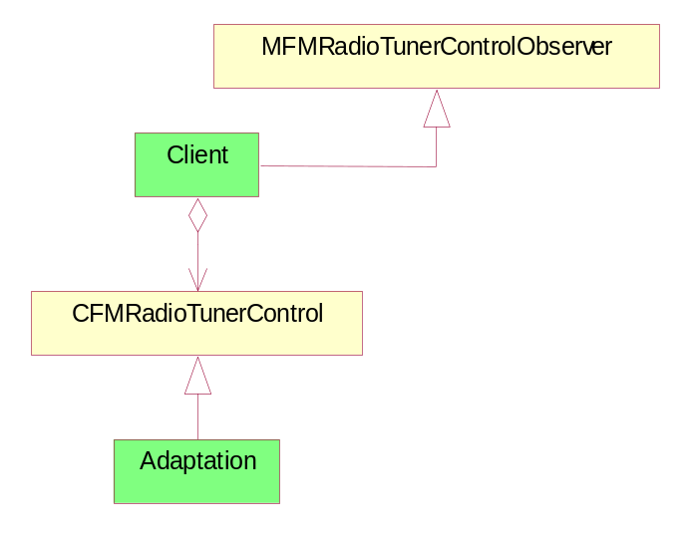
Figure 3.1 Interface class structure

Usage

Protocol
In order to control the FM Radio Tuner, the client must first create an instance of CFMRadioTunerControl by calling the NewL method. Tuner is turned off by default until the client issues the TunerOn request. Tuner must first be turned on before any tuner control request can be made. All requests made to CFMRadioTunerControl are asynchronous and therefore non-blocking.
In order to receive a request completion notification from CFMRadioTunerControl, the client must implement the callback interface specified in MFMRadioTunerControlObserver. The completion request indicates whether the request was completed successfully with KErrNone or if an error occurred with one of the error codes specified in Section 4.1.1.
All requests have their respective cancel method, which is synchronous. However, it is possible that the outstanding request may complete normally before the cancel request can be processed. In this case the cancel request will be ignored and the request will complete normally.
When the FM Radio Tuner Control is no longer needed, it should be deleted simply by issuing delete.

Error handling
FM Radio Control returns error codes through the request completion notification defined by MFMRadioTunerControlObserver. Error codes are listed in Section 4.1.1.
The client should first check tuner capabilities to check the supported features. When request for unsupported feature is issued, synchronous methods return KErrNotSupported in the return value and asynchronous methods return KErrNotSupported in the corresponding callback method.

Memory overhead
Since only one request is handled at a time, the memory consumption is very small. The estimated size of the Dynamically Linked Library (DLL), which implements CFMRadioTunerControl, is around 5~6Kb.

Extensions to the API
None.

Example

Typical Sequence
Figure 3.2 shows an example about how FM Radio Tuner Control might be used by the client application.
The client creates an instance of the CFMRadioTunerControl object by using the NewL method. After the object is created successfully, the object can be operated on using one of the available methods on the object. When the object is no longer needed it is deleted.
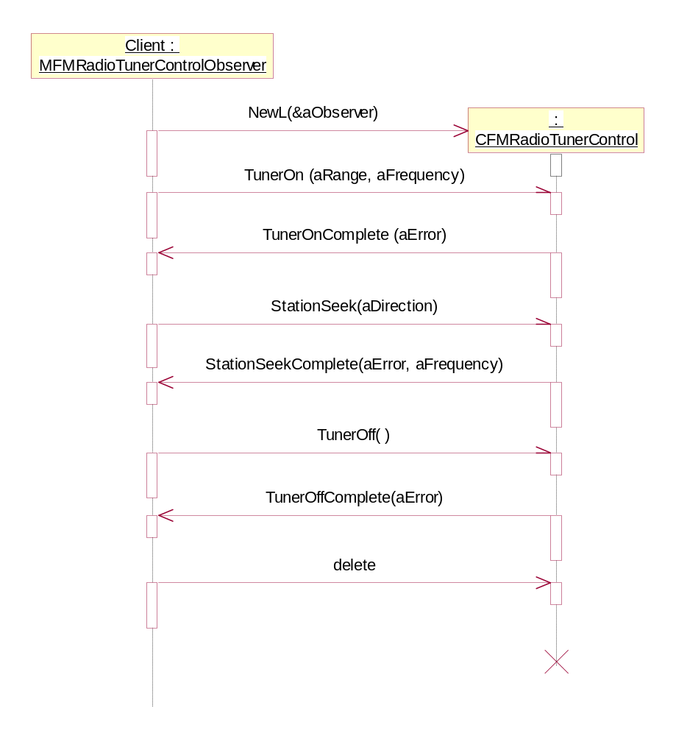
Figure 3.2 Example of FM Radio Tuner Control usage

API implementation
CFMRadioTunerControl is intended to be inherited by the adaptation. The platform only provides the header file, and the actual implementation must be provided by the adaptation. The following is an example on how the API can be implemented by the adaptation:

// Example implementation of Adaptation.h
#include <FMRadioTunerControl.h>

class CAdaptation : public CFMRadioTunerControl
{
public:
static CAdaptation* NewL(MFMRadioTunerControlObserver* aObserver);
void TunerOn(TFMRadioFrequencyRange aRange, TInt aFrequency);
void CancelTunerOn();
void TunerOff();
...

private:
...
}

// Example implementation of Adaptation.cpp
#include "Adaptation.h"

EXPORT_C CFMRadioTunerControl* CFMRadioTunerControl::NewL(
MFMRadioTunerControlObserver* aObserver )
{
return CAdaptation::NewL(aObserver);
}

CAdaptation* CAdaptation::NewL(
MFMRadioTunerControlObserver* aObserver )
{
CAdaption* self = new( ELeave ) CAdaption;
CleanupStack::PushL( self );
self->ConstructL( aObserver );
CleanupStack::Pop();
return self;
}

void CAdaption::TunerOn(
TFMRadioFrequencyRange aRange,
TInt aFrequency )
{
...
}

...

Detailed description

CFMRadioTunerControl
This class is the main interface from the client, and it provides interface to control the FM Radio Tuner. This class is implemented by the adaptation and may be expanded further.
Header (supplied by the platform):
FMRadioTunerControl.h
Library (supplied by the adaptation):
FMRadioTunerControl.dll
Methods:
See sections from 3.5.1.1 to 3.5.1.26.

NewL
Method | static CFMRadioTunerControl* NewL(MFMRadioTunerControlObserver& aObserver);
Description | Static constructor that creates a FM Radio Tuner Control object.
Parameter | aObserver: A reference to an observer object to which request completion notification is sent.
Return value | Pointer to the CFMRadioTunerControl object.
Asynchronous | No
Exceptions | This method may leave with one of the system wide errors for conditions such as out of memory.

TunerOn
Method | virtual void TunerOn(TFMRadioFrequencyRange aRange, TInt aFrequency) = 0;
Description | Turns on the tuner. The method does not block but returns immediately, and once the tuner is actually turned on the calling client will receive a notification via the callback mechanism.
Parameter | - aRange: The frequency range the tuner should be set to.  - aFrequency: The frequency (Hz) the tuner should be tuned to.
Return value
Asynchronous | Yes
Exceptions | It may not be possible to turn the tuner on, or configure it correctly. Failure reason is returned via the callback mechanism.

CancelTunerOn
Method | Virtual void CancelTunerOn() = 0;
Description | Cancels an outstanding TunerOn request. The method blocks while canceling the outstanding request.
Parameter
Return value
Asynchronous | No
Exceptions | If there is no outstanding TunerOn request, this method has no effect. It is possible that the outstanding request may complete normally before the cancel request can be processed. In this case the cancel request is ignored, and the TunerOn request completes normally.

TunerOff
Method | virtual void TunerOff() = 0;
Description | Turns off the tuner. The method does not block but returns immediately, and once the tuner is actually turned off the calling client will receive a notification via the callback mechanism.
Parameter
Return value
Asynchronous | Yes
Exceptions | It may not be possible to turn the tuner off. Failure reason will be returned via the callback mechanism.

CancelTunerOff
Method | virtual void CancelTunerOff() = 0;
Description | Cancels an outstanding TunerOff request. The method blocks while canceling the outstanding request.
Parameter
Return value
Asynchronous | No
Exceptions | If there is no outstanding TunerOff request, this method has no effect. It is possible that the outstanding request may complete normally before the cancel request can be processed. In this case the cancel request is ignored, and the TunerOff request completes normally.

SetFrequencyRange
Method | virtual void SetFrequencyRange(TFMRadioFrequencyRange aRange) = 0;
Description | Sets the tuner to the specified frequency range. The method does not block but returns immediately, and once the frequency range has been set the calling client will receive a notification via the callback mechanism.
Parameter | aRange: The frequency range the tuner should be set to.
Return value
Asynchronous | Yes
Exceptions | It may not be possible to set the tuner to the frequency range specified. Failure reason is returned via the callback mechanism.

CancelSetFrequencyRange
Method | virtual void CancelSetFrequencyRange() = 0;
Description | Cancels an outstanding SetFrequencyRange request. The method blocks while canceling the outstanding request.
Parameter
Return value
Asynchronous | No
Exceptions | If there is no outstanding SetFrequencyRange request, this method has no effect. It is possible that the outstanding request may complete normally before the cancel request can be processed. In this case the cancel request is ignored, and the SetFrequencyRange request completes normally.

SetFrequency
Method | virtual void SetFrequency(TInt aFrequency) = 0;
Description | Tunes the tuner to the specified frequency. The method does not block but returns immediately, and once the tuner has been tuned the calling client receives a notification via the callback mechanism.
Parameter | aFrequency: The frequency (Hz) the tuner should be tuned to.
Return value
Asynchronous | Yes
Exceptions | It may not be possible to tune the tuner to the frequency specified. (One possible reason is that the frequency is outside of the allowed frequency range). Failure reason is returned via the callback mechanism.

CancelSetFrequency
Method | virtual void CancelSetFrequency() = 0;
Description | Cancels an outstanding SetFrequency request. The method blocks while canceling the outstanding request.
Parameter
Return value
Asynchronous | No
Exceptions | If there is no outstanding SetFrequency request, this method has no effect. It is possible that the outstanding request may complete normally before the cancel request can be processed. In this case the cancel request is ignored, and the SetFrequency request completes normally.

StationSeek
Method | virtual void StationSeek(TFMRadioSeekDirection aDirection) = 0;
Description | Searches for a station in the direction specified (i.e. up or down), starting at the currently tuned frequency. The method does not block but returns immediately, and once a station is found the calling client receives a notification via the callback mechanism. The station found is returned in the callback.
Parameter | aDirection: The direction to search in.
Return value
Asynchronous | Yes
Exceptions | There may be no stations available. If the radio has returned to its initial frequency, it stops searching and returns an error code via the callback. The frequency of the radio is not changed.

CancelStationSeek
Method | virtual void CancelStationSeek() = 0;
Description | Cancels an outstanding StationSeek request. The method blocks while canceling the outstanding request.
Parameter
Return value
Asynchronous | No
Exceptions | If there is no outstanding StationSeek request, this method has no effect. It is possible that the outstanding request may complete normally before the cancel request can be processed. In this case the cancel request is ignored, and the StationSeek request completes normally.

AudioMode
Method | virtual void AudioMode() = 0;
Description | Retrieves the tuner’s current audio mode (i.e. stereo or mono). The method does not block but returns immediately, and once the request is completed the calling client receives a notification via the callback mechanism. Audio mode is returned in the callback.
Parameter
Return value
Asynchronous | Yes
Exceptions

CancelAudioMode
Method | virtual void CancelAudioMode() = 0;
Description | Cancels an outstanding AudioMode request. The method blocks while canceling the outstanding request.
Parameter
Return value
Asynchronous | No
Exceptions | If there is no outstanding AudioMode request, this method has no effect. It is possible that the outstanding request may complete normally before the cancel request can be processed. In this case the cancel request is ignored, and the AudioMode request completes normally.

SetAudioMode
Method | virtual void SetAudioMode(TFMRadioAudioMode aMode) = 0;
Description | Sets the tuner’s audio mode (i.e. stereo or mono). The method does not block but returns immediately, and once the audio mode is actually set the calling client receives a notification via the callback mechanism.
Parameter | aMode: The audio mode the tuner should be set to.
Return value
Asynchronous | Yes
Exceptions | It may not be possible to change the audio mode. Failure reason is returned via the callback mechanism.

CancelSetAudioMode
Method | virtual void CancelSetAudioMode() = 0;
Description | Cancels an outstanding SetAudioMode request. The method blocks while canceling the outstanding request.
Parameter
Return value
Asynchronous | No
Exceptions | If there is no outstanding SetAudioMode request, this method has no effect. It is possible that the outstanding request may complete normally before the cancel request can be processed. In this case the cancel request is ignored, and the SetAudioMode request completes normally.

MaxSignalStrength
Method | virtual void MaxSignalStrength() = 0;
Description | Retrieves the maximum possible signal strength (RSSI) of a tuned signal. The method does not block but returns immediately, and once the request is completed the calling client receives a notification via the callback mechanism. Maximum signal strength is returned in the callback.
Parameter
Return value
Asynchronous | Yes
Exceptions

CancelMaxSignalStrength
Method | virtual void CancelMaxSignalStrength() = 0;
Description | Cancels an outstanding MaxSignalStrength request. The method blocks while canceling the outstanding request.
Parameter
Return value | No
Asynchronous
Exceptions | If there is no outstanding MaxSignalStrength request, this method has no effect. It is possible that the outstanding request may complete normally before the cancel request can be processed. In this case the cancel request is ignored, and the MaxSignalStrength request completes normally.

SignalStrength
Method | virtual void SignalStrength() = 0;
Description | Retrieves the signal strength (RSSI) of the currently tuned frequency. The method does not block but returns immediately, and once the request is completed the calling client receives a notification via the callback mechanism. Signal strength is returned in the callback.
Parameter
Return value
Asynchronous | Yes
Exceptions

CancelSignalStrength
Method | virtual void CancelSignalStrength() = 0;
Description | Cancels an outstanding SignalStrength request. The method blocks while canceling the outstanding request.
Parameter
Return value
Asynchronous | No
Exceptions | If there is no outstanding SignalStrength request, this method has no effect. It is possible that the outstanding request may complete normally before the cancel request can be processed. In this case the cancel request is ignored, and the SignalStrength request completes normally.

Squelch
Method | virtual void Squelch() = 0;
Description | Retrieves the current squelching (muting in frequencies without reception) setting. The method does not block but returns immediately, and once the request is completed the calling client receives a notification via the callback mechanism. Squelch setting is returned in the callback.
Parameter
Return value
Asynchronous | Yes
Exceptions

CancelSquelch
Method | virtual void CancelSquelch() = 0;
Description | Cancels an outstanding Squelch request. The method blocks while canceling the outstanding request.
Parameter
Return value
Asynchronous | No
Exceptions | If there is no outstanding Squelch request, this method has no effect. It is possible that the outstanding request may complete normally before the cancel request can be processed. In this case the cancel request will be ignored, and the Squelch request completes normally.

SetSquelch
Method | virtual void SetSquelch(TBool aEnabled) = 0;
Description | Sets the current squelching (muting in frequencies without reception) setting. The method does not block but returns immediately, and once the squelch setting is actually set the calling client receives a notification via the callback mechanism.
Parameter | aEnabled: ETrue to enable squelching, EFalse to disable it.
Return value
Asynchronous | Yes
Exceptions | It may not be possible to change the squelching setting. Failure reason is returned via the callback mechanism.

CancelSetSquelch
Method | virtual void CancelSetSquelch() = 0;
Description | Cancels an outstanding SetSquelch request. The method blocks while canceling the outstanding request.
Parameter
Return value
Asynchronous | No
Exceptions | If there is no outstanding SetSquelch request, this method has no effect. It is possible that the outstanding request may complete normally before the cancel request can be processed. In this case the cancel request is ignored, and the SetSquelch request completes normally.

BufferToBeFilled
Method | virtual void BufferToBeFilled(TDes8& aBuffer) = 0;
Description | This function is called when data is needed for playing. BufferFilled should be called as quickly as possible after the data is read into buffer, or an underflow situation may occur.
Parameter | aBuffer: The buffer into which data should be read.
Return value
Asynchronous | Yes
Exceptions

Capabilities
Method | virtual TFMRadioCapabilities Capabilities() = 0;
Description | Retrieves the audio capabilities supported by the radio device.
Parameter
Return value | Supported audio capabilities.
Asynchronous | No
Exceptions

RdsControl
Method | virtual MRdsControl* RdsControl(MRdsControlObserver& aObserver) = 0;
Description | Returns a pointer to RDS control. Returns NULL if RDS is not supported.
Parameter | aObserver: A reference to an observer object to which request completion notification is sent.
Return value | Pointer to CFMRadioTunerControl object.
Asynchronous | No
Exceptions

GetFrequencyRange
Method | virtual TInt GetFrequencyRange(TFMRadioFrequencyRange& aRange, TInt& aMinFreq, TInt& aMaxFreq) const = 0;
Description | Get the current frequency range. It also returns the minimum and maximum frequencies (Hz) for the returned range. The client should always use the minimum and maximum frequencies returned by the tuner device, since it may vary slightly depending on the hardware.
Parameter | - aRange: On return contains the current frequency range.  - aMinFreq: On return contains the minimum frequency for the current frequency range.  - aMaxFreq: On return contains the maximum frequency for the current frequency range.
Return value | A standard system error code or FM tuner error (TFMRadioTunerError)
Asynchronous | No
Exceptions

MFMRadioTunerControlObserver
This abstract class provides an interface to be realized by the client of CFMRadioTunerControl. This interface is provided so that the calling client can receive notifications related to actions that it has requested.
Header (supplied by the platform):
FMRadioTunerControl.h
Methods:
See sections from 3.5.2.1 to 3.5.2.14.

TunerOnComplete
Method | virtual void TunerOnComplete(TFMRadioTunerError aError) = 0;
Description | Notification mechanism provided to inform client that the TunerOn request has completed.
Parameter | aError: The result of the request indicating whether the operation was successful or not.
Return value

TunerOffComplete
Method | virtual void TunerOffComplete(TFMRadioTunerError aError) = 0;
Description | Notification mechanism provided to inform the client that the TunerOff request has completed.
Parameter | aError: The result of the request indicating whether the operation was successful or not.
Return value

SetFrequencyRangeComplete
Method | virtual void SetFrequencyRangeComplete(TFMRadioTunerError aError) = 0;
Description | Notification mechanism provided to inform client that the SetFrequencyRange request has completed.
Parameter | aError: The result of the request indicating whether the operation was successful or not.
Return value

SetFrequencyComplete
Method | virtual void SetFrequencyComplete(TFMRadioTunerError aError) = 0;
Description | Notification mechanism provided to inform client that the SetFrequency request has completed.
Parameter | aError: The result of the request indicating whether the operation was successful or not.
Return value

StationSeekComplete
Method | virtual void StationSeekComplete(TFMRadioTunerError aError, TInt aFrequency) = 0;
Description | Notification mechanism provided to inform client that the StationSeek request has completed.
Parameter | - aError: The result of the request indicating whether the operation was successful or not.  - aFrequency: The frequency of the radio station that was found.
Return value

AudioModeComplete
Method | virtual void AudioModeComplete(TFMRadioTunerError aError, TFMRadioAudioMode aMode) = 0;
Description | Notification mechanism provided to inform client that the AudioMode request has completed.
Parameter | - aError: The result of the request indicating if the operation was successful or not.  - aMode: The audio mode of the radio.
Return value

SetAudioModeComplete

Method | virtual void SetAudioModeComplete(TFMRadioTunerError aError) = 0;
Description | Notification mechanism provided to inform client that the SetAudioMode request has completed.
Parameter | aError: The result of the request indicating whether the operation was successful or not.
Return value

MaxSignalStrengthComplete
Method | virtual void MaxSignalStrengthComplete(TFMRadioTunerError aError, TInt aStrength) = 0;
Description | Notification mechanism provided to inform client that the MaxSignalStrength request has completed.
Parameter | - aError: The result of the request indicating if the operation was successful or not.  - aStrength: The maximum possible signal strength of a tuned signal.
Return value

SignalStrengthComplete
Method | virtual void SignalStrengthComplete(TFMRadioTunerError aError, TInt aStrength) = 0;
Description | Notification mechanism provided to inform client that the SignalStrength request has completed.
Parameter | - aError: The result of the request indicating if the operation was successful or not.  - aStrength: The signal strength of the currently tuned frequency.
Return value

SquelchComplete
Method | virtual void SquelchComplete(TFMRadioTunerError aError, TBool aEnabled) = 0;
Description | Notification mechanism provided to inform client that the Squelch request has completed.
Parameter | - aError: The result of the request indicating whether the operation was successful or not.  - aEnabled: ETrue if squelching is enabled, EFalse if disabled.
Return value

SetSquelchComplete
Method | virtual void SetSquelchComplete(TFMRadioTunerError aError) = 0;
Description | Notification mechanism provided to inform client that the SetSquelch request has completed.
Parameter | aError: The result of the request indicating whether the operation was successful or not.
Return value

BufferFilled
Method | virtual void BufferFilled(TDes8& aBuffer) = 0;
Description | Notification mechanism provided to inform client that the BufferToBeFilled request has completed.
Parameter | aBuffer: The buffer with data to be played.
Return value

RadioEventAntennaStatusChange
Method | virtual void RadioEventAntennaStatusChange(TBool aAttached) = 0;
Description | Notification mechanism provided to inform that the antenna status has changed.
Parameter | aAttached: ETrue if antenna is attached.
Return value

RadioEventTunerControlChange
Method | virtual void RadioEventTunerControlChange(TInt aError) = 0;
Description | Notification mechanism indicating tuner control change.  When tuner receiver is forced to be turned off due to hardware conflict such as FM transmitter, this event is sent with KFMRadioErrFmTransmitterActive. Once the tuner control is restored, this event is sent again with KErrNone and client can re-issue TunerOn.
Parameter | aError: The result of the request indicating whether the operation was successful or not.
Return value

Code architecture
FM Radio Tuner Control (CFMRadioTunerControl), which implements the API specified in this document, is represented as a Dynamically Linked Library (DLL) called FMRadioTunerControl.dll.
The following header files exist:

Header File | Defines | Owner
FMRadioTunerControl.h | CFMRadioTunerControl  MFMRadioTunerControlObserver | Platform

Index

List of constants and enumerations

TFMRadioTunerError
In addition to the system wide errors, the following FM Radio Tuner Control errors may be returned:

typedef TInt TFMRadioTunerError
KFMRadioErrHardwareFaulty | Unable to communicate with the FM tuner hardware.
KFMRadioErrTuning | Unable to detect signal at the specified frequency.
KFMRadioErrFrequencyOutOfBandRange | Specified frequency is out of band range.
KFMRadioErrFrequencyNotValid | Specified frequency is not valid.
KFMRadioErrNotPermittedInCurrentState | The action requested is not allowed while the radio is in its current state.
KFMRadioErrDuplicateRequest | The request is not permitted because a request of the same type is already outstanding.
KFMRadioErrAntennaNotConnected | Antenna is not connected.
KFMRadioErrFmTransmitterActive | FM transmitter is active. Hardware conflict.

TFMRadioFrequencyRange

enum TFMRadioFrequencyRange
EFMRadioFrequencyEuroAmerica | European and American FM frequency range (87.5 – 108 MHz)
EFMRadioFrequencyJapan | Japanese FM frequency range (76 – 90 MHz)

TFMRadioAudioMode

enum TFMRadioAudioMode
EFMRadioAudioStereo | FM radio is in stereo mode.
EFMRadioAudioMono | FM radio is in mono mode.

TFMRadioSeekDirection

enum TFMRadioSeekDirection
EFMRadioSeekUp | Search for station upwards.
EFMRadioSeekDown | Search for station downwards.

TFMRadioCapabilities
The following tuner features are available.

enum TFMTunerFeatures
ETunerAvailableInOfflineMode | This bit is set if the tuner can be used even when the device is in offline mode. Some tuner may not allow this due to hardware conflict.
ETunerRdsSupport | This bit is set if the tuner has RDS support.
ETunerDualTunerSupport | This bit is set when the device supports dual tuner, which allows more extensive RDS feature support.

The FM radio capabilities should be bitwise ORed together to indicate which features are available. Adaptation can utilize this class to indicate the hardware limitations.

class TFMRadioCapabilities
iSampleRate | Bitmask using TFMRadioSampleRate.
iChannels | Bitmask using TFMRadioAudioMode.
iEncoding | Supported encoding – FourCC.
iTunerBands | Bitmask using TFMRadioFrequencyRange.
iTunerFunctions | Bitmask using TFMTunerFeatures

TFMRadioSampleRate

enum TFMRadioSampleRate
EFMRadioSampleRate8000Hz | 8000 Hz
EFMRadioSampleRate11025Hz | 11025 Hz
EFMRadioSampleRate12000Hz | 12000 Hz
EFMRadioSampleRate16000Hz | 16000 Hz
EFMRadioSampleRate22050Hz | 22050 Hz
EFMRadioSampleRate24000Hz | 24000 Hz
EFMRadioSampleRate32000Hz | 32000 Hz
EFMRadioSampleRate44100Hz | 44100 Hz
EFMRadioSampleRate48000Hz | 48000 Hz
EFMRadioSampleRate64000Hz | 64000 Hz
EFMRadioSampleRate88200Hz | 88200 Hz
EFMRadioSampleRate96000Hz | 96000 Hz

Alphabetical list of classes and methods

class CFMRadioTunerControl
virtual void AudioMode() = 0;
virtual void BufferToBeFilled(TDes8& aBuffer) = 0;
virtual void CancelAudioMode() = 0;
virtual void CancelMaxSignalStrength() = 0;
virtual void CancelSetFrequency() = 0;
virtual void CancelSetFrequencyRange() = 0;
virtual void CancelRadioOff() = 0;
virtual void CancelRadioOn() = 0;
virtual void CancelSetAudioMode() = 0;
virtual void CancelSetFrequency() = 0;
virtual void CancelSetFrequencyRange() = 0;
virtual void CancelSetSquelch() = 0;
virtual void CancelSignalStrength() = 0;
virtual void CancelSquelch() = 0;
virtual void CancelStationSeek() = 0;
virtual void CancelTunerOff() = 0;
virtual void CancelTunerOn() = 0;
virtual TFMRadioCapabilities Capabilities() = 0;
virtual TInt GetFrequencyRange(TFMRadioFrequencyRange& aRange, TInt& aMinFreq, TInt& aMaxFreq) const = 0;
virtual void MaxSignalStrength() = 0;
static CFMRadioTunerControl* NewL(MFMRadioTunerControlObserver& aObserver);
virtual void TunerOff() = 0;
virtual void TunerOn(TFMRadioFrequencyRange aRange, TInt aFrequency) = 0;
virtual MRdsControl* RdsControl(MRdsControlObserver& aObserver) = 0;
virtual void SetAudioMode(TFMRadioAudioMode aMode) = 0;
virtual void SetFrequency(TInt aFrequency) = 0;
virtual void SetFrequencyRange(TFMRadioFrequencyRange aRange) = 0
virtual void SetSquelch(TBool aEnabled) = 0;
virtual void SignalStrength() = 0;
virtual void Squelch() = 0;
virtual void StationSeek(TFMRadioSeekDirection aDirection) = 0;

class MFMRadioTunerControlObserver
virtual void AudioModeComplete(TFMRadioTunerError aError, TFMRadioAudioMode aMode) = 0;
virtual void BufferFilled(TDes8& aBuffer) = 0;
virtual void MaxSignalStrengthComplete(TFMRadioTunerError aError, TInt aStrength) = 0;
virtual void TunerOffComplete(TFMRadioTunerError aError) = 0;
virtual void TunerOnComplete(TFMRadioTunerError aError) = 0;
virtual void RadioEventAntennaStatusChange(TBool aAttached ) = 0;
virtual void RadioEventTunerControlChange(TInt aError) = 0;
virtual void SetAudioModeComplete(TFMRadioTunerError aError) = 0;
virtual void SetFrequencyComplete(TFMRadioTunerError aError) = 0;
virtual void SetFrequencyRangeComplete(TFMRadioTunerError aError) = 0;
virtual void SetSquelchComplete(TFMRadioTunerError aError) = 0
virtual void SignalStrengthComplete(TFMRadioTunerError aError, TInt aStrength) = 0;
virtual void SquelchComplete(TFMRadioTunerError aError, TBool aEnabled) = 0;
virtual void StationSeekComplete(TFMRadioTunerError aError, TInt aFrequency) = 0;

