S60 3.2
RDS Control Adaptation
API Specification Document

Team name | Author
 | David Luong

Change history:

Version | Date | Status | Comments
1.0 | 17.01.2007 | Approved

Table of contents:

1. Document control 4
1.1 References 4
1.2 Documentation conventions 4
1.3 Abbreviations 4
1.4 Definitions 4
2. Purpose 4
2.1 List of required interfaces 4
2.2 Product Platform and/or Symbian OS version constraints 4
3. Technical specification 4
3.1 Type of interface 4
3.2 Interface Class Structure 4
3.3 Usage 4
3.3.1 Protocol 4
3.3.2 Error handling 4
3.3.3 Memory overhead 4
3.3.4 Extensions to the API 4
3.4 Example 4
3.4.1 Typical sequence 4
3.4.2 API implementation 4
3.5 Detailed description 4
3.5.1 MRdsControl 4
3.5.1.1 GetCapabilities 4
3.5.1.2 GetRdsSignalStatus 4
3.5.1.3 NotifyRdsDataChange 4
3.5.1.4 CancelNotifyRdsDataChange 4
3.5.1.5 SetAutomaticSwitching 4
3.5.1.6 GetAutomaticSwitching 4
3.5.1.7 CancelAFSearch 4
3.5.1.8 SetAutomaticTrafficAnnouncement 4
3.5.1.9 GetAutomaticTrafficAnnouncement 4
3.5.1.10 StationSeekByPTY 4
3.5.1.11 StationSeekByTA 4
3.5.1.12 StationSeekByTP 4
3.5.1.13 CancelRdsStationSeek 4
3.5.1.14 GetFreqByPTY 4
3.5.1.15 CancelGetFreqByPTY 4
3.5.1.16 GetFreqByTA 4
3.5.1.17 CancelGetFreqByTA 4
3.5.1.18 GetPSByPTY 4
3.5.1.19 CancelGetPSByPTY 4
3.5.1.20 GetPSByTA 4
3.5.1.21 CancelGetPSByTA 4
3.5.1.22 GetProgrammeIdentification 4
3.5.1.23 GetProgrammeType 4
3.5.1.24 GetProgramService 4
3.5.1.25 GetRadioText 4
3.5.1.26 GetClockTime 4
3.5.1.27 GetTrafficAnnouncementStatus 4
3.5.1.28 GetTrafficProgramStatus 4
3.5.2 MRdsControlObserver 4
3.5.2.1 StationSeekByPTYComplete 4
3.5.2.2 StationSeekByTAComplete 4
3.5.2.3 StationSeekByTPComplete 4
3.5.2.4 GetFreqByTPYComplete 4
3.5.2.5 GetFreqByTAComplete 4
3.5.2.6 GetPSByTPYComplete 4
3.5.2.7 GetPSByTAComplete 4
3.5.2.8 RdsDataPI 4
3.5.2.9 RdsDataPTY 4
3.5.2.10 RdsDataPS 4
3.5.2.11 RdsDataRT 4
3.5.2.12 RdsDataCT 4
3.5.2.13 RdsSignalTA 4
3.5.2.14 RdsSearchBeginAF 4
3.5.2.15 RdsSearchEndAF 4
3.5.2.16 RdsStationChangeTA 4
3.5.2.17 RdsEventSignalChange 4
3.5.3 Code architecture 4
4. Index 4
4.1 List of constants and enums 4
4.1.1 TRdsControlError 4
4.1.2 TRdsCapabilities 4
4.1.3 TRdsData 4
4.1.4 TRTplusTag 4
4.1.5 Other Descriptors 4
4.2 Alphabetical list of classes and methods 4
4.3 Programme Type Definitions 4
4.4 List of RT Content Types 4

Document control

References
- S60 FM Radio Tuner Control Adaptation API Specification Document
- RDS Forum | http://www.rds.org.uk/

Documentation conventions
Code is shown with the Courier New font.

Abbreviations
AF | Alternative Frequency
API | Application Program Interface
CT | Clock Time and date
DLL | Dynamic Link Library
EON | Enhanced Other Networks information
FM | Frequency Modulation
PI | Program Identification
PS | Program Service name
PTY | Program TYpe
RBDS | Radio Broadcast Data System
RDS | Radio Data System
RT | Radio Text
TA | Traffic Announcement
TP | Traffic Program identification
VHF | Very High Frequency

Definitions
Adaptation Layer | The software layer close to the hardware platform that requires implementation that adapts to hardware peculiarities. In the context of the RDS, software implementing the MRdsControl API is considered adaptation.
Alternate Frequency | This allows a receiver to re-tune to a different frequency providing the same station when the first signal becomes too weak (e.g. when moving out of range). This is often utilized in car stereo systems.
Program Identification | This is the unique code that identifies the station. Every station receives a specific code with a country prefix.
Program Service | This is simply an eight-character static display that represents the call letters or station identity name.
Program Type | This coding of up to 31 pre-defined classes allows users to find similar programming by genre.
Ratio Text | This function allows a radio station to transmit free-form textual information that can be either static (e.g. station slogans) or in sync with the programming such as the title and artist of the currently playing song.
RBDS | Radio Broadcast Data System is the official name used for the U.S. version of RDS.
RDS | Radio Data System is a standard from the European Broadcasting Union for sending small amounts of digital information using conventional FM radio broadcasts. The RDS system standardizes several types of information transmitted, including time and station identification.
Traffic Program | The receiver can often be set to pay special attention to this flag. The TP flag is used to allow the user to find only those stations that regularly broadcast traffic bulletins whereas the TA flag is toggled to indicate the actual beginning and end of a traffic announcement.

Purpose
This document describes the Radio Data System (RDS) control adaptation API and services offered by the RDS Control.
RDS and its North American variant Radio Broadcast Data System (RBDS) provide enhanced functionality for FM/VHF receivers such as Program Identification (PI), Program Service name (PS) display, automatic tuning to Alternate Frequency (AF) with better reception or to a station broadcasting Traffic Announcement (TA), Radio Text (RT) for additional information such as the title of the currently broadcasting song, artist name, etc.
RDS Control Adaptation API provides the ability to control the RDS features on RDS enabled tuners. Currently, only FM radio tuner control (see reference document [1]) provides RDS functionality, however, RDS Control Adaptation API may be used with any RDS enabled tuner control.

List of required interfaces
RDS Control Adaptation API is provided as an enhancement to a tuner control API. Therefore, the client must first interface with an RDS enabled tuner control in order to gain access to this API.

S60 and/or Symbian OS version constraints
RDS Control Adaptation API is defined from S60 release 3.2 onwards.

Technical specification

Type of interface
RDS Control interfaces include both synchronous and asynchronous method calls. For asynchronous request, the client is notified through the observer interface upon completion or upon failure to process the request.

Interface class structure
Figure 3.1 shows the RDS Control interface structure. The diagram also shows the observer interface implemented by the client. The adaptation class must realize RDS Control API specified in MRdsControl. The diagram also shows a generic tuner control for clarification, since the RDS Control interface can only be obtained through a tuner control that supports RDS.
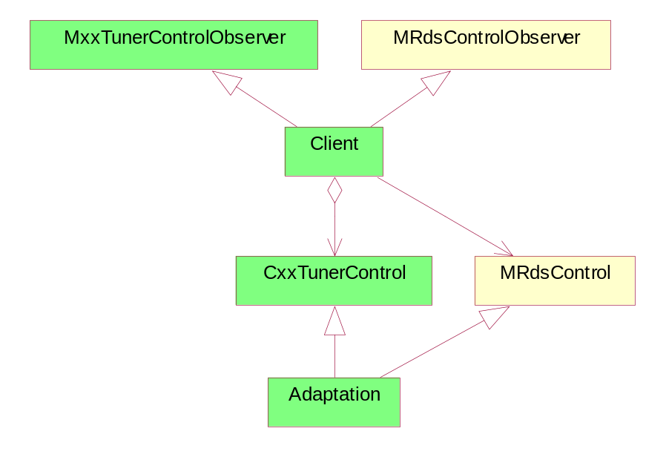
Figure 3.1 Interface class structure

Usage

Protocol
In order to control the RDS, the client must first create an instance of a tuner control and if RDS is supported, the client can request for a pointer to RDS Control. Client interfaces RDS Control through a Mixin class interface, hence the client does not own the object and cannot delete it.
The client can request RDS control for notification when RDS data is received. In order to receive such notification, the client must implement the callback interface specified in MRdsControlObserver. When new RDS data is received, the client is notified about the RDS data change and the client can fetch the actual data through the RDS Control API.
RDS Control API provides methods to seek stations based on RDS features, which are asynchronous since the request may take a while to complete. Although cancel methods exist (synchronous cancel), it is possible that the outstanding request may complete normally before the cancel request can be processed. In this case the cancel request will be ignored and the request will complete normally.
RDS Control is deleted when the tuner control is deleted.

Error handling
RDS Control API uses system wide errors. RDS Control API also uses additional RDS specific error codes listed in Section 4.1.1.
Client should first check RDS capabilities to check the supported features. When request for unsupported feature is issued, synchronous methods return KErrNotSupported in the return value and asynchronous methods return KErrNotSupported in the corresponding callback method.

Memory overhead
Since only one request is handled at a time, the memory consumption is very small. The estimated size of the Dynamically Linked Library (DLL), which implements MRdsControl, is around 6~7Kb. Note that this estimate is just for the implementation of MRdsControl. This should be added to the size of the tuner’s size.

Extensions to the API
None.

Example

Typical sequence
Figure 3.2 shows an example of how the RDS Control might be used by the client application.
The client obtains an instance of the MRdsControl from a tuner instance. After the object is created successfully, the object can be operated on using one of the available methods on the object. RDS control is owned and deleted by the tuner control.
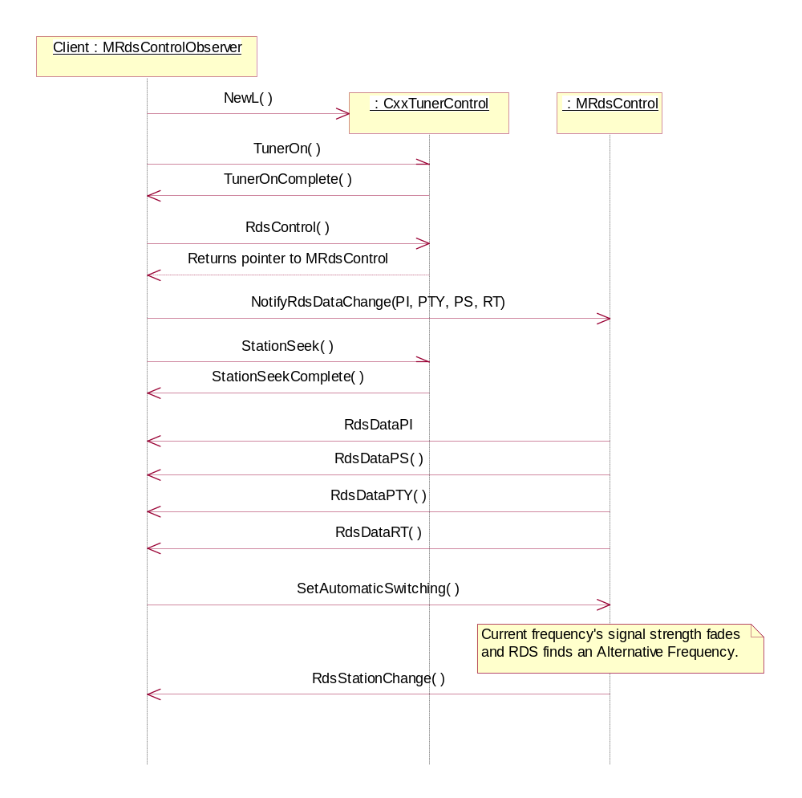
Figure 3.2 Example of RDS Control usage

API implementation
MRdsControl is intended to be inherited by the adaptation. S60 only provides the header file, and the actual implementation must be provided by the adaptation. The following is an example of how the API can be implemented by the adaptation:
// Example implementation of Adaptation.h
#include <TunerControl.h>
#include <RdsControl.h>

class CAdaptation : public CTunerControl,
public MRdsControl
{
public:
static CAdaptation* NewL( MTunerControlObserver* aTunerObserver );
MRdsControl* RdsControl( MRdsControlObserver* aRdsObserver );
TInt NotifyRdsDataChange( TRdsData aRdsData );
...

private:
...
}

// Example implementation of Adaptation.cpp
#include "Adaptation.h"

EXPORT_C CTunerControl* CTunerControl::NewL(
MTunerControlObserver* aTunerObserver )
{
return CAdaptation::NewL(aTunerObserver);
}

CAdaptation* CAdaptation::NewL(
MTunerControlObserver* aTunerObserver )
{
CAdaption* self = new( ELeave ) CAdaption;
CleanupStack::PushL( self );
self->ConstructL( aTunerObserver );
CleanupStack::Pop();
return self;
}

MRdsControl* CAdaption::RdsControl(
MRdsControlObserver* aRdsObserver )
{
...
return self;
}

...

Although the example above shows the same adaptation class inheriting from both tuner control and RDS control, the implementation detail is up to the adaptation. Adaptation may choose to implement MRdsControl as a separate class.

Detailed description

MRdsControl
This class is the main interface from the client, and it provides the interface to control the RDS features. This class is implemented by the adaptation.
Header (supplied by the platform):
RadioRdsControl.h
Methods:
See Sections from 3.5.1.1 to 3.5.1.28.

GetCapabilities
Method | virtual TInt GetCapabilities(TRdsCapabilities& aCaps) = 0;
Description | Get the capabilities of the RDS control on the device.
Parameter | aCaps – The capabilities object to fill
Return value | A standard system error code or RDS control error (TRdsControlError)
Asynchronous | No
Exceptions

GetRdsSignalStatus
Method | virtual TInt GetRdsSignalStatus(TBool& aRdsSignal) const = 0;
Description | Get the status of the RDS reception.
Parameter | aRdsSignal – On return, will be ETrue if RDS signal can be recepted, EFalse otherwise.
Return value | A standard system error code or RDS control error (TRdsControlError)
Asynchronous | No
Exceptions

NotifyRdsDataChange
Method | virtual TInt NotifyRdsDataChange(TRdsData aRdsData) = 0;
Description | Subscribe for notification for the specified RDS data. The client should first check the capabilities to see if a feature is supported.  Depending on which RDS data the client requested the notification for, the client may receive the following notifications:  MRdsControlObserver::RdsDataPI  MRdsControlObserver::RdsDataPTY  MRdsControlObserver::RdsDataPS  MRdsControlObserver::RdsDataRT  MRdsControlObserver::RdsDataCT  MRdsControlObserver::RdsDataTA
Parameter | aRdsData – Bitmap of RDS functions
Return value | A standard system error code or RDS control error (TRdsControlError)
Asynchronous | No
Exceptions | The request for notification for non-supported features is simply ignored. The client should first check RDS capabilities.

CancelNotifyRdsDataChange
Method | virtual void CancelNotifyRdsDataChange() = 0;
Description | Cancel NotifyRdsDataChange request. Client will not receive any further notifications about RDS data change.
Parameter
Return value
Asynchronous | No
Exceptions

SetAutomaticSwitching
Method | virtual TInt SetAutomaticSwitching(TBool aAuto) = 0;
Description | Turn on/off automatic switching of frequency based on Alternate Frequency. This causes RDS device to search for alternate frequency when the signal strength deteriorates. The user should be ready to receive MRdsControlObserver::RdsSearchBeginAF and MRdsControlObserver::RdsSearchEndAF callback functions.  Automatic switching is off by default.
Parameter | aAuto – ETrue to turn the automatic switching on, EFalse to turn it off.
Return value | A standard system error code or RDS control error (TRdsControlError)
Asynchronous | No
Exceptions | Returns KErrNotSupported if the feature is not supported.

GetAutomaticSwitching
Method | virtual TInt GetAutomaticSwitching(TBool& aAuto) = 0;
Description | Find out whether automatic switching is on or off.
Parameter | aAuto – ETrue indicates that automatic switching is on.
Return value | A standard system error code or RDS control error (TRdsControlError)
Asynchronous | No
Exceptions

CancelAFSearch
Method | Virtual void CancelAFSearch() = 0;
Description | Cancel ongoing search for an Alternate Frequency (AF) with stronger signal.  Client can issue this request to interrupt the search indicated with MRdsControlObserver::RdsSearchBeginAF.
Parameter
Return value
Asynchronous | No
Exceptions

SetAutomaticTrafficAnnouncement
Method | virtual TInt SetAutomaticTrafficAnnouncement(TBool aAuto) = 0;
Description | Turns on/off automatic switching of frequency based on Traffic Announcement.  This causes RDS device to search for frequencies broadcasting traffic announcement. This feature is based on TA/TP fields and/or EON. It is up to the client to return to the previous frequency when the traffic announcement is finished.  This is only supported in dual tuner configuration since the secondary tuner needs to perform continuous scanning for frequencies broadcasting traffic announcement, while the primary tuner is used for normal tuner activities.
Parameter | aAuto – ETrue to turn the automatic switching on, EFalse to turn it off.
Return value | A standard system error code or RDS control error (TRdsControlError)
Asynchronous | No
Exceptions | Returns KErrNotSupported if the feature is not supported.

GetAutomaticTrafficAnnouncement
Method | virtual TInt GetAutomaticTrafficAnnouncement(TBool& aAuto) = 0;
Description | Find out whether automatic traffic announcement is on or off.
Parameter | aAuto – ETrue indicates that automatic traffic switching is on.
Return value | A standard system error code or RDS control error (TRdsControlError)
Asynchronous | No
Exceptions

StationSeekByPTY
Method | virtual void StationSeekByPTY(TRdsProgrammeType aPty, TBool aSeekUp) = 0;
Description | Searches for a station broadcasting the specified Program Type in the direction specified (i.e. up or down) starting at the currently tuned frequency.  The method does not block but returns immediately, and once a station is found the calling client will receive a notification via the callback function MRadioRdsObserver::StationSeekByPTYComplete. The station found is returned in the callback.
Parameter | aPty – Program type. May be RDS or RBDS depending on the location.  aSeekUp – ETrue to search upwards, EFalse to search downwards
Return value
Asynchronous | Yes
Exceptions | There may be no stations available. If the radio has returned to its initial frequency, it stops searching and returns an error code via the callback. The frequency of the radio is not changed.

StationSeekByTA
Method | virtual void StationSeekByTA(TBool aSeekUp) = 0;
Description | Searches for a station broadcasting Traffic Announcement in the direction specified (i.e. up or down) starting at the currently tuned frequency.  The method does not block but returns immediately, and once a station is found the calling client receives a notification via the callback function MRadioRdsObserver::StationSeekByTAComplete. The station found is returned in the callback.
Parameter | aSeekUp – ETrue to search upwards, EFalse to search downwards.
Return value
Asynchronous | Yes
Exceptions | There may be no stations available. If the radio has returned to its initial frequency, it stops searching and returns an error code via the callback. The frequency of the radio is not changed.

StationSeekByTP
Method | virtual void StationSeekByTP(TBool aSeekUp) = 0;
Description | Searches for a station with Traffic Program flag in the direction specified (i.e. up or down) starting at the currently tuned frequency.  The method does not block but returns immediately, and once a station is found the calling client receives a notification via the callback function MRadioRdsObserver::StationSeekByTPComplete. The station found is returned in the callback.
Parameter | aSeekUp – ETrue to search upwards, EFalse to search downwards.
Return value
Asynchronous | Yes
Exceptions | There may be no stations available. If the radio has returned to its initial frequency, it stops searching and returns an error code via the callback. The frequency of the radio is not changed.

CancelRdsStationSeek
Method | virtual void CancelRdsStationSeek() = 0;
Description | Cancels an ongoing retune operation, as initiated by a call to StationSeekByPTY, StationSeekByTA, or StationSeekByTP.
Parameter
Return value
Asynchronous | No
Exceptions | If there is no outstanding seek request, this method has no effect. It is possible that the outstanding request may complete normally before the cancel request can be processed. In this case the cancel request is ignored, and the request completes normally.

GetFreqByPTY
Method | virtual void GetFreqByPTY(TRdsProgrammeType aPty) = 0;
Description | Get all frequencies sending the given Program Type (PTY).  The method does not block but returns immediately, and once all frequencies are found the calling client receives a notification via the callback function MRadioRdsObserver::GetFreqByPTYComplete. The frequencies found are returned in the callback.  This is only supported in dual tuner configuration since the secondary tuner needs to perform continuous scanning for frequencies broadcasting given program type, while the primary tuner is used for normal tuner activities.
Parameter | aPty – The type of program to search for.
Return value
Asynchronous | Yes
Exceptions | There may be no stations available. If the radio has returned to its initial frequency, it stops searching and returns an error code via the callback.

CancelGetFreqByPTY
Method | virtual void CancelGetFreqByPTY() = 0;
Description | Cancels an ongoing request to find all frequencies sending a given Program Type (PTY), as initiated by a call to GetFreqByPTY.
Parameter
Return value
Asynchronous | No
Exceptions | If there is no outstanding request, this method has no effect. It is possible that the outstanding request may complete normally before the cancel request can be processed. In this case the cancel request will be ignored, and the request completes normally.

GetFreqByTA
Method | virtual void GetFreqByTA() = 0;
Description | Get all frequencies sending Traffic Announcement (TA).  The method does not block but returns immediately, and once all frequencies are found the calling client receives a notification via the callback function MRadioRdsObserver::GetFreqByTAComplete. The frequencies found are returned in the callback.  This is only supported in dual tuner configuration since the secondary tuner needs to perform continuous scanning for frequencies broadcasting traffic announcement, while the primary tuner is used for normal tuner activities.
Parameter
Return value
Asynchronous | Yes
Exceptions | There may be no stations available. If the radio has returned to its initial frequency, it will stop searching and return an error code via the callback.

CancelGetFreqByTA
Method | virtual void CancelGetFreqByTA() = 0;
Description | Cancels an ongoing request to find all frequencies sending Traffic Announcement (TA), as initiated by a call to GetFreqByTA.
Parameter
Return value
Asynchronous | No
Exceptions | If there is no outstanding request, this method has no effect. It is possible that the outstanding request may complete normally before the cancel request can be processed. In this case the cancel request will be ignored, and the request completes normally.

GetPSByPTY
Method | virtual void GetPSByPTY(TRdsProgrammeType aPty) = 0;
Description | Get all Program Service names (PS) sending the given Program Type (PTY).  The method does not block but returns immediately, and once all frequencies are found the calling client receives a notification via the callback function MRadioRdsObserver::GetPSByPTYComplete. The frequencies found are returned in the callback.  This is only supported in dual tuner configuration since the secondary tuner needs to perform continuous scanning for frequencies broadcasting given program type, while the primary tuner is used for normal tuner activities.
Parameter | aPty – The type of program to search for.
Return value
Asynchronous | Yes
Exceptions | There may be no stations available. If the radio has returned to its initial frequency, it stops searching and returns an error code via the callback.

CancelGetPSByPTY
Method | virtual void CancelGetPSByPTY() = 0;
Description | Cancels an ongoing request to find all Program Service names (PS) sending a given Program Type (PTY), as initiated by a call to GetPSByPTY.
Parameter
Return value
Asynchronous | No
Exceptions | If there is no outstanding request, this method has no effect. It is possible that the outstanding request may complete normally before the cancel request can be processed. In this case the cancel request is ignored, and the request completes normally.

GetPSByTA
Method | virtual void GetPSByTA() = 0;
Description | Get all Program Service names (PS) sending Traffic Announcement (TA).  The method does not block but returns immediately, and once all frequencies are found the calling client receives a notification via the callback function MRadioRdsObserver::GetPSByTAComplete. The frequencies found are returned in the callback.  This is only supported in dual tuner configuration since the secondary tuner needs to perform continuous scanning for frequencies broadcasting traffic announcement, while the primary tuner is used for normal tuner activities.
Parameter
Return value
Asynchronous | Yes
Exceptions | There may be no stations available. If the radio has returned to its initial frequency, it will stop searching and return an error code via the callback.

CancelGetPSByTA
Method | virtual void CancelGetPSByTA() = 0;
Description | Cancels an ongoing request to find all Program Service names (PS) sending Traffic Announcement (TA), as initiated by a call to GetPSByTA.
Parameter
Return value
Asynchronous | No
Exceptions | If there is no outstanding request, this method has no effect. It is possible that the outstanding request may complete normally before the cancel request can be processed. In this case the cancel request is ignored, and the request completes normally.

GetProgrammeIdentification
Method | virtual TInt GetProgrammeIdentification(TInt& aPi) = 0;
Description | Get the current Program Identification code.  RDS data is received over the air and may not be available immediately following tune operation. If a value is returned, this is the last known value, which may not be up to date. To be notified of the most recent value, client should use NotifyRdsDataChange.
Parameter | aPi – On return contains Program Identification code
Return value | A standard system error code or RDS control error (TRdsControlError)
Asynchronous | No
Exceptions | KErrNotReady if information is not available yet.  KErrNotFound if current station does not support RDS.  KErrNotSupported if feature is not supported.

GetProgrammeType
Method | virtual TInt GetProgrammeType(TRdsProgrammeType& aPty) = 0;
Description | Get the current Program Type.  RDS data is received over the air and may not be available immediately following tune operation. If a value is returned, this is the last known value, which may not be up to date. To be notified of the most recent value, the client should use NotifyRdsDataChange.  Note that Program Type in RBDS differ from the ones in RDS.
Parameter | aPty – On return contains Program Type
Return value | A standard system error code or RDS control error (TRdsControlError)
Asynchronous | No
Exceptions | KErrNotReady if information is not available yet.  KErrNotFound if current station does not support RDS.  KErrNotSupported if feature is not supported.

GetProgramService
Method | virtual TInt GetProgramService(TRdsPSName& aPs) = 0;
Description | Get the current Program Service name.  RDS data is received over the air and may not be available immediately following tune operation. If a value is returned, this is the last known value, which may not be up to date. To be notified of the most recent value, client should use NotifyRdsDataChange.  Program Service name is fixed to 8 characters.
Parameter | aPs – On return contains Program Service name
Return value | A standard system error code or RDS control error (TRdsControlError)
Asynchronous | No
Exceptions | KErrNotReady if information is not available yet.  KErrNotFound if current station does not support RDS.  KErrNotSupported if feature is not supported.

GetRadioText
Method | virtual TInt GetRadioText(TRdsRadioText& aRt, RArray<TRTplusTag>& aRTplusTags) = 0;
Description | Get the current Radio Text.  RDS data is received over the air and may not be available immediately following tune operation. If a value is returned, this is the last known value, which may not be up to date. To be notified of the most recent value, the client should use NotifyRdsDataChange.  The maximum possible length for radio text is 64 characters.  If RT+ is supported, RT+ tags information is returned along with the RT. Array is owned by the client.
Parameter | aRt – On return contains Radio Text  aRTplusTags – RTplus tags
Return value | A standard system error code or RDS control error (TRdsControlError)
Asynchronous | No
Exceptions | KErrNotReady if information is not available yet.  KErrNotFound if current station does not support RDS.  KErrNotSupported if feature is not supported.

GetClockTime
Method | virtual TInt GetClockTime(TDateTime& aCt) = 0;
Description | Get the current Clock Time and date.  RDS data is received over the air and may not be available immediately following tune operation. If a value is returned, this is the last known value, which may not be up to date. To be notified of the most recent value, the client should use NotifyRdsDataChange.  The RDS standard states that this is broadcast within 0.1s of the start of a minute, and is accurate to one minute. The latency of the notification reaching the application cannot be guaranteed.
Parameter | aCt – On return contains current time and date.
Return value | A standard system error code or RDS control error (TRdsControlError)
Asynchronous | No
Exceptions | KErrNotReady if information is not available yet.  KErrNotFound if current station does not support RDS.  KErrNotSupported if feature is not supported.

GetTrafficAnnouncementStatus
Method | virtual TInt GetTrafficAnnouncementStatus(TBool& aTaStatus) = 0;
Description | Get Traffic Announcement status at the current station.
Parameter | aTaStatus – On return, is ETrue if current station has ongoing traffic announcement
Return value | A standard system error code or RDS control error (TRdsControlError)
Asynchronous | No
Exceptions | KErrNotReady if information is not available yet.  KErrNotFound if current station does not support RDS.  KErrNotSupported if feature is not supported.

GetTrafficProgramStatus
Method | virtual TInt GetTrafficProgramStatus(TBool& aTpStatus) = 0;
Description | Get Traffic Program status at the current station.
Parameter | aTpStatus – On return, is ETrue if current station supports traffic program.
Return value | A standard system error code or RDS control error (TRdsControlError)
Asynchronous | No
Exceptions | KErrNotReady if information is not available yet.  KErrNotFound if current station does not support RDS.  KErrNotSupported if feature is not supported.

MRdsControlObserver
This abstract class provides interface to be realized by the client of MRdsControl. This interface is provided so that the calling client can receive notifications related to actions that it has requested.
See Section 3.4.2 for an example how this observer class is passed to the object realizing MRdsControl interface.
Header (supplied by the platform):
RadioRdsControl.h
Methods:
See Sections 3.5.2.1 to 3.5.2.17.

StationSeekByPTYComplete
Method | virtual void StationSeekByPTYComplete(TInt aError, TInt aFrequency) = 0;
Description | Station seek by Program Type (PTY) complete event. This event is asynchronous and is received after a call to MRdsControl::StationSeekByPTY.
Parameter | aError – A standard system error code or RDS control error (TRdsControlError).  aFrequency – The frequency(Hz) of the radio station that was found. Valid only if aError is set to KErrNone.
Return value

StationSeekByTAComplete
Method | virtual void StationSeekByTAComplete(TInt aError, TInt aFrequency) = 0;
Description | Station seek by Traffic Announcement (TA) complete event. This event is asynchronous and is received after a call to MRdsControl::StationSeekByTA.
Parameter | aError – A standard system error code or RDS control error (TRdsControlError).  aFrequency – The frequency(Hz) of the radio station that was found. Valid only if aError is set to KErrNone.
Return value

StationSeekByTPComplete
Method | virtual void StationSeekByTPComplete(TInt aError, TInt aFrequency) = 0;
Description | Station seek by Traffic Program (TP) complete event. This event is asynchronous and is received after a call to MRdsControl::StationSeekByTP.
Parameter | aError – A standard system error code or RDS control error (TRdsControlError).  aFrequency – The frequency(Hz) of the radio station that was found. Valid only if aError is set to KErrNone.
Return value

GetFreqByTPYComplete
Method | virtual void GetFreqByPTYComplete(TInt aError, RArray<TInt>& aFreqList) = 0;
Description | Get frequencies by Program Type (PTY) complete event. This event is asynchronous and is received after a call to MRdsControl::GetFreqByPTY.  Client takes ownership of the array and therefore is responsible for deallocating it.
Parameter | aError – A standard system error code or RDS control error (TRdsControlError).  aFreqList – List of frequencies (Hz) of the radio station that was found. Valid only if aError is set to KErrNone.
Return value

GetFreqByTAComplete
Method | virtual void GetFreqByTAComplete(TInt aError, RArray<TInt>& aFreqList) = 0;
Description | Get frequencies by Traffic Announcement (TA) complete event. This event is asynchronous and is received after a call to MRdsControl::GetFreqByTA.  The client takes ownership of the array and therefore is responsible for deallocating it.
Parameter | aError – A standard system error code or RDS control error (TRdsControlError).  aFreqList – List of frequencies (Hz) of the radio station that was found. Valid only if aError is set to KErrNone.
Return value

GetPSByTPYComplete
Method | virtual void GetPSByPTYComplete(Tint aError, RArray<TRdsPSName>& aPsList) = 0;
Description | Get Program Service names (PS) by Program Type (PTY) complete event. This event is asynchronous and is received after a call to MRdsControl::GetPSByPTY.  Client takes ownership of the array and therefore is responsible for deallocating it.
Parameter | aError – A standard system error code or RDS control error (TRdsControlError).  aFreqList – List of frequencies (Hz) of the radio station that was found. Valid only if aError is set to KErrNone.
Return value

GetPSByTAComplete
Method | virtual void GetFreqByTAComplete(TInt aError, RArray<TRdsPSName>& aPsList) = 0;
Description | Get Program Service names (PS) by Traffic Announcement (TA) complete event. This event is asynchronous and is received after a call to MRdsControl::GetPSByTA.  The client takes ownership of the array and therefore is responsible for deallocating it.
Parameter | aError – A standard system error code or RDS control error (TRdsControlError).  aFreqList – List of frequencies (Hz) of the radio station that was found. Valid only if aError is set to KErrNone.
Return value

RdsDataPI
Method | virtual void RdsDataPI(TInt aPi) = 0;
Description | New Program Identification (PI) is available. This event is asynchronous and is received after a call to MRdsControl::NotifyRdsDataChange.  The client continues to receive this notification whenever new PI is available until client cancels notification request.
Parameter | aPi – Program identification
Return value

RdsDataPTY
Method | virtual void RdsDataPTY(TRdsProgrammeType aPty) = 0;
Description | New Program Type (PTY) is available. This event is asynchronous and is received after a call to MRdsControl::NotifyRdsDataChange.  The client continues to receive this notification whenever new PTY is available until client cancels notification request.  Note that Program Type in RBDS differ from the ones in RDS.
Parameter | aPty – Program type
Return value

RdsDataPS
Method | virtual void RdsDataPS(TRdsPSName& aPs) = 0;
Description | New Program Service name (PS) is available. This event is asynchronous and is received after a call to MRdsControl::NotifyRdsDataChange.  The client continues to receive this notification whenever new PS is available until client cancels notification request.  Program Service name is fixed to 8 characters.
Parameter | aPs – Program service name
Return value

RdsDataRT
Method | virtual void RdsDataRT(TRdsRadioText& aRt, RArray<TRTplusTag>& aRTplusTags) = 0;
Description | New Radio Text (RT) is available. This event is asynchronous and is received after a call to MRdsControl::NotifyRdsDataChange.  The client continues to receive this notification whenever new RT is available until client cancels notification request.  The maximum possible length for radio text is 64 characters.  If RT+ is supported, RT+ tags information is sent along with the RT.  The client takes ownership of the array and therefore is responsible for deallocating it.
Parameter | aRt – Radio text  aRTplusTags – RTplus tags
Return value

RdsDataCT
Method | virtual void RdsDataCT(TDateTime& aCt) = 0;
Description | New Clock Time (CT) is available. This event is asynchronous and is received after a call to MRdsControl::NotifyRdsDataChange.  The client continues to receive this notification whenever new CT is available until client cancels notification request.  The RDS standard states that this is broadcast within 0.1s of the start of a minute, and is accurate to one minute. The latency of the notification reaching the application cannot be guaranteed.
Parameter | aCt – Clock time
Return value

RdsSignalTA
Method | virtual void RdsDataTA(TBool aTaOn) = 0;
Description | Called when Traffic Announcement (TA) status changes. This event is asynchronous and is received after a call to MRdsControl::NotifyRdsDataChange.  The client continues to receive this notification whenever new TA is available until client cancels notification request.
Parameter | aTaOn – ETrue indicates that Traffic Announcement is on.
Return value

RdsSearchBeginAF
Method | virtual void RdsSearchBeginAF() = 0;
Description | Called when tuner starts to search for an Alternate Frequency (AF) with stronger signal. This event is asynchronous and is received after a call to MRdsControl::SetAutomaticSwitching.  The client continues to receive this notification whenever new search is started until clients turns automatic switching off.
Parameter
Return value

RdsSearchEndAF
Method | virtual void RdsSearchEndAF(TInt aError, TInt aFrequency) = 0;
Description | Called when search for an Alternate Frequency (AF) ends. This event is asynchronous and is received after a call to MRdsControl::SetAutomaticSwitching.  The client continues to receive this notification whenever new search is started until clients turns automatic switching off.  Most common error codes:  KErrNone - Successful, new frequency found  KErrNotFound - Ended, but frequency hasn't changed  KErrCancel – Cancelled
Parameter | aError – A standard system error code or RDS control error (TRdsControlError).  aFrequency – The frequency(Hz) of the radio station that was found. Valid only if aError is set to KErrNone.
Return value

RdsStationChangeTA
Method | virtual void RdsStationChangeTA(TInt aFrequency) = 0;
Description | Called when the tuner has re-tuned to another frequency that is broadcasting Traffic Announcement (TA). This notification sent only when the client has turned the automatic traffic announcement on.  It is up to the client to return to the previous frequency when the traffic announcement is finished.
Parameter | aFrequency – The frequency(Hz) of the radio station that was found.
Return value

RdsEventSignalChange
Method | virtual void RdsEventSignalChange(TBool aSignal) = 0;
Description | Called when RDS signal status change (i.e. signal is lost/restored).
Parameter | aSignal – ETrue if RDS signal is present, EFalse otherwise
Return value

Code architecture
The following header files exist:

Header File | Defines | Owner
RadioRdsControl.h | MRdsControl  MRdsControlObserver | Platform

Index

List of constants and enumerations

TRdsControlError
In addition to the system wide errors, the following RDS Control errors may be returned:

typedef TInt TRdsControlError
KRdsErrHardwareFaulty | Unable to communicate with the FM tuner hardware.
KRdsErrNotPermittedInCurrentState | The action requested is not allowed while the radio is in its current state.
KRdsErrDuplicateRequest | The request is not permitted because a request of the same type is already outstanding.

TRdsCapabilities
The following RDS features are available.

enum TRdsFeatures
ERdsProgrammeIdentification | Support for Program Identification
ERdsProgrammeType | Support for Program Type
ERdsProgrammeService | Support for Program Service name
ERdsRadioText | Support for Ratio Text
ERdsRadioTextPlus | Support for Ratio Text Plus
ERdsClockTime | Support for Clock Time and date
ERdsTrafficProgramme | Support for Traffic Program
ERdsTrafficAnnouncement | Support for Traffic Announcement based on TP and TA (automatic switching)
ERdsAlternateFrequency | Support for Alternate Frequency based on AF (automatic switching)

The RDS capabilities should be bitwise or’ed together to indicate which features are available.

class TRdsCapabilities
iRdsFunctions | Bitmask using TRdsFeatures.

TRdsData
The following RDS features are available.

enum TRdsFeatures
ERdsProgrammeIdentification | Notification for Program Identification
ERdsProgrammeType | Notification for Program Type
ERdsProgrammeService | Notification for Program Service name
ERdsRadioText | Notification for Ratio Text
ERdsClockTime | Notification for Clock Time and date
ERdsTrafficAnnouncement | Notification for Traffic Announcement based on TP and TA (automatic switching)

The RDS data should be bitwise or’ed together to indicate which notification the client wants to receive.

class TRdsCapabilities
iRdsFunctions | Bitmask using TRdsFeatures.

TRTplusTag
If Radio Text Plus is supported, the following structure is used to indicate the content type and the location of the information within the Radio Text descriptor.

class TRTplusTag
iContentType | Specified the content type according to the class code. See Section 4.4.
iStart | Indicates the position of the first character within the Radio Text. Start maker 0 means first character in RT.
iLength | Length (number of characters) of the RT+ tag

Other Descriptors
- typedef TBuf8<8> TRdsPSName;
Program Service name. RDS standard defines it as 8-bit characters with its maximum length set to eight characters.
- typedef TBuf8<64> TRdsRadioText;
Radio Text. RDS standard defines it as 8-bit characters with its maximum length set to 64 characters.

Alphabetical list of classes and methods
class MRdsControl
virtual void CancelAFSearch() = 0;
virtual void CancelGetFreqByPTY() = 0;
virtual void CancelGetFreqByTA() = 0;
virtual void CancelGetPSByPTY() = 0;
virtual void CancelGetPSByTA() = 0;
virtual void CancelNotifyRdsDataChange() = 0;
virtual void CancelRdsStationSeek() = 0;
virtual TInt GetAutomaticSwitching(TBool& aAuto) = 0;
virtual TInt GetAutomaticTrafficAnnouncement(TBool& aAuto) = 0;
virtual TInt GetClockTime(TDateTime& aCt) = 0;
virtual void GetFreqByPTY(TRdsProgrammeType aPty) = 0;
virtual void GetFreqByTA() = 0;
virtual TInt GetProgrammeIdentification(TInt& aPi) = 0;
virtual TInt GetProgramService(TRdsPSName& aPs) = 0;
virtual TInt GetProgramType(TRdsProgrammeType& aPty) = 0;
virtual void GetPSByPTY(TRdsProgrammeType aPty) = 0;
virtual void GetPSByTA() = 0;
virtual TInt GetRadioText(TRdsRadioText& aRt, RArray<TRTplusTag>& aRTplusTags) = 0;
virtual TInt GetRdsCapabilities(TRdsCapabilities& aCaps) = 0;
virtual TInt GetRdsSignalStatus(TBool& aRdsSignal) const = 0;
virtual TInt GetTrafficAnnouncementStatus(TBool& aTaStatus) = 0;
virtual TInt GetTrafficProgramStatus(TBool& aTpStatus) = 0;
virtual TInt NotifyRdsDataChange(TRdsData aRdsData) = 0;
virtual TInt SetAutomaticSwitching(TBool aAuto) = 0;
virtual TInt SetAutomaticTrafficAnnouncement(TBool aAuto) = 0;
virtual void StationSeekByPTY(TRdsProgrammeType aPty, TBool aSeekUp) = 0;
virtual void StationSeekByTA(TBool aSeekUp) = 0;
virtual void StationSeekByTP(TBool aSeekUp) = 0;

class MRdsControlObserver
virtual void GetFreqByPTYComplete(TInt aError, RArray<TInt>& aFreqList) = 0;
virtual void GetFreqByTAComplete(TInt aError, RArray<TInt>& aFreqList) = 0;
virtual void GetPSByPTYComplete(TInt aError, RArray<TRdsPSName>& aPsList) = 0;
virtual void GetPSByTAComplete(TInt aError, RArray<TRdsPSName>& aPsList) = 0;
virtual void RdsDataCT(TDateTime& aCt) = 0;
virtual void RdsDataPI(TInt aPi) = 0;
virtual void RdsDataPS(TRdsPSName& aPs) = 0;
virtual void RdsDataPTY(TRdsProgrammeType aPty) = 0;
virtual void RdsDataRT(TRdsRadioText& aRt, RArray<TRTplusTag>& aRTplusTags) = 0;
virtual void RdsDataTA(TBool aTaOn) = 0;
virtual void RdsEventSignalChange(TBool aSignal) = 0;
virtual void RdsSearchBeginAF() = 0;
virtual void RdsSearchEndAF(TInt aError, TInt aFrequency) = 0;
virtual void RdsStationChangeTA(TInt aFrequency) = 0;
virtual void StationSeekByPTYComplete(TInt aError, TInt aFrequency) = 0;
virtual void StationSeekByTAComplete(TInt aError, TInt aFrequency) = 0;
virtual void StationSeekByTPComplete(TInt aError, TInt aFrequency) = 0;

Program type definitions
Due to differing broadcast styles, the program type code definitions differ between European RDS and North American RBDS standards.
typedef TInt TRdsProgrammeType;

PTY Code | RDS Program Type | RBDS Program Type
0 | No program type or undefined | No program type or undefined
1 | News | News
2 | Current Affairs | Information
3 | Information | Sports
4 | Sport | Talk
5 | Education | Rock
6 | Drama | Classic Rock
7 | Culture | Adult Hits
8 | Science | Soft Rock
9 | Varied | Top 40
10 | Pop Music | Country
11 | Rock Music | Oldies
12 | M.O.R. Music | Soft
13 | Light Classical | Nostalgia
14 | Serious Classical | Jazz
15 | Other Music | Classical
16 | Weather | Rhythm and Blues
17 | Finance | Soft Rhythm and Blues
18 | Children’s Programs | Language
19 | Social Affairs | Religious Music
20 | Religion | Religious Talk
21 | Phone In | Personality
22 | Travel | Public
23 | Leisure | College
24 | Jazz Music | Unassigned
25 | Country Music | Unassigned
26 | National Music | Unassigned
27 | Oldies Music | Unassigned
28 | Folk Music | Unassigned
29 | Documentary | Weather
30 | Alarm Test | Emergency Test
31 | Alarm | Emergency

List of RT Content Types
There are 64 classes of content types available which a programmer service provider can offer and the listener can select from, each with a specific class code. This table is based on Radio Text Plus specification: RDS Forum 2006-07-21 R06/040_1.
enum TRdsRTplusClass

Category | Code | RTplus Classes
Item | 0 | DUMMY
Item | 1 | TITLE
Item | 2 | ALBUM
Item | 3 | TRACKNUMBER
Item | 4 | ARTIST
Item | 5 | COMPOSITION
Item | 6 | MOVEMENT
Item | 7 | CONDUCTOR
Item | 8 | COMPOSER
Item | 9 | BAND
Item | 10 | COMMENT
Item | 11 | GENRE
Info | 12 | NEWS
Info | 13 | NEWS.LOCAL
Info | 14 | STOCKMARKET
Info | 15 | SPORT
Info | 16 | LOTTERY
Info | 17 | HOROSCOPE
Info | 18 | DAILY_DIVERSION
Info | 19 | HEALTH
Info | 20 | EVENT
Info | 21 | SZENE
Info | 22 | CINEMA
Info | 23 | TV
Info | 24 | DATE_TIME
Info | 25 | WEATHER
Info | 26 | TRAFFIC
Info | 27 | ALARM
Info | 28 | ADVERTISEMENT
Info | 29 | URL
Info | 30 | OTHER
Program | 31 | STATIONNAME.SHORT
Program | 32 | STATIONNAME.LONG
Program | 33 | NOW
Program | 34 | NEXT
Program | 35 | PART
Program | 36 | HOST
Program | 37 | EDITORIAL_STAFF
Program | 38 | FREQUENCY
Program | 39 | HOMEPAGE
Program | 40 | SUBCHANNEL
Interactivity | 41 | PHONE.HOTLINE
Interactivity | 42 | PHONE.STUDIO
Interactivity | 43 | PHONE.OTHER
Interactivity | 44 | SMS.STUDIO
Interactivity | 45 | SMS.OTHER
Interactivity | 46 | EMAIL.HOTLINE
Interactivity | 47 | EMAIL.STUDIO
Interactivity | 48 | EMAIL.OTHER
Interactivity | 49 | MMS.OTHER
Interactivity | 50 | CHAT
Interactivity | 51 | CHAT.CENTER
Interactivity | 52 | VOTE.QUESTION
Interactivity | 53 | VOTE.CENTER
rfu | 49 | Reserved for Future Use
rfu | 50
Private classes | 56
Private classes | 57
Private classes | 58
Descriptor | 59 | PLACE
Descriptor | 60 | APPOINTMENT
Descriptor | 61 | HOTLINE
Descriptor | 62 | IDENTIFIER
Descriptor | 63 | GET_DATA

