S60 3.0
Effects API Specification
Document

Team name | Author
SACF | SACF

Change history:

Version | Date | Status | Comments
4.0 | 04.08.2006 | Approved | Updated Supported API List To match S60 3.0 Code.
3.0 | 25.08.2005 | Approved | Changed RollOffFactor unit to millimeters. Added DelayMax method in EnvironmentalReverb Effect
2.0 | 03.05.2005 | Approved | Added Two New API’s to Equalizer Utility. Removed Effects
1.0 | 08.02.2005 | Approved

Table of contents:
1. Document control 7
1.1 References 7
1.2 Documentation conventions 7
1.3 Abbreviations 7
1.4 Definitions 7
2. Purpose 8
2.1 List of the required interfaces 8
2.2 Constraints 8
3. Technical specification 9
3.1 Type of the interface 9
3.2 Interface class structure 9
3.3 Usage 9
3.3.1 Protocol 9
3.3.2 Error handling 10
3.3.3 Memory overhead 10
3.3.4 Extensions to the API 11
3.4 Example usage of an effect 11
3.4.1 Creating the effect 11
3.4.2 Changing the effect settings 11
3.4.3 Applying the effect settings 12
3.4.4 Spontaneous events 12
3.4.5 Disabling and removing the effect 13
3.5 Detailed description 14
3.5.1 CAudioEffect 14
3.5.1.1 ApplyL 14
3.5.1.2 DisableL 15
3.5.1.3 EnableL 15
3.5.1.4 EnforceL 15
3.5.1.5 HaveUpdateRights 16
3.5.1.6 IsEnabled 16
3.5.1.7 RegisterObserverL 17
3.5.1.8 Uid 17
3.5.1.9 UnregisterObserver 17
3.5.2 MAudioEffectObserver 17
3.5.2.1 EffectChanged 17
3.5.3 CBassBoost 18
3.5.3.1 NewL factory methods 18
3.5.4 MBassBoostObserver 21
3.5.5 CDoppler 21
3.5.5.1 CartesianVelocity 22
3.5.5.2 Factor 22
3.5.5.3 FactorMax 22
3.5.5.4 SetCartesianVelocity 22
3.5.5.5 SetFactorL 23
3.5.5.6 SetSphericalVelocityL 23
3.5.5.7 SphericalVelocity 24
3.5.6 CSourceDoppler 25
3.5.6.1 NewL – factory methods 25
3.5.6.2 Uid 27
3.5.7 C ListenerDoppler 27
3.5.7.1 NewL – factory methods 28
3.5.7.2 Uid 30
3.5.8 MDopplerObserver 30
3.5.9 CAudioEqualizer 31
3.5.9.1 NewL – factory methods 31
3.5.9.2 BandLevel 34
3.5.9.3 BandWidth 34
3.5.9.4 CenterFrequency 34
3.5.9.5 CrossoverFrequency 34
3.5.9.6 DbLevelLimits 35
3.5.9.7 NumberOfBands 35
3.5.9.8 SetBandLevelL 35
3.5.10 MAudioEqualizerObserver 35
3.5.11 CLoudness 36
3.5.11.1 NewL – factory methods 36
3.5.12 MLoudnessObserver 39
3.5.13 CDistanceAttenuation 40
3.5.13.1 NewL – factory methods 40
3.5.13.2 DistanceAttenuation 42
3.5.13.3 RollOffFactorMax 42
3.5.13.4 RoomRollOffFactorMax 43
3.5.13.5 SetDistanceAttenuationL 43
3.5.14 MDistanceAttenuationObserver 43
3.5.15 CLocation 44
3.5.15.1 LocationCartesian 45
3.5.15.2 LocationSpherical 45
3.5.15.3 SetLocationCartesianL 45
3.5.15.4 SetLocationSphericalL 46
3.5.16 MLocationObserver 46
3.5.17 CListenerLocation 47
3.5.17.1 NewL – factory methods 47
3.5.18 MListenerLocationObserver 49
3.5.19 CSourceLocation 50
3.5.19.1 NewL – factory methods 50
3.5.20 MSourceLocationObserver 52
3.5.21 COrientation 53
3.5.21.1 Orientation 53
3.5.21.2 OrientationVectors 54
3.5.21.3 SetOrientationL 54
3.5.21.4 SetOrientationVectorsL 55
3.5.22 MOrientationObserver 55
3.5.23 CListenerOrientation 56
3.5.23.1 NewL – factory methods 56
3.5.24 MListenerOrientationObserver 58
3.5.25 CSourceOrientation 59
3.5.25.1 NewL factory methods 59
3.5.26 MSourceOrientationObserver 61
3.5.27 CEnvironmentalReverb 61
3.5.27.1 NewL – factory methods 63
3.5.27.2 DecayHFRatio 64
3.5.27.3 DecayHFRatioRange 65
3.5.27.4 DecayTime 65
3.5.27.5 DecayTimeRange 65
3.5.27.6 DelayMax 65
3.5.27.7 Density 66
3.5.27.8 Diffusion 66
3.5.27.9 ReflectionsDelay 66
3.5.27.10 ReflectionsDelayMax 66
3.5.27.11 ReflectionsLevel 67
3.5.27.12 ReflectionsLevelRange 67
3.5.27.13 ReverbDelay 67
3.5.27.14 ReverbDelayMax 67
3.5.27.15 ReverbLevel 67
3.5.27.16 ReverbLevelRange 68
3.5.27.17 RoomHFLevel 68
3.5.27.18 RoomHFLevelRange 68
3.5.27.19 RoomLevel 68
3.5.27.20 RoomLevelRange 69
3.5.27.21 SetDecayTimeL 69
3.5.27.22 SetDecayHFRatioL 69
3.5.27.23 SetDensityL 70
3.5.27.24 SetDiffusionL 70
3.5.27.25 SetReflectionsDelayL 70
3.5.27.26 SetReflectionsLevelL 71
3.5.27.27 SetReverbDelayL 71
3.5.27.28 SetReverbLevelL 71
3.5.27.29 SetRoomHfLevelL 72
3.5.27.30 SetRoomLevelL 72
3.5.28 MEnvironmentalReverbObserver 72
3.5.29 CStereoWidening 73
3.5.29.1 NewL – factory methods 74
3.5.29.2 IsContinousLevelSupported 76
3.5.29.3 SetStereoWideningLevelL 77
3.5.29.4 StereoWideningLevel 77
3.5.30 MStereoWideningObserver 78
3.5.31 CRoomLevel 79
3.5.31.1 NewL – factory methods 79
3.5.31.2 Level 81
3.5.31.3 LevelRange 81
3.5.31.4 SetRoomLevelL 82
3.5.32 MRoomLevelObserver 82
3.5.33 Equalizer Utility 83
3.5.33.1 NewL – factory methods 83
3.5.33.2 ApplyPresetL 86
3.5.33.3 BassBoost 87
3.5.33.4 CreatePresetL 87
3.5.33.5 DeletePresetL 87
3.5.33.6 DisableEqualizerL 88
3.5.33.7 Equalizer 88
3.5.33.8 GetPresetL 88
3.5.33.9 ModifyPresetL 89
3.5.33.10 NumberOfPreDefinedPresets 89
3.5.33.11 Presets 89
3.5.33.12 ResetPresetL() 89
3.5.34 Environment Reverb Utility 90
3.5.34.1 NewL factory methods 91
3.5.34.2 ApplyPresetL 94
3.5.34.3 CreatePresetL 94
3.5.34.4 DeletePresetL 94
3.5.34.5 DisableReverbL 95
3.5.34.6 GetPresetL 95
3.5.34.7 ModifyPresetL 95
3.5.34.8 NumberOfPreDefinedPresets 96
3.5.34.9 Presets 96
3.5.34.10 ResetPresetL() 96
3.5.34.11 EnvironmentalReverb 97
3.5.35 Stereo Widening Utility 97
3.5.35.1 NewL – factory methods 98
3.5.35.2 ApplyPresetL 101
3.5.35.3 CreatePresetL 101
3.5.35.4 DeletePresetL 101
3.5.35.5 DisableStereoWideningL 102
3.5.35.6 GetPresetL 102
3.5.35.7 ModifyPresetL 102
3.5.35.8 NumberOfPreDefinedPresets 103
3.5.35.9 Presets 103
3.5.35.10 ResetPresetL() 103
3.5.35.11 StereoWidening 104
4. Index 105
4.1 List of constants and enumerations 105
4.1.1 Audio effect events 105
4.1.2 Bass boost effect events 105
4.1.3 Doppler effect events 105
4.1.4 Audio equalizer effect events 105
4.1.5 Distance attenuation effect events 105
4.1.6 Location effect events 106
4.1.7 Orientation effect events 106
4.1.8 Environmental reverb effect events 106
4.1.9 Stereo widening effect events 106

Document control

References

- SGL.GT0137.504 How to use the Client MMF API | http://www.symbian.com/

Documentation conventions
Code is written with the Courier New font.
In the UML diagrams, class names written in italics indicate that the class is abstract and cannot be directly instantiated. Any method names in italics indicate that the method is a pure virtual and is actually implemented in a subclass.

Abbreviations

API | Application Program Interface
DLL | Dynamic Link Library
HW | Hardware
ID | Identifier
mB | Millibel
MMF | Multimedia Framework

Definitions

Adaptation Layer | The software layer closer to the hardware platform that requires implementation that adapts to hardware peculiarities. In the context of the Effects Framework, the software below the MMFDevSound API is considered adaptation.
Audio Effects | Artificially created or enhanced sounds.
Custom Command | A mechanism for the controller plug-in to extend the basic API. It allows clients to send custom messages to the controller.
Custom Interface | A mechanism for the controller plug-in to extend the basic API. It allows clients to retrieve an interface by specifying the interface UID.
Effects Framework | Consists of a set of client-level APIs and callback interfaces that enable audio effects to be realized within the Multimedia Framework.

Purpose
This document describes the client interfaces for audio effects in Series 60 Platform release 3.0.
These client-level effect APIs give audio applications the ability to control audio effects. Audio effects are abstractions of audio processing that apply artificial sounds or enhancements to audio. Audio Effect APIs rely on the Effects Framework to communicate with software/hardware entities that handle audio effects processing.

List of the required interfaces
The Audio Effects API relies on one or more of following interfaces:
- MDA Client Utility APIs
- Custom Command API
- Custom Interface API
- MMF DevSound API

The MDA Client Utility APIs are defined by the classes: CMdaAudioConvertUtility, CMdaAudioInputStream, CMdaAudioOutputStream, CMdaAudioPlayerUtility, and CMdaAudioRecorderUtility. These utilities are application-level APIs that offer audio client applications the ability to play, record, or convert audio.
The Custom Command API is a generic interface that encapsulates the Custom Command APIs that are already provided by the MDA Client Utility API. A custom command is a custom message sent from the client to the controller via the Custom Command API.
The Custom Interface API is a generic mechanism for clients to retrieve an interface object by specifying the interface UID. Once retrieved, the client uses the interface as a normal API.
The MMF DevSound API is an interface to the adaptation layer of the audio subsystem.

Constraints
These Effect APIs are defined for Series 60 Platform release 3.0 and beyond. The Effects Framework makes extensive use of the custom command facility and requires a controller plug-in capable of supporting custom commands defined for the Effects Framework. These custom commands are only available from Series 60 Platform release 3.0 onwards.

Technical specification

Type of the interface
All the Effect interfaces are method calls. However, the Effects Framework relies on the MMF Controller Framework, which has a client-server boundary. When the client issues requests, the requests and data are encapsulated into messages that can be passed across the client-server boundary. Synchronous method calls block the client’s thread until they return, but most of the client’s method calls do not require a message to be sent. For the ones that do generate a message, they are completed immediately when possible.

Interface class structure
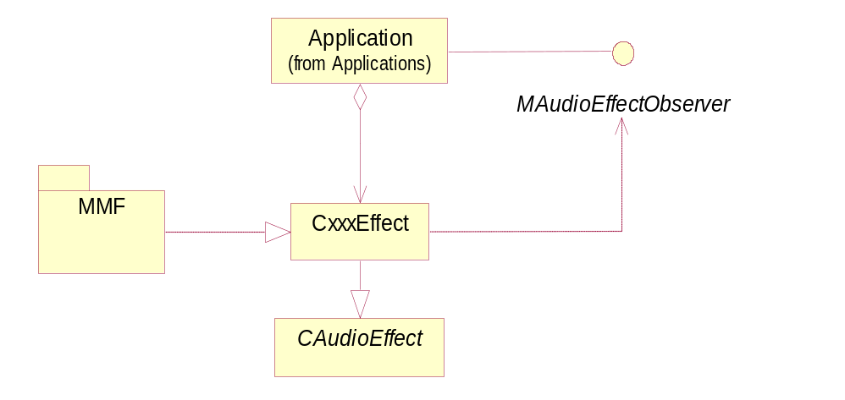
Figure 3.1 Interface class structure
All the Effect APIs have the same structure. Each effect has an observer interface that must be realized by an observer class if the client is interested in receiving notification events from the effect. The observer class is registered with the effect it is interested in receiving events.
The client creates an effect instance by using one of the NewL() methods in the effect subclass. See Section 3.5 for a detail description of each effect subclasses.

Usage

Protocol
Each effect is associated with an audio stream. This association with the audio stream is made when the effect is created by passing in the MDA utility that controls the audio stream in the effect’s NewL method. The client application should create the effect after it has initialized the MDA audio utility, but before it starts playing the audio (see reference document [1]). Conversely, the effect should be deleted before the MDA utility is deleted.
By default, an effect is disabled when it is created. After it has been created, it is up to the application to configure the effect and then enable it. Some effects can be configured and enabled when they are constructed.
To configure an effect, the application calls the appropriate set methods on the effect. After the effect is configured, the application then calls the ApplyL() method on the effect to apply the new settings. Settings are automatically applied when they are enabled or disabled.
Effect processing is started by calling the EnableL() method on the effect. Enabling an effect that is already enabled does nothing. To stop processing an effect, the DisableL() method on the effect is called. Disabling an effect that is already disabled does nothing.
It is possible for an application to update the settings of an effect when the audio is playing, but it is dependent on the specific hardware and drivers of a device whether or not these changes will have an effect.
Due to hardware limitations, it is possible that some hardware platforms can only support a limited number of instances of a specific effect. In this case, the effect will no longer be applied to the lowest priority audio streams. By default, the audio drivers will continue playing the audio streams without the effect applied. However, if the application does not want the audio to play without the effect applied, it can call the Enforce method on the effect. In this case, the audio will pre-empt the audio stream through the utility that controls that audio stream with the error KErrEnforcedEffectPreempted.
Depending on hardware capability, it is also possible to have one setting for an effect type that is being applied to multiple streams. In this case, only the highest priority audio stream will be allowed to modify the effect parameters. In the case where the priorities of the audio streams are the same, the application that set up the effect last will be the one that is allowed to modify the effect parameters. The applications that lose the right to update the effect will be notified through the observer interface with the event KLostUpdateRights. When an application regains the right to control the effects settings, it will be notified through the observer interface with the event KGaindUpdateRights. By default, all effects will initially have the update rights.
Effect processing is optional. In the case where it is not supported, the NewL() methods for the effects will leave with KErrNotSupported. Even if effect processing is supported, it is not guaranteed that every method of an effect will be implemented. In this case, unsupported operations on the effect will be ignored by the audio system.
Currently, Tone and Stream Utilities do not support custom interfaces. NewLs with custom interfaces as arguments will leave with KErrNotSupported.
All the x, y and z coordinates that used in those 3D Effect (Doppler, Orientation, and Location) follow the right-handed coordinate system.

Error handling
The leave mechanism of the Symbian OS environment is used to handle exception situations. Each leaving method has a list of possible leave codes and the meaning of the code. The client should TRAP the leaving methods and handle them appropriately or leave it up to a higher-level TRAP harness.
A number of error conditions can occur when the Effect APIs are used. Each Effect API has different error conditions. Refer to Section 3.5 for the specific effect error conditions. The errors common to all effects are listed in the table below.

Error code | Explanation
KErrAccessDenied | Attempting to apply effect settings when the effect has lost update rights.
KErrArgument | Attempting to set an effect setting to an invalid value.
KErrNoMemory | Insufficient amount of memory available to carry out the operation.
KErrNotSupported | The specified effect is not supported during effect creation process.

Memory overhead
For each effect interface object created, there will be two additional support objects and an adaption custom interface effect object created. The size of the support object depends on the effect type. Some effects have larger data structures than others but, in general, each effect object will require an estimated 2 Kbytes of RAM.

Extensions to the API
The basic functionality of an Effect API can be extended, but this will introduce binary compatibility issues if the interface class is changed. However, new effect classes with additional functionality can be created through derivation.

Example usage of an effect
This example shows how an equalizer effect can be used by the client audio application.
Prerequisites:
An MDA Player utility has been created.
Note: The MDA Utility (a player utility in this example) should not be deleted before deleting the effect object (equalizer effect in this example).
The following subsections illustrate the stages of an equalizer effect lifecycle. All effects have similar sequences while their operations and events may be different.

Creating the effect
The equalizer effect is created using the usual NewL() method. The client may register an observer with the effect. The effect is now ready to be used.
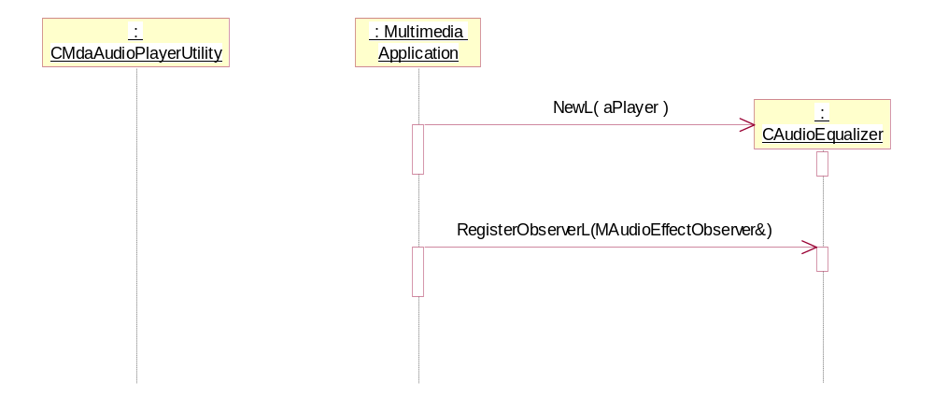
Figure 3.2 Creating the effect

Changing the effect settings
After the creation, the equalizer object assumes an initial state. The initial equalizer value varies and is set by the underlying audio system. Settings are made using one of the available set methods on the object.
Here, the preset values in the equalizer are checked and the values are changed. At this point, the equalizer preset has not been applied. It is possible to change the value many times before application but, unless the presets are applied, they will not take effect.
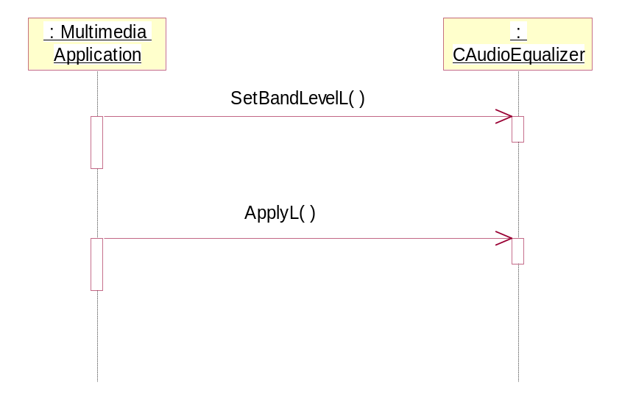
Figure 3.3 Changing the effect settings

Applying the effect settings
Effect settings are applied in one of two ways: Enable() or ApplyL().
The Enable() method must be used to enable the effect if it is disabled. Initially, all effects are disabled. Enabling will cause the effect settings to be applied. After the effect is enabled, new settings are applied by using the ApplyL() method. Figure 3.4 shows a new setting being applied after the effect is enabled.
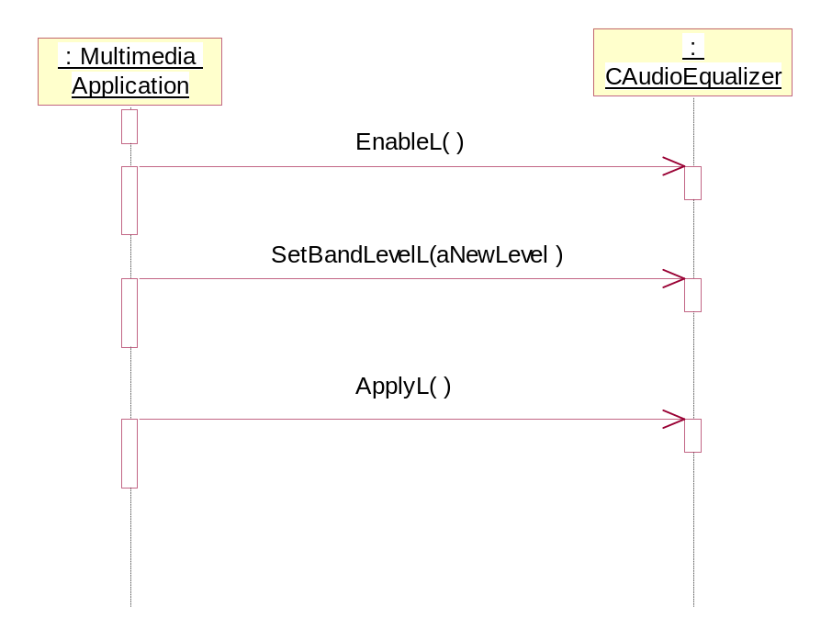
Figure 3.4 Applying the effect settings

Spontaneous events
Events may occur spontaneously during the lifetime of the effect. These events are reported to the client through the EffectChange() callback. Clients should expect to receive event notifications after successful registration. See Section 3.4.1 for the registration sequence. If the client does not want to receive further event notifications, use the UnregisterObserver() method. It is not advisable to not monitor events if the effect is enabled.
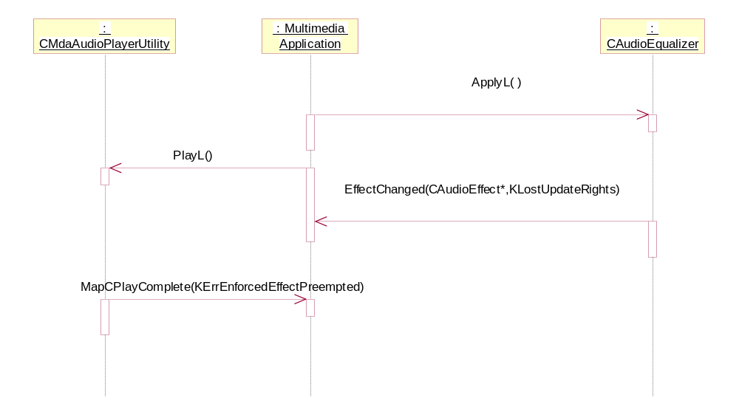
Figure 3.5 Spontaneous events
The sequence in Figure 3.5 follows the sequences in Section 3.4.2 and 3.4.3. When attempting to apply the effect on the stream, the effect cannot be applied. In this case, the effect does not have update rights. Additionally, because the client has indicated that the effect has to be enforced, the stream is pre-empted as well.

Disabling and removing the effect
An effect can be disabled using the DisableL() method. After disabling, the effect can be removed by deleting the object. The client can also delete the effect without disabling it first.
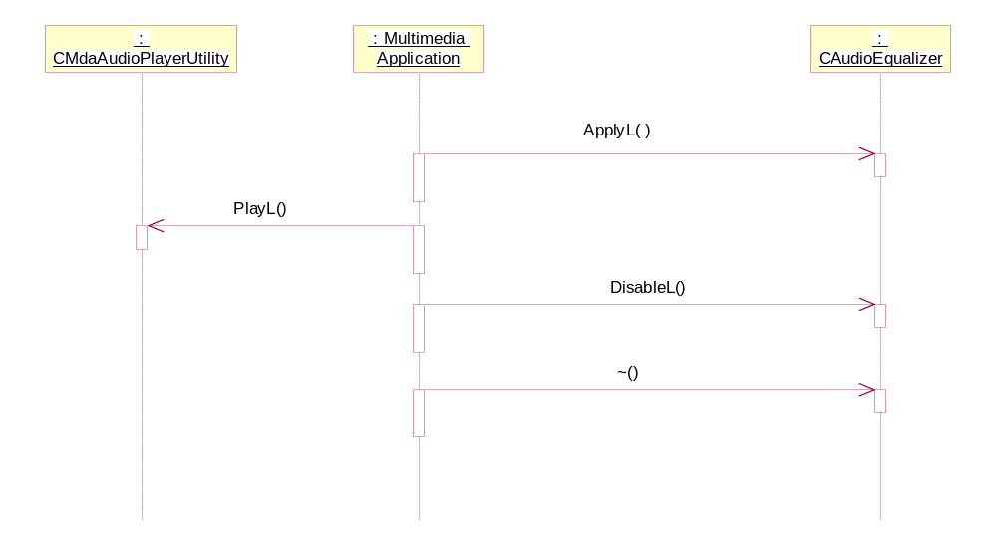
Figure 3.6 Disabling and removing the effect

Detailed description
This section describes the classes and methods in the Effects Framework.

CAudioEffect
This abstract class is a generalization of all effects and defines properties and operation that are common for all effects.
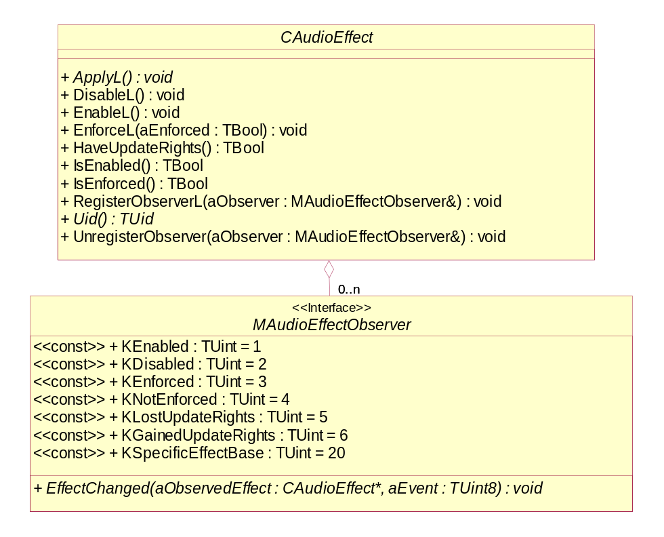
Figure 3.7 CAudioEffect
Headers:
AudioEffectBase.h, AudioEffectData.h, MAudioEffectObserver.h
Library:
AudioEffect.dll

ApplyL
virtual void ApplyL() = 0;

Applies updated settings to the effect. Apply is automatically called when the effect goes from disabled to enabled or vice versa. It is not called when Enable is called and the effect is already enabled. This method will block the client’s thread.
Arguments:
None.
Returns:
None.
Error handling:
This method leaves with the following typical leave codes:
- KErrNoMemory: unable to apply settings due to memory errors
- KErrAccessDenied: unable to apply settings due to loss of update rights

DisableL
virtual void DisableL() = 0;

This method is used for disabling the effect. If the effect is already disabled, any call to this method is ignored.
Arguments:
None.
Returns:
None.
Error handling:
This method leaves with the following typical leave codes:
- KErrAccessDenied: unable to disable effect due to lost of update rights

EnableL
virtual void EnableL() = 0;

This method is used for enabling the effect. The ApplyL() is called within it. If the effect is already enabled, any call to this method is ignored.
Arguments:
None.
Returns:
None.
Error handling:
This method leaves with the following typical leave codes:
- KErrAccessDenied: unable to enable the effect due to loss of update rights

EnforceL
virtual void EnforceL(TBool aEnforced) = 0;

Defines whether the effect is mandatory. When this is set to Etrue, the audio stream will not be processed unless the audio platform can add this effect. If this is set to Efalse, the audio platform will process the audio stream even if it cannot add the effect.
Arguments:
- TBool aEnforced: Set to ETrue if the effect should be enforced, otherwise EFalse. EFalse is the default value.
Returns:
None.
Error handling:
This method leaves with the following typical leave codes:
- KErrAccessDenied: unable to enable the effect due to loss of update rights

HaveUpdateRights
virtual TBool HaveUpdateRights() const;

A client can lose update rights in some hardware platforms where only a limited number of instances of an effect can exist at the same time. When there is a greater number of requested instances than supported, that audio drivers will remove the update rights of some of the instances temporarily. When an effect instance has lost update rights, the user can still change the effect settings, but any calls to apply the settings will be deferred until update rights are regained.
Arguments:
None.
Returns:
ETrue if this object currently has rights to update the settings of this effect, otherwise EFalse.

IsEnabled
virtual TBool IsEnabled() const;

Used by a client to determine if the effect is enabled.
Arguments:
None.
Returns:
ETrue if the effect is enabled, otherwise EFalse.

virtual TBool IsEnforced() const;

Used by a client to determine if the effect is set as enforced.
Arguments:
None.
Returns:
ETrue if the effect is enforced, otherwise EFalse.

RegisterObserverL
virtual void RegisterObserverL(MAudioEffectObserver& aObserver);

Adds an observer that implements MAudioEffectObserver. Observers will be notified when the effect changes.
Arguments:
- MAudioEffectObserver& aObserver: A reference to the observer.

Returns:
None.
Error handling:
This method leaves with the following typical leave codes:
- KErrAlreadyExists: attempting to register an observer that has already been registered.

Uid
virtual TUid Uid() const = 0;

Used by a client to fetch the unique identifier associated with the effect.
Arguments:
None.
Returns:
The unique identifier.

UnregisterObserver
virtual void UnRegisterObserver(MAudioEffectObserver& aObserver);

Removes the specified observer from an effect.
Arguments:
- MAudioEffectObserver& aObserver: A reference to the observer.

Returns:
None.

MAudioEffectObserver
This abstract class is a generalization of the observer classes for all audio effects. Individual effects can extend this to add needed observer methods.

EffectChanged
virtual void EffectChanged(const CAudioEffect* aObservedEffect, TUint8 aEvent) = 0;

Invoked by the audio effect object when the status of the audio effect has changed.
Arguments:
- CAudioEffect* aObservedEffect: The effect object that has changed.
- TUint8 aEvent: Defines the event ID for the effect that has changed.

Returns:
None.

CBassBoost
This class is used by an audio application for controlling bass boost. It is derive from CAudioEffect (see Section 3.5.1).
EMBED Visio.Drawing.11 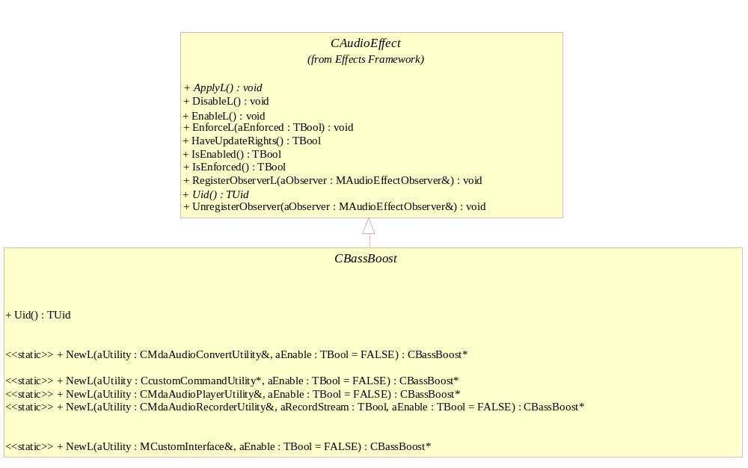
Figure 3.8 CBassBoost
Headers:
BassBoostEffect.h, BassBoostEffectData.h, MBassBoostEffectObserver.h
Library:
BassBosotEffect.dll

NewL factory methods

CBassBoost* NewL(CMdaAudioConvertUtility& aUtility, TBool aEnable = Efalse);

A static constructor that creates a bass boost object.
Arguments:
- CMdaAudioConvertUtility& aUtility: The convert utility that is to be associated with this effect.
- TBool aEnable: Set to ETrue if the effect should be enabled immediately, otherwise EFalse. By default, this parameter is set to EFalse.

Returns:
A pointer to CBassBoost.
Error handling:
This method leaves with the following typical leave codes:
- KErrNoMemory: unable to instantiate due to memory errors.
- KErrNotSupported: the effect is not supported.

CBassBoost* NewL(CMdaAudioPlayerUtility& aUtility, TBool aEnable = EFalse);

A static constructor that creates a bass boost object.
Arguments:
- CMdaAudioPlayerUtility& aUtility: The play utility that is to be associated with this effect.
- TBool aEnable: Set to ETrue if the effect should be enabled immediately, otherwise EFalse. By default, this parameter is set to EFalse.

Returns:
A pointer to CBassBoost.
Error handling:
This method leaves with the following typical leave codes:
- KErrNoMemory: unable to instantiate due to memory errors.
- KErrNotSupported: the effect is not supported.

CBassBoost* NewL(CMdaAudioRecordUtility& aUtility, TBool aRecordStream, TBool aEnable = EFalse);

A static constructor that creates a bass boost object.
Arguments:
- CMdaAudioRecordUtility& aUtility: The record utility that is to be associated with this effect.
- TBool aRecordStream: ETrue if the effect is to be applied to recording, EFalse if the effect is to be applied only to playback.
- TBool aEnable: Set to ETrue if the effect should be enabled immediately, otherwise EFalse. By default, this parameter is set to EFalse.

Returns:
A pointer to CBassBoost.
Error handling:
This method leaves with the following typical leave codes:
- KErrNoMemory: unable to instantiate due to memory errors.
- KErrNotSupported: the effect is not supported.

CBassBoost* NewL(MCustomInterface& aCustomInterface, TBool aEnable = EFalse);

A static constructor that creates a bass boost object.
Arguments:
- MCustomInterface& aCustomInterface: A utility that implements the MCustomInterface interface that is to be associated with this effect.
- TBool aEnable: Set to ETrue if the effect should be enabled immediately, otherwise EFalse. By default, this parameter is set to EFalse.

Returns:
A pointer to CBassBoost.
Error handling:
This method leaves with the following typical leave codes:
- KErrNoMemory: unable to instantiate due to memory errors.
- KErrNotSupported: the effect is not supported.

CBassBoost* NewL(CcustomCommandUtility* aUtility, TBool aEnable = EFalse);

A static constructor that creates a bass boost object.
Arguments:
- CcustomCommandUtility* aUtility: A utility that is to be associated with this effect.
- TBool aEnable: Set to ETrue if the effect should be enabled immediately, otherwise EFalse. By default, this parameter is set to EFalse.

Returns:
A pointer to a CBassBoost object.
Error handling:
This method leaves with the following typical leave codes:
- KErrNoMemory: unable to instantiate due to memory errors.
- KErrNotSupported: the effect is not supported.

MBassBoostObserver
This abstract class is a generalization of the bass boost observer. It defines the possible events that are specific to the bass boost effect. It is derived from MAudioEffectObserver (see Section 3.5.2).
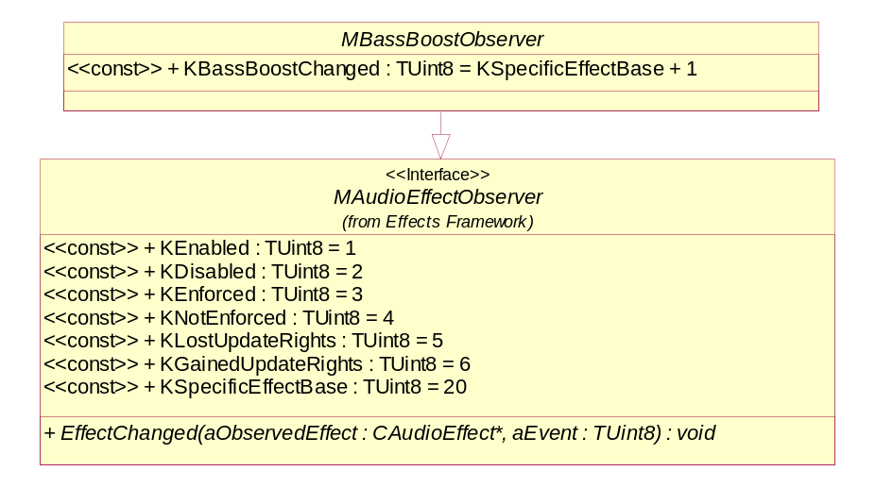
Figure 3.9 MBassBoostObserver
Methods:
EffectChanged(). Inherited from MAudioEffectObserver (see Section 3.5.2).

CDoppler
CDoppler inherits from CAudioEffect and is the base class for CSourceDoppler and ClistenerDoppler.
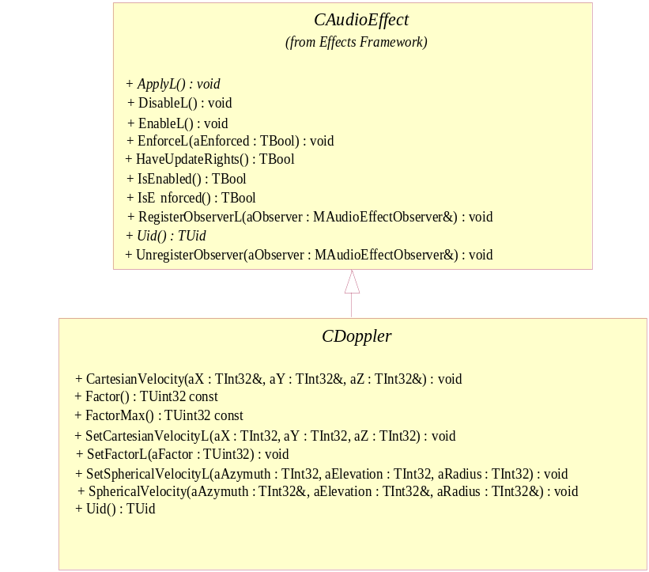
Figure 3.10 CDoppler
Headers:
DopplerBase.h, MDopplerObserver.h
Library:
Dopplerbase.dll

CartesianVelocity
void CartesianVelocity(TInt32& aX, TInt32& aY, TInt32& aZ);

Gets the velocity’s Cartesian settings.
Arguments:
- TInt32& aX : X direction speed in mm/s. Referenced memory will contain the value.
- TInt32& aY : Y direction speed in mm/s. Referenced memory will contain the value.
- TInt32& aZ: Z direction speed in mm/s. Referenced memory will contain the value.

Returns:
None.

Factor
TUint32 Factor() const;

Gets the current factor setting value.
Arguments:
None.
Returns:
The current factor setting value.

FactorMax
TUint32 FactorMax() const;

Gets the factor setting maximum value.
Arguments:
None.
Returns:
The factor setting maximum value.

SetCartesianVelocity
void SetCartesianVelocityL(TInt32 aX, TInt32 aY, TInt32 aZ);

Sets the velocity in Cartesian coordinates of the sound source with respect to the listener.
Arguments:
- TInt32 aX: X direction speed in mm/s.
- TInt32 aY: Y direction speed in mm/s.
- TInt32 aZ: Z direction speed in mm/s.

Returns:
None.
Error handling:
This method leaves with the following typical leave codes:
- KErrArgument: the argument value is out of range or invalid.

SetFactorL
void SetFactorL(TUint32 aFactor);

Sets the multiplier factor.
Arguments:
- TUint32 aFactor: A factor value in hundredths that ranges from 0 to FactorMax(), where 100 corresponds to 1.00, 200 corresponds to 2.00, etc. The factor is a multiplier that either exaggerates the Doppler effect or reduces it.

Returns:
None.
Error handling:
This method leaves with the following typical leave codes:
- KErrArgument: the argument value is out of range.

SetSphericalVelocityL
void SetSphericalVelocityL(TInt32 aAzimuth, TInt32 aElevation, TInt32 aRadius);

Sets the velocity in spherical coordinates of the sound source with respect to the listener.
Arguments:
- TInt32 aAzimuth: The Azimuth (thousandths of radians), and is measured from the negative z-axis in the direction of the x-axis.
- TInt32 aElevation: The elevation (thousandths of radians), and is measured from the x-z-plane in the direction of the y-axis.
- TInt32 aRadius: The radius (millimeters per seconds)

Returns:
None.
Error handling:
This method leaves with the following typical leave codes:
- KErrArgument: the argument value is out of range or invalid.

SphericalVelocity
void SphericalVelocity(TInt32& aAzimuth, TInt32& aElevation, TInt32& aRadius);

Gets the velocity’s Cartesian settings.
Arguments:
- TInt32& aAzimuth: The Azimuth (thousandths of radians), and is measured from the negative z-axis in the direction of the x-axis. Referenced memory will contain the value.
- TInt32& aElevation: The elevation (thousandths of radians), and is measured from the x-z-plane in the direction of the y-axis. Referenced memory will contain the value.
- TInt32& aRadius: The radius (millimeters per seconds). Referenced memory will contain the value.

Returns:
None.

CSourceDoppler
This class is used by audio applications for controlling source Doppler. It is derived from CDoppler (see Section 3.5.5).
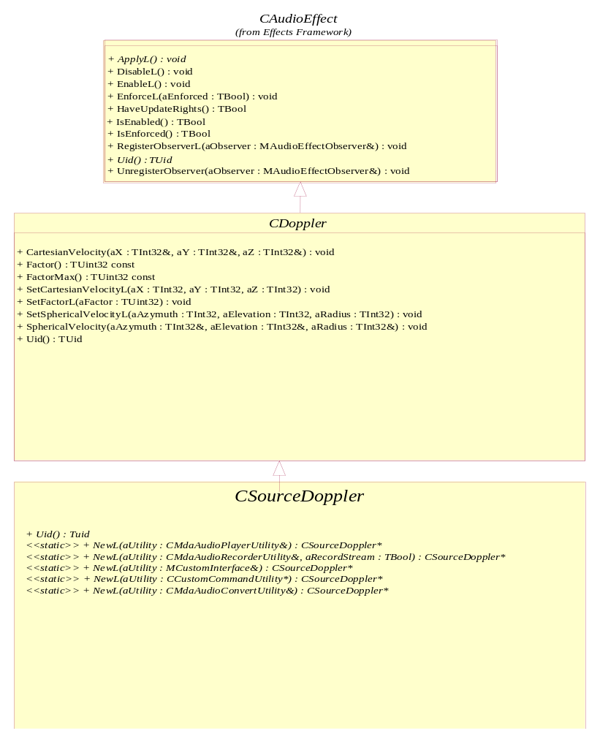
Figure 3.11 CSourceDoppler
Headers:
SourceDopplerBase.h, MSourceDopplerObserver.h
Library:
SourceDopplerEffect.dll

NewL – factory methods
CSourceDoppler* NewL(CMdaAudioConvertUtility& aUtility);

A static constructor that creates a Source Doppler object.
Arguments:
- CMdaAudioConvertUtility& aUtility: The convert utility that is to be associated with this effect.

Returns:
A pointer to CSourceDoppler.
Error handling:
This method leaves with the following typical leave codes:
- KErrNoMemory: unable to instantiate due to memory errors.
- KErrNotSupported: the effect is not supported.

CSourceDoppler* NewL(CMdaAudioPlayerUtility& aUtility);

A static constructor that creates a Source Doppler object.
Arguments:
- CMdaAudioPlayerUtility& aUtility: The play utility that is to be associated with this effect.

Returns:
A pointer to CSourceDoppler.
Error handling:
This method leaves with the following typical leave codes:
- KErrNoMemory: unable to instantiate due to memory errors.
- KErrNotSupported: the effect is not supported.

CSourceDoppler* NewL(CMdaAudioRecordUtility& aUtility, TBool aRecordStream);

A static constructor that creates a Source Doppler object.
Arguments:
- CMdaAudioRecordUtility& aUtility: The record utility that is to be associated with this effect.
- TBool aRecordStream: ETrue if the effect is to be applied to recording, EFalse if the effect is to be applied only to playback.

Returns:
A pointer to CSourceDoppler.
Error handling:
This method leaves with the following typical leave codes:
- KErrNoMemory: unable to instantiate due to memory errors.
- KErrNotSupported: the effect is not supported.

CSourceDoppler * NewL(CcustomCommandUtility* aUtility);

A static constructor that creates a Source Doppler object.
Arguments:
- CcustomCommandUtility* aUtility: A utility that is to be associated with this effect.

Returns:
A pointer to a CSourceDoppler object.
Error handling:
This method leaves with the following typical leave codes:
- KErrNoMemory: unable to instantiate due to memory errors.
- KErrNotSupported: the effect is not supported.

CSOurceDoppler* NewL(MCustomInterface& aCustomInterface);

A static constructor that creates a Source Doppler object.
Arguments:
- MCustomInterface& aCustomInterface: A utility that implements the MCustomInterface interface that is to be associated with this effect.

Returns:
A pointer to CSourceDoppler.
Error handling:
This method leaves with the following typical leave codes:
- KErrNoMemory: unable to instantiate due to memory errors.
- KErrNotSupported: the effect is not supported.

Uid
virtual TUid Uid() const = 0;

Used by a client to fetch the unique identifier associated with the effect.
Arguments:
None.
Returns:
The unique identifier.

C ListenerDoppler
This class is used by audio applications for controlling listener Doppler. It is derived from CDoppler (see Section3.5.5).
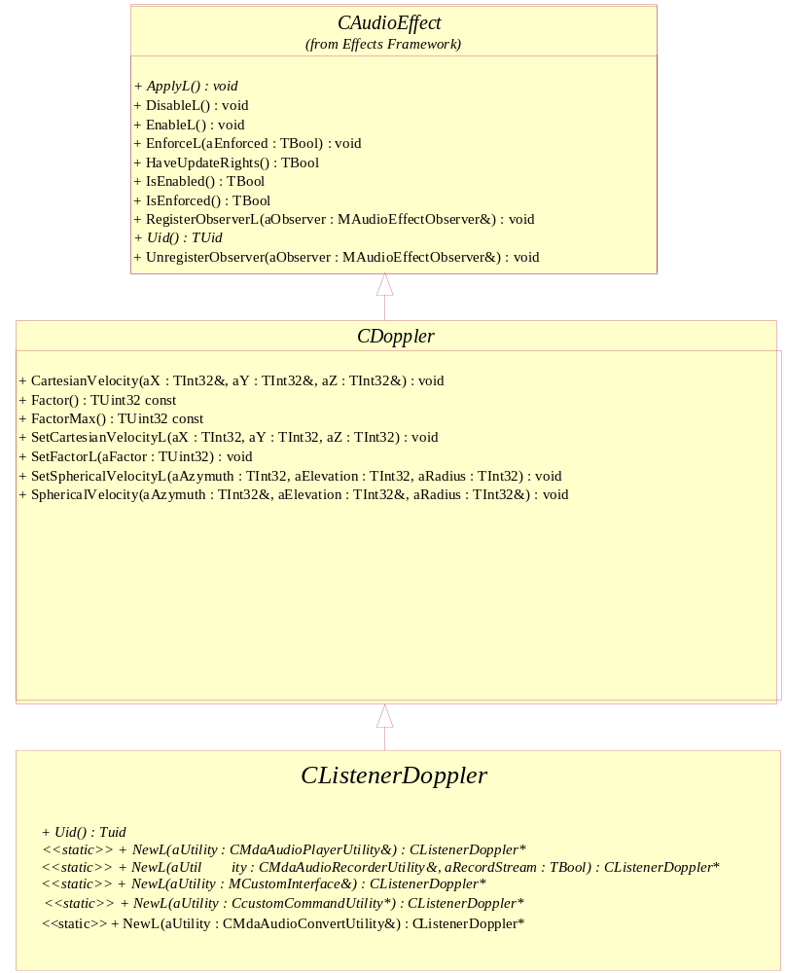
Figure 3.12 CListenerDoppler
Headers:
ListenerDopplerBase.h, MListenerDopplerObserver.h
Library:
ListenerDopplerEffect.dll

NewL – factory methods
CListenerDoppler* NewL(CMdaAudioConvertUtility& aUtility);

A static constructor that creates a Listener Doppler object.
Arguments:
- CMdaAudioConvertUtility& aUtility: The convert utility that is to be associated with this effect.

Returns:
A pointer to CListenerDoppler.
Error handling:
This method leaves with the following typical leave codes:
- KErrNoMemory: unable to instantiate due to memory errors.
- KErrNotSupported: the effect is not supported.

CListenerDoppler* NewL(CMdaAudioPlayerUtility& aUtility);

A static constructor that creates a Listener Doppler object.
Arguments:
- CMdaAudioPlayerUtility& aUtility: The play utility that is to be associated with this effect.

Returns:
A pointer to CListenerDoppler.
Error handling:
This method leaves with the following typical leave codes:
- KErrNoMemory: unable to instantiate due to memory errors.
- KErrNotSupported: the effect is not supported.

CListenerDoppler* NewL(CMdaAudioRecordUtility& aUtility, TBool aRecordStream);

A static constructor that creates a Listener Doppler object.
Arguments:
- CMdaAudioRecordUtility& aUtility: The record utility that is to be associated with this effect.
- TBool aRecordStream: ETrue if the effect is to be applied to recording, EFalse if the effect is to be applied only to playback.

Returns:
A pointer to CListenerDoppler.
Error handling:
This method leaves with the following typical leave codes:
- KErrNoMemory: unable to instantiate due to memory errors.
- KErrNotSupported: the effect is not supported.

CListenerDoppler* NewL(MCustomInterface& aCustomInterface);

A static constructor that creates a Listener Doppler object.
Arguments:
- MCustomInterface& aCustomInterface: A utility that implements the MCustomInterface interface that is to be associated with this effect.

Returns:
A pointer to CListenerDoppler.
Error handling:
This method leaves with the following typical leave codes:
- KErrNoMemory: unable to instantiate due to memory errors.
- KErrNotSupported: the effect is not supported.

CListenerDoppler * NewL(CcustomCommandUtility* aUtility);

A static constructor that creates a Listener Doppler object.
Arguments:
- CcustomCommandUtility* aUtility: A utility that is to be associated with this effect.

Returns:
A pointer to a ClistenerDoppler object.
Error handling:
This method leaves with the following typical leave codes:
- KErrNoMemory: unable to instantiate due to memory errors.
- KErrNotSupported: the effect is not supported.

Uid
virtual TUid Uid() const = 0;

Used by a client to fetch the unique identifier associated with the effect.
Arguments:
None.
Returns:
The unique identifier.

MDopplerObserver
This abstract class is a generalization of the Doppler observer. It defines the possible events that are specific to the Doppler effect. It is derived from MAudioEffectObserver (see Section 3.5.2).
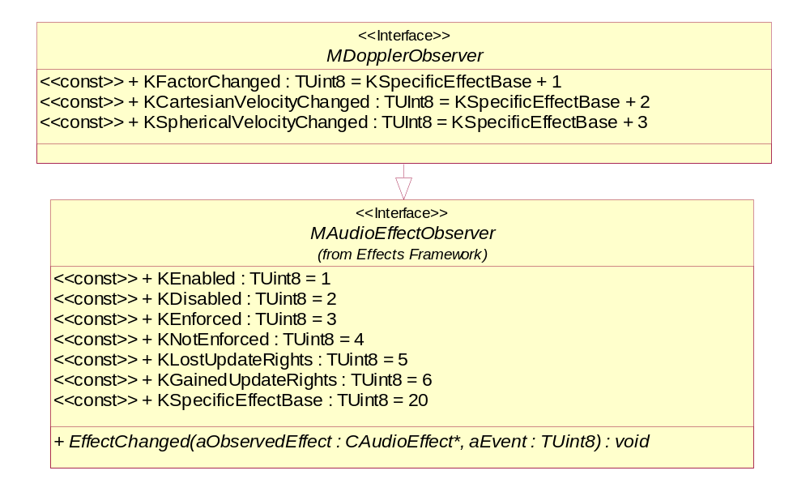
Figure 3.13 MDopplerObserver
Methods:
EffectChanged(). Inherited from MAudioEffectObserver (see Section 3.5.2).

CAudioEqualizer
This class is used by audio applications for controlling audio equalization. It is derived from CAudioEffect (see Section 3.5.1).

Figure 3.14 CAudioEqualizer
Headers:
EqualizerEffect.h, EqualizerEffectData.h, MEqualizerEffectObserver.h
Library:
EqualizerEffect.dll

NewL – factory methods
CAudioEqualizer* NewL(CMdaAudioConvertUtility& aUtility);

A static constructor that creates an audio equalizer object.
Arguments:
- CMdaAudioConvertUtility& aUtility: The convert utility that is to be associated with this effect.

Returns:
A pointer to a CAudioEqualizer object.
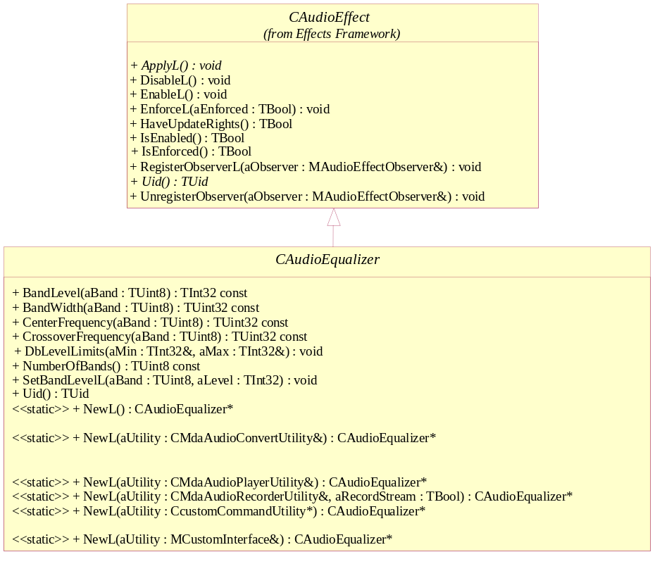
Error handling:
This method leaves with the following typical leave codes:
- KErrNoMemory: unable to instantiate due to memory errors.
- KErrNotSupported: the effect is not supported.

CAudioEqualizer* NewL(CMdaAudioPlayerUtility& aUtility);

A static constructor that creates an audio equalizer object.
Arguments:
- CMdaAudioPlayerUtility& aUtility: The play utility that is to be associated with this effect.

Returns:
A pointer to a CAudioEqualizer object.
Error handling:
This method leaves with the following typical leave codes:
- KErrNoMemory: unable to instantiate due to memory errors.
- KErrNotSupported: the effect is not supported.

CAudioEqualizer* NewL(CMdaAudioRecordUtility& aUtility, TBool aRecordStream);

A static constructor that creates an audio equalizer object.
Arguments:
- CMdaAudioRecordUtility& aUtility: The record utility that is to be associated with this effect.
- TBool aRecordStream: ETrue if the effect is to be applied to recording, EFalse if the effect is to be applied only to playback.

Returns:
A pointer to a CAudioEqualizer object.
Error handling:
This method leaves with the following typical leave codes:
- KErrNoMemory: unable to instantiate due to memory errors.
- KErrNotSupported: the effect is not supported.

CAudioEqualizer* NewL(MCustomInterface& aCustomInterface);

A static constructor that creates an audio equalizer object.
Arguments:
- MCustomInterface& aCustomInterface: A utility that implements the MCustomInterface interface that is to be associated with this effect.

Returns:
A pointer to a CAudioEqualizer object.
Error handling:
This method leaves with the following typical leave codes:
- KErrNoMemory: unable to instantiate due to memory errors.
- KErrNotSupported: the effect is not supported.

CAudioEqualizer * NewL(CcustomCommandUtility* aUtility);

A static constructor that creates a CAudioEqualizer object.
Arguments:
- CcustomCommandUtility* aUtility: A utility that is to be associated with this effect.

Returns:
A pointer to a CAudioEqualizer object.
Error handling:
This method leaves with the following typical leave codes:
- KErrNoMemory: unable to instantiate due to memory errors.
- KErrNotSupported: the effect is not supported.

BandLevel
TInt32 BandLevel(TUint8 aBand) const;

Gets the band level in mB for the specified band.
Arguments:
- TUint8 aBand: The frequency band

Returns:
The level in mB for the specified band, otherwise KErrArgument if aBand is invalid.

BandWidth
TInt32 BandWidth(TUint8 aBand) const;

Gets the bandwidth in Hz for the specified band.
Arguments:
- TUint8 aBand: The frequency band

Returns:
The bandwidth in Hz for the specified band, otherwise KErrArgument if aBand is invalid.

CenterFrequency
TInt32 CenterFrequency(TUint8 aBand) const;

Gets the center frequency in Hz the specified band.
Arguments:
- TUint8 aBand: The frequency band

Returns:
The center frequency in Hz for the specified band, otherwise KErrArgument if aBand is invalid.

CrossoverFrequency
TInt32 CrossoverFrequency(TUint8 aBand) const;

Gets the cross-over frequency between the given frequency band (aBand) and the next band.
Arguments:
- TUint8 aBand: The frequency band

Returns:
The crossover frequency in Hz for the specified band, otherwise KErrArgument if aBand is invalid.

DbLevelLimits
void DbLevelLimits(TUint32& aMin, TUint32& aMax);

Gets the range in millibels for the equalizer.
Arguments:
- TUint32& aMin: The minimum millibels. Referenced memory will contain the value.
- TUint32& aMax: The maximum millibels. Referenced memory will contain the value.

Returns:
None.

NumberOfBands
TUint8 NumberOfBands() const;

Gets the number of equalizer bands.
Arguments:
None.
Returns:
The number of equalizer bands.

SetBandLevelL
void SetBandLevelL(TInt8 aBand, TInt32 aLevel);

Sets the equalizer band level value in millibels, ranging from Min to Max.
Arguments:
- TInt8 aBand: The frequency band
- TInt32 aLevel: The band level in millibels, ranges from DbLevelLimits().

Returns:
None.
Error handling:
This method leaves with the following typical leave codes:
- KErrArgument: one or more argument values are out of range or invalid.

MAudioEqualizerObserver
This abstract class is a generalization of the audio equalizer observer. It defines the possible events that are specific to the audio equalizer effect. It is derived from MAudioEffectObserver (see Section 3.5.2).
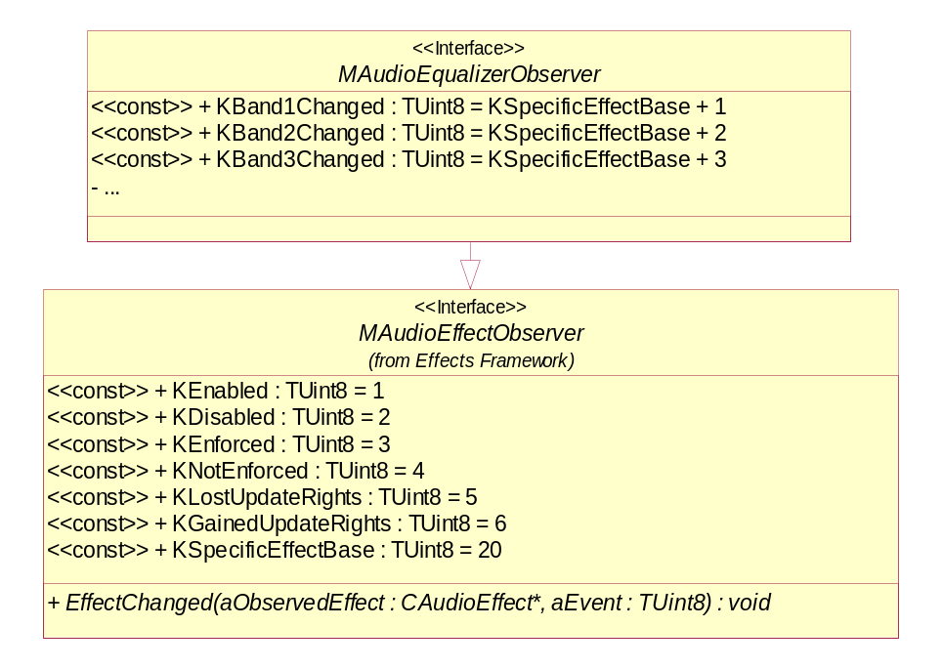
Figure 3.15 MAudioEqualizerObserver
Methods:
EffectChanged(). Inherited from MAudioEffectObserver (see Section 3.5.2).

CLoudness
This class is used by audio applications for controlling loudness. It is derived from CAudioEffect (see Section 3.5.1).

Figure 3.16 CLoudness
Headers:
LoudnessEffect.h, LoudnessEffectData.h, LoudnessEffectObserver.h
Library:
LoudnessEffect.dll

NewL – factory methods

CLoudness* NewL(CMdaAudioConvertUtility& aUtility);

A static constructor that creates a loudness object.
Arguments:
- CMdaAudioConvertUtility& aUtility: The convert utility that is to be associated with this effect.

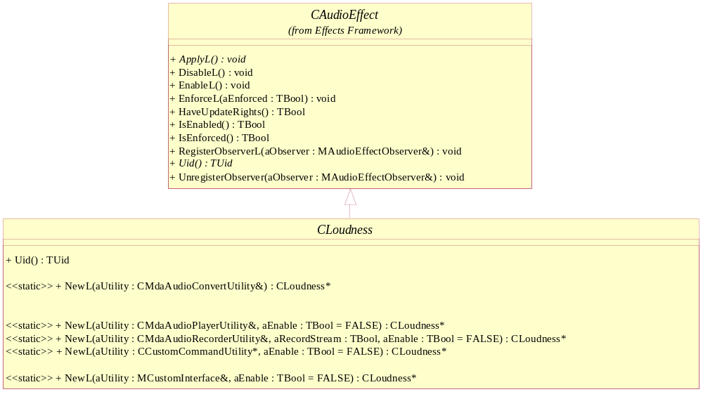
Figure 3.17 NewL – factory methods
Returns:
A pointer to a CLoudness object.
Error handling:
This method leaves with the following typical leave codes:
- KErrNoMemory: unable to instantiate due to memory errors.
- KErrNotSupported: the effect is not supported.

CLoudness* NewL(CMdaAudioPlayerUtility& aUtility, TBool aEnable = EFalse);

A static constructor that creates a loudness object.
Arguments:
- CMdaAudioPlayerUtility& aUtility: The play utility that is to be associated with this effect.
- TBool aEnable: Set to ETrue if the effect should be enabled immediately, otherwise EFalse. By default, this parameter is set to EFalse.

Returns:
A pointer to a CLoudness object.
Error handling:
This method leaves with the following typical leave codes:
- KErrNoMemory: unable to instantiate due to memory errors.
- KErrNotSupported: the effect is not supported.

CLoudness* NewL(CMdaAudioRecordUtility& aUtility, TBool aRecordStream, TBool aEnable);

A static constructor that creates a loudness object.
Arguments:
- CMdaAudioRecordUtility& aUtility: The record utility that is to be associated with this effect.
- TBool aRecordStream: ETrue if the effect is to be applied to recording, EFalse if the effect is to be applied only to playback.
- TBool aEnable: Set to ETrue if the effect should be enabled immediately, otherwise EFalse. By default, this parameter is set to EFalse.

Returns:
A pointer to a CLoudness object.
Error handling:
This method leaves with the following typical leave codes:
- KErrNoMemory: unable to instantiate due to memory errors.
- KErrNotSupported: the effect is not supported.

CLoudness* NewL(MCustomInterface& aCustomInterface, TBool aEnable);

A static constructor that creates a loudness object.
Arguments:
- MCustomInterface& aCustomInterface: A utility that implements the MCustomInterface interface that is to be associated with this effect.
- TBool aEnable: Set to ETrue if the effect should be enabled immediately, otherwise EFalse. By default, this parameter is set to EFalse.

Returns:
A pointer to a CLoudness object.
Error handling:
This method leaves with the following typical leave codes:
- KErrNoMemory: unable to instantiate due to memory errors.
- KErrNotSupported: the effect is not supported.

CLoudness * NewL(CcustomCommandUtility* aUtility, TBool aEnable);

A static constructor that creates a CLoudness object.
Arguments:
- CcustomCommandUtility* aUtility: A utility that is to be associated with this effect.
- TBool aEnable: Set to ETrue if the effect should be enabled immediately, otherwise EFalse. By default, this parameter is set to EFalse.

Returns:
A pointer to a CLoudness object.
Error handling:
This method leaves with the following typical leave codes:
- KErrNoMemory: unable to instantiate due to memory errors.
- KErrNotSupported: the effect is not supported.

MLoudnessObserver
This abstract class is a generalization of the loudness observer. It defines the possible events that are specific to the loudness effect. It is derived from MAudioEffectObserver (see Section 3.5.2).
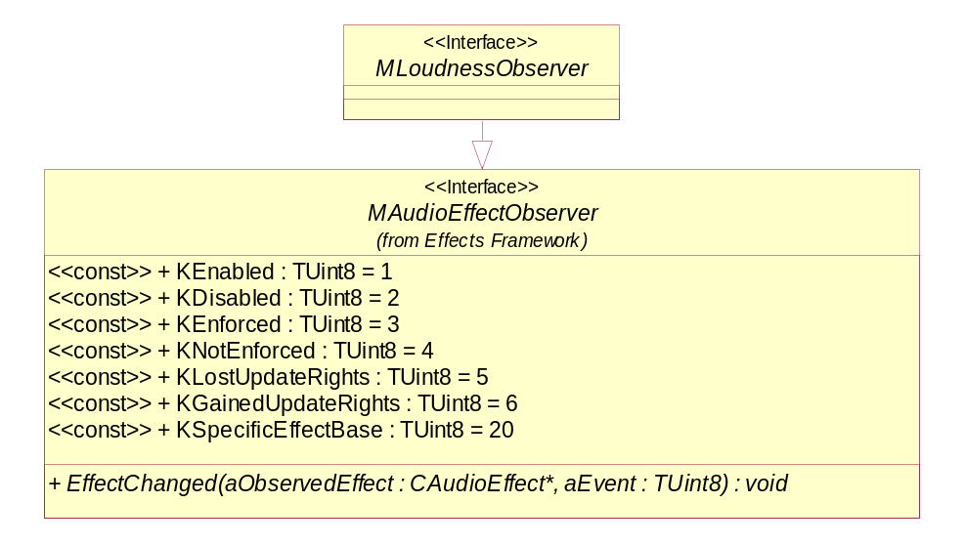
Figure 3.18 MLoudnessObserver
Methods:
EffectChanged(). Inherited from MAudioEffectObserver (see Section 3.5.2).

CDistanceAttenuation
This class is used by audio applications for controlling distance attenuation. It is derived from CAudioEffect (see Section 3.5.1).
EMBED Visio.Drawing.11 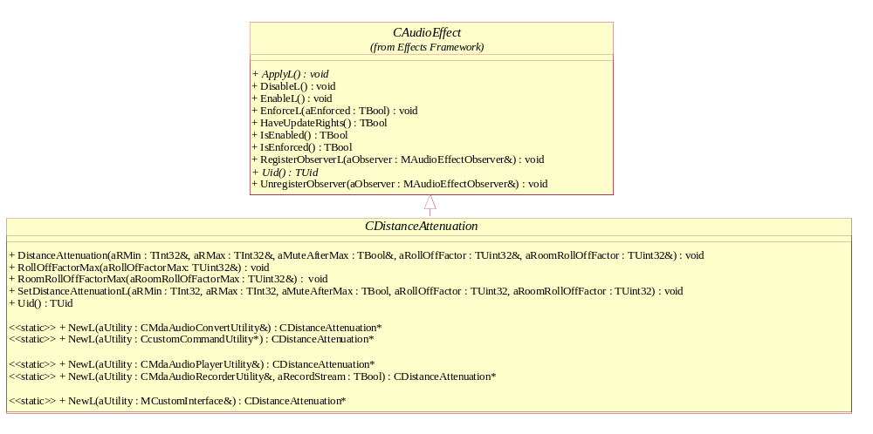
Figure 3.19 CDistanceAttenuation
Headers:
DistanceAttenuationEffect.h, DistanceAttenuationEffectData.h, MdistanceAttenuationEffectObserver.h
Library:
DistanceAttenuationEffect.dll

NewL – factory methods
CDistance attenuation* NewL(CMdaAudioConvertUtility& aUtility);

A static constructor that creates a distance attenuation object.
Arguments:
- CMdaAudioConvertUtility& aUtility: The convert utility that is to be associated with this effect.

Returns:
A pointer to CDistanceAttenuation.
Error handling:
This method leaves with the following typical leave codes:
- KErrNoMemory: unable to instantiate due to memory errors.
- KErrNotSupported: the effect is not supported.

CDistanceAttenuation* NewL(CMdaAudioPlayerUtility& aUtility);

A static constructor that creates a distance attenuation object.
Arguments:
- CMdaAudioPlayerUtility& aUtility: The play utility that is to be associated with this effect.

Returns:
A pointer to CDistanceAttenuation.
Error handling:
This method leaves with the following typical leave codes:
- KErrNoMemory: unable to instantiate due to memory errors.
- KErrNotSupported: the effect is not supported.

CDistanceAttenuation* NewL(CMdaAudioRecordUtility& aUtility, TBool aRecordStream);

A static constructor that creates a distance attenuation object.
Arguments:
- CMdaAudioRecordUtility& aUtility: The record utility that is to be associated with this effect.
- TBool aRecordStream: Set to ETrue if the effect is to be applied to recording, EFalse if the effect is to be applied only to playback.

Returns:
A pointer to CDistanceAttenuation.
Error handling:
This method leaves with the following typical leave codes:
- KErrNoMemory: unable to instantiate due to memory errors.
- KErrNotSupported: the effect is not supported.

CDistanceAttenuation* NewL(MCustomInterface& aCustomInterface);

A static constructor that creates an CDistanceAttenuation object.
Arguments:
- MCustomInterface& aCustomInterface: A utility that implements the MCustomInterface interface that is to be associated with this effect.

Returns:
A pointer to a CDistanceAttenuation object.
Error handling:
This method leaves with the following typical leave codes:
- KErrNoMemory: unable to instantiate due to memory errors.
- KErrNotSupported: the effect is not supported.

CDistanceAttenuation* NewL(CcustomCommandUtility* aUtility);

A static constructor that creates a CDistanceAttenuation object.
Arguments:
- CcustomCommandUtility* aUtility: A utility that is to be associated with this effect.

Returns:
A pointer to a CDistanceAttenuation object.
Error handling:
This method leaves with the following typical leave codes:
- KErrNoMemory: unable to instantiate due to memory errors.
- KErrNotSupported: the effect is not supported.

DistanceAttenuation
void DistanceAttenuation(TInt32& aRMin, TInt32& aRMax, TBool& aMuteAfterMax, TUint32& aRollOffFactor, TUint32& aRoomRollOffFactor);

Gets the distance attenuation parameters. The referenced memory will contain the value.
Arguments:
- TInt32& aRMin : The source to listener distance in mm below which the sound level is a constant.
- TInt32& aRMax: The source to listener distance in mm above which the sound level is a constant or zero.
- TBool& aMuteAfterMax: Indicates whether or not the sound is muted beyond Rmax.
- TUint32& aRollOffFactor: The multiplier factor to source-listener distance in hundredths, where 100 corresponds to 1.00, 200 corresponds to 2.00, etc.
- TUint32& aRoomRollOffFactor: The multiplier factor to source-listener distance for Room effect in hundredths, where 100 corresponds to 1.00, 200 corresponds to 2.00, etc.

Returns:
None.

RollOffFactorMax
void RollOffFactorMax(TUint32& aRollOfFactorMax);

Gets the roll off factor maximum value. The referenced memory will contain the value.
Arguments:
- TUint32& aRollOffFactorMax: The maximum multiplier factor to source-listener distance in hundredths, where 100 corresponds to 1.00, 200 corresponds to 2.00, etc.

Returns:
None.

RoomRollOffFactorMax
void RollOffFactorMax(TUint32& aRoomRollOffFactorMax);

Gets the roll off factor maximum value. The referenced memory will contain the value.
Arguments:
- TUint32& aRoomRollOffFactorMax: The maximum multiplier factor to source-listener distance for Room effect.

Returns:
None.

SetDistanceAttenuationL
void SetDistanceAttenuationL(TInt32 aRMin, TInt32 aRMax, TBool aMuteAfterMax, TUint32 aRollOffFactor, TUint32 aRoomRollOffFactor);

Sets the distance attenuation parameters.
Arguments:
- TInt32 aRMin: The source to listener distance in mm below which the sound level is a constant, its value should be greater than or equal to 1 mm.
- TInt32 aRMax: The source to listener distance in mm above which the sound level is a constant or zero, its value should be greater than or equal to aRMin.
- TBool aMuteAfterMax: Indicates whether or not the sound is muted beyond Rmax.
- TUint32 aRollOffFactor: The multiplier factor to source-listener distance in hundredths, where 100 corresponds to 1.00, 200 corresponds to 2.00, etc.
- TUint32 aRoomRollOffFactor: The multiplier factor to source-listener distance for Room effect in hundredths, where 100 corresponds to 1.00, 200 corresponds to 2.00, etc.

Returns:
None.
Error handling:
This method leaves with the following typical leave codes:
- KErrArgument: one or more argument values are out of range or invalid.

MDistanceAttenuationObserver
This abstract class is a generalization of the distance attenuation observer. It defines the possible events that are specific to the distance attenuation effect. It is derived from MAudioEffectObserver (see Section 3.5.2).
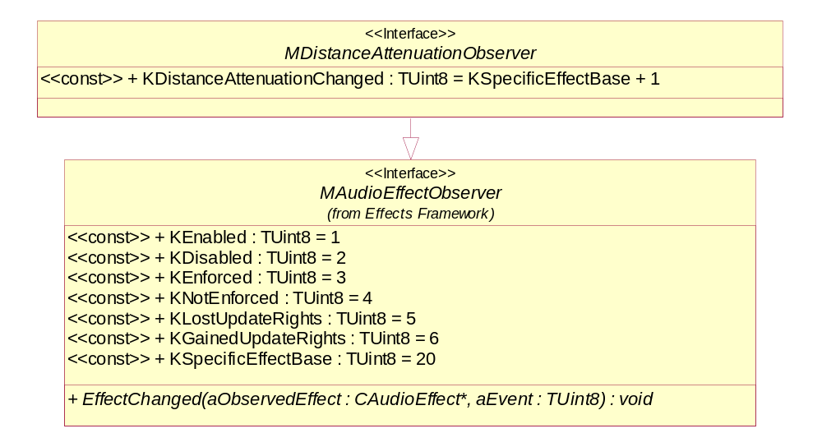
Figure 3.20 MDistanceAttenuationObserver
Methods:
EffectChanged(). Inherited from MAudioEffectObserver (see Section 3.5.2).

CLocation
This abstract class defines the methods needed for all location effects. It is derived from CAudioEffect (see Section 3.5.1).
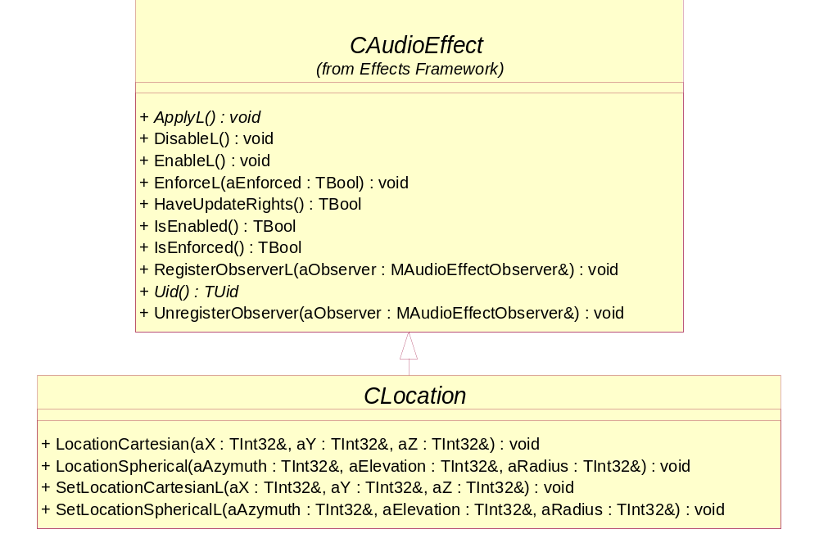
Figure 3.21 CLocation
Headers:
LocationBase.h
Library:
LocationEffect.dll

LocationCartesian
void LocationCartesian(TInt32& aX, TInt32& aY, TInt32& aZ);

Gets the Cartesian coordinates for the location of the position.
Arguments:
- TInt32& aX: X-coordinate value in millimeters. Referenced memory will contain the value.
- TInt32& aY: Y-coordinate value in millimeters. Referenced memory will contain the value.
- TInt32& aZ: Z-coordinate value in millimeters. Referenced memory will contain the value.

Returns:
None.

LocationSpherical
void LocationSpherical(TInt32& aAzimuth, TInt32& aElevation, TInt32& aRadius);

Gets the spherical coordinates for the location of the position.
Arguments:
- TInt32& aAzimuth: The Azimuth (in thousandths of radians), and is measured from the negative z-axis in the direction of the x-axis. Referenced memory will contain the value.
- TInt32& aElevation: The elevation (in thousandths of radians), and is measured from the x-z-plane in the direction of the y-axis. Referenced memory will contain the value.
- TInt32& aRadius: The radius (in millimeters per second). Referenced memory will contain the value.

Returns:
None.

SetLocationCartesianL
void SetLocationCartesianL(TInt32& aX, TInt32& aY, TInt32& aZ);

Sets the Cartesian coordinates for the location of the position.
Arguments:
- TInt32 aX: X-coordinate value in millimeters.
- TInt32 aY: Y-coordinate value in millimeters.
- TInt32 aZ: Z-coordinate value in millimeters.

Returns:
None.
Error handling:
This method leaves with the following typical leave codes:
- KErrArgument: the argument value is out of range or invalid.

SetLocationSphericalL
void SetLocationSphericalL(TInt32& aAzimuth, TInt32& aElevation, TInt32& aRadius);

Sets the spherical coordinates for the location of the position.
Arguments:
- TInt32 aAzimuth: The Azimuth (in thousandths of radians), and is measured from the negative z-axis in the direction of the x-axis.
- TInt32 aElevation: The elevation (in thousandths of radians), and is measured from the x-z-plane in the direction of the y-axis.
- TInt32 aRadius: The radius (in millimeters per second)

Returns:
None.
Error handling:
This method leaves with the following typical leave codes:
- KErrArgument: the argument value is out of range or invalid.

MLocationObserver
This abstract class is a generalization of the location observer. It defines the possible events that are specific to the location effect. It is derived from MAudioEffectObserver (see Section 3.5.2).
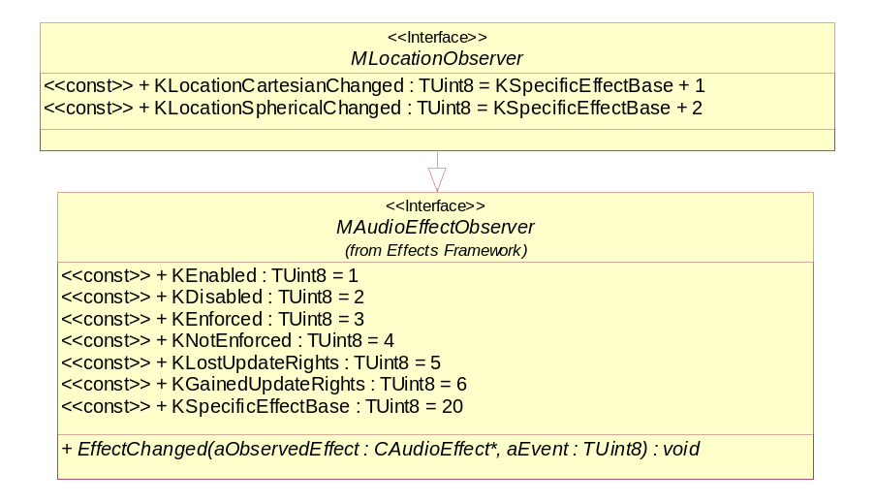
Figure 3.22 MLocationObserver
Methods:
EffectChanged(). Inherited from MAudioEffectObserver (see Section 3.5.2).

CListenerLocation
This class is used by audio applications for controlling the audio listener’s location. This should only be used for applications needing 3D audio, and may be limited by the system. It is derived from CLocation (see Section 3.5.15).
EMBED Visio.Drawing.11 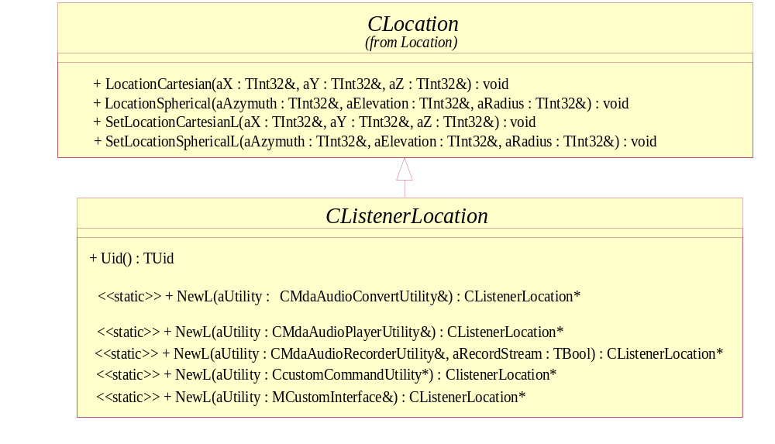
Figure 3.23 CListenerLocation
Headers:
ListenerLocationEffect.h, ListenerLocationEffectData.h, MListenerLocationEffectObserver.h
Library:
ListenerLocationEffect.dll

NewL – factory methods
CListenerLocation* NewL(CMdaAudioConvertUtility& aUtility);

A static constructor that creates a doppler object.
Arguments:
- CMdaAudioConvertUtility& aUtility: The convert utility that is to be associated with this effect.

Returns:
A pointer to CListenerLocation.
Error handling:
This method leaves with the following typical leave codes:
- KErrNoMemory: unable to instantiate due to memory errors.
- KErrNotSupported: the effect is not supported.

CListenerLocation* NewL(CMdaAudioPlayerUtility& aUtility);

A static constructor that creates a listener location object.
Arguments:
- CMdaAudioPlayerUtility& aUtility: The play utility that is to be associated with this effect.

Returns:
A pointer to CListenerLocation.
Error handling:
This method leaves with the following typical leave codes:
- KErrNoMemory: unable to instantiate due to memory errors.
- KErrNotSupported: the effect is not supported.

CListenerLocation* NewL(CMdaAudioRecordUtility& aUtility, TBool aRecordStream);

A static constructor that creates a listener location object.
Arguments:
- CMdaAudioRecordUtility& aUtility: The record utility that is to be associated with this effect.
- TBool aRecordStream: ETrue if the effect is to be applied to recording, EFalse if the effect is to be applied only to playback.

Returns:
A pointer to CListenerLocation.
Error handling:
This method leaves with the following typical leave codes:
- KErrNoMemory: unable to instantiate due to memory errors.
- KErrNotSupported: the effect is not supported.

CListenerLocation* NewL(MCustomInterface& aCustomInterface);

A static constructor that creates a listener location object.
Arguments:
- MCustomInterface& aCustomInterface: A utility that implements the MCustomInterface interface that is to be associated with this effect.

Returns:
A pointer to CListenerLocation.
Error handling:
This method leaves with the following typical leave codes:
- KErrNoMemory: unable to instantiate due to memory errors.
- KErrNotSupported: the effect is not supported.

CListenerLocation * NewL(CcustomCommandUtility* aUtility);

A static constructor that creates a CListenerLocation object.
Arguments:
- CcustomCommandUtility* aUtility: A utility that is to be associated with this effect.

Returns:
A pointer to a CListenerLocation object.
Error handling:
This method leaves with the following typical leave codes:
- KErrNoMemory: unable to instantiate due to memory errors.
- KErrNotSupported: the effect is not supported.

MListenerLocationObserver
This abstract class is a generalization of the listener location observer. It defines the possible events that are specific to the listener location effect. It is derived from MLocationObserver (see Section 3.5.16).
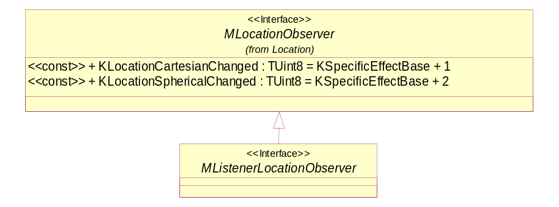
Figure 3.24 MListenerLocationObserver
Methods:
EffectChanged(). Inherited from MAudioEffectObserver (see Section 3.5.2).

CSourceLocation
This class is used by audio applications for controlling the audio source’s location. This should only be used for applications needing 3D audio, and may be limited by the system. It is derived from CLocation (see Section 3.5.15).
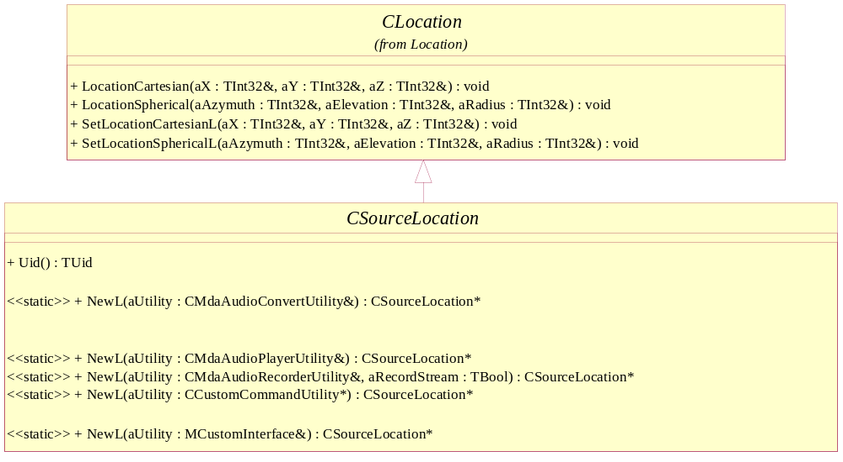
Figure 3.25 CSourceLocation
Headers:
SourceLocationEffect.h, SourceLocationEffectData.h, MSourceLocationEffectObserver.h
Library:
SourceLocationEffect.dll

NewL – factory methods
CSourceLocation* NewL(CMdaAudioConvertUtility& aUtility);

A static constructor that creates a source location object.
Arguments:
- CMdaAudioConvertUtility& aUtility: The convert utility that is to be associated with this effect.

Returns:
A pointer to CSourceLocation.
Error handling:
This method leaves with the following typical leave codes:
- KErrNoMemory: unable to instantiate due to memory errors.
- KErrNotSupported: the effect is not supported.

CSourceLocation* NewL(CMdaAudioPlayerUtility& aUtility);

A static constructor that creates a source location object.
Arguments:
- CMdaAudioPlayerUtility& aUtility: The play utility that is to be associated with this effect.

Returns:
A pointer to CSourceLocation.
Error handling:
This method leaves with the following typical leave codes:
- KErrNoMemory: unable to instantiate due to memory errors.
- KErrNotSupported: the effect is not supported.

CSourceLocation* NewL(CMdaAudioRecordUtility& aUtility, TBool aRecordStream);

A static constructor that creates a source location object.
Arguments:
- CMdaAudioRecordUtility& aUtility: The record utility that is to be associated with this effect.
- TBool aRecordStream: ETrue if the effect is to be applied to recording, EFalse if the effect is to be applied only to playback.

Returns:
A pointer to CSourceLocation.
Error handling:
This method leaves with the following typical leave codes:
- KErrNoMemory: unable to instantiate due to memory errors.
- KErrNotSupported: the effect is not supported.

CSourceLocation* NewL(MCustomInterface& aCustomInterface);

A static constructor that creates a source location object.
Arguments:
- MCustomInterface& aCustomInterface: A utility that implements the MCustomInterface interface that is to be associated with this effect.

Returns:
A pointer to CSourceLocation.
Error handling:
This method leaves with the following typical leave codes:
- KErrNoMemory: unable to instantiate due to memory errors.
- KErrNotSupported: the effect is not supported.

CSourceLocation * NewL(CcustomCommandUtility* aUtility);

A static constructor that creates a CSourceLocation object.
Arguments:
- CcustomCommandUtility* aUtility: A utility that is to be associated with this effect.

Returns:
A pointer to a CSourceLocation object.
Error handling:
This method leaves with the following typical leave codes:
- KErrNoMemory: unable to instantiate due to memory errors.
- KErrNotSupported: the effect is not supported.

MSourceLocationObserver
This abstract class is a generalization of the source location observer. It defines the possible events that are specific to the source location effect. It is derived from MLocationObserver (see Section 3.5.16).
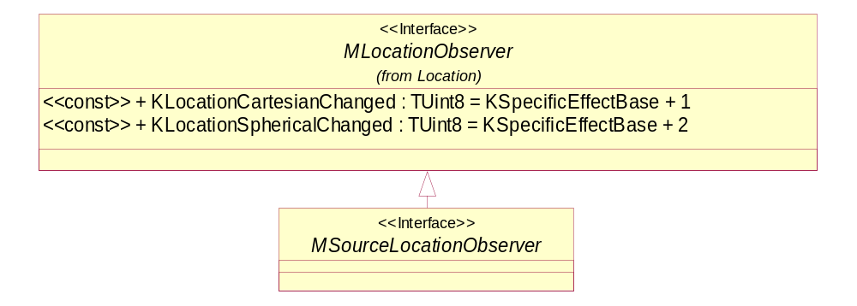
Figure 3.26 MSourceLocationObserver
Methods:
EffectChanged(). Inherited from MAudioEffectObserver (see Section 3.5.2).

COrientation
This abstract class defines the methods needed for all location effects. It is derived from CAudioEffect (see Section 3.5.1).
Orientation is defined in rotation angles around coordinate axes. Positive rotation directions around the coordinate axes are counterclockwise when looking towards the origin from a positive coordinate position on each axis. The initial orientation of an object is towards the negative Z-axis of the world. Orientation is defined in three angles: heading that represents rotation around the Y-axis of the object, pitch that represents rotation around the X-axis of the object, and roll that represents rotation around the Z-axis of the object. Orientation is applied in the following order: heading, pitch, and roll. Therefore, notice that heading rotates the X-axis and therefore affects the pitch, and similarly heading and pitch rotate the Z-axis and therefore affect the roll.

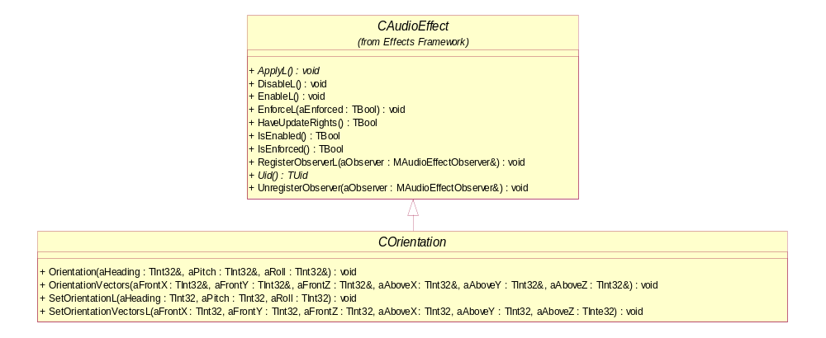
Figure 3.27 COrientation
Headers:
OrientationBase.h
Library:
OrientationEffect.dll

Orientation
void Orientation(TInt32& aHeading, TInt32& aPitch, TInt32& aRoll);

Gets the orientation values for the position.
Arguments:
- TInt32& aHeading: It is rotation around the Y-axis in degrees. The heading value (in thousandths of radians). Referenced memory will contain the value.
- TInt32& aPitch: It is rotation around the X-axis in degrees. The pitch value (in thousandths of radians). Referenced memory will contain the value.
- TInt32& aRoll: It is rotation around the Z-axis in degrees. The roll value (in thousandths of radians). Referenced memory will contain the value.

Returns:
None.

OrientationVectors
void OrientationVectors(TInt32& aFrontX, TInt32& aFrontY, TInt32& aFrontZ, TInt32& aAboveX, TInt32& aAboveY, TInt32& aAboveZ);

Gets the orientation vectors for the position.
Arguments:
- TInt32& aFrontX: X-component of the front vector. Referenced memory will contain the value.
- TInt32& aFrontY: Y-component of the front vector. Referenced memory will contain the value.
- TInt32& aFrontZ: Z-component of the front vector. Referenced memory will contain the value.
- TInt32& aAboveX: X-component of the above vector. Referenced memory will contain the value.
- TInt32& aABoveY: Y-component of the above vector. Referenced memory will contain the value.
- TInt32& aAboveZ: Z-component of the above vector. Referenced memory will contain the value.

Returns:
None.

SetOrientationL
void SetOrientationL(TInt32 aHeading, TInt32 aPitch, TInt32 aRoll);

Sets the orientation values for the position.
Arguments:
- TInt32 aHeading: The heading value (in thousandths of radians).
- TInt32 aPitch: The pitch value (in thousandths of radians).
- TInt32 aRoll: The roll value (in thousandths of radians).

Returns:
None.
Error handling:
This method leaves with the following typical leave codes:
- KErrArgument: the argument value is out of range or invalid.

SetOrientationVectorsL
void SetOrientationVectorsL(TInt32 aFrontX, TInt32 aFrontY, TInt32 aFrontZ, TInt32 aAboveX, TInt32 aAboveY, TInt32 aAboveZ);

Gets the orientation vectors for the position.
Arguments:
- TInt32 aFrontX: X-component of the front vector.
- TInt32 aFrontY: Y-component of the front vector.
- TInt32 aFrontZ: Z-component of the front vector.
- TInt32 aAboveX: X-component of the above vector.
- TInt32 aABoveY: Y-component of the above vector.
- TInt32 aAboveZ: Z-component of the above vector.

Returns:
None.
Error handling:
This method leaves with the following typical leave codes:
- KErrArgument: the argument value is out of range or invalid.

MOrientationObserver
This abstract class is a generalization of the orientation observer. It defines the possible events that are specific to the orientation effect. It is derived from MAudioEffectObserver (see Section 3.5.2).
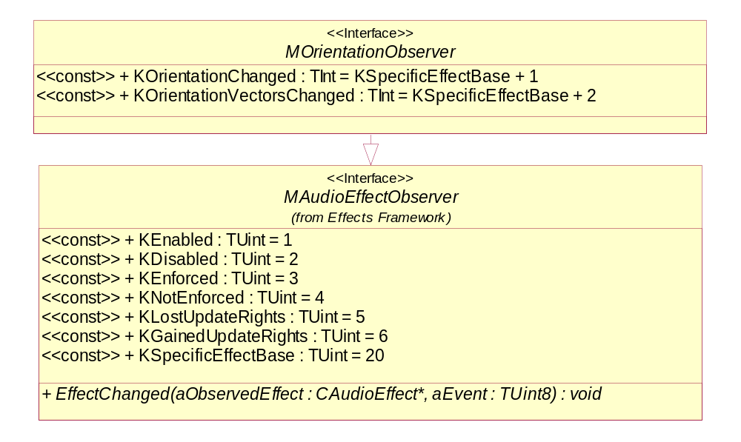
Figure 3.28 MOrientationObserver
Methods:
EffectChanged(). Inherited from MAudioEffectObserver (see Section 3.5.2).

CListenerOrientation
This class is used by audio applications for controlling the listener orientation. This should only be used for applications needing 3D audio, and may be limited by the system. It is derived from COrientation (see Section 3.5.21).
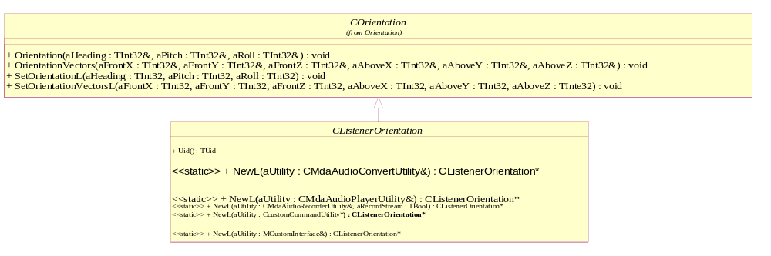
Figure 3.29 CListenerOrientation
Headers:
ListenerOrientationEffect.h, ListenerOrientationEffectData.h, MListenerOrientationEffectObserver.h
Library:
OrientationLocationEffect.dll

NewL – factory methods

CListenerOrientation* NewL(CMdaAudioConvertUtility& aUtility);

A static constructor that creates a listener orientation object.
Arguments:
- CMdaAudioConvertUtility& aUtility: The convert utility that is to be associated with this effect.

Returns:
A pointer to CListenerOrientation.
Error handling:
This method leaves with the following typical leave codes:
- KErrNoMemory: unable to instantiate due to memory errors.
- KErrNotSupported: the effect is not supported.

CListenerOrientation* NewL(CMdaAudioPlayerUtility& aUtility);

A static constructor that creates a listener orientation object.
Arguments:
- CMdaAudioPlayerUtility& aUtility: The play utility that is to be associated with this effect.

Returns:
A pointer to CListenerOrientation.
Error handling:
This method leaves with the following typical leave codes:
- KErrNoMemory: unable to instantiate due to memory errors.
- KErrNotSupported: the effect is not supported.

CListenerOrientation* NewL(CMdaAudioRecordUtility& aUtility, TBool aRecordStream);

A static constructor that creates a listener orientation object.
Arguments:
- CMdaAudioRecordUtility& aUtility: The record utility that is to be associated with this effect.
- TBool aRecordStream: ETrue if the effect is to be applied to recording, EFalse if the effect is to be applied only to playback.

Returns:
A pointer to CListenerOrientation.
Error handling:
This method leaves with the following typical leave codes:
- KErrNoMemory: unable to instantiate due to memory errors.
- KErrNotSupported: the effect is not supported.

CListenerOrientation* NewL(MCustomInterface& aCustomInterface);

A static constructor that creates a listener orientation object.
Arguments:
- MCustomInterface& aCustomInterface: A utility that implements the MCustomInterface interface that is to be associated with this effect.
Returns:
A pointer to CListenerOrientation.
Error handling:
This method leaves with the following typical leave codes:
- KErrNoMemory: unable to instantiate due to memory errors.
- KErrNotSupported: the effect is not supported.

CListenerOrientation * NewL(CcustomCommandUtility* aUtility);

A static constructor that creates a CListenerOrientation object.
Arguments:
- CcustomCommandUtility* aUtility: A utility that is to be associated with this effect.

Returns:
A pointer to a CListenerOrientation object.
Error handling:
This method leaves with the following typical leave codes:
- KErrNoMemory: unable to instantiate due to memory errors.
- KErrNotSupported: the effect is not supported.

MListenerOrientationObserver
This abstract class is a generalization of the listener orientation observer. It defines the possible events that are specific to the listener orientation effect. It is derived from MOrientationObserver (see Section 3.5.22).
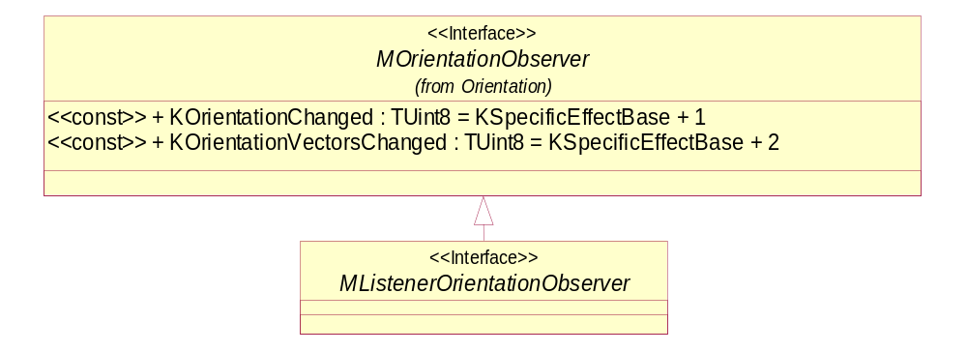
Figure 3.30 MListenerOrientationObserver
Methods:
EffectChanged(). Inherited from MAudioEffectObserver (see Section 3.5.2).

CSourceOrientation
This class is used by audio applications for controlling the source orientation. This should only be used for applications needing 3D audio, and may be limited by the system. It is derived from COrientation (see Section 3.5.21).
EMBED Visio.Drawing.11 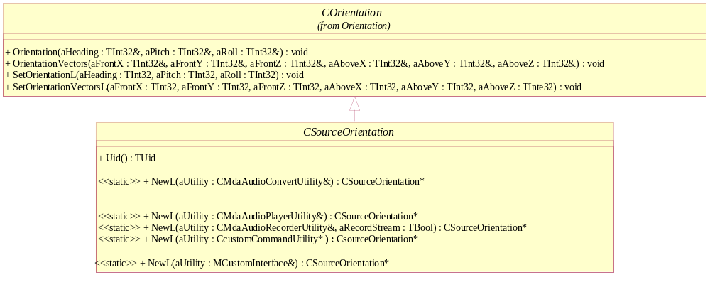
Figure 3.31 CSourceOrientation
Headers:
SourceOrientationEffect.h, SourceOrientationEffectData.h, MSourceOrientationEffectObserver.h
Library:
SourceOrientationEffect.dll

NewL factory methods
CSourceOrientation* NewL(CMdaAudioConvertUtility& aUtility);

A static constructor that creates a source orientation object.
Arguments:
- CMdaAudioConvertUtility& aUtility: The convert utility that is to be associated with this effect.

Returns:
A pointer to CSourceOrientation.
Error handling:
This method leaves with the following typical leave codes:
- KErrNoMemory: unable to instantiate due to memory errors.
- KErrNotSupported: the effect is not supported.

CSourceOrientation* NewL(CMdaAudioPlayerUtility& aUtility);

A static constructor that creates a source orientation object.
Arguments:
- CMdaAudioPlayerUtility& aUtility: The play utility that is to be associated with this effect.

Returns:
A pointer to CSourceOrientation.
Error handling:
This method leaves with the following typical leave codes:
- KErrNoMemory: unable to instantiate due to memory errors.
- KErrNotSupported: the effect is not supported.

CSourceOrientation* NewL(CMdaAudioRecordUtility& aUtility, TBool aRecordStream);

A static constructor that creates a source orientation object.
Arguments:
- CMdaAudioRecordUtility& aUtility: The record utility that is to be associated with this effect.
- TBool aRecordStream: ETrue if the effect is to be applied to recording, EFalse if the effect is to be applied only to playback.

Returns:
A pointer to CSourceOrientation.
Error handling:
This method leaves with the following typical leave codes:
- KErrNoMemory: unable to instantiate due to memory errors.
- KErrNotSupported: the effect is not supported.

CSourceOrientation* NewL(MCustomInterface& aCustomInterface);

A static constructor that creates a source orientation object.
Arguments:
- MCustomInterface& aCustomInterface: A utility that implements the MCustomInterface interface that is to be associated with this effect.

Returns:
A pointer to CSourceOrientation.
Error handling:
This method leaves with the following typical leave codes:
- KErrNoMemory: unable to instantiate due to memory errors.
- KErrNotSupported: the effect is not supported.

CSourceOrientation * NewL(CcustomCommandUtility* aUtility);

A static constructor that creates a CSourceOrientation object.
Arguments:
- CcustomCommandUtility* aUtility: A utility that is to be associated with this effect.

Returns:
A pointer to a CSourceOrientation object.
Error handling:
This method leaves with the following typical leave codes:
- KErrNoMemory: unable to instantiate due to memory errors.
- KErrNotSupported: the effect is not supported.

MSourceOrientationObserver
This abstract class is a generalization of the source orientation observer. It defines the possible events that are specific to the source orientation effect. It is derived from MOrientationObserver (see Section 3.5.22).
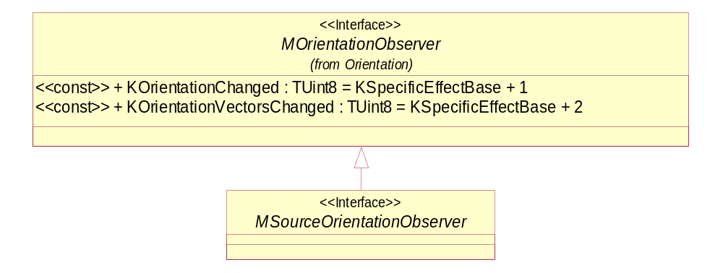
Figure 3.32 MSourceOrientationObserver
Methods:
EffectChanged(). Inherited from MAudioEffectObserver (see Section 3.5.2).

CEnvironmentalReverb
This class is used by audio applications for controlling environmental reverb. It is derived from CAudioEffect (see Section 3.5.1).
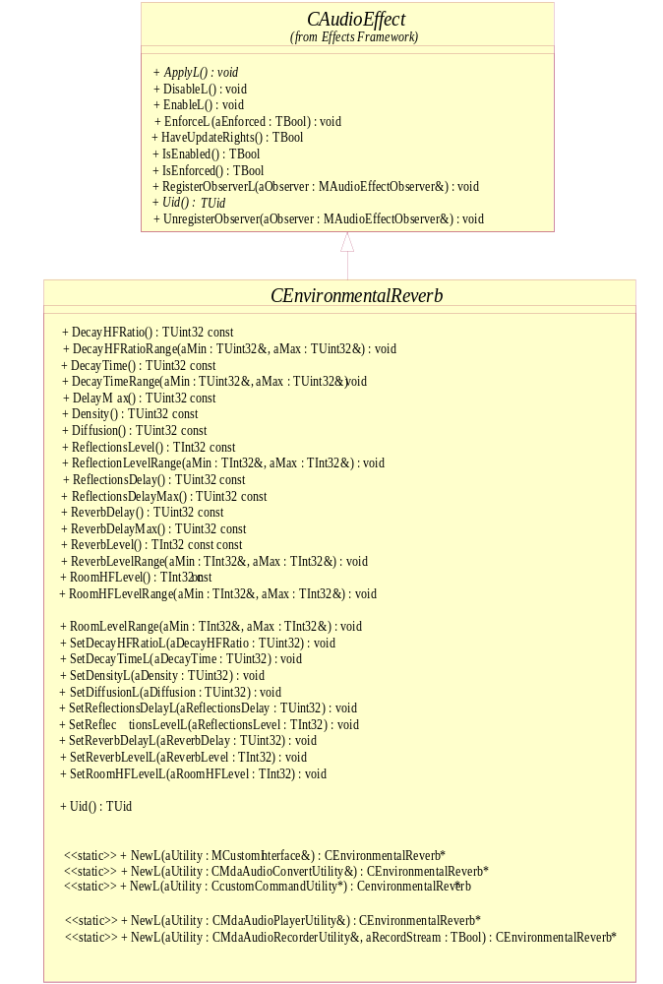
Figure 3.33 CEnvironmentalReverb
Headers:
EnvironmentalReverbEffect.h, EnvironmentalReverbEffectData.h, MEnvironmentalReverbEffectObserver.h
Library:
EnvironmentalReverbEffect.dll

NewL – factory methods
CEnvironmentalReverb* NewL(CMdaAudioConvertUtility& aUtility);

A static constructor that creates a reverb object.
Arguments:
- CMdaAudioConvertUtility& aUtility: The convert utility that is to be associated with this effect.

Returns:
A pointer to CEnvironmentalReverb.
Error handling:
This method leaves with the following typical leave codes:
- KErrNoMemory: unable to instantiate due to memory errors.
- KErrNotSupported: the effect is not supported.

CEnvironmentalReverb* NewL(CMdaAudioPlayerUtility& aUtility);

A static constructor that creates a reverb object.
Arguments:
- CMdaAudioPlayerUtility& aUtility: The play utility that is to be associated with this effect.

Returns:
A pointer to CEnvironmentalReverb.
Error handling:
This method leaves with the following typical leave codes:
- KErrNoMemory: unable to instantiate due to memory errors.
- KErrNotSupported: the effect is not supported.

CEnvironmentalReverb* NewL(CMdaAudioRecordUtility& aUtility, TBool aRecordStream);

A static constructor that creates a reverb object.
Arguments:
- CMdaAudioRecordUtility& aUtility: The record utility that is to be associated with this effect.
- TBool aRecordStream: ETrue if the effect is to be applied to recording, EFalse if the effect is to be applied only to playback.

Returns:
A pointer to CEnvironmentalReverb.
Error handling:
This method leaves with the following typical leave codes:
- KErrNoMemory: unable to instantiate due to memory errors.
- KErrNotSupported: the effect is not supported.

CEnvironmentalReverb* NewL(MCustomInterface& aCustomInterface);

A static constructor that creates a reverb object.
Arguments:
- MCustomInterface& aCustomInterface: A utility that implements the MCustomInterface interface that is to be associated with this effect.

Returns:
A pointer to CEnvironmentalReverb.
Error handling:
This method leaves with the following typical leave codes:
- KErrNoMemory: unable to instantiate due to memory errors.
- KErrNotSupported: the effect is not supported.

CEnvironmentalReverb * NewL(CcustomCommandUtility* aUtility);

A static constructor that creates a CEnvironmentalReverb object.
Arguments:
- CcustomCommandUtility* aUtility: A utility that is to be associated with this effect.

Returns:
A pointer to a CEnvironmentalReverb object.
Error handling:
This method leaves with the following typical leave codes:
- KErrNoMemory: unable to instantiate due to memory errors.
- KErrNotSupported: the effect is not supported.

DecayHFRatio
TUint32 DecayHfRatio() const;

Gets the decay HF Ratio in hundredths.
Arguments:
None.
Returns:
The decay HF Ratio in hundredths.

DecayHFRatioRange
void DecayHFRatioRange(TUint32& aMin, TUint32& aMax);

Gets the reverb decay HF Ratio minimum and maximum in hundredths.
Arguments:
- TUint32& aMin: The minimum decay HF Ratio. Referenced memory will contain the value.
- TUint32& aMax: The maximum decay HF Ratio. Referenced memory will contain the value.

Returns:
None.

DecayTime
TUint32 DecayTime() const;

Gets the decay time in milliseconds.
Arguments:
None.
Returns:
The decay time in milliseconds.

DecayTimeRange
void DecayTimeRange(TUint32& aMin, TUint32& aMax);

Gets the allowable reverb decay time range in milliseconds.
Arguments:
- TInt32& aMin: The minimum decay time in milliseconds. Referenced memory will contain the value.
- TInt32& aMax: The maximum decay time in milliseconds. Referenced memory will contain the value.

Returns:
None

DelayMax
TUint32 DelayMax() const;

Gets the maximum decay time in milliseconds. ReverbDelayMax() or the ReflectionsDelayMax() must be <= DelayMax(). Also ReflectionsDelayMax() should be less than ReverbDelayMax()
Arguments:
Returns:
The maximum delay time in milliseconds.

Density
TUint32 Density() const;

Gets the current density value as a percentage in hundredths.
Arguments:
None.
Returns:
The density percentage in hundredths.

Diffusion
TUint32 Diffusion() const;

Gets the current diffusion value as a percentage in hundredths.
Arguments:
None.
Returns:
The diffusion percentage in hundredths.

ReflectionsDelay
TUint32 RefectionsDelay() const;

Gets the reverb reflections delay in milliseconds.
Arguments:
None.
Returns:
The reflections delay in milliseconds.

ReflectionsDelayMax
TUint32 ReflectionsDelayMax() const;

Gets the reverb reflections delay maximum in milliseconds.
Arguments:
None.
Returns:
The delay maximum in milliseconds.

ReflectionsLevel
TInt32 ReflectionsLevel() const;

Gets the reverb reflections level in mB.
Arguments:
None.
Returns:
The reverb reflections level in mB.

ReflectionsLevelRange
void ReflectionsLevelRange(TInt32& aMin, TInt32& aMax);

Gets the reverb reflections level in mB.
Arguments:
- TInt32& aMin: The minimum reflections level. Referenced memory will contain the value.
- TInt32& aMax: The maximum reflections level. Referenced memory will contain the value.

Returns:
None.

ReverbDelay
TUint32 ReverbDelay() const;

Gets the reverb delay in milliseconds.
Arguments:
None.
Returns:
The reverb delay in milliseconds.

ReverbDelayMax
TUint32 ReverbDelayMax() const;

Gets the reverb delay maximum in milliseconds.
Arguments:
None.
Returns:
The reverb delay maximum in milliseconds.

ReverbLevel
TInt32 ReverbLevel() const;

Gets the current reverb level in mB.
Arguments:
None.
Returns:
The current reverb level.

ReverbLevelRange
void ReverbLevelRange(TInt32& aMin, TInt32& aMax);

Gets the current reverb level maximum and minimum in mB.
Arguments:
- TInt32& aMin: The minimum reverb level. Referenced memory will contain the value.
- TInt32& aMax: The maximum reverb level. Referenced memory will contain the value.

Returns:
None.

RoomHFLevel
TInt32 RoomHFLevel() const;

Gets the current room High Frequency level value in mB.
Arguments:
None.
Returns:
The current room High Frequency level ratio.

RoomHFLevelRange
void RoomHFLevelRange(TInt32& aMin, TInt32& aMax);

Gets the room High Frequency level maximum and minimum ratios in mB.
Arguments:
- TInt32& aMin: The minimum room HF level. Referenced memory will contain the value.
- TInt32& aMax: The maximum room HF level. Referenced memory will contain the value.

Returns:
None.

RoomLevel
TInt32 RoomLevel() const;

Gets the current room level ratio in mB.
Arguments:
None.
Returns:
The room level ratio.

RoomLevelRange
void RoomLevelRange(TInt32& aMin, TInt32& aMax);

Gets the room level maximum and minimum ratios in mB.
Arguments:
- TInt32& aMin: The minimum room level. Referenced memory will contain the value.
- TInt32& aMax: The maximum room level. Referenced memory will contain the value.

Returns:
None.

SetDecayTimeL
void SetDecayTimeL(TUint32 aDecayTime);

Sets the decay time in milliseconds.
Arguments:
TUint32 aDecayTime: The decay time in milliseconds.

Returns:
None.
Error handling:
This method leaves with the following typical leave codes:
- KErrArgument: the argument value is out of range or invalid.

SetDecayHFRatioL
void SetDecayHFRatioL(TUint32 aDecayHFRatio);

Sets the decay HF Ratio in hundredths.
Arguments:
- TUint32 aDecayHFRatio: The decay high frequency ratio in hundredths.

Returns:
None.
Error handling:
This method leaves with the following typical leave codes:
- KErrArgument: the argument value is out of range or invalid.

SetDensityL
void SetDensityL(TUint32 aDensity);

Sets the density value as percentage in hundredths.
Arguments:
- TUint32 aDensity: The density.

Returns:
None.
Error handling:
This method leaves with the following typical leave codes:
- KErrArgument: the argument value is out of range or invalid.

SetDiffusionL
void SetDiffusionL(TUint32 aDiffusion);

Sets the diffusion value as a percentage in hundredths.
Arguments:
TUint32 aDiffusion: The diffusion.
Returns:
None.
Error handling:
This method leaves with the following typical leave codes:
- KErrArgument: the argument value is out of range or invalid.

SetReflectionsDelayL
void SetReflectionsDelayL(TUint32 aRefectionsDelay);

Sets the reverb reflections delay.
Arguments:
- TUint32 aRefectionsDelay: The reflection delay in milliseconds.

Returns:
None.
Error handling:
This method leaves with the following typical leave codes:
- KErrArgument: the argument value is out of range or invalid.

SetReflectionsLevelL
void SetReflectionsLevelL(TInt32 aRefectionsLevel);

Sets the reverb reflections level in mB.
Arguments:
- TInt32 aRefectionsLevel: The reflection level in mB.

Returns:
None.
Error handling:
This method leaves with the following typical leave codes:
- KErrArgument: the argument value is out of range or invalid.

SetReverbDelayL
void SetReverbDelayL(TUint32 aReverbDelay);

Sets the reverb delay.
Arguments:
- TUint32 aReverbDelay: The reverb delay in milliseconds.

Returns:
None.
Error handling:
This method leaves with the following typical leave codes:
- KErrArgument: the argument value is out of range or invalid.

SetReverbLevelL
void SetReverbLevelL(TInt32 aReverbLevel);

Sets the reverb level.
Arguments:
- TInt32 aReverbLevel: The reverb level in mB.

Returns:
None.
Error handling:
This method leaves with the following typical leave codes:
- KErrArgument: the argument value is out of range or invalid.

SetRoomHfLevelL
void SetRoomHFLevelL(TInt32 aRoomHFLevel);

Sets the room HF level in mB.
Arguments:
- TUint32 aRoomHFLevel: The room high frequency ratio.

Returns:
None.
Error handling:
This method leaves with the following typical leave codes:
- KErrArgument: the argument value is out of range or invalid.

SetRoomLevelL
void SetRoomLevelL(TInt32 aRoomLevel);

Sets the room level in mB.
Arguments:
- TUint32 aRoomLevel: The room level.

Returns:
None.
Error handling:
This method leaves with the following typical leave codes:
- KErrArgument: the argument value is out of range or invalid.

MEnvironmentalReverbObserver
This abstract class is a generalization of the environmental reverb observer. It defines the possible events that are specific to the environmental reverb effect. It is derived from MAudioEffectObserver (see Section 3.5.2).
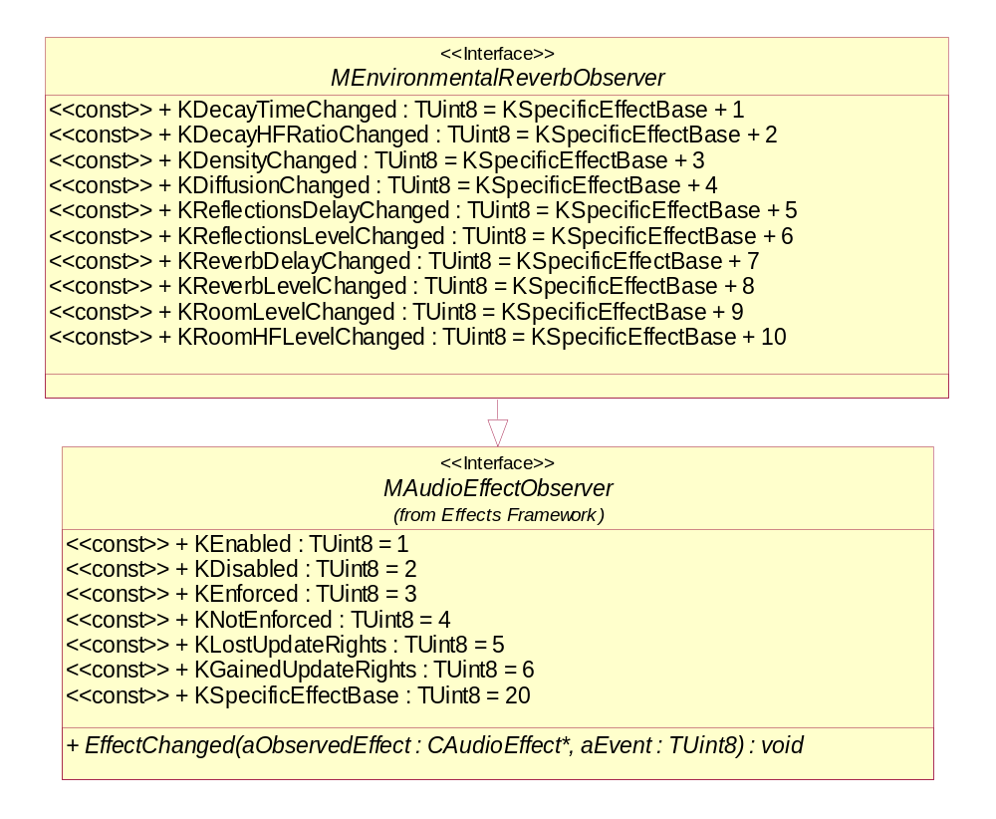
Figure 3.34 MEnvironmentalReverbObserver
Methods:
EffectChanged(). Inherited from MAudioEffectObserver (see Section 3.5.2).

CStereoWidening
This class is used by audio applications for controlling stereo widening. It is derived from CAudioEffect (see Section 3.5.1).
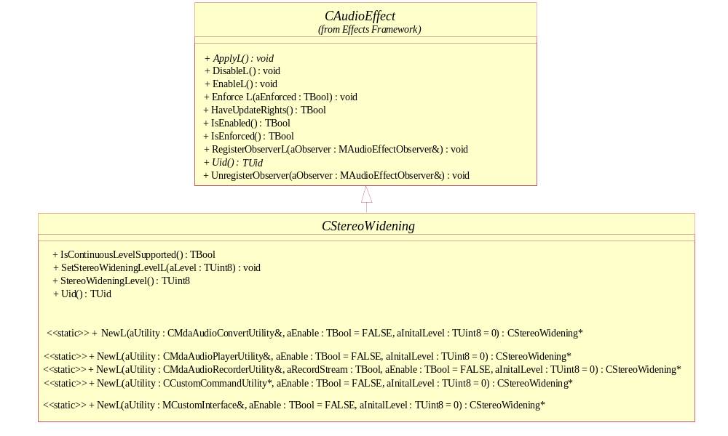
Figure 3.35 CStereoWidening
Headers:
StereoWideningEffect.h, StereoWideningEffectData.h, MStereoWideningEffectObserver.h
Library:
StereoWideningEffect.dll

NewL – factory methods
CStereoWidening* NewL(CMdaAudioConvertUtility& aUtility, TBool aEnable = EFalse, TInt8 aInitialLevel = 0 );

A static constructor that creates a stereo widening object.
Arguments:
- CMdaAudioConvertUtility& aUtility: The convert utility that is to be associated with this effect.
- TBool aEnable: Set to ETrue if the effect should be enabled immediately, otherwise EFalse. By default, this parameter is set to EFalse.
- TInt8 aInitialLevel: The stereo widening level value that will be used when aEnable is ETrue. When aEnable is EFalse, this value is ignored.

Returns:
A pointer to CStereoWidening.
Error handling:
This method leaves with the following typical leave codes:
- KErrNoMemory: unable to instantiate due to memory errors.
- KErrNotSupported: the effect is not supported.

CStereoWidening* NewL(CMdaAudioPlayerUtility& aUtility, TBool aEnable = EFalse, TInt8 aInitialLevel = 0 );

A static constructor that creates a stereo widening object.
Arguments:
- CMdaAudioPlayerUtility& aUtility: The play utility that is to be associated with this effect.
- TBool aEnable: Set to ETrue if the effect should be enabled immediately, otherwise EFalse. By default, this parameter is set to EFalse.
- TInt8 aInitialLevel: The stereo widening value that will be used when aEnable is ETrue. When aEnable is EFalse, this value is ignored.

Returns:
A pointer to CStereoWidening.
Error handling:
This method leaves with the following typical leave codes:
- KErrNoMemory: unable to instantiate due to memory errors.
- KErrNotSupported: the effect is not supported.

CStereoWidening* NewL(CMdaAudioRecordUtility& aUtility, Tbool aRecordStream, TBool aEnable = EFalse, TInt8 aInitialLevel = 0 );

A static constructor that creates a stereo widening object.
Arguments:
- CMdaAudioRecordUtility& aUtility: The record utility that is to be associated with this effect.
- Tbool aRecordStream: Set to ETrue if the effect is to be applied to recording, EFalse if the effect is to be applied only to playback.
- TBool aEnable: Set to ETrue if the effect should be enabled immediately, otherwise EFalse. By default, this parameter is set to EFalse.
- TInt8 aInitialLevel: The stereo widening value that will be used when aEnable is ETrue. When aEnable is EFalse, this value is ignored.

Returns:
A pointer to CStereoWidening.
Error handling:
This method leaves with the following typical leave codes:
- KErrNoMemory: unable to instantiate due to memory errors.
- KErrNotSupported: the effect is not supported.

CStereoWidening* NewL(MCustomInterface& aCustomInterface, TBool aEnable = EFalse, TInt8 aInitialLevel = 0 );

A static constructor that creates a stereo widening object.
Arguments:
- MCustomInterface& aCustomInterface: The utility that implements the MCustomInterface interface that is to be associated with this effect.
- TBool aEnable: Set to ETrue if the effect should be enabled immediately, otherwise EFalse. By default, this parameter is set to EFalse.
- TInt8 aInitialLevel: The stereo widening value that will be used when aEnable is ETrue. When aEnable is EFalse, this value is ignored.

Returns:
A pointer to CStereoWidening.
Error handling:
This method leaves with the following typical leave codes:
- KErrNoMemory: unable to instantiate due to memory errors.
- KErrNotSupported: the effect is not supported.

CStereoWidening* NewL(CcustomCommandUtility* aUtility, TBool aEnable, TInt8 aInitialLevel);

A static constructor that creates a CStereoWidening object.
Arguments:
- CcustomCommandUtility* aUtility: A utility that is to be associated with this effect.
- TBool aEnable: Set to ETrue if the effect should be enabled immediately, otherwise EFalse. By default, this parameter is set to EFalse.
- TInt8 aInitialLevel: The stereo widening value that will be used when aEnable is ETrue. When aEnable is EFalse, this value is ignored.

Returns:
A pointer to a CStereoWidening object.
Error handling:
This method leaves with the following typical leave codes:
- KErrNoMemory: unable to instantiate due to memory errors.
- KErrNotSupported: the effect is not supported.

IsContinousLevelSupported
TBool IsContinousLevelSupported() const;

Checks if continuous level is supported for stereo widening.
Arguments:
None.
Returns:
ETrue if continuous level is supported for stereo widening. If this returns EFalse, then the adaptation is actually setting the level to the nearest supported discrete value when SetStereoWidenlingLevelL is called.

SetStereoWideningLevelL
void SetStereoWideningLevelL(TUint8 aLevel);

Sets the widening level.
Arguments:
- TUint8 aLevel: The stereo widening level ranges from 0-100, where 0 is none and 100 is maximum widening.

Returns:
None.
Error handling:
This method leaves with the following typical leave codes:
- KErrArgument: the argument value is out of range or invalid.

StereoWideningLevel
TUint8 SteroWideningLevel() const;

Gets the stereo widening settings.
Arguments:
None.
Returns:
The level of widening.

MStereoWideningObserver
This abstract class is a generalization of the stereo widening observer. It defines the possible events that are specific to the stereo widening effect. It is derived from MAudioEffectObserver (see Section 3.5.2).
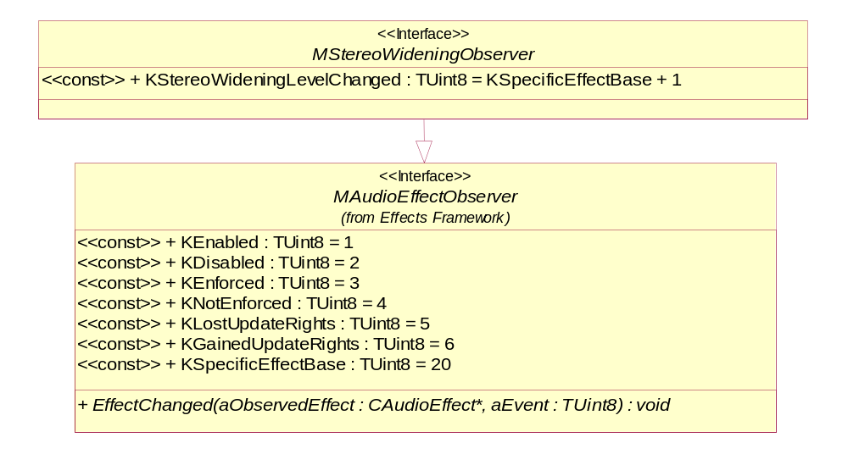
Figure 3.36 MStereoWideningObserver
Methods:
EffectChanged(). Inherited from MAudioEffectObserver (see Section 3.5.2).

CRoomLevel
This class is used by audio applications for controlling Room Level. It is derived from CAudioEffect (see Section 3.5.1).
EMBED Visio.Drawing.11 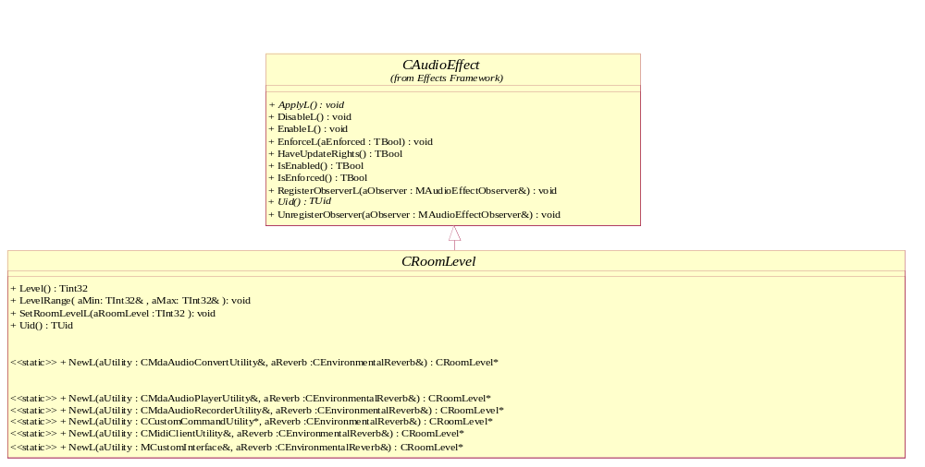
Figure 3.37 CRoomLevel
Headers:
RoomLevelBase.h, RoomLevelEffectData.h, MRoomLevelEffectObserver.h
Library:
RoomLevelEffect.dll

NewL – factory methods
CRoomLevel* NewL(CMdaAudioConvertUtility& aUtility, CEnvironmentalReverb& aReverb );

A static constructor that creates a stereo widening object.
Arguments:
- CMdaAudioConvertUtility& aUtility: The convert utility that is to be associated with this effect.
- CEnvironmentalReverb& aReverb: It is a reference to a CEnvironmentalReverb object created before.

Returns:
A pointer to CRoomLevel.
Error handling:
This method leaves with the following typical leave codes:
- KErrNoMemory: unable to instantiate due to memory errors.
- KErrNotSupported: the effect is not supported.

CRoomLevel* NewL(CMdaAudioPlayerUtility& aUtility, CEnvironmentalReverb& aReverb);

A static constructor that creates a stereo widening object.
Arguments:
- CMdaAudioPlayerUtility& aUtility: The play utility that is to be associated with this effect.
- CEnvironmentalReverb& aReverb: It is a reference to a CEnvironmentalReverb object created before.

Returns:
A pointer to CRoomLevel.
Error handling:
This method leaves with the following typical leave codes:
- KErrNoMemory: unable to instantiate due to memory errors.
- KErrNotSupported: the effect is not supported.

CRoomLevel* NewL(CMdaAudioRecordUtility& aUtility, CEnvironmentalReverb& aReverb);

A static constructor that creates a stereo widening object.
Arguments:
- CMdaAudioRecordUtility& aUtility: The record utility that is to be associated with this effect.
- CEnvironmentalReverb& aReverb: It is a reference to a CEnvironmentalReverb object created before.

Returns:
A pointer to CRoomLevel.
Error handling:
This method leaves with the following typical leave codes:
- KErrNoMemory: unable to instantiate due to memory errors.
- KErrNotSupported: the effect is not supported.

CRoomLevel* NewL(MCustomInterface& aCustomInterface, CEnvironmentalReverb& aReverb);

A static constructor that creates a stereo widening object.
Arguments:
- MCustomInterface& aCustomInterface: The utility that implements the MCustomInterface interface that is to be associated with this effect.
- CEnvironmentalReverb& aReverb: It is a reference to a CEnvironmentalReverb object created before.
Returns:
A pointer to CRoomLevel.
Error handling:
This method leaves with the following typical leave codes:
- KErrNoMemory: unable to instantiate due to memory errors.
- KErrNotSupported: the effect is not supported.

CRoomLevel* NewL(CcustomCommandUtility* aUtility, CEnvironmentalReverb& aReverb);

A static constructor that creates a CRoomLevel object.
Arguments:
- CcustomCommandUtility* aUtility: A utility that is to be associated with this effect.
- CEnvironmentalReverb& aReverb: It is a reference to a CEnvironmentalReverb object created before.

Returns:
A pointer to a CRoomLevel object.
Error handling:
This method leaves with the following typical leave codes:
- KErrNoMemory: unable to instantiate due to memory errors.
- KErrNotSupported: the effect is not supported.

Level
TInt32 Level() const;

Return the current room level.
Arguments:
None.
Returns:
Current room level.

LevelRange
void LevelRange( TInt32& aMin, TInt32& aMax );

Sets the RoomLevel range, it will leave if aRoomLevel is not within range of Min and Max
Arguments:
- TInt32& aMin: The minimum room level. Referenced memory will contain the value.
- TInt32& aMax: The maximum room level. Referenced memory will contain the value.

Returns:
None.
Error handling:
This method leaves with the following typical leave codes:
- KErrArgument: the argument value is out of range or invalid.

SetRoomLevelL
void SetRoomLevelL( TInt32 aRoomLevel );

Set the room level.
Arguments:
TInt32 aRoomLevel: The room level to be set.
Returns:
None

MRoomLevelObserver
This abstract class is a generalization of the room level observer. It defines the possible events that are specific to the room level effect. It is derived from MAudioEffectObserver (see Section 3.5.2).
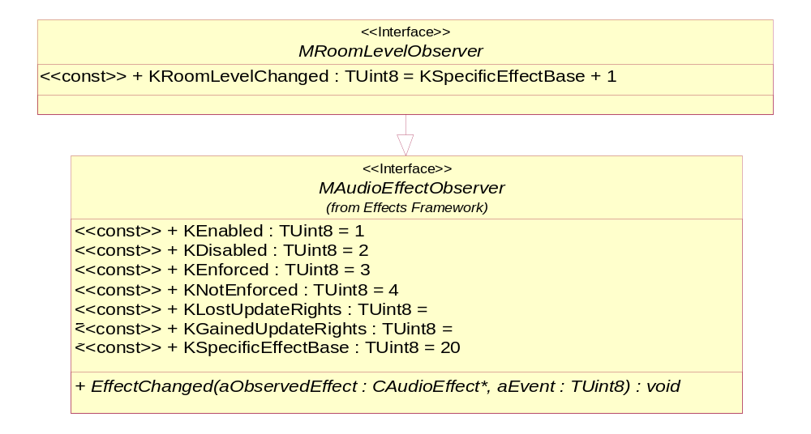
Figure 3.38 MRoomLevelObserver
Methods:
EffectChanged(). Inherited from MAudioEffectObserver (see Section 3.5.2).

Equalizer Utility
Equalizer Utility enables audio clients to use preset values stored in the Central Repository for use with the Equalizer effect.
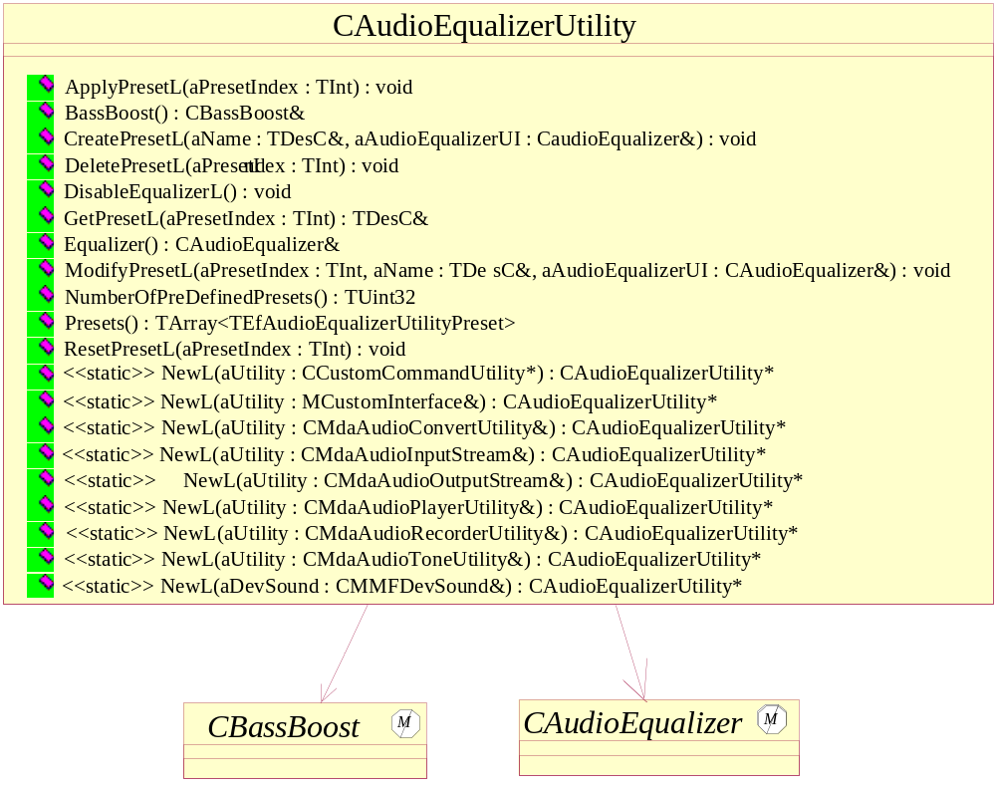
Figure 3.39 Equalizer Utility
Headers:
AudioEqualizerUtility.h
Library:
AudioEqualizerUtility.dll

NewL – factory methods
CAudioEqualizerUtility* NewL(CMMFDevSound& aDevSound);

A static constructor that creates an audio equalizer utility object.
Arguments:
- CMMFDevSound& aDevSound: The DevSound associated with this effect.

Returns:
A pointer to CAudioEqualizerUtility.
Error handling:
This method leaves with the following typical leave codes:
- KErrNoMemory: unable to instantiate due to memory errors.
- KErrNotSupported: the effect is not supported.

CAudioEqualizerUtility* NewL(CMdaAudioConvertUtility& aUtility);

A static constructor that creates an audio equalizer utility object.
Arguments:
- CMdaAudioConvertUtility& aUtility: The convert utility that is to be associated with this effect.

Returns:
A pointer to CAudioEqualizerUtility.
Error handling:
This method leaves with the following typical leave codes:
- KErrNoMemory: unable to instantiate due to memory errors.
- KErrNotSupported: the effect is not supported.

CAudioEqualizerUtility* NewL(CMdaAudioInputStream& aUtility);

A static constructor that creates an audio equalizer utility object.
Arguments:
- CMdaAudioInputStream& aUtility: The input stream utility that is to be associated with this effect.

Returns:
A pointer to CAudioEqualizerUtility.
Error handling:
This method leaves with the following typical leave codes:
- KErrNoMemory: unable to instantiate due to memory errors.
- KErrNotSupported: the effect is not supported.

CAudioEqualizerUtility* NewL(CMdaAudioOutputStream& aUtility);

A static constructor that creates an audio equalizer utility object.
Arguments:
- CMdaAudioOutputStream& aUtility: The output stream utility that is to be associated with this effect.

Returns:
A pointer to CAudioEqualizerUtility.
Error handling:
This method leaves with the following typical leave codes:
- KErrNoMemory: unable to instantiate due to memory errors.
- KErrNotSupported: the effect is not supported.

CAudioEqualizerUtility* NewL(CMdaAudioPlayerUtility& aUtility);

A static constructor that creates an audio equalizer utility object.
Arguments:
- CMdaAudioPlayerUtility& aUtility: The play utility that is to be associated with this effect.

Returns:
A pointer to CAudioEqualizerUtility.
Error handling:
This method leaves with the following typical leave codes:
- KErrNoMemory: unable to instantiate due to memory errors.
- KErrNotSupported: the effect is not supported.

CAudioEqualizerUtility* NewL(CMdaAudioRecordUtility& aUtility);

A static constructor that creates an audio equalizer utility object.
Arguments:
- CMdaAudioRecordUtility& aUtility: The record utility that is to be associated with this effect.

Returns:
A pointer to CAudioEqualizerUtility.
Error handling:
This method leaves with the following typical leave codes:
- KErrNoMemory: unable to instantiate due to memory errors.
- KErrNotSupported: the effect is not supported.

CAudioEqualizerUtility* NewL(CMdaAudioToneUtility& aUtility);

A static constructor that creates an audio equalizer utility object.
Arguments:
- CMdaAudioToneUtility& aUtility: The tone utility that is to be associated with this effect.
Returns:
A pointer to CAudioEqualizerUtility.
Error handling:
This method leaves with the following typical leave codes:
- KErrNoMemory: unable to instantiate due to memory errors.
- KErrNotSupported: the effect is not supported.
CAudioEqualizerUtility* NewL(MCustomInterface& aCustomInterface);

A static constructor that creates an audio equalizer utility object.
Arguments:
- MCustomInterface& aCustomInterface: A utility that implements the MCustomInterface interface that is to be associated with this effect.

Returns:
A pointer to CAudioEqualizerUtility.
Error handling:
This method leaves with the following typical leave codes:
- KErrNoMemory: unable to instantiate due to memory errors.
- KErrNotSupported: the effect is not supported.

CAudioEqualizerUtility* NewL(CcustomCommandUtility* aUtility);

A static constructor that creates a CAudioEqualizerUtility object.
Arguments:
- CcustomCommandUtility* aUtility: A utility that is to be associated with this effect.
Returns:
A pointer to a CAudioEqualizerUtility object.
Error handling:
This method leaves with the following typical leave codes:
- KErrNoMemory: unable to instantiate due to memory errors.
- KErrNotSupported: the effect is not supported.

ApplyPresetL
void ApplyPresetL(TInt aPresetIndex);

Used to apply the preset values.
Arguments:
- TInt aPresetIndex: The index of the preset to apply. The index is the index into the array of presets retrieved with the method Presets().

Returns:
None.
Error handling:
This method leaves with the following typical leave codes:
- KErrArgument: the argument value is out of range or invalid.

BassBoost
CbassBoost& BassBoost();

Gets the bass boost object.
Arguments:
None.
Returns:
A reference to the bass boost object.

CreatePresetL
void CreatePresetL(TDesC& aName, CAudioEqualizer& aAudioEqualizer);

Creates a user-defined preset with the specified equalizer settings.
Arguments:
- TDesC& aName: The name of the user-defined preset.
- CAudioEqualizer& aAudioEqualizer: An equalizer object configured to the values to be used in creating the user-defined preset.

Returns:
An updated list of presets is returned if the operation is successful.
Error handling:
This method leaves with the following typical leave codes:
- KErrArgument: the argument value is out of range or invalid.
- KErrNoMemory: an out of memory error encountered.

DeletePresetL
void DeletePresetL(TInt aPresetIndex);

Deletes the specified user-defined preset.
Arguments:
- TInt aPresetIndex: The index into the preset array retrieved with the method Presets().

Returns:
None.
Error handling:
This method leaves with the following typical leave codes:
- KErrArgument: the argument value is out of range or invalid.

DisableEqualizerL
void DisableEqualizerL ();

Deletes the specified user-defined preset.
Arguments:
Returns:
None.
Error handling:

Equalizer
CAudioEqualizer& Equalizer();

Gets the audio equalizer object.
Arguments:
None.
Returns:
A reference to the audio equalizer object.

GetPresetL
const TDesC& GetPresetL (TInt aPresetIndex);

Retrieves the Preset values from the Central Repository and stores it in the Equalizer Object. Also it returns the Name of the retrieved Preset.
Arguments:
- TInt aPresetIndex: The index of the preset to retrieve. The index is the index into the array of presets retrieved with the method Presets().

Returns:
Name of the Retrieved Preset.
Error handling:
This method leaves with the following typical leave codes:
- KErrArgument: the argument value is out of range or invalid.

ModifyPresetL
void ModifyPresetL(TInt aPresetIndex, TDesC& aName, CAudioEqualizer& aAudioEqualizer);

Modifies a user-defined preset with the specified equalizer settings.
Arguments:
- TInt aPresetIndex: The index into the preset array retrieved with the method Presets().
- TDesC& aName: The name of the preset to be used in modification.
- CAudioEqualizer& aAudioEqualizer: An equalizer object configured to the values to be used in modifying the preset.

Returns:
None.
Error handling:
This method leaves with the following typical leave codes:
- KErrArgument: the argument value is out of range or invalid.
- KErrNoMemory: an out of memory error encountered.

NumberOfPreDefinedPresets
TUint32 NumberOfPreDefinePresets() const;

Gets the number of predefined presets.
Arguments:
None.
Returns:
The number of predefined presets.

Presets
TArray< TEfAudioEqualizerUtilityPreset > Presets();

Gets the list of preset names, unique name keys and unique description keys.
Arguments:
None.
Returns:
An array of objects, which contains all the preset names (pre-defined and user-defined), their name keys and description keys. The pre-defined presets are in the beginning of the list.

ResetPresetL()
void ResetPresetL(TInt aPresetIndex);

Resets the specified preset.
Arguments:
- TInt aPresetIndex: The index of the preset to reset. The index is the index into the array of presets retrieved with the method Presets(). The Utility only allows resetting the PreDefined Presets.

Note: If the preset index points to a preset that cannot be reset, the method will leave with KErrArgument.
Returns:
None.
Error handling:
This method leaves with the following typical leave codes:
- KErrArgument: the argument value is out of range or invalid.

Environment Reverb Utility
Environment Reverb Utility enables audio clients to use preset values stored in the Central Repository for use with the Reverb effect.
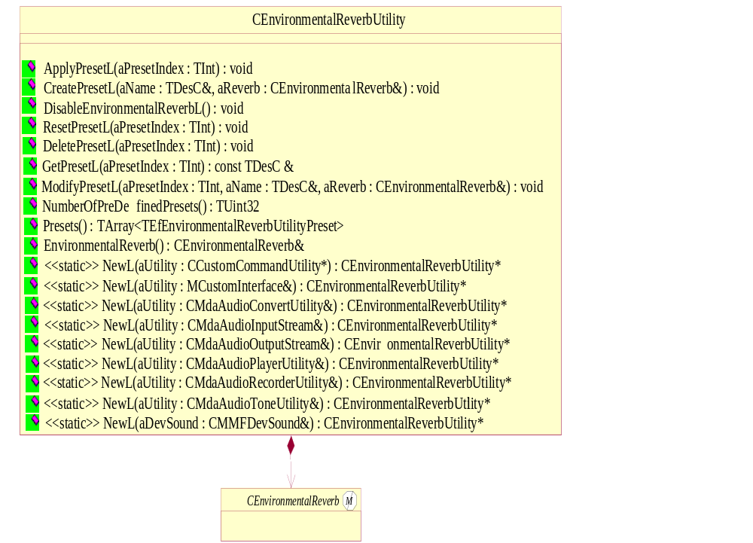
Figure 3.40 Environment Reverb Utility
Headers:
ReverbUtility.h
Library:
ReverbUtility.dll

NewL factory methods
CEnvironmentalReverbUtility* NewL(CMMFDevSound& aDevSound);

A static constructor that creates a reverb utility object.
Arguments:
- CMMFDevSound& aDevSound: The DevSound associated with this effect.

Returns:
A pointer to CEnvironmentalReverbUtility.
Error handling:
This method leaves with the following typical leave codes:
- KErrNoMemory: unable to instantiate due to memory errors.
- KErrNotSupported: the effect is not supported.

CEnvironmentalReverbUtility* NewL(CMdaAudioConvertUtility& aUtility);

A static constructor that creates a reverb utility object.
Arguments:
- CMdaAudioConvertUtility& aUtility: The convert utility that is to be associated with this effect.

Returns:
A pointer to CEnvironmentalReverbUtility.
Error handling:
This method leaves with the following typical leave codes:
- KErrNoMemory: unable to instantiate due to memory errors.
- KErrNotSupported: the effect is not supported.

CEnvironmentalReverbUtility* NewL(CMdaAudioInputStream& aUtility);

A static constructor that creates a reverb utility object.
Arguments:
- CMdaAudioInputStream& aUtility: The input stream utility that is to be associated with this effect.

Returns:
A pointer to CEnvironmentalReverbUtility.
Error handling:
This method leaves with the following typical leave codes:
- KErrNoMemory: unable to instantiate due to memory errors.
- KErrNotSupported: the effect is not supported.

CEnvironmentalReverbUtility* NewL(CMdaAudioOutputStream& aUtility);

A static constructor that creates a reverb utility object.
Arguments:
- CMdaAudioOutputStream& aUtility: The output stream utility that is to be associated with this effect.

Returns:
A pointer to CEnvironmentalReverbUtility.
Error handling:
This method leaves with the following typical leave codes:
- KErrNoMemory: unable to instantiate due to memory errors.
- KErrNotSupported: the effect is not supported.

CEnvironmentalReverbUtility* NewL(CMdaAudioPlayerUtility& aUtility);

A static constructor that creates a reverb utility object.
Arguments:
- CMdaAudioPlayerUtility& aUtility: The play utility that is to be associated with this effect.

Returns:
A pointer to CEnvironmentalReverbUtility.
Error handling:
This method leaves with the following typical leave codes:
- KErrNoMemory: unable to instantiate due to memory errors.
- KErrNotSupported: the effect is not supported.

CEnvironmentalReverbUtility* NewL(CMdaAudioRecordUtility& aUtility);

A static constructor that creates a reverb utility object.
Arguments:
- CMdaAudioRecordUtility& aUtility: The record utility that is to be associated with this effect.

Returns:
A pointer to CEnvironmentalReverbUtility.
Error handling:
This method leaves with the following typical leave codes:
- KErrNoMemory: unable to instantiate due to memory errors.
- KErrNotSupported: the effect is not supported.

CEnvironmentalReverbUtility* NewL(CMdaAudioToneUtility& aUtility);

A static constructor that creates a reverb utility object.
Arguments:
- CMdaAudioToneUtility& aUtility: The tone utility that is to be associated with this effect.

Returns:
A pointer to CEnvironmentalReverbUtility.
Error handling:
This method leaves with the following typical leave codes:
- KErrNoMemory: unable to instantiate due to memory errors.
- KErrNotSupported: the effect is not supported.

CEnvironmentalReverbUtility* NewL(MCustomInterface& aCustomInterface);

A static constructor that creates a reverb utility object.
Arguments:
- MCustomInterface& aCustomInterface: A utility that implements the MCustomInterface interface that is to be associated with this effect.

Returns:
A pointer to CEnvironmentalReverbUtility.
Error handling:
This method leaves with the following typical leave codes:
- KErrNoMemory: unable to instantiate due to memory errors.
- KErrNotSupported: the effect is not supported.

CEnvironmentalReverbUtility * NewL(CcustomCommandUtility* aUtility);

A static constructor that creates a CEnvironmentalReverbUtility object.
Arguments:
- CcustomCommandUtility* aUtility: A utility that is to be associated with this effect.
Returns:
A pointer to a CEnvironmentalReverbUtility object.
Error handling:
This method leaves with the following typical leave codes:
- KErrNoMemory: unable to instantiate due to memory errors.
- KErrNotSupported: the effect is not supported.

ApplyPresetL
void ApplyPresetL(TInt aPresetIndex);

Used to apply the preset values.
Arguments:
- TInt aPresetIndex: The index of the preset to apply. The index is the index into the array of presets retrieved with the method Presets().

Returns:
None.
Error handling:
This method leaves with the following typical leave codes:
- KErrArgument: the argument value is out of range or invalid.

CreatePresetL
void CreatePresetL(TDesC& aName, CEnvironmentalReverb& aReverb);

Creates a user-defined preset with the specified equalizer settings.
Arguments:
- TDesC& aName: The name of the user-defined preset.
- CEnvironmentalReverb& aReverb: An environmental reverb object configured to the values to be used in creating the user-defined preset.

Returns:
An updated list of presets is returned if the operation is successful.
Error handling:
This method leaves with the following typical leave codes:
- KErrArgument: the argument value is out of range or invalid.
- KErrNoMemory: an out of memory error encountered.

DeletePresetL
void DeletePresetL(TInt aPresetIndex);
Deletes the specified preset.
Arguments:
- TInt aPresetIndex: The index into the preset array retrieved with the method Presets().

Returns:
None.
Error handling:
This method leaves with the following typical leave codes:
- KErrArgument: the argument value is out of range or invalid.

DisableReverbL
void DisableReverbL ();

Deletes the specified user-defined preset.
Arguments:
Returns:
None.
Error handling:

GetPresetL
const TDesC& GetPresetL (TInt aPresetIndex);

Retrieves the Preset values from the Central Repository and stores it in the Equalizer Object. Also it returns the Name of the retrieved Preset.
Arguments:
- TInt aPresetIndex: The index of the preset to retrieve. The index is the index into the array of presets retrieved with the method Presets().

Returns:
Name of the Retrieved Preset.
Error handling:
This method leaves with the following typical leave codes:
- KErrArgument: the argument value is out of range or invalid.

ModifyPresetL
void ModifyPresetL(TInt aPresetIndex, TDesC& aName, CEnvironmentalReverb& aReverb);

Modifies a user-defined preset with the specified equalizer settings.
Arguments:
- TInt aPresetIndex: The index into the preset array retrieved with the method Presets().
- TDesC& aName: The name of the preset to be used in modification.
- CEnvironmentalReverb& aReverb: An environmental reverb object configured to the values to be used in modifying the preset.

Returns:
None.
Error handling:
This method leaves with the following typical leave codes:
- KErrArgument: the argument value is out of range or invalid.
- KErrNoMemory: an out of memory error encountered.

NumberOfPreDefinedPresets
TUint32 NumberOfPreDefinePresets() const;

Gets the number of predefined presets.
Arguments:
None.
Returns:
The number of predefined presets.

Presets
TArray<TEfAudioReverbUtilityPreset> Presets();

Gets the list of preset names.
Arguments:
None.
Returns:
An array of all the preset names (pre-defined and user-defined). The pre-defined presets are in the beginning of the list.

ResetPresetL()
void ResetPresetL(TInt aPresetIndex);

Resets the specified preset.
Arguments:
- TInt aPresetIndex: The index of the preset to reset. The index is the index into the array of presets retrieved with the method Presets().

Note: If the preset index points to a preset that cannot be reset, the method will leave with KErrArgument.
Returns:
None.
Error handling:
This method leaves with the following typical leave codes:
- KErrArgument: the argument value is out of range or invalid.

EnvironmentalReverb
CEnvironmentalReverb& EnvironmentalReverb();

Gets the reverb object.
Arguments:
None.
Returns:
A reference to an environmental reverb object.

Stereo Widening Utility
Stereo Widening Utility enables audio clients to use preset values stored in the Central Repository for use with the Stereo Widening effect.
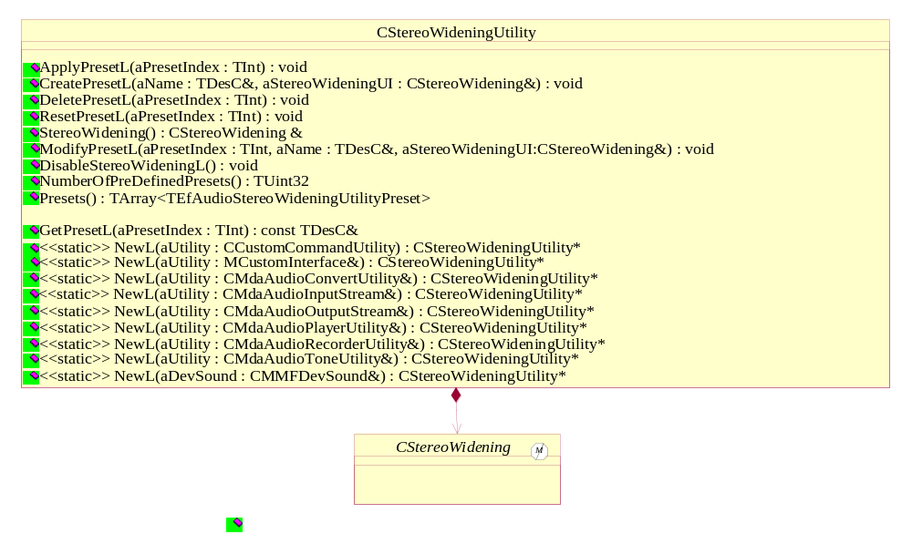
Figure 3.41 Stereo Widening Utility
Headers:
StereoWideningUtility.h
Library:
StereoWideningUtility.dll

NewL – factory methods
CStereoWideningUtility* NewL(CMMFDevSound& aDevSound);

A static constructor that creates a stereo widening utility object.
Arguments:
- CMMFDevSound& aDevSound: The DevSound associated with this effect.

Returns:
A pointer to CStereoWideningUtility.
Error handling:
This method leaves with the following typical leave codes:
- KErrNoMemory: unable to instantiate due to memory errors.
- KErrNotSupported: the effect is not supported.

CStereoWideningUtility* NewL(CMdaAudioConvertUtility& aUtility);

A static constructor that creates a stereo widening utility object.
Arguments:
- CMdaAudioConvertUtility& aUtility: The convert utility that is to be associated with this effect.

Returns:
A pointer to CStereoWideningUtility.
Error handling:
This method leaves with the following typical leave codes:
- KErrNoMemory: unable to instantiate due to memory errors.
- KErrNotSupported: the effect is not supported.

CStereoWidening* NewL(CMdaAudioInputStream& aUtility);

A static constructor that creates a stereo widening utility object.
Arguments:
- CMdaAudioInputStream& aUtility: The input stream utility that is to be associated with this effect.

Returns:
A pointer to CStereoWideningUtility.
Error handling:
This method leaves with the following typical leave codes:
- KErrNoMemory: unable to instantiate due to memory errors.
- KErrNotSupported: the effect is not supported.

CStereoWidening* NewL(CMdaAudioOutputStream& aUtility);

A static constructor that creates a stereo widening utility object.
Arguments:
- CMdaAudioOutputStream& aUtility: The output stream utility that is to be associated with this effect.

Returns:
A pointer to CStereoWideningUtility.
Error handling:
This method leaves with the following typical leave codes:
- KErrNoMemory: unable to instantiate due to memory errors.
- KErrNotSupported: the effect is not supported.

CStereoWidening* NewL(CMdaAudioPlayerUtility& aUtility);

A static constructor that creates a stereo widening utility object.
Arguments:
- CMdaAudioPlayerUtility& aUtility: The play utility that is to be associated with this effect.

Returns:
A pointer to CStereoWideningUtility.
Error handling:
This method leaves with the following typical leave codes:
- KErrNoMemory: unable to instantiate due to memory errors.
- KErrNotSupported: the effect is not supported.

CStereoWideningUtility* NewL(CMdaAudioRecordUtility& aUtility);

A static constructor that creates a stereo widening utility object.
Arguments:
- CMdaAudioRecordUtility& aUtility: The record utility that is to be associated with this effect.
Returns:
A pointer to CStereoWideningUtility.
Error handling:
This method leaves with the following typical leave codes:
- KErrNoMemory: unable to instantiate due to memory errors.
- KErrNotSupported: Effect is not supported.

CStereoWideningUtility* NewL(CMdaAudioToneUtility& aUtility);

A static constructor that creates a stereo widening utility object.
Arguments:
- CMdaAudioToneUtility& aUtility: The tone utility that is to be associated with this effect.

Returns:
A pointer to CStereoWideningUtility.
Error handling:
This method leaves with the following typical leave codes:
- KErrNoMemory: unable to instantiate due to memory errors.
- KErrNotSupported: the effect is not supported.

CStereoWideningUtility* NewL(MCustomInterface& aCustomInterface);

A static constructor that creates a stereo widening utility object.
Arguments:
- MCustomInterface& aCustomInterface: A utility that implements the MCustomInterface interface that is to be associated with this effect.

Returns:
A pointer to CStereoWidening.
Error handling:
This method leaves with the following typical leave codes:
- KErrNoMemory: unable to instantiate due to memory errors.
- KErrNotSupported: the effect is not supported.

CStereoWideningUtility * NewL(CcustomCommandUtility* aUtility);

A static constructor that creates a CStereoWideningUtility object.
Arguments:
- CcustomCommandUtility* aUtility: A utility that is to be associated with this effect.
Returns:
A pointer to a CStereoWideningUtility object.
Error handling:
This method leaves with the following typical leave codes:
- KErrNoMemory: unable to instantiate due to memory errors.
- KErrNotSupported: the effect is not supported.

ApplyPresetL
void ApplyPresetL(TInt aPresetIndex);

Used to apply the preset values.
Arguments:
- TInt aPresetIndex: The index of the preset to apply. The index is the index into the array of presets retrieved with the method Presets().

Returns:
None.
Error handling:
This method leaves with the following typical leave codes:
- KErrArgument: the argument value is out of range or invalid.

CreatePresetL
void CreatePresetL(TDesC& aName, CStereoWidening& aStereoWidening);

Creates a user-defined preset with the specified equalizer settings.
Arguments:
- TDesC& aName: The name of the user-defined preset.
- CStereoWidening& aStereoWidening: A stereo widening object configured to the values to be used in creating the user-defined preset.

Returns:
An updated list of presets is returned if the operation is successful.
Error handling:
This method leaves with the following typical leave codes:
- KErrArgument: the argument value is out of range or invalid.
- KErrNoMemory: an out of memory error encountered.

DeletePresetL
void DeletePresetL(TInt aPresetIndex);
Deletes the specified user-defined preset.
Arguments:
- TInt aPresetIndex: The index into the preset array retrieved with the method Presets().

Returns:
None.
Error handling:
This method leaves with the following typical leave codes:
- KErrArgument: the argument value is out of range or invalid.

DisableStereoWideningL
void DisableStereoWideningL ();

Deletes the specified user-defined preset.
Arguments:
Returns:
None.
Error handling:

GetPresetL
const TDesC& GetPresetL (TInt aPresetIndex);

Retrieves the Preset values from the Central Repository and stores it in the Equalizer Object. Also it returns the Name of the retrieved Preset.
Arguments:
- TInt aPresetIndex: The index of the preset to retrieve. The index is the index into the array of presets retrieved with the method Presets().

Returns:
Name of the Retrieved Preset.
Error handling:
This method leaves with the following typical leave codes:
- KErrArgument: the argument value is out of range or invalid.

ModifyPresetL
void ModifyPresetL(TInt aPresetIndex, TDesC& aName, CStereoWidening& aStereoWidening);

Modifies a user-defined preset with the specified equalizer settings.
Arguments:
- TInt aPresetIndex: The index into the user-defined preset array retrieved with the method Presets().
- TDesC& aName: The name of the preset to be used in modification.
- CStereoWidening& aStereoWidening: A stereo widening object configured to the values to be used in modifying the preset.

Returns:
None.
Error handling:
This method leaves with the following typical leave codes:
- KErrArgument: the argument value is out of range or invalid.
- KErrNoMemory: an out of memory error encountered.

NumberOfPreDefinedPresets
TUint32 NumberOfPreDefinePresets() const;

Gets the number of predefined presets.
Arguments:
None.
Returns:
The number of predefined presets.

Presets
TArray<TEfAudioStereoWideningUtilityPreset> Presets();

Gets the list of preset names.
Arguments:
None.
Returns:
An array of all the preset names (pre-defined and user-defined). The pre-defined presets are in the beginning of the list.

ResetPresetL()
void ResetPresetL(TInt aPresetIndex);

Resets the specified preset.
Arguments:
- TInt aPresetIndex: The index of the preset to reset. The index is the index into the array of presets retrieved with the method Presets().

Note: If the preset index points to a preset that cannot be reset, the method will leave with KErrArgument.
Returns:
None.
Error handling:
This method leaves with the following typical leave codes:
- KErrArgument: the argument value is out of range or invalid.

StereoWidening
CStereoWidening& StereoWidening();

Gets the reverb object.
Arguments:
None.
Returns:
A reference to a stereo widening object.

Index

List of constants and enumerations

Audio effect events
The following list defines the events that can be generated by all audio effects. Specific effects inherit these events and define effect-specific events that can be generated. Therefore, the set of events that can be generated by a particular effect is the union of the audio effects events and the effect-specific events.

Event | Value
KEnabled | 1
KDisabled | 2
KEnforced | 3
KNotEnforced | 4
KLostUpdateRights | 5
KGainedUpdateRights | 6
KSpecificEffectBase | 20

Bass boost effect events
There are no effect-specific events besides the audio effect events.

Doppler effect events
There are no effect-specific events besides the audio effect events.

Audio equalizer effect events
Event | Value
KBand1Changed | 1 + KSpecificEffectBase
KBand2Changed | 2 + KSpecificEffectBase
KBand3Changed | 3 + KSpecificEffectBase
KBand4Changed | 4 + KSpecificEffectBase
KBand5Changed | 5 + KSpecificEffectBase
KBand6Changed | 6 + KSpecificEffectBase
KBand7Changed | 7 + KSpecificEffectBase
KBand8Changed | 8 + KSpecificEffectBase
KBand9Changed | 9 + KSpecificEffectBase
KBand10Changed | 10 + KSpecificEffectBase
KBand11Changed | 11 + KSpecificEffectBase

Distance attenuation effect events
There are no effect-specific events besides the audio effect events.

Location effect events
Event | Value
KLocationCartesianChanged | 1 + KSpecificEffectBase
KLocationSphericalChanged | 2 + KSpecificEffectBase

Orientation effect events
Event | Value
KOrientationChanged | 1 + KSpecificEffectBase
KOrientationVectorsChanged | 2 + KSpecificEffectBase

Environmental reverb effect events
Event | Value
KDecayTimeChanged | 1 + KSpecificEffectBase
KDecayHFRatioChanged | 2 + KSpecificEffectBase
KDensityChanged | 3 + KSpecificEffectBase
KDiffusionChanged | 4 + KSpecificEffectBase
KRefectionsDelayChanged | 5 + KSpecificEffectBase
KReflectionsLevelChanged | 6 + KSpecificEffectBase
KReverbDelayChanged | 7 + KSpecificEffectBase
KReverbLevelChanged | 8 + KSpecificEffectBase
KRoomLevelChanged | 9 + KSpecificEffectBase
KRoomHFLevelChanged | 10 + KSpecificEffectBase

Stereo widening effect events
Event | Value
KStereoWideningChanged | 1 + KSpecificEffectBase

