S60
MemSpy
User’s Guide

Team name | Author
D RD SD SSS Dynamic Analysis Tools FI | Nokia Corporation

Change history:

Version | Date | Status | Comments
1.0 | 02.12.2009 | Approved

Table of contents:

1. Document control 5
1.1 References 5
1.2 Documentation conventions 5
1.3 Abbreviations and definitions 5
2. Introduction 6
2.1 Features of MemSpy 6
2.2 Order of tasks 6
2.3 Main use cases 7
3. Installing MemSpy 9
3.1 Installation 9
3.2 Setting data log output 9
4. MemSpy data 10
4.1 Common menu options 10
4.1.1 View 10
4.1.2 Phone information 11
4.1.3 Automatic capture 11
4.2 Processes & threads 12
4.2.1 General 14
4.2.2 Heap 14
4.2.3 Stack 16
4.2.4 Chunks 17
4.2.5 Code segments 18
4.2.6 Open files 19
4.2.7 Active objects 19
4.2.8 Handles to other threads 20
4.2.9 Handles to other processes 20
4.2.10 Servers running in thread 20
4.2.11 Client <-> server connections 21
4.2.12 Semaphores 21
4.2.13 References this thread 21
4.2.14 References this process 21
4.2.15 Mutexes 22
4.2.16 Timers 22
4.2.17 Logical DD channels 22
4.2.18 Change notifiers 22
4.2.19 Undertakers 22
4.2.20 Logical device drivers 22
4.2.21 Physical device drivers 22
4.2.22 Memory tracking 23
4.3 RAM info 23
4.4 ROM info 24
4.5 Font and bitmap server 25
4.6 Servers 26
4.7 Chunks 27
4.8 Code segments 27
4.9 Open files 28
4.10 System configuration 28
4.11 Kernel 29
4.12 System-wide memory tracking 31
4.13 Process-specific memory tracking 34
4.14 Drive summary 34
4.15 ECom 34
4.16 Window groups 35
5. Running MemSpy functions from the command line 37
5.1 Command line commands 37
5.2 Command line command parameters 38
5.3 Running batch file 39
6. Examples 40
6.1 Viewing specific thread heap information 40
6.1.1 Heap summary information 42
6.1.2 Heap cell listing 43
6.1.3 Heap data 44
6.2 Capturing the memory state of the entire device 45
6.3 Using MemSpy’s client-server interface 45
Appendix A: Understanding Symbian OS Heaps 47
Appendix B: Understanding Symbian OS stacks 52
Appendix C: SWMT change details 54

Document control

References
- MemSpy Carbide.c++ Extension documentation | Available in the MemSpy Carbide.c++ Extension help.
- Symbian Developer Community | http://developer.symbian.org/wiki/index.php/Main_Page
- Symbian OS documentation | http://developer.symbian.com/main/documentation/
- HAL documentation | http://developer.symbian.com/main/documentation/
- Publish & Subscribe documentation | http://developer.symbian.org/

Documentation conventions
Code is shown with the Courier New font.

Abbreviations and definitions
HAL | Hardware Abstraction Layer
SIS | Symbian Installation System

Introduction
MemSpy is a tracing application running on a Symbian device. MemSpy is typically used to narrow down the field of investigation. Once you know where the problem is (e.g. the thread or process), you can use other tools to perform a more detailed inspection.

Features of MemSpy
With MemSpy, you can find out the following:
- RAM usage of a thread or a process.
- Amount of stack each thread has.
- Active objects for a given thread.
- Files that are open in a system or files that have been opened by a thread.
- Device RAM/ROM configuration.
- Servers that are running (and their sessions).
- Any memory chunks.
- Heap memory changes over time.
- Bitmaps loaded by the font and bitmap servers.
- Track system changes to memory and resource usage.

Order of tasks
The following procedure outlines a basic order of tasks performed when using MemSpy:
- Start MemSpy.
- (Optional) Select an output mode by selecting Options > Tools > Change output mode, and select to output either to file or debug trace.
- Select a category to be inspected. The available categories are:
- Processes & Threads (see Section 4.1).
- RAM Info (see Section 4.3).
- ROM Info (see Section 4.4).
- Font & Bitmap Server (see Section 4.5).
- Servers (see Section 4.6).
- Chunks (see Section 4.7).
- Code Segments (see Section 4.8).
- Open Files (see Section 4.9).
- System Configuration (see Section 4.10).
- Kernel (see Section 4.11).
- System-Wide Memory Tracking (see Section 4.12).
- Process-Specific Memory Tracking (see Section 4.13).
- Drive Summary (see Section 4.14).
- ECom (see Section 4.15).
- Window Groups (see Section 4.16).
- Press the Select key and view more details of the selected category.
- (Optional) Transfer the log file(s) to a PC for analysis in the MemSpy Carbide.c++ Extension (see reference document [1]).

Main use cases
This section describes some typical use case scenarios that explain the types of data that MemSpy can trace.
Basic system characteristic information
- Use RAM Info. See Section 4.3.
- Use ROM Info. See Section 4.4.
- Use System Configuration. See Section 4.10.

IAD version verification
- Use the Code Segment Details main menu item. See Section 4.8.
- Use the Code Segment Details view from any individual thread/process. See Section 4.2.5.

Process and thread characteristics
- Useful when you want to highlight inefficiencies that are otherwise unknown.
- Use the Process & Threads views, e.g. General thread properties etc, active objects, timers, session handles etc. See Section 4.1.

Memory usage overview
- Useful when you want to get a quick snapshot of how efficient your software is in terms of memory usage.
- Use the Process & Threads > Heap view. See Section 4.2.2.
This shows the overall heap consumption, which may be surprisingly large. It may also raise interesting questions (e.g. why are there so many allocated or free cells).

Detailed memory usage investigation
- Use the Process & Threads > Heap view, but this time actually dumping the heap data or heap cell listing for detailed analysis. See Section 4.2.2.
The cell listing provides a basic textual list of heap cells and their corresponding sizes. It might be useful to get a quick feel for whether the heap usage is excessive in any given heap cell.

Stack usage/size verification
- Use the Process & Threads > Stack view. See Section 4.2.3.
The Stack view shows how much memory has been allocated towards each thread's user-mode stack. It also shows how close the thread is to using that stack space. This can give you some idea of potential for crash due to running out of stack, but only after you have actually run through a series of test cases that might exercise their thread to use the maximum amount of stack.

System memory characteristics
- Targeted at testers and platform integration and system architects because these items operate on a system-wide level, that is, they are not targeted towards any specific process or thread.
- Use the Options > Phone Information > General > Summary view about every thread and process in the OS.
- Use the Options > Phone Information > Heap > Compact Summary view to view an XML-formatted list of heap statistics for the entire OS.
- Use the Font & Bitmap Server view to show all loaded fonts and bitmaps. Fonts and bitmaps typically use a lot of memory and often show unexpected results.
- MemSpy has a supported API which allows you to programmatically perform some operations, such as capturing heap data or capturing kernel objects. This feature might be useful in investigating targeted defects (such as checking properties of a specific thread or process) and platform problems. A platform problem could exist in a middleware layer, and therefore affect all threads that depend upon it, or it could be a specific problem in an unidentified thread or process.
- MemSpy.exe allows the MemSpy operations to be performed from command line with specific command line arguments. This is especially useful in long term testing; test scripts, that can drive MemSpy, can be created.

Installing MemSpy

Installation
The \memspy\sis\ folder contains unsigned pre-built ARMv5 binaries of the MemSpy console UI, command line interface, engine and driver. The \memspyui\sis\ folder contains unsigned pre-built ARMv5 binaries of the MemSpy Symbian UI. To install MemSpy on a Symbian device, you need to sign these. Alternatively, you can install MemSpy manually by adding binary files on the ROM image of the target hardware.
After installation, the application appears in the Installed folder in the Symbian device menu.
Note: MemSpy works also in the emulator, although the functionality relating to the stack is restricted. The emulator uses Windows native stacks, and therefore it is not possible to obtain the same level of information as with Symbian OS native stacks. Furthermore, information relating to code segments is not available on the emulator for similar reasons.

Setting data log output
Before using MemSpy, consider how you want to log data. MemSpy supports two data output types: to XML file and via RDebug, which requires tracing hardware.
You can change the output type by selecting Options > Tools > Change output mode.
Note: This setting is global. This means that if for example File output is enabled, this affects all outputs.
MemSpy stores file output to \MemSpy\ on a memory card or on the device memory. MemSpy stores the output to the highest writable drive letter it finds, starting at Y: and working back towards C:.

MemSpy data
When MemSpy starts, the main menu with data categories is presented:
- Processes & Threads – displays a list of all running processes on the phone. Selecting a process allows you to view its thread(s). Each thread features a number of additional informative views.
- RAM Info – displays information about the RAM usage on the device.
- ROM Info – displays information about the ROM image that flashed to the device.
- Font & Bitmap Server – displays information about all the bitmaps that are loaded within the Font & Bitmap Server. You can view information about bitmaps, view a slideshow, or export the bitmaps to a memory card for viewing on a PC.
- Server List – displays a list of all the running servers on the device. Selecting a server displays a thread view for the thread in which the server resides.
- Chunk List – displays a list of all of the allocated chunks on the device. Selecting a chunk provides more detailed information about it.
- Code Segment List – displays a list of all the kernel-known Code Segments. Selecting an individual code segment displays more detailed information, such as size, global data size, or capabilities.
- Open Files – displays a list of all the files that are currently open on the device. The list is not filtered by thread. However, within the thread view, there is a similar feature which shows only the files that are opened by a particular thread.
- System Configuration – displays information about the system.
- Kernel – displays information about kernel objects, events, and heaps.
- System Wide Memory Tracking – allows you to track and view system wide memory information.
- Thread Specific Memory Tracking – allows you to track and view memory usage per thread.
- Drive Summary – displays information about the installed drives on the device.
- ECom – displays information about the implementations of specific ECom interfaces.
- Window Groups – displays information about window groups.

Common menu options
Each of the various MemSpy views displays information in lists, allowing you to choose and inspect items.
Some items feature context-specific menu options that are only displayed when a certain view is on-screen. Other options are available all the time via the normal Symbian Options menu.
This section briefly describes the menu options that are always available, irrespective of the currently displayed view.

View
The View menu usually provides a Refresh item that reconstructs the contents of the view.
Additionally, depending on the currently focused list box item, you may Open the item to display further information.

Phone information
MemSpy supports powerful heap and stack interrogation functions that can be used to list useful information about specific thread and additionally the device as a whole. This information is logged either to file or over the RDebug tracing channel.
This section describes each of the available device-wide logging options. All of these options operate over every thread and process in the OS (excluding MemSpy, and any kernel threads).
- General – provides general process and thread overview information.
This information includes, but is not limited to:
- Process name and properties (UIDs etc.)
- Child threads
- Code segments that are mapped into a process
- Chunk information for a thread
- Heap > Detailed Summary – provides summary information about the heap associated with a thread.
This information includes, but is not limited to:
- Heap size
- Heap (chunk) size
- Number of allocated cells
- Number of free cells
- Heap base address
- Fragmentation information
- Size of the largest allocated cell
- Size of the largest free cell
- Heap > Compact Summary – similar to Heap > Detailed Summary, but in XML format for an easy import to PC.
- Heap > Cell Listing – provides a list of every single heap cell that is allocated in a given thread. The listing contains information such as the size of the cell, whether it is allocated or free and (in the allocated case), any associated vTable information.
- Heap > Data (Binary) – allows the entire heap data to be exported from the selected thread. This data can then be analysed in conjunction with the symbol file (and any code segment information) to allow visual inspection of the heap layout.
- Stack > Detailed Summary – provides summary stack information for the given thread.
This includes information such as:
- The total stack size
- Currently used stack data size
- High watermark stack usage figure
- Stack > Compact Summary – similar to Stack > Detailed Summary, but in XML format for an easy import to PC.
- Stack > User Stacks (Binary) – like heap data, also stack data can be traced for any thread. This option dumps the user-side stack data.
- Stack > Kernel Stacks (Binary) – similar to User Stack data, but this traces the kernel-side stack data for a given thread.

Automatic capture
The Automatic Capture menu provides a mechanism that allows you to automatically perform one of the previous items after a certain elapsed period.
For example, it may be desirable to dump the heap info for the device every 5 minutes. This would permit certain use cases to be carried out.
There are three further sub-menu items associated with this option:
- Enable / Disable toggle – enable or disable auto-capture.
- Timer period – configure the period between auto-capture attempts (in seconds).
- Operation type – select the auto-capture operation type.

Processes & threads
To view information about processes and threads, select Processes & Threads in the MemSpy main view.
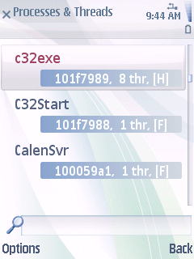
Figure 4.1 Processes & Threads view
Information about processes is presented on two lines.
- The top line displays the process name (e.g. c32exe).
- The lower line displays the most derived UID of the process, the number of child threads, and information about the process priority.

Process priority | Suffix
EPriorityLow | [L]
EPriorityBackground | [B]
EPriorityForeground | [F]
EPriorityHigh | [H]
EPriorityWindowServer | [WS]
EPriorityFileServer | [FS]
EPriorityRealTimeServer | [RTS]
EPrioritySupervisor | [SUP]
anything else | [?]

The following context-specific options are available for processes:
- Process > Info > Summary – generates a summary for this process to the chosen output medium.
- Process > Info > Handles – for every thread in the process, lists the contents of each subview.
- Process > Sort > By Id, By Name, By Number of Threads, By Code Segments, By Heap Usage, and By Stack Usage – changes the process listing order. By default, the process listing is sorted by process name.
- Process > End > Kill, Panic, and Terminate – kills, panics, or terminates an entire process.

To view information about the threads that a process owns, select a process and press the Select key.
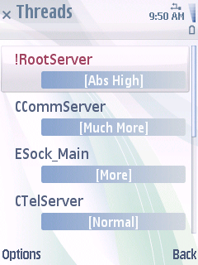
Figure 4.2 Threads view
The Threads view shows a list of all the threads that are owned by the selected parent process.
Information about threads is presented on two lines:
- The top line displays the thread name.
- The lower line displays the thread priority.

Thread priority | Suffix
EPriorityNull | [Null]
EPriorityMuchLess | [Much Less]
EPriorityLess | [Less]
EPriorityNormal | [Normal]
EPriorityMore | [More]
EPriorityMuchMore | [Much More]
EPriorityRealTime | [Real Time]
EPriorityAbsoluteVeryLow | [Abs Very Low]
EPriorityAbsoluteLow | [Abs Low]
EPriorityAbsoluteBackground | [Abs Bckgnd]
EPriorityAbsoluteForeground | [Abs Foregnd]
EPriorityAbsoluteHigh | [Abs High]
anything else | [Unknown Pri.]

To view detailed information about a thread, select it and press the Select key. Note that some of these items are only available on actual target hardware.
The following sections explain in more detail the thread objects you can view.

General
The General view shows basic overview information about the selected thread:
- Thread Id – displays the Symbian OS identifier of the thread.
- Process Id – displays the Symbian OS identifier of the process.
- SID – displays the Symbian OS Secure ID of the thread (obtained from the parent process).
- VID – displays the Symbian OS Vendor ID of the thread.
- Thread Priority – displays the Symbian OS priority of the thread.
- Process Priority – displays the Symbian OS priority of the parent process.
- Request Count – displays the thread’s request semaphore count. The request semaphore is created when a thread is created, and it is used to support asynchronous requests. A negative value implies that this thread is waiting for at least one asynchronous request to complete.
- Process Handles – displays the number of handles open by the parent process.
- Thread Handles – displays the number of handles open by this thread.
- Num. Proc. (Using) – displays the number of processes referencing this thread.
- Num. Thread (Using) – displays the number of threads referencing this thread.
- Attributes – displays the value of RThread::Attributes.
- CPU Time (us) – displays the value of RThread::GetCputime.
- Exit Type – shows whether the thread has ended and, if it has ended, returns how it ended.
- R00–R12 – displays ARM registers described by TArmRegSet. For details, see the ARM technical reference manual for your processor architecture.
- SP – displays the Stack Pointer Register (R13) described by TArmRegSet. For details, see the ARM technical reference manual for your processor architecture.
- LR – displays the Link Register (R14) described by TArmRegSet. For details, see the ARM technical reference manual for your processor architecture.
- PC – displays the Program Counter Register (R15) described by TArmRegSet. For details, see the ARM technical reference manual for your processor architecture.
- Flags – displays flags described by TArmRegSet. For details, see the ARM technical reference manual for your processor architecture.
- DACR – displays the thread’s register values at the time of measurement. Unless the thread was actively executing code, this likely indicates it is sleeping.

Heap
Background information about default Symbian OS heaps is available in Appendix A.
The Heap view shows statistics and useful summary information about the selected thread:
- Heap type – displays the type of allocator (RAllocator) in use by the thread. MemSpy only supports the analysis of RHeap allocators.
- Heap size – displays the amount of memory that is currently reserved for the heap.
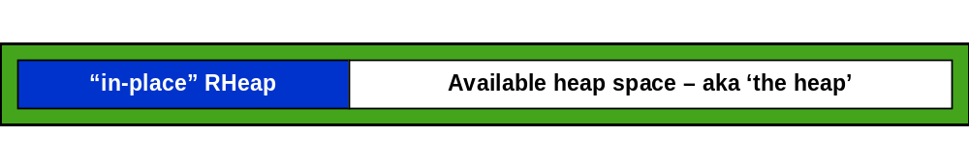
Figure 4.3 Heap chunk
The heap size is shown in white in Figure 4.3.
- Heap base address – displays the memory address (virtual, unless the EKA2 Direct Memory Model is being used) of the chunk. For more information, see your base port reference.
- Shared – indicates whether or not the heap is shared between multiple threads in a process. If a thread has its own heap, the value of Shared is No.
- Chunk size – displays the total amount of memory that is needed to hold both the allocated/free heap cells and the RHeap object itself. The chunk size is shown in green in Figure 4.3.
You can obtain the overhead of the RHeap object by subtracting one from the other – the overhead is usually a little over 1kb.
- Alloc count – displays the number of allocated cells that exist within this heap.
- Free count – displays the number of free cells that exist within the heap object.
- Biggest alloc. – displays the size of the single largest allocated heap cell.
- Biggest free – displays the size of the cell which has the largest free space, i.e. a non-allocated cell. The logic used to identify this cell deliberately does not include the free slack space at the end of the heap.
- Total alloc. – displays the sum of all the allocated heap cells.
- Total free – displays the sum of all the free heap cells (excluding the slack space).
- Slack free space – displays the amount of free space that resides at the very end of the heap. This free space is typically used when the heap is compressed – however, it is rounded to the nearest page, so not all the space is usable.
- Fragmentation – displays how much of the heap (as a percentage) currently contains free cells.
- Header size (A) and Header size (F) – these fields display the overhead for allocated (A) and free (F) cells respectively. Every heap cell contains some metadata, or bookkeeping overhead.
- Overhead (alloc), Overhead (free), Overhead (total), and Overhead – display how much of the heap is used in order to accommodate cell headers.
For allocated cells, the header length is different depending on whether a UDeb or URel version of EUSER is used. For a UDeb version, the allocated cell header length is 12 bytes (RHeap::SDebugCell). For URel, the length is 4 bytes.
For free cells, the header consists of a cell length and a pointer to the next free cell (RHeap::SCell).
- Min. length and Max length – display the minimum and maximum sizes defined for the heap. A heap cannot grow larger than its maximum size, and any attempt to allocate memory beyond this boundary will fail with KErrNoMemory irrespective of how much actual memory the device still has free.
- Debug Allocator Library – indicates the type of allocator library (debug or release) which changes the size of the bookkeeping metadata (header). This is just an indication of whether you are using a UDeb or URel version of euser.dll or ekern.exe.

The following context-specific options are available for heaps:
- Heap > Info – generates a heap information summary to the chosen output medium.
- Heap > Data > Cell list – generates a list of all the cells in the heap to the chosen output medium.
- Heap > Data > Heap data – generates the entire heap’s data to the chosen output medium.

Stack
Background information about Symbian OS stacks is available in Appendix B.
The Stack view shows information about the current thread’s stack. This information is obtained by the MemSpy driver. It captures the stack data for the current thread, parses it and then provides statistics about the stack to the MemSpy engine.
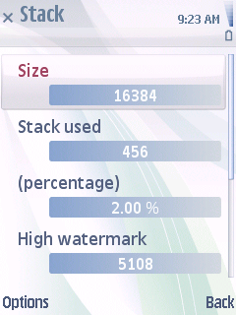
Figure 4.4 Stack view
This section briefly describes the individual fields that are displayed within the view.
- Size – displays the size of the stack in bytes. Note that the stack is allocated during thread creation, and it cannot be resized.
- Stack used – displays the amount of stacks in use (device hardware only), calculated by the MemSpy’s driver. Essentially, the driver obtains the current stack pointer position for the thread and then uses this value to work out how much of the stack has been occupied with real stack data. In case you have deeply nested function calls (such as a repeatedly nested active scheduler), you can use this data as an indication of a problem (that is, the stack usage always seems quite high).
- (percentage) – displays the stack used as a percentage of the total available stack size (device hardware only).
- High watermark – displays the peak fill point for the stack data. A stack is filled with magic rune during its creation, and the magic rune provides a reasonably accurate means of identifying how much stack has actually been used at its peak. The stack fills upwards, and when data is written to the stack it is typically initialized with a value that is something other than the magic rune. The MemSpy driver captures the entire stack data, then iterates through the data looking for the first 32 bits that are not equal to the magic rune. This location can be thought of a peak fill point for the stack data, that is, the high watermark.
If the high watermark is very close to the size of your stack, then it may indicate that your code is in danger of running out of stack space. The best solution to this problem is to study your code and see if you make excessive use of large stack-based data structures or nested (recursive) function calls. You should rewrite the affected code so that it uses less stack, for example, by using dynamic (heap) allocation instead.
Some common causes of high stack usage are things such as (but not limited to) the following:
- Descriptors – in particular TBuf<> descriptors use twice as much stack as you might expect, and an overhead for the descriptor classes themselves. This is because each character is represented by a 16-bit value.
- Stack-based arrays – for example, declaring a fixed, c-style array of integers on the stack.
- TFileName objects – these are typedef versions of TBuf<256> which uses about 520 bytes of memory per instance. These are a common cause of high memory usage in general, in both heaps and stacks. In general, it is suggested that you use an HBufC object to hold a filename rather than a fixed length T-descriptor. A TFileName requires about 520 bytes of RAM irrespective of the filename length. HBufC allocates a descriptor only the required length, rounded to the nearest 32 bits.
- Using TParse when TParsePtrC would be sufficient – other common high stack users are TParse and TFindFile. These both tend to be quite large data structures (in particular, TParse contains a complete filename buffer as a data member) and therefore can quickly gobble stack. TParsePtrC points to another descriptor and is therefore much more memory efficient.
The high watermark information is only available on device hardware. On the emulator, the native PC operating system is responsible for stack management, and this prevents MemSpy from obtaining any sensible information.
- (percentage) – displays the high watermark as a percentage of the total stack size (device hardware only).
- Base address – displays the virtual address that the stack has been mapped to.
- Current pointer – displays the current position of the stack pointer within the stack itself. Essentially, the stack pointer is the current position where further stack data is written (device hardware only).

The following context-specific options are available for stacks:
- Stack > Info – generates a stack summary to the chosen output medium.
- Stack > Data > User stack data – generates the entire user-side stack data to the chosen output medium.
- Stack > Data > Kernel stack data – generates the entire kernel-side stack data to the chosen output medium.

Chunks
The Chunks view shows a list of all the chunks that are currently mapped into the owning process. Chunk mappings actually occur at the process level, and therefore the list shown is not thread-specific.
In most cases, chunks are used to share data between multiple processes without having to copy the data around via IPC. For detailed description of chunks, see reference document [3].
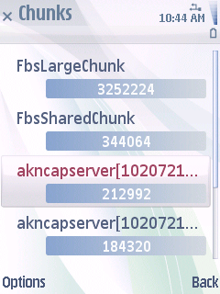
Figure 4.5 Chunks view
The screenshot in Figure 4.5 is from AknCapServer, which has a default $HEAP chunk and connections to several other chunks as well. AknCapServer needs access to the Symbian Font & Bitmap Server chunks. This FBServ chunk mapping occurs automatically by the Font & Bitmap Server framework.
The second line of each chunk is the size of the chunk itself in bytes.
Selecting a chunk provides further details about the chunk:
- Name – displays the name of the chunk.
- Type – displays the type of the chunk. MemSpy can only detect certain kernel chunks.
- Owning process – displays the process that is notionally responsible for the chunk. This is essentially the creator of the chunk.
- Address – displays the base address of the chunk, most often a process-specific address.
- Size – displays the reported size of the chunk.
- Max. size – displays how large the chunk is permitted to grow to, assuming it is enlarged.
- Attributes 1 and 2 – display kernel chunk attributes. For description of available attributes, refer to the kernel documentation.

Code segments
Code segments are the means by which binary code is represented by the Symbian OS kernel. For example, a code segment (DCodeSeg) can be created to represent an EXE or a DLL file.
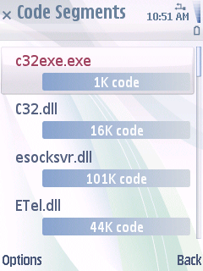
Figure 4.6 Code Segments view
The Code Segments view shows a list of all the binaries that are mapped to the address space of the current process:
- The top line displays the binary name.
- The lower line displays the size of the code segment.

Selecting a code segment provides further information:
- Name – displays the name of the binary.
- UIDs #1 to # 3 – display standard UIDs that are specified at the build time.
- Module Version – displays the module version, represented in hex.
- SID – displays the Secure ID.
- VID – displays the Vendor ID.
- Code Size, Total Data Size, Text Size Data Size, and BSS Size – may be displayed, depending on the configuration of your binary. Entries with non-zero data sizes tend to only exist for binaries that use global data or global constants that are not forced into the .constdata section. Note that each byte of global data results in a minimum of 4k (1 page) of RAM being used. It is therefore advised that you avoid global data where possible, for example by designing your code to not use global variables.
- Entrypoint Veneer and File Entrypoint – used internally by the file server and kernel when the code segment is created.
- Dependency Count – displays the number of RAM-loaded dependent DLL files to which this binary refers.
- ROM Code Load Addr. – used internally by the kernel.
- Capabilities # 1 to # 11 – display the capabilities that the binary has specified in its MMP file.

Open files
The Open Files view shows a list of files that the thread in question currently has open according to File Server.

Active objects
The MemSpy Active Objects view shows a list of the active objects that are currently registered with the active scheduler within the selected thread. The view is only activated if the following applies:
- The thread is using a normal RHeap heap,
- The thread contains an installed active scheduler, or
- The scheduler contains registered active objects.

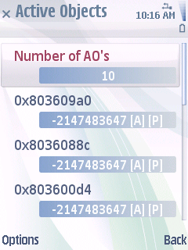
Figure 4.7 Active Objects view
Information about active objects is presented on two lines:
- The top line displays the address of the active object within the thread.
- The lower line displays the current request status value of the active object.
The [A] and [P] postfixes represent whether the object is active and whether it has an asynchronous request pending.

Selecting an active object provides further details about the object:
- Address – displays the object’s address within the thread’s heap.
- VTable – displays an estimate for the object’s vTable. You can look this address up in your ROM symbol file to find the type of the selected object.
- Status value – displays the current CActive::iStatus.Int() value.
- Is active – indicates whether or not the object has called SetActive().
- Request pending – indicates whether or not an asynchronous request has been issued.
- Priority – displays the active object’s priority at which the object was registered with the scheduler. This value affects the order in which the objects are displayed.

The following context-specific Option is available for active objects:
- Active Object > Output Listing – generates a listing of the active objects to the currently specified debug channel.

Handles to other threads
This view shows the other threads that the currently selected thread refers to.

Handles to other processes
This view shows the other processes that the currently selected thread refers to.

Servers running in thread
The Servers Running in Thread view shows a list of any servers that have been created within the currently selected thread. This view extends three levels deep.
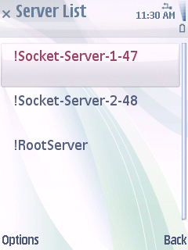
Figure 4.8 Server List view
Server List
The top-level view shows a list of all the servers that are running within the currently selected thread.
Selecting a server provides details about the server.
Server Details
The Server Details view shows the following items:
- Server Type – indicates whether or not the server supports shareable sessions.
- Connected Sessions – displays the number of client connections to this server.
- View Sessions – displays a list of all the threads that have connections to this server.

Connected Session List
This view shows the process and thread name corresponding to the client connections to the server selected previously.
Selecting a particular client connection takes you to the Thread view of the selected thread.

Client <-> server connections
The Session List view shows a list of all server connections that exist within the selected thread.
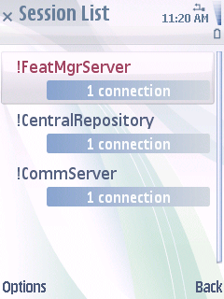
Figure 4.9 Session List view
Information about server connections is presented on two lines:
- The top line displays the server name.
- The lower line displays information about whether the RSessionBase-derived handle can be shared with other threads within your process. Additionally, if there are several connections to a particular server, the connection count appears in brackets.

Most application-level components have many sessions imposed by the framework. These always include at least the following:
- File Server connection, created by Control Environment (ConE).
- Window Server connection, created by Control Environment (ConE).
- Font & Bitmap Server connection, created by the Window Server client-side code.
- View Server connection, created by Control Environment (ConE).

Different UI frameworks also impose other connections, such as the following:
- CDLServer
- AknIconServer
- AknSkinServer

Semaphores
This view shows the semaphores that the currently selected thread owns or references.

References this thread
This view shows the threads that refer to this thread.

References this process
This view shows the processes that refer to this process.

Mutexes
This view shows the mutexes that this thread owns or references.

Timers
The Timers view shows a list of the timer objects that reside within the currently selected thread.
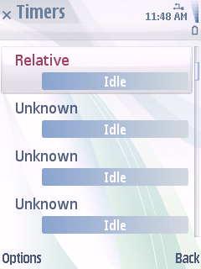
Figure 4.10 Timers view
Information about timers is presented on two lines:
- The top line displays the timer type. The Symbian OS kernel supports the following timer types:
- Relative – a timer that expires in a number of system ticks from an initial starting time.
- Absolute – a timer that expires at a specific future time.
- Inactivity – a timer that expires after a user period of inactivity.
- High Resolution – a fast ticking timer.
- Unknown – an unknown or uninitialized timer.
- The lower line displays the status of the timer.

Logical DD channels
This view shows any logical channel connections to the device drivers.

Change notifiers
This view shows the change notifier objects (RNotifier) that the currently selected thread owns.

Undertakers
This view shows the RUndertaker objects that the currently selected thread owns.

Logical device drivers
This view shows the logical device drivers that the currently selected thread implements.

Physical device drivers
This view shows the physical device drivers that the currently selected thread implements.

Memory tracking
Once tracking is turned on, the Memory Tracking view outputs to log or trace any memory events that relate to this process. For example, as heap chunks change size, or threads are created or destroyed, these events (and associated memory impact) are recorded to log.
This feature is similar to the system-wide memory tracker, however, it focuses more on chunks and is targeted towards one or more processes rather than the entire device.

RAM info
The RAM Info view shows information about the RAM status of the device.
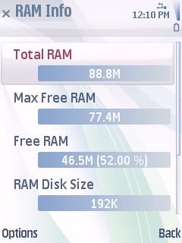
Figure 4.11 RAM Info view
- Total RAM – displays the amount of RAM that there is available on the device. In NAND devices this figure is less than the physical RAM size because the RAM allocated to the core image is removed from the available RAM prior to the Symbian OS kernel starting.
- Max Free RAM – displays the maximum amount of free RAM in the Symbian operating system. This figure is slightly less than the total RAM in cases where a dynamic RAM-based drive is mounted. In Symbian devices, this is typically the D:\ drive.
- Free RAM – displays the amount of currently free RAM available to the OS.
- RAM Disk Size – displays the size of the internal disk, that is, the RAM drive.
- Max RAM Disk Size – displays how large the RAM disk is permitted to get before it is pronounced “full”.
- Memory Page Size – displays the memory page size. The physical RAM is usually allocated in a multiple of the page size. This is usually 4 kb.

ROM info
The ROM Info view shows information about the currently flashed ROM image.
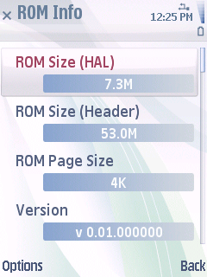
Figure 4.12 ROM Info view
- ROM Size (HAL) – displays the size of the ROM image, obtained from the HAL.
- ROM Size (Header) – displays the size of the ROM image according to the ROM image header.
- ROM Page Size –see the TRomHeader and TRomImageHeader documentation in reference document [2].
- Version – displays a version number that indicates the ROM image at ROMBUILD time.
- Timestamp – displays a timestamp that indicates when the ROM image was built.
- Address Range – see the TRomHeader and TRomImageHeader documentation in reference document [2].
- Primary File Address – see the TRomHeader and TRomImageHeader documentation in reference document [2].
- Secondary File Address – see the TRomHeader and TRomImageHeader documentation in reference document [2].
- Checksum – displays a checksum of the ROM image.
- Kernel Config. Flags – see the TRomHeader and TRomImageHeader documentation in reference document [2].
- PlatSec Enforcement – see the TRomHeader and TRomImageHeader documentation in reference document [2].
- PlatSec Diagnostics – see the TRomHeader and TRomImageHeader documentation in reference document [2].
- PlatSec Process Isolation – see the TRomHeader and TRomImageHeader documentation in reference document [2].
- Enforce \Sys\Bin – see the TRomHeader and TRomImageHeader documentation in reference document [2].
- Section Header Address – see the TRomHeader and TRomImageHeader documentation in reference document [2].
- Compressed Size – displays the compressed image size.
- Uncompressed Size – displays the uncompressed image size.
- Disabled Caps. #1 and #2 – display any disabled Platform Security capabilities.
- Trace Mask. #1 to #8 – display kernel trace mask.

Font and bitmap server
The Font & Bitmap Server is responsible for managing access to system-wide bitmap objects (CFbsBitmap). These objects are used widely throughout the OS, and they typically occupy large amounts of system RAM.
Overall Bitmap Listing
This view shows a list of all the currently loaded bitmaps.
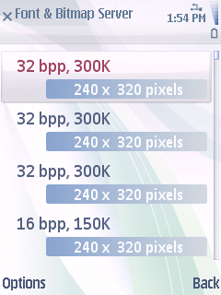
Figure 4.13 Font & Bitmap Server view
Information about fonts and bitmaps is presented on two lines:
- The top line displays information about the colour depths and the size (in bytes) of the bitmap.
- The lower line displays the dimensions of the bitmap (in pixels).

Selecting a bitmap provides further information:
- View Bitmap – allows you to see an on-screen preview of the image.
- Dimensions – displays the size of the bitmap in pixels.
- Handle – displays the unique reference number associated with this bitmap. This handle may be used to duplicate the bitmap (see CFbsBitmap::Duplicate).
- In ROM? – indicates whether or not the bitmap is read directly from the ROM image (XIP-style).
- Bits Per Pixel – displays the number of bits of colour information that is used to represent each pixel.
- Uncompressed data size – displays the amount of memory (in bytes) that this bitmap uses.
- Number of palette entries – displays the size of the palette that is required to display the bitmap.
- Colour – displays the amount of colours used in the bitmap.
- File compression type – displays the type of bitmap compression that was used on the bitmap (either when the bitmap was written to the ROM image or when it was compressed in RAM).

The following context-specific options are available for fonts and bitmaps:
- Images > Output Listing – generates the details of all bitmaps as a list to the chosen output medium.
- Images > Slideshow – displays all bitmaps on the screen in a slideshow manner. Canceling the slideshow will focus the listbox on the last displayed image.
- Images > Save All to Memory Card – saves all CFbsBitmap objects to the memory card. The images are saved in /MemSpy/Images/<unique folder name>/ as Windows bitmap objects (DIB). The images can then be previewed more quickly on a PC.

Servers
The Running Servers view shows a list of servers that are running in the entire OS.
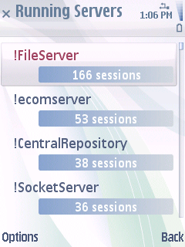
Figure 4.14 Running Servers view
Information about running servers is presented on two lines:
- The top line displays the server name.
- The lower line displays the number of sessions connected to that server.

The list is sorted by server connection count, so the most heavily accessed servers are at the top and the least frequently accessed at the bottom. In theory, servers with a session count of zero could be considered for re-architecting to make them transient – though this depends upon the nature of the server.
Selecting a server jumps to the Thread view for the thread in which the server resides.
The following context-specific Options are available for servers:
- Server List > Output > Listing – generates a listing of the servers to the chosen output medium.
- Server List > Output > Detailed Listing – similar to the standard listing, but it also includes the names of all the connected sessions.
- Server List > Sort > By Name – sorts the server list by name.
- Server List > Sort > By Number of Sessions – sorts the server list based upon the number of connected sessions. This is the default setting.

Chunks
The Chunks list view shows all the chunks that exist within the system.
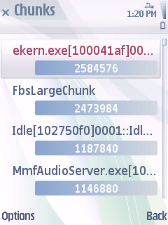
Figure 4.15 Chunks view
Information about chunks is presented on two lines:
- The top line displays the chunk name.
- The lower line displays the size of the chunk in bytes.

Selecting a chunk provides further details. See Section 4.2.4.
The following context-specific options are available for chunks:
- Chunk > Output Listing – generates a listing of the chunks to the chosen output medium.
- Chunk > Sort > By Name – sorts the chunks by name.
- Chunk > Sort > By Size – sorts the chunks based upon the size of the chunk itself. This is the default setting.

Code segments
The Code Segments view shows all of the RAM-resident code segments.
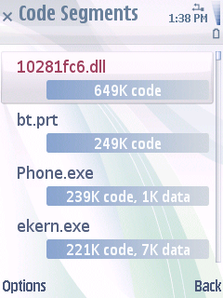
Figure 4.16 Code Segments view
Information about code segments is presented on two lines:
- The top line displays the binary name.
- The lower line displays the code size and data size (if available).

Selecting a code segment provides further details. See Section 4.2.5.
The following context-specific options are available for chunks:
- Code Segment > Output Listing – generates a listing of the code segments to the chosen output medium.
- Code Segment > Filter > None – shows all code segments. This is the default setting.
- Code Segment > Filter > By Global Data – shows only the code segments that use global data.
- Code Segment > Filter > By Capability – shows only the binaries that have a specific capability, for example, All Files or TCB. The filtering can be applied so that only processes are displayed, or alternatively all binaries that match the capability filter are displayed.
- Code Segment > Sort > By Name – sorts the code segment list by name.
- Code Segment > Sort > By Code Size – sorts the code segment list based upon the binary’s code size. This is the default setting.
- Code Segment > Sort > By Total Data Size – sorts the code segment list based upon the binary’s total data size.
- Code Segment > Sort > By UID – sorts the code segment list based upon the binary’s UIDs.

Open files
The Open Files view shows a list of all the files that are currently open on the device.
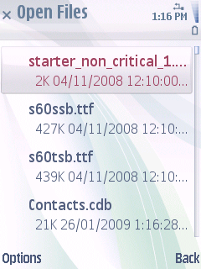
Figure 4.17 Open Files view
The list is not filtered or ordered in any way – it is purely a list of all the files that File Server currently has open.
The same information can be viewed on a per-thread basis from within the Thread view.
To write all the open files on the entire device to the chosen output medium, press Options > List open files.

System configuration
The System Configuration view shows useful information that has mostly been obtained from the Symbian OS HAL.
See reference document [4] in hal_data.h for the descriptions of each item.

Kernel
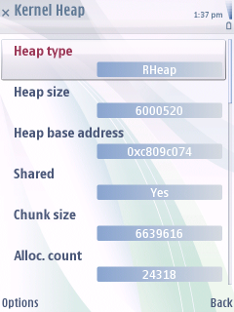
Figure 4.18 Kernel Heap view
Kernel Objects
The Kernel Objects view shows a list of all of the kernel side DObjectCon containers that are in use in a tabbed view.
Each kernel object type is displayed with the number of items associated with that entry and an estimate of the amount of RAM that the object is occupying. Note that this is purely an estimate – the RAM usage is most likely higher than this.
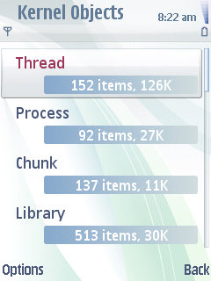
Figure 4.19 Kernel Objects view
To view objects of a specific type, select the object type and press the Select key. Each kernel object type is displayed in a separate tab that contains a list of objects.
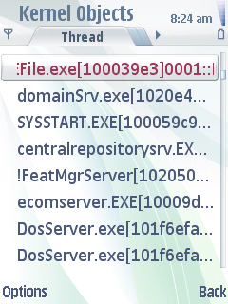
Figure 4.20 Kernel Objects type view
To open a scrollable details dialog, select an object and press the Select key.
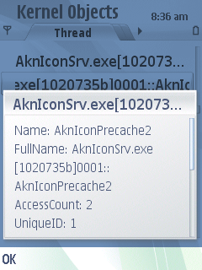
Figure 4.21 Kernel Objects detail view
You can log the kernel objects to the current output medium by selecting Options > Kernel Object> Output list. The Processes and Threads object types contain the additional menu options Terminate, Switch to, End, and Panic.
Kernel Heap
The Kernel Heap view displays information about the kernel’s heap status.
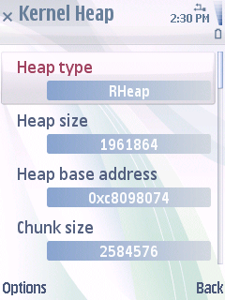
Figure 4.22 Kernel Heap view
While the user-side code generally has a heap associated with each thread, there is only one kernel-side heap that is shared amongst all kernel threads. The Kernel Heap view shows information about this kernel heap.
Much of the information displayed is similar to that of a user-side heap. See Section 4.2.2 for a description of the individual field types.
In addition, you can log the contents of the kernel heap to the currently selected output medium by selecting Options > Kernel Heap > Dump Heap. You can then parse the output in conjunction with the symbol file associated with the image in order to identify allocated object types.

System-wide memory tracking
System-Wide Memory Tracker (SWMT) tracks (over time) and shows information about a number of different subsystems that directly or indirectly contribute to overall System Memory usage.
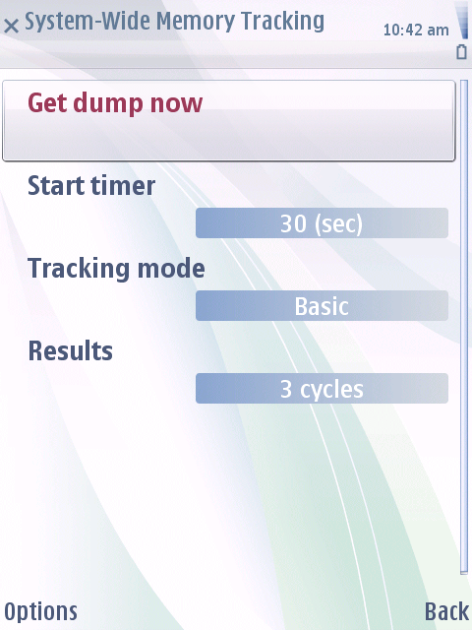
Figure 4.23 System Wide Memory Tracker
The subsystems that System Wide Memory Tracker interrogates and tracks are:
- Heaps (Symbian OS RHeap)
- User stacks
- Global data
- RAM-loaded code
- Open files
- RAM drive
- Disk usage
- Local or global chunks
- Kernel handles
- Bitmap handles
- Window groups

These subsystems are queried during a regular timer heartbeat to identify any differences between now and any previously completed cycles. The differences are saved in a log which can then be analysed on a PC. For information on the log file content, see Appendix C: SWMT change details.
The timer heartbeat that controls the subsystem checks can be configured with a timer period between 5 seconds and one hour (3600 seconds).
The System-Wide Memory Tracking view contains four options:
- Get dump now – runs only one tracking cycle.
- Start (Stop) timer – starts and stops the System Wide Memory Tracking. Snapshots are taken periodically according to the interval defined in Settings.
- Tracking mode – defines the tracking mode (Basic, Full, or Custom):
Basic:
- Categories: User Heap, User Stacks, Global Data, System Memory.
- Data dump: disabled.
- Tracking timer period: user defined via Settings.
Full:
- Categories: all.
- Data dump: all user heaps.
- Heap data thread filter: <No filtering>.
- Tracking timer period: user defined via Settings.
Custom:
- Categories: user defined via Settings.
- Data dump: user defined via Settings.
- Heap data thread filter: user defined via Settings.
- Tracking timer period: user defined via Settings.
- Results – displays any identified changes that MemSpy has detected.

Settings
The available configuration settings are:
- Tracking Timer Period – indicates how often the tracking calculations should be performed. MemSpy will check the heap situation for the entire device after the timer period has passed. Short timer periods, such as one second, may prevent useful testing.
- Categories – displays the number of categories currently selected for the system wide memory tracking. You can select any of the following categories:
- User Heap
- Kernel Heap
- User Stacks
- Global Data
- Disk Usage
- Open Files
- RAM-loaded Code
- System Memory
- Local Chunks
- Global Chunks
- RAM Drive
- FileServer Cache
- Kernel Handles
- Bitmap Handles
- Window Groups
- Dump Data – when MemSpy detects a change, optionally, it can also send the changed heap’s data to the currently selected output medium. The heap data can be large, and therefore note that this can slow down the tracking process. Also, note that at the beginning of the tracking process, the heap data for the entire device is sent to the output medium in order to have a baseline value for later comparison. If you are using output to file, it is recommended that you use a very large memory card.
- Disabled: no data is dumped.
- Custom: only data from specific user heaps is dumped. Heaps are filtered based on the Heap data thread filter value. Filtering is done against thread names.
- All user heaps: data from all user heaps is dumped.
- Heap data thread filter – text used as a filter in custom data dumps.

Results summary
Once you have started tracking, the Results view becomes populated with rows of data, with each row representing one tracker cycle.
- The first line displays the cycle number in square brackets, e.g. [000] for the initial baseline cycle, [001] for the first cycle, and so on. Note that when you enable the tracker, a baseline, that represents a snapshot of the entire device, is created.
Following the cycle number is the amount of free RAM in bytes. This figure is the total amount of available RAM (as returned by the HAL) at the time the cycle was created. By comparing the free RAM with the previous cycle you can identify whether overall RAM was freed or allocated.
- The second line has two sections.
The first section is the RAM delta. This value is prefixed by D: and specifies the number of bytes of RAM difference between this cycle and the previous. A negative delta value indicates that more RAM has been freed back to the OS. A positive number indicates that RAM has been used.
The second section is the number of changes that were detected in terms of heaps (or chunks). The tracker inspects the user thread and kernel heap changes (based upon currently configured settings), and the number of changes is displayed in this field.

To view further information about the cycle, press the Select key. This opens the Cycle Summary view for the selected cycle.
Cycle Summary
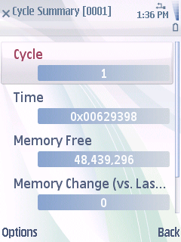
Figure 4.24 Cycle Summary view
The Cycle Summary view shows an overview of the detected changes to the system when comparing the previous cycle to the current cycle:
- Cycle – displays the cycle number. For the first cycle, i.e. the baseline, it is zero.
- Time – displays the timestamp associated with the change.
- Memory Free – displays the amount of overall free system RAM in bytes.
- Memory Change (vs Last Cycle) – displays the amount of RAM that has either been released back to the OS or taken from the OS free RAM pool during this cycle (when compared with the previous). For the first cycle, the change is zero.
- Number of changes – displays the total number of subsystem entries that changed compared with the previous cycle. For the first cycle, everything is “new” and therefore this number tends to be quite big.

Process-specific memory tracking
This view shows the processes that are being tracked. Once enabled, it shows statistics and information about the memory usage of the process, including peak usage in real time.
You can use the menu options to define the UID of processes that MemSpy automatically tracks as soon as it detects they are created or running. This way you can track their usage from the time they are created rather than manually having to enable MemSpy’s tracking. Similarly, you can define the autostart list by editing an XML file. An example of the autostart XML file is included in the MemSpy release.

Drive summary
This view shows summary information about all the drives mounted in the file system. For details about the file system types, refer to your File Server documentation.
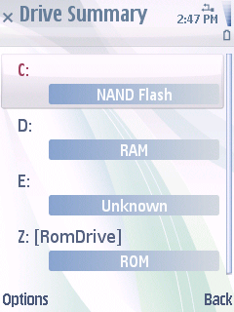
Figure 4.25 Drive Summary view

ECom
This view displays information about the implementations of specific ECom interfaces. You can define (in XML) the ECom plug-in interfaces that you want to show in MemSpy, and then MemSpy will query ECom to obtain the details about each implementation, such as name, UID and other metadata.
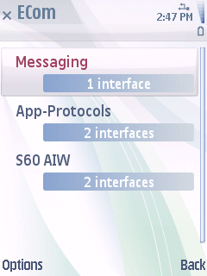
Figure 4.26 ECom view

Window groups
This view displays information about window groups. The view shows window groups and their IDs.
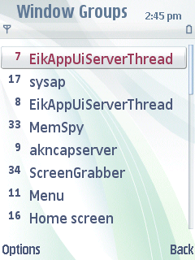
Figure 4.27 Window Groups view

To open a scrollable detail view, select a window group and press the Select key.
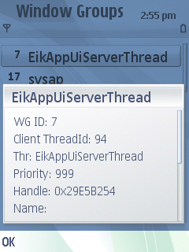
Figure 4.28 Window Groups detail view
The Window Groups view contains the additional menu options Terminate, Switch to, End, and Panic.

Running MemSpy functions from the command line
The MemSpy tool can be launched from the command line either on the emulator or on the device using the Eshell application. Each launch executes one function (command) which generates a log to the selected output. This way you can run MemSpy functions without user interaction.
Use the following syntax to run a MemSpy function from the command line:
memspy [command] [parameters]

Example:
memspy CmdSWMT_ForceUpdate HEAP

This command runs one cycle of the System Wide Memory Tracking function with only Heap category enabled.

Command line commands
Supplying a [command] is mandatory. Only one [command] at a time is supported. Available commands are described in the table below:

Command | Description
CmdHeap_Dump | Outputs the same information as described in Section 6.1.3, but only once for each heap, including the kernel. Output can be filtered by the name of the thread, see Section 5.2.
CmdHeap_Dump_Kernel | Outputs the same information as described in Section 6.1.3, but includes only the kernel.
CmdHeap_Compact | Outputs an XML formatted listing file containing heap information for every thread using a standard Symbian OS RHeap object, including the kernel.
CmdSWMT_ForceUpdate | Runs one cycle of System-Wide Memory Tracking and outputs its log. Output can be filtered by category and by the name of the thread, see Section 5.2. See a detailed description of the log format in Appendix C.
CmdSWMT_Reset | Clears data from the previous System-Wide Memory Tracking cycles and cancels the ongoing timer triggered cycles.
CmdOpenFile | Outputs a list of all the files that are currently open on the device. Output can be filtered by the name of the thread, see Section 5.2.
CmdContainer | Outputs information about all kernel objects (kernel-side DObjectCon containers). See the related feature in UI described in Section 4.11.
CmdBitmaps_Save | Exports all the bitmaps that are loaded within the Font & Bitmap server to a memory card for viewing on a PC.
CmdRAM_DisableAknIconCache | Disables the icon cache.
CmdOutput_ToFile | Switches the output mode to File.
CmdOutput_ToTrace | Switches the output mode to Debug Trace.
CmdUI_Background | Sends the MemSpy UI to background.
CmdUI_Foreground | Brings the MemSpy UI to foreground.
CmdUI_Exit | Shuts down the MemSpy UI.

Command line command parameters
Supplying parameters is optional. Each command has its specific parameters, and all commands do not have parameters.
CmdHeap_Dump command parameters are described in the table below:

Parameter | Description
[text string] | Any text string not containing empty spaces. Specifies the Heap data thread filter. By specifying the filter, only data from specific user heaps is dumped. Heaps are filtered based on the Heap data thread filter value. Filtering is done against a thread name.

CmdSWMT_ForceUpdate command parameters are described in the table below. Multiple parameters separated with empty space are supported.

Parameter | Description
HEAP | Enables the User Heap and Kernel Heap categories.
CHNK | Enables the Local Chunks and Global Chunks categories.
CODE | Enables the RAM-loaded Code category.
STAK | Enables the User Stacks category.
GLOD | Enables the Global Data category.
RAMD | Enables the RAM Drive category.
FILE | Enables the Open Files category.
DISK | Enables the Disk Usage category.
HGEN | Enables the Kernel Handles category.
FABS | Enables the Bitmap Handles category.
F32C | Enables the FileServer Cache category.
SYSM | Enables the System Memory category.
WNDG | Enables the Window Groups category.
HEAPFilter:[text string] | Specifies the Heap data thread filter. By specifying the filter, only data from specific user heaps is dumped. Any text string not containing empty spaces. This parameter is applicable only if the HEAP category is enabled.  Example:  memspy CmdSWMT_ForceUpdate HEAP HEAPFilter:akn  This command dumps the heap data only from threads which have akn in their name.

CmdOpenFile command parameters are described in the table below:

Parameter | Description
[text string] | Any text string not containing empty spaces. Specifies the Open File thread filter. By specifying the filter, only the files opened by specific threads are listed. Filtering is done against a thread name.

Running batch file
The MemSpy command line interface supports the running of the MemSpy functions defined in a text file (batch file). Use the following syntax to run a batch file from the command line:
memspy [batch file]

Example:
memspy memspycommands.txt

This command runs all commands defined in the memspycommands.txt file.
The [batch file] can be a filename with or without an absolute path. If a path is not defined, the file is searched non-recursively from the following folders in each drive in the system:
- \
- \data\
- \documents\
- \temp\
- \system\temp\

The format of the file is similar to the commands described in Section 5.1 with one exception: commands must be defined inside brackets. Each command is defined in a separate line.
Examples of MemSpy batches
The following batch runs one cycle of System-Wide Memory Tracking with all the categories enabled. After that, the MemSpy application is shut down. Results appear in files, as the first batch function switches the output mode to File.
[CmdOutput_ToFile]
[CmdSWMT_ForceUpdate] HEAP CHNK CODE STAK GLOD RAMD FILE DISK HGEN FABS F32C SYSM WNDG
[CmdUI_Exit]

The following batch will run one cycle of System-Wide Memory Tracking with the User Stack, User Heap and Kernel Heap categories enabled. After that, it outputs the same information as described in Section 6.1.3, but only once for each heap, including the kernel. Finally, the MemSpy application is shut down. Results appear in files, as the first batch function switches the output mode to File.
[CmdOutput_ToFile]
[CmdSWMT_ForceUpdate] STAK HEAP
[CmdHeap_Dump]
[CmdUI_Exit]

Examples

Viewing specific thread heap information
MemSpy contains powerful heap information extraction code that can be used to obtain memory consumption details about your heap or all heaps within the OS.
To view general information about a specific heap, navigate to the thread in question and then select the Heap view of that thread.
To view information about the Symbian OS Message Server heap, do the following:
- Start MemSpy.
- Select the Processes & Threads view and press the Select key.
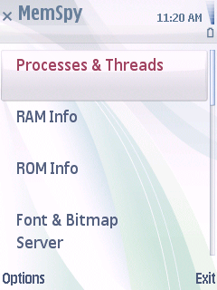
Figure 6.29 Selecting the Processes & Threads view
- Locate and select the message server process !MsvServer, and press the Select key. This shows a listing of the threads that exist within the message server process.
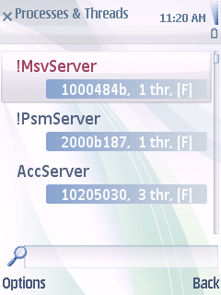
Figure 6.30 Selecting !MsvServer
- Select the thread you want to investigate, and press the Select key.
In this instance, there is only one thread (also called “!MsvServer”).
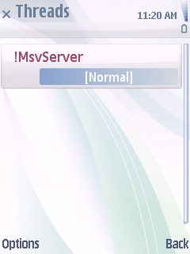
Figure 6.31 Selecting thread
- Select the Heap view and press the Select key.
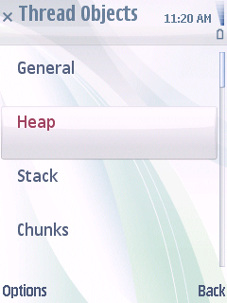
Figure 6.32 Selecting the Heap view
- The heap information for this thread is displayed.
The information in this view is described in detail in Section 4.2.2.
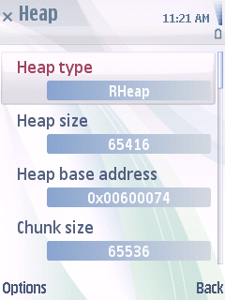
Figure 6.33 Heap information
- (Optional) To view additional information or to log information, do one of the following:
- To log heap information, press Options > Heap > Info. See Section 6.1.1.
- To log heap cell listing, press Options > Heap > Data > Cell List. See Section 6.1.2.
- To log the actual content of the heap, press Options > Heap > Data > Heap Data. See Section 6.1.3.

Heap summary information
Selecting Options > Heap > Info sends a summary about the selected heap to the currently selected output medium (either file or tracing). You can select the output medium by selecting Options > Tools > Output.
Example of a summary:
HEAP INFO FOR THREAD '!MsvServer::!MsvServer'
=============================================
Meta Data
=========
Type: Symbian OS RHeap
VTable: 0x802cf630
Object Size: 116
Chunk Name: !MsvServer[1000484b]0001::!MsvServer::$HEAP
Chunk Size: 81920
Chunk Base Address: 0x00600000
Debug Allocator: No
Overhead (Free): 8
Overhead (Alloc): 4
Shared: No
RAllocator
==========
RAllocator::iAccessCount 1
RAllocator::iHandleCount 2
RAllocator::iHandles 0x0060002c
RAllocator::iFlags 0x00000000
RAllocator::iCellCount 489
RAllocator::iTotalAllocSize 74292
RHeap
=====
RHeap::iMinLength 4092
RHeap::iMaxLength 4194304
RHeap::iOffset 0
RHeap::iGrowBy 4096
RHeap::iChunkHandle 0x00020001
RHeap::iBase 0x00600074
RHeap::iTop 0x00613ffc
RHeap::iAlign 8
RHeap::iMinCell 40
RHeap::iPageSize 4096
RHeap::iFree.next 0x006119f4
RHeap::iFree.len 0
RHeap::iNestingLevel 0
RHeap::iAllocCount 0
RHeap::iFailType 3
RHeap::iFailRate 50529027
RHeap::iFailed True
RHeap::iFailAllocCount 50529027
RHeap::iRand 50529027
RHeap::iTestData 0x00000000
Free Cell Statistics
====================
Number of cells: 2
Size of cells: 5552
Largest cell: 0x006119f4
Largest cell size: 2888
Slack: 0x00613594
Slack size: 2664
Allocated Cell Statistics
=========================
Number of cells: 489
Size of cells: 76248
Largest cell: 0x00605d6c
Largest cell size: 4104

Common Statistics
=================
Total cell count: 491
Total cell size: 81800

Heap cell listing
Selecting Options > Heap > Data > Cell List sends a text-based listing of all the heap cells within the specified heap to the currently selected output medium. Each cell’s type is identified as well as other useful information about the specific cell.
Example of a heap cell listing:
[Allocated Cell] cell: 0x32620074, cellLen: 28, allocNum: 1, nestingLev: 1, cellData: 0x6006c868, cellDataAddr: 0x32620080, headerSize: 12
[Allocated Cell] cell: 0x32620090, cellLen: 28, allocNum: 2, nestingLev: 1, cellData: 0x6006c878, cellDataAddr: 0x3262009c, headerSize: 12
[Allocated Cell] cell: 0x326200ac, cellLen: 40, allocNum: 883, nestingLev: 1, cellData: 0x4a7b5344, cellDataAddr: 0x326200b8, headerSize: 12
[Allocated Cell] cell: 0x326200d4, cellLen: 36, allocNum: 53, nestingLev: 1, cellData: 0x6006c68c, cellDataAddr: 0x326200e0, headerSize: 12
[Free Cell] cell: 0x3262d314, cellLen: 56, allocNum: -1, nestingLev: -1, cellData: 0x00000000, cellDataAddr: 0x3262d31c, headerSize: 08

Each heap cell is described in terms of the following:
- Cell Type, in square brackets. The types are explained in the table below:

Type | Meaning
Allocated Cell | A cell containing useful allocated data, such as an object.
Free Cell | Space which is claimed by the heap (i.e. allocated physical memory), but is not yet used to hold actual object data.
Bad Allocated Cell Size | An allocated cell, but with an invalid cell size.
Bad Allocated Cell Address | An allocated cell, but with an invalid address.
Bad Free Cell Size | A free cell, but with an invalid size.
Bad Free Cell Address | A free cell, but with an invalid address.
Unknown | An unknown cell. In practice, this should never be seen.

The “Bad” cell types should be very rare in normal operation. They are identified by MemSpy when it goes through the contents of the specified heap. The presence of a “Bad” cell indicates a serious problem with the heap in question.
- Cell Address, prefixed by cell. This is the address of the cell within the heap chunk.
- Cell Length, prefixed by cellLen. The length of each cell should be a multiple of four bytes and refer to how much memory is occupied by the cell.
- Allocation Number, prefixed by allocNum. This is only applicable for allocated cell types – for free cells it will be set to –1. When using a debug version of EUSER, the Symbian OS default heap allocator (RHeap) will assign a counter value to each allocated cell. This number is assigned in sequence as objects are created. Therefore, this information can be used to identify the order in which certain objects (cells) were created. This is not applicable when using a release mode EUSER.dll.
- Nesting Level, prefixed by nestingLev. This is only available when using a debug build of EUSER.dll and only associated with allocated cells. Free cells will have a value of –1.
- Cell Data, prefixed by cellData. The first four payload bytes of each allocated cell are displayed in a 32-bit format. If a C++ object is allocated in the heap cell, then most likely this address will correspond to the vTable of the object in question.
If the object is from a binary that resides in Core Image, then the value can be looked up in the Core Image symbol file.
If the object is from a RAM-loaded binary, you need to know the address ranges for the code segments that are loaded into the process.
In conjunction with these address ranges (for each binary) you can identify the binary from which the object was created. Additionally, if you have the MAP file for the binary (or Symbol File for e.g. an entire ROFS image), you can identify the type. MemSpy’s cell listing always includes the loaded code segments prior to the start of the cell listing itself, for example:
CodeSegs – f4ab1000-f4af2000 msexe.exe
If the cell data address is within the above memory range, the object in question have been implemented inside the associated binary.
- Cell Data Address, prefixed by cellDataAddr. Each heap cell, whether free or allocated, contains associated metadata that precedes the actual cell contents. This metadata varies in size depending on whether the cell type is free or allocated. The cell data address corresponds to the address (within the heap chunk) where the actual cell payload resides, for example, for allocated cells this would be the start of the object data.
- Cell Header Length, prefixed by headerSize. As mentioned above, the size of the cell’s metadata header varies depending on its type. This field describes the length of the associated cell header.

Heap data
Selecting Options > Heap > Data > Heap Data sends the actual contents of the heap to the currently selected output medium. For large heaps this can take several minutes. If you are capturing the heap data via a tracing channel such as RDebug::Print, then your tracing hardware needs to be reliable and also very fast. Note that using a standard RS232 serial port could result in a loss of data.
The heap data is output in text-encoded binary format. That is, each byte value is output encoded as a two-character hex code.
Heap Data
---------
32620074: 1c 00 00 00 01 00 00 00 01 00 00 00 68 c8 06 60 ............h..`
32620084: 88 c8 06 60 9c 00 62 32 00 00 00 00 1c 00 00 00 ...`..b2........
32620094: 01 00 00 00 02 00 00 00 78 c8 06 60 e8 1f 62 32 ........x..`..b2

The file format is inefficient, but it is convenient for trace output, and it is relatively fast to process on a PC.

Capturing the memory state of the entire device
One of the most powerful features of MemSpy is its ability to capture a snapshot of the entire device’s memory status.
This information can be lightweight or detailed – several modes are supported. The information that is obtained is mostly the same as described in Section 6.1. However, rather than having to navigate thread-by-thread to view each thread’s heap information step-by-step, it is possible to capture the same information for the entire device in a single operation.
To capture the memory state of the entire device, do the following:
- Start MemSpy.
- Select Options > Phone Information > Heap, and then one of the following:
- Detailed Summary – this is the same information as described in Section 6.1.1, but is output once for each thread.
- Compact Summary – this generates an XML formatted listing file containing heap information for every thread using a standard Symbian OS RHeap object, including the kernel.
- Cell Listing – this is the same information as described in Section 6.1.2, but is output once for each user side heap. The listing is not available for the kernel heap.
- Data (Binary) – this is the same information as described in Section 6.1.3, but is output once for each heap, including the kernel.

Using MemSpy’s client-server interface
The MemSpy’s engine exports a header to \epoc32\include\MemSpyEngineClientInterface.h.
To use the API, do the following:
- Type the following in your source code. You do not need to edit MMP files in order to use this API as it is entirely inline.
#include <MemSpyEngineClientInterface.h>
- Declare and connect an instance of RMemSpyEngineClientInterface to the server:
RMemSpyEngineClientInterface memSpy;
User::LeaveIfError( memSpy.Connect() );
memSpy.PerformOperation( … ); // Returns an error!
memSpy.Close();
- Start the MemSpy GUI application on your device.
- Perform your use case. The requested operation is performed and output redirected to the current output medium (file or debug). You change the output destination via the MemSpy GUI.

MemSpy’s external interface supports a number of the core MemSpy operations via a normal Symbian OS client-server interface. Additionally, some items can be performed on a thread-specific basis (e.g. listing one thread’s heap or stack data).
Therefore, there are two overloads of the PerformOperation method, one which is thread-agnostic and one which is thread-specific. Here is a short snippet of the API:
class RMemSpyEngineClientInterface : public RSessionBase
{
public:
inline RMemSpyEngineClientInterface();
inline TInt Connect();
inline TInt PerformOperation( TMemSpyClientServerOp aOperation );
inline TInt PerformOperation( TMemSpyClientServerOp aOperation, TThreadId aId );
};

The TMemSpyClientServerOp enumeration defines the operation to be performed:

Operation | Purpose
EMemSpyClientServerOpThreadInfo | List general overview information about a thread or all threads that are currently running.
EMemSpyClientServerOpHeapInfo | List heap information about a specific thread (or all threads).
EMemSpyClientServerOpHeapInfoLite | When using the thread-agnostic overload, this lists XML formatted heap information for the entire device. In thread-specific mode, the information is the same as in the heap info.
EMemSpyClientServerOpCellListing | Obtain a list of heap cells for either a specific thread or the entire device.
EMemSpyClientServerOpHeapData | Obtain the heap data for a specific thread or then the data for all threads.
EMemSpyClientServerOpStackInfo | Obtain stack information about a specific thread (or all threads).
EMemSpyClientServerOpStackInfoLite | When using the thread-agnostic overload, this will list XML formatted stack information for the entire device. In thread-specific mode, the information is the same as in the stack info.
EMemSpyClientServerOpUserStacks | Obtain user-side stack data for a specific thread or then the data for all threads.
EMemSpyClientServerOpKernelStacks | Obtain kernel-side (supervisor) stack data for a specific thread or then the data for all threads.
EMemSpyClientServerOpKernelHeap | Obtain the kernel supervisor’s heap data.

Appendix A: Understanding Symbian OS Heaps
Heap chunk
This section briefly explains how the Symbian OS default heap implementation, RHeap, works. It is not exhaustive – you can study the source code in the normal Symbian OS releases. The following comments only apply when the default heap allocator is used. If your code has its own allocator (as is possible in EKA2), this does not apply.
Generally speaking, each application typically uses the default Symbian OS RHeap implementation, though it does not have to. Symbian OS heaps are a thin layer on top of Symbian OS chunks. That is to say, heaps are implemented using a chunk. A chunk is a wrapper around a collection of pages of memory. The minimum size for a chunk is one page of RAM, and this is typically 4096 bytes.
When a process is created, a default heap is created for the main thread of execution within that process. The size of the heap is derived from the information contained within the process binary’s E32 header. This header is defined at build time by the Symbian toolchain; Elftran is used to create a Symbian OS binary with the correct header information. The heap typically starts at a pre-defined minimum or initial size and is permitted to grow up to a pre-defined maximum. If any attempt is made to allocate memory in a heap that would take it past the pre-defined maximum, the operation fails with KErrNoMemory.
As the main thread starts to spring into life, the E32 Process & Thread Startup framework creates a chunk in which the heap resides. See UserHeap::SetupThreadHeap which in turn calls UserHeap::CreateThreadHeap.
This chunk is created locally to the process and thread in question and has the name $HEAP. Therefore, if your process is called Foo and your thread is called Bar, the full name associated with your heap chunk is Foo::Bar::$HEAP.
Once the chunk is created by the kernel and is mapped into the process in question, an RHeap object is allocated in-place at the start of the chunk (see UserHeap::ChunkHeap). The heap object is configured with the sizing information from the E32 image header – this permits the heap to control its maximum amount of allocated memory.
After the heap is created and the kernel is informed of the thread’s allocator, the heap can be used via the normal operator new() or User::Alloc() methods.
The figure above shows a very simplified overview of the heap chunk.
The heap chunk is represented by the region in green. The start of the chunk is occupied by the in-place RHeap object – this object is created once and is essentially a fire-and-forget item. Note that when you are looking at the amount of RAM occupied by your heap chunk, the first 1 kb or so is this in-place RHeap.
The white region contains available memory that can be used to satisfy allocation requests as they are received by the heap code. This is the region that we typically think of as the heap itself, and the allocated heap objects are stored here.
As the heap allocation requests are received, the white area is gradually populated with allocated cells. Once there is insufficient space to satisfy the allocation request, the heap must be grown.
In simplistic terms, since the heap is implemented within a Symbian OS chunk, to grow the heap you must first grow the chunk itself. This logic is encapsulated by the RHeap::TryToGrowHeap method, which in turn calls RHeap::SetBrk, which in turn calls RChunk::Adjust. The latter method increases the size of the chunk while TryToGrowHeap is concerned with performing the housekeeping needed to make the newly allocated memory available for use.
Given that the RChunk class is used to hold the RHeap memory, the chunk allocation size grows as a multiple of the page size (4096 bytes).
Therefore, if your code allocates just one single byte of RAM, the minimum amount of RAM used by the heap will still be 4 kb. Of this 4 kb, approximately 1 kb is used by the in-place RHeap and the remainder is available for normal memory allocations.
It is worth considering a reasonable value for the minimum heap size. If you know that your code immediately allocates 20 kb of RAM upon start-up, then there is no benefit of defining the minimum as 4 kb. In the worst case, this will result in the RHeap class expanding the heap several times in order to satisfy the total number of allocations. If your code allocates the whole 20 kb in one allocation, then the heap code is somewhat logical in the sense that it adjusts the size of the chunk in one operation. However, if your memory operations are spread out over many smaller allocations, then in the worst case the heap must be grown four times (4 => 8, 8 => 12, 12 => 16, 16 => 2 kb). In this situation, it makes sense to specify 20 kb as the minimum.
Conversely, if the heap usage associated with your thread is very small, then do not specify an 8 kb minimum heap. The remaining space will be unused, but that memory is allocated to your process and cannot be used by others.
Heap
The heap is typically dynamic – usually, it starts off at some minimum size and can grow up to a maximum. This is usually 1 MB unless the thread owner has customised this via RThread::Create() or via the MMP file (in case the primary thread is associated with a process).
Though the heap occupies a certain size, some of the space within the heap may be free, that is to say that it may be ready for usage when further memory requires allocation. Most of the heap probably contains allocated objects, which are placed on the heap in response to clients allocating memory directly (e.g. via operator new or User::Alloc() etc).
Free heap space can be subdivided into two further areas – free cell space and free slack space.
The term free cell space refers to the space available within the heap that occurs between the lower heap boundary and the last allocated cell within the heap.
The figure below shows an example of a very simple heap (containing only 5 cells):
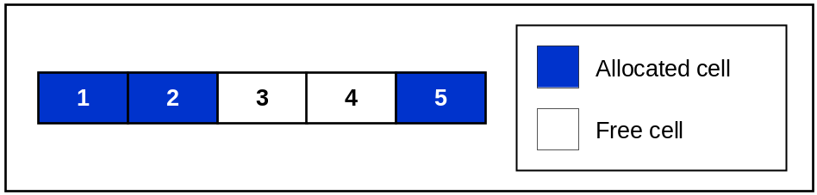
The heap contains five cells, of which three are allocated. The other two are free cells that exist within the boundary of the allocated heap space.
As more memory is allocated, it is possible that these free cells are reclaimed and used to hold objects. However, this is not always the case – it depends on how much free space those two cells occupy and how much memory needs to be allocated. Clearly if the free space is not large enough to satisfy any allocation request, then the space will go unused.
The default RHeap implementation makes an effort to combine adjacent free cells into contiguous space – so the example shown in the figure above is actually fictional. Cells 3 and 4 would actually be combined; therefore a more accurate representation would be as follows:
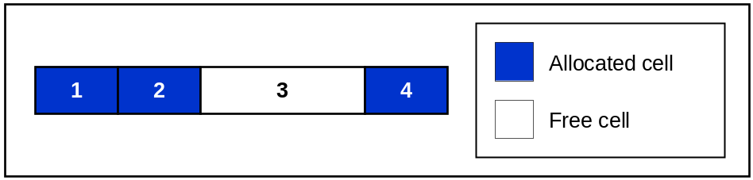
Combining the free cells helps to increase performance of the default Symbian heap implementation. Since the RHeap class maintains a list of free heap cells, it is more optimal to resize two adjacent free cells into one larger combined cell than it is to maintain two entries in the free cell list. This is because the free cell list must be walked each time a new allocation is requested in order to locate the first heap cell that is big enough to satisfy the allocation request.
There can also be another type of free space within a heap, called slack space.
As more memory is allocated within a heap, the heap usually grows (unless it starts with a very large initial size).
During the allocation of the heap memory, the implementation of RHeap attempts to locate a suitably sized free cell to contain the heap data. If there are no free cells, or the largest free cell is not of sufficient size to meet the requested allocation amount, the heap must be expanded. This expansion process was already touched on in the previous section, mainly from the chunk perspective.
The housekeeping mentioned in the previous section involves creating a new “free cell” at the end of the heap.
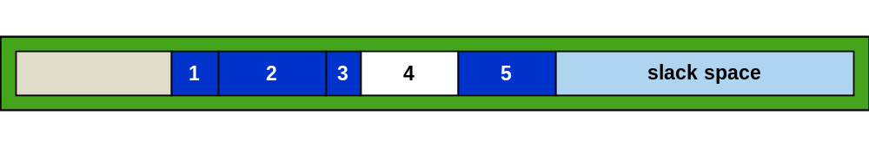
The figure above represents the heap chunk after it has just been extended in size. The first (grey) box is the in-place RHeap. Cells 1 to 5 are allocated/free cells. The final (light blue) box represents the slack space within the heap.
This is actually itself a ‘free cell’ within the RHeap data structure, but it also represents memory that is allocated to your process.
Slack space is slack only as long as it remains unused. As allocation requests are satisfied, this area will begin to be populated with allocated cells.
However, sometimes this RAM can remain allocated even when it is not needed. To elaborate, assume some code allocates 100 kb of RAM as a transient data buffer. This might be needed for downloading a web page over HTTP and storing the HTML contents in memory.
100 kb is a large amount of RAM, so almost certainly your heap chunk will have to be resized to accommodate such a large request. The heap chunk could look like this:
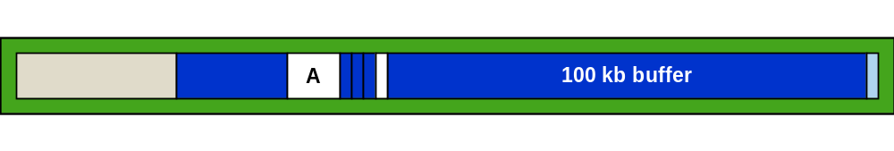
The large 100 kb buffer sits at the end of the heap, and a tiny amount of slack exists after it. This buffer is only needed for a short while. Assume you are spidering links from the HTML; after the links have been identified, the buffer is discarded and a new (more optimal) data structure is created instead. Since that data structure is more optimal, it is small enough to fit inside the free cell A. The heap chunk might now look like this:
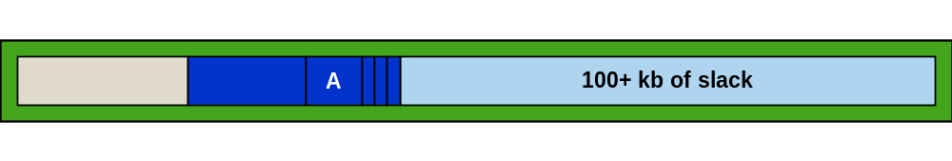
There are several interesting things to observe in this new layout:
- The new data structure is much more efficient, so it fits nicely inside the earlier free cell.
- There is an enormous slack space region at the end of the heap chunk. In the ‘kernel sense’ this memory is allocated, and it cannot be assigned to another task. However, in the context of our thread, this memory is not needed anymore.
- The other free cell at the end of the heap has now been subsumed into the slack space of the heap.

The 100+ kb of slack space can be used for any further allocations. However, if your code only allocates a handful of kilobytes of RAM during the rest of its lifetime, that other memory has effectively been wasted.
There is a solution for this problem – and that is to simply compress the heap. Compressing the heap does not perform any kind of data compression (such as zip or deflate). It means that the heap chunk is adjusted in size so that it becomes as small as is permissible given the existing requirements of your heap data. The adjusting occurs within RHeap::Reduce and RHeap::Compress. Note that depending on the size of your heap and the number of cells, this operation can take a while.
The heap itself cannot automatically decide when to compress itself since this would potentially cause the heap to compress itself at an inappropriate moment. Therefore, the client code needs to consider this problem and if appropriate, ensure the heap is compressed at a suitable time.
Understanding fragmentation
Fragmentation is a by-product of the chunk that often occurs within a heap. Most memory allocations occur transiently, that is, they have a short lifetime. These transient allocations may sometimes cause the heap chunk size to be adjusted (upwards), that is, growing the heap.
The previous section discusses why it can be useful to consider compressing the heap. However, often compressing the heap has no net benefit on the size of your chunk. Consider the example from the previous section, with a large buffer transiently allocated and subsequently destroyed:
The fictional use case consisted of parsing an HTML page in order to extract links. These links were then stored in a more optimized data structure elsewhere within the heap.
In the previous example, this new data structure was so efficient that it could easily be stored within the bounds of the free cell A. What if the data structure is extended to contain not only the links, but also a list of all the images in the page? This requires a larger data structure and therefore most likely requires more memory as well. Since the data structure is larger, unfortunately the free space A is not large enough to hold the new object. Therefore, the new data structure must go elsewhere – and the only place available in this fictional heap chunk is at the end of it (the heap must be grown again).
The data structure might now look like this:
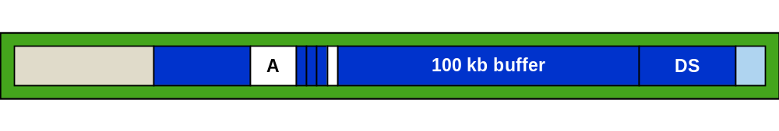
The new object is located at the end of the extended heap chunk. Assume you then finish parsing the HTML, and the transient buffer can be discarded. The chunk would now look like this:
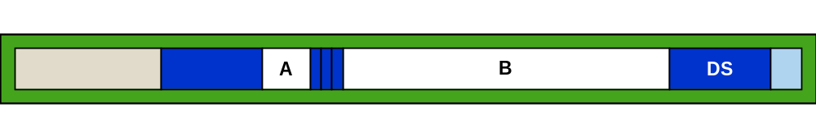
What used to be the 100 kb buffer is now fenced in by three small allocations (on the left) and the new data structure on the right (see the above figure). Compressing the heap chunk can only shrink the size of the heap to its high watermark (currently, the right hand edge of the data structure). Clearly, in this scenario, compressing the heap chunk will not help a great deal.
Generally, the advice to avoid fragmentation is to write your code in such a way as to ensure that any large transient data structures go at the end of the heap. This, of course, requires careful design and implementation.
Another example of fragmentation, though somewhat less extreme, is the case of a large number of smaller transient allocations.
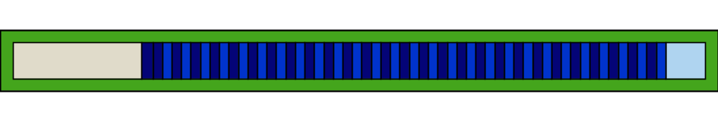
The idea is the same as before. This time the allocated cells are represented by bright and dark blue boxes. Again, there is a portion of slack space at the end of the heap chunk, though it is not really relevant to this example.
Assume the bright blue boxes represent 2 kb objects and the dark blue 1 kb objects – they could be a collection of files that have been loaded into memory for processing or analysis. A rather contrived example, but assume all but a few are discarded. The chunk could now look like this:
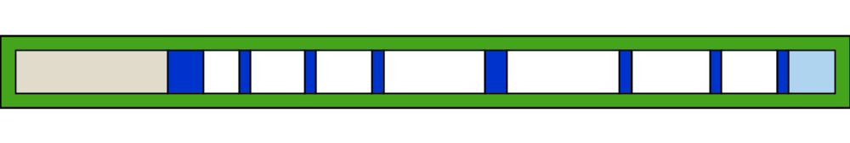
If the client of the heap never makes another allocation request, then all of the free cell space (and slack space) is effectively wasted. Compressing the heap will not help.

Appendix B: Understanding Symbian OS stacks
Architecture of Symbian stacks
Typically, there are two well-known types of memory that are associated with computer programming; heaps and stacks. For more information about the differences of the two types, see a computer architecture reference manual. This document does not explain the difference and assumes that you understand it.
Symbian OS stacks are fixed in size. They are allocated during the creation of a thread and they do not grow. Once the stack is exhausted, there is no dynamic capability for extension – which means it tends to be a very scarce and finite resource that must be treated with care.
Symbian OS stacks exist on both user and kernel side. User side stacks are used as temporary scratch storage inside functions or methods. The stack typically grows and shrinks wildly as the thread executes instructions. When one method calls another, the return address of the instruction which should be executed upon return from the called function can also be pushed onto the stack. This is one of the reasons why tools such as D_EXC can obtain a “call stack” when a thread panics or generates an exception.
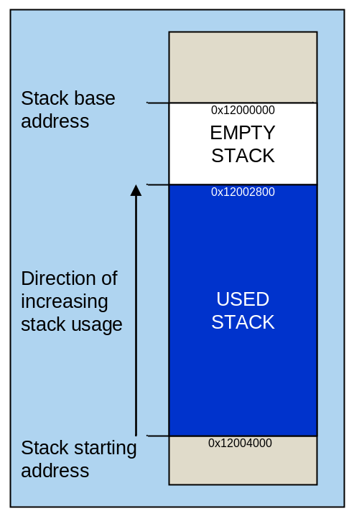
Stacks are usually placed at the top of a page boundary and the current stack pointer is set to the highest address within the stack. Therefore, stacks can be considered to flow backwards. That is to say, they start at some high memory address, and as data is pushed onto the stack, the address is decremented.
If the stack usage is so high that it causes the stack pointer to underflow off the top of the stack, a page fault exception will be raised. This typically is represented on the user side by a Kern-Exec 3. D_EXC and Crash Analyser are examples of tools that can diagnose stack overflows.
Kernel stacks
In EKA2, each thread also has a kernel side stack, called the supervisor stack. This stack is used for the following:
- Executive calls.
- If a hardware interrupt occurs while the thread is running and the interrupt queues IDFCs and/or DFCs.
- Rescheduling. A reschedule always occurs as a result of the current thread calling the scheduler. Inside the scheduler, the current thread’s register state is saved on its supervisor stack, and the final stack pointer value is saved in the thread control block. Then the stack pointer is loaded using the new thread’s saved stack pointer value, and its register state is restored from the stack (which is now the new thread’s supervisor stack).

Stack chunk
Note that the following paragraph is memory model dependent.
Whereas each heap usually resides within its own chunk, all user stacks for a process reside within the same chunk. Since each thread must have a stack, and stacks are not shared between threads, the minimum amount of RAM required by a stack for a given thread is one page (4 kb).
The default amount of RAM allocated for the thread’s stack is 8 kb. This value is used for creating the stack associated with the process’s main thread, assuming that the EPOCSTACKSIZE keyword was not used in the project’s MMP file. Again, Elftran writes this information to the E32Image header associated with your binary.
All stacks are allocated within the same chunk in the parent process. This chunk is called the $DAT chunk. Again, if your process is called Foo and your thread is called Bar, the chunk in which your stack resides is called Foo::$DAT. The thread name is not relevant in this scenario.
In order to detect stack overflows (or underflows, depending on how you look at it), each stack within this chunk is separated by a guard both for user and kernel side stacks. In EKA2 Moving Memory Model, the size of the guard is two pages for user side stacks and one page for kernel stacks.
Natural limits imposed by stacks
Stack sizes are defined in terms of the number of pages of RAM that is required. If you request a stack size of 5000 bytes, this figure is rounded upwards to the nearest page of RAM. Therefore, the actual amount of stack space that is allocated for a 5000 byte stack is 8192 bytes.
EKA2 Moving Memory Model currently limits the maximum stack size for any given thread to 64 kb. If this is not enough, it is suggested that you rewrite your code to use dynamic memory allocation instead (that is, the heap), or rewrite your code so that it does not need so much memory in the first place.
There is also a limit on the total stack space that can be used by any given process. Currently this is 2 MB (EKA2 Moving Memory Model). This figure, and the fact that there is the user side two-page guard between each stack, means that there is a natural limit to the number of threads per process. This limit is 128 threads per process (assuming an 8 kb stack per thread) or 170 threads per process (assuming a 4 kb stack per thread).
Stack creation
Stacks are created by the kernel when a thread is constructed. See DThread::AllocateUserStack (memory model specific).
The Symbian base code also does some rather helpful initialisation of your stack after it has been created. This initialisation occurs within DThread::EpocThreadFunction (for user side threads) and is responsible for filling the contents of the stack with a magic rune (0x29292929).
There is similar code for kernel side (supervisor) stacks. The magic rune in this case is 0xEEEEEEEE.

Appendix C: SWMT change details
The System Wide Memory Tracker log is automatically written to file or trace (depending on the MemSpy configuration), and it contains a detailed breakdown of each change. This information is not presented within the MemSpy user interface.
Each change is prefixed with a type identifier. In the following sections, the type identifier is included in parenthesis as {<type identifier>}. In addition, each change description includes a post-fix attributes field, the meaning of which is explained in the following table:
(Post-fix) Attributes
Field | Description
[N] | New entity – did not exist prior to this cycle.
[D] | Deleted/destroyed/dead entity – previously existed but now has been destroyed.
[A] | Alive entity – entity is present.
[S] | Shared heap – applicable only with {HEAP} items.

Heap changes {HEAP}
The following table describes the fields that are displayed in this view. The shaded items are not applicable to the kernel heap, should it have changed.
Field | Description
Thread Name | The owner of the heap.
Thread ID | The thread ID of the heap owner.
Chunk Size (Prev) | The previous heap chunk size.
Chunk Size (Now) | The current heap chunk size.
Alloc. Mem (Prev) | The amount of memory previously associated with allocated cells.
Alloc. Mem (Now) | The amount of memory currently associated with allocated cells.
Cell Count (A, Prev) | The number of previously allocated heap cells.
Cell Count (A, Now) | The current number of allocated heap cells.
Cell Count (F, Prev) | The number of previously free heap cells.
Cell Count (F, Now) | The current number of free heap cells.
Free Space (Prev) | The amount of previously free space within the heap.
Free Space (Now) | The current amount of free space within the heap.
Slack Space (Prev) | The amount of previously slack space, i.e. free space, at the end of the heap.
Slack Space (Now) | The current amount of slack (free) space at the end of the heap.

Chunk changes {CHNK}
Field | Description
Chunk Name | The name of the chunk. This may be a global chunk (in which case these tend to be fairly well named) or a local, process-relative chunk, in which case it will probably be named as something like <process name>::local-<numbers>.
Prev. Chunk Size | The previous size of the chunk.
Curr. Chunk Size | The current size of the chunk.

(Generic) Handle changes {HGEN}
Field | Description
Name | The name of the handle.
Address | The kernel-side address associated with the handle.
Type | The type of the handle (timer, session, server etc.).

(Publish & Subscribe) Handle changes {HPAS}
Field | Description
Name | The name of the handle.
Handle | The Publish & Subscribe handle.
Key Type | The type of the Publish & Subscribe key. See RProperty::TType.
Category | The category of the Publish & Subscribe key. See reference document [5].
Key | The Publish & Subscribe key within the specified category. See reference document [5].
Ref. Count | The number of references to this object.
Creator SID | The SID of the process which created the Publish & Subscribe key.
Thread ID | The thread which owns this handle.
Thread Name | The name of the thread which owns this handle.

RAM-loaded code (segment) changes {CODE}
Field | Description
Name | The name of the code segment.
Size | The size of the code segment.

RAM drive changes {RAMD}
Field | Description
RAM Drive Chunk Name | The name of the RAM drive.
Prev. Chunk Size | The previous size of the RAM drive.
Curr. Chunk Size | The current size of the RAM drive.

Stack changes {STAK}
Field | Description
Stack Chunk Name | The name of the chunk that contains the user-side stack. Kernel side stacks are stored elsewhere and are counted by one of the other entries.
Stack Size | The size of the stack. There is only one size, since once created Symbian OS stacks are fixed in size.

Global data changes {GLOD}
Field | Description
Global Data Chunk Name | The name of the chunk that contains the global data.
Prev. Global Data Size | The previous size of the global data.
Curr. Global Data Size | The current size of the global data.

Open file changes {FILE}
Field | Description
Name | The name of the file.
Thread | The name of the thread which has opened the file.
Size | The size of the file.
Instance ID | When a thread opens the same file multiple times, each instance is given a unique integer identifier.

Disk space changes {DISK}
Field | Description
Drive | The Symbian OS drive number which has changed.
Volume | The volume name.
Volume (Prev) | The previous volume name (if it has changed, e.g. removable media).
Free | The free space in bytes.
Free (Prev) | The previous amount of free space.
Size | The size of the disk.
Size (Prev) | The previous disk size.
UID | The unique identifier for the disk.
UID (Prev) | The previous unique identifier for the disk.

Bitmap changes {BITM}
Field | Description
Handle | Bitmap handle.
Dimensions [W x H] | Size of the bitmap in pixels (width by height).
BPP | Bits per pixel.
Disp. Mode | Bitmap display mode (TDisplayMode).
Color | See SEpocBitmapHeader::TColor.
Comp. Type | Compression type, TBitmapfileCompression.
Size (Bytes) | Bitmap size in bytes (SEpocBitmapHeader:: iBitmapSize).
In Rom | Is the bitmap included in the ROM image?
Is Large | Is the bitmap located within the large Font & Bitmap server chunk?
Is Mono | Is the bitmap monochrome?
Is Compressed in RAM | Is the bitmap compressed in RAM memory?

Font & Bitmap server {FABS}
Field | Description
FbsSharedChunk Handle | The font and bitmap server “shared chunk” handle. This chunk contains small bitmaps which are usually fixed at a specific memory address. These bitmaps then remain fixed in location for the entire time they are loaded.
FbsSharedChunk Base | The base address of the chunk.
FbsSharedChunk Size | The chunk size.
FbsSharedChunk Max Size | The maximum size of the chunk.
FbsLargeChunk Handle | The font and bitmap server “large chunk” handle. This chunk contains large bitmaps which are too big to fit within the shared chunk. Bitmaps in this chunk can change address as and when the font and bitmap server (de)fragments the chunk.
FbsLargeChunk Base | The base address of the chunk.
FbsLargeChunk Size | The chunk size.
FbsLargeChunk Max Size | The maximum size of the chunk.
AllBC | The total number of user-accessible bitmaps that are managed by FBSERV. FBSERV contains a list (index) of all the bitmaps of which it is aware, and this list defines those bitmaps that can be accessed by its clients. However, sometimes it keeps several copies of the same bitmap (if, for example, the bitmap contents are being changed and the bitmap is shared amongst multiple clients). This means that its user-accessible bitmap list may be different from its internal “total” bitmap list. This number only represents the user-accessible bitmap list count.  When a bitmap is shared amongst multiple clients, and the bitmap is being changed by one of those clients, FBSERV creates a new bitmap that represents the latest content, and marks the old bitmap as dirty. It requests that all clients of the old (dirty) bitmap update their references so that they now refer to the new content instead. When all clients have done this, the dirty bitmap is discarded.  As far as clients of FBSERV are concerned, they can only access the clean (or “current”) version of any bitmap. However, clearly FBSERV must maintain both the clean and dirty bitmaps for as long as it is necessary.
BCC | This is the total count of bitmaps currently maintained by the font and bitmap server “bitmap container.” This is an internal list which combines the user-accessible bitmaps with those duplicates (or “dirty”) bitmaps which FBSERV is currently maintaining until all clients have moved to the clean version. Essentially, this number represents all the bitmaps that FBSERV currently has loaded.
FCC | This number represents the total number of font objects that FBSERV currently has loaded.

File Server cache {F32C}
Field | Description
Name | The File Server cache chunk name. This chunk contains read and write cache data for open files.
Handle | The chunk handle.
Base Addr | The base address of the chunk.
Size | The current chunk size.
Max Size | The maximum size of the chunk.

Window groups {WNDG}
Field | Description
ID | The unique identifier of the window group.
Name | The caption of the window group. If the caption data is not available, the value will be the name of the thread that owns the window group.
Order | The ordinal position of the window group (0..n). The smaller the position, the closer to the foreground.
Event | The event that has occurred for the window group during the last cycle:  0 = No event.  1 = Caption of the window group has changed.  2 = The window group has gained focus.  3 = The window group has lost focus.

