S60
Performance Investigator Profiler
User’s Guide

Team name | Author
D RD SD SSS DTD Dynamic Analysis Tools | Nokia Corporation

Change history:

Version | Date | Status | Comments
2.0 | 09.11.2009 | Approved | Edited sections 3.1 Modifying the general settings and 3.4 Starting and stopping profiling to include the timed profiling.
1.0 | 25.05.2009 | Approved

Table of contents:

1. Document control 4
1.1 References 4
1.2 Documentation conventions 4
1.3 Abbreviations 4
1.4 Definitions 4
2. Introduction 5
2.1 Profiling as part of performance analysis 5
2.2 Sampler plug-in types 6
2.3 Dependencies to other tools 6
2.4 Order of tasks in using PI Profiler 6
3. Using the PI Profiler tool 8
3.1 Modifying the general settings 8
3.2 Enabling samplers 9
3.3 Modifying plug-in-specific settings 9
3.4 Starting and stopping the profiling 10
3.5 Transferring data files to the PC for analysis 10
3.6 Running PI Profiler from EShell 10
3.7 Leaving the PI Profiler Engine running for other applications 11

Document control

References
- Symbian documentation
- Forum Nokia | http://www.forum.nokia.com/

Documentation conventions
File and folder names as well as user input are shown in italics.

Abbreviations
API | Application Programming Interface
CPU | Central Processing Unit
PI | Performance Investigator

Definitions
Profiling | Profiling is run on the target device, with the purpose of investigating an application's performance using the data gathered while an application is executed. Typically, profiling attempts to find out which sections of the application may need to be optimized.
Sampler | A specific profiler process in the device that gathers data about the device's performance (e.g. CPU load or button and touch events).
Tracing | Tracing is a way to record debugging information that can be used during software development. With tracing, you can generate detailed, low-level information about an application's execution in the target device.  Note the distinction between tracing and logging as general terms. Tracing is primarily for debugging and diagnostic purposes, whereas logging writes records of program usage and is often a functional requirement of a program.

Introduction
The Performance Investigator (PI) Profiler is a tool for collecting several performance related measurements from an S60 target device. Most of the data gathering is based on sampling at regular intervals.
The Performance Investigator Profiler produces trace data that can either be stored locally to the file system of an S60 device or exported directly to a debug port from the device during tracing.
The Performance Investigator Profiler Engine is the key part of the tool’s architecture. It manages the loading, configuring, trace launching, trace data handling and trace finalization of the sampler plug-ins. The control commands themselves may come from different sources.

Profiling as part of performance analysis
Profiling is performance analysis that investigates an application's performance using information gathered as an application executes. Typically, the goal of profiling is to find out which sections of the application may need to be optimized, for example, to increase its speed or decrease its memory consumption.
Profiling is done in two stages:
- Tracing (or trace data gathering) is run on the target device using the PI Profiler. Tracing is based on sampling, which records the status of the device in specified intervals (in milliseconds).
- The gathered performance data is analysed to find trends, patterns or peaks. The analysis is done in Performance Investigator analyzer software, delivered as part of the Carbide.c++ integrated development environment (IDE).

The following figure illustrates the basic scenario to gather and analyze software performance data.
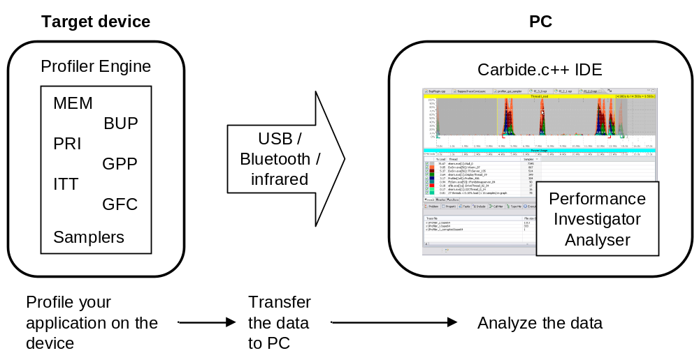
Figure 2.1 Overview of the profiling and analysis process

Sampler plug-in types
A specific profiler process that gathers data about the device's performance is called a sampler. Samplers are located at the device and they collect data of specific performance-related things. The plug-ins are implemented using the ECom plug-in framework.
PI Profiler provides a basic set of samplers as plug-ins. The basic sampler plug-in group contains the trace types that are included in the delivery package. This does not mean that they should be always on when a use case is traced, but they are always available.
Table 2.1 Basic samplers
Abbreviation | Name | Description
GPP | General Purpose Processor Trace | Statistical trace for thread load / function load activity.
MEM | Memory trace | Takes samples of memory consumption of threads.
GFC | Generic Function Call trace | Records function call-relations during execution.
ITT | Instruction trace | Records data about executed binaries.
PRI | Priority trace | Takes samples of thread priorities.
BUP | Button Press | Records button and touch events .

A given sampler plug-in may have parameters that can be configured. For more information on this task, see Section 3.3.

Dependencies to other tools
Before you can carry out the profiling and related analysis of the data, check that you have the following software and files:
- Performance Investigator analyzer software, delivered as part of Carbide.c++ IDE Professional or Developer Edition (for how to obtain, see reference document [2]).
- For analysing results on function and binary level, a symbol file (.symbol). The file is included in R&D builds, and you can produce it yourself by generating a ROM image for your device.
- (Optional) Profiler Activator Carbide.c++ Extension for starting profiling from a PC.

Note: PI Profiler uses the same power usage sampling channel as Nokia Energy Profiler (NEP). If you have NEP running on the device when starting PI Profiler and sampling power usage, the profiling fails, and you receive an error notice that power sampling is ignored for this round. Press OK to confirm to disable power usage sampling.

Order of tasks in using PI Profiler
To use the PI Profiler tool, the following steps must be taken:
- Configure the profiling options by modifying PI Profiler’s general settings for capturing trace data. See Section 3.1.
- Enable the sampler types you want to use in profiling. See Section 3.2.
- Modify sampler-specific settings (e.g., the sampling rate and other applicable options).
See Section 3.3.
- Start profiling and carry out the use case with your application. When finished, stop profiling. See Section 3.5.
- Transfer the profile data to PC for analysis. See Section 3.7.
- In Carbide.c++, import the profiler data file to the Performance Investigator analyzer tool and study the graphs of the captured data. For more information on the analysis, refer to the online documentation of Performance Investigator available in Carbide.c++ IDE.

Using the PI Profiler tool
When you have installed the application into the device, select the PI Profiler icon from the S60 application list. By default, it is found under RnD Tools. The start-up screen displays the available sampler plug-ins, as shown in Figure 3.1 below.
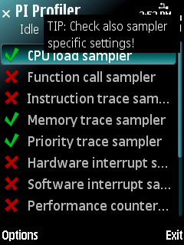
Figure 3.2 The start-up screen of PI Profiler
In Figure 3.1, the samplers that are marked with green are enabled and can be used to gather trace data. The samplers marked with red are disabled and must be enabled before they can be used. For instructions, see Section 3.2.
Tip: To view more details of the samplers, do the following:
- Select a sampler on the list.
- Select Options > Sampler control > Sampler info, or
on touch UI, tap the sampler, and select Sampler info.

Modifying the general settings
Modify the general PI Profiler settings to determine where and how to save the trace output.
Note: These settings are applied for all sampler types. To change sampler-specific settings (e.g., the rate in milliseconds) see Section 3.3.
To modify the settings:
- Select Options > Settings.
- To modify the default values, select Options > Change, or
on touch UI, tap a value.
- In Output to, define where the output is generated:
- File system on your device (e.g. a memory card).
- Printed on debug on your device.
- (Optional) If using the file system: In Save file in, define the location for the trace files on the device.
- (Optional) If using the file system: In File prefix, define the identification for the trace files.
- (Optional) If using timed profiling: In Profiling period (sec.), define the duration of profiling in seconds.
- Select Back to return to the PI Profiler main screen.
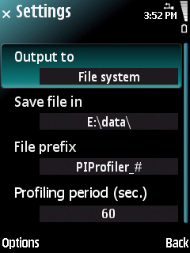
Figure 3.3 Example of the settings

Enabling samplers
Before a sampler can be used in profiling, it must be enabled first.
To enable a sampler:
- Select a sampler on the list.
- Select Options > Sampler control > Enable, or
on touch UI, tap the sampler, and select Enable.
The sampler is marked with a green symbol.
- Repeat the steps above for as many samplers as you want to enable for the profile.

To disable a sampler from profiling:
- Select the sampler on the list.
- Select Options > Sampler control > Disable, or
on touch UI, tap the sampler, and select Disable.
The sampler is marked with a red symbol.

Note: You cannot enable all samplers at once.
Note: You cannot select, enable, or disable any samplers during the profiling process.

Modifying plug-in-specific settings
Each available sampler plug-in type contains options for setting e.g. the specific sampling rate. The available options depend on the sampler.
To modify sampler-specific settings:
- Select a sampler on the list.
- Select Options > Sampler control > Sampler Settings, or
on touch UI, tap the sampler, and select Sampler Settings.
- To modify a value, select Options > Change, or on touch UI, tap the value.
- Edit the value.
- Select OK and Back to return to the PI Profiler main screen.

Starting and stopping the profiling
Note that the profiling only includes the enabled sampler types.
- To start profiling, select Options > Start.
- To start and stop the profiling manually, select Profiling.
To use timed profiling, select Profiling for n sec.
The trace output is written to the output defined in PI Profiler’s settings (see Section 3.1).
An example is depicted below:
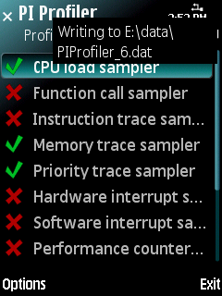
Figure 3.4 An example of profiling in progress
- Go to your application and perform the use case you want to analyse.
- Select Options > Stop profiling.
The gathered data is stored to the location defined in the general settings.
Note that if you use timed profiling, the profiling stops automatically.

Transferring data files to the PC for analysis
You can transfer files to a PC in several ways:
- Save the files to a memory card and transfer via a memory card reader.
- (Optional) Save the files to a memory card or to the device and transfer via Nokia PC Suite.
- (Optional) Use Profiler Activator Carbide.c++ Extension that imports the data files automatically after profiling.

Running PI Profiler from EShell
If you want to run PI Profiler from EShell, check the following requirements:
- The eShell.sis application is installed to the target device (C:\).
- You have configured PI Profiler Settings with the PI Profiler application.
Note: In EShell, ENTER is given by pressing 0 three times.

To run PI Profiler from EShell, do the following:
- Launch the EShell application.
- At the command prompt, go to the folder Z:\sys\bin.
- At the command prompt, type a command:
- To start profiling, type piprofiler start c:\data\piprofilersettings.txt.
- To stop profiling, type piprofiler end c:\data\piprofilersettings.txt.
- To start profiling with a timer, type piprofiler timed c:\data\piprofilersettings.txt ##.
In these commands, c:\data\piprofilersettings.txt is the PI Profiler settings file
and ## is the timer duration in seconds.

Leaving the PI Profiler Engine running for other applications
You can leave the PI Profiler Engine process running in the background, even if you close the PI Profiler UI. The PI Profiler Engine can then be accessed by other applications, such as other Profiler sessions or Application Programming Interfaces (APIs). You can access these processes later by re-starting the PI Profiler UI.
To leave the PI Profiler Engine running:
- Select Exit to quit the PI Profiler UI.
- Confirm the question Leave profiling on by selecting Yes.
- The PI Profiler Engine process may now be accessed from other applications.

