How-to Create a Root Certificate for Inclusion in the SWI Certificate Store as a Trust Anchor
Security Classification: |  | Team/Department: | Crypto Services
Document Reference: |  | Author(s): | Martin Hardman
Status: | Issued | Owner(s):
Version: | 1.1 | Approver(s) | Andy Harker
Last Revised Date: | 11th Jan 2006 |  | Andy Harker

1 Purpose 1
2 Introduction 2
3 OpenSSL 2
4 The Process 3
5 Generating a trust anchor 3
5.1 The configuration file 4
6 Generating/signing an End Entity Certificate 5
6.1 Stage 1: Generating a certificate request 6
6.1.1 Using OpenSSL to generate a certificate request 6
6.1.2 Using makekeys to generate a certificate request 6
6.2 Stage 2 - Processing the certificate request 7
6.3 The configuration file 8
6.4 Stage 3 - Signing the SIS file 9
7 Further Information 10
7.1 Glossary 10
7.2 References 11
7.3 Document History 11
8 Appendix A – OpenSSL configuration file 12

Purpose
This document gives a very high level overview of how the tool OpenSSL can be used to create a trust anchor and generate a verifiable End Entity certificate which may subsequently be used to sign a SIS file.
It is intended as a quick-start reference for anybody who may need to generate a trust anchor for inclusion in the Symbian swicertstore (Software Installation Certificate Store) [R2] and to use this to sign an EE certificate which may be used to sign a SIS file.

Introduction
When a Symbian software installation package (.SIS file) is installed onto a device, the software installation component (SWI) may require that the package be signed with a verifiable End Entity certificate, signed with a trust anchor which is present on the Symbian device in the Software Installation Certificate Store (or signed by an intermediate CA which provides the necessary coupling between the issued verifiable EE certificate and the trust anchor).
There may be instances, during testing for example, when a developer needs to generate their own test root certificate, install it on the device as a trust anchor, and use it to sign EE certificates which can be used to sign SIS files for subsequent installation. This document is only relevant to Symbian OS licensee developers or Symbian partner developers etc. who are in a position to populate a swicertstore with root certificates and deploy it to an emulator or test hardware environment. Everybody else, i.e. 3rd party developers, should consult www.symbiansigned.com regarding the use of Developer Certificates.

This document describes how the open source tool, OpenSSL, may be used to generate a root certificate for inclusion in swicertstore and how to generate a verifiable EE certificate for signing SIS files. Note that the Symbian supplied tool makekeys.exe is not capable of generating CA certificates; hence, it is necessary to use tools such as OpenSSL to generate these.
Note that it does not offer a full explanation of certificates, nor of the OpenSSL tool. Instead it is intended as a quick-starter reference for readers who may need to generate their own certificates for testing or similar purposes.
The reader is assumed to have some familiarity with certificates and PKIX etc.

OpenSSL
OpenSSL (http://www.openssl.org/) is an open source cryptography toolkit implementing the Secure Sockets Layer (SSL v2/v3) and Transport Layer Security (TLS v1) network protocols and related cryptography standards required by them.
It can be used to generate and sign certificates, however it is a complex tool with many commands and configuration options, and anybody using it is advised to consult its accompanying online documentation. What is presented in this document is a highly simplified overview of its use.

The easiest way to get started using the tool is to download the executable openssl.exe. A listing of versions can be found at http://www.stunnel.org/download/stunnel/win32/, with a downloadable version at http://www.stunnel.org/download/stunnel/win32/openssl-0.9.7f-zlib/ for example, (the version used in the construction on the document was downloaded from: http://www.stunnel.org/download/stunnel/win32/openssl-0.9.7c/)
The tool can then be invoked from an MS-DOS command prompt. Note that when using the tool, care should be taken typing the commands as they, and the contents of the associated configuration file, are case sensitive.

The Process
The following diagram shows the sequence of steps described through the course of this document.

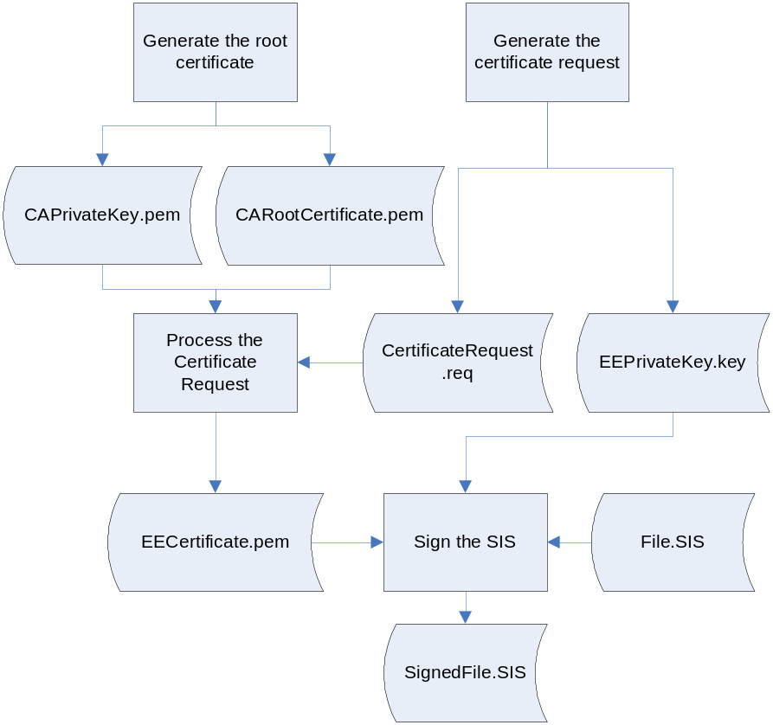

Generating a trust anchor
Depending upon the Symbian device’s software installation policy settings [R1], software packages being installed on the device may need to have been signed with a verifiable EE certificate which is “derived” from a trust anchor which is present in the Software Installer’s Certificate Store [R2].
This section describes how a test root certificate may be generated which can subsequently be included within that software install specific certificate store as a trust anchor.

The OpenSSL command req may be used; this generates a self-signed X.509 v3 root certificate:
openssl req -x509 -newkey rsa:1024 -keyout CAPrivateKey.pem -out CARootCertificate.pem -extensions CA_Root_Certificate_Extensions -config openssl.config -nodes

Command | Description
req | The req command can primarily be used to either generate a certificate request or to generate a self-signed certificate. When the –x509 command is specified in conjunction with the req command, as it is here, then a self-signed certificate is generated.
x509 | This command outputs a self signed certificate instead of a certificate request.
newkey | This command creates a new private key to accompany the generated self-signed certificate. The command takes an argument in two forms, in this case rsa:1024 is specified to generate an RSA key 1024 bits in size.
keyout | This gives the filename to write the newly created private key to.
out | This specifies the filename to write the certificate to.
extensions | This specifies that the certificate is to be created with a set of certificate extensions, the extensions are specified in a configuration file, openssl.config, in the section named CA_Root_Certificate_Extensions
config | Specifies the name of a configuration file where various options and parameters are set. In this example the configuration file is named openssl.config.
nodes | This indicates that the private key generated will not be encrypted (if an encrypted key is required, removal of this parameter will cause OpenSSL to prompt the user for a password. Alternately, the password can be added to the configuration file if user-interaction is not desirable)

Once the req command above has run, a key/certificate pair will have been created – CAPrivateKey.pem and CARootCertificate.pem.

The certificate can be added to the swicertstore [R2], but first it is necessary to convert it to DER format.
The default output of the certificate using the above set of command parameters is in PEM format which is not suitable as input to the swicertstore. The OpenSSL x509 command can be used to convert files from PEM to DER format:
openssl x509 -in CARootCertificate.pem -outform DER -out CARootCertificate.der
The resulting certificate, CARootCertificate.der, is now in a format suitable for inclusion in the swicertstore.

The configuration file
Most OpenSSL commands take a configuration file as input where various settings and options are specified. Below is an example of the contents of a simple configuration file showing the sections required to generate a root certificate:

[ req ]
distinguished_name = root_ca_distinguished_name
prompt = no

[ root_ca_distinguished_name ]
commonName = Symbian Software Ltd
stateOrProvinceName = London
countryName = UK
emailAddress = Somebody@Symbian.com
organizationName = Symbian Software Ltd

[ CA_Root_Certificate_Extensions ]
keyUsage=critical,keyCertSign
basicConstraints=critical,CA:TRUE, pathlen:5
subjectKeyIdentifier=hash

The configuration file is split into a number of sections – indicated by a section name enclosed between square brackets.
[req] | Configuration options are specified in the req section.  distinguished_name – this specifies the section containing the distinguished name fields.  prompt - if set to the value no this disables prompting of certificate fields and just takes values from the config file directly.
[ root_ca_distinguised_name ] | This section contains the field names and values to use for the certificate’s distinguished name.
[ CA_Root_Certificate_Extensions ] | This section specifies a set of extensions to be added to the generated root certificate. An explanation of X.509 certificate extensions is beyond the scope of this document.  See RFC 3280 for a full explanation of X.509 certificate extensions.

Generating/signing an End Entity Certificate
If a SIS file is being installed onto a Symbian device then the software installer component may require it to have been signed with a verifiable EE certificate issued by a certification authority which chains back to a trust anchor. Signing the SIS file with such a certificate is a three stage process:
- A certificate request is generated
- The certificate request must be processed, generating a verifiable EE certificate that is signed with the root certificate
- The SIS file must be signed with the verifiable EE certificate

Stage 1: Generating a certificate request

Using OpenSSL to generate a certificate request
The OpenSSL command req may be used to generate a certificate request. The command requires the use of a configuration file, a sample relevant portion of a configuration file for an EE certificate is given below, (see also Appendix A).
[ req ]
distinguished_name = distinguished_name
prompt = no

[ distinguished_name ]
commonName = EE User
stateOrProvinceName = London
countryName = UK
emailAddress = ee_user@symbian.com
organizationName = Symbian Software Ltd

openssl req -config openssl_req.config -newkey rsa:1024 -keyout EEPrivateKey.key -out CertificateRequest.req -nodes

Command | Description
req | The req command can primarily be used to either generate a certificate request (in PKCS#10 format) or to generate a self-signed certificate. When the –x509 command is not specified in conjunction with the req command then a certificate request is generated.
config | The same configuration file that was used to generate the root certificate can be used for creation of the certificate request.
newkey | Indicates that a corresponding private key should be generated along with the certificate request. In this example it is an RSA key of length 1024 bits.
keyout | The name of the file to contain the generated key
out | The name of the file to contain the generated request
nodes | Specifies that the generated key is not encrypted

After the command has run, two files will have been created: EEPrivateKey.key and CertificateRequest.req.

Using makekeys to generate a certificate request
Instead of using OpenSSL to generate the certificate request, the Symbian OS tool makekeys can be used.
This is a two-stage process; first makeykeys is used to generate a private key and a self-signed EE certificate:
makekeys -cert -dname “CN=A Developer O=Some Company” EEPrivateKey.key Certificate.cer

Then the generated key and certificate from above are used as input into makekeys to generate the certificate request:
makekeys -req -dname "CN=A Developer O=Some Company" EEPrivateKey.key Certificate.cer CertificateRequest.req

The output from running makekeys twice as above is two files of interest will have been created: EEPrivateKey.key and CertificateRequest.req.

Stage 2 - Processing the certificate request
Once a certificate request has been generated, the OpenSSL command ca can be used to process it – producing a public key certificate signed with the CA’s private key generated in section 5 (generating a root certificate).
Before the ca command can be run it is first necessary to create two text files - the location and names of which are specified in the configuration file described in the next section – in this example they are created in the current directory with names:
index.txt – information is written to this during the signing process. Simply create an empty text file with this name.
serial.txt – contains the value of the serial number which is assigned to the certificate, create an empty text file containing 01 for example (an error will be generated if it contains an odd number of characters i.e. 555 or 1).
Either of the certificate requests generated in sections 6.1.1 or 6.1.2 may be used as input:
openssl ca -config openssl_ca.config -name Signing_Parameters -in CertificateRequest.req -extensions Signing_Extensions -extfile openssl_ca.config -batch -out EECertificate.pem

Command | Description
ca | The ca command is a minimal Certification Authority command and is used in this instance to sign the certificate request
config | Specifies the name of the configuration file to use
name | Specifies the name of the section in the configuration file where various options and input parameters to the ca command may be obtained.
in | The filename containing the certificate request to be signed
extensions | Specifies the name of a section in a configuration file for a set of certificate extensions that will be added to the generated EE certificate
extfile | Specifies the name of the configuration file containing the extensions section
batch | Signs the certificate automatically – if not specified the user will be prompted for various options
out | The name of the file to contain the generated certificate. If not present, the generated certificate will be named xx.pem where xx is the value that was specified in serial .txt – see below.
Once the ca command has executed, the file EECertificate.pem is created; this is a signed verifiable EE certificate which may now be used to sign a SIS file.

The configuration file
During the signing process, various settings are read from the configuration file. The following example sections may be used to process the certificate request:
[ Signing_Parameters ]
database = index.txt # index file
new_certs_dir = . # new certs dir
certificate = CARootCertificate.pem # The CA cert
serial = serial.txt # serial no file
private_key = CAPrivateKey.pem # CA private key
default_days = 365 # how long to certify for
default_crl_days = 30 # how long before next CRL
default_md = md5 # md to use
policy = ca_policy # the policy
email_in_dn = no # Don't add the email into cert DN
nameopt = default_ca # Subject name display option
certopt = default_ca # Certificate display option
copy_extensions = none # Don't copy extensions from request

[ ca_policy ]
organizationName = supplied
commonName = supplied

[ Signing_Extensions ]
extendedKeyUsage=codeSigning

A full description of all the available options and the meaning of these sections is beyond the scope of this document. Some relevant parts however are:
Parameter | Description
database | The name of the index file
new_certs_dir | The name of the directory where the signed certificate should be placed
certificate | The CA certificate to use for the signing process
serial | The name of the serial file
Private_key | The CA private key to use for the signing process
extendedKeyUsage | Generate the EE certificate with the X.509 code signing extension, identified by OID 1.3.6.1.5.5.7.3.3.  See RFC 3280 for details on X.509 certificate extensions and [R1] for details regarding the relationship between certificate extensions and Symbian software installation policies

Stage 3 - Signing the SIS file
Once the certificate request has been processed, the result will be a signed EE certificate. This, along with the corresponding private key generated in section 6.1.1 or 6.1.2 can be used to sign a Symbian installation package:
signsis File.sis SignedFile.sis EECertificate.pem EEPrivateKey.key

EECertificate.pem is the root linked certificate, the verifiable EE certificate signed with the CA’s private key file that was created in 6.2.
signsis takes the unsigned SIS file, File.sis, and signs it using the private key generated from section 6.1.1 or 6.1.2 and the certificate, EECertificate.pem, generated from section 6.2 to produce the signed SIS file SignedFile.sis.

If the root certificate, CARootCertificate.der, generated in section 5 has been added to the device’s swicertstore then when SignedFile.sis is installed onto the device it will have been signed with a certificate which chains back to this root certificate.

Further Information

Glossary
Term | Description
ASN.1 | Abstract Syntax Notation 1, an all-encompassing meta syntax description language used generally in computer security applications. It is used in X.509, PKCS and related standards. PGP, for instance, doesn't use it.
CA | A Certification Authority is an organization which performs various functions in a PKI such as: provided trusted root certificates to users, certifying users, generating certificates, supporting certificate revocation and revocation checking.
CA Certificate | A Certification Authority Certificate.
Certificate Extension | Data elements to be added to the certificate, with corresponding processing rules in the PKI.
Certification Authority Certificate | A CA certificate is a certificate that's used for signing other certificates.
DER | Distinguished Encoding Rules is a method for encoding any ASN.1 structure, such as an X.509 certificate, as binary data.
DevCert | Developer Certificate.
Developer Certificate | A Developer Certificate (DevCert) permits developers to develop and test applications on target devices before submitting them for signing. See www.symbiansigned.com for further details.
DSA | The Digital Signature Algorithm (DSA) is a United States Federal Government standard for digital signatures. It was proposed by the National Institute of Standards and Technology (NIST) in August 1991 for use in their Digital Signature Standard (DSS).
EE Certificate | An End Entity Certificate.
End Entity Certificate | A certificate which has been signed by a Certification Authority. An EE certificate may be used to sign a SIS file or a MIDlet, but may not be used to sign certificates.
Executable | A compiled program which runs (executes) on the emulator or device. Both EXEs and DLLs are considered executables by SWI.
Intermediate CA | A valid CA certificate that can be verified by a root certificate.
Makekeys | Makekeys (also known as the Certificate Generator) is a PC based command line tool which creates a private/public key pair and issues certificate requests. The resultant private key is used to digitally sign installation files, enabling SWI to authenticate them. It is not capable of generating CA certificates.
OCSP | Online Certification Status Protocol, RFC2560. Online Certificate Status Protocol, a communication protocol to determine if a certain certificate has been revoked.
OID | An object identifier is a numeric string that is used to uniquely identify an object. It is created by self-extending a private enterprise number that an institution has acquired.
OPENSSL | Open Source toolkit implementing the Secure Sockets Layer (SSL v2/v3) and Transport Layer Security (TLS v1) protocols as well as a full-strength general purpose cryptography library.
Package | A set of files delivered by a SIS file.
PEM | Privacy Enhanced Mail is a method for encoding a data object, such as an X.509 certificate, to be digitally signed or to have its signature verified. PEM is just base64-encoded DER, plus a header and footer.
PKI | A public key infrastructure (PKI) is an arrangement which provides for third-party vetting of, and vouching for, user identities. It also allows binding of public keys to users. This is usually carried out by software at a central location together with other coordinated software at distributed locations. The public keys are typically in certificates.
PKIX | Public Key Infrastructure, X.509, is a working group in the Internet Engineering Task Force (IETF) security area.
Root Certificate | A self signed certificate: the root of a certification hierarchy.
RSA | RSA is an algorithm for public-key encryption and signing. It was described in 1977 by Ron Rivest, Adi Shamir and Len Adleman at MIT; the letters RSA are the initials of their surnames.
Secure Sockets Layer | Precursor to TLS. SSL has been through three versions: the first two are considered insecure, and the third is almost identical to TLS.
SIS File | A collection of executables and/or data files packaged in a form suitable so that SWI can install them onto a device.
Software Installer | The Software Installer. A Symbian OS component, part of the security subsystem, which is responsible for the installation of all native software packages (.SIS files).
SSL | Secure Sockets Layer.
SWI | The abbreviation for the Software Installer.
Swicertstore | This is a software implementation of the Cert Store API that holds and provides access to certificates for use during installation of software onto the device. It is provided for the sole purpose of housing certificates used for validating software to be installed on the device.
TLS | Transport Layer Security.
Transport Layer Security | A client-server security protocol providing secrecy and optionally authentication, and running over TCP/IP. Used by many merchants on the web to protect credit card numbers while in transit.
Trust Anchor | A trust anchor is a certificate on the device that is trusted directly by the device for some purpose, such as verifying EE certificates used to sign SIS packages.
Verifiable EE Certificate | A valid End Entity Certificate that is verifiable by a Trust Anchor
X.509 | X.509 is an ITU-T standard for public key infrastructure (PKI). X.509 specifies, amongst other things, standard formats for public key certificates and a certification path validation algorithm.

References
[R1] | How-to Configure Software Installation Policies
[R2] | How-to Configure the SWI Certificate Store

Document History
Date | Version | Status | Author | Description
11/01/2006 | 1.1 | Issued | Dominic Pinkman | Editorial review
22/12/2005 | 1.0 | Issued | MG | Final Check (spelling, glossary, TOC, etc)
21-12-2005 | 0.9 | Draft | MH | Incorporated review comments/changes by Tim Gover
11-11-2005 | 0.4 | Draft | MH | Incorporated changes following review by Andy Harker. Added a Glossary
18-10-2005 | 0.3 | Draft | MH | Changes following review by Mathieu George. Added diagram.
17-10-2005 | 0.2 | Draft | MH | Cleaned bits up, added further clarification, rearranged sections
05-10-2005 | 0.1 | Draft | MH | Initial draft

Appendix A – OpenSSL configuration file
For reference, the complete configuration file used in the examples is:

# openssl.config

[ req ]
distinguished_name = root_ca_distinguished_name
prompt = no

[ root_ca_distinguished_name ]
commonName = Symbian Software Ltd
stateOrProvinceName = London
countryName = UK
emailAddress = Somebody@Symbian.com
organizationName = Symbian Software Ltd

[ CA_Root_Certificate_Extensions ]
keyUsage=critical,keyCertSign
basicConstraints=critical,CA:TRUE, pathlen:5
subjectKeyIdentifier=hash

[ ca ]
default_ca = ca_default # the default ca section

[ Signing_Parameters ]
database = index.txt # index file.
new_certs_dir = . # new certs dir
certificate = CARootCertificate.pem # The CA cert
serial = serial.txt # serial no file
private_key = CAPrivateKey.pem # CA private key
default_days = 365 # how long to certify for
default_crl_days= 30 # how long before next CRL
default_md = md5 # md to use
policy = ca_policy # the policy
email_in_dn = no # Don't add the email into cert DN
nameopt = default_ca # Subject name display option
certopt = default_ca # Certificate display option
copy_extensions = none # Don't copy extensions from request

[ Signing_Extensions ]
extendedKeyUsage=codeSigning, 1.2.826.0.1.1796587.1

[ ca_policy ]
organizationName = supplied
commonName = supplied

To use a DSA key, first run the command openssl dsaparam –out dsaparam.pem 1024 then substitute the command parameter –newkey rsa:1024 with –newkey dsa:dsaparam.pem
Take care to ensure the contents of the configuration file conform to the documentation for OpenSSL, for example, changing the country from UK to United Kingdom would generate a cryptic such as: “problems making Certificate Request 1324:error:0D07A097:asn1 encoding routines:ASN1_mbstring_copy:string too long: crypto/asn1/a_mbstr.c:154:maxsize=2”
The Symbian OS certificate validation algorithm processes the following X.509 extensions: Basic Constraints, Subject Alt Name, Issuer Alt Name, Key Usage, Name Constraints, Policy Constraints, Certificate Policies, Certificate Policies, Policy Mapping, Authority Key Id, Subject Key Id, Extended Key Usage.
Note that if you run the ca command twice then the following error may be reported: failed to update database TXT_DB error number 2. To remove the error, delete the contents of index.txt before re-running the command. You may also wish to re-set the contents of serial.txt back to their original value as they are automatically incremented each time the command is executed.

