How-to Deploy a Writeable SWI Certificate Store
Security Classification: |  | Team/Department: | Crypto Services
Document Reference: |  | Author(s): | Martin Hardman
Status: | Issued | Owner(s):
Version: | 1.1 | Approver(s) | Andy Harker
Last Revised Date: | 12th January 2006 |  | Andy Harker

1 Purpose 1
2 Introduction 2
2.1 Example Use Cases 2
2.2 Software Installer Certificate Store Overview 2
2.3 Updating the Writeable SWI Certificate Store 3
3 Example Usage 5
3.1 Step 1 – Create and install the ROM SWI Certificate Store data file 6
3.2 Step 2 – Attempt to Install HelloWorldA.SIS 7
3.3 Step 3 – Create the Writeable SWI Certificate Store data file 7
3.4 Step 4 – Generate the Updater program and package as a SIS file 8
3.5 Step 5 – Install the Updater package and execute the Updater program 9
3.6 Step 6 – Sign HelloWorld.SIS with a new certificate 10
3.7 Step 7 – Install HelloWorldB.SIS 10
4 Further Information 11
4.1 Glossary 11
4.2 References 11
4.3 Document History 12

Purpose
A device contains a collection of trust anchors used for verification purposes when new software is being installed onto the device. These certificates are held in the Software Installer Certificate Store (swicertstore), which physically is composed of an immutable part (in ROM) and a writable part on the C: drive. This document describes how the writeable part may be updated on a device post market.

Introduction
When a software package (.SIS File) is being installed onto a device, the installation is handled by the Software Installer component (SWI). SWI makes use of a Public Key Infrastructure (PKI) based security model to prevent installation of unauthorised packages. Depending upon device configuration, SWI may only allow installation of packages signed with a verifiable EE certificate. SWI may also perform an OCSP check upon all certificates in the chain (excluding the trust anchor), either at installation time or later, and a root certificate may be explicitly marked for use during this process.
The trust anchors are held in the SWI Certificate Store (swicertstore). This is a new store introduced with Symbian OS 9.x specifically to hold certificates for use by SWI in the situations outlined above.
There are two parts to the swicertstore – there is an immutable store held in ROM and a writeable store that may be updated post market. The remainder of this document describes how the writeable store may be configured post market, see [R1] for details on how to configure the ROM store and for background information relevant to this document.

Example Use Cases
The following are some example use cases which illustrate the need for the writeable swicertstore and some uses to which it can be put:
- An enterprise IS administration department desires to add a mandatory root to their company's devices to prevent unapproved applications from being installed. The administration department generates their own root certificate and submits it to the device manufacturer to be packaged as a signed SIS file. The SIS file is returned to the administration department, and is then installed on the devices. The devices will then refuse to install software unless it has been countersigned by the IS administration root certificate.
- A network operator wants to run their own certification program in addition to the manufacturer's program or the Symbian Signed scheme. The network operator generates their own root certificate and submits it to the device manufacturer to be packaged as a signed SIS file. The SIS file is returned to the network operator and is then installed on all devices distributed by them. The devices will then permit software signed by the network operator to be installed without any warnings.
- As for above, but the network operator wants their certification program to replace the manufacturer's program or Symbian Signed. In this case, the root certificate is marked as mandatory, and devices will only permit software signed by the network operator to be installed.

Software Installer Certificate Store Overview
Certificate stores in Symbian OS are accessed via the Cert Store API; there can be multiple software implementations of that API to provide access to various certificate stores. The swicertstore is one such implementation of that API which provides access to stores holding certificates used by the Software Installer to perform checks when installing software on the device.
The swicertstore component is implemented as a DLL, while the actual certificates’ data and metadata is held in two data files: one of which is held in ROM while the other is held on the C drive.
SwiCertStore.dll provides a unified view of the two data files to its users. The Software Installer (a TCB component) accesses the swicertstore directly. However, other components (i.e. non TCB components) can access the contents of swicertstore via the Unified Certificate Store interface using the ECOM based CryptoToken Framework.

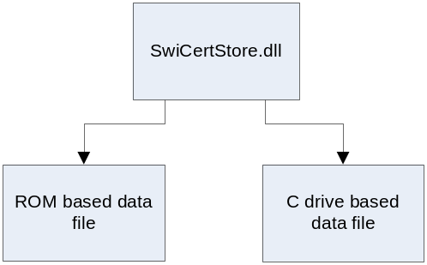

The ROM based data file is read-only and its contents are therefore fixed for the lifetime of the device. The C drive based data file may be changed at any point during a device’s lifetime.
The ROM data file must be configured prior to device shipment, how to do this is described in [R1]. The remainder of this document describes how a new C: drive based data file (from this point forth referred to as the Writeable swicertstore) can be created and installed onto the device.

The Writeable swicertstore data file resides in c:\resource\swicertstore\, which is an area of the file-system that may only be written to by executables that have the TCB capability. The device as shipped from the factory may not contain a Writeable swicertstore, in which case SwiCertstore.dll defaults to using just the ROM swicertstore. SWI also prevents any SIS files from installing a data file to the Writeable swicertstore directory.

Updating the Writeable SWI Certificate Store
The Writeable swicertstore can only be updated by executing a special program on the device, SwiCertStoreUpdater.exe. This executable can be installed onto the device by packaging and delivering it as a SIS file. The following diagram gives an overview of the steps involved in this process.

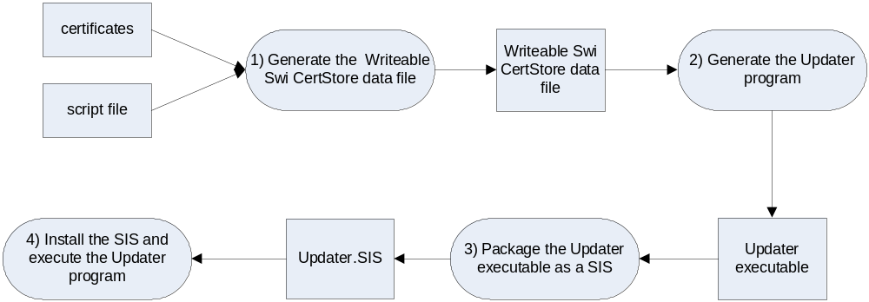

- First the data file containing the certificates to be installed to the Writeable swicertstore must be generated. The process for this is identical to generating the ROM based swicertstore data file and is described in [R1].
- An updater program must be generated then executed on the device in order to install the data file generated from stage 1. The updater program is generated on a PC as a .cpp source file using the Perl script SwiCertStoreToBin.pl. The updater .cpp code contains within it the data from the Writeable swicertstore data file and hence must be dynamically generated each time a new store is to be installed to the device. SwiCertStoreToBin can also compile the updater program into an executable. The generated executable cannot be used to deliver other updates to the device.
- The updater executable must be packaged into a signed SIS file; SwiCertStoreToBin can also automatically generate and sign the SIS file if required.
- The SIS file is installed on the device and the updater is run automatically.
- The updater program notifies users of Unified Cert Store of the change by setting a publish & subscribe flag.
It is also possible to upgrade an existing SwiCertStoreUpdater.exe program – with normal SWI upgrade rules applying.
The process of installing a new Writeable swicertstore is atomic – the update either completes fully or has no lasting effect (even in the event of power failure). Partial updates are not permitted and any previous Writeable swicertstore is completely overwritten. Certificates in the Writeable swicertstore augment, and do not obscure, the certificates in the ROM swicertstore. The stores are additive, rather than eclipsing one another, though searches of certificates visit the writeable store first. Once the update is installed on the device, dependent processes (i.e. processes that have loaded swicertstore.dll) will each synchronize their internal state at the earliest opportunity – processes will see the new store update as long as they don’t hold the store open indefinitely.

It is not possible to modify, delete or augment in any way the contents of the Writeable swicertstore by means of the swicertstore.dll API.
Updates to the store are not applied retrospectively; the state of an installed application is not affected. Updates to the store will however apply to any subsequent updates to those applications.

Users of the Unified CertStore and swicertstore dlls are notified of updates via the Publish and Subscribe mechanism – the KUnifiedCertStorePropertyCat being signalled when the contents of the store are updated.
It is possible to uninstall the updater executable program from the device. However, it is not possible to uninstall the Writeable swicertstore once it has been installed. The only way to reverse the effect of an update to the store is to deliver and install a newer store that overwrites the former (an update may contain no certificates).

Note that the Writeable swicertstore is not backed up during a backup and restore operation. Currently, manufacturers are therefore required to re-run the relevant updater executable at an appropriate point.

Example Usage
A (contrived) scenario is described below, in which a device is shipped with no root certificates endorsing a particular system capability; however it is a requirement that software using that capability be installable on the device. The scenario demonstrates how delivering and installing a new Writeable swicertstore to the device can remedy the situation.
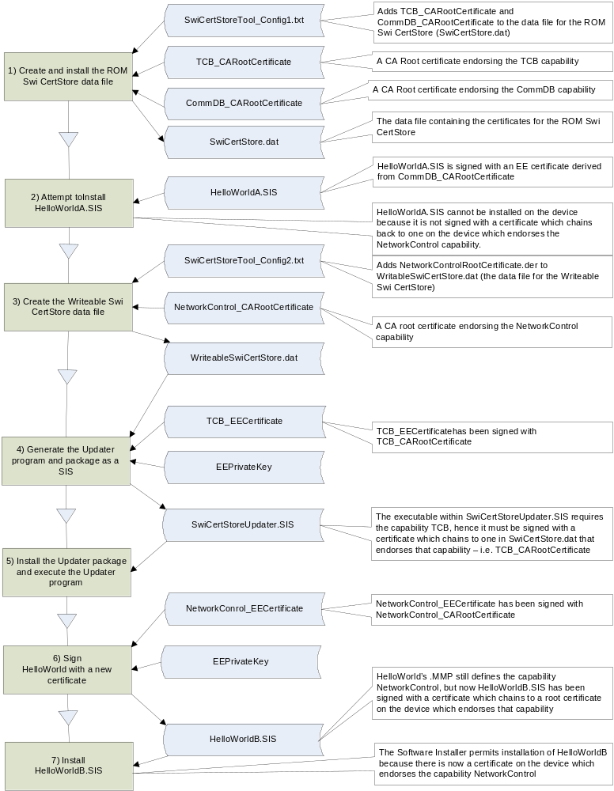

File | Description
SwiCertStoreTool_Config1.txt | The ROM SwiCertStore data file (SwiCertStore.dat) is created using the SwiCertStoreTool executable which takes as input a configuration file naming the certificates to be added and the capabilities they endorse. SwiCertStoreTool_Config1.txt is that input configuration file.
TCB_CARootCertificate | A root certificate endorsing the TCB capability that gets added to SwiCertStore.dat
CommDB_CARootCertificate | A root certificate endorsing the CommDB capability that gets added to SwiCertStore.dat
SwiCertStore.dat | The ROM swicertstore data file.
HelloWorldA.SIS | HelloWorldA.SIS’s contained executable uses the NetworkControl capability however the SIS file has been signed with an End Entity certificate which derives from CommDB_CARootCertificate which only endorses the CommDB capability.
SwiCertStoreTool_Config2.txt | The configuration input file for SwiCertStoreTool.exe, used to create the Writeable swicertstore data file. It specifies that WriteableSwiCertStore.dat should contain the certificate NetworkControl_CARootCertificate which endorses the NetworkControl capability.
NetworkControl_CARootCertificate | A Root certificate endorsing the NetworkControl capability.
WriteableSwiCertStore.dat | The Writeable swicertstore data file
TCB_EECertificate | A verifiable End Entity certificate signed with TCB_CARootCertificate
EEPrivateKey | The associated EE private key for the EE certificates
SwiCertStoreUpdater.SIS | The signed package file to install SwiCertStoreUpdater.exe to the device which when run establishes WriteableSwiCertStore.dat as the writeable SWICertStore
NetworkControl_EECertificate | A verifiable End Entity certificate signed with NetworkControl_CARootCertificate.
HelloWorldB.SIS | Contains the same contents as HellowWorldA.SIS; however this has been signed with NetworkControl_EECertificate.

Step 1 – Create and install the ROM SWI Certificate Store data file
This step emulates the process that would be carried out by a device manufacturer prior to a device shipping – namely that of configuring and installing in ROM the immutable swicertstore
This step uses the emulator executable tool, SwiCertStoreTool.exe, to create the physical data file (SwiCertStore.dat) for the ROM swicertstore, placing two root certificates inside it, one endorsing the TCB capability and the other endorsing the CommDB capability (TCB_CARootCertificate & CommDB_CARootCertificate). See [R1] for a description of the use of SwiCertStoreTool.exe and its configuration file.

The contents of SwiCertStoreTool_Config1.txt are:
[Root Certificate Endorsing TCB]
file = c:\TCB_CARootCertificate.der
capability = TCB
application = SWInstall
[Root Certificate Endorsing CommDB]
file = c:\CommDB_CARootCertificate.der
capability = CommDB
application = SWInstall

After SwiCertStore.dat has been created, it needs to be placed in ROM at:
z:\resource\swicertstore.dat
Which in the emulator corresponds to:
\Epoc32\release\(platform)\(build)\z\resource\swicertstore.dat

The device is now shipped.

Step 2 – Attempt to Install HelloWorldA.SIS
A network operator has a requirement to install an application, HelloWorld.exe onto the devices, however the installation always fails.
HelloWorldA.SIS contains HelloWorld.exe which has been built with the system capability NetworkControl. If an attempt is made to install this software package then it will fail:
- If HelloWorldA.SIS is unsigned then installation will fail because NetworkControl is a system (as opposed to user) capability and all executables using system capabilities must be signed before they can be installed.
- If HelloWorldA.SIS is signed with an End Entity certificate derived from either TCB_CARootCertificate or CommDB_CARootCertificate, or is self-signed, or signed with any other certificate then installation will still fail. This is because an executable using system capabilities being installed on the device must be signed with a verifiable EE certificate, whose root certificate endorses the requested capabilities.

Step 3 – Create the Writeable SWI Certificate Store data file
In order to allow the network operator to install HelloWorld.exe on shipped devices it is necessary to first deliver and install a Writeable swicertstore containing a root certificate endorsing the NetworkControl capability.

In order for HelloWorld.exe to be installed, it must be signed with a verifiable EE certificate, whose root certificate endorses the NetworkControl capability. However, no such certificate exists on the device.
If the device has already shipped yet there is requirement that packages containing HelloWorld.exe be installable then the situation can be rectified. First, install a new root certificate on the device which does endorse the NetworkControl capability. Secondly, create a verifiable EE certificate from the newly created root certificate. Finally, deliver HelloWorld.exe to the device within a package signed with the verifiable EE certificate, whose root certificate endorses the NetworkControl capability.
Steps 3, 4 and 5 describe how that new root certificate can be securely delivered and installed to the device.
The first step is to generate a data file, WriteableSwiCertStore.dat, containing the new root certificate, NetworkControl_CARootCertificate, endorsing the NetworkControl capability. As with Step 1, SwiCertStoreTool.exe is used, the input configuration file, SwiCertStoreTool_Config2.txt is:

[Root Certificate endorsing NetworkControl]
file = c:\NetworkControl_CARootCertificate.der
capability = NetworkControl
application = SWInstall

Step 4 – Generate the Updater program and package as a SIS file
The writeable WriteableSwiCertStore.dat file produced from step 3 can only be installed onto the device using a special program, SwiCertStoreUpdater.exe, delivered to the device as a signed SIS file. The SwiCertStoreToBin tool can be used to automatically generate the SwiCertStoreUpdater.cpp source code, compile it, and package it in a signed SIS file.
The following command line options to SwiCertStoreToBin can be used create the necessary signed SIS file. See Appendix A for further details regarding the use of SwiCertStoreToBin.

swicertstoretobin –g -m –warnings -u 0x80334578,0x0000000 -i WriteableSwiCertStore.dat -o SwiCertStoreUpdater -C TCB_EECertificate.pem -K EEPrivateKey.key -l "localised vendor name" -n "non localised vendor name" -s 0x80334588 –t urel –p armv5

argument | description
-g | This instructs the tool to generate the source code (SwiCertStoreUpdater.cpp) as well as generating the .SIS and .PKG files.
-m | This instructs the tool to make, i.e. compile, the generated source code into an executable.  Also the signed .SIS file will be generated provided the –c and –k command arguments are specified.
-u UID,VID | Specifies the application UID and vendor ID to be added to the .MMP file. Note that the UID is mandatory but the VID may be omitted.
-i | Specifies the name of the Writeable swicertstore data file.
-o | Specifies the name of the generated .cpp, .mmp, .pkg, .sis files and the directory in which they are all built.
-C | Specifies the End Entity certificate with which to sign the SIS file. (Note –C is uppercase, there is also a –c command used from cleaning prior to building).
-K | Specifies the End Entity private key with which to sign the SIS file.
-l | Specifies the localised vendor name to be inserted into the generated .pkg file.
-n | Specifies the non localised vendor name to be inserted into the generated .pkg file.
-s | Specifies the mandatory SIS file unique identifier to be added to the generated .pkg file.
-t | Specifies the variant, urel or udeb, if not specified the default is udeb.
-p | Specifies the platform, winscw, eabi etc. If not specified the default is winscw.

When the tool is run with the above set of command line parameters it will create the directory \gen\swicertstoreupdater\ containing a number of files, including the .mmp for SwiCertStoreUpdater, the .pkg from which the SIS file is generated and the actual signed SIS file itself.

The generated .mmp looks similar to the following, with the first UID that was supplied to the –u command parameter used as the application’s 3rd UID:
CAPABILITY TCB
TARGET swicertstoreupdater.exe
TARGETTYPE exe
UID 0x1000007A 0x80334578
SOURCEPATH .
SOURCE swicertstoreupdater.cpp
SYSTEMINCLUDE \epoc32\include
LIBRARY euser.lib, EFSRV.lib, hash.lib
Note that the updater program requires the TCB capability; hence the corresponding SIS file must be signed with a verifiable EE certificate, whose root certificate endorses this capability. In this case it must be signed with an EE certificate derived from TCB_CARootCertificate, as is TCB_EECertificate.

The generated .pkg is similar to the following, with the values for the –s, -l and -n command arguments inserted into the secure id, localised vendor, and non-localised vendor sections respectively.
;Languages
&EN
#{"swicertstoreupdater-EN"}, (0x80334588), 0, 0, 0, TYPE=SA
;FILERUN, RUNINSTALL
"\epoc32\RELEASE\armv5\urel\swicertstoreupdater.exe" –
"C:\sys\bin\swicertstoreupdater.exe", FR, RI
; Localised vendor
%{"localised vendor name"}
; Non-localised vendor
:"non localised vendor name"

The generated signed SIS file may now be installed on the device.

Step 5 – Install the Updater package and execute the Updater program
If the SIS file generated in step 4 is now installed on the device this will install the SwiCertStoreUpdater.exe program, and as the .pkg specifies that this should be run upon installation (via the RUNINSTALL directive) it in turn will install the Writeable swicertstore – this results in the following file getting created:

\resource\swicertstore\dat\00000001
Which on the emulator corresponds to the following location:
epoc32\winscw\c\resource\swicertstore\dat\00000001

There is now a new root certificate, NetworkControl_CARootCertificate, installed on the device in the swicertstore and available to the software installer to reference when installing software packages:

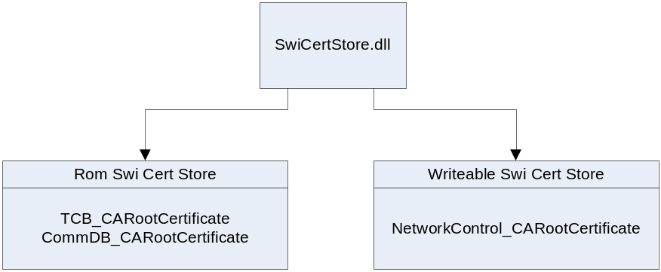

Step 6 – Sign HelloWorld.SIS with a new certificate
Previously HelloWorld was signed with a verifiable EE certificate, CommDB_EECertificate, which chains to the root certificate CommDB_CARootCertificate. However, in order to install it on the device it is necessary to sign it with a different verifiable EE certificate, NetworkControl_EECertificate, which chains to the newly installed root certificate, NetworkControl_CARootCertificate.

Step 7 – Install HelloWorldB.SIS
HelloWorld uses the NetworkControl capability; however, HelloWorldB is signed with a verifiable EE certificate, which chains to NetworkControl_CARootCertificate on the device and endorses the NetworkControl capability, so the package will install successfully.
(HelloworldA.SIS will still fail to install).

Further Information

Glossary
Term | Description
CA | A Certification Authority is an organization which performs various functions in a PKI such as: providing trusted root certificates to users, certifying users, generating certificates, supporting certificate revocation and revocation checking.
CA Certificate | A Certification Authority Certificate.
Cert Store API | This is an API that licensees/partners can implement to provide access to certificate stores on the device (for example a WIM).
Certification Authority Certificate | A CA certificate is a certificate that's used for signing other certificates.
Eclipse | To eclipse a file is to hide it by placing another with the same name earlier in the list of paths being searched. In most cases, a file on the ROM drive, Z: is eclipsed by one placed on the C: drive.
EE Certificate | An End Entity Certificate.
End Entity Certificate | A certificate which has been signed by a Certification Authority. An EE certificate may be used to sign a SIS file or a MIDlet, but may not be used to sign certificates.
Executable | A compiled program which runs (executes) on the emulator or device. Both EXEs and DLLs are considered executables by SWI.
OCSP | Online Certification Status Protocol, RFC2560. Online Certificate Status Protocol, a communication protocol to determine if a certain certificate has been revoked.
Package | A set of files delivered by a SIS file.
PEM | Privacy Enhanced Mail is a method for encoding a data object, such as an X.509 certificate, to be digitally signed or to have its signature verified. PEM is just base64-encoded DER, plus a header and footer.
PKI | A public key infrastructure (PKI) is an arrangement which provides for third-party vetting of, and vouching for, user identities. It also allows binding of public keys to users. This is usually carried out by software at a central location together with other coordinated software at distributed locations. The public keys are typically in certificates.
Root Certificate | A self signed certificate: the root of a certification hierarchy.
SIS file | A collection of executables and/or data files packaged in a form suitable so that SWI can install them onto a device.
Software Installer | The Software Installer. A Symbian OS component, part of the security subsystem, which is responsible for the installation of all native software packages (.SIS files).
SWI | The abbreviation for the Software Installer.
Swicertstore | This is a software implementation of the Cert Store API that holds and provides access to certificates for use during installation of software onto the device. It is provided for the sole purpose of housing certificates used for validating software to be installed on the device.
Unified Cert Store | This is an API that allows clients to access all certificates stored on the device. It is not described further in this document.
Trust Anchor | A trust anchor is a certificate on the device that is trusted directly by the device for some purpose, such as verifying EE certificates used to sign SIS packages.
Verifiable EE Certificate | A valid End Entity Certificate that is verifiable by a trust anchor.

References
[R1] | How-to Configure the SWI Certificate Store

Document History
Date | Version | Status | Author | Description
12/01/2006 | 1.1 | Issued | Dominic Pinkman | Editorial review.
22/12/2005 | 1.0 | Issued | MG | Final Check (spelling, glossary, TOC, etc)
21-12-2005 | .0.9 | Draft | MH | Review comments/changes from Tim Gover incorporated
8-12-2005 | 0.2 | Draft | MH | Incorporated some comments from Andy Harker’s review of 0.1
2-11-2005 | 0.1 | Draft | MH | Initial draft

If the device is reset and the writeable store consequently removed then this would effectively be a means of circumventing the network operator’s desires. In which case provision must be made (by the manufacturer) to locate the latest updater executable program and run it after a device reset in order to re-install the cert store.
Actually, the updating process involves installing an entirely new Writeable swicertstore, overwriting any previously existing one; hence it is more accurate to refer to the process as replacement rather than updating.
The reasons being: 1) a user may decide to retain a backup of the CertStore, and then subsequently restore it, in the event that a subsequently updated CertStore was not to their liking. 2) A user may decide to restore a backup of the CertStore from disparate devices. This may result in the user being able to install software intended for a particular device on a device for which it was not intended. 3) With the current implementation of backup and restore it cannot be guaranteed that the CertStore backup will not be tampered with.
At the time of writing, the SECUREID field is not being added to the generated .MMP file, this is a defect.
Updates are delivered to a new file whose name is numerically one greater than the current writable CertStore if one exists, otherwise it will be named 00000001.

