Introduction to Cryptography and Key Management
SGL.GT0128.55
Owner:
Author: | William Bamberg
Contributors:
Last revised: | 04 March 2002
Revision: | 0.02
Status:
Reviewers:
Approval:
Contents
1. Introduction 3
1.1 Purpose and scope 3
1.2 The role of the security technologies in the Symbian OS 3
1.2.1 Electronic commerce 3
1.2.2 Personal privacy 3
1.3 Security technologies versus system security 3
1.4 Some definitions 4
1.4.1 Secrecy 4
1.4.2 Integrity 4
1.4.3 Authentication 4
1.4.4 Non-repudiation 4
1.5 References 4
1.5.1 Articles 4
1.6 Revision History 5
2. Cryptographic algorithms 5
2.1 Symmetric algorithms 5
2.1.1 Block ciphers and stream ciphers 6
2.1.2 Types of symmetric algorithm 6
2.1.3 The key distribution problem 6
2.2 Asymmetric algorithms 7
2.2.1 Using asymmetric encryption to distribute symmetric keys 7
2.2.2 Digital signatures 8
2.2.3 Message Digest/Hash algorithms 8
2.2.4 Types of asymmetric algorithms 9
2.2.5 Key management considerations 9
3. Public Key Infrastructure 9
3.1 Overview 10
3.1.1 Root certificates 11
3.1.2 Certificate revocation 12
3.2 Hierarchical PKI 12
3.2.1 CA certificates 12
3.2.2 Multi-level hierarchies 12
3.2.3 Certification of End Entities and Registration Authorities 13
3.2.4 Certificate Revocation 14
3.3 A flat PKI: PGP and the Web of Trust 14
3.3.1 Key Distribution 15
3.3.2 Key Revocation 15
3.3.3 PGP Limitations 15
3.4 Problems with PKI 15
3.4.1 The usefulness of the issuer’s assertions 15
3.4.2 Trusting the CA 16
3.4.3 Naming 16
4. Security of the device 17
4.1 Software protection 17
4.2 Smart cards 17
4.3 Trusted paths 18
5. Applications of cryptography 18
5.1 Secure browsing: SSLv3, TLS, WTLS 18
5.1.1 TLS ‘classes’ 18
5.1.2 TLS handshake overview 19
5.2 Code-signing 21
5.2.1 Prerequisites 21
5.2.2 Certification 21
5.2.3 Signing and publication 21
5.2.4 Signature verification 22
5.2.5 Some problems with code-signing 23
5.3 WML Script Crypto SignText 24
5.3.1 Non-repudiation 24

Introduction

Purpose and scope
This document is intended to provide an introduction to cryptography and the associated problems of key management. Its purpose is to explain some of the security technologies developed within Symbian. This includes how these technologies work and interrelate, what they achieve and what applications they enable. It should not be taken as making any statements about the work Symbian intends to undertake in the future.

The introduction explains the role of the security technologies in the Symbian OS in high level terms, and provides some definitions which will be used later on.

Section 2 discusses the main types of cryptographic algorithms along with their properties.

Sections 3 and 4 cover key management: section 3 explains how public key infrastructures are used to support the use of asymmetric or public key cryptography, while section 4 discusses features of the device which are needed to support the use of cryptography, such as protecting keys and securing user interfaces.

The final section outlines some applications of these technologies.

The role of the security technologies in the Symbian OS
Very broadly put, the role of the security team is to enable Symbian devices to behave in a dependable manner, so that their users may justifiably trust them.

Electronic commerce
The most often quoted driver for security is that it should enable the user to participate in electronic commerce (e.g. shopping, banking, share dealing) using such devices. This entails that:

- the device should support secure communications protocols offering secrecy of communications, so, for example, eavesdroppers can't learn my bank account details, and authentication, so I can be sure that it really is my bank I'm talking to, and the bank can be sure that the instructions it receives are really from me.
- these protocols should be executed correctly on the device so, for example, either malicious code such as viruses can't get on to the device or, even if it does, it cannot subvert these protocols.
- access to information on the device should be controlled

Electronic commerce is the most often quoted driver for security technology primarily because where there is money being spent there is the opportunity for money to be made from fraud. But a lot of attacks don't have an obvious payoff for the attacker although they harm the user: Internet worms such as Melissa are an example of this. A dependable device should be resistant to attacks occurring outside the commercial sphere.

Personal privacy
Also, these are personal devices; a user should be prepared to store confidential data on the device in the assurance that it will stay private. Even if the user never engages in electronic commerce, they probably still don't want their address book and diary open to the world, and so have security requirements.

Security technologies versus system security
To date, work on security in Symbian has mostly been concerned with the development of basic security technologies: these are elements used in the construction of secure protocols and a secure system, such as cryptographic algorithms, smart card software and certificate/key management systems.

In the future, while continuing with this work, Symbian will work on making the Symbian OS a (more) secure system. This work will involve development but also consultancy, ensuring that technologies developed across the company will not interact in such a way as to break the system's security. Many of the weaknesses found in systems (such as Microsoft Windows) arise from unforseen aspects of interactions between independently secure components.

The distinction between these two sorts of work can be put like this: the first is concerned with providing dedicated bits of technology required to build secure systems, whereas the second is concerned with securing whole systems. The distinction is not absolutely clear cut; the security of our key management software is likely to depend on the security of the system hosting it. This document concentrates on the first. The second is a lot harder than the first.

Some definitions
The goals that security technologies are intended to achieve are typically divided into four types, defined below. The definitions are approximate:

Secrecy
This means that access to information is controlled: for example, it means that two entities (e.g. people, machines, processes) are able to communicate with one another without any other entities being able to access the information communicated, so that an entity may store some information and be assured that only this entity will be able to access it.

Integrity
This means that we can be assured that the information we are dealing with has not been changed, either accidentally or maliciously; for example, that the value of the cheque I write has not been changed from £10 to £10 000.

Authentication
Usually, this means that I can be assured of the identity of the entity with which I am communicating. So, I know that this really is my bank's Web site and not just someone pretending to be my bank. However, the meaning of the term 'identity' here is not well-defined, and this will cause us problems later on.

Non-repudiation
This has the effect that an entity making a declaration cannot subsequently deny having made it: so I can't claim that I never wrote that cheque. This also tends to be a controversial concept.

References

Articles
[KEYLENGTH] | Minimal Key Lengths for Symmetric Ciphers to Provide  Adequate Commercial Security  http://www.counterpane.com/keylength.html
[DIGSIG] | Digital Signatures, Certificates and Electronic Commerce  http://jya.com/bg/digsig.pdf
[RISKS] | Ten Risks of PKI: What You're Not Being Told About Public Key Infrastructure  http://www.counterpane.com/pki-risks.html
[FAILURE] | The Inevitability of Failure: The Flawed Assumption of Security in Modern Computing Environments  http://www.cs.utah.edu/flux/fluke/html/inevitability.htm

Revision History
Date | Version | Status | Description
04 March 2002 | 0.02 | Draft | Incorporated review comments

Cryptographic algorithms
Cryptographic algorithms underlie all security protocols. This section discusses three different sorts of algorithms:
- symmetric
- asymmetric or public key algorithms
- message digest or hash algorithms.

They all have different properties and uses. I'll deal with hash algorithms as a subsection to the section on asymmetric algorithms; the general remarks here apply only to the first two sorts.

Cryptographic algorithms turn meaningful information into random gibberish, ciphertext, by the application of a key. The information can only be retrieved by breaking the algorithm or knowing/guessing the key. If an algorithm is considered secure, then breaking it is not feasible. If the key is well-protected, the attacker is reduced to guessing the key. The longer the key, the greater the number of possible keys and hence the longer it will take to guess the key, on average. In practice key length is not such a big deal; of course you should use long enough keys for your purposes, but there is no point using longer keys than this, and the size of the key is almost never the weakest link in a supposedly secure system.

Random number generators are used to generate cryptographic keys. Strictly speaking they're generally pseudorandom number generators, but they should have the property that the numbers they generate are hard to predict.

Symmetric algorithms
Symmetric algorithms have the property that if a message is encrypted under a given key, it can only be decrypted using the same key: 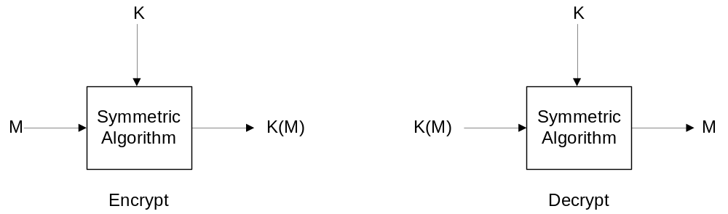

So it provides secrecy (and also some kind of authentication). If Alice encrypts a secret using a key known only to her, then only she can access the secrets.

It can also be used for communication: if Alice shares a key with Bob (and only Bob) she can encrypt her messages to them, and only Bob can decrypt them. In this case the key is a ‘shared secret’ enabling private communications.

[KEYLENGTH] recommends that symmetric keys for newly deployed commercial systems should be at least 90 bits. Symmetric keys are just a bunch of random data.

Symmetric algorithms are much faster than asymmetric algorithms so are used to encrypt and decrypt large amounts of data.

Block ciphers and stream ciphers
Stream ciphers are essentially functions which are initialised with a key, and output a stream of pseudorandom bits, this 'keystream' is typically XOR-ed with the plaintext to generate the ciphertext. So they encrypt a bit of plaintext at a time.

Block ciphers encrypt several bits at once in a fixed-size block. The cipher and its mode of operation define the block size: the plaintext is split up into appropriately-sized blocks and each block is fed into the cipher. There are two issues here which don't occur with stream ciphers:
- padding: the total size of the input has to be a multiple of the block size, so the plaintext usually has to be padded to fit
- combining blocks: if you just encrypt each plaintext block with the cipher and then concatenate the ciphertext blocks, then an attacker who knows something about the structure of a message can switch the order of the ciphertext blocks to alter the meaning of the message. For example, if the plaintext includes instructions like 'pay £XXX to account holder ABC, reference number YYY' then an attacker could replace the encryption of XXX with some of the encryption of YYY. This leads to other techniques for combining blocks, called modes, where, for example, the output of the last block is fed into the input for the next one, so the output is not just a function of that plaintext block and the key, but is a function of that plaintext block, the key, and all preceding ciphertext blocks.

Types of symmetric algorithm
Some widely-used symmetric algorithms:
- DES (Data Encryption Standard): the old US standard symmetric block cipher. It has a key length of 56 bits. In 1998 the Electronic Frontier Foundation built a machine for under $250 000, that recovered a DES key in less than three days, demonstrating that it is time to use longer keys. It's estimated that by 2015 it should be possible to recover a DES key on a single PC in a few months.
- Triple-DES: Triple-DES performs DES three times using three keys (e.g. K1, K2, K3), doing an encrypt, then a decrypt, then an encrypt. The reason for this is that with K1=K2=K3 the result is the same as a single-DES encryption, giving you backward compatibility with legacy systems (DES has been around a while, and
lots of hardware implementations exist which are not cheap to upgrade). It's very often used with two keys, where K1=K3, as this is thought to give adequate security. Triple-DES has enabled DES to survive beyond its natural lifespan while the search for a standardised successor was going on. Since it uses 2 DES keys, it would appear to have a key length of 112 bits, but actually provides more like 90 effective bits.
- RC4: a widely-used, variable-size stream cipher
- AES (Advanced Encryption Standard): a block cipher, the successor to DES. This was only chosen as the successor in late 2000, but will become the most widely used symmetric cipher in the next few years. It may be used with a key length of 128, 192 or 256 bits.

The key distribution problem
The problem with using symmetric algorithms for secret communications is that of key distribution. Once Alice and Bob (and only Alice and Bob) share the secret key, they are fine. But somehow Alice has to communicate the secret key to Bob (or vice versa), and nobody else, and Bob has to be convinced that the key really came from Alice and not someone pretending to be her.

This is a very difficult problem, especially in a highly distributed environment like the Internet, where Alice might want to communicate individually and privately with hundreds of entities she has never met.

Asymmetric algorithms
With this class of algorithm a key is generated as a key pair. The algorithm has the property that if one key in the pair is used to encrypt some data, only the other key can decrypt it, and vice versa. If the keys in the key pair are called K1 and K2, and the message is M, then:

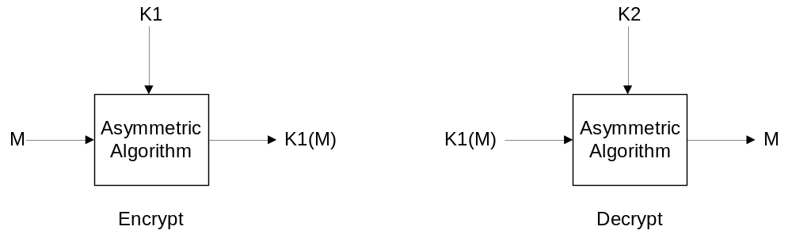

Because the parts of a key pair must share a mathematical relationship, issues of what the minimum key length should be and how the keys are generated depend on the specific algorithm used. Key lengths are mentioned along with the algorithms types in section 2.2.4; key generation still uses random numbers, but not just any random numbers will do, so key generation, although it varies depending on the specific algorithm, is much slower than for symmetric keys.

Asymmetric algorithms are based on the idea that some mathematical operations are easy to do in one direction, but hard to do in the opposite direction. For example, it's easy to multiply two large numbers together to find the result, but hard to do the reverse: that is, factor the large number to find the numbers you started with. The most widely used asymmetric algorithm, RSA, uses this specific problem: part of the public key is a very large number which is the product of two prime numbers, and the private key is the two prime numbers. So although it is mathematically possible to derive the private key from the public key, it's very difficult.

Using asymmetric encryption to distribute symmetric keys
Asymmetric cryptography appears to offer a solution to the key distribution problem.

Alice can generate a key pair, keep one key secret (the private key) and publish the other (the public key). Then Bob can retrieve the public key, generate a symmetric key, encrypt the symmetric key using Alice’s public key, and send this to her. Since only Alice has access to the private key, only she can retrieve the symmetric key, so now they share the key and nobody else knows it; they can now use this to secure their communications (ignoring for the time being the fact that Alice doesn't know who sent the message).

If the Alice’s public key is K1 and its private key is K2, and the symmetric key is K, then Bob encrypts K using K1, then sends it to the Alice who decrypts it using K2:

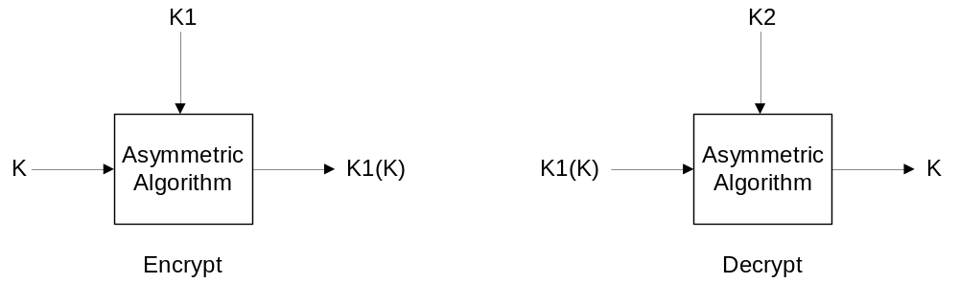

Then they can use K to secure their communications.

Digital signatures
Another application of asymmetric cryptography is digital signatures.
Suppose Bob’s a bank, and Alice is a customer of this bank. She wants to send Bob an instruction to transfer money from her account to someone else's. Bob needs to be convinced the instruction really came from Alice and not someone pretending to be her.

So, she generates a key pair, publishes the public key under her name, then encrypts the instruction with her private key and sends the instruction and the encrypted instruction together to Bob. Since Bob has Alice’s public key, he can decrypt the encrypted instruction and compare the result with the instruction: if they match the signature is valid because only someone with access to the private key could generate a data structure which, when decrypted using the corresponding public key, was the same as the accompanying data.

Message Digest/Hash algorithms
Hash algorithms are widely used outside cryptography, but I'll concentrate on their uses in conjunction with asymmetric algorithms. Hash algorithms take a variable-length input and produce a fixed length output known as a digest, or hash, of the input.

To be useful here, they need to be one-way functions: it should not be possible to deduce the input from the digest, or even any part of the input. Even very small changes to the input should give rise to radical changes in the output. Also, it should be hard to find collisions: that is, two different inputs which produce the same output.

Hash algorithms are used in conjunction with asymmetric cryptography because asymmetric cryptography is slow: encrypting the whole of the bank transaction using a private key would be inefficient. So instead Alice can create a hash of the transaction, encrypt that with her private key to make the signature, then send the transaction to Bob along with the signature. Bob hashes the transaction, decrypts the signature using Alice’s public key and compares the 2 hash values: if they match the signature is valid.

Two other uses of hash algorithms are interesting, though not strictly relevant here.
- They are often used to derive symmetric keys from other data, such as random data or a user's passphrase.
- They are also useful to store passphrases in a form in which the passphrase itself cannot be derived, but can be validated: so when a passphrase is set up, it is hashed and only the hash is stored. When the user enters their passphrase it is hashed and the hash is compared with the stored hash. Even if an attacker gets access to the passphrase-hash file, they can't get the passphrase.

There are a few different hash algorithms:

- MD5 produces a 128 bit digest. It is considered to be potentially vulnerable, and should not be used in any new applications.
- SHA-1 produces a 160 bit digest and is the most widely used hash algorithm in cryptography.
- SHA-2 produces a 256 bit digest and will become widely used as AES does, for generating AES keys.

Types of asymmetric algorithms
Not all asymmetric algorithms are suited to both encryption/decryption and digital signing.

- RSA: the most widely used asymmetric algorithm, which may be used for both encryption and digital signatures. A safe key length for RSA is thought to be 1024 bits. Until September 2000 the company RSA held a patent on this algorithm.
- Diffie-Hellman: an algorithm used for key distribution
- DSA (Digital Signature Algorithm): the US Government-developed standard signature algorithm.
- ECC (Elliptic Curve Cryptography): not a new sort of algorithm as such, but a different way to represent and use the mathematical structures employed in existing asymmetric algorithms. ECC is relatively new and not widely supported right now, but is exciting a fair bit of interest especially in the wireless/embedded areas because it reduces the memory and computation overhead for cryptographic operations.

Key management considerations

Authenticity of the public key
Asymmetric algorithms help us with the key distribution problem, but they don't solve it.

How does Bob know the key he retrieved in section 2.2.1 really is Alice’s? He’s just downloaded a data structure from the Internet; there's no way for him to know this wasn't put there by a fraudster pretending to be Alice. If it is, they can now access all the confidential data he sends her.

Similarly, in section 2.2.2, suppose an attacker publishes his own public key under Alice’s name. Now he can send signed instructions, ostensibly from Alice, to pay money into the attacker’s account. When Bob tries to verify the signature it all looks fine, because he’s using the attacker’s public key to verify the signatures, but just thinks it’s Alice’s.

So asymmetric algorithms reduce the requirement on key distribution from one of secrecy (from section 2.1.2) to one of authentication. This problem is what a public key infrastructure is intended to solve, and that's the subject of the next section.

Privacy of the private key
Similarly, the security of these operations depends on the privacy of the private key. If the attacker knows Alice’s private key, he can sign cheques on her behalf; if he knows Bob’s private key he can decrypt the confidential information Alice sends.
Section 4 discusses these issues in more detail.

Security of the device
The other assumption we're making is that the environment in which we're performing these operations is secure. When we want to sign, encrypt or decrypt information we are trusting the device to perform the operation we ask it to perform; signing the right data, or encrypting data under the right key. If the software we're using has been subverted so it signs a cheque for £10 000 instead of £10, or encrypts the data to A.Hacker rather than my bank, then the cryptography can work perfectly but we are not secure. Section 4 also covers some of these issues.

Public Key Infrastructure
The essential problem that a PKI is intended to solve is that of authentication of public keys; enabling me to be sure that a given public key really does belong to my bank and conversely, enabling them to be sure that the key it’s using to verify signed instructions I send really is mine, and not an attacker’s.

The basic idea of a PKI is described in the next section. Then I’ll try to distinguish two sorts of PKI, which I’ll call a ‘hierarchical’ and a ‘flat’ PKI, in the following two sections. This is not entirely straightforward, since much of the terminology I’ll use in the next section is taken from the hierarchical model. However, the concepts denoted by these terms are common to both models. Most of the discussion will focus on issues with hierarchical PKIs; I’ll introduce an example of a flat PKI just to emphasize that hierarchical PKIs are not the only way to do it.

Overview
Alice and Bob have never communicated before, Bob doesn’t know what Alice’s public key looks like. But:
- Bob does know that he has a genuine copy of Dave’s public key (let’s gloss over for the time being how he knows this)
- Bob trusts Dave to identify other entities

In the diagrams below, Dave’s public key is DKu, his private key is DKr, Alice’s public key is AKu and private key is AKr, and the message is M. The notation K(M) is used to mean “M signed using K”.

Alice can go to Dave, supplying her name, the public key she wants certifying, some proof of her identity and some proof that that she is in possession of the associated private key.

Dave will check Alice’s credentials, and if all goes well will use his private key to sign a data structure consisting of his name, her name, and her public key. This data structure is a public key certificate for Alice, issued by Dave. It’s essentially an assertion by Dave that the key belongs to Alice.

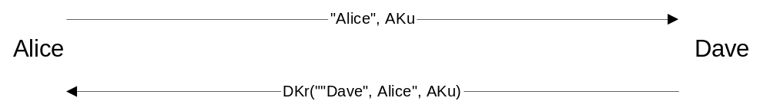

Then she signs her message for Bob:

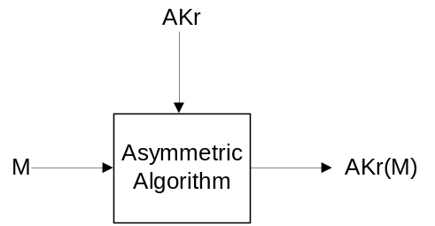

She sends Bob the message, the signature and her certificate:

Bob looks at the certificate and figures out that it was signed using Dave’s private key (because the certificate has his name in it). Since he has a genuine copy of Dave’s public key, he can use this to verify the signature on the certificate, so can be sure it was made by Dave (i.e. that Dave really made the assertion):

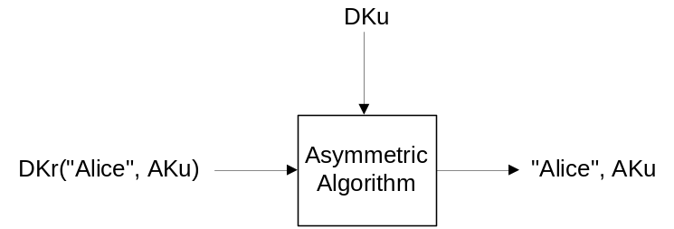

Since he trusts Dave to identify other entities, he believes Dave’s assertion, so he can now assume that Alice’s public key is also genuine, so can use it to verify that the message really came from Alice:

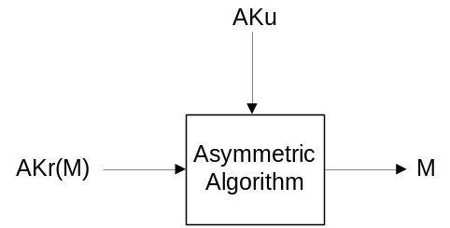

A public key certificate binds a public key to an entity; another way to put this is that it is an assertion by the signer that the entity named in the certificate is the owner of the public key it contains. The signer of the certificate is the issuer, and the owner of the signed key is the subject. Most types of certificates have a validity period, so an issued certificate may only be used for a limited time before needing to be renewed.

In the example above, Alice and Dave are called certificate-holders, and Bob is called the relying party (or RP) since he’s the one relying on the validity of Alice’s signature (some people object to the term ‘Relying Party’ but I won’t get into that here).

Root certificates
It should be clear that the effectiveness of the scheme above depends on Dave being qualified to identify Alice, and on Bob having an authentic copy of Dave’s public key. Because his trust in Alice’s signature, and certificate, derives from Dave’s key, Dave’s key is called a trust anchor or, since it will typically be distributed in the form of a certificate itself, a root certificate.

We can define a root certificate as a certificate whose authenticity cannot be established by cryptographic means: instead, its authenticity is a prerequisite for any other authentication to be possible.

So we need another way to distribute these certificates, and this has to be a secure ‘out of band’ method. That means that the distribution channel (or at least the authentication channel) can’t be the same as the one we’re using the certificate to secure. For example, Bob could download Dave’s certificate from the Internet, then create a hash of the certificate, then phone Dave and get him to read the certificate hash. Assuming the two match, and the phone system hasn’t been subverted, this offers a fair assurance that the certificate is genuine. The hash of a certificate or public key used in this way is often called a fingerprint, since it is supposed to identify the key.

In practice, root certificates are usually distributed along with the software product that uses them, and the user trusts them because they trust the software vendor.

So, Bob will have a set of root certificates which his software will use to validate non-root certificates.

Apart from the distribution of the root certificates, it is important that they are kept somewhere safe: if an attacker is able to add his own certificate as a root certificate, he can then fool Bob into trusting people he shouldn’t. So there is a requirement here for tamper-resistance of his store of root certificates.

Certificate revocation
Another requirement here is that it must be possible for Alice’s certificate to be revoked. If she gets a certificate, then an attacker learns her private key, the attacker can now pretend to be Alice, signing messages claiming to be from her, and enclosing her public key certificate to demonstrate this.

To protect against this attack, we need a mechanism for the binding between Alice and her key pair to be broken again. Another way to put this is that Bob needs some evidence that the certificate he’s presented with is still good.

The mechanism used to notify users of the PKI that a certificate can no longer be relied upon – to unbind the certificate holder and the certified key pair – is called certificate revocation. We can look at specific revocation mechanisms in the context of specific PKI models.

Hierarchical PKI
We define a hierarchical PKI as one which enforces a distinction between two types of certificates-holders:
- certificate-holders who use their keys only to issue certificates to other entities
- certificate-holders who are not entitled to issue certificates to other entities

The first type of certificate holder is called a Certification Authority (CA). The second sort is called an End Entity (EE).

In the discussion above, Dave is a CA and Alice is an EE. CAs are organizations which perform the following functions in a public key infrastructure:

- providing trusted ‘root’ certificates to users, by supplying them with the CA’s public key via out-of-band means
- certifying users: checking that they are who they say they are, and generating certificates
- supporting certificate revocation and revocation checking

The classic hierarchical PKI standard is X.509/PKIX. X.509 defines a format for certificates and various other related objects. PKIX defines a profile of X.509 to be used on the Internet, and a series of protocols to support operations such as certification of EEs and revocation of their certificates.

CA certificates
Certification Authorities have a signing key pair that they use to generate certificates.
The public half of these key pairs are usually distributed as ‘self-signed’ certificates: the public key inside the certificate is signed using the associated private key. In the example above it looks like: DKr(“Dave”, “Dave”, DKu). This gives us integrity (we can be sure nobody’s changed the certificate data) but not authenticity (we have no idea whether the keys really are Dave’s). They are generally distributed along with the software that uses them.

Multi-level hierarchies
CA certificates are not always self-signed. Firstly, there’s nothing to stop CAs certifying other CAs, and secondly, CAs should create their own certification hierarchy, for security and ease of management.

Their self-signed certificate is extremely valuable and revocation of it is a very costly business, so CAs should create subordinate CA certificates under their self-signed root, and use these to sign EE certificates. This reduces the exposure of the self-signed root certificate, which reduces the risk of key compromise.

Also, if they want to certify different sorts of EEs they ought to do this using different signing keys. For example, Symbian’s code-signing CA might want to certify code from Symbian and code from third parties, and use different CA certificates to certify the two groups:

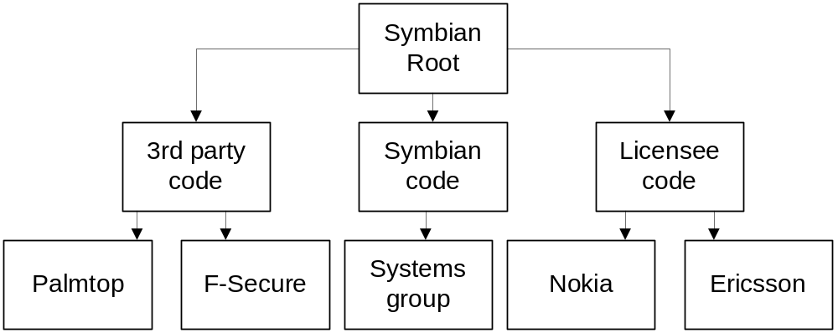

Here, the certificates at the second level of the hierarchy are non-self-signed CA certificates.

Another example is the model used by the US Department of Defense. This has a top level CA key pair for a Policy Approval Authority(PAA), with an associated self-signed certificate. The PAA defines certification policies for subordinate Policy Control Authorities by certifying them appropriately. The Policy Control Authorities enforce the policies by certifying Certification Authorities which follow them, and the Certification Authorities certify EEs.

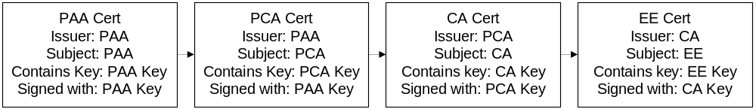

The set of certificates from an EE up to a trusted root CA certificate is called a certificate chain, or a certification path (most people don’t count the root certificate in measuring the chain’s length, which makes the length of the chain in the Symbian code-signing example above 2).

Certification of End Entities and Registration Authorities
Certification of end entities requires an organisation called a registration authority (RA). This is responsible for validating the credentials of the applicant and informing the CA, which handles the mechanics of actually generating and distributing the certificate.

So, an EE will apply to an RA for a certificate, supplying her name, the public key she wants certifying and some proof that she is in possession of the associated private key. The application is called a certificate request.

The RA will do some checking that she really is who she says she is, and if all goes well will ask the associated CA to generate and return a certificate for her. The procedures followed by the RA here will vary depending on the RA, the value of the certificate and its purpose.

In practice, for most commercial CAs, the functions of the RA and the CA are combined, so we’ll just use the term CA to refer to both RA and CA functions in this document.

In the X.509/PKIX world, a data structure called PKCS 10 is often used for certificate requests (it is essentially a public key and a name, signed using the associated private key). The responses are often represented in a PKCS 7 data structure.

Certificate Revocation
There are various reasons why certificates need to be revoked. The most glamorous is key compromise: the certificate holder discovers that someone else has gained access to her key. More likely reasons are more pedestrian: for example, a company might issue certificates to its employees identifying them as such, and need to revoke the certificates when they leave.

Revocation in a hierarchical PKI is handled by either the certificate holder or another party (e.g. the company, in the second example above) sending a revocation request to the CA. The request should include some authentication to prevent an attacker from revoking someone else’s certificate in a denial of service attack.

More problematic is how the relying party can find out if a certificate has been revoked, when they are sent a signed message. The classic way this is handled in X.509/PKIX is using Certificate Revocation Lists (CRLs) which is a list of identifiers for revoked certificates issued periodically by a CA, and signed using the CA’s key.

This has some problems, however. First, the CRL is not always going to be fresh: if key compromise is reported just after the last CRL was published the attacker has a window in which the CRL will not list the compromised certificate. Secondly, CRLs can potentially get very big, although partitioning techniques can help with this at the cost of extra complexity. The central problem they have is that the relying party is placed in the position of trying to prove a negative.

A somewhat better solution is a protocol called the Online Certificate Status Protocol (OCSP). In this protocol the CA maintains a server which answers queries about the status of certificates. It is a very simple request-response protocol: the client sends a set of identifiers for certificates it needs to know the status of, and the server replies with a set of statuses for the certificates, signed using the CA’s signing key (or a different root key). OCSP is probably more suitable for mobile devices than CRLs, but still has its problems.

A flat PKI: PGP and the Web of Trust
PGP is a very widely used encryption program. Its main purposes are encryption of a user’s confidential data and encrypting/signing email. PGP consists of a set of hash, asymmetric and cryptographic algorithms, a pseudorandom number generator, formats for signed/encrypted messages, protection for private keys and tools for authentication of public keys.

As in the model above, public keys are authenticated by having them signed by some other entity who is trusted by the relying party. However, PGP does not enforce a distinction between CAs and EEs. In fact, PGP does not mandate any particular form of PKI: it can be used in a hierarchical form, and this is actually how we use it at Symbian where our PGP keys have to be signed by an administrator who plays the role of a CA.

However PGP is usually associated the Web of Trust. In this model, rather than users having to trust any centralized authorities, they express trust in each others’ public keys by signing them. This trust derives, initially at least, from out of band techniques: for example, somebody I know and trust hands me a disk with their public key on it, or emails me their public key, but also phones me up and tells me the key’s fingerprint.

The trust relationships may extend beyond people with whom I have come into physical contact if I am prepared to trust, not just someone else’s identity, but their own judgement of trust. For example, suppose I sign my friend Alice’s key, having verified out of band that it really is her key. Then I receive a signed message from Bob; I have never met Bob but see that Alice has signed Bob’s public key. If I trust Alice not to sign a public key without having checked its ownership, then I may trust Bob as well, and sign his key. Unlike X.509, a key can be signed more than once, which may encourage a relying party to trust it.

The idea is that a network of ‘trust webs’ may be built up in a distributed fashion, mirroring the social inter relationships between people (this mirroring is important because it is social, or out of band, contact that underpins the whole thing).

Users of PGP always get to decide whether to trust a particular signed key or not: it emphasises the responsibility of the relying party more than X.509, which tends to encourage users to delegate their trust to a CA.

Key Distribution
PGP does not rely on an infrastructure for key distribution; typically keys are distributed in an ad hoc fashion. Key servers also exist which enable users to distribute their keys more widely; however this is of limited usefulness since the distribution must always be underpinned by out of band authentication.

Key Revocation
In PGP users can revoke their keys by signing a ‘revocation certificate’ with the key they suspect has been compromised. This means that if a user forgets the passphrase used to protect the private key there is no way it can be revoked; as Phil Zimmerman, the creator of PGP, puts it: ‘I’m sorry, you’re hosed’. The revocation certificate is distributed in the same fashion as the public key, i.e. using ad hoc distribution and key servers.

PGP Limitations
This kind of model works well in small groups of responsible, clued up people who know each other. It is also popular with the more paranoid users of security since there is no requirement to trust an organisation.
However, it scales poorly when:
- a lot of people are using it, not all of whom understand how it should be used
- people are interacting commercially rather than socially

The problem with PGP is that everyone in the web of trust needs to be trustworthy. In the X.509 model, only CAs need to be trustworthy; in PGP’s model as soon as an untrustworthy user gets into your web of trust the whole thing starts to unravel.

A similar problem applies to key revocation; this is handled by you telling everyone you can think of in your web of trust not to use your certificate any more, but you just have to hope that they will forward it to everybody they have previously given your key to, and so on. This seems alarmingly haphazard, and the more people are involved, the more likely it is that something will go wrong.

Problems with PKI
Public key infrastructures suffer from serious problems, to the extent that many computer security experts consider them fundamentally broken. [DIGSIG] and [RISKS] both give a good overview of these problems: I’ll mention a few of them here.

The usefulness of the issuer’s assertions
Certificates are supposed to authenticate public keys. But it’s not always clear that the sort of authentication they provide is actually the sort that the relying party needs in order to decide whether to trust the originator of the message.

Within the context of a specific application the relying party usually has quite specific requirements for what they want the issuer to assert, and this is usually not a matter of simple identification. Another way to put this is that PKI fails because its model tends to be one in which issuers perform some entirely generic act of identification, whereas the relying party needs the issuer to make some application-specific act of authorisation.

For example, suppose we have a code-signing scheme in which developers apply to a CA for code-signing certificates, which they use to sign the binaries they publish. The relying party (the user of the target device in this case) has an authentic copy of the CA’s public key certificate. His software verifies the signature on the developer’s certificate, and the signature on the binary and reports that they are good. But it’s not clear what that says about the quality or trustworthiness of the software. If the certificate simply identifies users, then the most it says is ‘this software was written by Alice’. This doesn’t demonstrate that the code can be trusted - which is what the relying party wants to know - without the unverified assumption that ‘Alice doesn’t write viruses’. It is possible, of course, that the CA carefully reviewed the source code for the software, but the user doesn’t know this. Commercial CAs are not authoritative about the quality of source code, so are not qualified to issue certificates for this purpose.

Similarly, suppose we want to be able to sign digital medical prescriptions that we can present to an online pharmacy, who will mail us the drugs. The pharmacist (the RP in this case) doesn’t care about the name in the certificate, but only cares that the entity identified in the certificate as the holder of the key used to sign the prescription is a qualified to sign prescriptions (i.e. is a medical doctor). Even if the certificate includes the name ‘Dr Crippen’ this doesn’t help; Dr Crippen could be a doctor of philosophy. Again, commercial CAs are not qualified to identify entities qualified to sign prescriptions.

The obvious answer here is that CAs issuing certificates for such applications need to be administered by an organisation which is qualified to make the assertions required. So in the first case the CA should be run by the device manufacturer, and in the second case by the BMA. But this is not the way public key infrastructure is usually deployed: commercial CAs like VeriSign make lots of money fulfilling exactly this context-free identification role. Arguably, there is no case, ever, for this sort of CA.

X.509 certificates contain a set of variables called Certificate Policies, which are supposed to help with this situation. A certificate policy is a name for a set of rules that indicates the applicability of a certificate within the context of a particular application. Certificate processing software can require the presence of specific policies. Again, these are not very widely used, and are not an ideal way of achieving this goal.

In some cases, only the relying party knows the cost of misidentification, and relying parties are unlikely to go and read the certificate policies associated with a certificate, or understand it if they do.

Trusting the CA
Similarly, if the relying party is to know whether to trust a certificate, he needs to know what practices the CA follows. For example, how well does it secure its private signing key, and how does it handle revocation? What liability does the CA assume if it makes a mistake? All the procedures followed by a CA are documented in a publicly available Certification Practices Statement. But users are never going to do and download, read and understand one of these documents, which typically run to over a hundred pages of legalese.

Naming
We have said that certificates contain the name of the subject and the name of the issuer. But if Bob receives a certificate containing the name ‘Alice’, how is he to know if the Alice identified in the certificate is his friend Alice, from whom he expects to be receiving a signed message? All it tells him is that someone called ‘Alice’ has a public key certificate from an authority.

The problem here is that names in this context need to be meaningful and unique. The names we use for each other are meaningful, but only unique in the local context in which we use them, whereas PKI pretends to offer a global solution. Conversely, we could assign all people unique identifiers but they wouldn’t mean anything to anyone.

This problem is most serious for X.509, since this is part of the X.500 series of standards, which defines a global directory schema in which every entity in the world would be uniquely named (X.509 is just the ‘authentication’ part of this directory standard). Thus the name used in X.509 certificates is the X.500 Distinguished Name, which describes a path through an X.500 Directory Information Tree. This probably seemed like a good idea at the time, but X.500 has largely failed to come into existence, and certainly not as a global directory infrastructure. So the certificate format still exists, but the naming scheme underlying it does not have the semantics it needs to be useful (a specific example: X.500 Distinguished Names don’t even allow for email addresses, which are fairly essential name components for an email encryption PKI).

Security of the device
The previous section dealt with conditions to support public key cryptography that must hold in the world outside the device. This section covers conditions that must hold on the user’s device. That is, the security of the public key cryptography should not be compromised by an attacker who has access to the device, or by malicious code running on the device.

Since this starts to blur with system security, I’ll keep it short.

Briefly, there are two sorts of data that need to be protected on the device:
- the user’s private keys have a requirement of secrecy: it should not be possible for an attacker to learn them, or to be able to use them to sign or decrypt data. If they can, they can access confidential information or, worse, impersonate you.
- the user’s store of root certificates have a requirement of integrity: it should not be possible for an attacker to modify the store. If they can, they can insert root certificates of their choice, and then fool your software into trusting people you should not.

Software protection
Protecting private keys in software is usually done by encrypting them with a symmetric key derived from a passphrase: when the user wants to use the key they enter the passphrase, the key is decrypted, used and deleted from memory. This offers reasonable protection, depending on how strong the passphrase is. It is possible that an attacker could read the private key while in the memory of the process using it, but this is a much harder attack than simply reading it off the disk.

On the other hand, tamper-resistance in software, for protecting the integrity of the root certificate store, is practically impossible without having support from the underlying operating system. It is possible to support tamper-evidence (i.e. you can’t stop an attacker adding new root certificates, but you know when they have) by signing the store, but the public key you use to verify the signature on the store still needs tamper-resistance.

Smart cards
The idea of using smart cards to protect keys is to move all the sensitive operations out of the complex, insecure environment of the device and into a much simpler, dedicated, secure device.
A smart card should provide the following areas of functionality:

- access control (for example, making the user enter a PIN to access the functionality)
- secure storage (providing secrecy and some degree of tamper-resistance for keys and certificates)
- key pair generation (not all smart cards do this; for some the keys are generated when the card is set up)
- cryptographic functionality (for signing and decryption operations)

The idea is that keys can be generated in the secure device, and because the secure device can perform private key operations itself, the private key never leaves it. Even if an attacker learns the PIN needed to sign data, they still need to sign data through the smart card interface; they can’t make a copy of the key to use at their leisure.

WIM is a specification for a smart card application for storing signing keys and generating digital signatures for WAP security standards such as WTLS and the WMLScript Crypto API.

Most commercially available smart cards can be hacked by a determined attacker without much difficulty. This is not necessarily a problem, depending on the way the system as a whole is designed. In general, if the security of the system depends on the card having secrets from the card-holder, such as those used for Pay TV systems, then the system is vulnerable simply because the card-holder has physical access to the card. If it doesn’t (for example, if it just contains your signing key pair) then it’s not a very serious problem if the card is hackable because the attacker needs physical access, and the card-holder is likely to notice if the card goes missing.

Trusted paths
The real problem with smart cards is with the interface. Suppose I want to sign an instruction for my bank: “Pay Amazon.com £10”. I enter the text, enter the PIN to unlock my signing key, and hit enter. This information will pass through various software components before it reaches the smart card itself: any one of these could substitute the phrase I want to sign with one reading “Pay Mafia Holdings £10 000”, and I would have no way of knowing this.

We can only defend against this by ensuring that the software that accepts the user’s input and transmits it to the smart card is trustworthy. This is sometimes called a trusted user interface, but is more accurately a trusted path since it is a path through multiple software components, with the UI at one end and the smart card interface at the other.

This implies that smart cards can only be used securely if the operating system to which they are attached is also secure, at least in part. But since the justification for having smart cards is that the operating system is insecure, this raises the question, why use smart cards at all?

There are other more general problems associated with the trustworthiness of the operating system software. for example, if the certificate validation software is subverted to always validate certificates, then the whole system of authentication breaks down.

The depressing conclusion is that cryptography only works securely in a secure operating system environment. A fine analysis of this is [FAILURE].

Applications of cryptography
This section gives an overview of some applications of cryptography.

Secure browsing: SSLv3, TLS, WTLS
These protocols are all very closely related. SSLv3 (Secure Sockets Layer) and TLS (Transport Layer Security) are secure communications protocols running over TCP/IP, providing secrecy and optionally authentication.

- SSLv3 is the third version of a protocol developed by Netscape (versions 1 and 2 are broken).
- TLS is an IETF-standardised version of SSL (there are some other minor differences).
- WTLS (Wireless Transport Layer Security) is closely based on TLS: it runs over the WAP transport protocol and is optimised for wireless devices.

TLS is very widely used for electronic commerce on the Web, where HTTP runs over it: the HTTPS specification describes how HTTP should be layered over TLS.

These are client server protocols in which the client and server engage in a handshake, the output of which is a shared master secret from which a symmetric session key may be derived. This session key is subsequently used for encryption of the data exchanged. The client and the server may optionally authenticate each other.

TLS ‘classes’

Anonymous TLS
When TLS is used without client or server authentication it is called anonymous TLS. WTLS calls this Class 1.
Anonymous TLS requires no certificate handling or key management at all; it just requires the symmetric algorithms, hashing algorithms, and the public operations in asymmetric algorithms.
With anonymous TLS your communications are secret but you have no idea who you are talking to, so its usefulness is severely limited.

Server authentication
This is where the server authenticates itself by sending its public key in a certificate which the client can verify, but the client does not authenticate itself to the server. WTLS calls this Class 2.
For server authentication the client needs to be able to validate the server certificate against a store of trusted root certificates, and to use the same cryptography as in anonymous TLS.
This is probably the most widely used mode of TLS for operations like e-commerce. Usually the server doesn’t care too much who the client is, because the client is going to present a credit card number to the server, which is all the site owner really cares about. However the user is obviously going to care about who he gives his credit card number to, so cares who the server is.

Client authentication
This is where the client authenticates itself to the server by sending its certificate in the Client Certificate message, then subsequently signing the handshake messages in the Certificate Verify message. WTLS calls a handshake with server and client authentication a Class 3 handshake.
Client authentication requires that the client be able to generate and securely manage asymmetric key pairs, and acquire and manage certificates for them.
It is seen as being potentially valuable in its ability to reduce the risk of credit card fraud on the Internet.

TLS handshake overview
This diagram from the TLS specification shows the messages that are exchanged in a TLS handshake:

Client Server

ClientHello -------->
ServerHello
Certificate*
ServerKeyExchange*
CertificateRequest*
<-------- ServerHelloDone
Certificate*
ClientKeyExchange
CertificateVerify*
[ChangeCipherSpec]
Finished -------->
[ChangeCipherSpec]
<-------- Finished
Application Data <-------> Application Data

* Indicates optional or situation-dependent messages that are not always sent.

Client Hello
This consists of:
- a random number: this will later be used as input to the shared secret calculation
- a session ID: this enables the client and server to reuse a previously negotiated session
- a set of preferred cipher suites: a cipher suite consists of a symmetric algorithm for data encryption, and an asymmetric algorithm along with a hash algorithm for exchanging parts of the shared secret

Server Hello
This consists of:
- a random number: this will later be used as input to the shared secret calculation
- a session ID: this indicates whether they can resume the old session ,in which case the handshake ends here, or whether they need a new one
- its choice of cipher suite

Certificate
If server authentication is to take place the server then sends its certificate in the Certificate message. In TLS this is an X.509 certificate; in WTLS it is a WTLS certificate.

Server Key Exchange
If the server certificate message did not give the client enough data to allow the client to send the server its part of the master secret, the server sends an explicit Server Key Exchange message: this might, for example, consist of a public key.

Certificate Request
If the server wants the client to authenticate itself then it sends a certificate request message indicating the set of root CA certificates it recognises. The client should have a certificate issued by one of these CAs.

Server Hello Done
This indicates that the server has finished.

Client Certificate
If the server has requested a certificate the client sends it in the Client Certificate message. In both TLS and WTLS the client certificate is an X.509 certificate.

Client Key Exchange
The client then sends the Client Key Exchange message: this consists of some more randomness, which will be used in calculating the shared secret. It is sent to the server encrypted under the server’s public key (either the key out of the server certificate or the key sent in Server Key Exchange).

Now both parties can calculate the shared secret, using the random numbers they exchanged in their hello messages and the random number the client sent in the Client Key Exchange message. They can then derive a symmetric key from this that they use to encrypt their communications.

Certificate Verify
If client authentication is to take place the client signs all the previous handshake messages using its private key, and sends this as the Certificate Verify message. The server can use this to check that the client has possession of the private key corresponding to the public key in the certificate sent by the client in the Client Certificate message.

Finished
Both parties send Finished messages

Code-signing
Code-signing schemes are supposed to help prevent malicious code getting on to the device. Symbian provides support on the device for a simple code-signing scheme, which is summarised here.

Prerequisites
Symbian’s code-signing scheme uses a hierarchical PKI with X.509 certificates. The device manufacturer:
- owns a certificate-signing asymmetric key pair
- defines registration and certification policies to control the use of the key pair
- may outsource the CA functions to another organisation
- needs to arrange for the appropriate infrastructure for handling revocation requests, and an OCSP server to be operational to handle queries about the status of certificates
- must ensure that the devices it sells contain a certified copy of its certificate-signing public key

Symbian needs to provide software running on the developer's PC to:
- generate code-signing asymmetric key pairs
- generate certificate requests and process the responses
- use the key to sign their code
- generate signed install packages, containing the code, the signature and the developer's certificate

Symbian needs to provide software running on the Symbian OS device to:
- verify the signature on the install package
- validate the developer's certificate
- make OCSP requests and process the responses

Certification
A developer targeting the device generates an asymmetric key pair, then applies to the RA to have the public half certified, supplying identifying information and probably other information to satisfy the RA that the developer will not be producing buggy or malicious code. The exact nature of the information required is defined in the registration policies. If the information supplied is OK the CA issues a certificate for him.

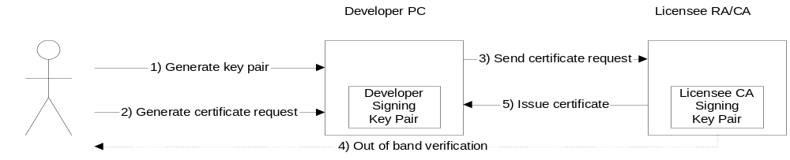

Signing and publication
The developer uses the private key to sign the finished binary, and distributes it in an installable file format.

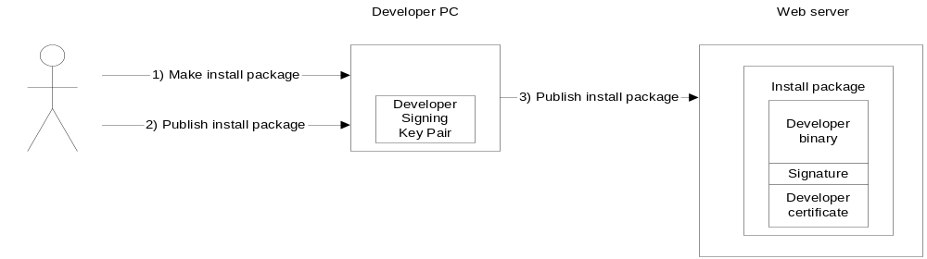

Signature verification
The user of the device downloads the installable and attempts to install it. The install program on the device attempts to verify the signature on the binary, and to verify that a valid certification path can be made back to a root which was installed on the device at manufacture time, and which is trusted as a root for software authentication. It also checks that none of the certificates have been revoked by asking the OCSP server.

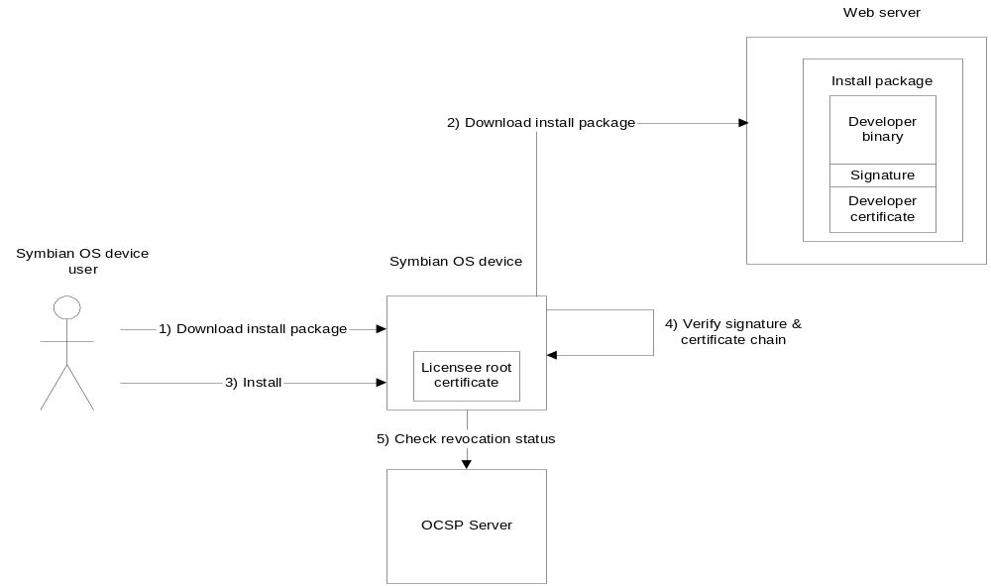

Certificate policies are used to distinguish different sorts of software: for example, the UI may display different information to the user depending on whether the software came from the device manufacturer itself or from a third party. The values of the policies are customisable by device manufacturers as they depend on the certification hierarchy designed by the manufacturer.

The behaviour of the client in response to different policies and different results from the validation function is also customisable by the device manufacturer, because some manufacturers are more paranoid than others. The device may refuse to install unsigned software, or software whose authenticity cannot be demonstrated, or may allow this but show the user a warning message. If the software is successfully validated it may be installed.

Some problems with code-signing

What is the CA asserting?
This is a specific example of the problem we looked at in 3.4.1. A problem here of which the user has no visibility is what checks the device manufacturer has made which will reduce the likelihood of the binary being dangerous (either intentionally or unintentionally).

- asserting the developer’s identity is no use, since that does not say the developer is not either incompetent or malicious
- asserting that the developer is recognised as one participating in a development programme run by the manufacturer is not much better, since developers can write good and bad, benign and malicious code
- asserting that the developer is a fairly well-known software company helps with issues of liability, but will kill off any possibility of people writing code for the platform in their spare time
- asserting that the code is good by actual code review, and having the manufacturer sign individual binaries, is technically an excellent solution, but is far too expensive, and also unlikely that developers will agree to it, and will make certification very much more expensive, which will also discourage people from developing for the platform

The decision about the certification policies is a difficult mixture of legal, commercial and technical issues.

How does the developer control his private key?
Even if the developer is neither incompetent nor malicious, we are issuing him with a signing certificate which will allow anyone with access to the associated private key to get code installed on the platform. How is the device manufacturer to know that the developer takes proper care of his private key? They can sign a contract to the effect that they will, but the manufacturer needs some way of enforcing that. The only solution I can think of to this is to have the manufacturer regularly audit authorised developers, which would be incredibly expensive.

All-or-nothing installation
This sort of code-signing is not very helpful to the user. Typically they will be shown some information (a name, maybe a reassurance that the manufacturer says the developer is OK) and then asked to make a decision about whether to give the code untrammelled access to the device, by installing it, or not to install the code at all. They do not have enough information to make an informed decision here.

What would help here would be if they could install the software, but restrict the things it could do, so for example it couldn’t make phone calls, sends emails or access the user’s address book. Obviously, this is not feasible without support in the underlying operating system to enforce these restrictions.

Certificate expiry problems
X.509 certificates have limited validity periods. Suppose the developer’s certificate is valid for a year: six months into this time he uses the associated key to sign a program. Seven months after that the user tries to install the program. The certificate was valid at the time the software was signed, but not at the time the signature was verified. Should the validation software accept this?

If the answer is no, this is going to cause developers a lot of problems, as they will have to re-sign all their software whenever their certificate expires. If the answer is yes, this is a fairly serious vulnerability, since we cannot assume that a developer will take good care of his private key after the associated certificate has expired (because ostensibly, the key is no longer good for authentication).

The solution here is timestamping: when developers sign their binaries they send the signed binary to a timestamping authority which signs the already-signed binary, along with the current time, using its signing key. Then the device has a copy of the timestamping server’s public key which it can use to verify the timestamp on the install file, and can thus assure itself that the binary was signed when the certificate was valid.

WML Script Crypto SignText
The signing in TLS and code-signing is just used to establish who the signer is. The WMLScript Crypto API includes a function ‘SignText’ that is used to generate a signed data structure with a different purpose: to demonstrate the signer’s assent to a piece of human-readable text. This is much more like the examples we had earlier where the signer signs a transaction saying ‘Pay £10 to Amazon.com’.

This is potentially a very powerful use of public key cryptography. TLS and WTLS only authenticate as far as the server (or the gateway in the case of WTLS). Also, the authentication is ephemeral, only providing a basis for a secure session. The data structures produced by SignText can be sent from the gateway to the machines that actually process the instructions, and verified there, so the server itself doesn’t have to be secure. Also, the instructions can be stored, then retrieved and verified later on, in case of disputes.

The input to the function is the text to sign, some options concerning which other information should be included in the object, and an identifier for the key to use.

The text is displayed to the user, who enters her PIN for the associated key if she agrees to it. The software on the device creates a data structure including the text to sign and other optional attributes such as the time of signing, and this is sent to the WIM along with the PIN for the appropriate key. The WIM signs the structure and returns the signature. The software on the device creates the final data structure including the signature, optionally the text that was signed, and optionally the signer’s certificate. This is then returned to the gateway.

Non-repudiation
Since SignText is intended to demonstrate the user’s assent to the text, the function uses a different asymmetric key pair to that used for WTLS. WTLS uses a ‘signing’ key pair, SignText uses a ‘non-repudiation’ key pair. Technically there is no difference between these two key pairs. The difference lies in what can be inferred from a signature made by one key or the other. Signatures made using a signing key are repudiable: a user can get away with denying that she generated the signature. Signatures made using a non-repudiation key are not: thus the signer may be held liable for any statements they sign using the key.

Because non-repudiation keys are so powerful, the requirements for their protection are tighter. Non-repudiation keys must be kept on a WIM, and they must be protected with a PIN that must be entered every time the key is used. However, non-repudiation used in this context is very controversial: given the conclusions reached in 4.3, it seems indefensible to require that such signatures should not be repudiable. If SignText ever gets used very much we can probably expect this question to be settled in the courts.

