Security/DRM Functional Specification

Security Classification: | Confidential
Document Reference: | SGL.GT0176.053
Status: | Issued
Version: | 2.1
Team/Department : | Core/Telephony & Security/Security/DRM
Author(s): | Andy Harker
Owner(s): | Andy Harker

Approver(s): | Craig Heath, Timo Bruns, SMG. | Distribution: | Symbian Internal, Licensees.

Contents
1 Introduction 4
1.1 Purpose and Scope 4
2 Overview 4
2.1 Zephyr DRM Scope 4
2.2 Key Concepts 4
2.2.1 The Content Access Agent (CAA) 4
2.2.2 The Content Access Framework (CAF) 6
3 DRM Zephyr Delivery Specification 7
3.1 Symbian Work 7
3.2 Licensee Work 8
3.3 Enabling the Consumer Applications for Restricted Content 8
3.3.1 Storage of Restricted Content in Zephyr 8
4 Security/CAF: Functional Specification 8
4.1 General Non-functional Requirements/Goals 8
4.2 Framework Specification 9
4.2.1 Security/CAF: Abstract Content Consumer Interface 9
4.2.2 Security/CAF: Abstract Manager Interface 9
4.2.3 Security/CAF: Abstract Supplier Interface 10
4.2.4 Security/CAF: Recognizer Support 11
4.3 Agent Specification 11
4.3.1 Security/CAF: Content Supplier API 12
4.3.2 Security/CAF: Content Consumer API 12
4.3.3 Security/CAF: DRM Manager/Browser API 13
4.3.4 Security/CAF: Crypto API 13
4.4 Other Notable Omissions: 15
4.4.1 Reference Secret Store/Crypto Authentication 15
4.4.2 Revocation of Rights 15
4.4.3 Superdistribution 15
4.4.4 Native Execution of Restricted Content 15
5 Security Threats 15
5.1 Future Integration with Platform Security 15
6 Backup and Restore 16
6.1 Orphaned Restricted Data 16
6.2 Reuse of Content Encryption Keys 16
6.3 Backup Opt-Out 16
7 Other Issues 16
7.1 Migration 16
8 Further Information 17
8.1 People 17
8.2 References 17
8.2.1 Internal Document References 17
8.2.2 Specification References 17
8.3 Glossary 17
8.4 Document History 18
8.5 Document Review Date 18
Appendix A - Architectural Contributors 19
Appendix B - Additional Implementation Notes (for Agents) 20
B.1.1 Ordering when multiple rights exist 20
B.1.2 Specific Approaches to Storage of Content and Rights 20
Appendix C - OMA Phase 1 ODRL Subset 21
C.1 Actions 21
C.2 Constraints 21
Appendix D - OMA Mime-Types 22
Appendix E - DDR Tables 23
E.1 Security/CAF: Content Consumer (1951) 23
E.1.1 Abstract Content Consumer Abstraction 23
E.2 Security/CAF: Content Manager 24
E.3 Omissions 24
E.3.1 Secret Store/Crypto Authentication 24
E.3.2 Content Format 25
E.3.3 Rights Enforcement 25
E.3.4 Rights Interpretation 25
E.3.5 Handling of Incoming DRM Content and Rights (2173) 25
E.3.6 DRM Manager and Browser API (1951) 26
E.3.7 Security/DRM: Crypto API 26
E.3.8 Multiple Rights 27

Introduction

Purpose and Scope
This functional specification details the functionality that is required by the Symbian OS Security/CAF Infrastructure. It also defines key API requirements of a proposed Content Access Agent (CAA), but not the specific implementation behind this interface.
Please note, that although interfaces and components have been identified (and described in section 2), not all APIs and behaviours will be fully defined for the initial release of the Content Access Framework. The actual deliverables are covered in section 3.

Overview
From a holistic perspective, Digital Rights Management – The Digital Management of Rights - addresses the issue of protection, identification, distribution, and rights enforcement of any type of content. Some background information can be found in [2], while more specific Symbian roadmap information can be found in [1].

Zephyr DRM Scope
The Zephyr deliverable focuses on providing access to restricted content for content consumers such as multimedia applications or plug-ins. Other aspects of the Content Access Framework such as:
- The ability to deliver content to a CAA,
- The management of content/rights, and
- Protection of content/rights.
… are covered for completeness, but are only partially specified within the scope of this deliverable.

Key Concepts

The Content Access Agent (CAA)
The CA Agent is intended to be an entity on the device that manages content within a particular DRM domain.
The key aims of the CAA are to:
- Control access to protected content (both on and off the device).
- Protect the integrity of rights (which are stored on the device).
As an conforming entity which resides within the CA Framework (see below), the CAA will have well-defined interfaces – some of which are defined later within this document.
To see how the CA Agent fits into a complete architectural solution, please refer to the diagram in Appendix A - Contributors.

General Agent Responsibilities
It is the intent that a particular CA Agent will exist to handle the specifics of one type of DRM scheme (e.g. OMA, MPEG-21, and CPRM). As such it will be responsible for:
- Parsing and interpreting incoming messages specified by the scheme.
- Parsing the specific rights language.
- Protecting content and rights appropriately. Some schemes or applications may demand that content and rights are encrypted and signed respectively.
- Evaluating the rights associated with a piece of content in the context of some specified intent (e.g. PLAY)
- Maintaining any state required as part of the rights-evaluation process (e.g. decrementing counts or evaluating date criteria etc).
The diagram below depicts an example OMA CA Agent with the interfaces that all agents will (ultimately) support. The OMA scheme – as a specific example, defines:
- The MIME-types and formats in which OMA DRM content and rights are delivered.
- The modes and types of delivery (forward-lock, separate, combined).
- The rights language, actions and constraints that must be supported (OMA-REL).
- Other requirements relating to agent behaviour and the protection of OMA restricted content.
Note that while CA Agents provide three APIs (consumer, supplier, and manager), they also employ a fourth internal API: the Crypto API. This is covered in more detail later.
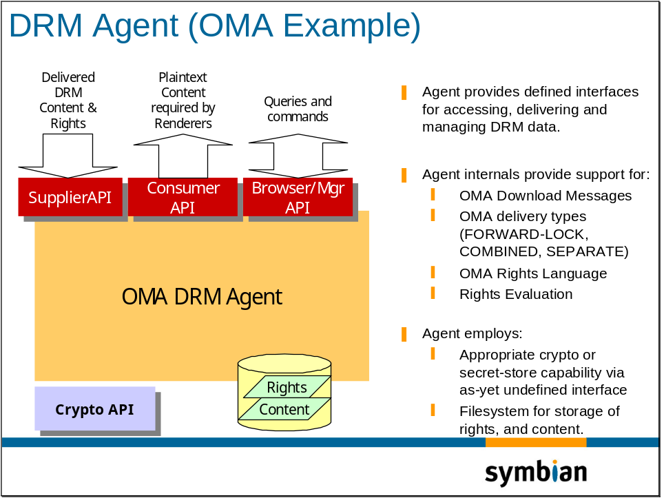

Storage of Content
Phase 1
Phase 1 of the content access work will not impose that agents store protected content themselves. Such a demand would require a significant change to the behaviour of all applications since the general Symbian OS approach has been for applications to take care of their own storage requirements. As such, phase 1 will arrange for content to be imported by a CA agent and returned to the application for storage in a traditional fashion.
In summary, therefore, phase 1’s requirements on applications is that they use the new content access mechanisms to open & read content. It’s also likely that these applications will need to register for new DRM-related mime-types.

Phase 2
Phase 2 may involve further changes in application behaviour relating to how and where they file and discover content with which they have an interest. Ultimately this may result in the agents storing protected contents in secure areas of the filesystem, and applications ‘discovering’ the existence of relevant content not only by searching known directories, but also by querying content availability via a CAF interface.

The Content Access Framework (CAF)
The Content Access Framework provides the necessary infrastructure to support the presence of one or more CAAs, and is designed to enable multiple DRM solutions to coexist without burdening applications with specific behaviour. Its key roles are:
- To define how applications obtain access to restricted content in such a way that multimedia applications have no knowledge about the specific agent that handles a particular piece of content.
- To provide information about all of the restricted content currently stored on the device (i.e. any content which is being managed by the agents in a phase 2 sense).
- Provide the means by which content and rights can be delivered to a given CAA.
Note that it will not be possible to make existing multimedia applications completely unaware that the content they are accessing is restricted. This is because:
- At some point they will need to communicate (DRM) intent (e.g. PLAY) – something that cannot be inferred from basic file-system operations.
As such, multimedia applications will require modification or DRM enabling if they are to support the rendering of restricted content. See 3.3.
As a means of promoting common code in the multimedia infrastructure, the consumer interface will also be capable of handling unrestricted (normal) content. In such a situation, any signalled DRM intent is redundant and is therefore ignored.

DRM Zephyr Delivery Specification
Although a complete framework and agent structure has been defined in the previous section, only a subset of this framework will be made available in the Zephyr release. Other components and interfaces will be defined and provided in subsequent releases.
The following diagram indicates the Zephyr-available subset of the DRM architectural framework:
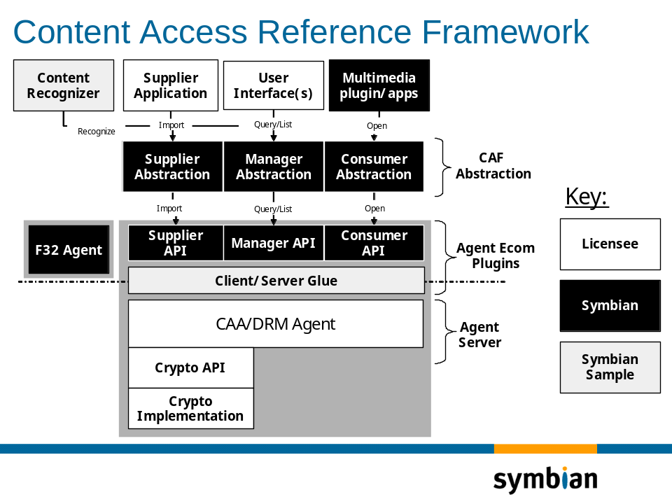

Symbian Work
The first Symbian delivery to Licensees is, essentially
- Definition of supplier, manager and consumer abstraction APIs – essentially the top-level abstract APIs employed by applications on the device. In brief:
  - The consumer API which allows access to protected (and unprotected) content.
  - The supplier API that allows content to be delivered into, and protected by a given agent. This API is partial and may be further developed.
  - The manager API that allows applications to make queries relating to content e.g. rights and other attributes. This API is also partial and may be further developed.
- Definition of the per-Agent Ecom API’s which support the above operations. Agent developers will need to understand these APIs.
- A fallback F32 client-side agent (F32Agent) which allows non-protected content to be accessed through the same framework APIs.
- Some pre-enabled multimedia plug-ins and Java/SIS file install support.
- A reference client/server infrastructure which allows the agents to be linked and run as servers. This is the recommended approach for protection in the forthcoming Symbian OS Platform Security environment.
- A reference recognizer which employs individual recognition capability provided by each CA Agent.
Note that DRM HOWTOs (e.g. the steps required to implement a Symbian OS CAA to the above Ecom interfaces will be addressed in in-source Doxygen documentation.

Licensee Work
Licensees must reuse, adapt or enhance the supplied reference code, and develop new components in order to forge a product-ready solution. This will include:
- A CAA implementation that supports the prescribed interfaces, makes the required provisions for the protection of restricted data, and supports the necessary rights evaluation capabilities.
- A product-ready Supplier Application that will deliver restricted data to the CAA. This application may include UI support. Future CAA integration work may couple the messaging server into this API so that DRM messages can be immediately processed by the CAF.
- If required, adaptation of the supplied recogniser to return the required specific, general or embedded content types of a piece of content.
- A protection implementation that may support the encryption and signing of content and rights – if this is required. This support may employ a hardware secret key-store, and make provisions for authentication of the caller (CAA) in order to keep device-specific keys secret.
- Any extended required content & rights management capability or UI (over and above the basic query capabilities that the abstract manager provides at the framework level).

Enabling the Consumer Applications for Restricted Content
Client access to restricted content will be explicit i.e. via a new interface rather than by employing any file-system transparency mechanisms. (Such transparency would have knock-on implications for system internals – especially the OS loader) This means that:
- Applications will need to be enabled i.e. modified to use the new interface.
- Old applications will continue to be able to handle traditional (unrestricted) content, but should not be able to process restricted content – probably by ensuring this is the case via recogniser mechanisms.

Storage of Restricted Content in Zephyr
As briefly mentioned earlier, rather than manage and store restricted content privately within the file system, the Zephyr (Phase 1) approach is for the Agent(s) to return the protected content to the supplier application.

Security/CAF: Functional Specification
Important Note: The functional specification described here specifies the requirements of the Content Access Framework. Any issues raised that relate to the behavioural aspects of an agent (i.e. CAA internals) or interfaces & components that are not Zephyr-specified should be considered to be recommendations.

General Non-functional Requirements/Goals
In general, the framework meets the following non-functional requirements:
- To allow different DRM schemes to be supported on Symbian OS.
- To allow these schemes to operate independently side-by-side (and simultaneously).
- To provide a single common interface capable of operating on both restricted and unrestricted related content, and regardless of the DRM scheme under which a specific piece of content is stored.
- To reduce the amount of duplicated code required by renderers to support DRM.
- To reduce the need for future evolution of the defined interfaces as:
- New DRM or Content-Access schemes require supporting.
- New rights policies and constraints become available for current DRM schemes (e.g. up-versioning and support for new DRM specifications).
- New crypto and authentication mechanisms become available, and
- Symbian OS Platform Security evolves. See [4].
- The implementation will aim to limit the performance overhead for content that is not restricted.
Note that no ROM budget is currently specified.

Framework Specification

Security/CAF: Abstract Content Consumer Interface
The Abstract Content Consumer API is the means by which renderers, multimedia applications or multimedia plug-ins access restricted content.

Limited Abstraction Capability for Content
As well as hiding the fact that multiple CAAs may be managing content, the Content Consumer API aims to provide renderers with some limited transparency capability.
This means that a renderer application will be able to:
- Access both unrestricted-content (plaintext) as well as restricted content; thus providing some degree of content transparency.
- Control some of the other aspects of restricted data access which are required such as the ability to seek() and manipulate buffer sizes for latency reasons.

DRM Intent
DRM Intent is an additional piece of metadata that accompany calls to the CAF Abstract Consumer interface. For example, an open() with a qualifier of “PLAY” indicates that the application wishes for the CAA to evaluate the rights for the ‘play’ action. If a ‘play’ constraint exists, and is rejected, then the OPEN will fail with an extended error code (indicating DRM rights failure).
Similarly, an OPEN with a qualifier “PEEK” (or alternatively a NULL intent) indicates that the application does not want rights constraints exercised in any way, since the application is simply peeking at the file for other legitimate reasons.
Note that Symbian will administer the CAF Intent-space across all agent implementations.

Security/CAF: Abstract Manager Interface
Although the fact that content may be protected can be hidden from some applications, other parts of the system – managers, browsers, UI etc - may need to be aware about whether content is restricted or has other attributes. For example, a UI may want to depict protected content with a certain icon, or additionally indicate that a piece of content has no associated rights.
Being at the abstract level, these attributes are designed to be – and limited to – those that are applicable to any DRM domain.
Only limited manager support will be defined and provided in the Zephyr release, and this support will be satisfied at the framework level. Limited support will exist for the deletion of content (so that agents can manage their rights appropriately), and support for a request for a given CA Agent to go into browse mode (see 4.2.2.1.1 below).
Note that Symbian will administer the attribute-space across all agent implementations.

Browse Mode
Due to the likely diversity shown by rights across DRM implementations, no attempt will me made to allow rights and content to be managed comprehensively via the CAF. Initially, therefore, agents will provide their own browsing support (and UI) – the CAA API providing one of the stimuli which causes this mode to be activated.
Later releases of CAF might allow more complex management operations to be performed.

Security/CAF: Abstract Supplier Interface
The CAF supplier is simply an API through which all DRM messages are processed. The CAF will identify the relevant owning agent and handle the call appropriately.
DRM messages may contain content, rights, or both and are likely to conform to a delivery standard – such as that specified by the OMA. To general supplier applications, however, DRM messages ought to be opaque and unusable until they have been imported and processed.
Depending on the Agent implementation, one or more of the following may occur:
- Unrecognised content is rejected (no applicable agent was found for the message type).
- Unprotected content is protected.
- Protected content is filed in the file-system.
- Protected content is returned to the caller (the supplier application).
The calling client shall react appropriately to any errors signalled on return from the CAA supplier interface. Errors are one of a set of generic DRM or Content-Access conditions which may include:
- Operation Not Supported
- No Agent
- No Rights
- No Permission
- Rights Pending
- Message parse failure
- Content parse failure
- Rights parse failure
- Rights storage failure
- Content storage failure
- Crypto failure
Calling clients will also observe the following possible conditions:
- Protected content is being returned.
- Protected content is being kept/hijacked (with accompanying path information)
- Rights were processed, but no content was returned.
- Rights were processed and receipt was returned.

CAF Supplier Application
The CAF supplier application may be a standalone application, launched by recogniser and designed solely to import DRM messages. It may also re-launch the recognition process based on the resultant type of the protected content.
It is more likely, however, that, existing OS components - such as the messaging server - may be modified to process content immediately as it arrives on the device – allowing the CAF import process to take place behind the scenes.
As an alternative to calling the CAF import operations for all incoming messages, the supplier interface will also be able to provide lists of CAF-supported DRM message types (though the benefits of dynamic installation of agents will be lost if this list is cached for long periods).

Multiple Rights
Some DRM schemes may allow for the fact that multiple rights may be delivered and/or exist for a piece of content. If required, this capability should fully supported by the CAA implementation. For further discussion, see B.1.1.

Security/CAF: Recognizer Support
Recognition support is required for a number of reasons:
- So applications can identify new DRM-related mime-types (container types)
- So the CAF can identify the relevant agent when a caller wishes to read, play or consume content.
- So that supplier applications can recognise DRM messages, and also so that the CAF can identify the agent tasked with the import operation.
The recogniser infrastructure will be split into:
- an external recogniser which will be configurable in that it will be able to return:
  - a DRM message type
  - a DRM content type in one of a number of ways:
    - the DRM content container, e.g. oma.content…
    - a new compound mime-type e.g. oma.content/jpeg…
    - a generic DRM compound mime-type e.g. drm/jpeg, or
    - perhaps even the embedded content type e.g. image/jpeg.
- recognition logic implemented in each CA agent capable of recognizing container type and embedded content type.
This approach allows flexibility for licensees since they can select the most appropriate recognition response, and the system benefits from the ability to bring new recognisers into play automatically as new agents are installed.
Note that it not intended for the options in (b) to be run-time configurable – they will be build-time configurable based on the licensee’s chosen policy.
Of the four (b) options above, the most useful is (iii) since this allows new applications to register for a set of new generic DRM mime-types once, and maintains the content abstraction which is presented to applications.
(ii) breaks the abstraction, but is useful of some applications are written only to work with a particular domain (e.g. OMA).
(iv) provides total DRM transparency, but may fool legacy applications into opening protected content with non-CAF APIs. Such applications mail fail if presented with ‘garbage’ – which is how such content will appear to them.

Agent Specification
Four CAA interfaces are proposed.
- CAA Supplier API: This interface allows the import of DRM message content intended for a given agent. These messages are likely to - according to the scheme - contain one or both of:
- Restricted content (encrypted or plaintext)
- DRM Rights
In addition, it is likely that the implementation behind the Supplier interface will opt to store data such as rights in such a way as to prevent tampering.
- CAA Content Consumer API: This is the interface that provides the framework with access to content managed by a targeted CAA.
- CAA Manager/Browser API: This interface provides the CAF with information about stored content and rights with a view to allowing other infrastructure to behave appropriately with this content.
- CAA Crypto Service: This interface provides the CAA with at least some basic crypto and signing services, and at most some secret key-store capability - to which access can be authenticated.
This API is undefined and unimplemented in Zephyr.

Security/CAF: Content Supplier API
The agent Content Supplier API is the interface through which DRM-domain specific message data is passed into a CAA for further processing.

Content Handling in Zephyr (basic use-case)
As an example, an OMA forward-lock MP3 file might be handled as follows:
- The message server receives data of type application/vnd.oma.drm.message
- The message server delivers this to the CAF supplier.
- The CAF supplier uses the internal recognisers to identify the message container as OMA.
- The CAF forwards this to the OMA agent.
- The OMA CAA unpacks the message and extracts the content (in this case plaintext)
- The OMA CAA encrypts the content and creates a default rights object for this content.
- The OMA CAA re-packages the content within an application/vnd.oma.drm.content container and returns this to the caller with a mime type of x-drm-audio/mp3.
- The message server shows this content as present in the inbox.

Security/CAF: Content Consumer API
The agent’s content consumer API is the means by which the framework validates and gains access to a piece of restricted data owned by a specific CA agent.
The role of the agent consumer implementation is to:
- Identify rights associated with the target content
- Evaluate the rights in the context of the supplied intent.
- Execute the rights in the context of the supplied intent.
- If appropriate, grant access to the plaintext content.
- Provide attribute information relating to target content.
- Provide rights information relating to one item of target content.

Use-case continued…
Continuing the above use-case…
- On user invocation, the (new) drm/mp3 application will be launched.
- Based on CAF attribute queries, the player will allow the data to be saved once. Other UI operations such as ‘forward via Bluetooth’ will be unavailable.
- The player will then open the content with a given DRM intent.
- The CAF will identify the appropriate CAA based on internal recognition capability.
- The rights will be identified and evaluated in the context of the supplied intent.
- The player is given a handle to the plaintext version of the data.

Rights Enforcement
The responsibility for rights enforcement (and therefore trust) is essentially one that is shared between the renderer and CAA. The CAA role, in this instance, is to provide the mechanisms – implicit or otherwise - to allow the renderer to enforce these rights responsibly. This involves:
- Processing intent qualifiers that are supplied to the CAA when the renderer is accessing data via the Content Consumer interface. These new indicators qualify the basic file operations and provide the CAA with a hint as to which high-level action the renderer is taking and therefore whether or not to evaluate constraints.
- Managing any stateful values associated with constraints. [In OMA-REL v1.0 reference implementation this would mean handling the ‘count’ constraint.]
Note that in the case where multiple rights objects exist, separate copies of state are also maintained (e.g. two rights objects each containing a ‘play’ action with a ‘count’ constraint). See B.1.1 if this is relevant to your CAA implementation.
Point (1) has implications for plug-ins and intermediaries which exist between the top-level applications and the CA Framework: Only the top-level applications can really determine DRM intent, and by doing so can be classed as trusted DRM applications. Very little benefit would be gained by specifying that DRM intent was determined by a plug-in, especially if the application employing the plug-in allows the plaintext data to be saved or redistributed.

Trust Mechanisms
When platform security capabilities are available, a couple of trust mechanisms will be available to the agent:
- Capability: The ability to query the capability of a caller.
- SID: The ability to query the SID of a caller i.e. verify on a per-vendor basis,
..and a combination of the two. Both require, however, a client/server separation, but need no enhancement to existing APIs.
Independently of platform security, challenge/response mechanisms may also be employed, but these are likely to require that APIs be modified in order to carry the additional information. For more information on platform security see 5.1 below.

Security/CAF: DRM Manager/Browser API
The agent manager API is the interface through which the framework queries and manages restricted content owned or managed by a particular CAA. It will provide the CA framework with a number of standard CAA services:
- Delete Content (request)
- Enter browse mode (not targeted at a particular piece of content).
Later versions of the CAF manager API (beyond Zephyr) may support:
- List agent-managed content (optionally filtered by mime-type)
- List orphaned content (if the agent manages its own content)
- Delete/manage/obtain rights
- Manage Rights as a whole (rather than via specific content items)

Security/CAF: Crypto API
The proposed Secret Store/Crypto interface provides a means by which a third-party (licensee) implementation can provide authenticated access to a set of functions provided by security hardware.
Most services will probably deem it appropriate for rights and content to be protected in some way while they are stored on a device. In some delivery modes (e.g. see 4.3.1) either rights or content – or both – may warrant some form of protection (such as signing and encryption) while stored on the device.
The likely (and not mandatory) crypto services required by the CAA are:
- Encryption of data, decryption of data
- Signing of data, validation of data
Note that the means to determine if callers to this interface are appropriately authorised is not in the scope of this specification, and is assumed to be performed in some device-specific fashion – perhaps in hardware. See omission 4.4.1. As such, it is appropriate to assume that any implicit use of an authentication mechanism in the above crypto interfaces may cause the above API calls to fail with an error indicating, for example, that the caller is not properly authorised.
Note that the Crypto. API will remain unspecified for Zephyr, and that no underlying crypto. implementation will be provided in this release.

Supporting Hardware
Hardware, which is available on some devices, may provide certain benefits. Depending on its sophistication, cryptographic operations may be performed in software, with the hardware used only to protect the terminal-specific keys, or the hardware may encapsulate and/or accelerate the cryptographic operations directly.
The diagram below illustrates both possible scenarios. The left approach implements all of the crypto. capability in software, while the hardware simply provides authenticated access to key data. The approach on the right benefits from enhanced hardware capability that provides both key protection and crypto. facilities.
Other than recognising that both approaches serve to satisfy the needs of the CAA Crypto API, the specifics are outside the scope of this document.
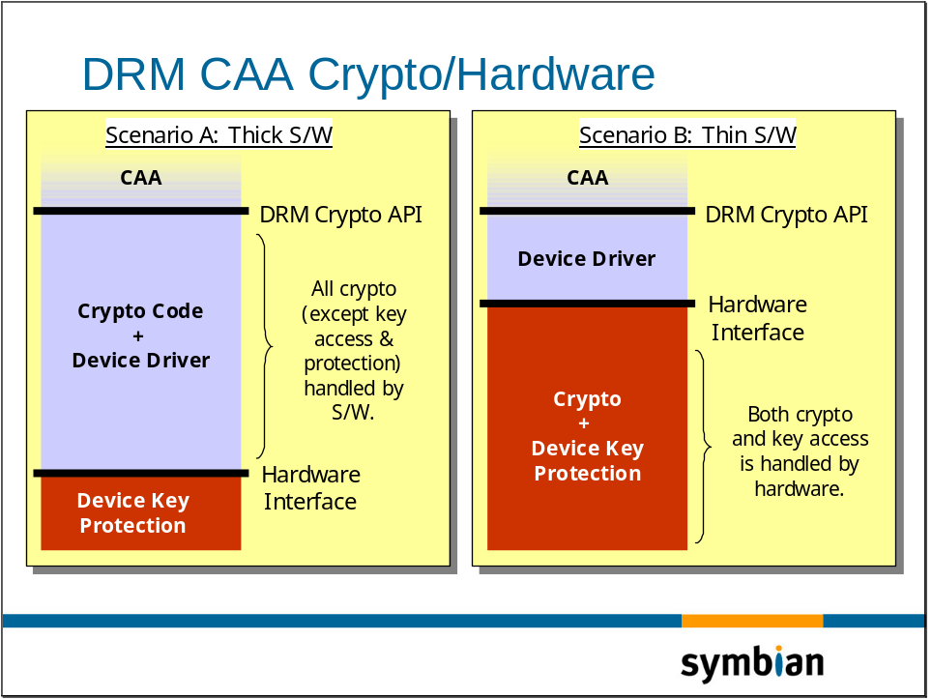

Other Notable Omissions:

Reference Secret Store/Crypto Authentication
A CAA ought to be one of the few trusted entities permitted to employ a cryptography interface which uses secret device keys for encryption and signing purposes. This requires that the cryptography system supports authentication of the calling entity.
This interface and its association with the above cryptographic operations is outside the scope of this document. CAA suppliers are therefore left to define and employ this capability as they see fit.

Revocation of Rights
There are a number of ways revocation could conceivably take place; OCSP validation being one possible approach – with the necessary downside of requiring network access.
Currently, revocation is outside the scope of this document and will not form part of any initial reference implementation.

Superdistribution
The CAF reference implementation for Zephyr will contain no explicit support for superdistribution, or conversely, any mechanisms preventing off-device transfer of protected rights and/or content. CAA implementation providers are free to support this capability within the abstract and CAA manager APIs if desired.

Native Execution of Restricted Content
The CAF reference implementation will provide no support for execute action in the context of native code (e.g. DRM-protected native EXEs). However, Java MIDlet execution via class loader will be supported by the Java team.

Security Threats
Security threats are very briefly visited in the requirements document (internal [3]), and will be examined in far more detail in a subsequent document in a platform security context. In brief, however:
- It is not currently possible to prevent malicious manipulation of the AppArc handlers in order to gain access to incoming DRM Messages. Certain mime types could be re-vectored to a new rogue application that can gain access to content or CEKs.
- It may be possible to re-route certain mime-types to an alternative (rogue) application by altering the system AIF file.
- An inability to authenticate renderers means that renderers which do not respect DRM intent can gain access to content without signalling the required DRM action.
- Without an authenticated secret-store capability, the implementation will be unable to restrict access to device keys used to sign rights, encrypt content; or encrypt/decrypt keys associated with the content.
- Currently, malicious manipulations of DLL search paths could allow rogue CA libraries to eclipse genuine ones.
- More specific attacks such as an application examining the message inbox for OMA plaintext keys prior to the content being recognised and forwarded to the CAA for encryption and filing.

Future Integration with Platform Security
Platform Security defines a number of new mechanisms that can be used to address the threats above. Two of them are:
- Application and .DLL capability.
New rules will ensure that applications (and DLLs) can only load a target DLL if the target’s capability set is greater than or equal to the capability set of the loading executable. (This rule also applies to IPC.) Essentially, this rule protects applications from loading rogue .DLLs, and DLL capability can be controlled through verification of signed capabilities during the install process.
Capability will also limit unauthorised activity since various OS subsystems will be able to verify a callers capability before continuing.
- Data Caging.
A new file-system structure now allows applications to have their own private storage areas which are inaccessible to others e.g. /private/<SID>. This will prevent unauthorised access to AppArc files, or unauthorised access to private data such as the message server’s inbox, for example.
Such areas would also be appropriate for the storage of a CAA’s rights objects, and perhaps – in subsequent releases – storage of restricted content data as well.
Many of the enhancements in [4] will alleviate the threats briefly visited in section 5, although dealing with the problem of the authentication of renderers is something which will require further security infrastructure.

Backup and Restore
Technically, the only data that should require backup and restore are the CAA-managed rights and content files. Problems may occur if old rights backups are restored over updated ones, so these types of problem are likely to manifest themselves as orphaned rights (rights with no target content) or vice-versa (content with no rights). As such, CAA implementations ought to be resilient to unexpected inconsistencies between content & rights etc.
Similarly, the restore of older stateful rights over recent ones may allow proper rights processing to be circumvented. Agent implementers may therefore choose to exclude stateful information from backup, but it will be not be possible for a user to transition DRM data from one device to another without re-obtaining rights (and hence a valid state) from a rights issuer.

Orphaned Restricted Data
In Zephyr, protected content will be owned by the applications while the CAA manages and owns rights. Inconsistencies may therefore occur if content and/or rights become orphaned through partial backup and restore operations. The agents should be tolerant to such scenarios, and future management applications (employing the manager/browser API) will give visibility of such problems to the user.

Reuse of Content Encryption Keys
Assuming rights and content are signed and encrypted respectively, with a device secret key, then it is only going to be possible to verify and decrypt that data with the same key. This may have implications (or benefits) if different devices have different keys, and a user attempts to backup from one device and restore to another.
Note that backup and restore consistency is the responsibility of CAA providers.

Backup Opt-Out
If implementations choose to keep restricted content in plaintext form (perhaps in a secure part of the file system) then under circumstances it may be necessary to opt-out of the backup process. As a result, opt-out support in the OS may be required soon.

Other Issues

Migration
The Zephyr approach imposes specific requirements on how agents support the content-supplier capability. It specifies that:
- Agents will process and return content to the supplier
- The returned content must conform to a format prescribed by the framework.
Essentially, this is a compromise that defers the need to mandate that all applications immediately change the way they store and manage content.
In the future, agents may, themselves, be responsible for storing content – not the applications. This means that DRM-enabled applications will need to discover which applicable content exists by querying the CA framework as well as examining their traditional directory locations.

Further Information

People
Role | Person / People
Contributor(s) | Keith Robertson, Will Bamberg, Craig Heath
Reviewer(s) | Craig Heath, Will Bamberg, Keith Robertson, Corinne Dive-Reclus, Simon Lewis, Kevin Butchart, Katie Sheehy, Martine Budden.

References

Internal Document References
No. | Document Reference | Version | Description
[1] | DRM Roadmap (Craig Heath) | 1.1 | Early Proposals for DRM Support.
[2] | DRM Backgrounder [SGL.BCD001] | 0.3 | Aims, principles and technologies applicable to DRM.
[3] | DRM Requirements (RequisitePro-sourced to SGL.GT0176.051.Rev0.13_Zephyr_DRM_DDR.doc) | 0.13 | DRM requirements document.
[4] | SGL.SM0007.001.Rev1.0.PlatformSecurityEngineeringGuide.doc | 1.0 | Platform Security Engineering Guide

Specification References
No. | Document Reference | Version | Description
 | OMA-Download-DRM-v1_0-20020905-C | 1.0 | Describes the delivery mechanisms and contents formats for OMA-DRM Phase 1.
 | OMA-Download-DRMCF-v1_0-20020913-C | 1.0 | Describes the content format for DRM data
 | OMA-Download-DRMREL-v1_0-20020913-C | 1.0 | Describes the Rights Expression Language (i.e. subset of ODRL)

Glossary
The following technical terms and abbreviations are used within this document.
Term | Definition
CAA | Content Access Agent (e.g. DRM Agent). Described in 2.2.1
CAF | Content Access Framework. Described in 2.2.2.
CEK | Content Encryption Key. Any key – whether created externally or internally to the device, which allows symmetric encryption or decryption of some data.
DCF | DRM Contents Format
DRM | Digital Rights Management
HWSS | Hardware Secret Store
OCSP | Online Certification Status Protocol
ODRL | Open Digital Rights Language
OMA | Open Mobile Alliance
REL | Rights Expression Language (specifically OMA-REL).
Renderer | Any application, or plug-in which consumes (i.e. is a consumer of) data (whether rights-controlled or unrestricted). An example of such a render might be a WAV, MP3, or AC3 player, a video player, or image viewer. In this context, an application launcher such as a Java class loader could also be considered to be a renderer since it consumes Java class data and loads it into the Java runtime.
RO | Rights Object
SAX | Simple API for XML. Generally refers to a type of XML parser with which applications register for parse-events rather than being handed an in-memory representation of a whole XML document.
SDP | Session Description Protocol. As defined by RFC2327 which describes how multimedia sessions are announced, initiated, and parties are invited etc.

Document History
Date | Version | Status | Description
20 February 2004 | 2.1 | Issued | Minor pre-A4 changes from email review.
20 October 2003 | 2.02 | For Review | Updates covering evolutionary changes through ongoing discussions with licensees.
19 June 2003 | 2.0 | Reviewed | Post review changes (pre A2).
19 May 2003 | 1.2 | For Review | Updated to reflect new multi-agent requirements. Additional internal comments. More detail regarding reference implementation proposals. Brief security threats summary.
06 May 2003 | 1.0 | Reviewed | First peer review & initial Licensee comments
07 April 2003 | 0.13 | Draft | Further minor changes to address internal comments
02 April 2003 | 0.11 | Draft | Post-initial review comments. Note that functional specification tables have been removed and places in the supplementary document.
28 March 2003 | 0.1 | Draft | First draft

Document Review Date
Last Reviewed 20 Feb. 2004.
- Architectural Contributors
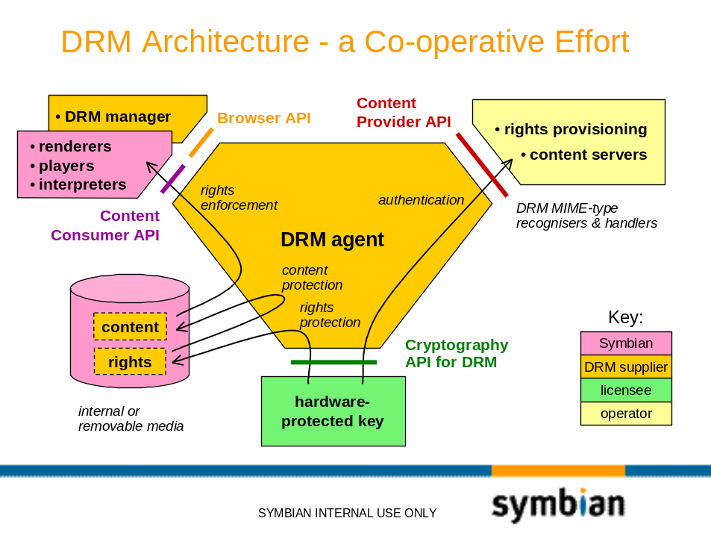
- Additional Implementation Notes (for Agents)
    - Ordering when multiple rights exist
At some point, standards may define the behaviour that a CAA should exhibit when faced with the problem of validating the a rights action when multiple rights objects exist e.g. one piece of content with:
- A rights object with a date range which is valid for action, plus
- A second rights object with a valid count constraint for action.
In such a scenario, the behaviour is defined as follows:
In any situation where multiple valid rights exist for a piece of content, then an attempt to satisfy non-stateful constraints will made first.
In this particular example, therefore, the count constraint would only be executed if the (non-stateful) date range proved to be invalid.
    - Specific Approaches to Storage of Content and Rights
Currently, the specific mechanisms used for protecting content and rights are delegated to the implementation. The remainder of this section describes one particular approach – for OMA implementations, and is for information only.
There are certain degrees of content protection (associated with the DRM delivery modes specified in the OMA documents) which ought to influence how the information is protected when stored on the device.
Essentially the guidelines are as follows:
- All plaintext content is locally encrypted using a key forged from a random number. This will apply to DRM restricted content received in FORWARD-LOCK and COMBINED delivery modes. This will not apply to content received by the SEPARATE mechanism, since the content will be pre-encrypted.
- The content encryption keys (CEKs) – regardless of whether they were generated locally or externally – are themselves protected. As such, any unprotected CEK appearing in stored rights will be encrypted using the API provided by the Secret Store API.
Note that for FORWARD-LOCK, no original rights existed. Note: To maintain consistency with the other delivery mechanisms, a rights object is created by the CAA infrastructure, and the CEK is stored within it.
- Rights will be signed so that any tampering with rights information can be detected. Again, the signing and verification is provided through access to the Secret Store API.

- OMA Phase 1 ODRL Subset
  - Actions
- Play
- Display
- Execute
- Print
  - Constraints
- Count – must be initialised, managed, and evaluated by CAA
- Date Range – Must be evaluated by CAA
- Interval – Must be initialised, managed and evaluated by CAA

<?xml version="1.0" encoding="UTF-8"?>
<!ELEMENT o-ex:rights (o-ex:context, o-ex:agreement)>
<!ATTLIST o-ex:rights
xmlns:o-ex CDATA #FIXED “http://odrl.net/1.0/ODRL-EX”
xmlns:o-dd CDATA #FIXED “http://odrl.net/1.0/ODRL-DD”
>
<!ELEMENT o-ex:context (o-dd:version?, o-dd:uid?)>
<!ELEMENT o-dd:version (#PCDATA)>
<!ELEMENT o-dd:uid (#PCDATA)>
<!ELEMENT o-ex:agreement (o-ex:asset, o-ex:permission)>
<!ELEMENT o-ex:asset (o-ex:context, o-ex:cek?)>
<!ELEMENT o-ex:cek (o-ex:plainTextKey)>
<!ELEMENT o-ex:plainTextKey (#PCDATA)>
<!ELEMENT o-ex:permission (o-dd:play?, o-dd:display?, o-dd:execute?, o-dd:print?)>
<!ELEMENT o-dd:play (o-ex:constraint?)>
<!ELEMENT o-dd:display (o-ex:constraint?)>
<!ELEMENT o-dd:execute (o-ex:constraint?)>
<!ELEMENT o-dd:print (o-ex:constraint?)>
<!ELEMENT o-ex:constraint (o-dd:count?, o-dd:datetime?, o-dd:interval?)>
<!ELEMENT o-dd:count ( o-dd:fixed)>
<!ELEMENT o-dd:fixed (#PCDATA)>
<!ELEMENT o-dd:datetime (o-dd:start?, o-dd:end?)>
<!ELEMENT o-dd:start (#PCDATA)>
<!ELEMENT o-dd:end (#PCDATA)>
<!ELEMENT o-dd:interval (#PCDATA)>

- OMA Mime-Types

OMA DRM Recogniser Specifics
As specified in the OMA-Download-DRM v1.0 Specification, an OMA Supplier Application recogniser would need to recognise and handle the following types of message:
- FORWARD-LOCK. Here, plaintext content is delivered with no accompanying rights. The media type which is supported:
application/vnd.oma.drm.message

Note that default (full) rights are created for forward lock content.
- COMBINED-DELIVERY. In this instance, plaintext content is delivered along with accompanying rights – together in the same message. Relevant media types are:
application/vnd.oma.drm.message
application/vnd.oma.drm.rights+xml

- SEPARATE-DELIVERY. In this mode, content and rights arrive in two separate and distinct messages. Here, the content is encrypted for further protection. Generally it is assumed that the content will be delivered first, with an indication that rights are to follow. Relevant media types:

application/vnd.oma.drm.rights+xml
application/vnd.oma.drm.rights+wbxml
…
application/vnd.oma.drm.content

When processing content via HTTP, latency indicators are given in the form:
X-Oma-Drm-Separate-Delivery : “X-Oma-Drm-Separate-Delivery” “:” [delta-seconds]

- DDR Tables
Note that these tables are for internal use only.
  - Security/CAF: Content Consumer (1951)
    - Abstract Content Consumer Abstraction
<FUNC_SPEC_ID | “SysUtils/CA Framework/Content Consumer API”
<TITLE> | High-Level Consumer API | </TITLE>
<DESCRIPTION> | Provide public API which clients employ to obtain access to DRM content  API also provides DRM-implementation-agnostic (intent) access qualifiers (or DRM actions) which indicate the intent of the renderer.  Likely to be based on a streams-like interface for future extensibility.  Content-access over the network is API intended, but not supported by the reference implementation | </DESCRIPTION>
<STATUS> | Not yet implemented.. | </STATUS>
<SOURCE> |  | </SOURCE>
<OWNER> | GT0176 | </OWNER>
<PARENT_ID> | REQ1951 | </PARENT_ID>
<VERSION> |  | </VERSION>
<RELEASE> |  | </RELEASE>
<REQ> | REQ1951.4, REQ1951.4.1, REQ1951.2 | </REQ>
</FUNC_SPEC_ID>

<FUNC_SPEC_ID | “SysUtils/CA Framework/Content Consumer API”
<TITLE> | DRM Consumer API Client-Side Support (Framework) | </TITLE>
<DESCRIPTION> | Provide the client-side support that will identify the type or target content and establish context with the relevant CAA or F32. | </DESCRIPTION>
<STATUS> | Not yet implemented. | </STATUS>
<SOURCE> |  | </SOURCE>
<OWNER> | GT0176 | </OWNER>
<PARENT_ID> | REQ1951 | </PARENT_ID>
<VERSION> |  | </VERSION>
<RELEASE> |  | </RELEASE>
<REQ> | REQ1951.4, REQ1951.4.1, REQ1951.2 | </REQ>
</FUNC_SPEC_ID>

<FUNC_SPEC_ID | “SysUtils/CA Framework/Content Consumer API”
<TITLE> | Consumer Abstraction Server-Side (Agent) | </TITLE>
<DESCRIPTION> | Provide the per-agent support that will interface with the CAA content consumer API – as defined by the framework. | </DESCRIPTION>
<STATUS> | Not yet implemented. | </STATUS>
<SOURCE> |  | </SOURCE>
<OWNER> | GT0176 | </OWNER>
<PARENT_ID> | REQ1951 | </PARENT_ID>
<VERSION> |  | </VERSION>
<RELEASE> |  | </RELEASE>
<REQ> | REQ1951.4, REQ1951.4.1, REQ1951.2 | </REQ>
</FUNC_SPEC_ID>
  - F32 Agent
<FUNC_SPEC_ID | “SysUtils/CA Framework/Content Consumer API”
<TITLE> | F32 Agent for handling non restricted content | </TITLE>
<DESCRIPTION> | Provide a CA agent that will allow consumption of non-DRM files | </DESCRIPTION>
<STATUS> | Not yet implemented. | </STATUS>
<SOURCE> |  | </SOURCE>
<OWNER> | GT0176 | </OWNER>
<PARENT_ID> | REQ1951 | </PARENT_ID>
<VERSION> |  | </VERSION>
<RELEASE> |  | </RELEASE>
<REQ> | REQ1951.4.5 | </REQ>
</FUNC_SPEC_ID>

  - Reference Client/Server Implementation
<FUNC_SPEC_ID | “SysUtils/CA Framework/Content Consumer API”
<TITLE> | Reference Agent Client/Server Infrastructure | </TITLE>
<DESCRIPTION> | Provide client/server infrastructure in order to simply the creation of a server side agent | </DESCRIPTION>
<STATUS> | Not yet implemented. | </STATUS>
<SOURCE> |  | </SOURCE>
<OWNER> | GT0176 | </OWNER>
<PARENT_ID> | REQ1951 | </PARENT_ID>
<VERSION> |  | </VERSION>
<RELEASE> |  | </RELEASE>
<REQ> | REQ1951.4.6 | </REQ>
</FUNC_SPEC_ID>

  - SIS Install
<FUNC_SPEC_ID | “SysUtils/CA Framework/Content Consumer API”
<TITLE> | SIS Install will support DRM framework | </TITLE>
<DESCRIPTION> | It shall be possible to install a SIS application which is supplied as DRM content | </DESCRIPTION>
<STATUS> | Not yet implemented. | </STATUS>
<SOURCE> |  | </SOURCE>
<OWNER> | GT0176 | </OWNER>
<PARENT_ID> | REQ1952 | </PARENT_ID>
<VERSION> |  | </VERSION>
<RELEASE> |  | </RELEASE>
<REQ> | REQ1952.1 | </REQ>
</FUNC_SPEC_ID>

  - MIDP Install
<FUNC_SPEC_ID | “SysUtils/CA Framework/Content Consumer API”
<TITLE> | MIDP Install will support DRM framework | </TITLE>
<DESCRIPTION> | It shall be possible to install a MIDP application which is supplied as DRM content | </DESCRIPTION>
<STATUS> | Not yet implemented. | </STATUS>
<SOURCE> |  | </SOURCE>
<OWNER> | GT0176 | </OWNER>
<PARENT_ID> | REQ1952 | </PARENT_ID>
<VERSION> |  | </VERSION>
<RELEASE> |  | </RELEASE>
<REQ> | REQ1952.2 | </REQ>
</FUNC_SPEC_ID>

  - Security/CAF: Content Manager
<FUNC_SPEC_ID | “SysUtils/CA Framework/Content Consumer API”
<TITLE> | Management Abstraction API (Framework) | </TITLE>
<DESCRIPTION> | Provide API and framework support for basic content attribute query i.e. restricted vs. non-restricted. | </DESCRIPTION>
<STATUS> | Not yet implemented. | </STATUS>
<SOURCE> |  | </SOURCE>
<OWNER> | GT0176 | </OWNER>
<PARENT_ID> | REQ2542 | </PARENT_ID>
<VERSION> |  | </VERSION>
<RELEASE> |  | </RELEASE>
<REQ> | REQ2542.1 | </REQ>
</FUNC_SPEC_ID>

  - Omissions
Note that many omissions are due to a shift in emphasis from providing a DRM Agent implementation to providing Content Consumer CA Framework support for Agents.
    - Secret Store/Crypto Authentication
<FUNC_SPEC_ID | “SysUtils/CA Framework/Secret Store-Crypto API”
<TITLE> | Secret Store/Crypto API | </TITLE>
<DESCRIPTION> | This API provides the DRM Infrastructure with a basic encrypt/decrypt, sign/verify capability. Reference implementation will implement to this API – but with no authentication capability (see E.7.1). | </DESCRIPTION>
<STATUS> | Not yet implemented | </STATUS>
<SOURCE> |  | </SOURCE>
<OWNER> | GT0176 | </OWNER>
<PARENT_ID> | REQ1953 | </PARENT_ID>
<VERSION> |  | </VERSION>
<RELEASE> |  | </RELEASE>
<REQ> | REQ1953.1, REQ1953.2, REQ1953.3, REQ1953.4 | </REQ>
</FUNC_SPEC_ID>
    - Content Format
<FUNC_SPEC_ID | “SysUtils/CA Framework/Content Supplier API”
<TITLE> | Ability to Parse OMA-DCF v1.0 | </TITLE>
<DESCRIPTION> | The reference CAA implementation will be fully compliant with the OMA-CF v1.0 specification. | </DESCRIPTION>
<STATUS> | No longer a framework issue. | </STATUS>
<SOURCE> | OMA-REL v1.0 | </SOURCE>
<OWNER> | GT0176 | </OWNER>
<PARENT_ID> | REQ2173 | </PARENT_ID>
<VERSION> |  | </VERSION>
<RELEASE> |  | </RELEASE>
<REQ> | REQ2173.1.1 | </REQ>
</FUNC_SPEC_ID>
    - Rights Enforcement
<FUNC_SPEC_ID | “SysUtils/CA Framework/Content Consumer API”
<TITLE> | Rights Enforcement | </TITLE>
<DESCRIPTION> | The Content Consumer allows a consumer to signal DRM intent when invoking operations of the DRM Content Consumer API. A failure to meet the rights criteria which is associated with the intent causes the file access or operation to fail with an indication that this was DRM-related. The hint allows rights to be enforced by the CAA and operations to be failed accordingly if rights criteria are not met. | </DESCRIPTION>
<STATUS> | No longer a framework issue. | </STATUS>
<SOURCE> |  | </SOURCE>
<OWNER> | GT0176 | </OWNER>
<PARENT_ID> | REQ1951 | </PARENT_ID>
<VERSION> |  | </VERSION>
<RELEASE> |  | </RELEASE>
<REQ> | REQ1951.2 | </REQ>
</FUNC_SPEC_ID>
    - Rights Interpretation
<FUNC_SPEC_ID | “SysUtils/CA Framework/Content Manager API”
<TITLE> | Ability to Parse OMA v1.0 REL | </TITLE>
<DESCRIPTION> | The reference CAA implementation will be fully compliant with the OMA-REL v1.0 specification | </DESCRIPTION>
<STATUS> | No longer a framework issue. | </STATUS>
<SOURCE> | OMA-REL v1.0 | </SOURCE>
<OWNER> | GT0176 | </OWNER>
<PARENT_ID> | REQ1954 | </PARENT_ID>
<VERSION> |  | </VERSION>
<RELEASE> |  | </RELEASE>
<REQ> | REQ 1954, REQ1954.1 | </REQ>
</FUNC_SPEC_ID>
    - Handling of Incoming DRM Content and Rights (2173)
<FUNC_SPEC_ID | “SysUtils/CA Framework/Content Supplier API”
<TITLE> | AppArc recogniser for OMA DRM Messaging | </TITLE>
<DESCRIPTION> | This is the implementation of a reference recogniser for OMA DRM Messaging content. | </DESCRIPTION>
<STATUS> | Not yet implemented | </STATUS>
<SOURCE> | See: OMA-Download Spec v1.0 (for details concerning DRM message types) and OMA-CF Spec (for details concerning the content format of these messages). | </SOURCE>
<OWNER> | GT0176 | </OWNER>
<PARENT_ID> | REQ2173 | </PARENT_ID>
<VERSION> |  | </VERSION>
<RELEASE> |  | </RELEASE>
<REQ> | REQ2173.1, REQ2173.2 | </REQ>
</FUNC_SPEC_ID>

<FUNC_SPEC_ID | “SysUtils/CA Framework/Content Supplier API”
<TITLE> | Server-side support for content delivery | </TITLE>
<DESCRIPTION> | Implementation needs to glue server side functionality to a content-supplier mixin which the DRM framework specifies as a mandatory interface for DRM Agents | </DESCRIPTION>
<STATUS> | Not yet implemented | </STATUS>
<SOURCE> |  | </SOURCE>
<OWNER> | GT0176 | </OWNER>
<PARENT_ID> | REQ2173 | </PARENT_ID>
<VERSION> |  | </VERSION>
<RELEASE> |  | </RELEASE>
<REQ> | REQ2173.2 | </REQ>
</FUNC_SPEC_ID>
    - DRM Manager and Browser API (1951)
<FUNC_SPEC_ID | “SysUtils/CA Framework/Content Consumer API”
<TITLE> | Content Abstraction Capability – Browsing Extension | </TITLE>
<DESCRIPTION> | Extend the abstract consumer API to allow content listings to be obtained across all present DRM Agents. Will need to include Agent server-side support. | </DESCRIPTION>
<STATUS> | Not yet implemented.. | </STATUS>
<SOURCE> |  | </SOURCE>
<OWNER> | GT0176 | </OWNER>
<PARENT_ID> | REQ1951 | </PARENT_ID>
<VERSION> |  | </VERSION>
<RELEASE> |  | </RELEASE>
<REQ> | REQ1951.4.4 | </REQ>
</FUNC_SPEC_ID>

    - Security/DRM: Crypto API
<FUNC_SPEC_ID | “SysUtils/CA Framework/Crypto API”
<TITLE> | Internal CAA Crypto API Definition | </TITLE>
<DESCRIPTION> | Define (but not implement) the internal CAA crypto interface. | </DESCRIPTION>
<STATUS> | Not yet implemented. Will need licensee agreement. | </STATUS>
<SOURCE> |  | </SOURCE>
<OWNER> | GT0176 | </OWNER>
<PARENT_ID> | REQ1953 | </PARENT_ID>
<VERSION> |  | </VERSION>
<RELEASE> |  | </RELEASE>
<REQ> | REQ1953.1-4 | </REQ>
</FUNC_SPEC_ID>

    - Multiple Rights
<FUNC_SPEC_ID | “SysUtils/CA Framework/Content Manager API”
<TITLE> | Multiple Rights Objects per Content Object | </TITLE>
<DESCRIPTION> | The DRM infrastructure supports multiple rights objects per content object. | </DESCRIPTION>
<STATUS> | No longer a framework issue. | </STATUS>
<SOURCE> |  | </SOURCE>
<OWNER> | GT0176 | </OWNER>
<PARENT_ID> | REQ2173 | </PARENT_ID>
<VERSION> |  | </VERSION>
<RELEASE> |  | </RELEASE>
<REQ> | REQ2173.9 | </REQ>
</FUNC_SPEC_ID>

Note that in previous versions of this document, this is referred to as the DRM Agent (DRM-A)
No specific API is implied here, other than the intent for it to be as DRM-generic as possible.

