Introduction
This document simply serves as a container for the Visio diagrams which represent the Native Software Install flow – including interaction with UI call-backs.
Note 1: the diagrams represent a snapshot in time, and may not necessarily accurately represent the behaviour of a given release of code in the Master Codeline i.e. the diagrams may be out of date, or represent code not yet fully propagated to licensees/partners.
Note 2: the flow depicted illustrates the native software installation process, and although it may bear some resemblance to a Java installation, the two processes are entirely separate from both a flow and interface perspective.

SWI Flow
Start
installation
DisplayInstallL()
User
continue?
Yes
End
installation
No
Certificates
valid?
No
User
cancels
Display
security error
OCSP
Success?
No
Yes
Valid upgrade?
Display
upgrade dialog
Yes
User agrees
Upgrade?
Display
language
Display
options
Display
drive
Display text
files
Event: Start
copying files
Copy files
Event:
update
progress bar
Event:
Installation
complete
End
installation
End
installation
No
No
Package has
optional
dependencies?
Yes
Display
missing
dependencies
User
overrides?
No
End
installation
No
Yes
Yes
Display
Security
Information (ok/
cancel)
Package has
dependencies?
Report missing
dependencies
No
Override?
End
installation
No
Device
compatible?
Display
incompatible
device dialog
User
Overrides?
No
End
installation
No
Yes
Sufficient
capabilities?
User can
grant?
No
Display
security
error
No
End
installation
Display and
request
capabilities
Granted by
user?
No
More Embedded
Controllers?
Run binaries
Yes
Yes
Yes
No
Yes
May also be called later
after options have been
selected
Yes
Yes
No
See associated flow chart
For internal OCSP flow and
behaviour, please see the
associated OCSP flow chart.
SWI Flow v1.1
Only display if options

are present

May not be called if paths are
upgrade is underway

hard-coded or partial

Shaded indicates UI
callback and user choice

OCSP Flow
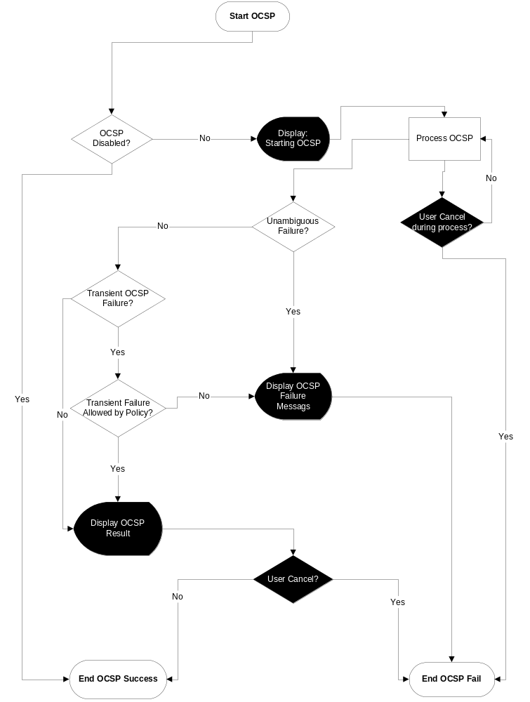

Further Information

People
Role | Person / People
Reviewers
Contributors | Chris Davies
Distribution | Licensees, UI developers

References
No. | Document Reference | Version | Description
[R1] | F:\Shadow\Briefcase\SGL.GT0235.201_Security_9.2_Functional_Specification_Superset.doc | 0.1 | Security Services Functional Specification for SymbianOS 9.2

Open Issues

Glossary
Term | Definition

Document History
Date | Version | Status | Author | Description
01-06-2005 | 0.1 | Draft | Andy Harker | Revised
28-7-2005 | 0.2 | Draft | Steven Bruce | Swapped the order of “Choose Options” and “Choose Drive” dialogs

