Contents
1 Introduction 3
1.1 Purpose and Scope 3
2 Design Overview 3
3 Detailed Design 3
3.1 Linked Fonts feature 3
3.1.1 Overview 3
3.1.2 Design Unit Behaviour 9
4 Scenarios 10
5 Design Considerations 11
6 Further Information 14
6.1 References 14
6.2 Open Issues 14
6.3 Glossary 14

Introduction
This is the component design document for the font store (fntstore) which is a component in the graphics subsystem.

Purpose and Scope
The purpose of this document initially is to document the linked font feature of font store. This document is the appropriate place for design documentation of font store for continuity (maintenance and new features).

Design Overview
Font store is a DLL which is used by the font and bitmap server. Font rendering and drawing to screen makes use of BitGDI or Direct GDI. The linked fonts feature makes use of the font and bitmap server, BitGDI or Direct GDI, in addition to font store.
A font rasterizer plug-in is a DLL which recognises and reads font files stored in a particular format, and provides character bitmaps to the Font and Bitmap server. The rasterizer needs to support the linked fonts feature for linked fonts to work. Currently the default freetype rasterizer does not support this, but a rasterizer supplied by Monotype Imaging does. The rasterizer is not documented here. A different type of rasterizer exists for bitmaps, which is unrelated to the font rasterizer.

Detailed Design
This design is partly by feature and not strictly by component. If there is a font related feature such as linked fonts, then the design is shown in this document, no matter which component the functionality resides in. Please see the font and bitmap server component design document R3, and the graphics architecture document R4 to see how font store interacts with other parts of the graphics subsystem.

Linked Fonts feature
It is not the purpose of this design document to restate the purpose or API usage of linked fonts. Please refer to R1 and R2 before reading this document section.

Overview
There are 3 main use cases for linked fonts, each of which is described separately.
- Linked typeface creation. This is all done in fontstore client side classes.
- Linked typeface registration with the rasterizer
- Rendering a character using a linked font- see 3.1.2,
Obtaining a linked font is done in exactly the same way as getting a non-linked font, so there is no need for additional documentation.

Linked Typeface Creation
The following UML diagram does not describe all operations. These classes are in the API which is published partner. The Symbian Developer Library should be consulted for details of the API calls.
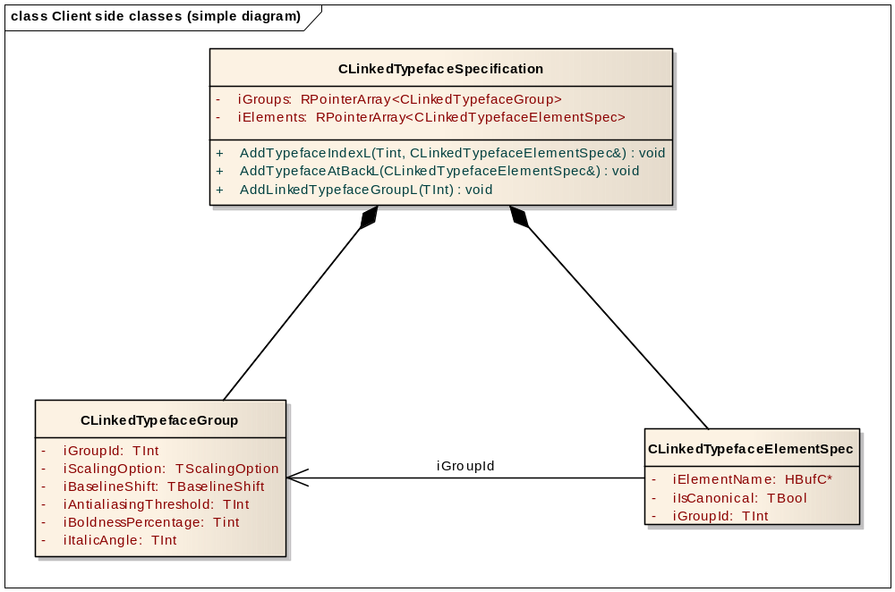
Figure 1: Client Side classes: simplified diagram
A CLinkedTypefaceElementSpec is created with an associated group. The element spec has the name of the typeface for linking, and is associated with the group using a group ID. A group is created with a group ID.
Element specs and groups are added separately to the CLinkedTypefaceSpecification class. They are not stored, but are in a body class, which is in a private header, and this is shown in figure 2.
Ownership is taken when a group or element spec is added to a CLinkedTypefaceSpecification. As a result the relationship is shown as a composition in the diagram above, although creation is independent.
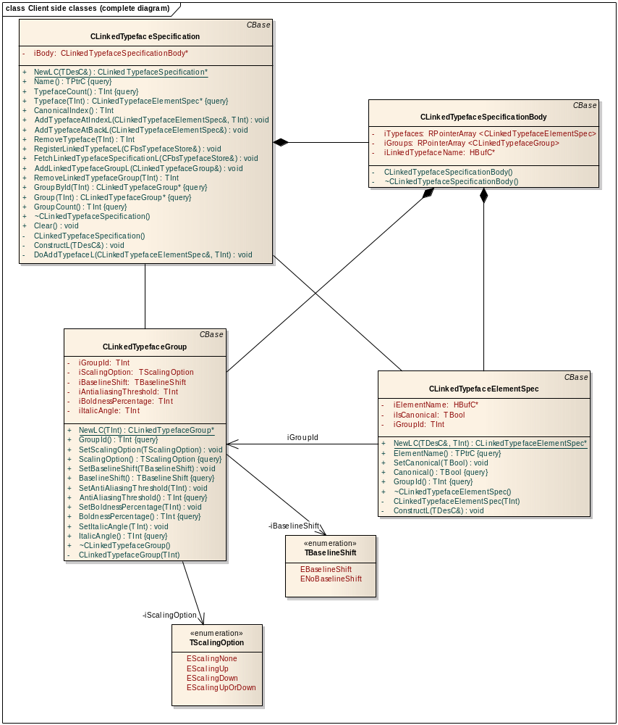
Figure 2: Client side classes: complete diagram

Linked typeface registration
Here there are classes for client server communication, and additional classes for interfacing to the rasterizer.
For client server communication it was decided to limit the number of fonts which can compose a linked font to twelve. This means that T-type classes can be used. This should be sufficient for foreseeable requirements. In addition since linked fonts can be nested the maximum number of fonts which can compose a linked font can be larger than this fixed limit.

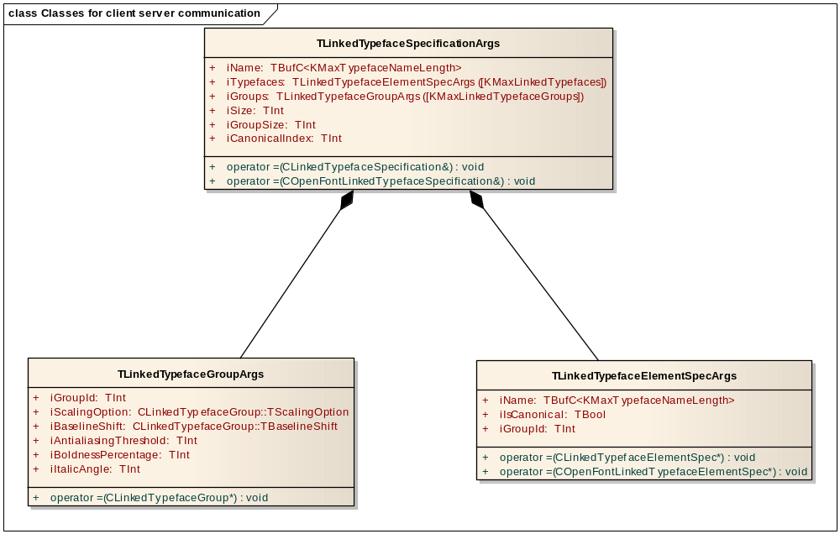
Figure 3: Classes for client server communication
Figure 4 shows the sequence of calls needed for client server communication during linked fonts registration. Fetching a linked font is similar. Since this is only needed occasionally (typically during installation) performance is not critical, but may have an impact on boot time.
Once linked fonts have been created they are persisted in the folder c:\private\10003a16\lfonts in a *.ltt file where they are loaded automatically by the rasterizer during phone boot.

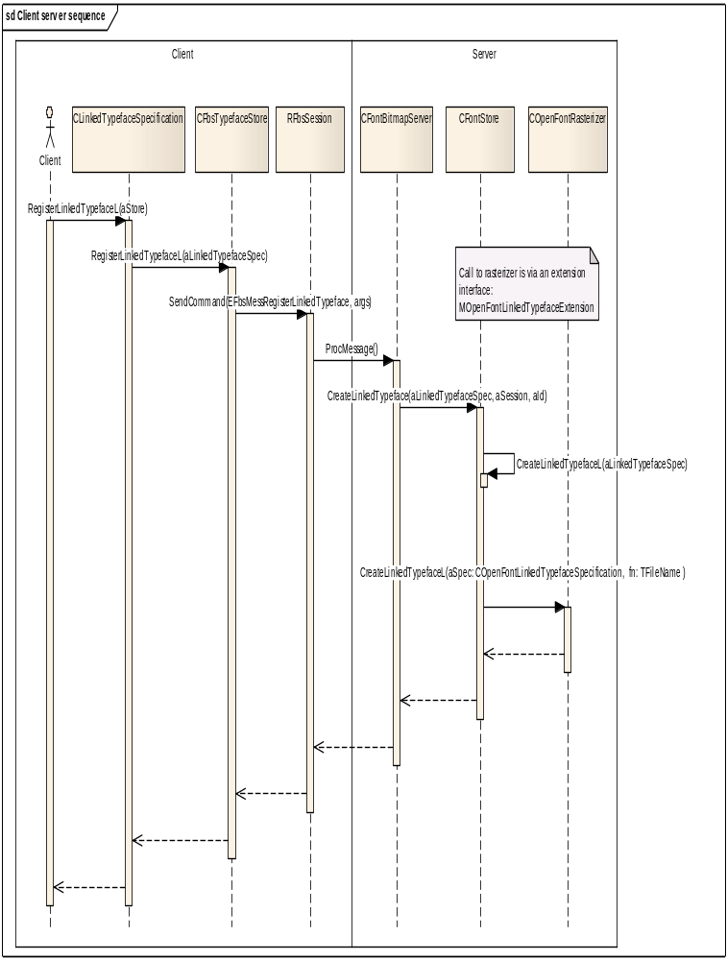

Figure 4: Client- server sequence diagram

Figure 5 shows the classes for server- rasterizer communication. These are similar to the client side classes, but there is no body, and there is also the filename for the font. These classes are very similar to the classes for the published API, but there is the addition of a filename and also a separate body is not used. It was done this way to decouple rasterizer classes from the client classes so that one could be changes without the other. However there would be fewer lines of code to maintain if the rasterizer classes were derived from the API classes: a lesson learnt.
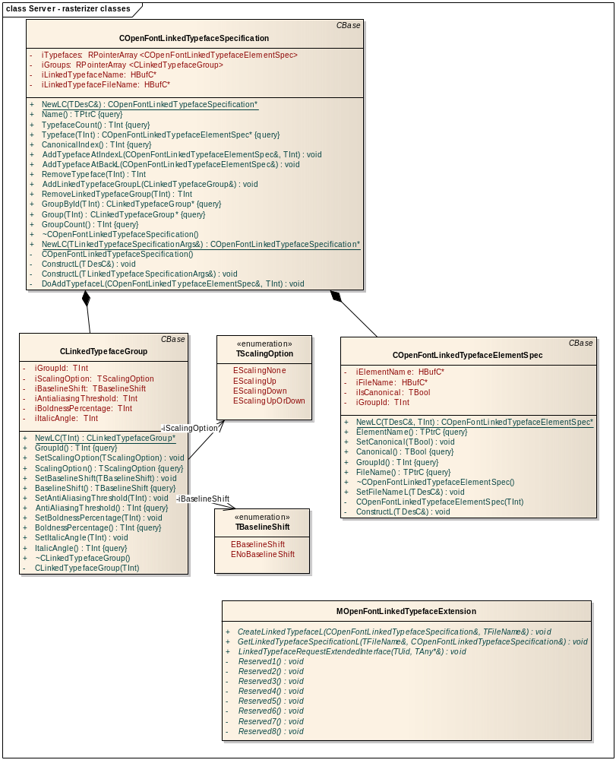
Figure 5: Class diagram for server-rasterizer communication

Design Unit Behaviour
This section describes functionality implemented when drawing characters using linked fonts.
With linked fonts there are differences with the usage of the rendered characters compared to non-linked fonts. This is because some characteristics of the font are on a per-character basis instead of a per-font basis.

Underline/Strikeout position
The underline position is now calculated on a per character basis. There is the function GetUnderlineMetrics() in CGraphicsContext. This gets the top and bottom of a rectangle to be filled, relative to the baseline to produce the underline, but this is inadequate in the case of linked fonts since it does not take the text drawn into account.
The reason that underlines need to be on a per-character basis is to make best use of the available space. For example if there is Chinese text then the underline may be low, or if there are Latin only characters then the underline may be higher since it can go through descenders. With mixed Latin and Chinese characters the underline should be the lowest for any character in the output text.
When a character is rendered the baseline correction should be set in TOpenFontCharMetrics using SetBaselineCorrection(). This is retrieved per character using TOpenFontCharMetrics:: BaselineCorrection(). The maximum (lowest) value is used to correct the underline position. The baseline correction is then added to the underline position values from GetUnderlineMetrics().
Unfortunately scanning through every character of the output string for largest baseline correction will have a performance impact, but this should be minimal, since after the character has been rendered once for the font, it is cached, and no client server calls are needed.
One refinement which may be required in the future (but will not be implemented until necessary) is to use baseline correction associated with an output glyph instead of an input character.
The following illustrates that underline position can look different with different fonts:
The quick 帚帛 Gungsuhche font (underline below characters)
The quick Times New Roman font, underline through descenders.
The quick 帚帛 Times New Roman font, Gungsuhche font.

Glyph Type
The glyph bitmap type is needed when drawing characters since there are slight variations for drawing characters with type of EAntiAliasedGlyphBitmap and EFourColourBlendGlyphBitmap. This is the enum declaration which is in gdi.h. Please see the developer library for more details.

/**
An enumerated type for the format of a glyph bitmap. This type is currently
used to indicate whether glyph bitmaps for scalable fonts are drawn anti-aliased.
Additional values may be defined in the future.

@see TFontStyle::SetBitmapType()
@see CFbsTypefaceStore::SetDefaultBitmapType()
@publishedAll
@released
*/
enum TGlyphBitmapType
{
EDefaultGlyphBitmap = 0,
EMonochromeGlyphBitmap,
EAntiAliasedGlyphBitmap,
ESubPixelGlyphBitmap,
EFourColourBlendGlyphBitmap,
EGlyphBitmapTypeNotDefined,
};

The glyph bitmap type is determined for each character output, and the appropriate character drawing routine called. For EAntiAliasedGlyphBitmap or EFourColourBlendGlyphBitmap the function (BitGDI case) CFbsBitGc::DoDrawCharacterAntiAliased() is called and for plain characters the function CFbsBitGc::DoDrawCharacterEx() is called.
Prior to linked fonts the glyph bitmap type was the same for every character in a font, but with linked fonts this value can be different. There is the function CLinkedTypefaceGroup::SetAntiAliasingThreshold(), which may mean that smaller characters of a linked font are output plain, without any anti-aliasing effect.
For compatibility with existing rasterizers the value obtained from each character can be EAntiAliasedGlyphBitmap, EFourColourBlendGlyphBitmap, EDefaultGlyphBitmap, or EGlyphBitmapTypeNotDefined.
EDefaultGlyphBitmap is a value which is set for a character explicitly by the rasterizer. This means that the character is a plain character without EAntiAliasedGlyphBitmap or EFourColourBlendGlyphBitmap effects i.e. the function CFbsBitGc::DoDrawCharacterEx() is called whatever the overall font setting.
EGlyphBitmapTypeNotDefined is the value obtained for a character when the glyph bitmap type is not set. The drawing code in e.g. CFbsBitGc::DoDrawTextEx() then looks at the overall font setting to determine the type of character drawing which should be used. This enum value ensures compatibility with rasterizers which do not set the glyph bitmap type on a per character basis.
The bitmap glyph type and baseline offset are stored in one TUint16 value: iBaselineCorrectionAndGlyphType in TOpenFontCharMetrics. This is because the class TOpenFontCharMetrics cannot be extended for binary compatibility reasons, and there were only two reserved members prior to this change. The bottom twelve bits are used for the baseline correction(including sign bit), and the top 4 bits are used for the TGlyphBitmapType. The functions used to set and get the bitmap glyph type and baseline offset are not inline, so maintenance and development should be easier.

Scenarios
If a linked font cannot be created, linked font registration fails.

Design Considerations
Linked fonts operation requires a rasterizer which supports the linked fonts feature. The default supplied rasterizer: FreeType does not support this feature.

Linked fonts testing
Please see the test specification [R5] for details of the tests performed.
There are four cpp files in graphics\fntstore\tfs which are concerned with linked fonts testing. The first is t_linkedfonts2.cpp which is concerned with basic operation and out of range conditions.
The second is t_linkedfontsmemory.cpp which has out of memory testing. There are three heaps where out of memory conditions need to be tested. These are:
- Client heap
- Server heap
- Font and bitmap server shared heap.
The server heap and shared heap tests require client server messages to simulate low memory conditions.
The third file is t_linkedfontscomparison.cpp which generates text output using linked fonts with a variety of attributes. This file is important since it tests many use cases. To make modification of the use cases easier linked typefaces, linked fonts and text output is specified using tables.
The fourth file is t_linkedfontscapability.cpp which tests the security capability of the linked fonts feature. The capabilities required are writedevicedata for registering a linked font, and readdevicedata for fetching a linked font.

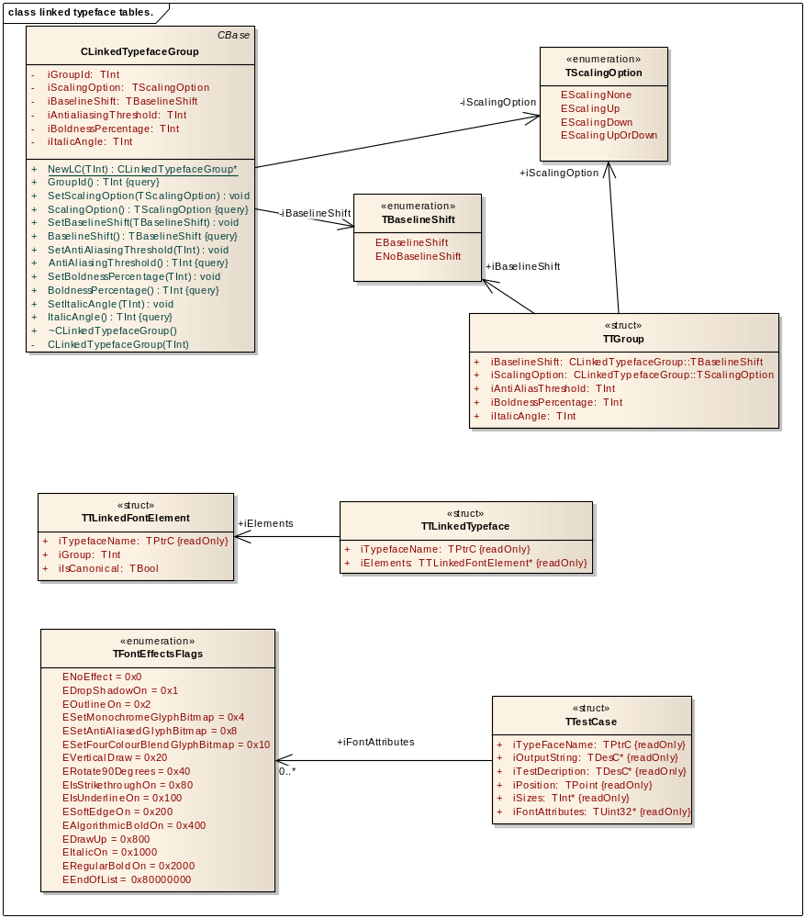
Figure 6: structures for linked typeface comparison testing

In figure 6 it can be seen that there are a number of structures. These are to:
- Define groups
- Define typefaces
- Define tests
Constant arrays are defined using the structures. See Appendix A for sample tables, or the code for the most recent version.
An item which may need further development is that all linked typefaces have all groups added, and so only twelve groups can be tested with the source in its current form. The group ID is taken from the index in the array of group definitions which was adequate for the required use cases.

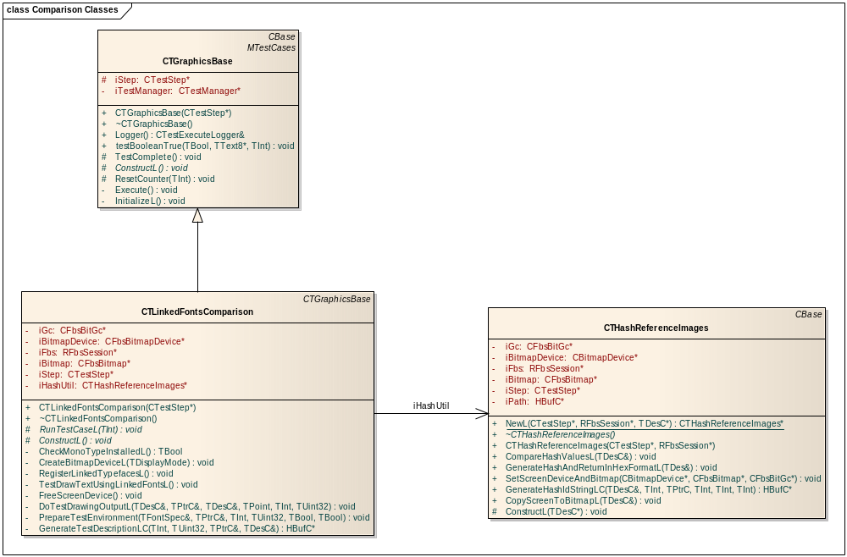
Figure 7: Class diagram for comparison test code.

Further Information
This document requires updating for the whole of font store.

References
No. | Document Reference | Version | Description
[R1] | Symbian OS Developer Library | 9.5 (published partner edition) | This is for the public API on linked fonts. Class CLinkedTypefaceSpecification and related classes.
[R2] | Graphics Font Store How-To Document | 0.1 | There is useful information on linked fonts creation
[R3] | Graphics Font and Bitmap Server Component Design Document | N/A | This document has not been written yet.
[R4] | Graphics Architectural Description | 3.7 | This document places the font store component in context in the graphics subsystem.
[R5] | Linked fonts test specification | Latest | This document is derived from in-source comments.

Open Issues

Glossary
Term | Definition

- Sample linked font testing tables.
These are a snapshot of the tables used to test many use cases. This tables does not need to be kept up-to-date.

const TTGroup KPlainGroup =
{
CLinkedTypefaceGroup::ENoBaselineShift,
CLinkedTypefaceGroup::EScalingNone,
KMinTInt, //this value means do not set
KMinTInt, //this value means do not set
KMinTInt, //this value means do not set
};

const TTGroup KGroup1 =
{
CLinkedTypefaceGroup::ENoBaselineShift,
CLinkedTypefaceGroup::EScalingNone,
10, //antialiased
KMinTInt, //this value means do not set
KMinTInt, //this value means do not set
};

const TTGroup* KGroupList[]=
{
&KPlainGroup, /* index 0 */
&KGroup1,
};

const TTLinkedFontElement KLatinFontCanonical =
{
_L("LinkedFontTestFont"),0, ETrue //name, group zero, is canonical
};

/**
*/
const TTLinkedFontElement KJapaneseNotCanonical =
{
_L("TBKomachiG-R"), 0, EFalse //name, group zero, not canonical
};

/** Japanese
*/
const TTLinkedFontElement KJapaneseNotCanonicalGroup1 =
{
_L("TBKomachiG-R"), 1, EFalse //name, group , not canonical
};
const TTLinkedFontElement KLatinFontTTNotCanonicalGroup0 =
{
_L("SwissA"), 0, EFalse
};

const TTLinkedFontElement KLatinFontTTCanonicalGroup0 =
{
_L("SwissA"), 0, ETrue
};

/** Devanagari OT Eval
*/
const TTLinkedFontElement KHindiCanonical =
{
_L("Devanagari OT Eval"), 0, ETrue
};

/** Terminator
*/
const TTLinkedFontElement KNullElement =
{
_L(""), 0, EFalse
};

/** Devanagari OT Eval
*/
const TTLinkedFontElement KHindiNotCanonical =
{
_L("Devanagari OT Eval"), 0, EFalse
};

/** linked typeface, this list is terminated by KNullElement
*/
const TTLinkedFontElement KLatinFontHindi[]=
{
KLatinFontTTNotCanonicalGroup0,
KHindiCanonical,
KNullElement,
};
/** linked typeface, this list is terminated by KNullElement
*/
const TTLinkedFontElement KLatinFontJapanese[]=
{
KLatinFontCanonical,
KJapaneseNotCanonical,
KNullElement
};

const TTLinkedFontElement KEnglishJapanseHindiFont[]=
{
KLatinFontTTCanonicalGroup0,
KJapaneseNotCanonical,
KHindiNotCanonical,
KNullElement
};

const TTLinkedTypeface KLinkedTypefaces[] =
{
//name, list of linked font elements
{_L("LatinFontHindi"), KLatinFontHindi},
{_L("LatinFontJapanese"), KLatinFontJapanese},
{_L("EnglishJapaneseHindi"), KEnglishJapanseHindiFont},
};

/** an array of sizes used during testing, terminated by zero
*/
const TInt KFontSizeNormalTesting[]=
{
10,
20,
35,
0
};

/** an array of attributes used during font testing, terminated by EEndOfList
*/
const TUint32 KFontAttributesNormalTest[] =// probably need to expand this with position
{
ENoEffect,
EIsUnderlineOn,
EIsStrikethroughOn,
ESetFourColourBlendGlyphBitmap,
EIsUnderlineOn| EIsStrikethroughOn,
EAlgorithmicBoldOn,
EVerticalDraw,
EVerticalDraw | EIsUnderlineOn,
EVerticalDraw | EIsUnderlineOn | ERotate90Degrees,
EEndOfList,
};

// here are the output strings which are used for testing
_LIT(KHindiText,"\x0915\x094D\x0937\x0924\x094D\x0930\x093F\x092F\x0020");
_LIT(KEnglishText,"The quick brown fox 123");
_LIT(KEnglishHindiText,"TEST 123 \x0915\x094D\x0937\x0924\x094D\x0930\x093F\x092F\x0020");
_LIT(KEnglishJapaneseText,"T\x308a\x3093\x3054 ESghy LINKED FONTS 123");
_LIT(KEnglishJapaneseHindiText, "T\x308a\x3093\x3054\x306e EST FOnTS LINKED \x0915\x094D\x0937\x0924\x094D\x0930\x093F\x092F\x0020 123");
_LIT(KLinkedFontTestString,"lInKED FOnTS");

// test descriptions
_LIT(KEnglishTest,"English test");
_LIT(KHindiTest,"Hindi test");
_LIT(KEnglishHindiTest,"English Hindi test");
_LIT(KEnglishJapaneseTest,"English Japanese test");
_LIT(KEnglishJapaneseHindiTest,"English Japanese Hindi test");

const TTestCase KTestCases[]=
{
{_L("LatinFontHindi"), &KHindiText,&KHindiTest, TPoint(50,50),KFontSizeNormalTesting, KFontAttributesNormalTest},
{_L("LatinFontHindi"), &KEnglishText, &KEnglishTest, TPoint(50,50),KFontSizeNormalTesting, KFontAttributesNormalTest},
{_L("LatinFontJapanese"),&KEnglishText, &KEnglishTest, TPoint(50,50),KFontSizeNormalTesting, KFontAttributesNormalTest},
{_L("LatinFontJapanese"),&KEnglishJapaneseText, &KEnglishJapaneseTest, TPoint(50,50),KFontSizeNormalTesting, KFontAttributesNormalTest},
{_L("EnglishJapaneseHindi"),&KEnglishJapaneseHindiText, &KEnglishJapaneseHindiTest, TPoint(50,50),KFontSizeNormalTesting, KFontAttributesNormalTest},
};

