Series 60 Platform 2.x
Japanese Language Utilities
Design Document

Team name | Author

Change history:

Version | Date | Status | Comments
1.0 | 14.07.2004 | Approved

Table of contents:

1. Document control 4
1.1 Documentation conventions 4
1.2 Definitions 4
2. General 5
2.1 Introduction 5
2.2 Subsystem environment 5
2.3 Services required 5
2.3.1 From the Symbian OS subsystems 5
2.3.2 From the Domestic OS subsystems 5
2.3.3 From HW 5
2.4 Services provided 5
2.4.1 UI 5
2.4.2 SW IF 5
3. Design 6
3.1 Class diagrams 6
3.1.1 Subsystem 6
3.2 Class descriptions 7
3.2.1 API definitions 7
3.2.1.1 <AknJapaneseReading.H> CaknJapaneseReading 7
3.2.1.2 <AknReadingConverter.H> CreadingConverter 7
3.3 Operations 8
3.3.1 Getting the Reading string 8
4. System resource usage 10
4.1 Files 10
4.2 Databases 10
4.3 Memory consumption 10
4.4 Task allocation 10
5. Exception handling 11
6. Usage 12
6.1 Building 12
6.2 User's guide 12

Document control

Documentation conventions
Code is shown with Courier New font.

Definitions

ATOK | A convertion engine for Japanese. Justsystem provides ATOK binaries and documents.
AtokCore | AtokCore component is the core object for ATOK, which is a Japanese Input Engine with predictive input functions. AtokCore is a Polymorphic DLL loaded from PtiEngine, and the CAtokCore class derives from the MPtiCore.
FEP | Front End Processor
Hiragana | The cursive-formed Japanese Kana syllabary. Hiragana is mostly used for grammatical particles, verb inflection, and Japanese words which are not written in Kanji, or which are too difficult for an educated person to read or write in Kanji.
Kanji | The Japanese word for a Han character used in Japanese. Kanji constitutes a part of the writing system used to represent the Japanese language in written, printed and displayed form. The term is also used for the collection of all Kanji letters.
Katakana | The square-formed Japanese Kana syllabary.  Katakana is mostly used to write foreign names, foreign words and loan words as well as to present onomatopeia, plant and animal names.
PtiEngine | Predictive text input engine. It tries to guess the words the user will input, in order to reduce the number of user key presses.
Reading | Reading is a phonetic sign using Hiragana and Katakana.  Reading is needed in order to pronounce a Kanji. Moreover, Reading is used for sorting lists (for example Phonebook list). Reading is the same as Furigana.

General

Introduction
AknJapaneseReading is a DLL derived from CCoeStatic class. AknJapaneseReading supports a function to get the Reading string from the Japanese FEP. It is possible to use this function in all applications.

Subsystem environment
AknJapaneseReading object is created by AknFEP component in Japanese environment only. In case of the other environments (for example Chinese or English), this object is not created.
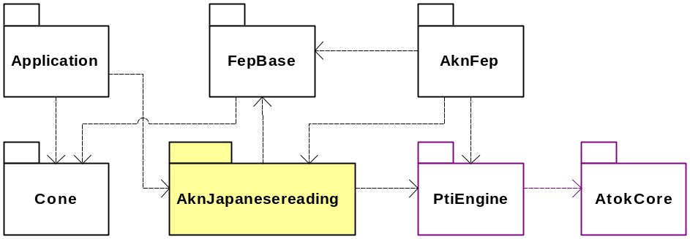
Figure 2.1 Subsystem environment

Services required

From the Symbian OS subsystems
Services of Symbian OS infrastructure (including UI Control Framework) are required.

From the Domestic OS subsystems
This component has no interfaces to the Domestic OS side subsystems.

From HW
This component has no direct HW interfaces.

Services provided

UI
This component possesses no UI.

SW IF
This component is called when getting the Reading string after committing Kanji characters.

Design

Class diagrams

Subsystem
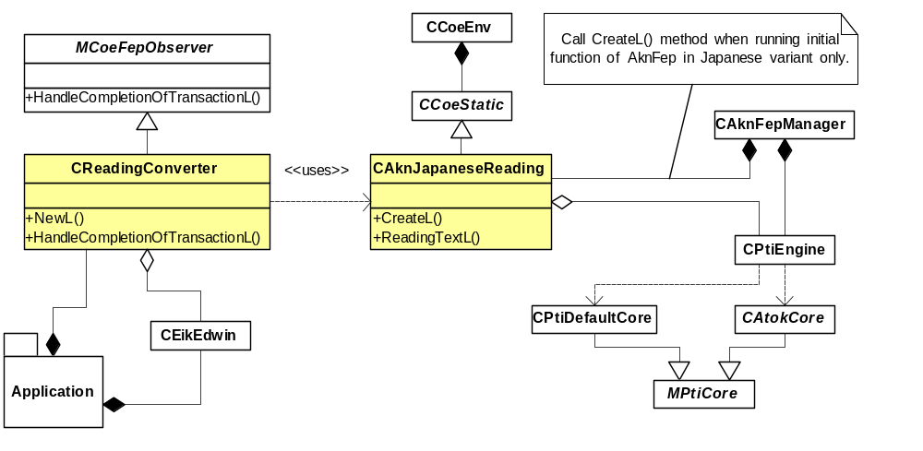
Figure 3.2 AknJapaneseReading relative classes
Figure 3.2 shows all CAknJapaneseReading relative classes. CAknJapaneseReading::CreateL() API is called when loading CAknFepManager class. If an application needs to get the Reading string, the application should call CAknJapaneseReading::ReadingTextL() API when HandleCompletionOfTransactionL() API is called in the application side after committing Kanji (including Hiragana and Katakana) characters. The application must be derived from MCoeFepObserver class in order to handle HandleCompletionOfTransactionL() API that is called by FEP framework.
In case there are two editors of Kanji input and Reading input in the application, for example, if the Name field is Kanji input editor and the Reading field is Reading input editor, it is possible to use CReadingConverter class. In this case, the application must set two editors to CReadingConvert class using SetMainEditor() API and SetReadingEditor() API. Reading characters are automatically added to Reading editor, that is set to SetReadingEditor() API after commiting Kanji characters in the Name field, that is set to SetMainEditor().

Class descriptions

Class | Description | Header file
CAknJapaneseReading | This class is simply a means to provide a consistent interface, by means of encapsulation, to the API provided by CAknJapaneseReading. All the public member functions in CAknJapaneseReading are declared as static exports. In case this class has to utilize its functionality, CAknJapaneseReading::CreateL() API must be called. | AknJapaneseReading.H
CReadingConverter | This utility class is used for updating Reading fields in the Japanese Series 60 Platform. The class binds two editors together: the user enters Kanji characters to the main editor. When a Kanji character entry is completed, this object updates the Reading editor. | AknReadingConverter.H

API definitions

<AknJapaneseReading.H> CaknJapaneseReading

Class CAknJapaneseReading
// Public API
static void CreateL(CPtiEngine* aPtiEngine); | Creates this class.
static TPtrC ReadingTextL(); | Returns the Reading string when Kanji characters are committed.
// Private API
static CAknJapaneseReading* Static(); | Gets a pointer to the CAknJapaneseReading class derived from CCoeStatic class.

<AknReadingConverter.H> CreadingConverter

Class CReadingConverter
// Public API
static CReadingConverter* NewL(CEikEdwin& aMainEditor, CEikEdwin& aReadingEditor); | Creates this class.  Both main editor and Reading editor are set as arguments.
static CReadingConverter* NewL(); | Creates this class.
virtual void HandleCompletionOfTransactionL(); | This method is the main method of this class. It is called by the FEP and it checks that main editor has focus, requests Reading text from CAknJapaneseReading class and sets the received text into Reading editor.
void SetMainEditor(CEikEdwin& aMainEditor); | Sets method for setting main editor.
IMPORT_C CEikEdwin& MainEditor() const; | Gets method for main editor.
IMPORT_C void SetReadingEditor(CEikEdwin& aReadingEditor); | Sets method for setting Reading editor.
IMPORT_C CEikEdwin& ReadingEditor() const; | Gets method for Reading editor.
// Private API
CReadingConverter(CEikEdwin* aMainEditor, CEikEdwin* aReadingEditor); | C++ default constructor.
void ConstructL(); | Symbian 2nd phase constructor.

Operations

Getting the Reading string

Operation | Getting the Reading string
Preconditions | Works in Japanese environment on emulator or proto.  CAknJapaneseReading is created.
Description | When HandleCompletionOfTransactionL API is handled in the application derived from MCoeFepObserver class, CAknJapaneseReading::ReadingTextL() is called.  After this CPtiEngine::ReadingTextL() and CAtokCore::ReadingTextL() are called. After that the Reading string from ATOK convertion engine is received, and the return value is set.
Inputs
Modifies
Outputs | A TPtrC value is returned, the Reading string is returned in Japanese environment. If it calls in another environment, the value of TPtrC(NULL, 0) is returned.
Post conditions
Related To | Classes CPtiEngine::ReadingTextL(), CAtokCore::ReadingTextL()
Related Event | MCoeFepObserver::HandleCompletionOfTransactionL()
Exceptions | Exceptions are handled by AVKON.

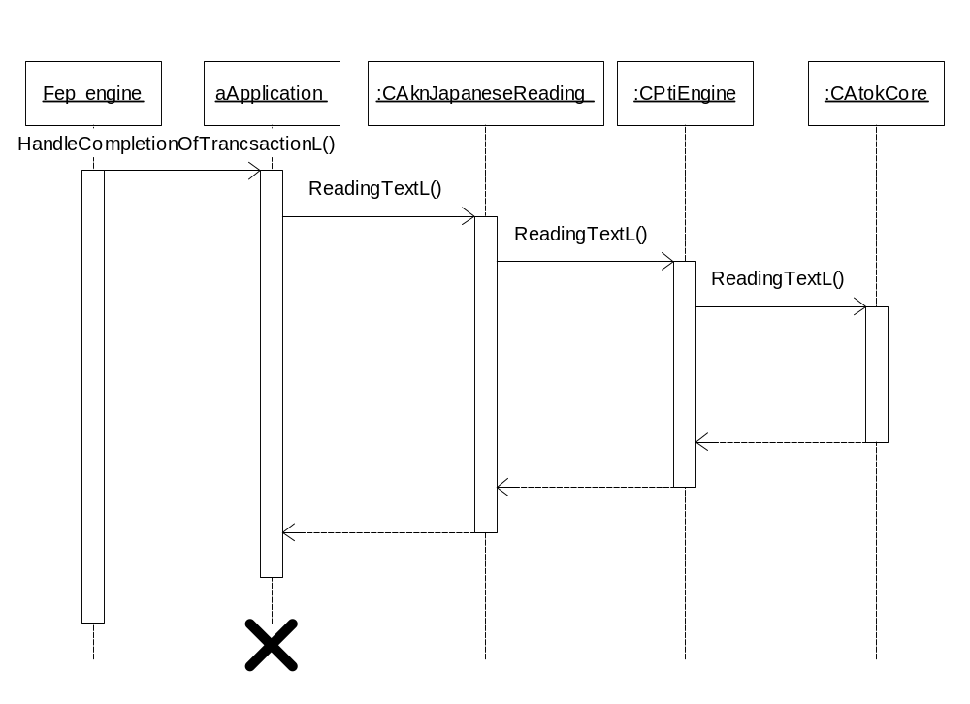
Figure 3.3 Getting Reading string

System resource usage

Files
This component does not use any files.

Databases
This component does not use any databases.

Memory consumption
Memory consumption has been taken into consideration and kept to minimum in the implementation of this component.

Task allocation
This component runs in the thread in which it is launched.

Exception handling
The leave mechanism of Symbian OS environment is used to handle memory exhaustion.

Usage

Building
The building is done by the usual Symbian OS sequence:
- Change directory \s60\AknJapaneseReading\group.
- Type bldmake bldfiles, hit Enter.
- Type abld build, hit Enter.

User's guide
The following are examples of using ReadingText() API provided by the AknJapaneseReading.
If you use Reading API, AknJapaneseReading.DLL must be linked.
When selecting a candidate or completing a string, it is possible to get Reading text using Reading API.

// Call this function from fep when selecting a candidate or completing string
void XXXXX::HandleCompletionOfTransactionL()
{
if (iName && iName->IsFocused())
{
TBuf<100> text;
iReading->GetText(text);
TPtrC ptr = CAknJapaneseReading::ReadingTextL();
if (ptr.Length() > 0)
{
text.Append(ptr);
iReading->SetTextL(&text);
iReading->DrawNow();
}
}
}

