S60
HeaderAnalyser
Design Document

Team name | Author

Table of contents:

1. Document control 4
1.1 References 4
1.2 Documentation conventions 4
1.3 Abbreviations 4
2. Introduction 5
3. System overview 6
3.1 Dependencies 6
3.2 Goals and guidelines 6
4. System architecture 7
5. Subsystem architecture 10
5.1 BBC Analysis subsystem architecture 10
6. Detailed system design 11
6.1 Analyser 11
6.2 CommandLine 12
6.3 CommandFile 12
6.4 CPPParser 12
6.5 Xerces::DOMDocument 12
6.6 ReportGenerator 12
6.7 AnalyserParams 12
6.8 MacroAnalyser 12
6.9 BBCFileUtils 12
6.10 HANodeIterator 12
6.11 NodeIndex 13
6.12 ReportIssue 13
7. Detailed subsystem design 14
7.1 Detailed BBC subsystem design 14
7.1.1 Check Macros 14
7.1.2 Pre Analysis 15
7.1.3 Node analysis 16
7.2 Compiling the Headers with Platform Data 20

Change history:

Version | Date | Status | Comments
5.0 | 12.02.2009 | Approved | The document was made release-free. Also minor editorial corrections throughout the text.
4.0 | 10.01.2008 | Approved | Added chapter 7.2.
3.0 | 29.08.2007 | Approved | Chapter 7.1.3.6: NodeTypeComparator class diagram added. Added a rule which allows changes in const qualifier of function return value, function parameter or function itself.  Version numbers of this document fixed.
2.0 | 14.06.2007 | Approved | Added more detailed node analysis specifications in chapter 7.1.3.
1.0 | 02.10.2006 | Approved

Document control

References
- S60 Compatibility Analyser User’s Guide
- GCCXML | http://www.gccxml.org/
- Xerces | http://xml.apache.org/xerces-c/
- S60 Compile-Time Dependency Scanner Design Document

Documentation conventions
Code is shown with the Courier New font.

Abbreviations
BBC | Backward Binary Compatibility
BC | Binary Compatibility
CDS | Compile-Time Dependency Scanner

Introduction
HeaderAnalyser is a command line tool that is used to analyze changes between different C++ software component versions based on their header files.
You can read more information about the tool as well as about binary compatibility in general from reference [1].

System overview
HeaderAnalyser analyses two versions of C++ header files and reports the changes between them. The reported changes in C++ components depend on the used analysis algorithms. In this document the design of binary backward compatibility (BBC) analysis for the tool is presented.
The tool takes C++ header files as input and produces XML formatted textual report from the discovered issues in BBC.
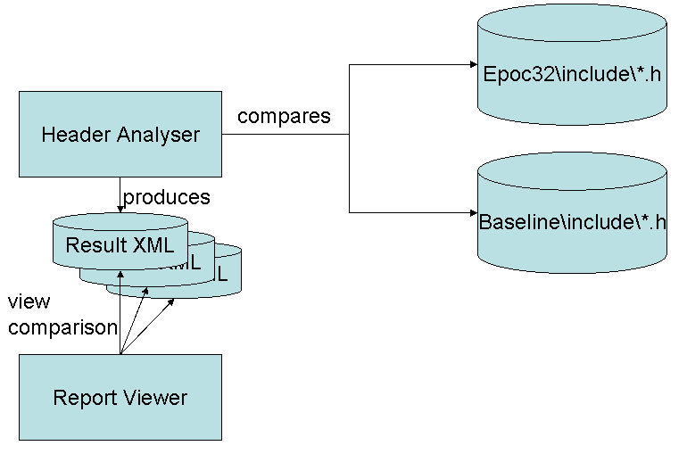
Figure 3-1 Interfaces of the HeaderAnalyser tool
In Figure 3-1 the external interfaces of the tool are presented. The design of the Report Viewer does not belong in the scope of this document, and it is represented only for a general view of the system.

Dependencies
The tool utilizes two open source components: the GCCXML program (see reference [2]) for C++ parsing, and the Xerces C++ library (see reference [3]) for XML parsing and XML document generation. The tool is available for both Microsoft Windows and Linux and the aim is to have a portable tool for easy utilization in UNIX type operating systems.
The end users of the tool include developers analyzing single header files and integrators analyzing whole releases with multiple header files.

Goals and guidelines
The tool should be optimized for speed rather than memory usage.

System architecture
The overall system architecture is composed of GCCXML C++ parser, Xerces XML parser, analyser subsystem and the result viewer subsystem.
The data flow between the components of the analyser is represented in Figure 4-2. Inputs of the analyser are the to-be-analyzed header files (Source files) and the platform headers (Platform headers) used for inclusion in analyzed source files.
The GCCXML is also used for providing a list of all defined macros (Macros.lst) which is used for detecting changes in the defined macros.
The GCCXML parses the pre-processed source to produce the XML document (XML) representing the parsing tree of the source code. This document is loaded by the XML Parser in memory and the Analyser uses this data to analyze BBC breaks.
The Analyser produces the result.xml that includes all the issues detected in analysis and also the BBCResults.xsl which is a style sheet for the result.xml. This style sheet is used to represent the results in a web browser.
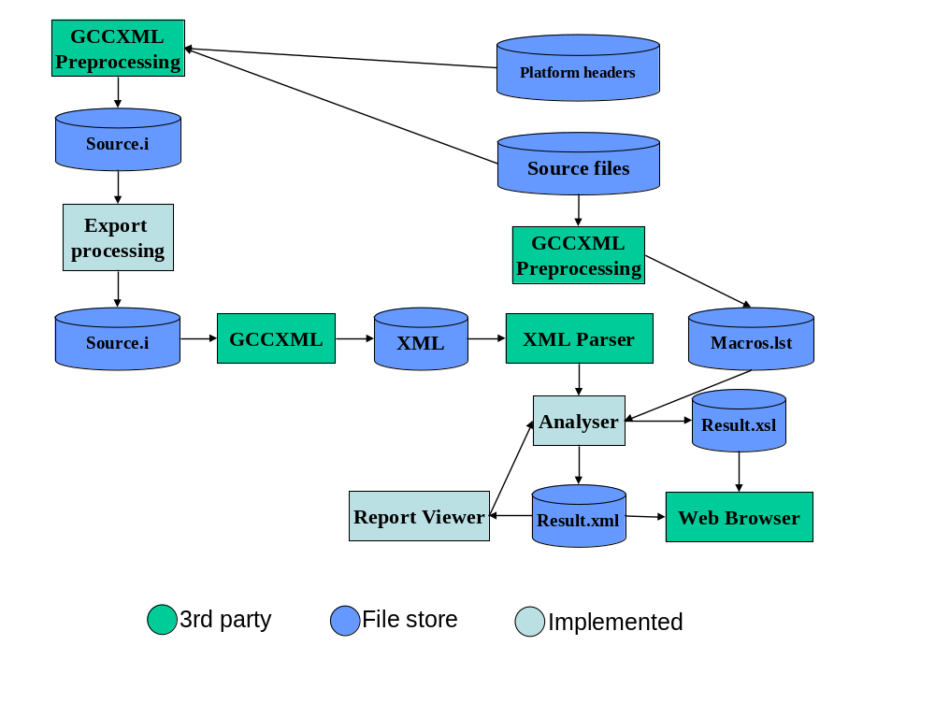
Figure 4-2 Overview of the software components and the information flow between them
The HeaderAnalyser command line utility architecture is represented in Figure 4-3.
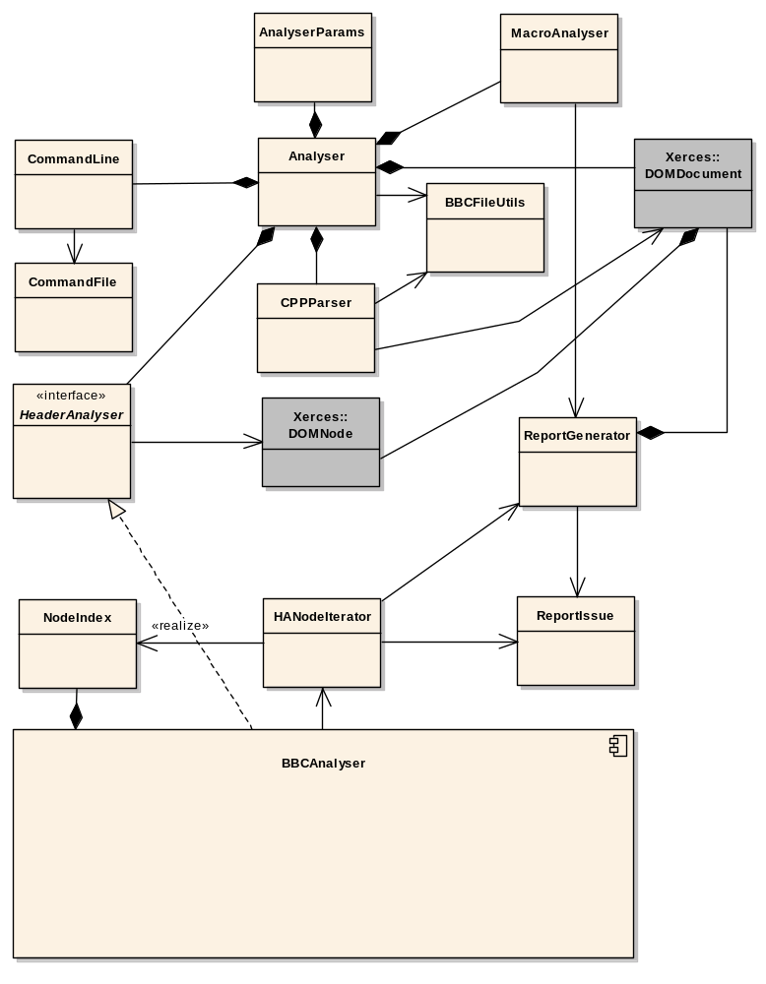
Figure 4-3 The architecture of the analyser framework
The Analyser class is the main class of the application and coordinates the functioning of the other classes.
The class CommandLine handles the command line parsing and represents the options for the program in an easy way. The CommandFile class is a utility class for the CommandLine class, so that the CommandLine class can represent the given parameters in a unified way given in a command line or a command file. The parameters are stored in the AnalyserParams class.
The CPPParser provides interface for the GCCXML program for C++ parsing functionality. It produces a XML document that the HeaderAnalyser interface receives as a input for BBC analysis. The result of the analysis from the HeaderAnalysis is also a XML document.
The BBCAnalyser implements the HeaderAnalyser interface and includes the analysis functionality.
The MacroAnalysis class analyses differences between the baseline and the current version and adds issues to the ReportGenerator.
The BBCAnalyser utilizes the HANodeIterator for easy access to a GCCXML generated XML document. The HANodeIterator provides methods for an indexed access to the XML nodes with a node ID and a fully qualified name. The issues are also reported through the HANodeIterator.

Subsystem architecture

BBC Analysis subsystem architecture
The BBCAnalyser includes two kinds of analysis. Firstly, some frequently used properties of declarations are calculated and saved in XML document for usage in further analysis. These are implemented in classes implementing the PreAnalysis interface.
Secondly, the declarations are analyzed by classes that implement the NodeAnalysis interface. The idea is to have the top level NodeAnalysis to analyze all global declarations and delegate the complex declarations to other NodeAnalysis classes for further analysis. This enables the problem partitioning in solvable units and keeps the analysis algorithms maintainable.
Figure 5-4 presents the class hierarchy for the BBC analysis subsystem.
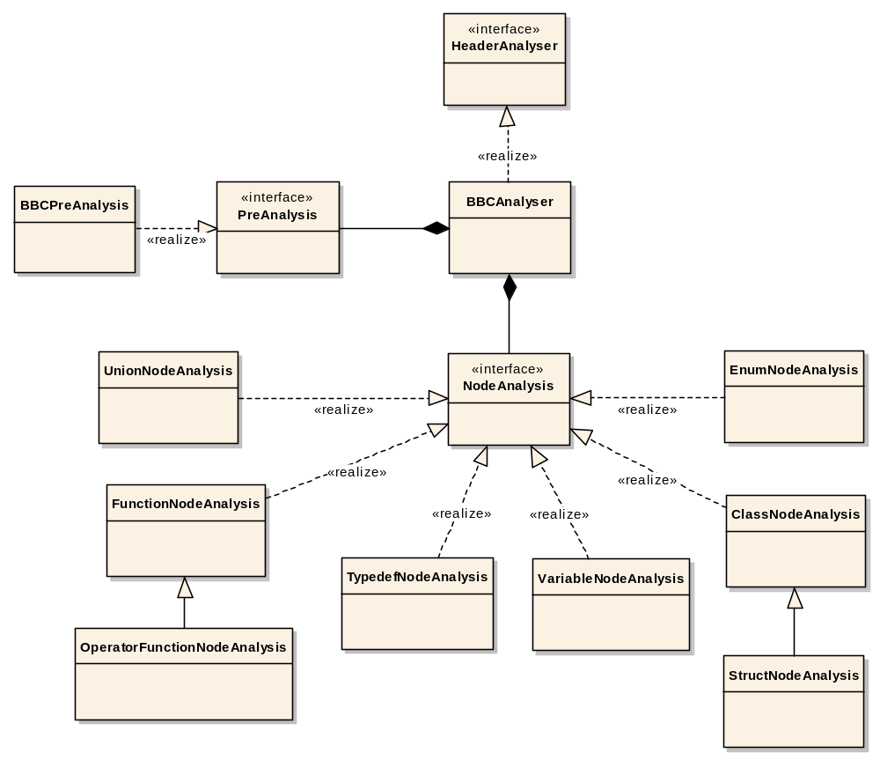
Figure 5-4 The class hierarchy of the BBC analysis subsystem

Detailed system design
Figure 6-5 presents the normal sequence of operations in the analysis tool. The Analyser coordinates the operation of other components and utilizes the CPPParser and HeaderAnalyser for each of the header file pair to accumulate the issues found in the Result.xml document.
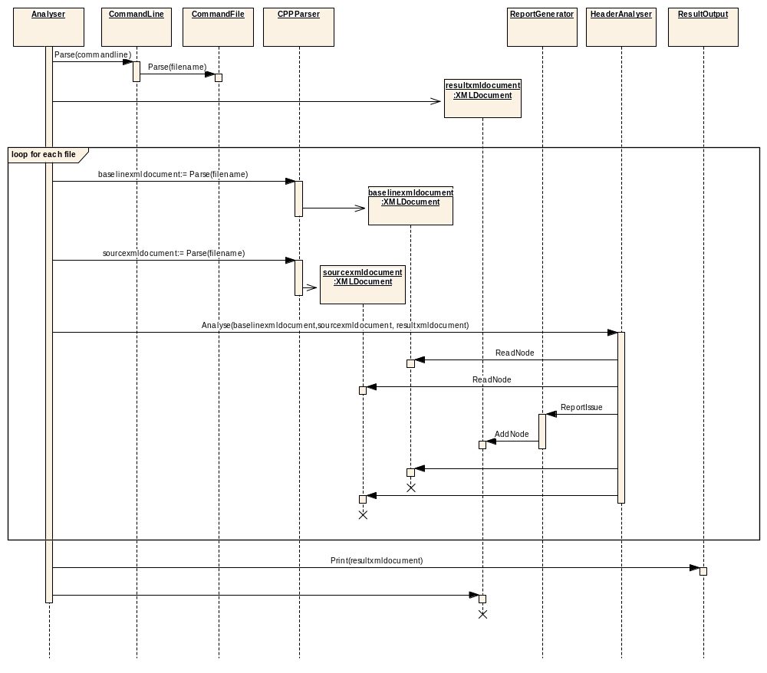
Figure 6-5 The sequence diagram of the running of the analysis tool

Analyser
The analysis tool can be used to compare two different versions of a single C++ header file, or multiple header files in different directories, for issues affecting the BBC.
The class Analyser coordinates the operation of other components and handles the environment variables handling. The analysis tool is a command line tool and the options given in a command line overwrite the options given through the environment variables.

CommandLine
The class CommandLine handles the command line parsing and utilizes the command file parsing if needed. The options given in a command line overwrite the options given in a command file.
The location of the analyzed header files and directories, the location of the temporary files, and their port output file and version information (for both the baseline and the compared headers) can be given in a command line.
The paths given can be either relative or absolute and wildcards can be used in directory analysis to limit the analysis only to matching files.

CommandFile
The CommandFile class parses the command file given in command line.
Command file can be used to list multiple distinct header files to be analyzed. All the options that can be given in command line can also be given in the command file.

CPPParser
The CPPParser is an interface to the GCCXML and export preprocessing. The CPPParser utilizes the third party C++ parsing program GCCXML (see reference [2]).

Xerces::DOMDocument
The Xerces::DOMDocument is a class from a third party XML parser library and includes the XML parsing functionality.

ReportGenerator
The ReportGenerator defines an issue reporting interface for the analysis to use. It defines issue type IDs and issue severities and constructs the XML document based on the reported issues. The ReportGenerator also implements the saving of the resulting XML document to the file system.

AnalyserParams
The AnalyserParams class stores the command line parameters.

MacroAnalyser
The MacroAnalyser class detects changes in macro definitions and adds them to the report.

BBCFileUtils
The BBCFileUtils class gathers file system utilities.

HANodeIterator
The HANodeIterator class encapsulates the Xerces::DOMNode tree and, together with NodeIndex, provides helper functions for the fast retrieving of the node by ID from the XML node tree and attribute retrieval.

NodeIndex
The NodeIndex class indexes the nodes of the XML node tree by the fully qualified name and node ID.

ReportIssue
The ReportIssues class is a data class that encapsulates the data for an issue.

Detailed subsystem design

Detailed BBC subsystem design
The analysis for the BBC (see Figure 7-6) includes macro analysis, pre analysis and node analysis. The macro analysis treats any change in macro definitions as a possible binary break.
The pre analysis calculates some frequently used properties of the classes beforehand.
The node analysis travels the parse tree and compares the two versions of the analyzed header and analyses if the changes are safe or not.
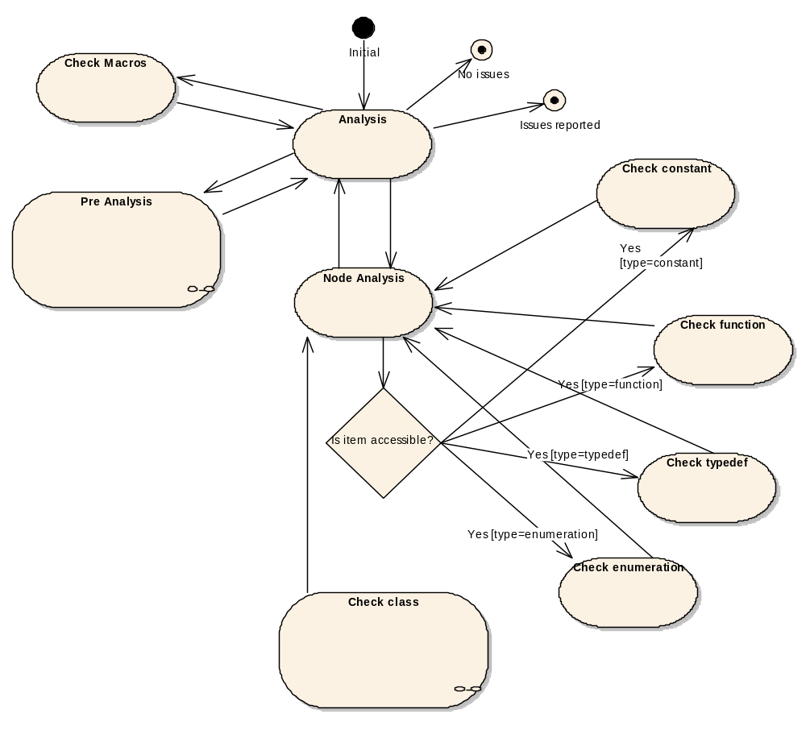
Figure 7-6 The BBC analysis state diagram

Check Macros
The macros are analyzed for any changes and the changes are reported. The component utilizes GCCXML for dumping the macro definitions and then compares the macro definitions of the two versions of the header files.

Pre Analysis
Pre analysis is used for checking some frequently used properties of the classes to be used in node analysis (Figure 7-7).
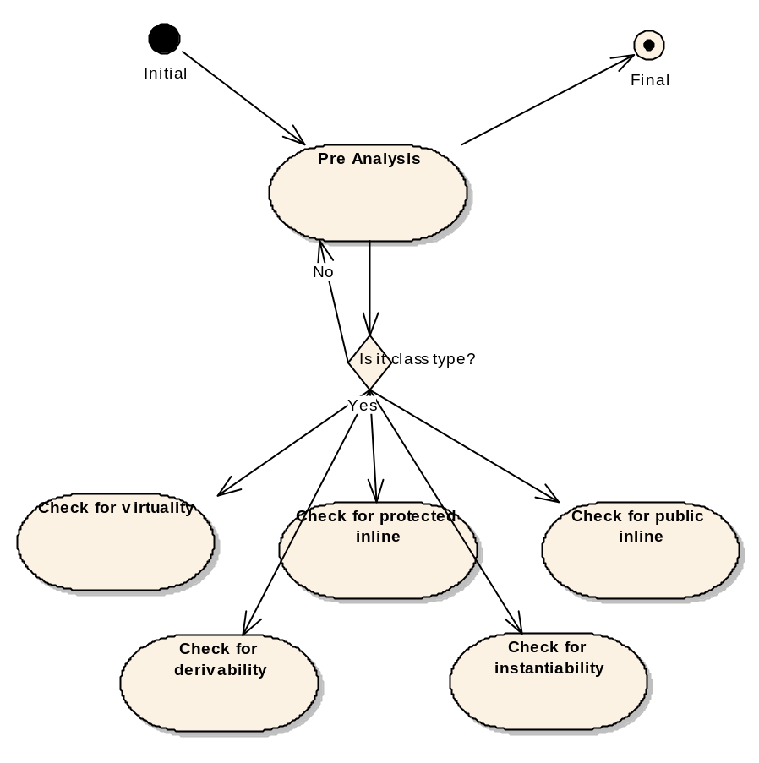
Figure 7-7 The Pre Analysis state diagram

Detection of instantiable classes
The class is marked instantiable if it has any of the following properties:
- Public exported constructor and destructor.
- Public inline constructor and destructor.
- Implicit constructor and destructor.

Detection of derivable classes
The class is marked as derivable if it has any of the following properties:
- Public or protected inline constructor and destructor.
- Public or protected exported constructor and destructor.
- Implicit constructor and destructor.

Detection of virtual classes
The class is marked as virtual if it has any virtual functions or it derives from a class that has virtual functions.

Detection of classes with public and/or protected inline functions
The methods of the class are scanned and the class is marked to have public and/or protected inline functions if found. If a class has public inline functions or it has protected inline functions and is derivable, the class is considered to be exposing its private and protected members. Changes in those exposed members are also reported.

Node analysis
Node analysis travels the parse tree and analyses the nodes of the parse tree for changes. The analysis algorithm is determined by the node type (see Figure 7-8).
Check enumeration
Check function
Check constant
Check typedef
Is item accessible?
Check class initial
No issues
Issues found
Check base classes
Check virtual
functions
Check size and
alignment
Check class
Check member
variables
Yes [type=typedef]
Yes
[type=class]
Yes [type=function]
Yes
[type=constant]
No
Yes [type=enumeration]
Figure 7-8 The class analysis state diagram

Check class
The analysis of the class to more specialized algorithms is delegated. The base classes of a class and accessible classes declared inside a class are analyzed, and any significant change in them is reported. Any removed accessible classes are also reported.
The following changes related to a class are reported:
- Removal of the class. Severity: BBC Break. If the class declaration is moved to another header and this header is included in the analyzed one, HeaderAnalyser should be able to find the moved class and compare them. However, there may be cases when GCCXML does not parse the class in enough detail for the comparison, and the type might be left as “incomplete”. See the next bullet.
- If the current platform’s class is of incomplete type, HeaderAnalyser should report that the class could not be analyzed. Severity: Informative. This kind of issue may result, for example, if the class declaration is changed to a forward declaration in an analyzed header file. GCCXML marks incomplete types with the ‘incomplete=”1” attribute.
- Access modifier of a class is changed to more restrictive. Severity: Informative. Access modifier is marked with the ‘access’ attribute.
- Furthermore, if either one or both of the compared classes are using virtual inheritance, it is reported as an Informative issue. In case of virtual inheritance, the Base sub-object of the analyzed class is marked with the ‘virtual=”1”’ attribute.
Implemented in ClassNodeAnalysis.

Check size and alignment
The size and alignment of the classes is compared, and a change in the size or alignment of an instantiable or derivable class is reported with severity BBC Break. This requirement also includes the changes in the base class(es) that have an effect on the size or alignment of the class.
The following changes related to the size and alignment of an instantiable and/or derivable class are reported:
- Size is changed. Severity: BBC Break. Size is marked with the ‘size’ attribute.
- Size of the base class is changed. Severity: BBC Break.
- Alignment of the class is changed. Severity: BBC Break. GCCXML reports the alignment with ‘align’ attribute. Alignment is calculated by the compiler, which means that the data structure is padded with unnamed data to ensure proper alignment of the data structure in the computer memory. The class is padded with additional data so that after the compilation its size will be a multiple of the value of an align attribute.
Implemented in ClassNodeAnalysis.

Check base classes
Any changes in the inheritance (the order of classes, the adding and removal of classes) that can affect the BBC are analyzed and reported. The following changes related to inheritance and base classes are reported:
- Change in the virtuality of the inheritance. If the base class is derived virtually, GCCXML marks it with the ‘virtual=”1”’ attribute. Severity: Possible BBC Break.
- Base class is removed. Severity: Possible BBC Break.
- Base class is added. Severity: Possible BBC Break.
- The order of the base classes is changed. Severity: Possible BBC Break.
- The virtual table of the base class is changed. Severity: BBC Break.
Implemented in ClassNodeAnalysis.

Check virtual functions
Requirement: HABC004
Changes in the virtual functions of the class are analyzed. Any change in the virtual function signature, the order of the virtual functions, an addition or a removal of a virtual function is considered to be a binary break and is reported.
The virtual table of the class is built before analyzing it. The virtual table is constructed by adding first all the virtual functions of the primary base class, if one exists. Primary base class has an ‘offset’ attribute with value zero. After recursively adding the primary base’s virtual functions, the virtual functions implemented in the analyzed class, but not in the primary base class, are added. In case of a multiple inheritance, the virtual tables of other base classes are checked in the base class checking phase (see 7.1.3.3).
As a summary, the following changes in the analyzed class or in any of its base classes should be reported:
- Add a virtual function to an accessible class, severity BBC Break.
- Remove a virtual function from an accessible class, severity BBC Break.
- Change the order of virtual functions in an accessible class, severity BBC Break.
Implemented in ClassNodeAnalysis.

Check constants
The constants are analyzed for changes in initialization values. Any change in an initialization value is considered a binary break, and removed or changed constants are reported.
The following changes in analyzed constants are reported:
- The type of an accessible constant is changed, severity Possible BBC Break.
- The initial value of an accessible constant is changed, severity Possible BBC Break.
- Access is changed to more restrictive, severity Informative.
Implemented in VariableNodeAnalysis.

Check function
Changes in function signatures are analyzed. Any change in the signature of an accessible function is considered to be a binary break. Removed or changed exported functions, accessible exported method of a class or inline functions of a class are reported.
The following table specifies the rules for exported and inline non-virtual functions:
Change | Type | Access | Severity
Remove a function or change its signature | Exported | Public | BBC Break
Remove a function or change its signature | Exported | Protected | If the class is derivable, this is reported as BBC Break.  If the class is not derivable, but has public inline functions, this is reported as Possible BBC Break.  Otherwise not reported.
Remove a function or change its signature | Exported | Private | If the class contains any public inline functions, or it contains protected inline functions and is derivable, this is reported as Possible BBC Break, otherwise not reported.
Remove a function or change its signature | Inline | Public | Informative
Remove a function or change its signature | Inline | Protected | Informative
Remove a function or change its signature | Inline | Private | If the class contains any public inline functions, or it contains protected inline functions and is derivable, this is reported as Informative, otherwise not reported.
Add function | Exported | Any | Not reported
Add function | Inline | Any | Not reported
Change the order | Exported | Any | Not reported (can be checked with Ordinal Checker)
Change the order | Inline | Any | Not reported

Function attributes, arguments and the return type are compared using comparator objects. In addition to the default comparator, which requires an exact match, there can be comparators whose rules are less strict in validating the types. Comparator classes implement the NodeTypeComparator interface and are instantiated and stored by ComparatorFactory class, which is a singleton class. A class diagram of the comparator and the factory is represented in Figure 7-9.
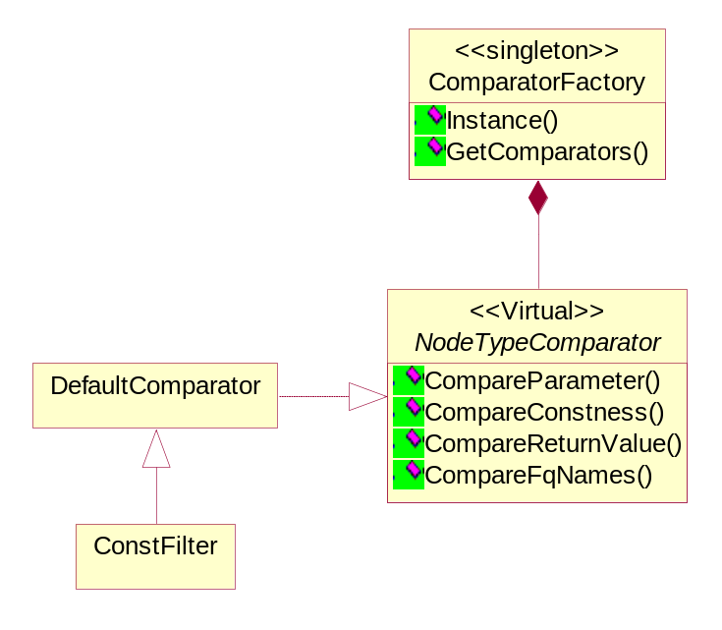
Figure 7-9 NodeTypeComparator class diagram.

The ConstFilter object shown in Figure 7-9 above allows the following changes in signatures of non-virtual functions:
- Change function return value from const to non-const.
- Change function parameter from non-const to const.
- Change function from non-const to const.
Implemented in FunctionNodeAnalysis.

Check typedef
The changes in typedefs are analyzed. Any change in an accessible typedef is considered to be a binary break. Removed or changed typedefs, and a removal or a change in an accessible typedef inside a class is reported. Changes in accessible typedefs are reported as follows:
- Remove an accessible typedef, severity Possible BBC Break.
- Change the type of the accessible typedef, severity Possible BBC Break.
- If the type of the accessible typedef is a function pointer, the changed return type of that function is reported with severity Possible BBC Break.
- Changing the access of the typedef to more restrictive is reported with severity Informative.
Implemented in TypedefNodeAnalysis.

Check enumeration
The enumerations for changes in initialization values and order are analyzed. Any change in the accessible enumerations is considered to be a binary break.
Removed or changed enumerations, and a removal or a change in accessible enumerations inside a class are reported as follows:
- Remove an accessible enumeration, severity Possible BBC Break.
- Remove a value of an accessible enumeration, severity Possible BBC Break.
- Add a value to the middle of an accessible enumeration, severity Possible BBC Break.
- Alignment of an enumeration is changed. If the enumeration is accessible publicly or via derivation, the change is reported with severity BBC Break. If the enumeration is accessible via a public or protected inline function, it is reported with severity Possible BBC Break.
- The size of an enumeration is changed. If the enumeration is accessible publicly or via derivation, the change is reported with severity BBC Break. If the enumeration is accessible via a public or protected inline function, it is reported with severity Possible BBC Break.
- Change the access of the enumeration to more restrictive, severity Informative.
- Changes in the order or in the initial values of accessible enumeration values are reported with severity Possible BBC Break.
Implemented in EnumNodeAnalysis.

Check member variables
The member variables are analyzed for changes in order, type, removal, addition and visibility. Any change, including removal and addition, of the accessible data members of a class is reported using the following rules. If a member variable is publicly available, it means here that it is either declared as public, or it is declared as protected and the class is derivable.
- The access of the member variable is changed to more restrictive, severity Informative.
- Removing a publicly available member variable is reported with severity BBC Break. Removing the private or protected member variable exposed by public or protected inline function is reported with severity Possible BBC Break. Removing a private variable from a class not containing public or protected inline functions is reported as informative. Note: Removing a member variable changes the size of the class, which is reported also (see 7.1.3.2).
- Adding a member variable to a class is reported with severity Informative.
- Changing the offset of the member variable. If publicly available, severity BBC Break, or if exposed by public or protected inline function, severity Possible BBC Break.
- Changing the type of the member variable. If publicly available, severity BBC Break, or if exposed by public or protected inline function, severity Possible BBC Break.
- Changing the size of the member variable. If publicly available, severity BBC Break, or if exposed by public or protected inline function, severity Possible BBC Break.
Implemented in ClassNodeAnalysis.

Compiling the Headers with Platform Data
In some cases, HeaderAnalyser has problems to compile analyzed headers successfully. Couple of common reasons, among others, are missing include directives in the header and/or missing include path given to the compiler. In order to handle these problems better, HeaderAnalyser tool contains functionality, which allows user to give additional information about compile-time dependencies of the analyzed headers. The platform data, containing the compile time dependencies of the analyzed platform can be given with command-line parameters:
- BASELINEPLATFORMDATA [file]
- CURRENTPLATFORMDATA [file]
Data in file must be in XML-format, defined in [3]. HeaderAnalyser parses the data with Xerces parser [2] to DOM-objects and builds its own containers for the data. The class diagram of the containers is shown in Figure 7-10.

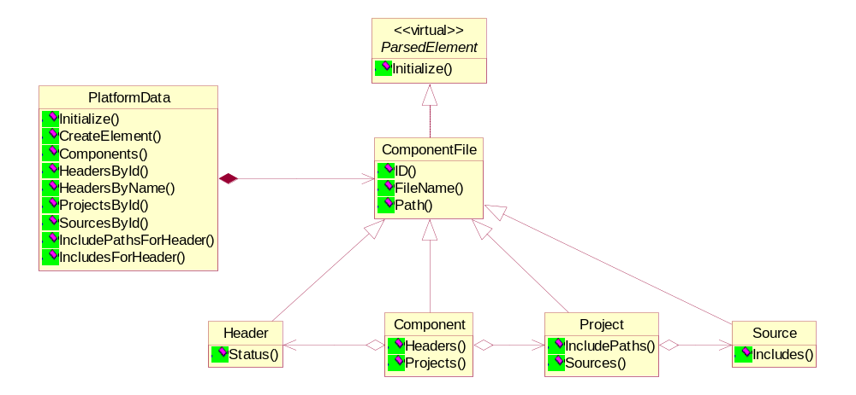
Figure 7-10 PlatformData class diagram

The analyzer contains two pointers to PlatformData objects; one for the baseline platform and one for the product platform. When the platform data should be used (indicated using both of the command line parameters), HeaderAnalyzer uses the PlatformData -objects when compiling the headers. If there are still compilation errors, HeaderAnalyzer tries to compile them also without the platform data, using the default include paths defined in command line parameters.

