S60
Compatibility Analyser
User’s Guide

Team name | Author
D RD SD SSS DTD Static Analysis Tools | Nokia Corporation

Change history:

Version | Date | Status | Comments
10.0 | 16.02.2010 | Updated | Section 4.5 added for Qt header and library analysis.
9.0 | 01.12.2009 | Updated | Appendix B is updated with new HA param details.
8.0 | 06.10.2009 | Approved | Updated sections 5.2.1 and 5.2.2.
7.0 | 18.08.2009 | Approved | Added Header issue and Library issue information in section 5.2.1 and 5.2.2.
6.0 | 18.06.2009 | Approved | New supported file type .rh added to Sections 1.3 and 2.3.
5.0 | 01.06.2009 | Approved | Source Compatibility (SC) is also supported. This was added to Definitions, as well as to Section 5.2.
4.0 | 09.04.2009 | Approved | New:  - Header analysis also supports HPP and PAN file types, library analysis also supports DLL files.  - Appendix C: New command line parameters: -baselinedlldir and -currentdlldir.  Updated:  - OrdinalChecker tool name changed to LibraryAnalyser throughout the document.  - New location of the BCTools directory updated throughout the document.  - Section 3.1: The tips section updated due to new configurable parameters for library analysis.  - Section 5.2: Report sample graphic updated.  - Table 5.3: Table updated with new issues.  - Appendix C: oc.exe is now la.exe, parameters -baselinedir and -currentdir changed to -baselinelibdir and -currentlibdir.  Removed:  - Table 3.1: listing Compatibility Analyser directories.
3.0 | 16.12.2008 | Approved | Editorial correction to a graphic in Chapter 5.
2.0 | 16.10.2008 | Approved | Updated Appendix C: OrdinalChecker (oc.exe) now supports multiple directories. Also minor modifications to the command line help.
1.0 | 22.08.2008 | Approved

Table of contents:

1. Document control 4
1.1 References 4
1.2 Documentation conventions 4
1.3 Abbreviations 4
1.4 Definitions 4
2. Introduction 6
2.1 Overview to compatibility tools 7
2.2 Why to analyse header and library files 7
2.3 Main features and supported file types 8
2.4 Preconditions for use 9
2.5 Order of tasks in using Compatibility Analyser 10
3. Installation and configuration 11
3.1 Modifying the configuration file 11
3.2 Configuration tips 12
4. Using the Compatibility Analyser tool 13
4.1 Basic walk-through 13
4.2 Analysing all headers 13
4.3 Analysing a single file 13
4.4 Analysing multiple files 14
4.5 Analysing Qt header and library files 14
4.6 Generating a filtered report 15
4.7 Filtering existing reports 15
5. Analysing the compatibility reports 17
5.1 Report format 17
5.2 Reported binary compatibility issues 17
5.2.1 Header issues 18
5.2.2 Library issues 21
Appendix A: CheckBC command line parameters 24
Appendix B: HeaderAnalyser stand-alone usage 25
Appendix C: LibraryAnalyser stand-alone usage 28
Appendix D: BCFilter stand-alone usage 30
Appendix E: Compile-Time Dependency Scanner stand-alone usage 31
Appendix F: Legal notices 32

Document control

References
- S60 Binary Compatibility Verification Document
- S60 Launcher User’s Guide
- The GNU project | http://www.gnu.org

Documentation conventions
Argument choices are shown in < > brackets, e.g., <choice>. User input is shown in italics.

Abbreviations
BBC | Backward Binary Compatibility
BC | Binary Compatibility
CDS | Compile-Time Dependency Scanner
DLL | Dynamic Link Library
DSO | Dynamic Shared Object
GCCE | GNU Compiler Collection
H, HPP | C++ header file
HRH | Common header file for resources and C++ programs
LIB | Import Library
MBG | Generated bitmap header file
PAN | User-defined panic code file
RH | Resource header file
RSG | Generated resource header file
RVCT | RealView Compilation Tools
SC | Source Compatibility
SDK | Software Development Kit
XML | eXtensible Markup Language
XSL | eXtensible Stylesheet Language

Definitions
Baseline SDK | A recorded, identified, and frozen configuration of approved configuration items. A baseline should represent a consistent situation that can be considered a safe reference point for subsequent activities.
Binary Compatibility | Compatibility which enables the same binary file, or executable, to run on multiple platforms without source code changes or recompilation.
Current SDK | The SDK that is used to compile the given current header and library files. The version number of this SDK must be greater than in the baseline SDK.
GCCE toolchain | Required mainly in the creation of DSO files. Also required for analysing libraries (LIB), which are built using these toolchains.
Knownissues file | The knownissues.xml file is used for filtering the results of compatibility analysis, to get an updated view of existing problems. The file indicates if certain Binary Compatibility problems are already known in the S60, or if they are new problems introduced by the product being developed.
RVCT toolchain | Required mainly in the creation of the LIB file. Required also for analysing libraries (DSO), which are built using these toolchains.
Software Development Kit (SDK) | A set of programming tools for creating applications and enhancing the use of certain software.
Source Compatibility | Source Compatibility (SC) means you can rebuild without making changes to the code. SC is broken when, for example, renaming a function.
Static analysis | Static analysis means testing the code during development to, for example, find changes that possibly break Binary Compatibility. Static analysis tools analyze changes in the source code between the current version and the baseline version of the code.

Introduction
Compatibility Analyser compares a set of files in two different versions of S60 releases against predefined Binary Compatibility (BC) criteria, and reports any changes that affect BC.
The analysis is done on header files or import libraries of the platform source code. Preserving BC is central in S60 development to ensure that any executable that was built against an older version (for example, S60 3.0) can be run without changes on a newer version of the platform (for example, S60 3.1 onwards). This document is release-free.
The comparison is made between a baseline version of an S60 release (for example, a Public SDK from Forum Nokia) and a newer, current SDK version that needs to be verified. BC can be broken if there is a mismatch between the part of the interface that the executable was built against and the part of the interface the executable is running against. BC can also be broken if the format of data files has changed. Changes such as adding new code or modifying or deleting existing code can break the compatibility.
Compatibility reports can be filtered so that they compare the found issues against a known issues file. This file (knownissues.xml) contains information on whether or not the same BC problems have occurred before in the S60 Platform and what should be done about them. If the knownissues.xml file does not return any information, the BC issue is new and introduced by the product.
See the following figure for a simplified overview of the process, including the use of the known issues file.
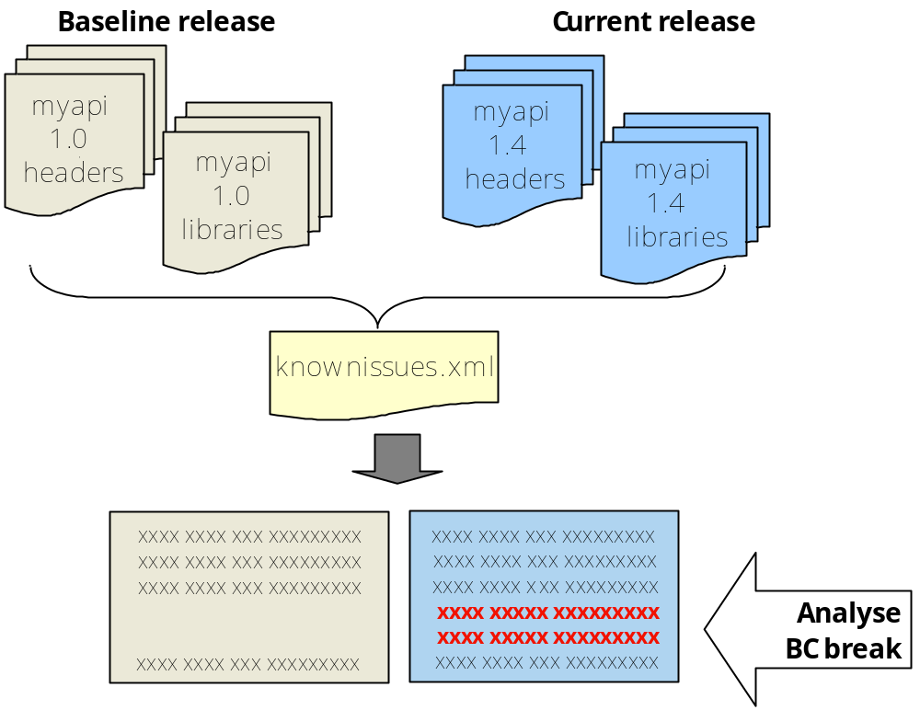
Figure 2-1 Overview of compatibility analysis
For more information on Binary Compatibility and S60 coding practices for maintaining BC, see reference [1].

Overview to compatibility tools
Compatibility Analyser consists of the following script tools, as illustrated in Figure 2-2.
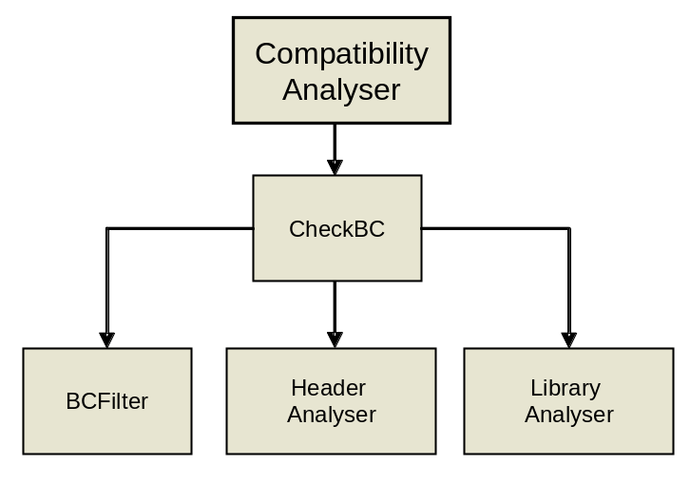
Figure 2-2 Compatibility tools
- CheckBC: The main interface and the recommended way to run compatibility analysis. It calls the other script tools with a set of parameters, and makes the analysis more straightforward and less prone to errors.
- HeaderAnalyser: HeaderAnalyser is used to compare a set of modified header files to those in a baseline and report any changes that may affect binary compatibility. HeaderAnalyser has a command line interface and can read its parameters from a configuration file. The tool produces an XML file which lists all such changes. Usually the baseline is an SDK and the modified header files are the header files found in the product's epoc32\include directory and its subdirectories.
- LibraryAnalyser: LibraryAnalyser is used to compare modified DSO, LIB and DLL files to those in the baseline and to report any changes that can affect binary compatibility. It reads the symbol tables from import libraries and compares symbol tables of two versions of the same file.
- BCFilter: BCFilter is used to check the header and library report files against a list of known issues in the S60 Platform.

Note: Using the CheckBC script is the recommended way to run static analysis. However, you can run the scripts separately from the command line, using their own parameters and options. For more information, see Appendix B (HeaderAnalyser), Appendix C (LibraryAnalyser), and Appendix D (BCFilter).

Why to analyse header and library files
Headers and libraries are the static interfaces of a published API. They define the layout of data structures and functions, but not the functionality of the API. These components can be tested for compatibility using the static analysis tools.

- How do changes in headers affect compatibility?
Analysing headers helps to easily find areas in which the programming interface promise has been broken. One example of in which analysis can help detect compatibility issues is adding more data members to a class definition. For example, if the modifications to class data members violate the BC rules, data may become corrupted. This may be hard to detect but can result as unwanted side effects.
In addition, modifications to the virtual table or virtuality of functions can typically result in incompatible functionality to be called at application runtime. Usually, all changes reported after header analysis must be manually verified for a confirmation of a break.
- How do changes in libraries affect compatibility?
A removed library means that dependent components can no longer be compiled. If an application has a static dependency to a DLL and the DLL is no longer available in the device, the application in question will not launch at all. The Launcher tool (see reference [2]) can be used to verify that all DLLs and resource files are available on the device.
If the function ordinals in the library have moved or have been removed, the components built using this library will exhibit changes in behaviour and will most possibly crash during execution. This can also lead to incorrect functionality of the application since it is calling the wrong function. Modification of function signatures can also be detected in library analysis. Such modifications may mean that originally intended behaviour is no longer preserved.
- Are all findings harmful?
Changes in headers and libraries fall under three categories: BBC Break, Possible BBC Break or Informative. Informative items are reported to help the analyst and do not as such constitute a BC break. However, items marked with one of the other two levels of severity need to be analysed to determine whether they are BC breaks or not.
All of the above issues are compatibility issues, that is, issues that prevent older binaries to work as expected along with newly updated dependent components without modification.
- What causes Binary Compatibility (BC) versus Source Compatibility (SC) problems?
Here are some examples:
- Changing the name of a data item generally breaks Source Compatibility.
- Changing the type of a data item generally breaks Binary Compatibility.
- Changing the name of a virtual member function breaks Source Compatibility.
- Changing the order of virtual member functions breaks Binary Compatibility.
Source Compatibility is relative to the code being compiled. No matter how small an API change is, some program will always be affected.

Information on how to preserve BC in APIs can be found in [1]. For more information on how to interpret the results of the analysis, see Chapter 5 in this document.

Main features and supported file types
Main features of the Compatibility Analyser tool include:
- Compatibility analysis for header files (by default, *.h, *.hpp, *.hrh, *.pan, *.rh, *.rsg;*.mbg).
- Compatibility analysis for library files (*dll, *.lib, *.dso).
- With header files, the baseline is an SDK and the modified header files are the header files found in the product’s epoc32\include directory and its subdirectories.
- With library files, the tool uses primarily DSO files to read the symbol table but supports LIB files too.

Table 2-1 Supported file types
Extension | Description
.h  .hpp | A C++ header file.  A header (or include) file is automatically included in another source file by the compiler. Typically, header files are included via compiler directives at the beginning (or head) of the other source file.
.hrh | A common header file for resources and C++ programs.  Contains enumerations that are used in .rss, .h and .cpp files. The typical content of such a file is the list of commands that are defined in the application menus, toolbars, etc.
.mbg | A generated bitmap header file.  Generated by the toolchain when creating the Symbian OS multi bitmap file (MBM) file.
.pan | A user-defined panic code file.  In .pan files, you can define your own panic codes. The use of custom panics makes it easier to find bugs in your application.
.rh | Resource header file  Resource structure definitions must be defined in the .rh file.
.rsg | A generated resource header file.  Created at compile time by the resource compiler. These files should be included by .cpp files to handle resources.
.lib | An import library file.  An archive file created from stubs generated for each of the exported symbols. A library file represents the exported interface of the .dll file. This allows other programs to use the .dll, by linking against the import library at build time.
.dll | A dynamic link library file.  A function library that can be loaded into memory once and called by one or more applications so that the operating system dynamically resolves the entry points, or the addresses of the called routines, at run time.
.dso | A dynamic shared object file.  The .dso file has all the associated sections required for an Executable and Linking Format (ELF) object, such as the symbol table, string table, etc. It also has the information required for the linker to link to the correct ordinals to the DLL.

Preconditions for use
Before you can run Compatibility Analyser, check that the following software is installed on your workstation:
General requirements:
- Python versions 2.4 - 2.x.
- Minimum of one SDK on your local workstation.

Additional requirements:
- For running the CheckBC script: S60 5.0 SDKs are supported.
- For running LibraryAnalyser separately from the command line: all versions of Symbian OS 6.1 onwards are supported.
- For running HeaderAnalyser separately from the command line: all versions from S60 3.0 onwards are supported.

Toolchain requirements for ordinal analysis:
The purpose of toolchains is to help in the creation of .lib and .dso files, to help in the analysis of existing .lib and .dso files, and to make content of the library files readable.
The following toolchains are supported:
- Symbian GCC.
- CSL Arm Toolchain (GCCE, this is default unless specified otherwise in the configuration file).
- RealView Compilation Tools (RVCT).

Note: The GCCE toolchain is installed when you install a Public SDK, and is typically found in: C:\Program Files\CSL Arm Toolchain\bin. If you download the latest version of GCCE from the Internet, the installation directory is: c:\Program Files\Sourcery G++ Lite\bin. If you have problems with library analysis, add the location of GCCE on your workstation to the TOOLCHAIN_PATH parameter in the configuration file. See Section 3.1.

Order of tasks in using Compatibility Analyser
The following list gives an overview to the main tasks in using Compatibility Analyser:
- Modify the configuration settings. This means mainly specifying the current and baseline SDKs. See Section 3.1.
- Run the CheckBC script with options. You can analyse headers and libraries, and also filter the results with a knownissues.xml file. See Chapter 4 for examples of usage and a general walk-through.
- Study the report. The compatibility report contains information, for example, on the severity of the found issues and if they are known issues in the S60 platform. For guidelines on what types of BC issues are reported, see Chapter 5.

Installation and configuration
The scripts for the Compatibility Analyser suite can be run as such, without installing.
The Compatibility Analyser suite is available in the following directory: epoc32\tools\s60rndtools\bctools\compatibilityanalyser. The main script and the configuration file are located at the root of this directory.

Modifying the configuration file
The configuration file for CheckBC enables you to set the baseline and current SDK values, as well as some header and library-analysis specific options.
To modify the configuration file:
- Open the command prompt in the <bctools installation directory>\compatibilityanalyser directory.
- Open the configuration file for editing:
edit [configfile]
- Modify the mandatory entries listed in the following table.

BASELINE_NAME | The name for the baseline file set (for example, SDK 3rd Edition).
BASELINE_SDK_DIR | The root directory for files in the baseline directory (for example, C:\Symbian\9.2\S60_3rd_FP1\).
BASELINE_SDK_S60_VERSION | The S60 version of the baseline set (for example, 3.1).
CURRENT_NAME | The name for the current release file set (for example, RnD SDK).
CURRENT_SDK_DIR | The root directory for files in the current release directory (C:\ S60_5_0_RnD).
CURRENT_SDK_S60_VERSION | The S60 version of the current release file set (for example, 5.0).  Note: The S60 version of the current release should be bigger than that of the baseline.

- (Optional) The rest of the parameters in this file are optional. For more information, see the descriptions in the file and Section 3.2 below.
- To save the modifications, select File > Save.
- Return to the command prompt by selecting File > Exit.

Configuration tips
See the following table for useful tips on how to modify the configuration file for your purposes.
Table 3-2 Examples of user configurable parameters
Parameter group | Guidelines on usage
Common | - If a parameter is not used, you can either leave it empty or remove it completely.  - If any of the path names contain spaces, place them within quotation marks (“ “).  - To separate multiple entries (for example, header directories, filtered report files, or versions of the knownissues.xml file), use the semi-colon (;).  - File paths for baseline and current release SDKs in the mandatory section are used as defaults, unless you define other paths in the Header and Library analysis sections.
Header analysis specific options | - It is recommended to use platform data files to ensure that headers are compiled successfully (USE_PLATFORM_DATA=true).  - It is possible to analyse also files under subdirectories (RECURSIVE_HEADERS=true).  - To ensure successful compilation of headers, you can define forced headers to be included, both for baseline and the current SDK. (For example, BASELINE_FORCED_HEADERS=\bin\forced_9.1.h, CURRENT_FORCED_HEADERS=\bin\forced_9.3.h).  - If you know that a filename has changed between releases, specify the file pairs to be compared. The old and new filenames are separated by a semi-colon (;) (for example, REPLACE_HEADERS=fileABC;fileABD).
Library analysis specific options | - If necessary, add the toolchain locations on your workstation to the TOOLCHAIN_PATH parameter.  - Specify any other import library directory or DLL directory than the \epoc32\release by using the following sets of parameters:  - BASELINE_IMPORTLIBRARIES and CURRENT_IMPORTLIBRARIES  - BASELINE_IMPORTDLLS and CURRENT_IMPORTDLLS  Note: these pairs are tightly coupled: if you specify one set (for example, the libraries), you must also specify the other (the DLLs). Otherwise, an error is displayed.
Filtering specific options | - You can define one or more knownissues.xml files to be used for filtering. The files can be located either locally on your workstation or on a Web server.  - Using the file from a Web server ensures that the latest version is always used. This way, compatibility reports do not list known issues that are already fixed.

Using the Compatibility Analyser tool

Basic walk-through
Before you start
Configure at least the baseline and current release SDKs in the configuration file of Compatibility Analyser. See Section 3.1 for instructions and tips.
To execute the CheckBC script with options:
- Open the command prompt in the <bctools installation directory>\compatibilityanalyser directory.
- Run the CheckBC script with the command of your choice. The basic syntax is as follows:
CheckBC <configfile> [-ha/-hm/-hs] [-la/-lm/-ls] [-f] [reportid]
The configuration filename is the only mandatory parameter. For a quick reference on command option and qualifier usage, see Appendix A.
Example
To analyse all headers and generate a filtered report to the defined location:
CheckBC myconfig -ha -f c:\temp\reports\mysample.xml
- Analyse the report to find any BC breaks. For instructions, see Chapter 5.

The following sections provide examples on specific commands.
Tip: You can append tags to the XML report names, which makes them easier to identify. The tags can be, for example, the week of the build that was tested or some other identification, such as the workstation ID where the test was run. The use of tags is shown in the examples below.

Analysing all headers
The following example runs a header analysis for all headers in a particular directory.
Before you start
In the configuration file, check the following:
- Specify the directory for the header files (unless using the SDKs in the Common section).
- Specify the directory and filename (XML) for the report file: REPORT_FILE_HEADERS parameter.
Command example
CheckBC myconfig -ha

You can also specify the report filename as a part of the command in the configuration file:
CheckBC myconfig -ha wk23

Analysing a single file
The following example runs a header analysis for a single header (myheader.h) and a single library (avkon.lib) file.
Before you start
In the configuration file, check the following:
- Specify the directory for the header files (if not using the default SDKs in the Common section).
- Specify the directory and filename (XML) for the report files: REPORT_FILE_HEADERS and REPORT_FILE_LIBRARIES parameters.
Command example
CheckBC myconfig -hs myheader.h -ls avkon.lib wk23

In this example, the report file name is appended with the wk23 tag.

Analysing multiple files
The following example shows a command where header analysis is run for all headers in a particular directory, but a library analysis is run for a set of multiple files mentioned in the libs.txt file.
Before you start
In the configuration file, specify the following:
- The directory for the header files (if not using the default SDKs in the Common section).
- The directory for the libs.txt file: BASELINE_IMPORTLIBRARIES, CURRENT_IMPORTLIBRARIES. (Also fill in the BASELINE_IMPORTDLLS, CURRENT_IMPORTDLLS entries.)
- The directory and filename (XML) for the report files: REPORT_FILE_HEADERS, REPORT_FILE_LIBRARIES and REPORT_FILE_FILTER parameters.

Command example
CheckBC myconfig -ha -lm libs.txt wk23
In this example, the report file name is appended with the wk23 tag.

Analysing Qt header and library files
From TB9.2 onwards, the Qt headers and libraries are present in sdk.
All the Qt libraries are present under the epoc32\release\<target>\lib folder, similar to other S60 libraries.Qt headers are present under the epoc32\include\mw folder.
Compatibility analyser tool supports Qt analysis on S60 from TB9.2 SDK onwards.
The epoc32\include\mw has many Qt header folders like Qtcore, Qtgui, Qtsql, and Qt and so on.The mw\Qt contains duplicate header entries. So, analysis of this may result in unnecessary compilation issues.
Notes:
- The epoc32\include\mw\Qt folder should be excluded using config_template file.The excluded param in config is EXCLUDE_DIR_HEADERS.
For example: EXCLUDE_DIR_HEADERS =Qt
- CA does not support Qt header analysis for SDK version prior to 5.2

Generating a filtered report
You can filter the compatibility reports so that they compare the found issues against a knownissues.xml file.
The following example runs a full analysis for all the header and library files listed in the directory specified in the configuration file.
Before you start
In the configuration file, make the following modifications:
- Specify the directory for the library files to be analysed (if not using the default SDKs in the Common section).
- Specify the used knownissues.xml file used as input: ISSUES_FILE parameter.
- Specify the report file name used as output: REPORT_FILE_LIBRARIES parameter.

Command example
CheckBC myconfig -ha -la -f

In this example, the report file name is used without any appendices.
Note: If the knownissues.xml file does not return any information, the BC issue in question is new and introduced by the product. In this case, consult a Binary Compatibility expert who can carry out further analysis.

Filtering existing reports
You can also use the filtering command separately, for example, to filter an older set of report files against the latest knownissues.xml version. You can filter either a single file or multiple files at a time. Multiple files can be separated by a semi-colon (;).
The following examples show a command using the -f parameter that filters all the report files listed in the configuration file.
Before you start
In the configuration file, make the following modifications:
- Specify the full paths of the report files, for example: REPORT_FILE_FILTER=c:\reports\issuesfile1;c:\reports\issuesfile2
- Specify the full output paths of the report files, for example: OUTPUT_FILE_FILTER=c:\temp\filtered1;c:\temp\filtered2
- Note: Without giving the OUTPUT_FILE_FILTER parameter or giving a separate name for the filtered results, the original report files are replaced by the filtered ones.

Command example
CheckBC myconfig -f filter_rep
In this example, all output report file names will be appended with the filter_rep tag.

The following example shows a command where both header and library analysis are run for week 24 build, while filtering an older compatibility report with the latest knownissues.xml file at the same time.
Command example
CheckBC config_wk24 -ha -la -f wk24
In this example, the tool appends the wk24 tag to all reports, making them easier to identify.

Analysing the compatibility reports

Report format
The result of the compatibility analysis is a report in eXtensible Markup Language (XML) format. The report includes all the issues the CheckBC script has found during a header or a library analysis. The report can be viewed in Web-formatted layout, based on the BBCResults.xsl stylesheet, which is included by default in the following location:
<bctools installation directory>\compatibilityanalyser\reports.

Reported binary compatibility issues
The first part of the report lists general information such as the creation date, the baseline and current versions, and the parameters used, for example:
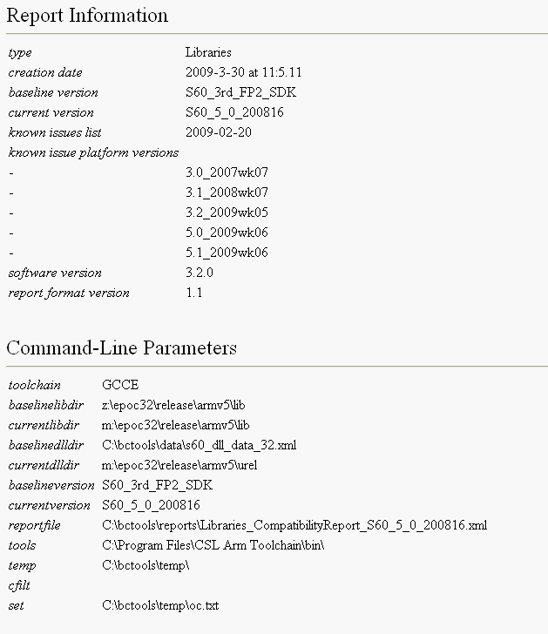
Figure 5-3 Short example of the basic information in library analysis
The second part of the report displays the found problems. The report shows slightly different information for headers and libraries, see Sections 5.2.1 and 5.2.2 for details.
Severity can be:
- For Binary Compatibility: BBC Break, Possible BBC Break or Informative.
- For Source Compatibility: SC Break, Possible SC Break, or Informative.
Informative items are reported to help the analyst and do not as such constitute a BC/SC break.
Items marked with one of the other two levels of severity need to be analysed to determine whether they are BC/SC breaks or not.
Some of the breaks come from the S60 Platform and some are introduced by the product. To ease the analysis, make sure that you have the report generated for the S60 Platform release the product is based on, as well as a list of known issues (knownissues.xml) in the Platform.
For each break (or possible break) in the product, the report for the platform is then checked.
- If the break is also in the platform, you can check the list of known issues and see whether it is a real break.
- If the break is not a known break in the platform, it usually means it has been introduced by the product. In this case, consult a binary compatibility expert who can carry out further analysis.

Header issues
The header report lists the baseline header file and the matching current header file for each header file with problems. Below them are listed the changes that may affect the BC or SC. Each item contains the following information:
- A description of the problem.
- The cause.
- The level of severity.

Headers can be viewed based on issue and sorting type by using two drop down list boxes. Issues can be sorted by issue types All, BC break and SC breaks. Headers can be sorted by header file name, API name or category name.
The API info and release category of each header are mentioned just below the header file name in the report file. In the below example, Phonebook Data Management API is the API name for the header, and Public is the release category of the API.
To view the differences in the files in more detail, click the baseline, current and diff links on the report. See the following example:
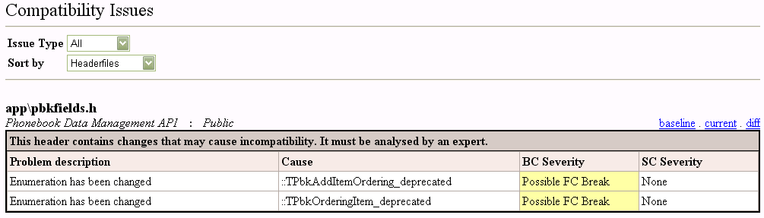
Figure 5-4 Example of reported issues in a header analysis
The tables below list the analysed BC issues and how they are reported in the final report.
Table 5-3 Binary compatibility issues
Issue | Severity | Comment
Removing an accessible class. | BBC Break
A class has an incomplete type. | Informative | This may be the result of, for example, changing the class declaration to a forward declaration. This issue is raised because incomplete classes cannot be analyzed properly.
Changing the access to the class to more restrictive. | Informative
An accessible class is using a virtual inheritance. | Informative
Changing the size of an accessible class. | BBC Break
Changing the size of the base class of an accessible class. | BBC Break
Changing the alignment of an accessible class. | BBC Break | Alignment is calculated by the compiler, and it represents the amount of data that is padded to the data structure in order to ensure its proper alignment in the computer memory.
Changing the virtuality of the inheritance. | Possible BBC Break
Removing a base class of an accessible class. | Possible BBC Break
Adding a base class to the accessible class. | Possible BBC Break
Changing the order of the base classes of an accessible class. | Possible BBC Break
Changing the virtual table of the base class of an accessible class. | BBC Break
Adding a virtual function to an accessible class. | BBC Break
Removing a virtual function from an accessible class. | BBC Break
Changing the order of the virtual functions in an accessible class. | BBC Break
Changing the type of an accessible constant. | Possible BBC Break
Changing the initial value of an accessible constant. | Possible BBC Break
Changing the accessibility of a constant to more restrictive. | Informative
Removing an accessible typedef. | Possible BBC Break
Changing the type of an accessible typedef. | Possible BBC Break
Changing the access of a typedef to more restrictive. | Informative
Removing an accessible enumeration. | Possible BBC Break
Removing an enumeration value. | Possible BBC Break
Adding a value to the middle of an accessible enumeration. | Possible BBC Break
Changing the alignment of an accessible enumeration. | BBC Break / Possible BBC Break | If the enumeration is accessible publicly or via derivation, the change is reported with the severity BBC Break. If the enumeration is accessible via a public or protected inline function, it is reported with the severity Possible BBC Break. Alignment is calculated by the compiler.
Changing the size of an accessible enumeration. | BBC Break / Possible BBC Break | If the enumeration is accessible publicly or via derivation, the change is reported with the severity BBC Break. If the enumeration is accessible via a public or protected inline function, it is reported with the severity Possible BBC Break.
Changing the access of an enumeration to more restrictive. | Informative
Changing the order or initial values of an accessible enumeration. | Possible BBC Break
Changing the access of a member variable to more restrictive. | Informative
Removing a member variable. | BBC Break / Possible BBC Break / Informative | Removing a publicly available member variable is reported with the severity BBC Break. Removing the private or protected member variable exposed by public or protected inline function is reported with the severity Possible BBC Break. Removing a private variable from a class not containing public or protected inline functions is reported as Informative.
Adding a member variable to a class. | Informative
Changing the offset of a member variable. | BBC Break / Possible BBC Break | If publicly available, severity BBC Break, or if exposed by public or protected inline function, severity Possible BBC Break.
Changing the type of a member variable. | BBC Break / Possible BBC Break | If publicly available, severity BBC Break, or if exposed by public or protected inline function, severity Possible BBC Break.
Changing the size of a member variable. | BBC Break / Possible BBC Break | If publicly available, severity BBC Break, or if exposed by public or protected inline function, severity Possible BBC Break.

There is more variation in the rules when analyzing exported non-virtual or inline functions. These rules are listed in Table 5-4 below.
Table 5-4 Binary compatibility issues for exported non-virtual functions and inline functions
Issue | Type | Access | Severity
Removing a function or changing its signature.  Note: Function signature can be changed in the following ways:  - Return value can be changed from const to non-const.  - Parameter can be changed from non-const to const.  - Function can be changed from non-const to const. | Exported | Public | BBC Break
 | Exported | Protected | If the class is derivable, this is reported as BBC Break.  If the class is not derivable but has public inline functions, this is reported as Possible BBC Break.  Otherwise not reported.
 | Exported | Private | If the class contains any public inline functions or it contains protected inline functions and is derivable, this is reported as Possible BBC Break. Otherwise not reported.
 | Inline | Public | Informative
 | Inline | Protected | Informative
 | Inline | Private | If the class contains any public inline functions or it contains protected inline functions and is derivable, this is reported as Informative. Otherwise not reported.
Adding a function. | Exported | Any | Not reported.
Adding a function. | Inline | Any | Not reported.
Changing the order. | Exported | Any | Not reported (can be checked with Ordinal Checker).
Changing the order. | Inline | Any | Not reported.

Library issues
In a library report, the issue section of the compatibility report lists possible BC or SC issues that were found affecting libraries. When an issue is found, the following message is printed on the report:
“This library contains changes that may cause incompatibility. It must be analysed by an expert.”
The issues can be viewed by severity type as shown in the below example.
The report also lists a description and details for every found issue. Only those functions and libraries are listed where issues were found. See the following example:
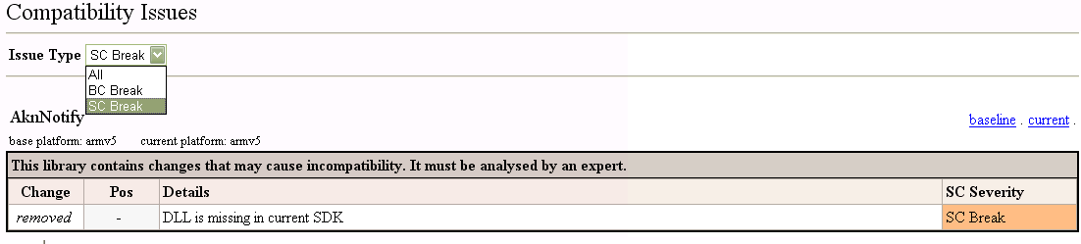
Figure 5-5 Example of reported issues in a library analysis
The table below lists the compatibility issues in library analyses.
Table 5-5 Issues in library reports
Issue type | Comment
Removing a library | If a library is found in the baseline but not in the target, the message “Library is no longer available” is printed on the report.
Adding a library | If a library is found in the target but not in the baseline, the message “Library has been added” is printed on the report.
Moving a function | If a function has a match in the target, but at a different ordinal, the message “Function has moved” is printed on the report together with the function name and its original and new position.  For example:  Function has moved CClkAlmModel::ClockAlarmInfo(int, SClockAlarmInfo &) const @ 3 => @ 4
Removing a function | If a function has no match in the target, and either the target has no function at the ordinal or the function at the ordinal in the target matches some other function in baseline, the message “Function has been removed” is printed on the report, together with the function name and position.  For example:  Function has been removed CClkAlmModel::ClockAlarmSet(int, SClockAlarmInfo const &) @ 4
Modifying a function | If the function has no match in the target and the target has a function at the ordinal that does not match any baseline function, the message “Function has been modified” is printed on the report together with the name and position of both the function found in the baseline and the function found in the target.  For example:  Function has been modified CContactDatabase::SetCntServerHeapFailure(RHeap::TAllocFail, int) @ 221 => CContactDatabase::SetCntServerHeapFailure(int, int) @ 221
Inserting a function | If the baseline has no match for the function and the function has been inserted to a slot where the baseline function at the ordinal has been matched to something else, the message “Function has been inserted” is printed on the report together with the name and position of the new function.  For example:  Function has been inserted CClkAlmModel::ClockAlarmSet(SClockAlarmInfo const &) @ 5
Adding a function | If the baseline has no function at the corresponding ordinal of the target, and the function has been added to a new slot at the bottom of the list, the message “Function has been added” is printed on the report together with the name and position of the new function.  For example:  Function has been added CContactDatabase::ICCTemplateIdL(void) @ 411
Removing a DLL | If a DLL is found in the baseline but not in the target, the message “DLL is missing” is printed on the report.
Modifying the UID1 | UID1 indicates the structure of the file, for example, whether it is an executable, a DLL, or a file store.  If the UID1 in the target does not match UID1 in baseline, the message “Target type/UID1 has been changed” is printed on the report.
Modifying the UID2 | The meaning of UID2 depends on the type of object it applies to.  - For polymorphic interface DLLs, UID2 identifies the interface that the DLL implements.  - For static interface DLLs that others link to, the UID2 value is always the same.  - For executables (with the exception of GUI applications), the UID2 value is ignored.  If the UID2 in the target does not match UID2 in baseline, the message “UID3 has been changed” is printed on the report.
Modifying the UID3 | UID3 distinguishes between objects with the same UID2 and can be thought of as a project identifier. For example, for an application, the same UID3 is shared by the executable, registration file, and all documents.  If the UID3 in the target does not match UID3 in baseline, the message “UID3 has been changed” is printed on the report.
Modifying the Secure ID | In OS versions with platform security, the Secure ID (SID) for a binary is taken to be the same as the third UID for that file. If an application does not specify a UID3 or specifies it as zero, then the Secure ID is undefined for the application. This has several consequences, including lack of privacy for data used by that application.  If the Secure ID in the target does not match Secure ID in baseline, the message “Secure ID has been changed” is printed on the report.
Modifying the capability | If any of the capability of the baseline DLL is missing from the target DLL, the message “Capability has been changed” is printed on the report.

Appendix A: CheckBC command line parameters
The basic command for the CheckBC script is as follows:
CheckBC <configfile> [-ha/-hm/-hs] [-la/-lm/-ls] [-f] [reportid]

Basic parameters | Required | Description
configfile | Yes | The name of the configuration file.  Note: This is required as the first parameter.
reportid | No | The identification for the report file that contains the results of the compatibility analysis. The report format is XML.  The ID can be specified either from the command line or from the configuration file.

Commands | Description
-ha | Checks all headers.
-hm FILE | Checks multiple headers that are listed in a text file.
-hs FILE | Checks a single header file that you can define with the file parameter.
-la | Checks all libraries.
-lm FILE | Checks multiple libraries that are listed in a text file.
-ls FILE | Checks a single library file that you can define with the file parameter.
-f | Filters the results after analysis by using the version of knownissues.xml that is specified in the configuration file.

Appendix B: HeaderAnalyser stand-alone usage
Note: You can run the Header Analyzer tool as a stand-alone tool from the command line, using its own parameters described below. When analysing platform header files, it is recommended to use the CheckBC.py script instead of the HA executable (ha.exe). CheckBC abstracts the analysis by hiding the details of tool specific command line parameters, which makes the analysis less prone for errors.
Purpose of the tool
The purpose of HeaderAnalyser is to compare a set of modified header files to those in a baseline and report any changes that may affect binary compatibility.
Tool versions are available for both Microsoft Windows and Linux.
Note: When using Linux, the command line parameters that contain file names or paths must be given in quotes. This prevents the shell from expanding the wild characters.
Executing the tool
To execute HeaderAnalyser:
- Open the command prompt in the installation directory of HeaderAnalyser.
- Enter the following command:
ha [parameters]
Example: The following command compares two individual files, by defining the files with the baseline and current parameters with paths.
ha -baseline "z:\app\test.h" -current "x:\app\test.h" -reportfile "report.xml" -baseplatformheaders "z:\epoc32\include" -currentplatformheaders "x:\epoc32\include"
Command line parameters
The following syntax is used in the table below:
FILE replace with a filename (for example, testheader.h)
DIR replace with a directory (for example, ..\testcases)
NAME replace with a text string (for example, foobar)
; separate multiple items such as filenames

Parameter name | Required | Description
-baseline FILE  -current FILE | No | The baseline and current parameters are used when comparing two files.  - Required if a baselinedir/currentdir is not specified.  - Paths can be relative or absolute.
-baselinedir WILDCARDS;WILDCARDS  -currentdir DIR;DIR | No | The baselinedir and currentdir parameters are used when comparing two directories.  - Required if baseline/current is not specified.  - Paths can be relative or absolute.  - The filename in baselinedir must contain a filename (with wildcards) that specifies the files to be analysed.  - If a file set is given (using the set parameter) then baselinedir can only define a directory.  - -If a wildcard is given for currentdir parameter, it is stripped off.  - If a wildcard is given for baselinedir parameter when file sets are in use, the wildcard is ignored.
-baselineversion NAME | No | Defines a name for the baseline.
-currentversion NAME | No | Defines a name for the current version.
-reportfile FILE | Yes | Specifies where to save the XML report file.
-commandfile FILE | No | Reads command line parameters from a file.
-baseplatformheaders DIR;DIR  -currentplatformheaders DIR;DIR | Yes | Reads baseline and current platform headers from this directory.  The headers can de defined as the BASEPLATFORMHEADERS and CURRENTPLATFORMHEADERS environment variables.
-forcebaseinclude FILE;FILE | No | Forces the defined files to be always included for the baseline.  The files are always included first in the generated temporary CPP file for the baseline release.  Note: This parameter is recommended to make sure HA generates valid results.
-forcecurrentinclude FILE;FILE | No | Forces the defined files to be always included for the current release.  The files are always included first in the generated temporary CPP file for the current release.  Note: This parameter is recommended to make sure HA generates valid results.
-recursive | No | Includes subdirectories when scanning the files.  This parameter can only be used with the baselinedir and currentdir parameters.
-excludedirs DIR;DIR | No | When recursive scan is in use, this parameter defines which directories can be skipped. The directory can be a relative path or a directory name.
-set FILE;FILE | No | Includes only this file in the analysis. Wildcards can be used too.
-replace FILE NEWFILE | No | Specifies files that have been renamed between versions.  The filename can be simply a file, in which case the directory does not matter, or a relative path with a filename that is used as is. This applies to both the original and the replacement file.
-bundlesize COUNT | No | Defines how many files are processed in one go (in one compilation unit). This parameter can be used to increase performance.  - The default is 1 and the value can be between 1 and 9999 – other values are discarded.  - Uses more memory when the value is bigger than 1.
-temp DIR | Yes | Defines where intermediate files are written. This parameter can also be defined as the TEMP environment variable.
-docurl URL | No | If given, the documentation URL is added to the report file for each issue. The specifier is appended at the end of the URL.
-baseplatformdata FILE  -currentplatformdata FILE | No | Reads baseline and current platform data from a file. The data is used when compiling the baseline headers.  Specifies the file containing compile time dependencies of the baseline platform.
-usethread | No | Enables multiple threading logic.Useful for Public vs Rnd Sdk analysis or small no of headers (<3000). For Rnd vs Rnd sdk all header analysis or for large no. of headers, this should not be used to avoid high memory consumption crash.

Command line examples
The following example compares two individual files, by defining the files with the baseline and current parameters, with relative paths.
ha -baseline "base\test.h" -current "current\test.h" -reportfile "report.xml" -baseplatformheaders "base\epoc32\include" -currentplatformheaders "current\epoc32\include"

The following example compares directories or file sets that have renamed files, by defining the files whose names have been changed with the replace command line parameter. In this example, recursion is used. Define the original file name first and the new name next, separated by a space.
ha -baselinedir "z:\epoc32\include\*.h" -currentdir "x:\epoc32\include" -reportfile "report.xml" -baseplatformheaders "z:\epoc32\include" -currentplatformheaders "x:\epoc32\include" -recursive -replace "test.h" "test2.h" "test2.h" "inc\test3.h" "inc2\test4.h" "inc\test5.h" "inc\test4.h" "inc\test6.h"

To compare multiple files in two different directories, define the folders with the baselinedir and currentdir parameters. With the baselinedir parameter, you can also use a wildcard by which files in the directory are selected. With the currentdir parameter, you can only give a directory. The tool uses the same wildcard with the currentdir parameter that was defined for the baselinedir parameter. Both parameters can be defined with absolute or relative paths.
ha -baselinedir "z:\epoc32\include\*.h" -currentdir "x:\epoc32\include" -reportfile "report.xml" -baseplatformheaders "z:\epoc32\include" -currentplatformheaders "x:\ epoc32\include"

Tip: To make sure that the results generated by the HA script are accurate, it is recommended to use the -forcebaseinclude and -forcecurrentinclude parameters. This means defining additional header files that are always included to ensure the successful compilation of headers. The \compatibilityanalyser\bin directory of the BCTools.zip package contains precreated sample files for each Symbian OS version (for example, forced_9.1.h and so on).
ha -baselinedir "z:\epoc32\include\*.h" -currentdir "x:\epoc32\include" -reportfile "report.xml" -baseplatformheaders "z:\epoc32\include" -currentplatformheaders "x:\epoc32\include" -forcebaseinclude “\bin\forced_9.2.h;forced_9.3.h” -forcecurrentinclude “\bin\forced_9.2.h;forced_9.3.h”

Appendix C: LibraryAnalyser stand-alone usage
Note: You can run the LibraryAnalyser tool as a stand-alone tool from the command line, using its own parameters described below. When analysing import libraries, it is recommended to use the CheckBC.py script instead of the LA executable (LA.exe). CheckBC abstracts the analysis by hiding the details of tool specific command line parameters, which makes the analysis less prone to errors.
Purpose of the tool
LibraryAnalyser is a command line tool that can be used to compare modified DSO, LIB and DLL files to those in a baseline and to report any changes that can affect binary compatibility.
Ordinal Checker supports the following toolchains:
- Symbian GCC.
- CSL Arm ToolChain (GCCE).
- RVCT.

The tool uses primarily DSO files to read the symbol table, but supports LIB files as well. The exception to this is the Symbian GCC tool chain, where there is no support for DSO files, only for LIB files.
Executing the tool
To execute LibraryAnalyser:
- Open the command prompt in the installation directory of LibraryAnalyser.
- Enter the following command:
la <toolchain GCC|GCCE|RVCT> [options]
Example: The following command uses the GCCE toolchain and specifies the baseline and current SDK releases, the name and location of the report file to use, the location of the toolchain directory, and the location of intermediate files.
la GCC -baselinelibdir "C:\SDK\S6012\Series60\Epoc32\Release\thumb\urel" -currentlibdir "C:\SDK\S6020\Epoc32\release\thumb\urel" -baselineversion "Public SDK 1.2" -currentversion "Public SDK 2.0" -reportfile "c:\temp\GCC_EX_Report.xml" -tools "C:\SDK\S6012\Shared\EPOC32\gcc\bin" -temp "c:\temp"
Command line parameters
The following syntax is used in the table below:
<DIR> replace with a directory (for example, ..\testcases)
<FILE> replace with a directory and a filename (for example, c:\base2\test2.h)
<NAME> replace with a text string (for example, foobar).
; separate multiple items such as directories

Parameter name | Required | Description
-baselinelibdir <DIR;DIR> | Yes | Specifies one or more directories for the baseline libraries.
-currentlibdir <DIR;DIR> | Yes | Specifies one or more directories for the current libraries.
-baselineversion <NAME> | Yes | Defines the name of the baseline.
-currentversion <NAME> | Yes | Defines the name for current files.
-reportfile <FILE> | Yes | Specifies where to save the XML report file.
-cfilt <FILE> | Yes (with RVCT) | Specifies the location of the c++filt utility.  Only required when the RVCT tool chain is used.
-tools <DIR> | No | Specifies where the used toolchain is installed.  If this parameter is not given, LibraryAnalyser attempts to find the tool chain from the PATH environment variable.
-temp <DIR> | No | Specifies where intermediate files are stored.  If this parameter is not given, LibraryAnalyser attempts to find the directory from the TEMP environment variable.
-set <FILE> | No | Specifies the location and the name of the text file that has a list of libraries to check.
--uselibs | No | Sets the LibraryAnalyser to check LIB files instead of DSO files by default.  Note that this parameter is only used with GCCE and RVCT tool chains.
-baselinedlldir <DIR|FILE> | No | Read baseline DLLs from the specified directory, or DLL data from the specified file.
-currentdlldir <DIR|FILE> | No | Read DLLs from the specified directory, or DLL data from the specified file for the current release.

Command line examples
The following example describes a full LibraryAnalyser execution command when the GCCE tool chain is used:
la GCCE -baselinelibdir "C:\SDK\S60_3rd_MR\Epoc32\release\armv5\lib" -currentlibdir "C:\SDK\3.0wk24\Epoc32\release\armv5\lib" -baselineversion "Public SDK 3.0" -currentversion "Test release wk24" -reportfile "c:\temp\GCCE_EX_Report.xml" -tools "C:\Program Files\CSL Arm Toolchain\bin" -temp "c:\temp"

The following example describes a full LibraryAnalyser execution command without the -tools and -temp parameters, when the RVCT toolchain is used. Note that with RVCT toolchain, the location of the c++filt utility is needed. In this example, the parameter -set is used to specify the location and name of the text file that has a list of libraries to check.
la RVCT -baselinelibdir "S:\epoc32\release\armv5\lib" -currentlibdir "Z:\epoc32\release\armv5\lib" -baselineversion "SDK 3.0" -currentversion "3.1 RnD wk24" -reportfile "c:\reports\RVCT_EX_Report.xml" -cfilt "cfilt.exe" -set c:\myido.txt

Appendix D: BCFilter stand-alone usage
Note: You can run the BCFilter tool as a stand-alone tool from the command line, using its own parameters described below. When filtering reports with a knownissues file, it is recommended to use the CheckBC.py script instead of the BCFilter executable (bcfilter.exe).
Purpose of the tool
BCFilter is a script that filters the results of the analysis against issues reported in a knownissues.xml file.
Executing the tool
To execute BCFilter:
- Open the command prompt in the installation directory of BCFilter.
- Enter the following command:
bcfilter <reportfile> <issuefile> [outputfile]
Example: The following command filters an existing XML report file, using a specified version of the knownissues file, and writes the filtered result into the specified directory.
bcfilter c:\temp\reports\headers_wk23.xml c:\BCTools\compatibilityanalyser\data\knownissues.xml c:\temp\filtered\headers_wk23.xml
Command line parameters
The stand-alone BCFilter script uses the following parameters:

Parameter name | Required | Description
reportfile | Yes | The XML report name created by HeaderAnalyser or LibraryAnalyser.
issuefile | Yes | The knownissues.xml file containing the known issues in the S60 Platform.
outputfile | Yes | The name and location of the filtered XML report file generated by BCFilter.

Appendix E: Compile-Time Dependency Scanner stand-alone usage
Purpose of the tool
Compile-Time Dependency Scanner (CDS) for Header File Analysis is a script tool that explores and produces the dependency information needed for compiling C++ header files of the S60 Platform. It scans and analyses the project, source and header files, and the resulting information is used in binary compatibility analysis.
The script, written in Python programming language, scans and reads the project files. It produces a platform-specific XML file containing the information needed in header file compilation.
Executing the tool
To execute CDS:
- Open the command prompt in the installation directory of CDS.
- Edit the necessary parameters in the config.py file (see the table below).
- Type the following command to start the scan:
cds
The script starts recursively scanning the directories given in the configuration file, and reads all the necessary project files found.
The output is in XML format and all the information is stored in platform-specific files, so that each XML file represents one S60 Platform. The root element of the output file is the platform, which contains one or more component-elements.
Command line parameters
Parameter | Meaning
PLATFORM_VERSION | The version ID of the platform. Allowed values are '3.0', '3.1', 3.2' and '5.0'. By default, the version string is used also in report and error log filenames.
BUILD | The build is, for example, the week of the build.
REPORT_FILENAME | Filename of the XML report.
PLATFORM_PATHS_HRH_LOCATION | The platform_paths.hrh file is searched from this directory.
PLATFORM_PATHS_HRH_FILE | Name of the platform_paths.hrh file.
IGNORED_FOLDERS | A list of folder names that were ignored and thus not scanned.
TOOL_DIR | Directory for the report output files. Report file and log files are created under this directory.
REPORT_FULLNAME | The complete name of the generated report (in XML format).
ERROR_LOG_FILENAME | Filename of the error log file.
ACTIVE_PROCESSORS | A list of active processors.
ACTIVE_SCANNERS | A list of active scanners.
SCANNER_PATHS | Source directories that should be scanned.
WARN_FILENAME | A filename for a warnings file.
LOG_FILENAME | A filename for a log file.

Appendix F: Legal notices
This product includes software developed by The Apache Software Foundation
(http://www.apache.org/ ).
Portions of this software were originally based on the following:
- software copyright (c) 1999, IBM Corporation, http://www.ibm.com

This Nokia Product includes Open Source Software. Certain software included in this Nokia Product is licensed and distributed under GNU General Public License (GPL) and/ or other copyright licenses, disclaimers and notices containing obligation or permission to provide the source code of such software with the binary / executable form delivery of the said software. The source code is delivered to you in accordance with the referred license terms and conditions in the media attached to this document. The exact license terms of GPL and said certain other licenses, as well as the required copyright and other notices, permissions and acknowledgements are reproduced in and delivered to you as part of the referred source code.

