S60
Carbide.ct User’s Guide

Team name | Author
S60 A&F MM Dev Tools Config FI | Hussein Ismail, Jere Paavola

Change history:

Version | Date | Status | Comments
1.0 | 29.04.2009 | Approved

Table of contents:

1. Document control 4
1.1 Documentation conventions 4
1.2 Abbreviations and definitions 4
2. Introduction 5
2.1 Understanding Configuration Projects 5
2.2 Preconditions for use 5
2.3 Order of tasks in using Carbide.ct 6
3. Using the Carbide.ct tool 7
3.1 Installing the tool 7
3.2 Overview of Carbide.ct 7
3.3 Creating a new Configuration Project 7
3.4 Creating a new layer 8
3.5 Importing ConfML files into a layer 9
3.6 Creating Configuration root files and including other ConfMLfiles 10
3.7 Selecting active Configuration root file 11
3.8 Overriding data with Value Editor 12
3.9 Creating a new View definition 14

Document control

Documentation conventions
Code is shown with the Courier New font.

Abbreviations and definitions
Configuration | Configuration in Configuration Project defines a collection of layers and their order in relation to each other. In other words, it defines a chain of layers, and related metadata. Configuration can also refer to configuration element inside Configuration Markup Language File, which defines zero or more configuration elements in terms of features and settings.
Configuration process | End-to-end process, which starts from defining the configurable features and ending to taking software into use in manufacturing.
Configuration process phase | A single step in the configuration process, such as integrating several components into one delivery, or modifying delivery values due to interest of some stakeholder.
Configuration root file | ConfML file describing layer chaining and related properties.
ConfML | Configuration Markup Language is an XML-based markup language for defining software configuration elements and configuration data of S60 devices.
Configuration Project | A Configuration Project specifies the logical structure, related data and related methods, which enable efficient tooling support for configurability needs throughout the feature, platform, product and variant creation lifecycles. It contains all ConfMLs, ImplMLs, documentation and content that are needed to create variant for a specific configuration.
CPF | Configuration Project File. Container file containing Configuration Project Structure.
ImplML | Implementation Markup Language for defining settings transformation. These files are optionally used to convert ConfML files into platform- or component-specific format.
Layer | A structural unit of a Configuration Project, representing full or partial set of settings and customizable resources produced in certain phase of configuration process.
Variant | Software product that is the subject of a configuration process.

Introduction
The Carbide.ct tool is a tool for handling Configuration Projects, which is explained in the next section. It can be used by developers, variant engineers and build engineers for the following purposes:
- Developers can use the tool to create new Configuration Markup Language (ConfML) files for type definitions and to refine existing ones.
- Variant engineers can use the tool to specify variant data and manage variant content.
- Build engineers can use Carbide.ct and associated tools to do batch operations on ConfML data.

With this tool, you can:
- Manage Configuration Projects: create a new project, add and remove layers, import files to the layers, edit the files, and add content to the project, and so on.
- Import and export Configuration Project Files (CPF).
- Create and modify ConfML files.
- Refine existing configuration elements (features and settings) using different internal editors.
- Import or define implementation markup languages (ImplML) for configuration elements.
- Convert ConfML files and associated content to the target device format.
- Validate ConfML files.
- Package created files into an image file usable by target devices and emulators.

This document is valid from S60 release 5.1 onwards.

Understanding Configuration Projects
Carbide.ct is based on the concept of Configuration Project. A Configuration Project specifies the logical structure, related data and related methods, which enable efficient tooling support for configurability needs throughout the feature, platform, product and variant creation lifecycles. It contains all ConfMLs, ImplMLs, documentation and content that are needed to create variant for a specific configuration.
Configuration Project defines how software configuration is composed and managed throughout the configuration process. This allows collecting and managing the settings and customisable resources in consistent way, thus creating harmonized environment for automatisation.
During the process, each integration or customization phase is composed into separate layer residing in the project. Single layer contains things relevant for that specific phase, consisting mainly of ConfML definitions (e.g. configuration interfaces, data and view definitions), mapping rules to implementation and related content. The basic principle is that layers are connected to each other, and layers added later in the process are able to override the data and content defined in earlier layers.
Information about collection of layers, their order and related metadata form a single configuration. Configuration Project can consist of any number of configurations.

Preconditions for use
The only requirement for utilizing the tool is that proper Java Runtime Environment must be installed in order to use the tool. The officially supported version of JRE is 1.5.
Tool does not require external configuration files. Everything is included in the ZIP package.

Order of tasks in using Carbide.ct
Take the following steps to start using the tool:
- To install, download the ZIP package and extract it to the folder of your choice.
- Create a new Configuration Project.
- Create one or more layers for the project.
- Import the files into the layer.
- Add layer and configuration root files to the Configuration Project.
- Select active Configuration root file.
- Refines values with Value Editor.
- Define new View definitions for grouping of ConfML features and settings.

Using the Carbide.ct tool

Installing the tool
Carbide.ct tool comes in a ZIP package, which can be extracted to any location. To run the tool, make sure that the proper version of Java Runtime Environment is installed on your machine.

Overview of Carbide.ct
The following figure shows an overview of the Carbide.ct tool’s user interface elements in Eclipse. Each Configuration Project can contain one or more configurations and layers, and you can edit their details.
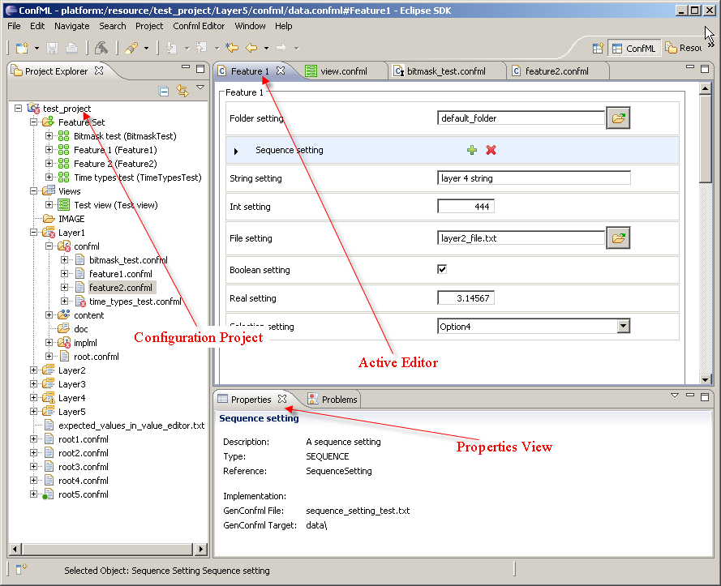
Figure 3.1 Sample of the Carbide.ct user interface

Creating a new Configuration Project
To create a new Configuration Project:
- Right-click the Project Explorer and select New > Project.
- On the wizard, choose Configuration Project.
- Specify the name of the project (e.g. product name).
- Click Finish.

The project is created, as shown in Figure 3.2.
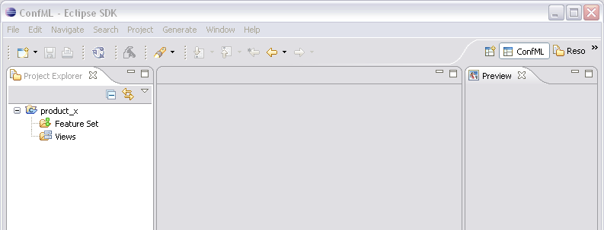
Figure 3.2 Example of a new Configuration Project

Creating a new layer
A Configuration Project can contain any number of layer folders, each representing a set of settings and customizable resources produced in certain phase of the configuration process. Names of these layers can be arbitrary. Each layer contains at least the following folders: confml, implml, content and doc. The Confml folder contains ConfML files, implml folder contains implementation files, content folder contains customizable resources and doc folder contains documentation files.
To create a new layer:
- Right-click the project name and select New > Configuration layer.
- Specify the name of the layer (e.g. s60).
- Click Finish. The layer is added to the project, as shown in Figure 3.3. It contains only empty folders.
- Add a layer root file by selecting the layer and right-clicking New > Configuration file (s60.confml in the figure). The layer root file usually includes all ConfML files in the layer.
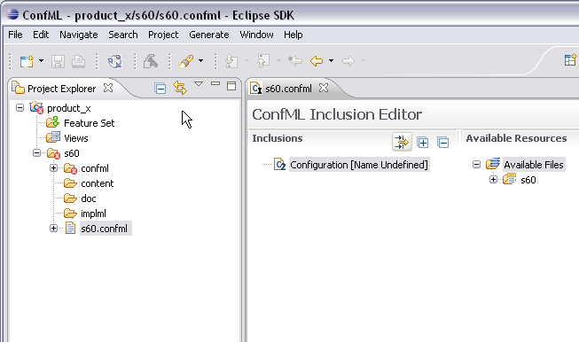
Figure 3.3 Example of a new layer inside configuration project

Importing ConfML files into a layer
To import Configuration Markup Language files into a layer:
- Right-click the folder where you want to import the files (usually the confml folder in the layer).
- Select Import.
- In the wizard, select Import set of ConfML files and press Next.
- Specify where the files to be imported are located, as shown in Figure 3.4.

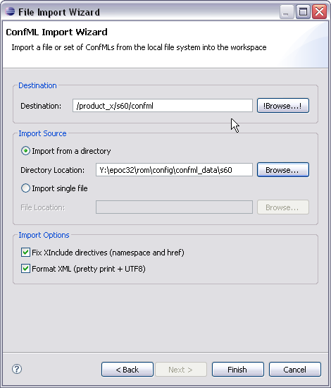
Figure 3.4 Importing set of ConfML files
- Click Finish. The ConfML files are listed under the layer, as shown in Figure 3.5.
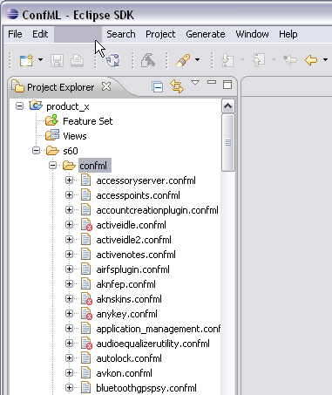
Figure 3.5 After import
- In the same way, it is possible to import implementation files. Other types of resources (e.g. images and ring tones) can just be dragged and dropped into the appropriate folder.

Creating Configuration root files and including other ConfMLfiles
Configuration root files (in ConfML format) can be created for the Configuration Project or for the individual layers. They define both the layer properties and inclusions of other ConfML files. Each layer must have at least one layer root file.
To create a configuration root file:
- Right-click the project and select New > Configuration file.
- In the dialog, specify the name of the root file and click Next.
- Select the version of the ConfML file (usually confml 2).
- Select the Configuration Root or Layer root option, as shown in Figure 3.6:

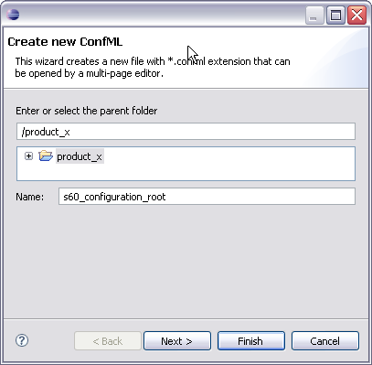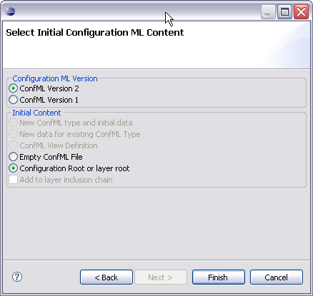
Figure 3.6 Root file creation wizard
- Click Finish. You can now edit the file with Inclusion Editor, which opens automatically, as shown in Figure 3.7.

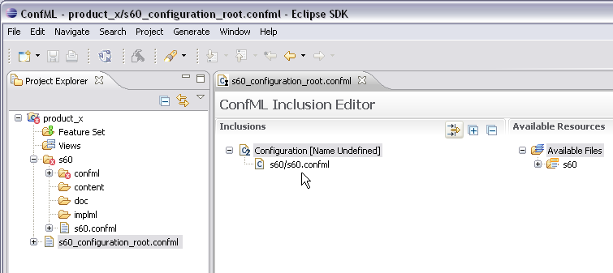
Figure 3.7 Including ConfML files into root file
- Repeat this sequence to add layer root files (e.g. to s60 layer add s60/s60.confml)

Selecting active Configuration root file
To activate a configuration root, right-click and select Configuration > Use as Configuration Root, this causes the tool to create internal model of the active configuration and show all availables features and settings under Feature Set node. All availables ConfML Views are also shown under the Views node in the project explorer.
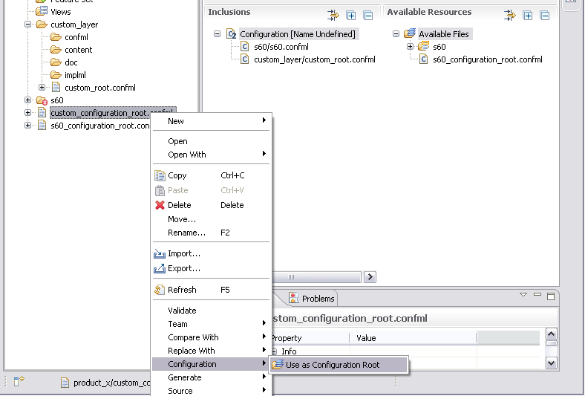
Figure 3.8 Activating an existing Configuration root file. After activation, the Configuration root file has a small green marker

Overriding data with Value Editor
Using Value Editor the user can override the default values of settings in the configuration. To accomplish this, follow the steps below:
- On the Project Explorer under Feature Set right-click the feature you want to edit and select Open Feature Editor.
- Modify the values in the editor as needed. See the following graphic for an overview.

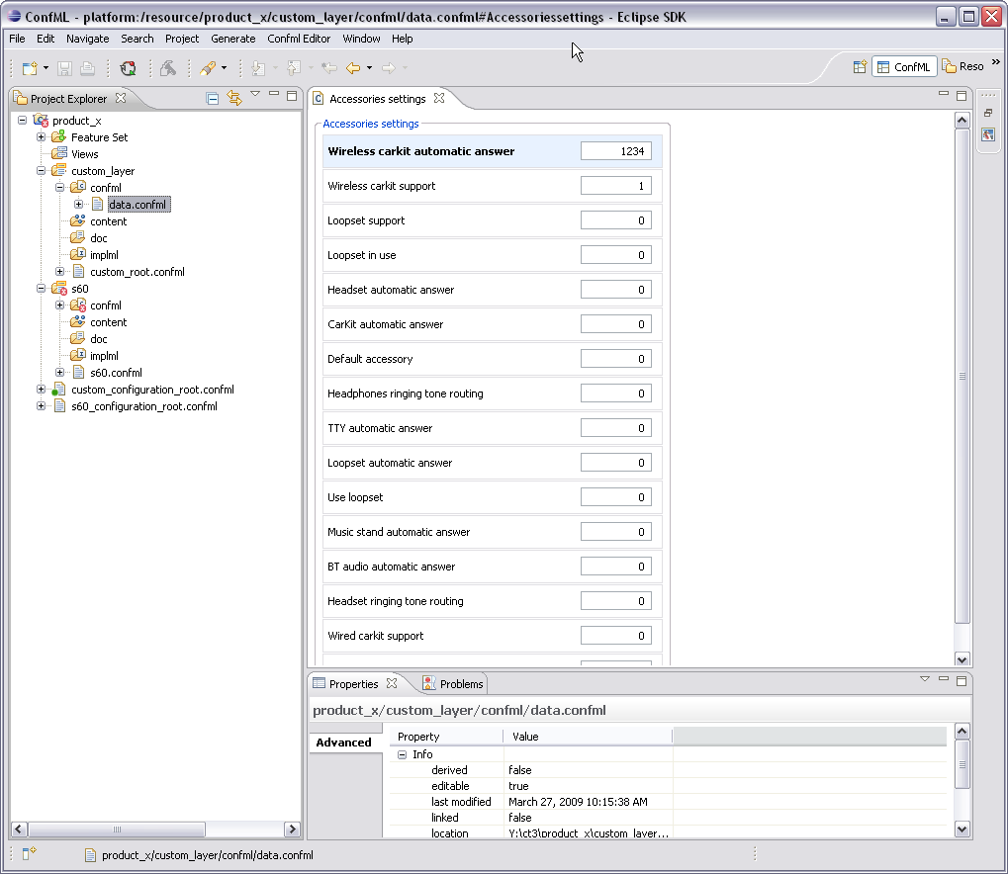
Figure 3.9 Modifying default values with Value Editor. All user modified settings appear bolded.
- Save your changes at the end. The changes are saved in the active Configuration root file’s last layer, in this case custom_layer/confml/data.confml.

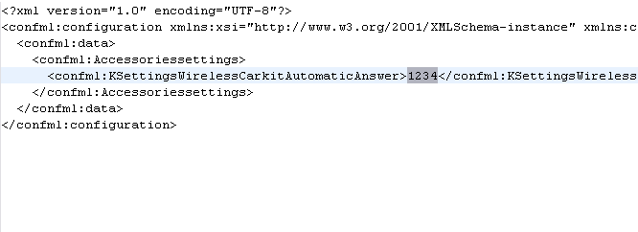
Figure 3.10 Data overrides

Creating a new View definition
A view is a structure of ConfML syntax which refers to selected features and settings in other ConfML files, grouping them in a logical way and managing their visibility.
To create a view:
- From Project Explorer, select the folder to put the new ConfML view file and right-click and select New > Configuration. Specify the name and select Next.

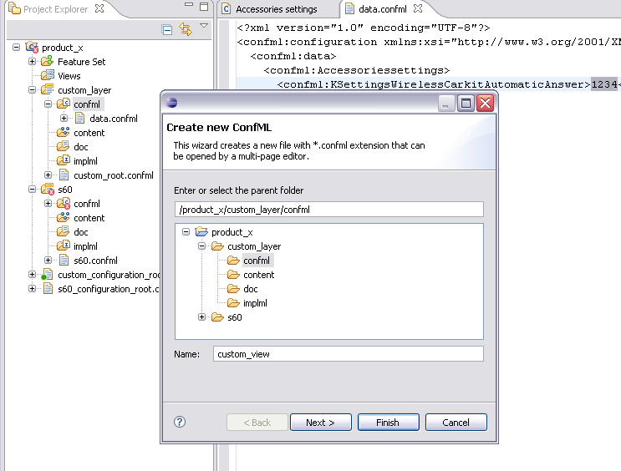
Figure 3.11 Creation of a new ConfML View definition
- Select Confml View Definition as in Figure 3.12.
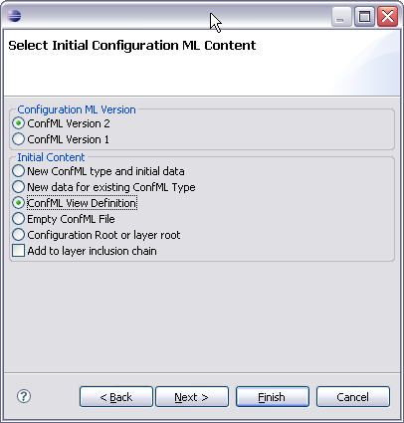
Figure 3.12 ConfML view creation wizard
- Edit the view by adding features and settings from the Unallocated Settings list. Also add new groups as needed.

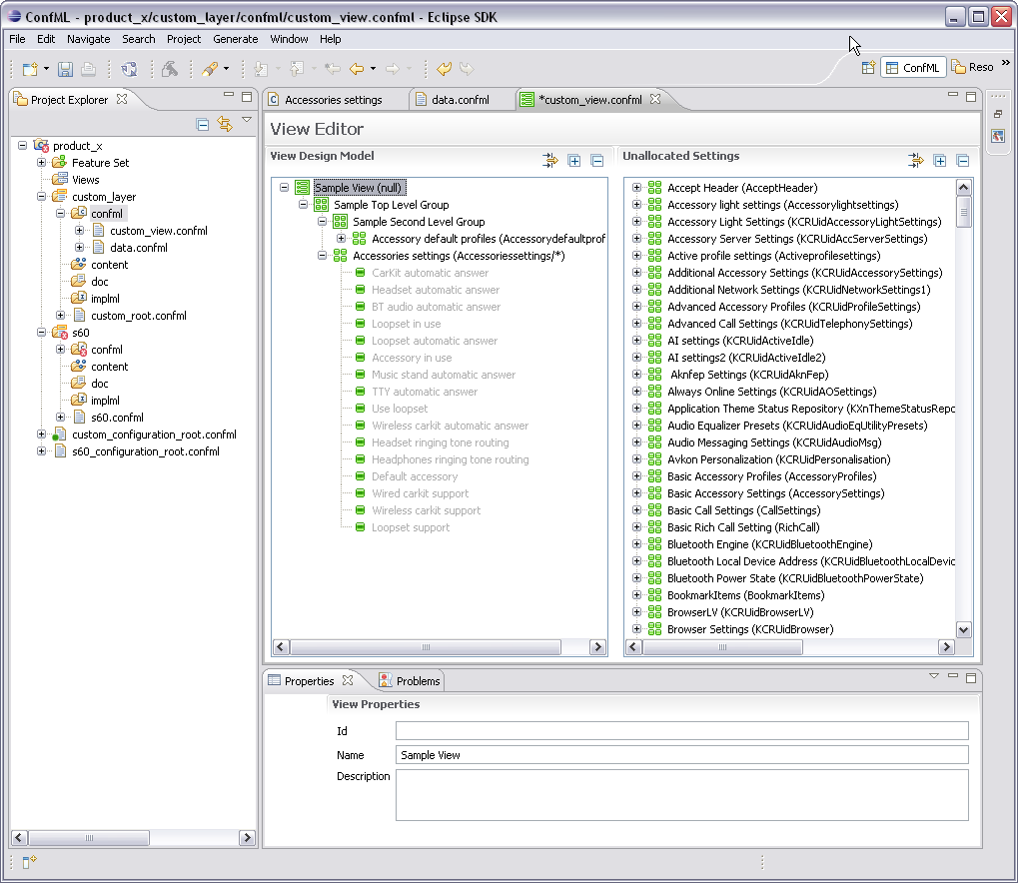
Figure 3.13 Adding groups and settings to a view
Optionally, edit the properties of the view, group and settings. New groups and subgroups can be easily added by selecting the parent group and right-clicking it and using the pop-up menu that appears.

