How To Build SDB

Required tools and settings:
- JDK 1.5 - http://java.sun.com/javase/downloads/index_jdk5.jsp
- Apache ANT - http://ant.apache.org/bindownload.cgi
- Add ANT to your $PATH variable

- Get SDB sources
- Perforce location: //DP/master/sf/depl/swconfigmdw/settingsengines/sdb
- Build SDB
- Run ANT build.release task by running the following command in SDB directory (root SDB directory should contain build.xml file):
Cmd > ant build.release
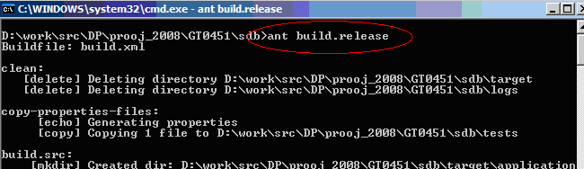

Successful build should finish with message ‘BUILD SUCCESSFUL’
