Automatic Component Based Releasing Design Specification
Security Classification: | INTERNAL | Team/Department: | Productisation
Document Reference: | <SGL.PR0080.150> | Author(s): | Iain Williamson, Andrew Beck
Status: | Draft | Owner(s): | Iain Williamson
Version: | 1.4 | Approver(s) | Mark Shackman
Last Revised Date: | 7th January 2004 |  | Mark Shackman

Introduction

Purpose and Scope
This document describes the design of an automated system for making component based releases. Functionality is already covered in the document ‘How to Componentise Zephyr’ [R1] and will only be outlined in this document. This document should be read by anyone implementing or maintaining a future automated system for componentising a build.

Design

Overview
The system needs to reflect the stages that were performed in order to componentise zephyr manually. These will be implemented as separate classes conforming to a standard interface. A simple script to collect a set of stages and run them can then be provided and used both for the overnight build, and also used (with a different set of stages) for manual running which will be useful for testing purposes.
The process will need manual intervention should the .mrp files prove not to be correct. In a manually run process, the process would pause at this point and be resumed following updates to the mrp files. However, as part of the overnight build, the system will instead halt at this point and provide a build error indicating that the .mrp files are incorrect.

Setting up the drive
As a prerequisite for the stages which follow, the build system must have set up the following:
- Source and binaries from the Techview build in a directory on a clean drive.
- GT binaries in a different directory on that same drive.
The binaries used must be those which were previously zipped up into ‘ock’ zips – that is all binaries in epoc32 and other binary folders with certain exceptions (e.g. don’t copy epoc32\build, don’t copy .sym files etc.).
Rearrange directories as described in ‘How to Componentise Zephyr’ [R1] (e.g. move product directory out of the source tree and into the root). However, do not re-export or rebuild makefiles on any components at this stage.

GT+Techview Release Stages

Create the release drive
Subst a drive to the directory containing Techview source and binaries. Install a standard ‘reltools.ini’ file in epoc32\relinfo. Create a release notes file from a template file.
Required inputs: Location to copy reltools.ini from, Spare drive letter, Directory containing Techview source and binaries, Build identifier, Location of release notes template, Location to put the updated release notes

Configure the release tools
In order to prepare the components for release, re-export and rebuild makefiles for certain specified components. Check the output of any abld commands performed using scanlog to determine errors (which can be found on the newly created release drive in epoc32\tools).
Required inputs: List of components to perform exports on, List of components to rebuild makefiles on, Spare drive letter

Identify the previous release
Use the ‘latestrel’ tool on the GT+Techview baseline component to identify the last release to use in the following stages. Should the previous release version number already be set, this stage can be skipped (to enable this identification to be overridden).
Required inputs: GT+Techview baseline component name
Output: Previous release version number

Identify any updated mrp files
Identify any mrp files (either GT or Techview components) which have been moved or whose contents have changed since the last release. The record of the mrp files in the last release is stored in the baseline component for the previous release, and this record contains the path of all mrp files plus a checksum of their contents.
Required inputs: Baseline component name, Previous release version number, List of Techview components and corresponding .mrp files, List of GT components and corresponding .mrp files
Outputs: List of components whose .mrp files have been updated

Validate against previous GT+Techview release
Invoke ‘validateenv -s’ against the previous GT+Techview release.
Parse the output of the ‘validateenv’ command to identify the list of dirty components reported at the end
Required inputs: Previous release version number, GT+Techview baseline component name
Outputs: List of dirty components

Identify added or removed components
Compare the list of .mrp files and component names for both GT and Techview to that used for the previous GT+Techview release (by examining the environment of the previous release of the GT+Techview baseline component) to determine any added or removed entries.
Required inputs: List of Techview components and corresponding .mrp files, List of GT components and corresponding .mrp files, Previous release version number
Outputs: List of added components, List of removed components

Prepare any dirty components
Add the list of added components and the list of components with updated .mrp files to the list of dirty components. If the GT+Techview baseline component is not included in the list, add it.
Take this new list and run ‘preprel’ on all components contained in it. Remove any components in the list of deleted components without removing any binaries from the disc.
Required inputs: List of dirty components, List of added components, List of removed components, List of components whose .mrp files have been updated, List of Techview components and corresponding .mrp files, List of GT components and corresponding .mrp files, GT+Techview baseline component name and .mrp location, Component version number to use for new releases

Check the updated environment
Invoke ‘envinfo –fv’.
The ‘envinfo’ tool must report that the environment is ‘pending release’. If the environment is ‘dirty’, the .mrp files are incorrect and the system must report a build error and halt.
The ‘envinfo’ tool should not have reported that the environment is ‘clean’. This may only happen if the tool failed to prepare the baseline component or any others for release.

Release environment
Invoke the ‘makerel’ tool. Check for errors. Under normal circumstances completion of this stage indicates that the release has been made and has been published to the local archive.
Required inputs: Archive name to publish to

Store .mrp file status
Record the current state of the .mrp files for use by the stage Identify any updated mrp files (2.3.4) in the archive under the i.e. record mrp file paths and checksums.
Required inputs: GT+Techview baseline component name, Component version number used for this release, List of Techview components and corresponding .mrp files, List of GT components and corresponding .mrp files

GT Only Release Stages

Remove non-GT components
Examine the current environment, and run ‘removerel’ on any components which do not correspond with an entry in the list of GT components and corresponding .mrp files. Remove the GT+techview baseline component.
Required inputs: List of GT components and corresponding .mrp files.

Install GT versions of conflicting files
Parse through the techview_dups.log file generated during the product build process, and copy over any files listed from the GT-built binaries to the current drive (still subst’ed to the Techview binaries directory). Any files which are already present will not be overwritten and will result in an error.
Generate an mrp file describing all of the files just installed (the ‘gt_overwritten’ component)
Required inputs: Location of techview_dups.log file, Directory containing GT-built binaries, Location to put the ‘gt_overwritten’ mrp file, Name of gt_overwritten component

Prepare new components
Run preprel on the GT only baseline component, and on the ‘gt_overwritten’ component, described by the mrp file generated in the previous stage.
Required inputs: GT only baseline component name and corresponding mrp location, Name of gt_overwritten component, Location of gt_overwritten mrp file

Check updated environment
Exact repeat of stage 2.3.8

Release environment
Exact repeat of stage 2.3.9

Strong Crypto component release stages

Remove weak crypto
Run ‘removerel’ on the weak crypto component
Required inputs: Name of weak crypto component

Install strong crypto binaries
Copy the strong crypto binaries onto the current drive
Required inputs: Location of strong crypto binaries
N.B.: This stage is only valid if strong crypto binaries are available

Prepare strong crypto
Run ‘preprel’ on the strong crypto component.
Required inputs: Name of strong crypto component, Location of strong crypto mrp file, Component version number to use for new releases

Release environment
Exact repeat of stage 2.3.9

Stage Design

Stage based main system
A number of tested algorithms for performing some of the stages above have already been coded and will be reused to speed up and improve the quality of this system. Those algorithms have been coded in Perl, so this system will also be coded in Perl in order to benefit.
One of the common failings of a stage based system is failing to report and act upon errors correctly. In order to ensure this aspect of system quality is maintained, an interface class has been defined which specifies how fatal errors should be handled. It also specifies that warnings (non-fatal errors) should simply be passed to STDOUT, and later picked up by scanlog or some other tool. This interface driven mechanism also allows stages to be run by a simple iterator, which allows stages to be reused in differing systems:
Class CProcessStage
CProcessStage new(CConfig* aOptions) | Constructor – Takes a reference to all options as a parameter. This is stored in the class for later use, and by CheckOpts() which is then called.
public virtual void CheckOpts() | Performs initial checks by retreiving configuration options. Calls CConfig->Die if a required input is not present, or the value of an input is invalid. Does not make any assumptions about previous stages having completed.
public virtual boolean PreCheck() | Pre-stage validator – Ensures that previous stages have completed by checking that all required inputs are in the stored CConfig class. Returns true if the check passes, or false if the stage cannot be run. If the check fails, a justification may be printed using CConfig->Print if this is useful. These warnings must be in scanlog compatible format.
public virtual boolean Run() | Stage runner – Performs the step which the class implements, using values . Displays warnings and errors as required in scanlog compatible format using CConfig->Print. Returns true, or false if the stage experienced fatal problems. Warnings should not count as fatal problems. Any results which need to be returned are stored in the CConfig object.
public CConfig iOptions(…) | Options getter/setter. If given a CConfig object as its parameter, stores this object, or it not, it returns the previously stored CConfig object.
public scalar iName(…) | Name data. Contains the name of the current stage.

Each stage must implement this class, with the exception of the initial ‘Obtaining the build’ stage – this initial stage varies considerably depending on where the system is run. For this instance where the process runs on the build machine, this stage will be implemented as part of interfacing with the build system. For the rest of the stages, this will allow a simple script (MakeCBR) to be constructed which contains a list of stages, each of which are first constructed, then each checked, then run, using a simple iterative loop.
The constructor of the MProcessStage interface takes a CConfig object. CConfig is a general purpose option store, and stores any number of values (only limited by available memory) each of which is identified by a scalar key (the option name). In Perl, this will likely be implemented as a hash. This class API will be implemented as follows:
Class CConfig
CConfig new (scalar aFilename) | Constructor – creates a CConfig object and calls Reload(aFilename) on it. Warns if problems are encountered when loading.
public boolean Set (scalar aOptionName, scalar aValue) | Setter – Sets value of option ‘aOptionName’ to aValue. Takes scalar values or list references only. Returns true if there were no problems encountered.
public scalar Get (scalar aOptionName) | Getter – Returns the value of option ‘aOptionName’. Option name matching is case insensitive.
public boolean Reload (scalar aFilename) | Loads in an option file and populated CConfig. Returns true if successful, false otherwise
public boolean Save (scalar aFilename) | Saves the current option set to a new option file. Overwrites the file if it is already present. Returns true if save is successful, false otherwise.
public boolean SetLog (scalar aFilename) | Takes the name of a file to write all logging output to. Makes a backup of this file first if it already exists.
public void Print (scalar aMessage) | Writes the message to the log file, or standard output if a log file is not defined, on a new line.
public void Status (scalar aMessage) | Writes a status message to standard output if a log file is defined, in order to indicate progress to the operator.
public void Die (scalar aError) | Writes the error to the log file, or standard output if a log file is not defined. Always panics.

A simple class which takes a list of stage class names and runs them provides the framework for the script at the head of the system (MakeCBR).
Class CStageRunner
CStageRunner new (MProcessStage[] aStages, CConfig aOptions) | Constructor – instantiates a set of stages. Calls CConfig->Die if any stage fails at this point.
public boolean Run () | Stage runner – calls PreCheck() and then Run() on each stage object in turn. Returns true, unless a stage failed to execute.
The entry point to the system will therefore be MakeCBR which parses command line options, creates a CConfig object containing those options and creates and invokes a CStageRunner and exits with a non-zero value should CStageRunner.Run() return false. This script will be invoked first by setting up the drive (as described in ‘obtaining the build’), then kicked off.
The syntax for running the script will be:
perl MakeCBR.pl [options]
where required options are:
–b build_identifier - An identifier of the build (e.g. build number)
–c filename - Name of the config file to use (see below)
–v release_version - Version to attach to any new component releases made
where the following options are optional:
–p previous_version - Previous release of the baseline component to compare against. Overrides automatic determination.
–d debug_filename - Name of the file to write a debug file of all current options in the case of any error during execution of the stages.
–log log_filename - Name of the file to write the log to. If this already exists, it will be preserved by renaming it with an appended ‘.bak’ extension. In this case, an existing ‘.bak’ backup file will be overwritten. If this option is omitted, log output appears on the screen.
In practice, this means something like the following:
perl MakeCBR.pl –c options.txt –b 03000_Symbian_OS_v8.0b –v SY_80b_200350_001
–log %logsdir%\MakeCBR.log
The file options.txt will be a CConfig compatible file which defines:
- the location of the reltools.ini file
- the directory containing binaries from the Techview build (including GT-built binaries) plus all the source.
- the directory containing GT-built binaries
- the location of the release notes template
- the location to place the completed release notes
- the location of a file containing a list of Techview components and corresponding .mrp files in use
- the location of a file containing a list of GT components and corresponding .mrp files in use
- the name of the GT+Techview baseline component and location of the corresponding .mrp file
- the name of the GT only baseline component and location of the corresponding .mrp file
- the location of techview_dups.log file
- the location to put the ‘gt_overwritten’ mrp file
- the name to use for the gt_overwritten component
- a list of components to perform exports on
- and a list of components to rebuild makefiles on
This options.txt file will therefore be stored in the source control system and only changed occasionally. The file containing the list of components and .mrp files referred to by options.txt will change slightly more often (every time a component is added or removed). Both of these files will be maintained by the kits team who must be notified of any additions or removals of components, in an analogous way to how the build team maintain the genbuild files (e.g. gt.txt).

Class Diagram
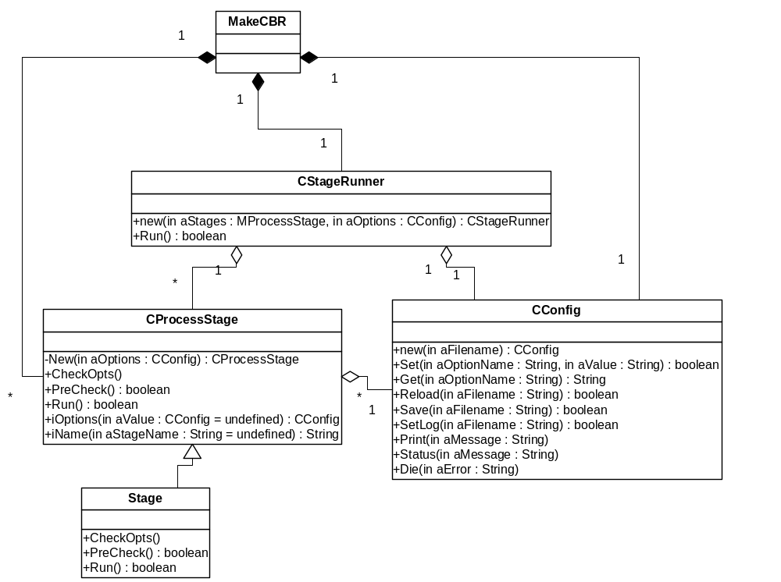

Interfacing with the build system
Preparation of the drive will use a series of standard DOS commands (subst, xcopy, copy, mkdir) to create the required environment. These commands will be added to the Master config XML file for the build system as defined in Enhanced Overnight Build Process Document [R2].
A very small Perl script will be written to kick off the MakeCBR.pl script, this script will test the return value and on non-zero return value use zip.exe to zip up the entire drive contents and place it in the location defined by the ProductPublish Environment variable.
All files in the directory specified by ProductPublish Environment variable are copied to the Publish Location specified by the Master config XML

Further Information

People
Role | Person / People
Reviewers | Uma Ahamed, Kanta Vekaria, George Sin, Richard Hulbert, Mark Shackman
Contributors | Iain Williamson, Andrew Beck
Distribution | Productisation (kits), Build & CM

References
No. | Document Reference | Version | Description
[R1] | SGL.PR0080.109 How To Componentise Zephyr.v0.1.doc | 0.1 | How to Componentise Zephyr
[R2] | //PR/share/build/documents/procedures/Enhanced Overnight Build Process 0.2.doc | 0.2 | Enhanced Overnight Build Process Description

Open Issues
- Is including the GT+TV baseline in the TV components and the GT only baseline in the GT components the right thing to do?

Glossary
The following technical terms and abbreviations are used within this document.
Term | Definition
GT | Generic Technology

Document History
Date | Version | Status | Author | Description
7-1-2004 | 1.4 | Draft | Iain Williamson | Updates due to CR GSIN-5TEKY2 (relating to release of strong crypto component)
4-12-2003 | 1.3 | Draft | Iain Williamson | Minor change to knock out source coverage tests for initial release.
29-10-2003 | 1.2 | Draft | Iain Williamson | Additional stages added to design to handle additional GT-only baseline releases.  Added –p and –d flags to makecbr.pl  Additional stages added to check for changes to mrp files.
15-10-2003 | 1.1 | Draft | Iain Williamson | Extensions and slight modifications made to the original design in implementation documented.
09-09-2003 | 1.0 | Issued | Iain Williamson | Input from Mark Shackman
08-09-2003 | 0.5 | Draft | Iain Williamson | Updated following feedback from Kanta Vekaria, George Sin and review of build team input.
04-09-2003 | 0.4 | Draft | Andrew Beck | Added Build Team Input and updated to Reference Zephyr instead of Typhoon.
22-08-2003 | 0.3 | Draft | Iain Williamson | Changed stages to take account of being run as part of the overnight build, cleared up open issues.
23-07-2003 | 0.2 | Draft | Iain Williamson | Elaborated on stages, added stage design section
16-07-2003 | 0.1 | Draft | Iain Williamson | First draft based on SGL.PPS001.500 Lightweight Document Template Rev 8.1

