1)Find all the information about each products

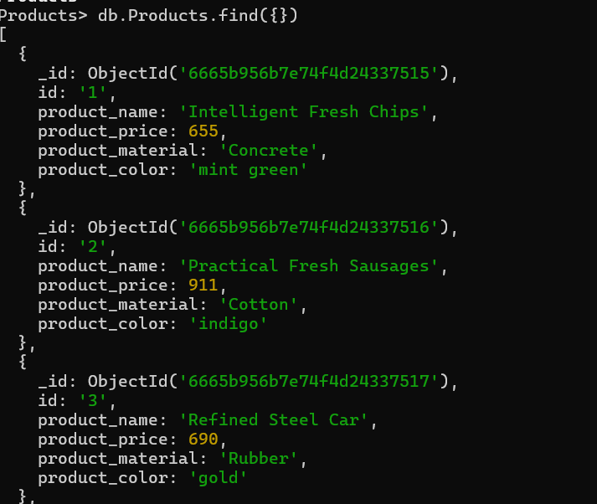

2) Find the product price which are between 400 to 800

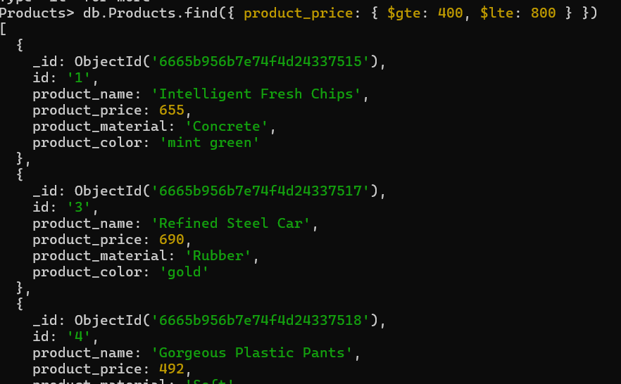

* Find the product price which are not between 400 to 600

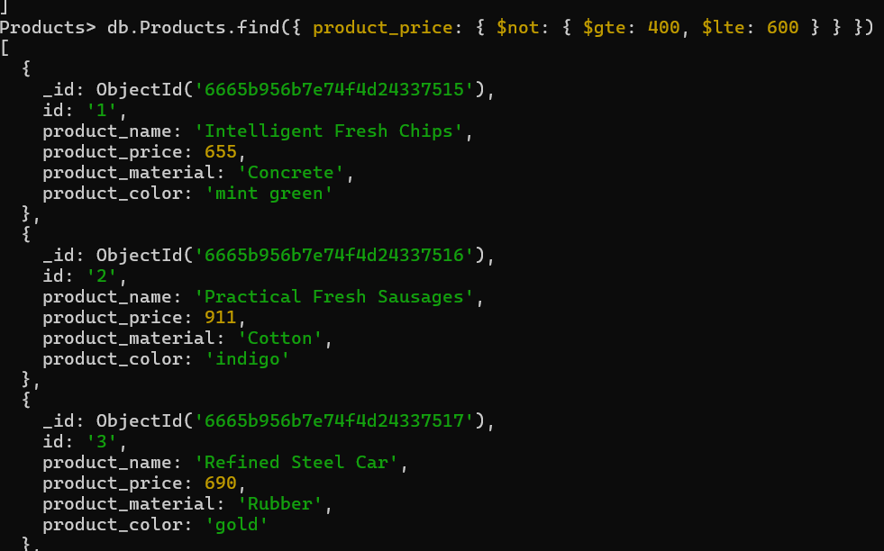

* List the four product which are greater than 500 in price

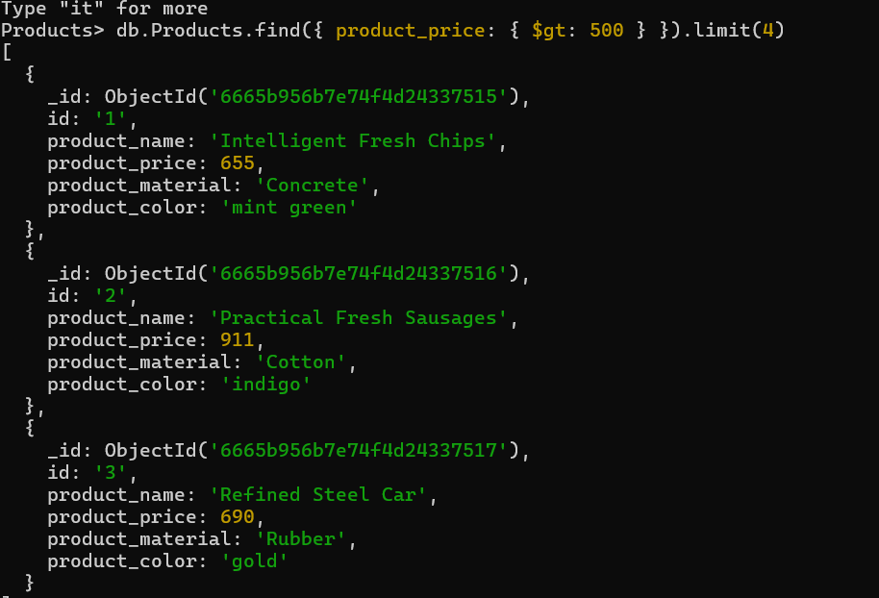

* Find the product name and product material of each products

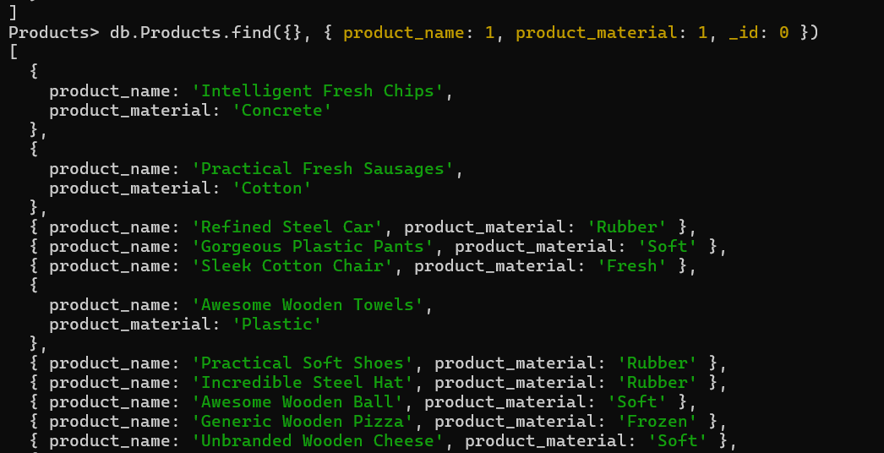

* Find the product with a row id of 10

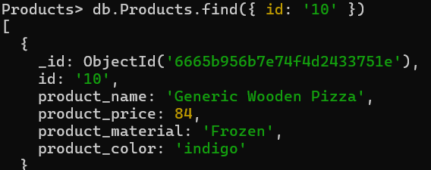

* Find only the product name and product material

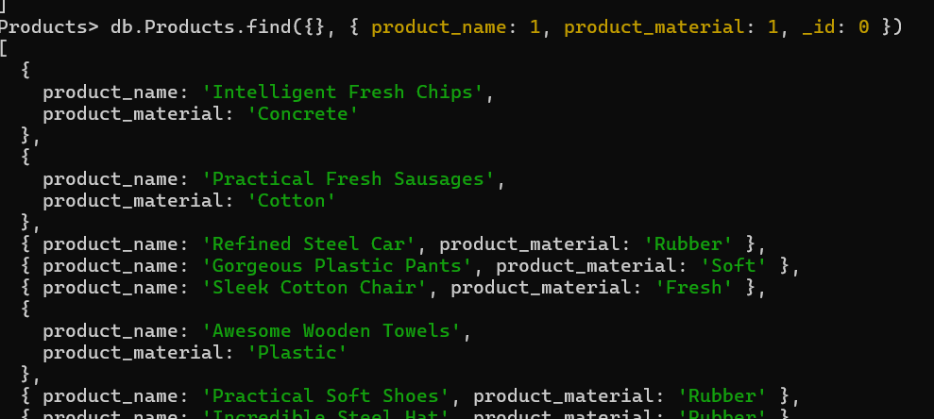

Find all products which contain the value of soft in product material

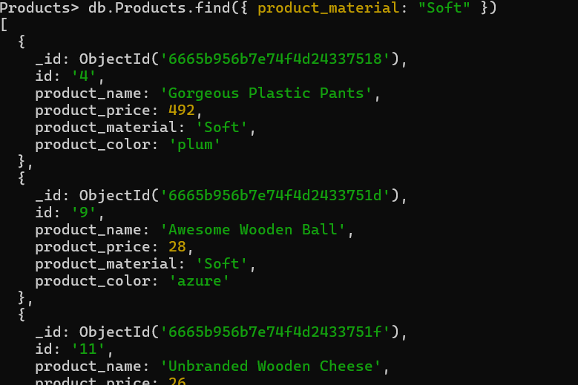

* Find products which contain product color indigo  and product price 492.00



* Delete the products which product price value are 28

