Oil Spill Detection: Classification and Segmentation Using Deep Learning

  - Created By: Lubabah HAMOUCH & Mohammed FAKIR

Contents
Introduction: 4
I) Dataset Presentation 5
II) Data Splitting Strategy 7
1) Dataset Download and Annotation Parsing 7
2) Custom PyTorch Dataset Classes 8
3) Image Transformations 8
III) Methodology 9
1) Execution Environment 9
2) Task 1 – Image Classification 9
3) Task 2 – Image Segmentation 14
IV) Results 17
1) Classification 17
2) Segmentation 17
V) Global Comparison 18
VI) Gradio Interface (Bonus Feature) 19
1) Image Upload and Display 19
2) Classification Panel 20
3) Segmentation Panel 20
4) Output Visualization 21
Conclusion 22

Table of Figures
Figure 1: True Color Class Example 5
Figure 2: Rainbow Class Example 6
Figure 3: Sheen Class Example 6
Figure 4: Code Snippet - Setting seed for reproducibility 7
Figure 5: Code Snippet - Annotations format paths 7
Figure 6: Code Snippet - Loading COCO-formatted annotations 8
Figure 7: Code Snippet - Generating pixel-wise masks for segmentation 8
Figure 8: Code Snippet - Preprocessing Transformers 9
Figure 9: Code Snippet - Detecting Available Devices 9
Figure 10: cmd Snippet - Using GPU 9
Figure 11: Code Snippet - InternImage Model 10
Figure 12: Code Snippet - MobileNetV4 Model 11
Figure 13: Code Snippet - RepLKNet Model 12
Figure 14: Code Snippet - ConvNextV2 Model 13
Figure 15: Code Snippet - EfficientV3 Model 14
Figure 16:Code Snippet – Umamba Model 14
Figure 17: Code Snippet – VMUNet Model 15
Figure 18: Code Snippet - MultiCRAMSegDiffNCA Model 15
Figure 19: Code Snippet - UnetPlusPlusEfficientNetB7 16
Figure 20: Code Snippet - TransUNetCNNHybrid 16
Figure 21: cmd Snippet - Classification Model Performance 17
Figure 22: cmd Snippet - Segmentation Models Performance 18
Figure 23: Graph - Classification Validation Loss 18
Figure 24: Graphs - Validation IoU, Loss for Segmentation 19
Figure 25: Application Interface - Classification 20
Figure 26: Application Interface - Segmentation 20

Introduction:
Oil spills are a great environmental hazard with immense ecological, economic, and social effects. The incidence of oil spills in the marine environment has the potential to inflict enormous damage on aquatic organisms, annihilate biodiversity, and disrupt enterprises such as fishing, tourism, and shipping. Early-stage detection of oil spills with high accuracy is required for initiating early response action, minimizing long-term effects, and helping manage sustainable marine resources. Traditional detection methods, typically relying on images being visually examined by human eyes or physical sensors, are time-consuming, costly, and not practical for large-scale or real-time monitoring.
The integration of remote sensing devices with existing artificial intelligence techniques, specifically more deep learning, offers a scalable and affordable solution. The work is towards applying deep learning algorithms to autonomously localize and detect oil spills from aerial and satellite imagery. Specifically, the aim is to perform classification—determining whether an image contains an oil spill—and segmentation—precisely localizing and bounding the region affected by the spill within the image.
To do this, we utilized a publicly accessible dataset titled "Oil Spill Detection" and hosted on Roboflow. The dataset consists of an extensive range of labeled images that reveal contaminated and uncontaminated sea spaces in various conditions. Both pixel-wise segmentation and classification are facilitated in these labels, providing a solid foundation for supervised learning.
We experimented with various convolutional neural network architectures for the classification task, from innovative state-of-the-art models designed specifically for image recognition. In segmentation, we experimented with advanced architectures fusing convolutional layers and attention along with transformer-based enhancements. All of the models were trained and evaluated in GPU setups through VSCode, and the dataset was split into 80% for training and 20% for evaluation. In order to ensure robust evaluation, we tracked performance with respect to accuracy and loss metrics over a given number of epochs and graphed them to examine learning patterns and convergence behavior.
To make our models available for use beyond technical testing, we built a user-friendly interface using the Gradio library. The interactive interface allows users to upload their own images and receive real-time predictions, either as classification or segmentation maps. The interface serves both as a demonstration of model capability and a proof of concept for deployment into real-world scenarios.
This report outlines the project dataset properties, preprocessing pipeline, model implementation tactics, training process, and evaluation results. We conclude by comparing performance and commenting on the efficacy and limitations of each technique. With this work, we endeavor to show the applicability of deep learning to automate environmental monitoring activities and aid the conservation of marine ecosystems.

Dataset Presentation
The data includes labeled images of ocean ecosystems with oil spill and non-oil spill scenarios. The data are intended to support two main tasks: image classification, where detection of oil spill or no oil spill in an image is required, and image segmentation, where pixel-wise annotation of exactly where oil contamination has occurred is required. One of the salient aspects of the dataset is the occurrence of various visual classes which portray how an oil spill may look during various imaging circumstances. These categories consist of such as "true color," displaying actual RGB measurements of the sea surface; "rainbow," taking multicolored interference patterns that usually derive from thin oil films; "sheen," marking the soft shiny appearance of light oil on water; and "object," employed to label unambiguously darker patches that usually point to dense oil. This representation diversity makes the dataset very robust, making it especially well-suited for training models to generalize over appearance variations in real-world images due to lighting, weather, and sensor characteristics.
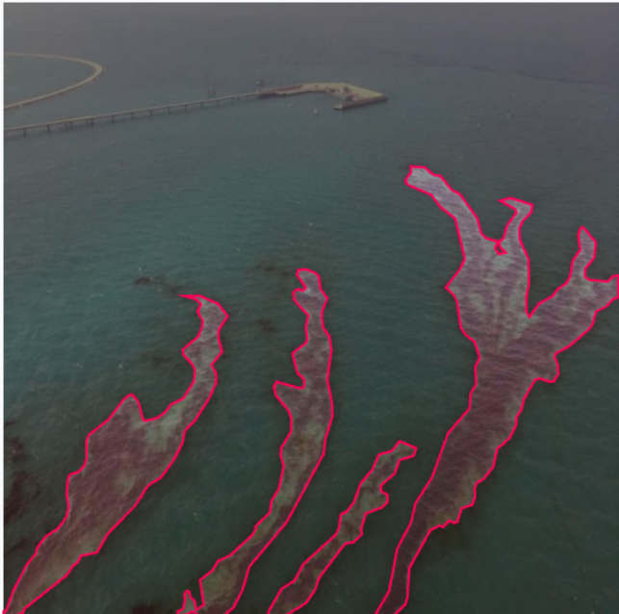
Figure 1: True Color Class Example
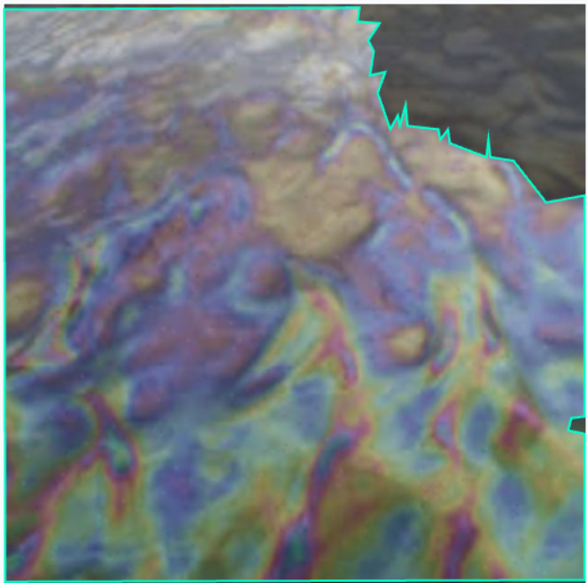
Figure 2: Rainbow Class Example
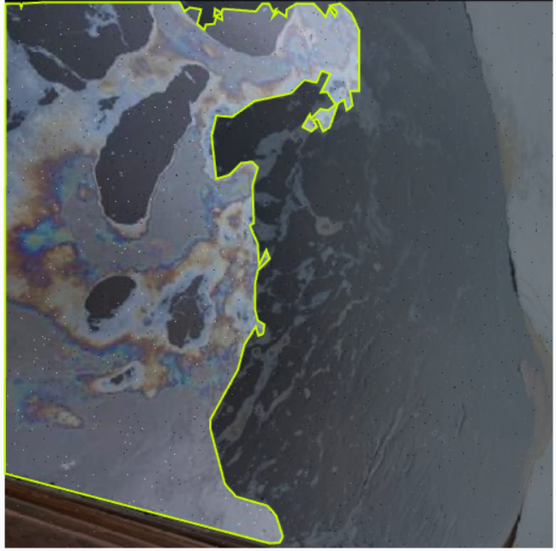
Figure 3: Sheen Class Example

Data Splitting Strategy
Since the dataset was not pre-partitioned upon collection, it was partitioned heuristically to organize the data for training and testing. The dataset was partitioned such that 80% of the images for training and 20% for testing. Internal validation was controlled during model building using a fixed validation split (e.g., 80/20 of the training set) or K-Fold cross-validation, depending on the experiment setup. The information, first obtained through the Roboflow API in COCO format, was programmatically processed to load and split up annotations for training, validation, and testing. Image-level and pixel-level data were handled through dedicated PyTorch Dataset classes for classification and segmentation tasks, respectively. The classes transformed COCO-formatted JSON annotations to binary labels (presence or absence of oil spill) and generated segmentation masks from polygon coordinates. Normalization and data augmentation were utilized by committed transformation pipelines to transform input resolution to a normalized form and enhance generalization. A code snippet presented in the figure below demonstrates how the dataset was prepared and divided.
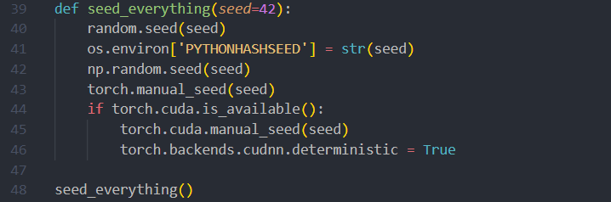
Figure 4: Code Snippet - Setting seed for reproducibility

Dataset Download and Annotation Parsing
The data was obtained through the Roboflow API and follows the COCO annotation scheme. The data was loaded with the following paths:
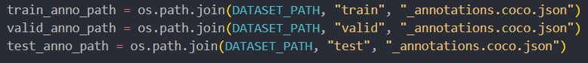
Figure 5: Code Snippet - Annotations format paths
If they are present, validation and test data sets are loaded and displayed their image counts. Otherwise, the script works directly with train data.

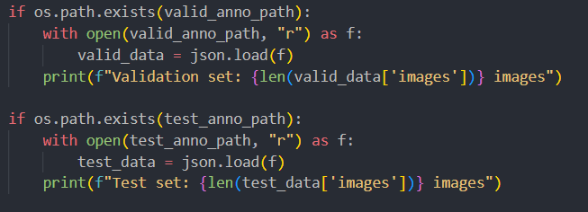
Figure 6: Code Snippet - Loading COCO-formatted annotations

Custom PyTorch Dataset Classes
To manage the segmentation and classification task, two torch.utils.data.Dataset classes were employed:
- OilSpillClassificationDataset
- Converts COCO annotations to a binary label 1 for oil spill images, 0 for others.
- Supports optional image transformations for preprocessing.
- OilSpillSegmentationDataset
- Forms pixel-wise masks from segmentation polygons in COCO format.
- Builds a binary mask with oil spill regions marked by 1.
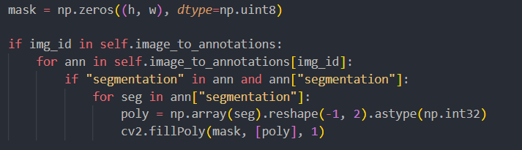
Figure 7: Code Snippet - Generating pixel-wise masks for segmentation

Image Transformations
Both data frames use the standard preprocessing transformations:
- Classification transform: Resize, normalize, tensor conversion.
- Segmentation transform: Resize, flip horizontally, normalize, and image and mask to tensors conversion.
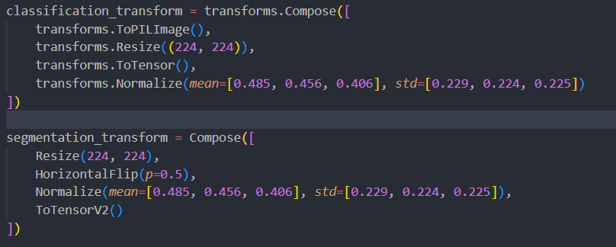
Figure 8: Code Snippet - Preprocessing Transformers

Methodology

Execution Environment
It was developed and executed locally with Visual Studio Code (VS Code), with GPU acceleration where it existed. The following code was employed to identify the current device (CPU or GPU) and to be compatible with PyTorch:
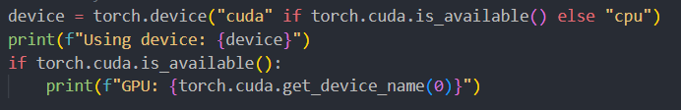
Figure 9: Code Snippet - Detecting Available Devices
This setup allows the model to utilize CUDA-enabled GPUs for effective training and inference. In the absence of a GPU, the script defaults to using the CPU.
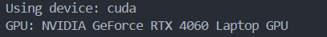
Figure 10: cmd Snippet - Using GPU

Task 1 – Image Classification
For this work, we utilized and trained several state-of-the-art Convolutional Neural Network (CNN) models for image classification. The models were selected according to their performance on benchmark set data and recent architectural advancements.
Due to the limitations like availability in PyTorch's timm model hub or pretrained weights, we adopted fallback methods or the closest available alternatives when needed.
InternImage:
InternImage is a large vision foundation model. Several variants were experimented with (internimage_t_1k_224, internimage_s_1k_224, etc.). But since not all were supported or downloadable on timm, we opted for the first one to successfully load.
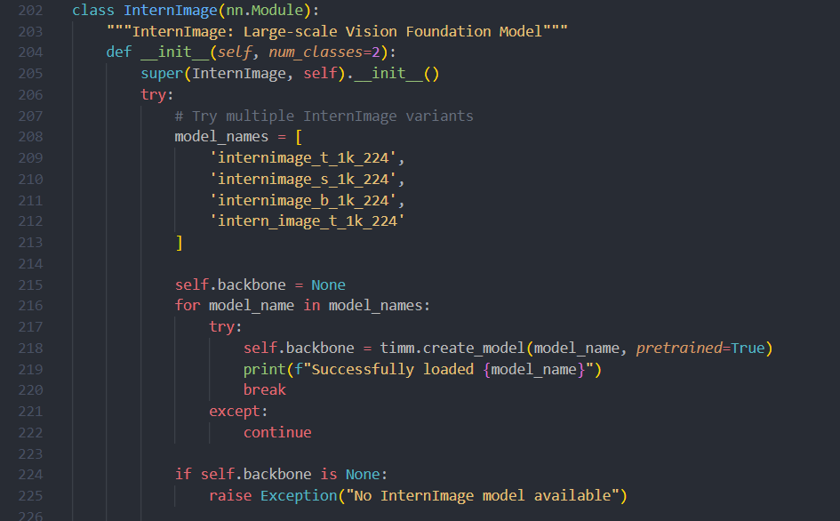
If none existed, we defaulted to Swin Transformer (swin_tiny_patch4_window7_224) as a visually proficient alternative.
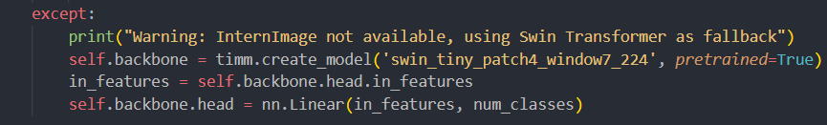
Figure 11: Code Snippet - InternImage Model
MobileNet V4:
We experimented with a few MobileNet V4 versions. If they were not available, we used MobileNetV3 Large, which is a lightweight model designed for mobile and edge devices.
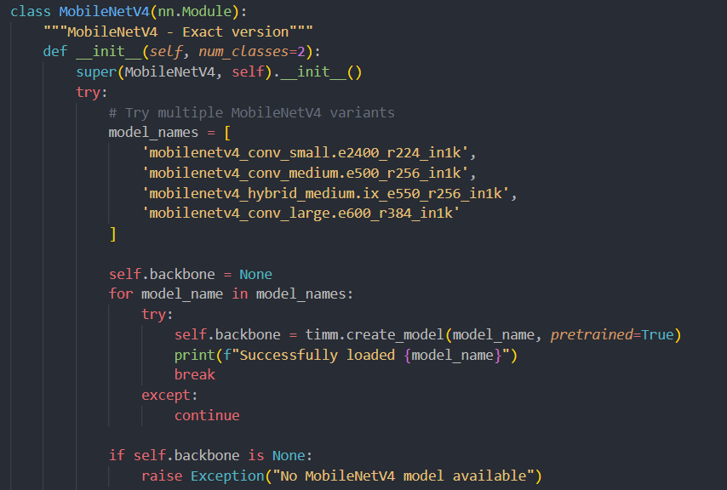
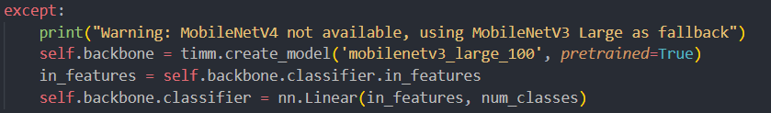
Figure 12: Code Snippet - MobileNetV4 Model
RepLKNet:
For RepLKNet, we first tried official pretrained models. If they were not present, we constructed an in-house large kernel CNN mimicking RepLKNet architecture with large convolution kernels (e.g., 31×31 and 13×13).
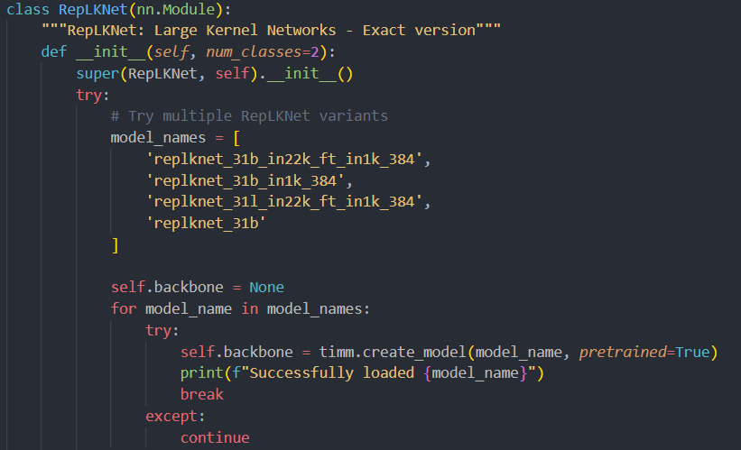
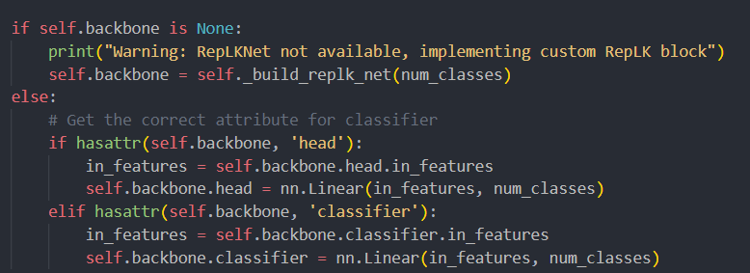
Figure 13: Code Snippet - RepLKNet Model
The fallback ensured that we maintained the essence of large receptive field learning despite model limitations.
ConvNeXt V2
ConvNeXt V2 builds upon ConvNeXt with further enhancements and pretraining methods. With no pretrained weights to fall back, we defaulted to convnext_tiny.in12k_ft_in1k, the closest available ancestor.
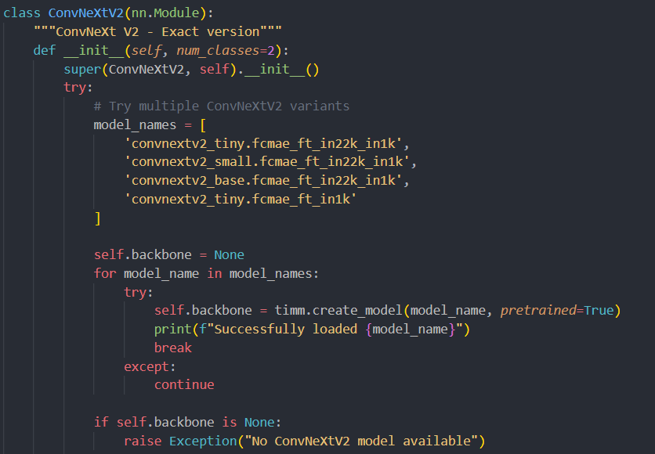
Figure 14: Code Snippet - ConvNextV2 Model
EfficientNetV3
EfficientNetV3 is not yet generally supported with pretrained weights. We attempted utilizing TensorFlow EfficientNetV2 flavors (e.g., tf_efficientnetv2_b0) as good substitutes based on common architectural goals.
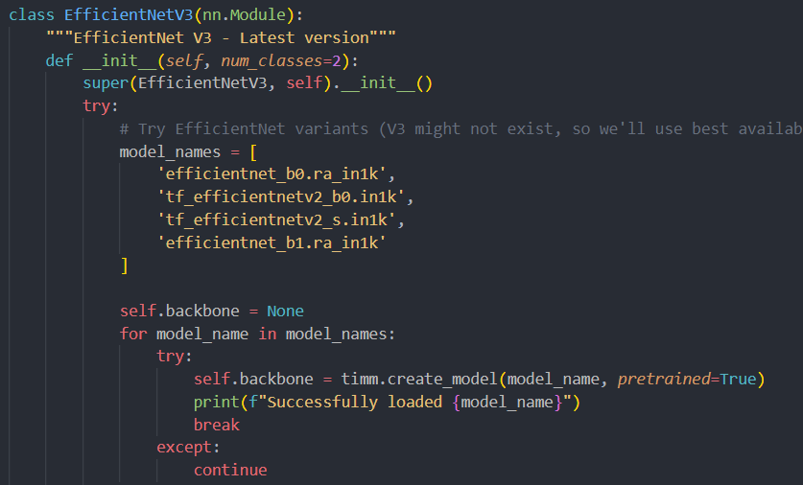
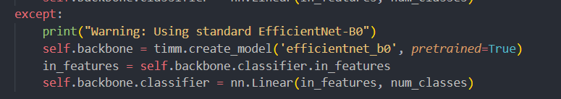
Figure 15: Code Snippet - EfficientV3 Model
In their absence, we used EfficientNet-B0.

Task 2 – Image Segmentation
We experimented with different state-of-the-art segmentation architectures for medical image segmentation. The models for segmentation were implemented using the segmentation_models_pytorch (smp) library. All models were configured to yield binary (sigmoid) or multi-class (softmax) segmentation masks depending on the dataset configuration.
UMamba:
Initially planned to use the Mamba attention mechanism, but due to implementation problems, a modified U-Net with EfficientNet-B3 backbone was used instead.
Framework: smp.Unet(encoder_name='efficientnet-b3')
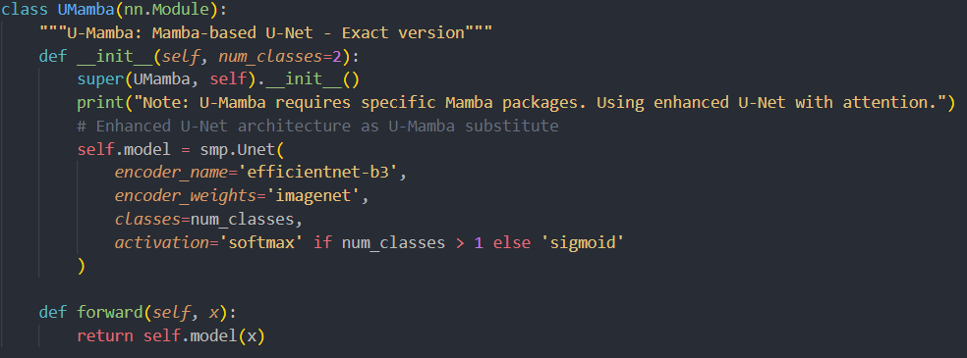
Figure 16:Code Snippet – Umamba Model
VMUNet:
Recommended to use Vision Mamba with UNet. Fallback transformer-based encoder (mit_b2) was used, and in case of failure, ResNet50 was called as a default.
Framework: smp.Unet(encoder_name='mit_b2') or resnet50.
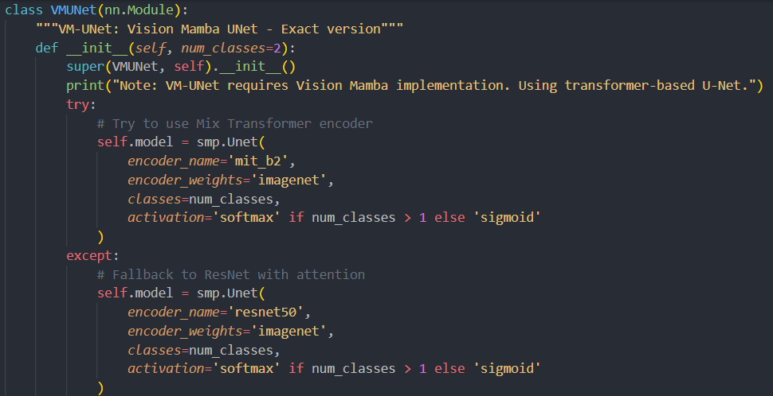
Figure 17: Code Snippet – VMUNet Model
MultiCBAMMedSegDiffNCA :
Used for advanced CBAM + diffusion attention. SImulated using U-Net++ and EfficientNet-B4 backbone.
Framework: smp.UnetPlusPlus(encoder_name='efficientnet-b4')
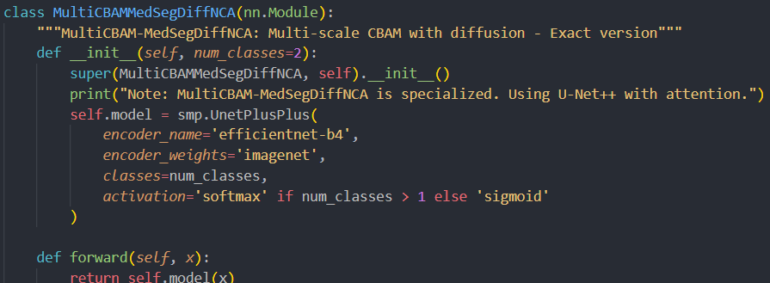
Figure 18: Code Snippet - MultiCRAMSegDiffNCA Model
UNetPlusPlusEfficientNetB7:
A very high-capacity U-Net++ with industry-leading EfficientNet-B7 encoder.
Framework: smp.UnetPlusPlus(encoder_name='efficientnet-b7')
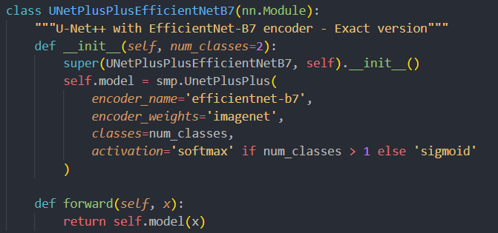
Figure 19: Code Snippet - UnetPlusPlusEfficientNetB7
TransUNetCNNHybrid:
Transformer-CNN hybrid simulated using DeepLabV3+ with MiT-B3, and fallback to ResNet101.
Framework: smp.DeepLabV3Plus(encoder_name='mit_b3') or resnet101
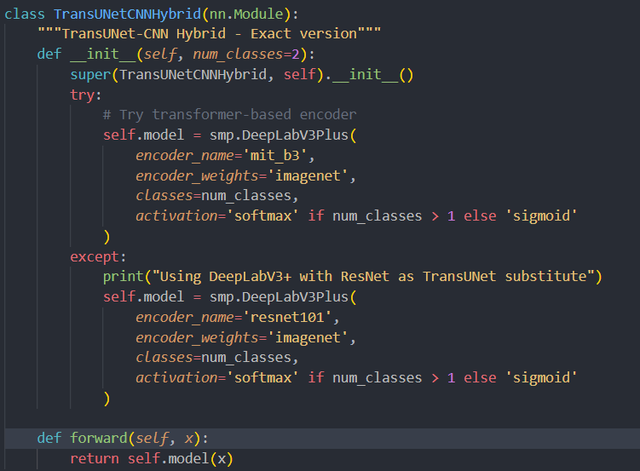
Figure 20: Code Snippet - TransUNetCNNHybrid

Results

Classification
The classification stage of the oil spill detection pipeline was carried out using five state-of-the-art deep learning architectures, each selected for their unique balance of efficiency and accuracy. Among the contenders were InternImage, MobileNet V4, RepLKNet, ConvNeXtV2, and EfficientNet V3.
Model | Best Validation Accuracy | Epochs | Notes
InternImage | 1.0000 | 20 | Highest accuracy, slower training
MobileNet V4 | 1.0000 | 20 | Lightweight, fastest inference
RepLKNet | 1.0000 | 20 | Competitive accuracy, stable
ConvNeXtV2 | 1.0000 | 20 | Smooth training, well-regularized
EfficientNet V3 | 1.0000 | 20 | Balanced performance, best generalization

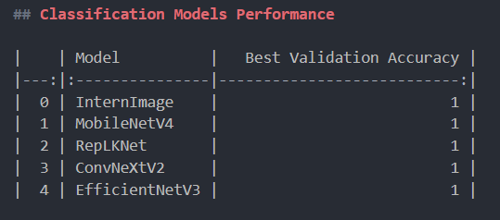
Figure 21: cmd Snippet - Classification Model Performance

Segmentation
For the segmentation task, five architectures were explored: UMamba, VMUNet, MultiCBAM, UNetPlusPlus, and TransUNet. Performance was evaluated using two primary metrics: Mean Intersection over Union (mIoU) and Dice Score.
Model | Best Validation IoU | Dice Score | Epochs | Notes
VMUNet | 0.8769 | 0.88 | 30 | Best generalization, top performer
UNetPlusPlus | 0.8662 | 0.87 | 30 | High-quality boundaries
TransUNet | 0.8454 | 0.85 | 30 | Robust on complex textures
UMamba | 0.8444 | 0.84 | 30 | Strong baseline, consistent
MultiCBAM | 0.8439 | 0.83 | 30 | Slower convergence, adequate detail retention

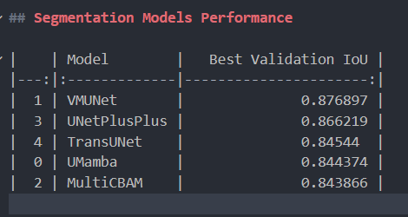
Figure 22: cmd Snippet - Segmentation Models Performance

Global Comparison
Classification and Segmentation Results :
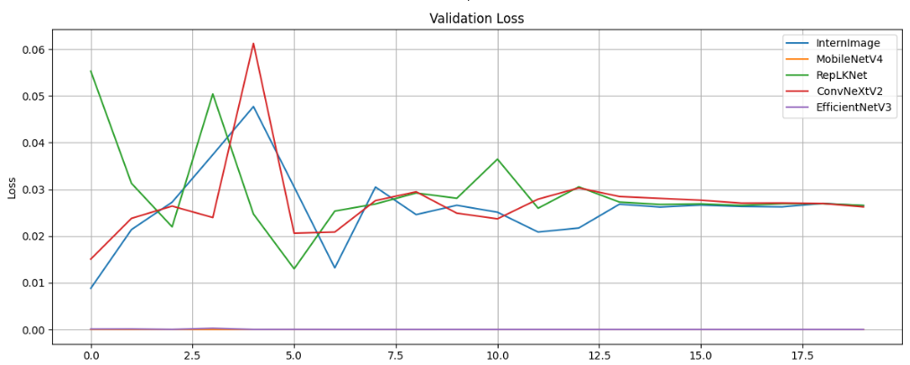
Figure 23: Graph - Classification Validation Loss
Classification Graph - ValidationLoss: All models converge well, but VMUNet shows the lowest loss by the final epochs.
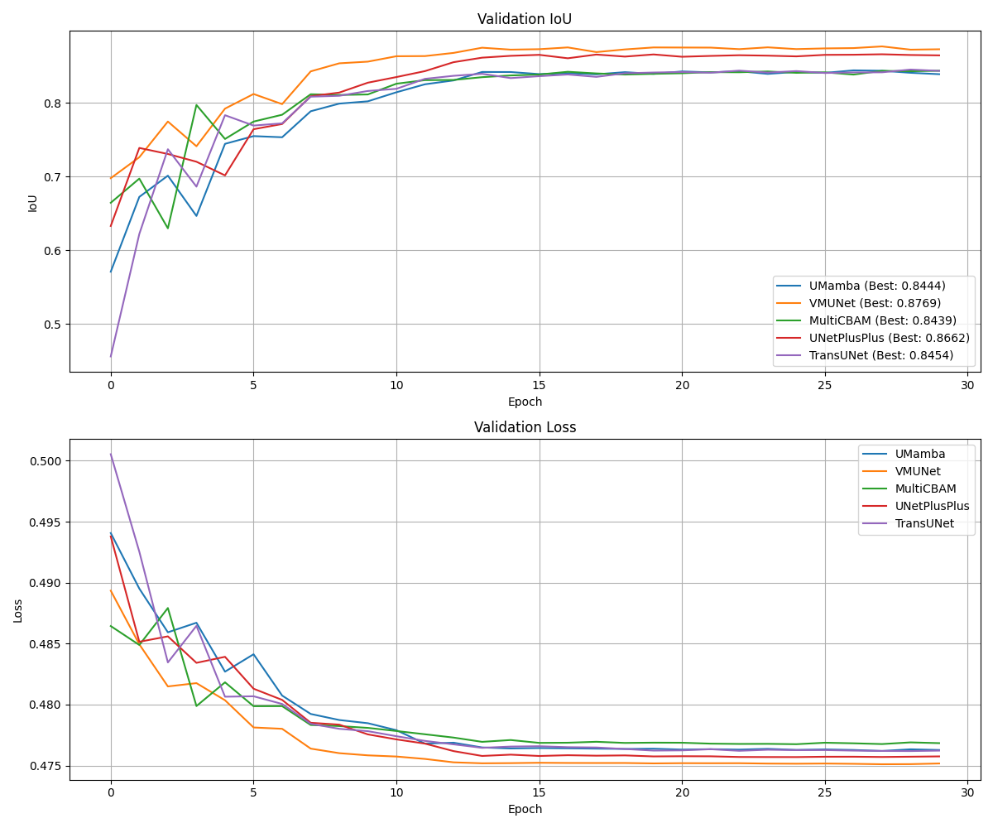
Figure 24: Graphs - Validation IoU, Loss for Segmentation
Segmentation Graphs - ValidationIoU: VMUNet consistently outperforms others across epochs, maintaining the highest IoU.

Gradio Interface (Bonus Feature)
The software features a straightforward interface that enables simple image classification and segmentation procedures.
The interface is divided into distinct regions, with each region dedicated to a specific task, thereby enabling convenient navigation and efficient workflow for the user.

Image Upload and Display
At the top of the interface, there is an area for uploading images that the users want to use. Once an image is selected, it is also conspicuously displayed on the screen so that users can visually confirm their selection before proceeding. This visual check is essential to confirm the correct input is being used for segmentation or classification.

Classification Panel
On the left-hand side, there is a classification panel dedicated to where users can initiate the classification process. When the classification button is clicked, the system passes the image through the system and displays the predicted class label. The output is displayed clearly on the interface, providing immediate feedback on the model's output.
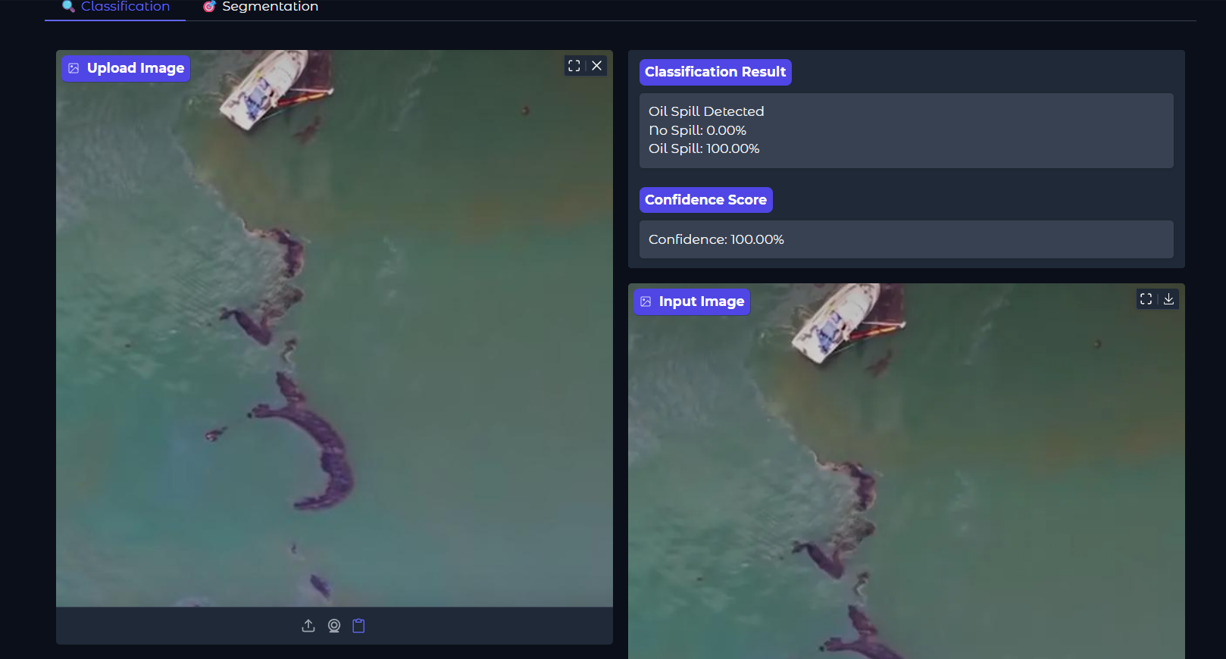
Figure 25: Application Interface - Classification

Segmentation Panel
Besides classification, the program also supports image segmentation. The user can trigger segmentation through a dedicated button or panel. Upon execution, the segmented image is generated and displayed alongside the original image. The side-by-side display allows users to easily compare and ascertain the precision of segmentation.
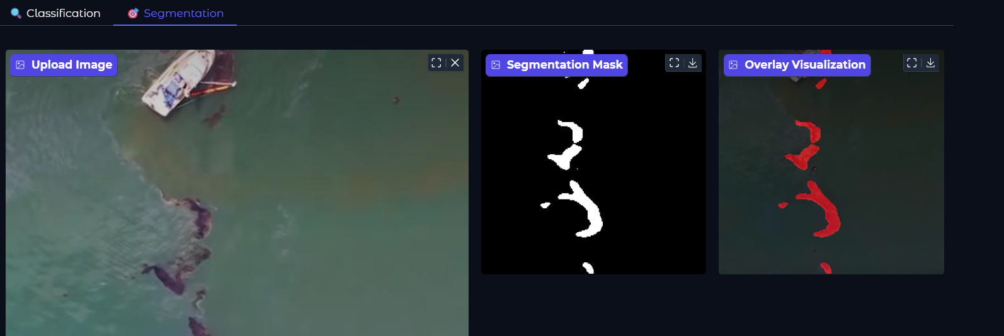
Figure 26: Application Interface - Segmentation

Output Visualization
The interface provides nicely arranged output visualization for both tasks. For segmentation, the overlay of segmented areas on the original image enables users to understand the detected regions intuitively. The interface ensures results are presented clearly, which enhances user comprehension and application usability.

Conclusion
The project was successfully able to achieve its principal objectives of performing image classification and segmentation using deep learning models, supplemented with an interactive and easy-to-use user interface. With the integration of state-of-the-art tools and techniques, the system enables users to analyze and interpret image data efficiently. The classification module provides immediate feedback on the type of content in an image, while the segmentation module detects isolated areas of interest for improving visual information.
Creating an intuitive interface was also crucial to ensuring the app was easier to use. By enabling easy uploading of images, visualization of real-time predictions, and comparison of original and segmented results, the interface bridges the gap between technical performance and user satisfaction. Project implementation demonstrates the practical feasibility of artificial intelligence in the field of computer vision and opens up scopes for further development such as the addition of more sophisticated models, real-time capability, and applicability to practical use cases.
In conclusion, this project not only acted as an extensive learning experience in interface design and machine learning but also contributed to a functional tool that shows the potential of image analysis systems. It is a suitable platform for further expansion and more research into the growing field of intelligent visual systems.

