**GLOW 2024**  
Implement code to send the number of present sensors to the server

Table of Contents

Introduction 1

Results 1

Conclusion 2

Introduction

In this document we will describe the steps taken to make sure that the client sends the number of present sensors to the server. In other words, the number of sensors that measure something between 7 cm and 2 meters will be sent to the server. The server uses this value to control the music. In addition, the client can use the value to change the lighting. The tube has 16 sensors in total. This means that the value can vary from 0 to 16.

Results

At the moment the client only sends the distance in centimeters to the serial monitor, see this [Github-repository](https://github.com/Glow-Delta/Client/commit/30bd0f009c3f1fdae9f6009d4380fd5e34ce0a1a). We noticed that not all the sensors were activated in a consequent sequence. This means that simply incrementing an integer if one of the 16 sensors measures something between 7 centimeters and 2 meters will not work. Therefore, we implemented a new technique. We created an array which keeps track of the activated status of each sensor (in this code only 8 sensors were used). With the use of a UpdateSensorStatus() and GetAmountOfPresentSensors()-methods we could get a value of 0 to 8. This value can be sent to the server. See Figure 1.

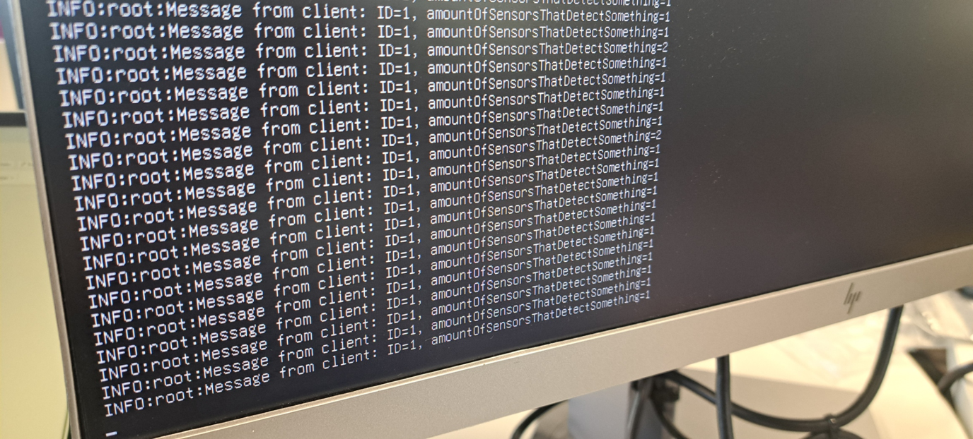

Figure 1 Server receives number of present sensors.

Sometimes the value does not reach 0 again, when none of the sensors is activated. The core functionality works, but there is some extra optimization necessary. See the code in this [Github-repository](https://github.com/Glow-Delta/Client/blob/e7f7b3df5b260384a8f701e7d526ce1fe4275f6a/ClientCode/ClientCode.ino).

Conclusion

The client code on the Arduino is now able to send the number of present sensors to the server. The client can use this value to change the light itself, and the server can use this to change the music. In some rare cases the value does not reach 0 again, when nothing should be detected by the sensors. Further optimization is needed.