To: Dr. Satici, Brian Higgins

From: Robotic Vision Team: Daniel Pullicar, Roscoe Ambrose, Mason Cannon, Haston LaGrone

Subject: Update Memo 10/2 – 10/16

Date: 10/16/2022

Hello professors, this memo is a brief update on progress the robotic vision team has made in the last two weeks.

# Work Completed

Our first focus of the last two weeks was to pin down the core objective of our project. From our communication with Dr. Satici we need to do the following:

* Localize the puck with any camera that may be placed anywhere in the room with a field of view that contains the air-hockey table. (Primary Objective)
* Use multiple camera outputs to perform sensor fusion.

We also clarified a few constraints, such as the shape and color of the puck and at what level of priority the sensor fusion aspect was.

Our next focus was on bringing the group up to speed on Python, as it is the code base we will be working with the most. All respective members installed Anaconda and their choice of IDE, as well as began familiarizing themselves with the language in general.

We worked together to identify potential benchmarks for gauging our progresses with the robot and identified candidate web cameras that could improve the overall vision of the robot. Regarding progress benchmarks, there are other air-hockey playing robots in which the performance is well documented online. Comparing this footage to our eventual progress will allow the team to gauge how effective (or ineffective) our design is. We can also use the robot’s prior performance as a reference.

There are a handful of reasonably priced web cameras we identified as candidates for this project. Each carries its own benefits and downsides of which can be more closely evaluated if the decision is made to add more. Also, one candidate has a much wider field of view than the current camera and may serve as a valid replacement if that is discovered to be one of the greatest issues.

Mason Cannon took time to go into the robotics lab and check the view of both cameras mounted on the frame. He captured stills to share with the rest of the group that showed both the lack of view on the human player side, as well as a potential issue with the glare of the lights over the board. These images are shown in Figures 1 and 2 in the Appendix.

# Work Pending

Mason

* Set up Python on PC (10/21)
* Research capabilities of OpenCV (10/23)
  + Capture images through OpenCV
  + Research image processing settings in OpenCV (Run someone else’s code examples)
  + Apply and test effects
* Research CNN method (10/25)

Haston

* Set up Python on PC (10/21)
* Research capabilities of OpenCV (10/23)
  + Capture images through OpenCV
  + Research image processing settings in OpenCV (Run someone else’s code examples)
  + Apply and test effects
* Research CNN Method (10/25)

Roscoe

* Research capabilities of OpenCV (10/23)
  + Capture images through OpenCV
  + Research image processing settings in OpenCV (Run someone else’s code examples)
  + Apply and test effects
* Set up a way to adjust settings easily (Sliders/dials in a GUI for now) (10/25)

Daniel

* Research capabilities of OpenCV (10/23)
  + Capture images through OpenCV
  + Research image processing settings in OpenCV (Run someone else’s code examples)
  + Apply and test effects
* Organize/setup shared code repository (10/25)

Future ideas:

* Fuse 2 cameras (merge images)
  + Use Open CV stitching

As a team, our focus for the coming weeks is to further familiarize ourselves with OpenCV as well as continuing our research on how to implement code that will allow the robot to “see.” After becoming more familiar with OpenCV and general Python syntax it will be easier to break down the future code necessary for this project. We still need to decide if we are going to use machine learning for this project. As this will dictate much of our implementation going forward, this decision needs to be promptly made.

# Conclusion:

The last two weeks of work consisted of solidifying our foundation with the project. We have clarified the desired outcome and began familiarizing ourselves with the tools needed to accomplish this goal. Much of the focus in the coming weeks is going to be on how to implement code that can interface with the camera and convert visual data into data usable by the robot.

# Appendix A: Images

Mason’s captures of the table. Figure 1 is the view from the unconnected second camera, while Figure 2 shows the current camera’s view and shows off the glare.

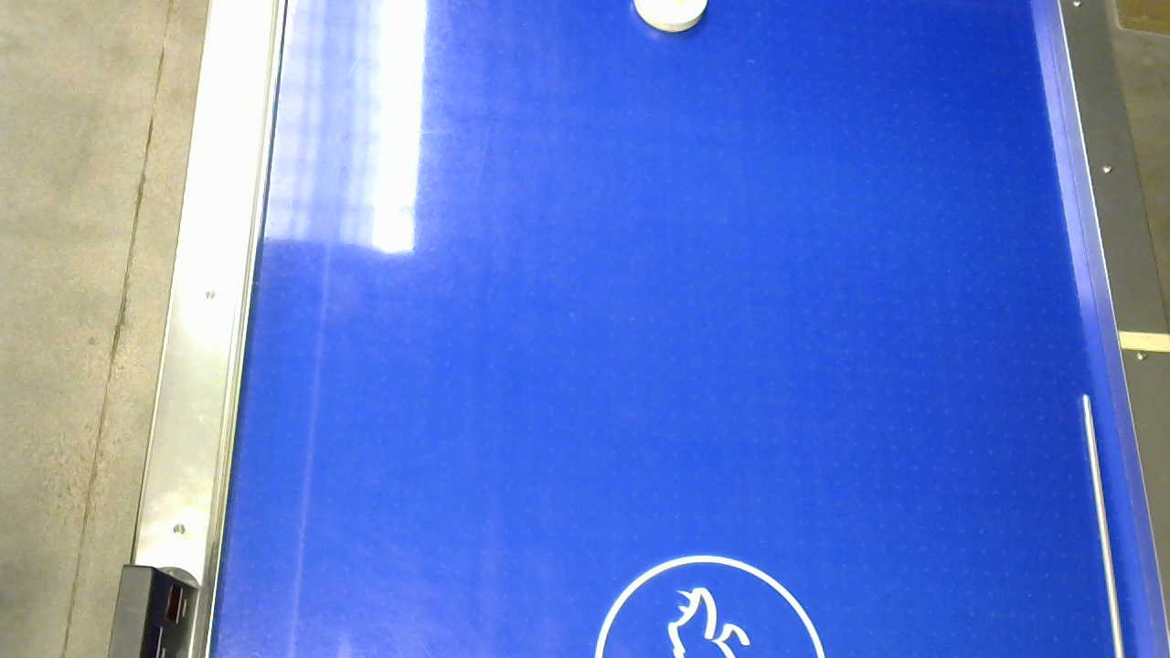

Figure 1: Secondary Camera View

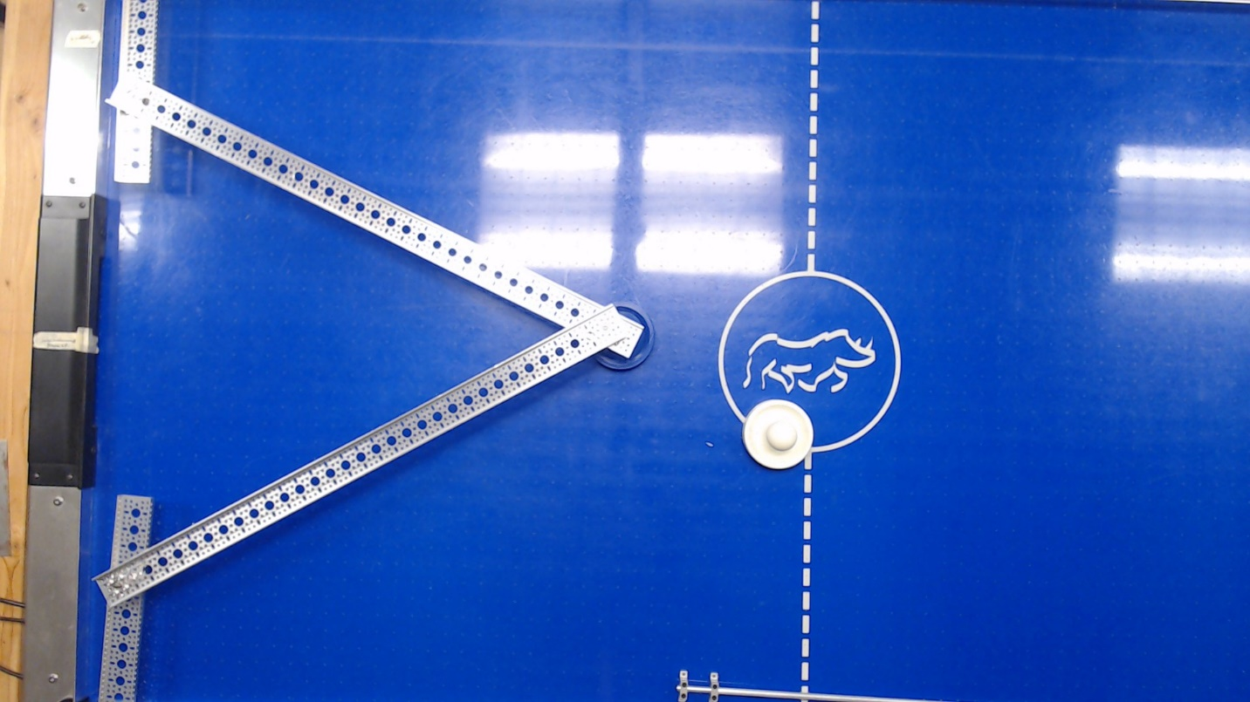

Figure : Primary Camera View