Quarto Basics

For a demonstration of a line plot on a polar axis, see Figure 1.

import numpy as np  
import matplotlib.pyplot as plt  
  
r = np.arange(0, 2, 0.01)  
theta = 2 * np.pi * r  
fig, ax = plt.subplots(  
 subplot_kw = {'projection': 'polar'}  
)  
ax.plot(theta, r)  
ax.set_rticks([0.5, 1, 1.5, 2])  
ax.grid(True)  
plt.show()

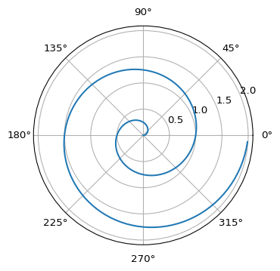

Figure 1: A line plot on a polar axis