A unique attraction is the Cable Car across the Volga River to Bor,
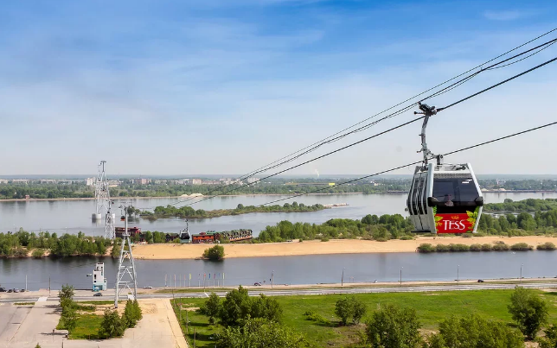
which is Europe's longest passenger cable car crossing over water. There are many iconic museums in the city: the Gorky Literary Museum in the mansion of merchant Bugrov, Gorky's Apartment Museum on Semashko Street, as well as the interactive museum "Russia - My Story" in a modern complex on Strelka. The Kremlin also has an Arsenal, a center for contemporary art.
There are many iconic museums in the city: the Gorky Literary Museum in the mansion of merchant Bugrov, Gorky's Apartment Museum on Semashko Street, as well as the interactive museum "Russia - My Story" in a modern complex on Strelka. The Kremlin also has an Arsenal a center for contemporary art.
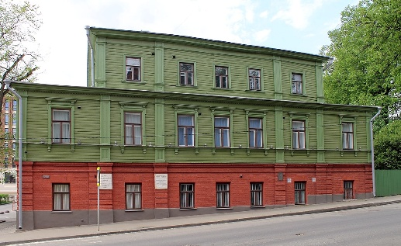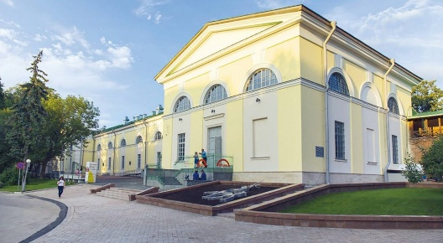
Museum of Maxim Gorky Arsenal – the art center

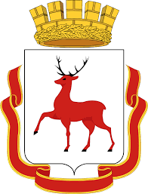

Nizhny Novgorod

Date of foundation – 1221 (second Saturday on August)

Language: Russian
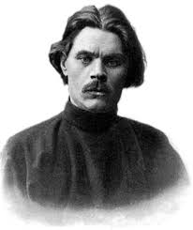

Population: 1,198,245 people
Nationalities:
- Russians — 93.93% Maxim Gorky
- Tatars — 1.33%
- Mordvins — 0.58%
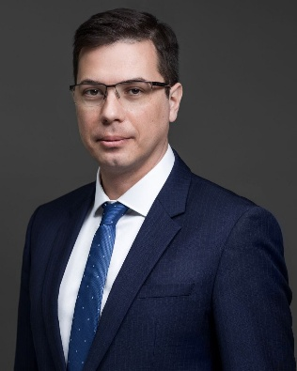
- Ukrainians — 0.53%
- Armenians — 0.40%
- and others — 3.23%
The mayor of the city - Yuri Shalabaev

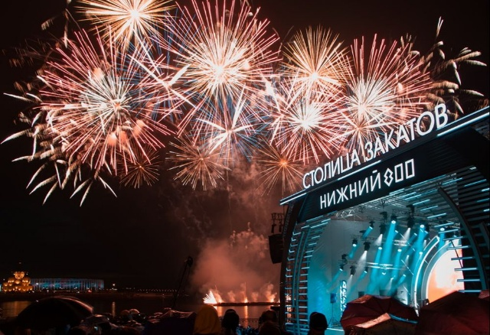

The "Stolitsa Zakatov" (Capital of Sunsets) Festival is a large summer music festival in Nizhny Novgorod that runs throughout the summer, from late May through August, at various venues across the city. It features performances by popular artists (rock, pop, indie, and electronic) and creates a unique atmosphere against the backdrop of beautiful sunsets over the Volga and Oka rivers.
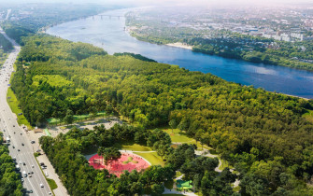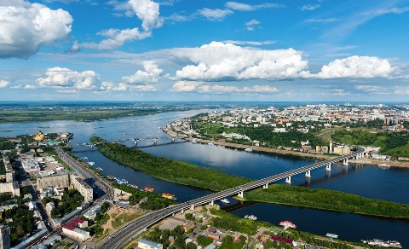
Switzerland Rivers (Oka and Volga)
Nizhny Novgorod has two main rivers: the Oka and the Volga. The city itself and its main landmark, the Kremlin, are located right where the Oka flows into the Volga.
The forests of Nizhny Novgorod and the surrounding region are mixed and broadleaf forests with oak, linden, spruce, and pine trees, home to elk, wild boar, and foxes.
The Nizhny Novgorod Kremlin is the heart of the city. Its impregnable brick walls and 13 towers of the XVI century protect the historical center. The Mikhailovsky Archangel Cathedral, the oldest temple and tomb of Kuzma Minin, is located on the territory. The Kremlin walls offer perhaps the best views of Strelka, the confluence of the Oka and Volga rivers, and the Zarechnaya part. The famous Chkalovskaya Staircase begins at the walls of the Kremlin, descending in a giant figure of eight to the Volga River and the monument to the Hero boat.
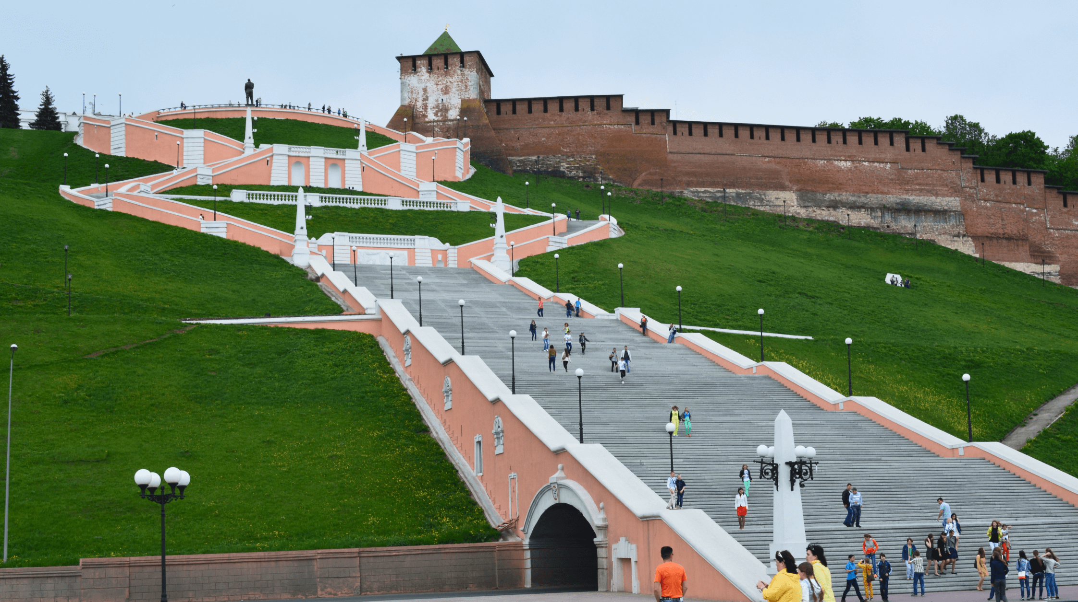
The main pedestrian artery, Bolshaya Pokrovskaya, originates from the Dmitrievskaya Tower of the Kremlin. It has completely preserved the atmosphere of a merchant city with elegant mansions, a drama theater, a neo-Russian-style State Bank building and funny bronze sculptures. In parallel, there is an equally interesting Rozhdestvenskaya Street, a reserve of merchant architecture of the 19th century. Here, the eye is attracted by the bright building of Blinovsky Passage, the magnificent Stroganov (Christmas) temple and the elegant Church of the Cathedral of the Blessed Virgin Mary.
For lovers of panoramas, the Verkhne-Volzhskaya embankment is a must. There are noble mansions here, like the Rukavishnikov Estate, and the Nizhny Novgorod State Art Museum with a collection of Russian paintings. From here, you can take the funicular down to the Nizhne-Volzhskaya embankment to the river station and the modern park.

