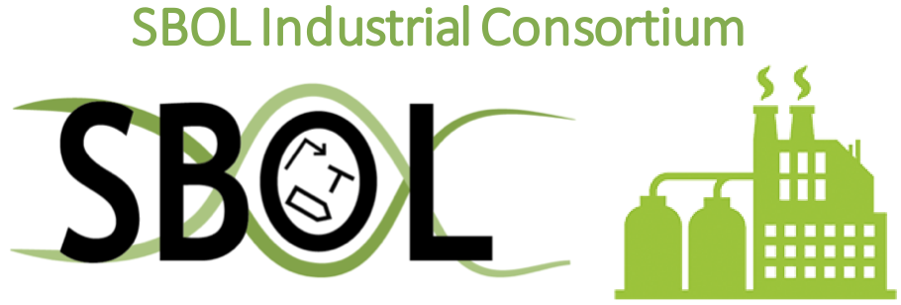**Call for Proposals:**

**SBOL Industrial 2022 Summer Program**

The SBOL Industrial Consortium is sponsoring summer projects related to SBOL, with the goal of advancing state-of-the-art technology in the fields of synthetic biology and bio-design automation through SBOL standards and associated tool development. While any project within this scope will be considered, SBOL Industrial is particularly interested in projects that provide:

* User-friendly methods for defining and encoding variant libraries
* Improved integration of SBOL with commercial design tools
* Improved visualization of SBOL information
* Integrations that overcome specific impediments to industrial applications

Additional project suggestions can be found on [the SBOL Industrial Program issue tracker](https://github.com/SynBioDex/SBOL-Industrial-Summer-Program/issues).

Project proposals are welcomed from any individual with the appropriate skills and expertise to conduct the work proposed. All projects must be supervised by a technical advisor with relevant expertise, either industrial or academic. Each project will also be assigned a liaison from the SBOL Industrial community.

Projects are intended for a 3 month summer period with compensation of $6,000 (US), though smaller-scale projects are acceptable as well. Proposals are due by February 15th, 2022, following the forms below, and will be notified of acceptance or rejection by March 15th, 2022.

Proposals should be sent to [sbol-industrial@googlegroups.com](mailto:sbol-industrial@googlegroups.com) with the following information:

**Proposer:**

Name:

Institution:

Address:

Email:

Phone:

**Project Requirements:**

Period of support requested (up to 3 months):

Proposed Technical Advisor:

**Project description:**

Please attach a 1-page description of the proposed project including:

* Description of the proposed work
* Significance of the proposed work with respect to SBOL and the larger SynBio community
* Relevant qualifications of the proposer and their technical advisor
* Specific technical goals to be accomplished
* Milestones in 1-month increments, with criteria for success or failure at each milestone