**SQL MINI PROJECT**

GROUP 8

**PROBLEM STATEMENT**: **DEVELOP A DATABASE FOR A VEHICLE RENTAL SYSTEM** (THE SYSTEM SHOULD TRACK VEHICLE DETAILS, RENTAL RECORDS, AND CUSTOMERS).

|  |  |
| --- | --- |
| **NAME** | **ROLL NO.** |
| JIT SARKAR | 23CS8036 |
| SAYAN PRAMANIK | 23CS8037 |
| MADDU JAYASREE | 23CS8038 |
| DASARI KEERTHANA | 23CS8039 |
| NARAYAN PAUL | 23CS8040 |

**TABLE CREATION**

CREATE TABLE Vehicles (

VehicleID INT PRIMARY KEY,

Model VARCHAR(50) NOT NULL,

Type VARCHAR(50) NOT NULL,

PricePerDay DECIMAL(10,2) NOT NULL,

AvailabilityStatus VARCHAR(20) NOT NULL

);

CREATE TABLE Customers (

CustomerID INT PRIMARY KEY,

Name VARCHAR(100) NOT NULL,

Contact VARCHAR(50),

LicenseNumber VARCHAR(50)

);

CREATE TABLE Rentals (

RentalID INT PRIMARY KEY,

CustomerID INT,

VehicleID INT,

RentDate DATE,

ReturnDate DATE,

TotalCost DECIMAL(10,2),

FOREIGN KEY (CustomerID) REFERENCES Customers(CustomerID),

FOREIGN KEY (VehicleID) REFERENCES Vehicles(VehicleID)

);

**INSERTION OF DATA**

INSERT INTO Vehicles (VehicleID, Model, Type, PricePerDay, AvailabilityStatus) VALUES

(1, 'Tata Nexon', 'SUV', 2500.00, 'Available'),

(2, 'Maruti Swift', 'Comfort', 1200.00, 'Available'),

(3, 'Hyundai Verna', 'Coupe', 1800.00, 'Available'),

(4, 'Mahindra Thar', 'Off-Road', 3500.00, 'Available'),

(5, 'Tata Motors', 'MPV', 3000.00, 'Available'),

(6, 'Tata Altroz', 'SUV', 2200.00, 'Not Available'),

(7, 'Honda City', 'Coupe', 2000.00, 'Available'),

(8, 'Maruti Ertiga', 'MPV', 1600.00, 'Available'),

(9, 'MG Hector', 'SUV', 2800.00, 'Not Available'),

(10, 'Hyundai i20', 'Comfort', 1400.00, 'Available');

INSERT INTO Customers (CustomerID, Name, Contact, LicenseNumber) VALUES

(101, 'Rajesh Kumar', '8765432109', 'DL-0420110034567'),

(202, 'Priya Sharma', '9876543210', 'MH-0320150076543'),

(303, 'Vikram Singh', '7654321098', 'KA-0720180089012'),

(404, 'Ananya Patel', '9988776655', 'GJ-0520190123456'),

(505, 'Suresh Reddy', '8877665544', 'AP-0620170045678'),

(606, 'Meena Verma', '9871234769', 'UP-0920160056789'),

(707, 'Arjun Kapoor', '7766554433', 'PB-0320130067890'),

(808, 'Deepika Malhotra', '9900112233', 'HR-0820140078901'),

(909, 'Rahul Gupta', '8612908747', 'TN-0220180089012'),

(1010, 'Nisha Joshi', '8899001122', 'MP-1020170090123');

INSERT INTO Rentals (RentalID, CustomerID, VehicleID, RentDate, ReturnDate, TotalCost) VALUES

INSERT INTO Rentals (RentalID, CustomerID, VehicleID, RentDate, ReturnDate, TotalCost) VALUES

(1001, 101, 1, '2025-03-01', '2025-03-05', 10000.00),

(2002, 202, 2, '2023-03-10', '2024-03-12', 2400.00),

(3003, 303, 3, '2020-03-15', '2021-03-18', 5400.00),

(4004, 404, 3, '2021-03-20', '2024-03-25', 15000.00),

(5005, 505, 4, '2022-04-01', '2025-04-03', 7000.00),

(6006, 606, 7, '2022-04-05', '2023-04-10', 10000.00),

(7007, 707, 8, '2020-04-12', '2025-04-14', 3200.00),

(7256, 101, 8, '2022-04-12', '2024-04-14', 3300.00),

(8008, 808, 10, '2021-04-18', '2023-04-22', 5600.00),

(7258, 101, 9, '2022-04-12', '2023-04-14', 3300.00),

(7265, 101, 6, '2020-04-12', '2024-04-14', 3300.00),

(9009, 909, 1, '2021-05-01', '2025-05-05', 10000.00),

(10010, 1010, 3, '2025-04-01', '2025-04-03', 3600.00);

**QUERIES**

**1.LIST OF ALL AVAILABLE VEHICLES**

SELECT * FROM Vehicles

WHERE AvailabilityStatus = 'Available';

**OUTPUT:**

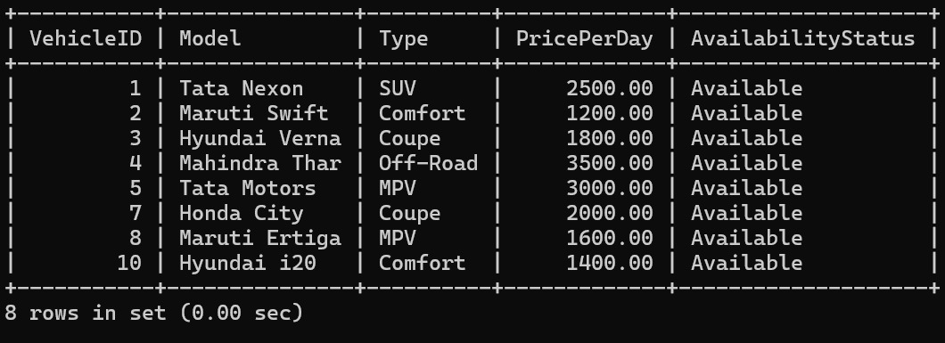

**2.GET RENTAL DETAILS OF A SPECIFIC CUSTOMER**

SELECT * FROM Rentals

WHERE CustomerID = 101;

**OUTPUT:**

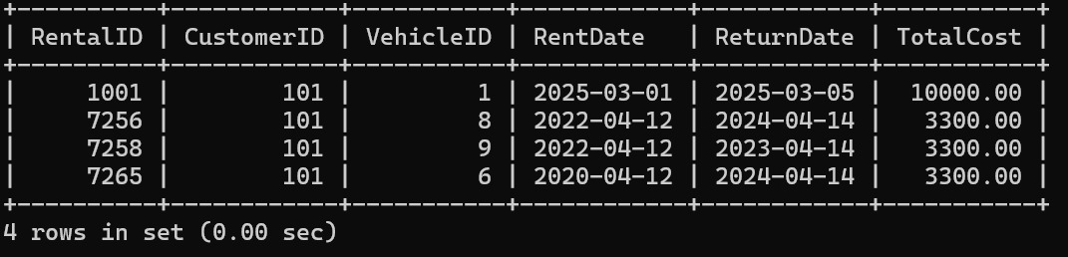

**3.CALCULATE TOTAL REVENUE FROM RENTALS**

SELECT SUM(TotalCost) AS TotalRevenue FROM Rentals;

**OUTPUT:**

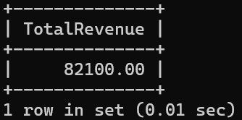

**4.FIND CUSTOMERS WHO RENTED MORE THAN 3 TIMES**

SELECT CustomerID, COUNT(*) AS TotalBookings

FROM Rentals

GROUP BY CustomerID

HAVING COUNT(*) > 3;

**OUTPUT:**

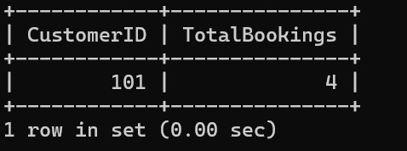

**5.UPDATE VEHICLE AVAILABILTY AFTER A RENTAL**

UPDATE Vehicles

SET AvailabilityStatus = 'Not Available'

WHERE VehicleID = 2;

SELECT * FROM Vehicles;

**OUTPUT:**

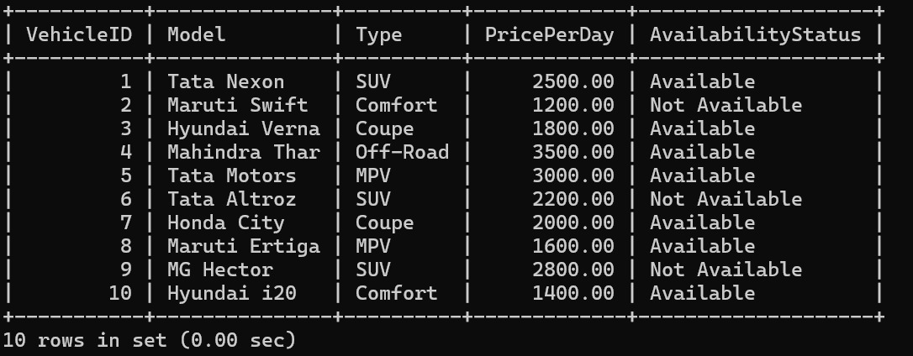

**6.RETRIEVE RENTAL RECORDS FOR THE LAST 30 DAYS**

SELECT * FROM Rentals

WHERE RentDate >= CURDATE() - INTERVAL 30 DAY;

**OUTPUT:**

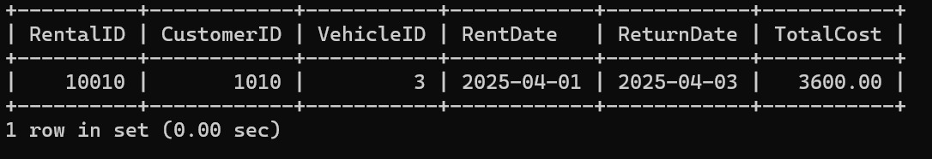

**7.DELETE OLD RENTAL RECORDS OLDER THAN A YEAR**

DELETE FROM Rentals

WHERE RentDate < CURDATE() - INTERVAL 1 YEAR;

SELECT * FROM Rentals;

**OUTPUT:**

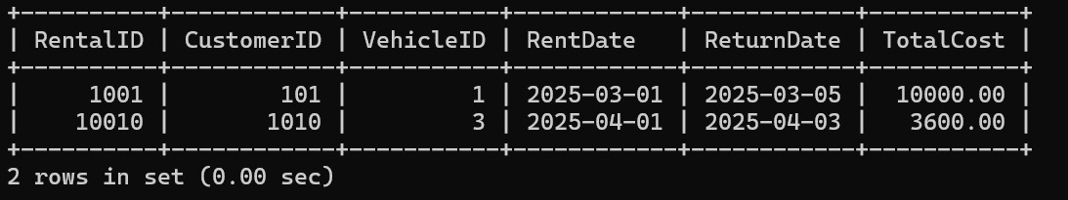

**8.IDENTIFY MOST FREQUENTLY RENTED VEHICLES**

SELECT VehicleID, COUNT(*) AS TimesRented

FROM Rentals

GROUP BY VehicleID

ORDER BY TimesRented DESC;

**OUTPUT:**

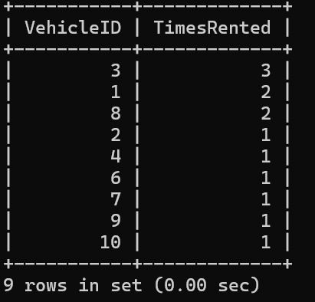

**9.FIND CUSTOMERS WITH THE LONGEST RENTAL DURATIONS**

SELECT CustomerID, DATEDIFF (ReturnDate, RentDate) AS TripLength

FROM Rentals

ORDER BY TripLength DESC;

**OUTPUT:**

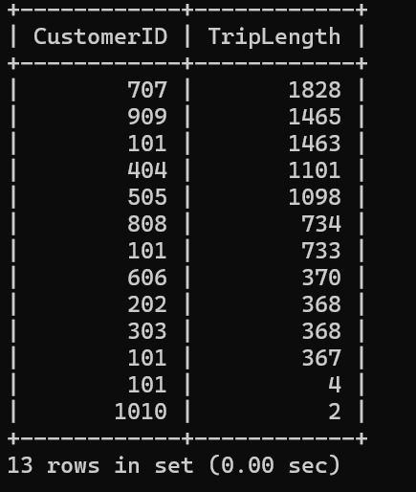

**10.RETRIEVE VEHICLES THAT GENERATE THE HIGHEST REVENUE**

SELECT v.VehicleID, v.Model, SUM(r.TotalCost) AS TotalEarnings

FROM Vehicles v

JOIN Rentals r ON v.VehicleID = r.VehicleID

GROUP BY v.VehicleID, v.Model

ORDER BY TotalEarnings DESC;

**OUTPUT:**

