RT AUTOMATION

**TABLE OF CONTENTS**

PREREQUISITES

SOURCE CODE LOCATION

CODE ORGANIZATION/ARCHITECTURE

[HOW TO SETUP](https://docs.google.com/a/synerzip.com/document/d/1TkTZPI3pxwv_ZSAqJzSh30NRBb4JV0oyE9TG5zUIP0Q/edit#heading=h.hnrfkimhoy9)

[HOW TO RUN](https://docs.google.com/a/synerzip.com/document/d/1TkTZPI3pxwv_ZSAqJzSh30NRBb4JV0oyE9TG5zUIP0Q/edit#heading=h.vbzlltnlq6jq)

TEST DATA USED

[LINK TO REPORT](https://docs.google.com/a/synerzip.com/document/d/1TkTZPI3pxwv_ZSAqJzSh30NRBb4JV0oyE9TG5zUIP0Q/edit#heading=h.dlhc03chk1pw)

[NOTES](https://docs.google.com/a/synerzip.com/document/d/1TkTZPI3pxwv_ZSAqJzSh30NRBb4JV0oyE9TG5zUIP0Q/edit#heading=h.623q1iw10tkd)

# **PREREQUISITES**

1. For running RT:
   1. OS: Ubuntu
   2. Python version: 2.7.6
2. For checking file validity:
   1. OS: Windows 7 Professional
   2. Ms Office: 2007 SP3
   3. Microsoft .Net Framework 4.5

# **SOURCE CODE LOCATION**

[scratch/dotNet/PUNETETools/dotNetTools/RT-AUTOMATION](https://quickoffice-internal.googlesource.com/html-office/+/scratch/dotNet/PUNETETools/dotNetTools/RT-AUTOMATION/)

# **CODE ORGANIZATION/ARCHITECTURE**

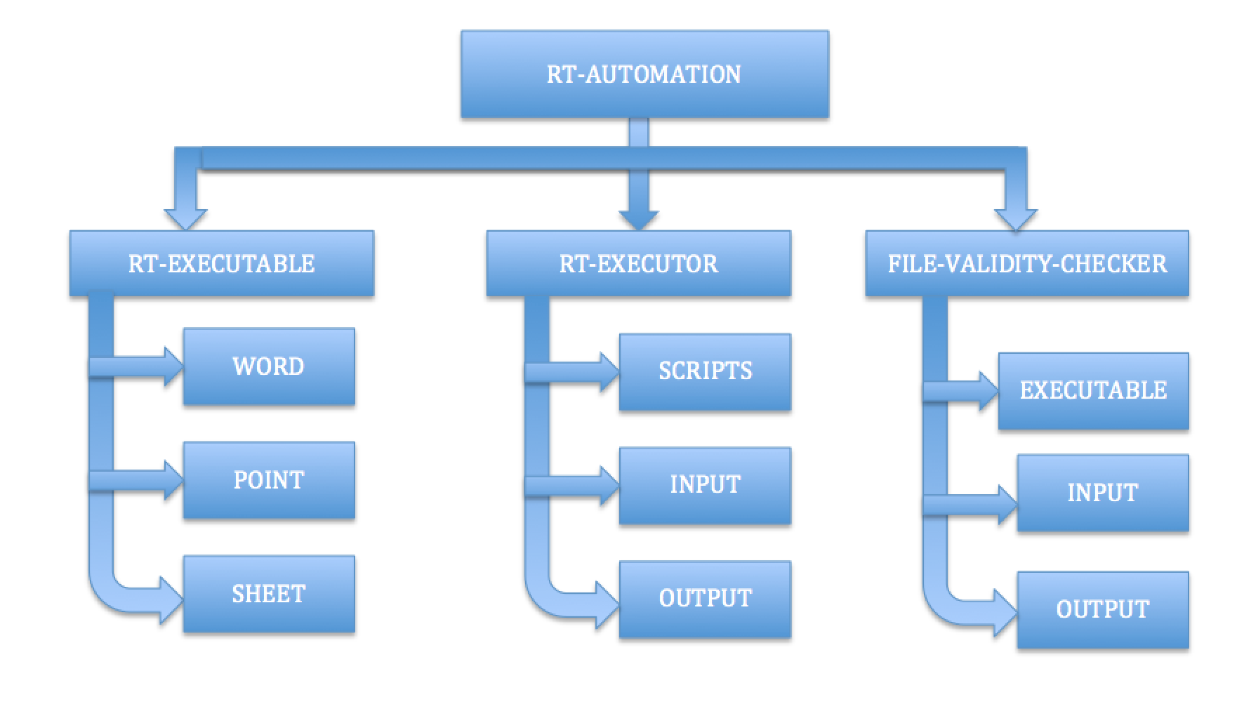

# **HOW TO SETUP**

* Clone the repository: git clone <https://quickoffice-internal.googlesource.com/html-office>
* git checkout scratch/dotNet

# **HOW TO RUN**

1. **FILE-VALIDITY-CHECKER [Windows]:** 
   1. Get the input test files and put it into **FILE-VALIDITY-CHECKER/INPUT**  folder.
   2. To discard the invalid files from getting into RT, run file validity checker executable from **FILE-VALIDITY-CHECKER/EXECUTABLE** folder.

**OfficeFileValidityChecker.exe <INPUT FOLDER PATH>**

* 1. Executable folder has **BaseLibrary.dll** which is internally called by **OfficeFileValidityChecker.exe**
  2. This will create the output folder with following subfolders in it:
     1. Corrupt_Files: Files shows error while opening.
     2. Dubias_Files: This folder contains files which we are not able to categories in any of the other category.
     3. ExtensionMisMatchingFiles: This folder contains files which are having invalid file format
     4. Protected_Files: Password protected files
     5. Valid_Files: This folder contains working microsoft office files

1. **ROUNDTRIP-EXECUTOR [Ubuntu]:**
   1. Put respective RT executables in **RT-EXECUTABLE** folder.That means word rt executable inside **WORD** folder.
   2. Get the valid files from step 1 and put it in **RT-EXECUTOR/INPUT** folder.For running word rt put only doc and docx files here.
   3. This folder should have only one RT executable in it.That means if you want to run RT for word files put only word RT executable.
   4. Change the directory to **RT-EXECUTOR/SCRIPTS.** From the scripts folder run shell script as below with respective command line parameter.For example to run RT script for word run it as below:

**$ sh runner.sh word**

* 1. This script internally uses python scripts (rt_utils.py and roundtrip_automation.py) from that folder.
  2. This will generate round tripped files in **RT-EXECUTOR/OUTPUT** folder.
  3. OUTPUT folder has following subfolders in it.
     1. OpenCrash: Open crash files.
     2. SaveCrash: Save crash files.
     3. InvalidFiles: extension mismatch files(.txt,.png etc).
     4. logs: logs for of RT process.
     5. OriginalMoved: The original file for which RT is successful.
     6. RoundTripFiles: Round Tripped files.
     7. TimeOutFiles: Original files for which RT is not generated after waiting for 10 Minutes.
     8. RoundTripResult.csv: CSV report for round-trip process.The report contains file size before and after RT and time required for RT for individual files.

1. **FILE-VALIDITY-CHECKER [Windows]:**
   1. Get the RT files from step 2 and put it in **FILE-VALIDITY-CHECKER/INPUT** folder.
   2. Run file validity checker on these files

**OfficeFileValidityChecker.exe <INPUT FOLDER PATH>**

* 1. This will create the output folder with following subfolders in it:
     1. Corrupt_Files: Files shows error while opening.
     2. Dubias_Files: This folder contains files which we are not able to categories in any of the other category.
     3. ExtensionMisMatchingFiles: This folder contains files which are having invalid file format
     4. Protected_Files: Password protected files
     5. Valid_Files: This folder contains working microsoft office files

# **TEST DATA USED**



# **LINK TO REPORT**

[File Save Stability Report](https://docs.google.com/spreadsheets/d/1ih646tORip7Zwn6-X9NXtKeSjafYiOOL1pljUB5Gscw/edit?usp=sharing)