

FHIR Appliance Installation

03 – Quickstart Install

Version 2 – May 2021

Table of Contents

1 Introduction 4

1.1 Purpose of this Document 4

2 The Quickstart Design 5

2.1 Overview 5

2.2 Database (Postgres or MSSQL) 5

2.3 FHIR Appliance 6

2.4 Keys and Certificates 6

3 Configuration Files 8

3.1 Download Configuration 8

3.2 Tour of the Configuration 8

3.2.1 Docker Compose Configuration 8

3.2.2 FHIR Appliance Configuration 9

3.2.3 Example Certificates and Keys 10

4 Quickstart Installation 11

5 Smoke Test 13

6 Appendix A – Generating a Self-Signed Certificate 16

**Version Control**

|  |  |  |  |
| --- | --- | --- | --- |
| **Version** | **Release Date** | **Released By** | **Reason for Release** |
| 1 | 18/02/2021 | Tim Davey | Preliminary Draft |
| 2 | 18/05/2021 | Tim Davey | Revised and updated |

**Reviewers**

|  |  |  |  |
| --- | --- | --- | --- |
| **Initials** | **Name** | **Role** | **Organisation** |
|  |  |  |  |
|  |  |  |  |
|  |  |  |  |
|  |  |  |  |
|  |  |  |  |
|  |  |  |  |
|  |  |  |  |
|  |  |  |  |
|  |  |  |  |
|  |  |  |  |
|  |  |  |  |
|  |  |  |  |
|  |  |  |  |
|  |  |  |  |
|  |  |  |  |
|  |  |  |  |
|  |  |  |  |
|  |  |  |  |
|  |  |  |  |
|  |  |  |  |
|  |  |  |  |
|  |  |  |  |

# Introduction

## Purpose of this Document

This document is part of a set which walks through the entire process of installing the FHIR Appliance and connecting to the messaging exchange. It is assumed that the preceding document(s) have already been read, and material already covered will not be repeated.



This document covers setting up a “Quickstart” installation – in other words a full working prototype environment on a single box. This could be used as a developer / demo environment, or as a rehearsal prior to the main install. Important points to note are:

* ***It is assumed that you have already worked through paper “02 – Server Preparation” to install prerequisites on the server***
* ***It is assumed that you will go on to study the remaining papers before deploying to production – ie the steps in this paper do not lead to a production-ready deployment.***
* ***There are two options for the “quickstart” install:***

1. ***Linux Containers, with Postgres – ie on Linux or with Docker Desktop (Windows 10 or Mac).***
2. ***Windows Containers, with MSSQL – ie on Windows Server 2019***
   * + For Linux then the quickstart also bundles a containerised postgres database along with the FHIR Appliance, all on the same box. Note that this is not a best-practice for production, but enables a quick and easy demo deployment.
     + The quickstart is pre-configured with the most common server/database pairings, but note that other combinations are possible if desired for your own deployments

The good news is that, having completed the Server Preparation steps, then docker makes the actual install very quick and easy. Most of this document therefore focuses on explaining what is being installed and how it works and is configured. The actual installation is at the end and is brief.

# The Quickstart Design

## Overview

The Quickstart solution is provided as a Docker Compose file. This spins up the entire infrastructure with a single command. However before looking at the technical configuration, this section explains the design we are trying to build. The diagram below provides an overview – the two variants are essentially the same except for the choice of database:

**Linux Quickstart**



**Windows Quickstart**



## Database (Postgres or MSSQL)

**On Linux:**

A containerised installation of Postgres is bundled as an open source database. See <https://www.postgresql.org/>. It is used to store FHIR Resources and the Audit trail.

* The database listens on port 5432.
* The pgadmin client is also included as a database administration tool. See <https://www.pgadmin.org/>. It is exposed on port 80.

**On Windows Server:**

There is not a suitable containerised option for Microsoft SQL Server, so this will need to be installed separately, along with an administration tool such as SQL Server Management Studio

. Options might include:

1. Reusing an existing MSSQL test server which you have access to
2. Provisioning a cloud-hosted managed service
3. Installing MSSQL. For example a simple and free option if it is only for demo purposes would be to install SQL Server Express on the same box: <https://www.microsoft.com/en-gb/sql-server/sql-server-downloads>

* You will need to install and/or connect your own SQL Server administration tool (eg SQL Server Management Studio) if you wish to look at the database (eg see <https://docs.microsoft.com/en-us/sql/ssms/download-sql-server-management-studio-ssms>)
* It is necessary to create a new database and user on the server. See the “misc” folder
* The database listens on port 1433.

## FHIR Appliance

This is the core software provided to assist with connecting to the messaging exchange . In this quickstart configuration then two endpoints are configured:

* One endpoint is for “internal” integration use and is exposed via http on port 8300. This means you can simply call it with no security hurdles to overcome – thus providing instant gratification for a demo! In a more realistic environment this approach could still be relevant for your own internal services to connect to. For example, your own internal integration engine loading FHIR Resources. There is the option to add an API Key to provide additional internal security if desired.
* The other endpoint is the “external” API Gateway and is secured and available only via https on port 443:
  + It has transport security configured - specifically SSL and TLS Mutual Authentication.
  + It has JWT message signature validation configured - to apply security checking to the message content.

## Keys and Certificates

The quickstart comes configured with a set of self-signed keys. As such they are not intended to be secure, and they will not work with the central messaging exchange. However they do work for an initial local demo and can help to demonstrate the concepts and configuration. These keys and certificates may be considered in three groups:

* **SSL**
  + A ***server key and certificate pair*** to establish SSL connectivity (https)
  + The ***public root certificate*** used to provide TLS Mutual Authentication of incoming connections. (Approved clients such as the messaging exchange hold a matching private key which they use to prove their identity)
* **JWT**
  + The public IAM certificate used to verify incoming messages. (Approved clients such as the messaging exchange hold a matching private key which they use to sign the message tokens used in their requests).
* **PIX**

PIX is the Patient Identifier X-ref – it is the component of the central messaging exchange where Data Providers must register the NHS Numbers of patients about whom they hold information. The FHIR Appliance offers the ability to automate this process by triggering central PIX registration whenever a Patient Resource is loaded to the local repository. Additional credentials are needed for this, including

* + ***SSL client certificate, key, and public Root certificate*** – to establish identity at a transport level when connecting to the central servers
  + ***IAM signing key*** – to further prove identity by signing messages when requesting access tokens from IAM

Note that these PIX credentials are NOT included in the quickstart - as it is not meaningful to demo with self-signed examples. Proper certificates will need to be obtained as part of the Onboarding process, and so this will be returned to later when we look at the additional considerations for production and onboarding.

# Configuration Files

## Download Configuration

***Copy the configuration files onto your chosen server.***

* Open in a browser to <https://github.com/yorkshire-and-humber-care-record/fhir-appliance>, look for the green “Code” button, select “Download ZIP”, and unzip the files

The location of the install on the server is your choice

Once you have a copy of the files downloaded then look inside the “quickstart” folder

***The first thing to notice is that the installation is very small and consists of only a few text-based configuration files. Docker will automatically download the latest version of the actual container images the first time it is run.***

## Tour of the Configuration

It is worth taking some time to examine each configuration file to understand what it does. (There is a separate folder for Linux and Windows, although with very similar contents)

***It is strongly recommended to take some time and understand the configuration.***

***However everything is configured with defaults and ready-to-go – so it is possible to proceed directly to the next section and run up the system if you wish!***

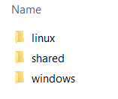 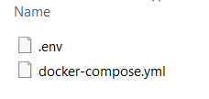

### Docker Compose Configuration

* ***docker-compose.yml*** – this is the main Docker Compose configuration file which describes the whole environment. ***Please take some time to study this file, and make sure you understand each section and what it does***. Even without a deep knowledge of Docker Compose it should be fairly easy to match up the configuration in the file with the diagram in section 2.1. If necessary refer to the Docker Compose documentation at <https://docs.docker.com/compose/compose-file/compose-file-v3/> or other online tutorials.

A couple of points that may need further explanation:

* + You will see some “***volumes***” entries – these are mostly fairly obvious and mount configuration files so that they are visible inside the docker environment. A separate volume is also created to persist the database files. This ensures that they persist even when the docker environment is spun down. (Otherwise the database would be wiped. If you actually want to wipe the database then ***docker-compose down -v*** destroys all volumes to achieve this.).

### FHIR Appliance Configuration

The ***.env*** file is the configuration file for the FHIR Appliance. The file is well documented with comments, so again ***please take some time to study this file and understand the various sections***. These can be summarised as:

* ***Personalisation Settings*** – these configure several domain names and identifiers that need to match your organisation and environment. Whilst not vital for a quick initial developer demo, they are important to configure correctly before connecting to the central message exchange
* ***Database Connection String*** – this can be either mssql or postgres, with standard options to configure user, server, and database details
  + NB1: Referencing the database server by FQDN does not always work - IP address is more reliable. (When running inside docker for the quickstart then the host name is simply the name of the docker container)
  + NB2: The quickstart for Linux comes with default postgres settings pre-configured. ***However it is strongly recommended to change the default database password***. Note that a corresponding change needs to be made in the docker-compose file where the database itself is initialised.
* ***Endpoints*** – there are many options here, and the quickstart comes with some useful defaults configured for an initial demo. As-per the “Design Overview” section above these provide two endpoints – one fully secured for external use and another open for internal use. There are many other options available and it is worth reviewing the possibilities. Typical configuration patterns for a production deployment are discussed in a later document.
  + NB: Auditing is an option for each endpoint, and is enabled for the quickstart. This meets the requirements of the central messaging exchange to maintain a local audit trail of all requests
  + NB: The https endpoint is configured to use the standard port of 443, but if necessary this can be changed. Be wary of port clashes – eg if you already have a web server running on the server. (The docker error message in this case may be misleading – eg mentioning a “file lock”).
* ***Authentication*** – message-level authentication is also an option for each endpoint.
  + The external API endpoint is configured with full JWT signature verification – this is the most secure option and is required for connections to the central messaging exchange
  + The internal integration endpoint is configured with no message authentication – for maximum ease-of-use and a quick demo. Note also the option for an API Key – this is an intermediate option for internal use, based on a shared secret in the HTTP Headers
* ***PIX Auto Registration*** – as discussed above, this triggers central PIX registration whenever a Patient Resource is loaded to the local repository. There is a switch to enable the feature, and the rest of the settings relate to credentials needed to connect with the central PIX servers.
  + NB: PIX registration requires proper onboarding to connect with the central servers. It is therefore switched off for this quickstart demo. We will return to it in a later document when considering a more complete / production deployment.
  + Other Settings – there are various other settings, eg relating to logging. These may be reviewed, but will usually be left at the defaults

### Example Certificates and Keys

The “***shared***” folder contains certificates. As described further in the “Design Overview” section above these are split into SSL, JWT, and PIX – as corresponds to the relevant sections of the .env configuration file.

* These are all self-signed certificates for initial demo purposes only. In a real implementation then they will be replaced with certificates generated via the Onboarding process
* The PIX folder is empty – as discussed above, it is not meaningful to demonstrate PIX without “proper” certificates and a connection to the central messaging exchange
* There is also a “***central***” sub-folder. This holds the “private” keys for TLS-Mutual Auth and IAM Token signing. These would normally be held securely in the central messaging exchange and you would not have access to them! However for demo purposes then the self-signed private keys are provided here. We will use them later to demonstrate in practice how the security layers work.

# Quickstart Installation

Check that you have completed the necessary previous steps:

* Server prepared (see “***FHIR Appliance Install 02 - Server Preparation***”)
* Configuration files downloaded and inspected (see Section 3 above)
* For Windows / MSSQL only – install and configure MSSQL

Options might include:

1. Reusing an existing MSSQL test server which you have access to
2. Provisioning a cloud-hosted managed service
3. Installing MSSQL. For example a simple and free option if it is only for demo purposes would be to install SQL Server Express on the same box: <https://www.microsoft.com/en-gb/sql-server/sql-server-downloads>
   * You will need to install and/or connect a SQL Server administration tool (eg SQL Server Management Studio <https://docs.microsoft.com/en-us/sql/ssms/download-sql-server-management-studio-ssms>)
   * It is necessary to create a new database and user on the server. **See the “misc” folder of the download for a sql script to do this**.

*NB: For Linux / Postgres then a containerised version of postgres is bundled with the quickstart and so this step is not necessary*

Once these preparations are complete then the benefit of docker is that the actual install itself is very simple:

***NB: On Linux you may need to prefix these commands with sudo***

1. Ensure your current directory is the relevant “quickstart” directory (either linux or windows) where the “docker-compose.yml” file is located
2. Enter the command to spin up the installation: ***docker-compose up***

The first time you run this it will take some time, and you will see it downloading the images. There will also be some delay on startup whilst the database is initialised. (You may see some errors and the other components “spinning around” with retries whist they wait for the database to become available). Subsequent runs will be much faster.

Once successful then you will see logging output similar to the below:

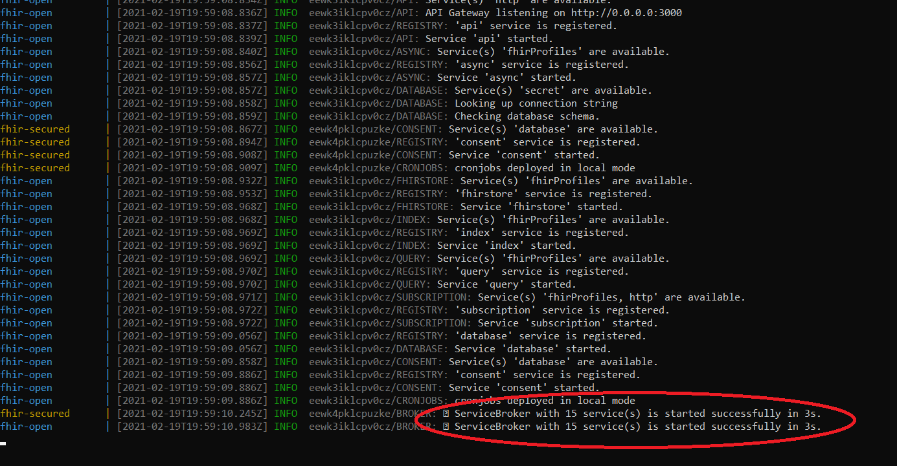

The exact order of events may vary slightly, but near the bottom you should see a message from the “fhir-appliance” to say that the ServiceBroker has started successfully.

It is worth taking some time to study these logs and get a feel for what they are saying. The coloured labels on the left identify activity from the different components, and it is worth a careful check that there are no errors highlighted. (Notwithstanding the above notes about a delay due to database initialisation on the first run). Any other errors should be investigated before proceeding. One of the more likely errors is a database connection failure due to passwords mismatch – in which case check through the configuration files again.

The system is now running in the command window – which is good for testing as you can easily see the logging output.

1. When done press ***ctrl-C*** to exit.

Alternatively you can start it up in “detached” mode to run in the background using: ***docker-compose up -d***

* You can then check it is running with: ***docker ps***
* And view the log output with ***docker logs <name>***

When you have finished then you can spin down the infrastructure and tidy up with

1. ***docker-compose down***

# Smoke Test

If all appears to be working then it is good to do a few simple tests to confirm basic functionality:

1. Spin up the infrastructure again if necessary: ***docker-compose up***
2. ***In a browser navigate to:*** ***<http://localhost:8300/fhir/stu3/metadata>***. (Or alternatively ***curl*** [***http://localhost:8300/fhir/stu3/metadata***](http://localhost:8300/fhir/stu3/metadata))

This is the big test! You should see the server’s metadata statement, similar to the screenshot below:

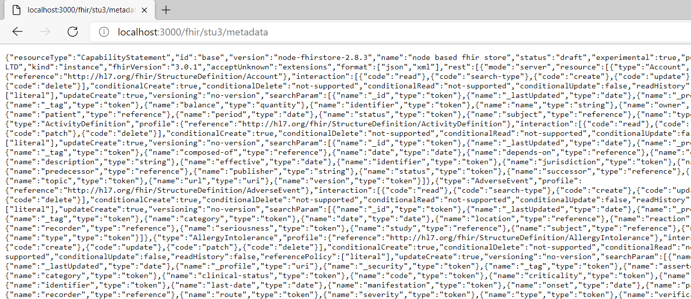

***Troubleshooting tip****: one thing to try if it doesn’t work is replacing “localhost” with the actual server IP address. Historically there have sometimes been problems with docker resolving local loopback routing).*

You can also try just [***http://localhost:8300***](http://localhost:8300) which should return basic uptime information This can also be useful for healthchecks.

1. ***In a browser navigate to:*** [***https://localhost/fhir/stu3/metadata***](https://localhost/fhir/stu3/metadata).

The previous test was going via the “open” route in. You can also try the “secured” route – at this stage this is obviously not expected to work, and you will see the TLS Mutual Authentication rejecting the connection:

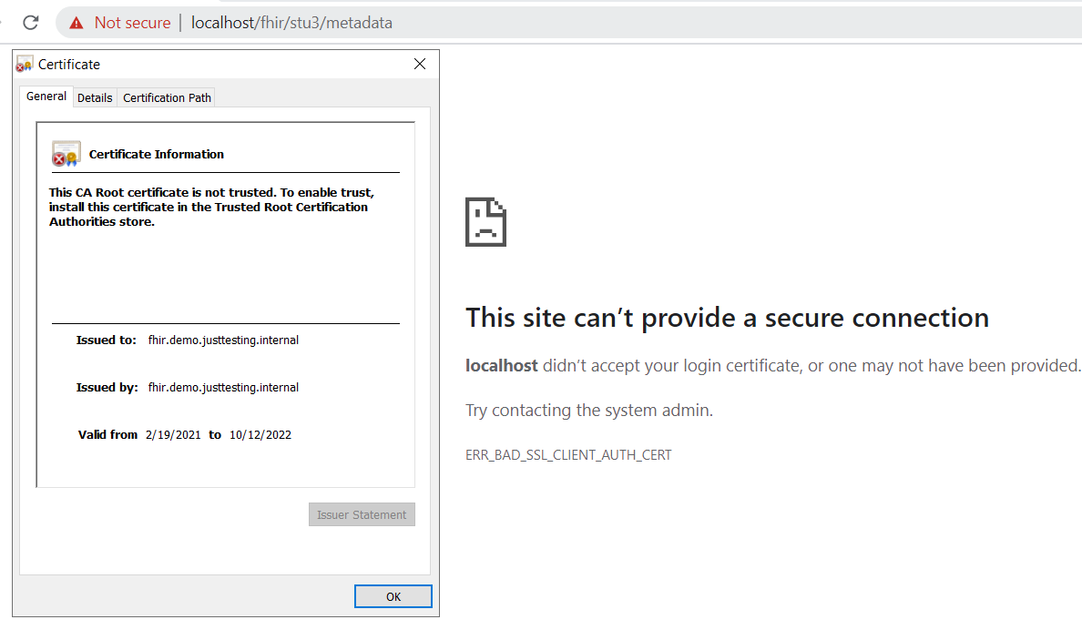

Note that before getting to this screen the browser will warn you that the https certificate is not trusted. We already know that this is because it is a self-signed certificate (see also certificate details in the screenshot above), so it is OK to override this warning. (To silence the warnings then you could install the self-signed cert into your computer’s Trusted Root CA store, plus set up “hosts” and/or DNS routing entries for the FQDN – however this may not be desirable and is not really necessary).

***Overcoming the security layers protecting this “secured” route in is something we will tackle as an exercise in its own right later***

1. ***For Linux quickstart only - In a browser navigate to*** [***http://localhost:80***](http://localhost:80)

You should see a logon screen for the database client

(As previously discussed, you will need to provide your own database client for windows)

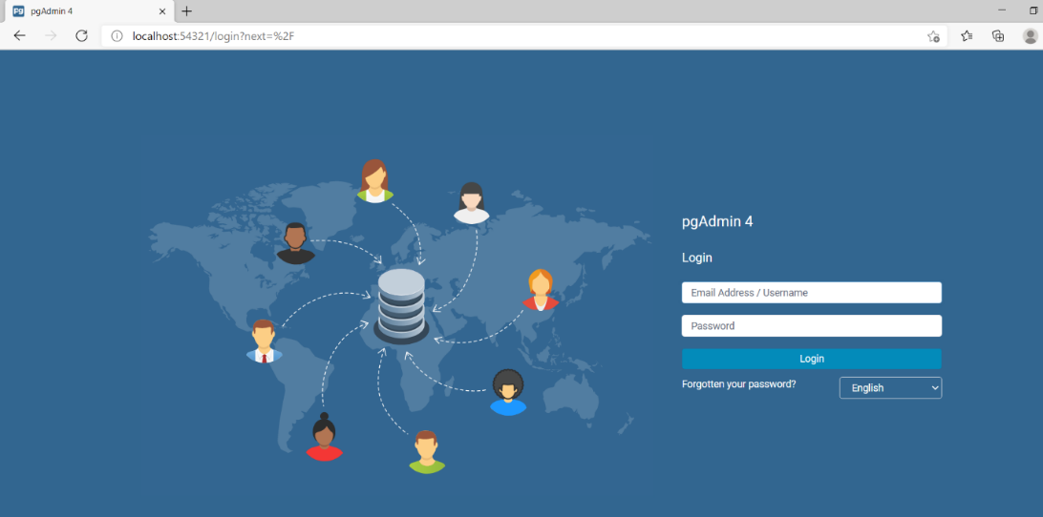

***If you reach this point, then CONGRATULATIONS – your installation is successful!***

However we have so far only done some very simple smoke-tests. In the next document we will go back for a more detailed tour and to explore the functionality in more depth.

# Appendix A – Generating a Self-Signed Certificate

This is an optional exercise, if you wish to replace the provided self-signed SSL certificates with your own.

***NB: The example here describes how to generate a self-signed certificate-key pair. If you work in a large organisation then there may well be established procedures for generating SSL certificates to use on test servers, in which case you should obviously follow these established practices.***

Otherwise… using OpenSSL issue the command:

***openssl req -x509 -newkey rsa:4096 -sha256 -keyout openssl.key -out openssl.crt -subj "/CN=yourservernamehere" -days 600 -nodes***

Notes:

* On Windows you may have to go into a different command shell to do this – see “***FHIR Appliance Install 02 - Server Preparation***” for details
* The ***-nodes*** flag means that the key file is not password protected. Generally it is a good practice to use passwords, in which case remove this flag.
* This generates a simple self-signed certificate with a CN, but not a corresponding Server Alternative Name (SAN). Whilst not essential for this exercise, populating a SAN is considered best-practice and is checked by modern browsers such as Chrome. For example, see <https://stackoverflow.com/questions/43665243/invalid-self-signed-ssl-cert-subject-alternative-name-missing>

To achieve this then change the command to:

***openssl req -x509 -newkey rsa:4096 -sha256 -keyout openssl.key -out openssl.crt -days 600 -config san.cnf -nodes***

And provide a configuration file (in this example called san.cnf) containing the following text:

[req]

distinguished_name = req_distinguished_name

x509_extensions = v3_req

prompt = no

[req_distinguished_name]

CN = yoursevernamehere

[v3_req]

keyUsage = critical, digitalSignature, keyAgreement

extendedKeyUsage = serverAuth

subjectAltName = @alt_names

[alt_names]

DNS.1 = yoursevernamehere

* If you are determined to actually silence the browser’s warnings about certificate mismatches, then you will need to satisfy the browser’s checks that the domain name used in the browser address bar matches the CN in the self-signed certificate. You will probably need to make routing entries to do this – eg either in the “hosts” file on the server where the browser is running or in a local DNS server which you control.