

FHIR Appliance Installation

04 – Quickstart Demo

Version 2 – May 2021

Table of Contents

1 Introduction 4

1.1 Purpose of this Document 4

2 The RESTful FHIR API 5

2.1 Introduction 5

2.2 FHIR Background 5

2.3 Postman 5

2.4 Demonstration Postman Collection 6

3 The FHIR Store Database 9

3.1 Overview 9

3.2 Connect to the Database 9

3.3 The “public” Schema 10

3.4 The “audit” Schema 10

4 Using the Secured API 11

4.1 Overview 11

4.2 TLS Mutual Authentication 11

4.3 JWT Token Validation 12

**Version Control**

|  |  |  |  |
| --- | --- | --- | --- |
| **Version** | **Release Date** | **Released By** | **Reason for Release** |
| 1 | 19/02/2021 | Tim Davey | Preliminary Draft |
| 2 | 19/05/2021 | Tim Davey | Revised and updated |

**Reviewers**

|  |  |  |  |
| --- | --- | --- | --- |
| **Initials** | **Name** | **Role** | **Organisation** |
|  |  |  |  |
|  |  |  |  |
|  |  |  |  |
|  |  |  |  |
|  |  |  |  |
|  |  |  |  |
|  |  |  |  |
|  |  |  |  |
|  |  |  |  |
|  |  |  |  |
|  |  |  |  |
|  |  |  |  |
|  |  |  |  |
|  |  |  |  |
|  |  |  |  |
|  |  |  |  |
|  |  |  |  |
|  |  |  |  |
|  |  |  |  |
|  |  |  |  |
|  |  |  |  |
|  |  |  |  |

# Introduction

## Purpose of this Document

This document is part of a set which walks through the entire process of installing the FHIR Appliance and connecting to the messaging exchange. It is assumed that the preceding document(s) have already been read, and material already covered will not be repeated.



***This document takes as its starting point the “Quickstart Install” that you should now have working.***

It returns to look at the quickstart installation in more depth and to try out the various features. Whilst the detail will be of more interest to developers than infrastructure admins, an overview of the system’s functionality may be useful for all.

# The RESTful FHIR API

## Introduction

This section takes as its starting point the test you have already done by typing into a browser:

<http://localhost:8300/fhir/stu3/metadata>

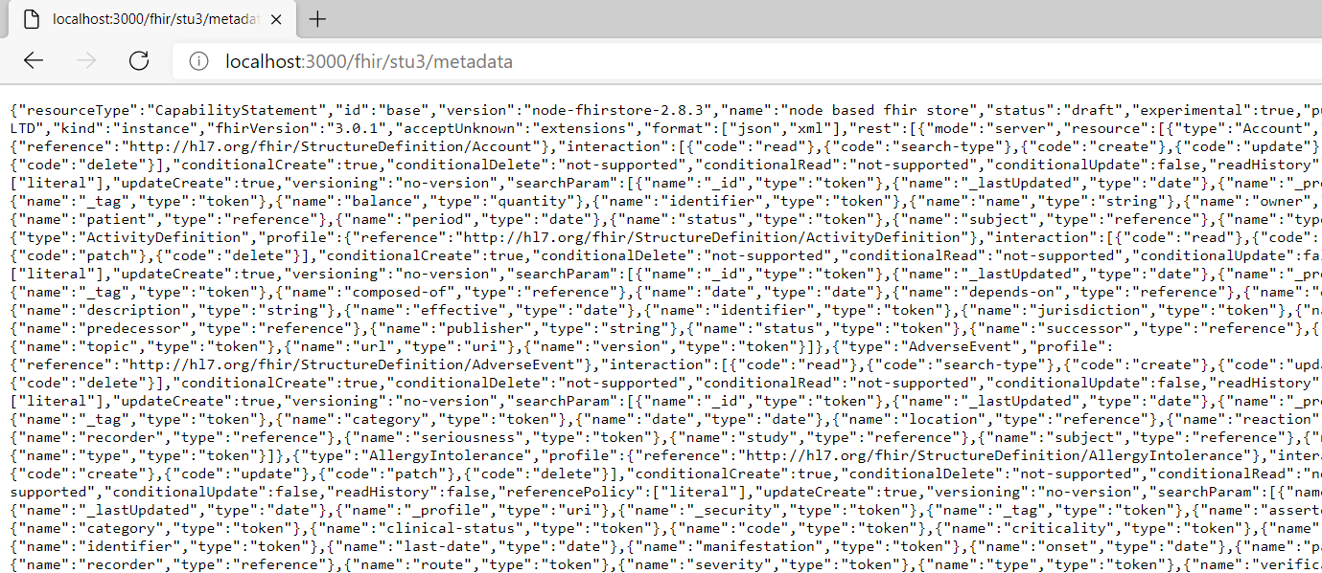

The purpose of the FHIR Appliance is to expose a FHIR API for publishing Health and Social Care data. The above URL returns the FHIR metadata statement which is one of the simplest things you can do. There are many other FHIR interactions possible, and in this section we will explore further.

## FHIR Background

FHIR is a RESTful API ie it represents data using http methods and resources:

<https://en.wikipedia.org/wiki/Representational_state_transfer>

FHIR is the international standard for representing healthcare data as RESTful Resources. There are several versions of FHIR, and the messaging exchange currently uses STU3:

<http://hl7.org/fhir/stu3/resourcelist.html>

The core FHIR specifications are further refined for UK usage (eg use of NHS Number) by the Care Connect profiles - see: <https://nhsconnect.github.io/CareConnectAPI/> and <https://fhir.hl7.org.uk/>

If any of this is new to you then following along with this section should bring it to life and start to illustrate how it works.

***If you are tasked with developing your organisation’s integration with the messaging exchange then a good knowledge of FHIR and Care Connect standards is fundamental. It is beyond the scope of this document to teach these skills to the necessary level of expertise. The examples here can give you a good start, however you will need to invest time in your own additional research and/or training.***

## Postman

As you have already seen, it is perfectly possible to use an ordinary browser to work with FHIR Resources – for example returning the metadata resource as above. However for serious development then this is not very productive and there are better tools available.

Postman is a tool for working with FHIR APIs: <https://www.postman.com/> It is free to sign up for a basic account. Effectively it is a specialised browser – in that it allows you to view URLs, but also to easily manipulate the various settings and headers. It also has powerful scripting capabilities which allow you to save useful scripts and to automate RESTful API testing.

***It is beyond the scope of this document to teach Postman. However if it is not already familiar then it is highly recommended to learn more about the tool if you will be working with RESTful APIs such as FHIR. There are many free online resources and tutorials available.***

For now we will use Postman in a simple way, and the tool is quite intuitive so you should be able to follow along.

## Demonstration Postman Collection

A demonstration Postman Collection is available here:

<https://github.com/synanetics/synfhir-store/blob/master/docs/postman.md>

If it is the first time you have used Postman then you will need to sign up for a free account. And then select “Postman for Web”.

Before moving on to more complex examples it is good to start with something simple and familiar. Click on “+” to start a new tab in Postman, and in the Postman address bar type the familiar request: ***http://localhost:8300/fhir/stu3/metadata***

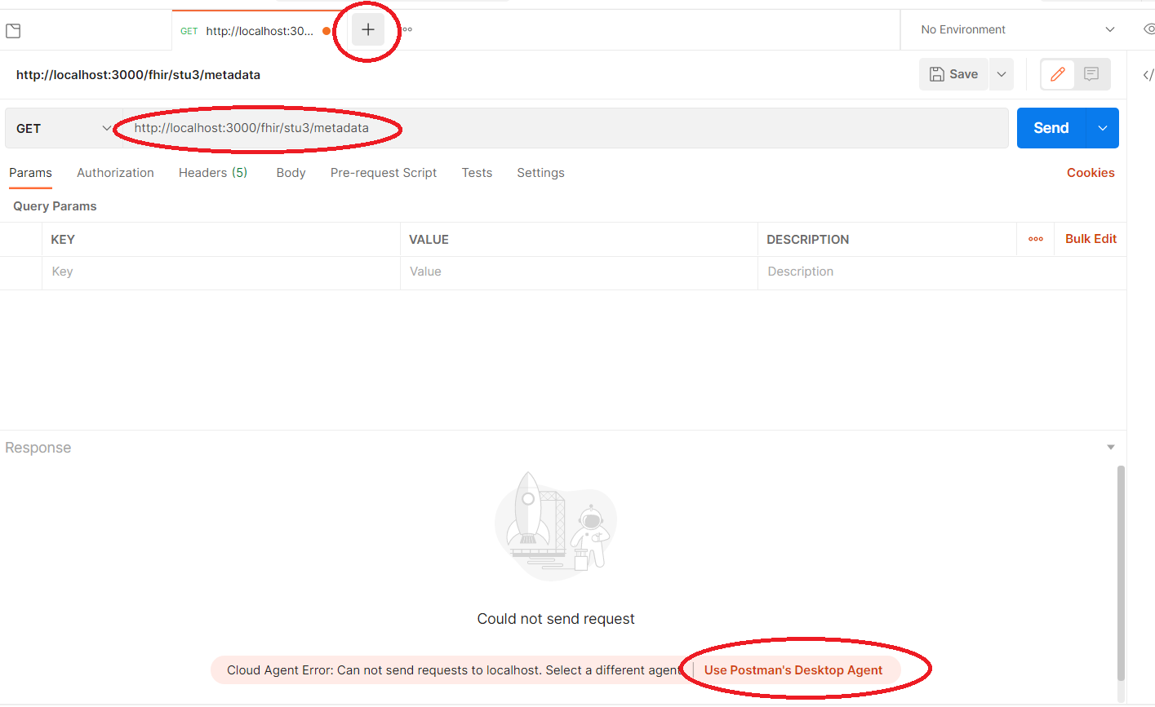

This will fail initially – because actually you are running the request from an external webserver belonging to Postman, and not on your own localhost at all! However take the suggested option to install the Postman Desktop Agent to overcome this setback.

A second attempt should then bring success. (Notice how Postman formats the output more nicely than an “ordinary” browser)

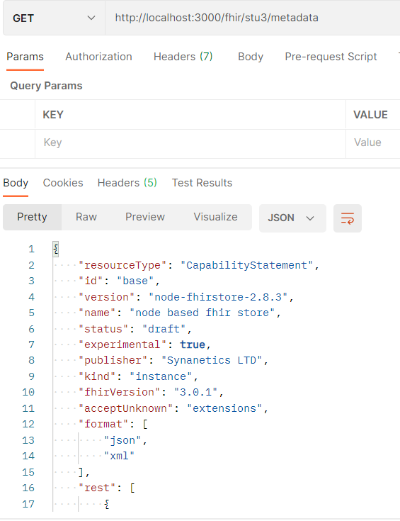

You can then work through the imported test collection. This runs through a series of tests which demonstrate storing and retrieving data in the FHIR Appliance using some of the most common FHIR Resources. It is highly recommended to run through these tests to get a hands-on appreciation of how the FHIR Server works.

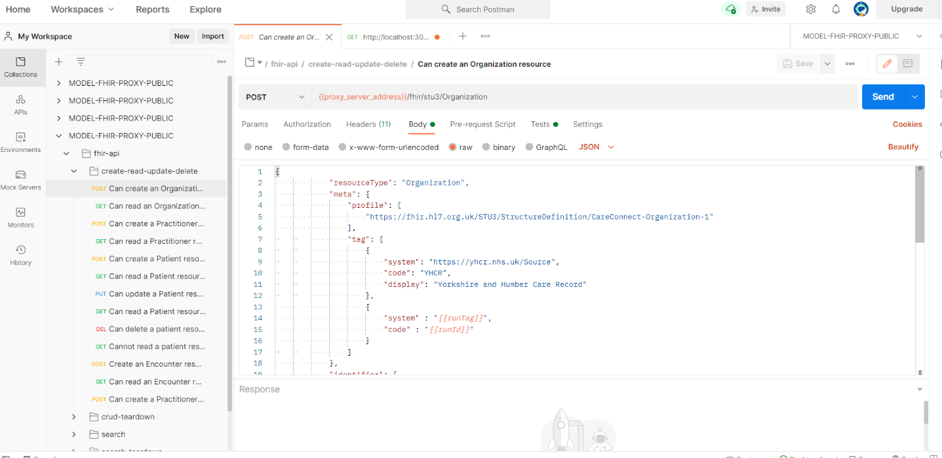

Tips:

* You will need to tell it the ***{{proxy_server_address}}*** for your server (eg http://localhost:8300). If you are familiar with Postman then you will see that this can be set as an environment variable. If you are less familiar then you can always just overtype it into the address bar.
* It is fairly intuitive to follow along by selecting each request and pressing “Send”. However if Postman is new to you then you will definitely get more out of the exercise by spending a little time first reading the Postman documentation and/or viewing an online tutorial.
* If you will be responsible for developing your organisation’s FHIR implementation then it is worth setting aside some time to look closely at these examples. They provide a good illustration of how FHIR Resources work and the kind of thing you are going to need to do yourself.

# The FHIR Store Database

## Overview

The FHIR Appliance uses its database as a persistence store. Whilst it is possible to treat this as a “black box”, in practice it is useful to understand what is happening inside.

## Connect to the Database

**MSSQL**

Open the MSSQL management tool of your choice (eg SQL Server Management Studio – if necessary install from <https://docs.microsoft.com/en-us/sql/ssms/download-sql-server-management-studio-ssms>). Log on to the database using the username and password you configured.

**Postgres**

The pgadmin client tool is provided as part of the quickstart and can be opened by going in a browser to <http://localhost:80>

* Logon using the credentials in the docker-compose file, section “fhir-appliance-db-client” (eg support@myorg.org)
* Right click on “Servers”, select “Create >”, “Server…” and fill out the dialog box. (This is not really creating a server, it is just creating a connection to existing server)
* Give it a name (eg fhir-appliance-db)
* On the “Connection” tab then the Host is the name of the docker container (fhir-appliance-db), the Username is “iamonfhir” and the password is as-per the docker-compose file, section “fhir-appliance-db”

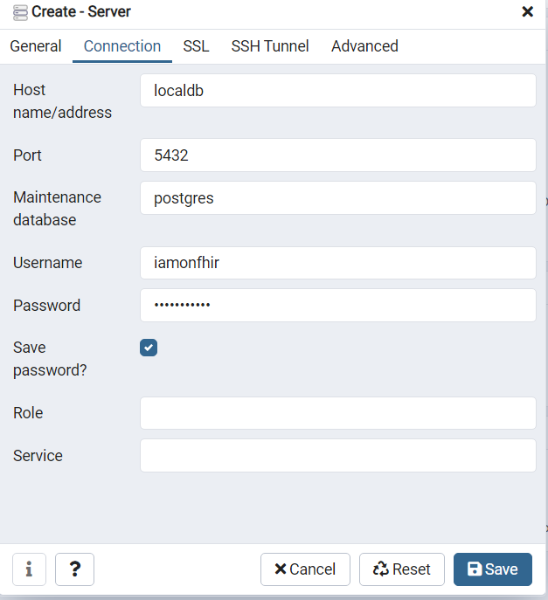

* The navigate into the fhirstore database, Schemas, and right click to choose “Query Tool”

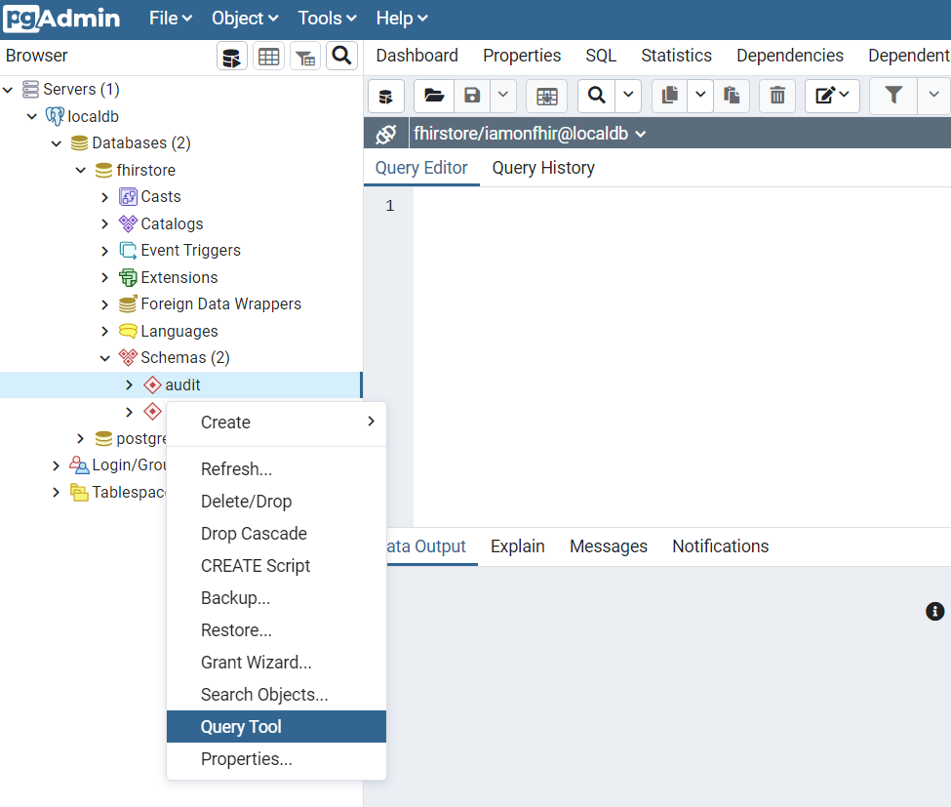

## The “public” Schema

This schema stores the FHIR Resources.

Look in some of the tables, to see the FHIR Resources that have been created by running the Postman Collection

For example: ***select * from public."ResourceData"***

(Note the quotes which are necessary for Postgres to preserve case correctly)

You will see that the main table is ***ResourceData*** which contains a json representation of the FHIR Resources. The table ***ResourceIndex*** contain “indexes” which extract key fields into relational form for faster searching.

## The “audit” Schema

This schema stores the audit trail, in compliance with audit requirements.

In a similar way to above, open up the schema and have a look at the tables. You will see that the audit records are also FHIR Resources

Please refer to the Design Paper 09 for a full specification of how audit works: <https://yhcr.org/wp-content/uploads/2019/05/YHCR_Design_Paper_009.__Auditing.docx>

# Using the Secured API

## Overview

So far we have been using the “open” route into the FHIR Appliance API. Now it is time to look at the “secured” route and to understand the additional security checks which apply. There are two security layers to navigate:

1. TLS Mutual Authentication
2. JWT Token Verification

It is recommended to use Postman for this exercise, due to the easier control it offers over HTTP headings and settings.

## TLS Mutual Authentication

Open Postman, and use the address bar to navigate to: <https://localhost/fhir/stu3/metadata>

This will not work yet, specifically you should see the request being rejected by Mutual Authentication. (NB: On the first attempt it may be necessary to select the option to “Disable SSL Verification” in order to override SSL certificate warnings from the self-signed certificate first):

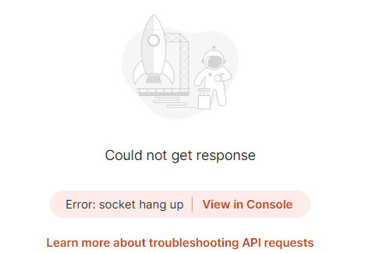

The instructions at the following link explain how to configure Postman to present a client key for TLS Mutual Authentication: <https://learning.postman.com/docs/sending-requests/certificates/>

There is however a snag, as Postman only allows files to be uploaded from its “working directory”. This is configured on the “General” tab of Settings. There is a bug (as of this writing) – as it is configured to “users/<current user>/Postman/files” But the directory on disk is actually called “users/<current user>/Postman Agent/files”. Rename the directory to bring them into alignment

Then copy the client certificate files that we want into this Postman/files directory. We want the root ca certification from ***quickstart/shared/ssl***, and also the corresponding private key from ***quickstart/shared/central***

Once this is done then, as per the instructions referenced above, go into Settings, Certificates tab, add Certificate, and upload these cert and key files (eg for “localhost”)

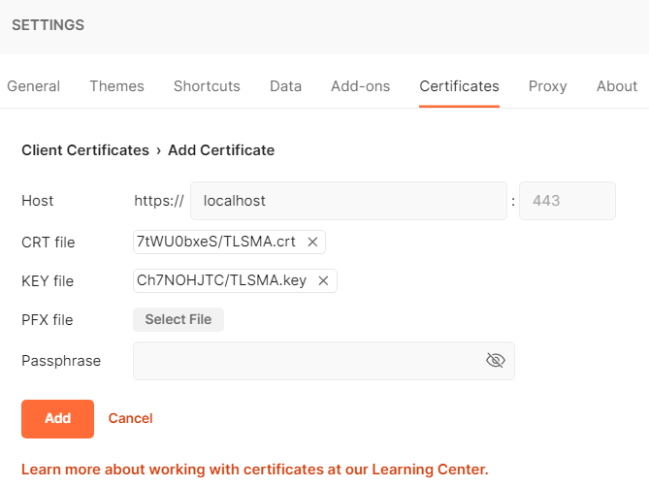

If this is successful then you should find that TLS Mutual Authentication passes, and you will see a new error message which is an Operation Outcome returned from the FHIR Appliance itself:

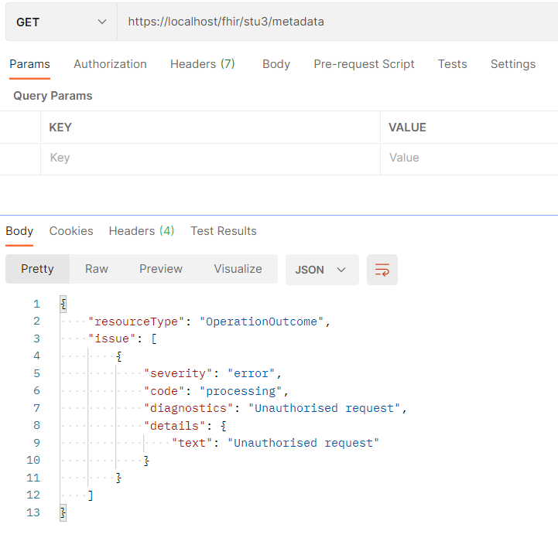

## JWT Token Validation

To get through this second security layer we need to supply a JWT token as part of our FHIR request. Full details of the contents of this token are provided in the Design Paper 05: <https://yhcr.org/wp-content/uploads/2020/11/YHCR_Design_Paper_005__Identity_and_Access_Management_v1.1.docx>

As the Design Paper explains there are a number of fields. Most of these have to be populated with values issued during the Onboarding process, plus there are important options to select regarding the Role and Reason presented for access. For now, here is an example of a token payload that will work for demo purposes:

{

    "jti":"36ee43c9f57e42bba265607508f0c8bc",

    "iss":"LCR",

    "aud":"IAM",

    "sub":523738395,

"pat":{

"nhs":1234567890,

"fam":"Jones",

"giv":"Jack",

"dob":"19651206"

},

    "ods":"8JL372",

"usr":{

"fam":"Smith",

"giv":"John",

"rol":2,

"ids": [{

"sys":"ERS",

"idc":"653990037"

}],

"org":"8JL372"

},

"rsn":1,

    "iat":50734946427,

    "exp":50734947327

}

You will need to make two modifications to this payload:

1. Update the “issued” and “expiry” timestamps in “ist” and “exp”. The times are in Unix format, for example see <https://www.unixtimestamp.com/>
2. Provide a new unique id in “jti”. This is just a string. To ensure uniqueness then a guid is a good idea, for example see <https://www.guidgenerator.com/online-guid-generator.aspx>

You now need to convert this information into JWT format. An explanation of how this is done can be found at <https://jwt.io/introduction>. It involves converting the text to Base64 format, and signing with a private key. (The signing key that matches your self-signed public IAM cert can be found in folder ***quickstart/shared/central***)The site also provides references to libraries in all major programming languages. However for a quick test without the aid of programming tools then the same website offers a handy online utility and learning tool:

<https://jwt.io/#debugger-io>

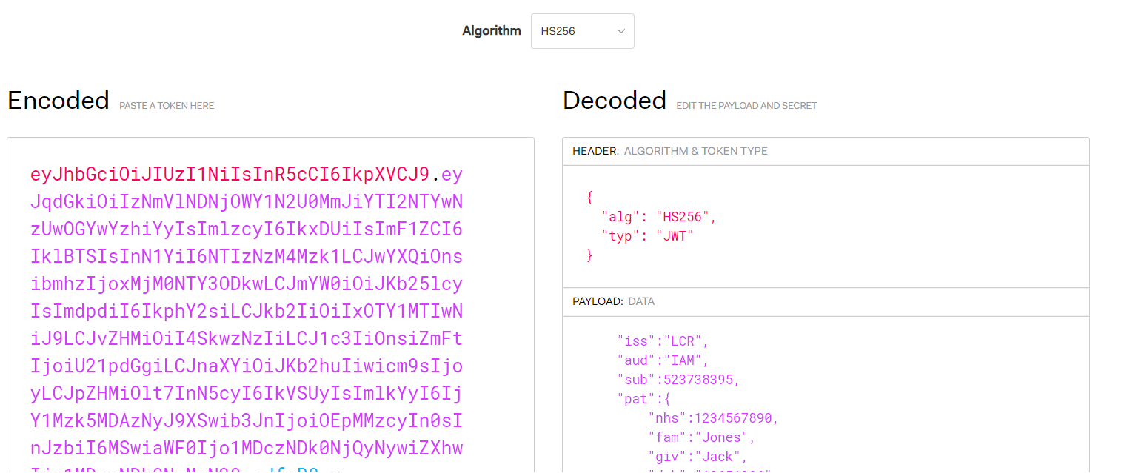

Select RS256 as the algorithm, paste in your payload (see above), and paste in your private key.

It is also a good idea to use the this tool to verify your token, by pasting in the public certificate – this will be the self-signed public IAM certificate that is in ***quickstart/shared/jwt***. Check for the blue “signature verified” tick.

The encoded token can then be copied, ready to use

***IMPORTANT: This is a useful website for demo purposes when working with an unimportant key-pair. However obviously you should never paste a “real” private key into a public website!***

Finally, it is time to use this token in our FHIR Request.

In Postman, select Bearer Token, paste in the token, and retry the FHIR Metadata request.

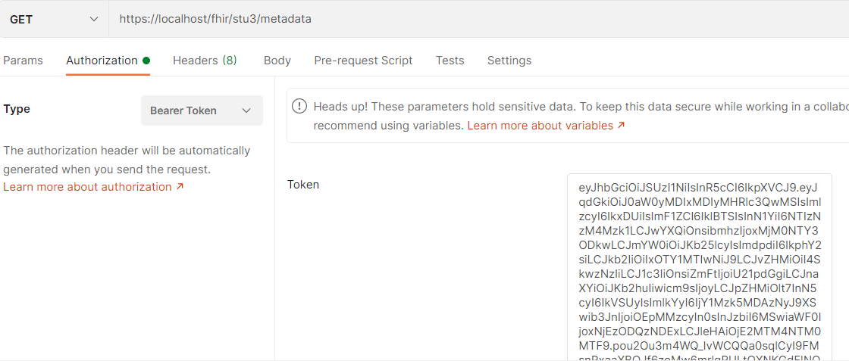

With luck the final security layer will be cleared, and the metadata statement will be visible!

*(Note: When connected to the messaging exchange there is an extra step - as these tokens must first be sent to the central IAM service to be approved and signed. We will come back to this later when discussing Onboarding).*

**This concludes the tour!**

**You have now installed a complete demonstration system and explored in some detail what the FHIR Appliance can do. In the next document we will move on to consider how to productionise an installation.**