

FHIR Appliance Installation

05 – Production Install

Version 2 – May 2021

Table of Contents

1 Introduction 4

1.1 Purpose of this Document 4

2 Design Considerations 5

2.1.1 Resilient deployment of the FHIR Appliance 5

2.1.2 Resilient deployment of the database 5

2.1.3 Network security and Web Proxy 6

2.1.4 SSL Termination 6

2.1.5 Internal vs External connectivity 6

3 Illustrative Deployment 7

4 FHIR Appliance Installation 9

4.1 Production Install Steps 9

4.2 Applying Updates 13

5 Technical Onboarding 14

**Version Control**

|  |  |  |  |
| --- | --- | --- | --- |
| **Version** | **Release Date** | **Released By** | **Reason for Release** |
| 1 | 22/02/2021 | Tim Davey | Preliminary Draft |
| 2 | 19/05/2021 | Tim Davey | Revised and updated |

**Reviewers**

|  |  |  |  |
| --- | --- | --- | --- |
| **Initials** | **Name** | **Role** | **Organisation** |
|  |  |  |  |
|  |  |  |  |
|  |  |  |  |
|  |  |  |  |
|  |  |  |  |
|  |  |  |  |
|  |  |  |  |
|  |  |  |  |
|  |  |  |  |
|  |  |  |  |
|  |  |  |  |
|  |  |  |  |
|  |  |  |  |
|  |  |  |  |
|  |  |  |  |
|  |  |  |  |
|  |  |  |  |
|  |  |  |  |
|  |  |  |  |
|  |  |  |  |
|  |  |  |  |
|  |  |  |  |

# Introduction

## Purpose of this Document

This document is part of a set which walks through the entire process of installing the FHIR Appliance and connecting to the messaging exchange. It is assumed that the preceding document(s) have already been read, and material already covered will not be repeated.



This document looks at planning for a Production install.

* It assumes that, based on working through the “quickstart” exercise, then you already have a good understanding of the FHIR Appliance software, its configuration, and functionality
* In this document we therefore give guidance on moving from a simple demo install to a production configuration. The document collates as much real-life experience as possible to help you achieve a successful production deployment

**Note that the guidance given here cannot be entirely “step-by-step” or prescriptive. There are too many variations in local policy and practice to cover every eventuality. Based on the information provided you will need to make your own design decisions - and configure your own infrastructure in a way which combines this guidance with your own organisation’s security and infrastructure best-practices and policies.**

# Design Considerations

In this section we highlight some of the key questions which you will need to consider when designing your production deployment.

***Fundamentally the FHIR Appliance is similar to any other “web app” – consisting of a server which responds to HTTP(S) plus a database backend. The headings below provide more detail of these components. However if you already have an approach to deploying this kind of standard web-based system then the FHIR Appliance is likely to fit the same pattern.***

***The only real points of note are the need to use certificates provided by the messaging exchange for TLS (including Mutual Authentication), plus the option for an “internal” vs “external” route into the service.***

**Whilst the rest of this document elaborates in more detail, typically the main differences from a “quickstart” deployment are:**

* **Use of a “normal”, dedicated, database server. (As opposed to the quickstart containerised option)**
* **Offloading SSL termination from the FHIR Appliance itself to a dedicated Web Proxy server in the DMZ**
* **Adding additional servers and load-balancing for scale and resilience**

### Resilient deployment of the FHIR Appliance

This is the core software provided by to assist with connecting to the messaging exchange. It provides a stateless RESTful service responding to HTTP traffic. Resilience is therefore achieved in a similar way to any other “website” – ie by deploying in a load-balanced configuration across at least two servers.

### Resilient deployment of the database

Resilience for the database also needs to be planned for, for example:

* ***Redundancy*** – normal best-practices for avoiding a single point of failure in the database need to be considered - whether active-passive failover or an active-active cluster. It is beyond the scope of this document to cover this, however see ***FHIR Appliance Install 99 - 3rd Party Technologies*** for references.
* ***Backups*** – again it is important that the database is backed up, and normal best-practices apply. Backups of the audit schema provide an additional function, in terms of providing assurance that a temper-proof copy of the audit trail is securely archived
* ***Management*** – the database needs to be managed and maintained in line with normal DBA best-practices
  + The ***“public” schema*** will contain record(s) for each FHIR Resource published – in many cases this is likely to consume only a small amount of storage. A fast response to queries on the indexes will be required.
  + The ***“audit” schema*** will contain record(s) for each request made to the FHIR server. Depending on traffic this could get large. It is however append-only, and with queries likely to be rare.

Note that it is possible to co-locate the FHIR Appliance and Database on a single server if desired for test deployments. However, as for any application, the different characteristics of an application server vs database mean that dedicated servers are best-practice for production.

### Network security and Web Proxy

It is assumed that, as with any web application, the production FHIR Appliance will not be directly connected to external networks – rather it will be protected by a DMZ and Reverse Proxy layer.

The external-facing endpoint will need to present a static IP address which can be configured in the central messaging exchange to route messages to your organisation. (The messaging exchange does not by default use public DNS routing). Your organisation’s firewalls will also need to be opened to allow access for HTTPS traffic from the messaging exchange’s static IP address.

### SSL Termination

Related to the previous point is deciding where SSL from incoming connections will be terminated. Key points to consider are:

* It is required to use certificates signed by the messaging exchange for SSL
* It is also required to TLS Mutual Authentication (client authentication) using certificates signed by the messaging exchange

You will also need to consider whether or not SSL is furthermore needed for traffic on your own internal networks.

Planning will therefore be needed as to how these certificate requirements are incorporated. It is obviously easiest on a separate web server, however most modern web servers also provide options to configure multiple services on a single box. ***FHIR Appliance Install 99 - 3rd Party Technologies*** provides further references.

### Internal vs External connectivity

* The main “external” route to the server will come via the network security layers discussed above, and will require signed JWT tokens to be included with each message.
* There may also be a need for internal services (eg the integration engine loading the data) to connect, and therefore an option to have a simpler “internal” route for these to use.

# Illustrative Deployment

This section provides an example of how a deployment might look, based on the considerations above.

***IMPORTANT: This example is illustrative only and is not the “right” or “only” answer. You will need to design your own deployment based on knowledge of your own internal infrastructure and policies.***



Points of note in the diagram include:

* The ***FHIR Appliance*** software is hosted on Docker, via a Docker Compose file
  + It is deployed across two application servers for resilience.
  + It includes an internal endpoint (listening on Port 8300), plus an external endpoint (listening on Port 3000). Both endpoints use http - as https termination is offloaded to the web proxy.
  + The external endpoint has full jwt authentication configured. The internal endpoint has simpler API Key authentication configured
  + Auto-PIX registration is also configured
* The ***database*** is deployed in an active-passive configuration – with a primary and log-shipping to a secondary replica. (Other options include an active-active configuration)
* A resilient ***Web Proxy*** layer is deployed in the DMZ, to provide reverse-proxy and Layer 7 Load Balancing services. It offers a static VIP for the messaging exchange to connect to and provides TLS termination using the centrally-signed certificates for both encrypting the connection and TLS Mutual Authentication. (The diagram shows dedicated infrastructure, however there would also be options for segregated configuration and routing on shared web proxy infrastructure).
* ***Network connections within the organisation*** are shown using HTTP. Alternatively it might be required to enable SSL for some or all of the internal connections. The FHIR Appliance has the option to enable SSL on an endpoint if required.
* The ***integration engine*** is shown with a very simple configuration connecting to one of the FHIR Appliance instances. This assumes that resilience would be provided via queuing and retries, with application-level monitoring and error handling to trigger switching to the other server in the event of an outage. (Alternatively it could be connected to an internal load-balancer across the two application servers)
* ***Disaster Recovery*** is not explicitly shown in the diagram, but the secondary database might normally be on a remote site. The other servers are stateless and could have server images replicated for warm or cold standby to a remote site. Other more elaborate active-active arrangements would also be possible – the FHIR Appliance is no different to any other 3-tier application in this respect.

# FHIR Appliance Installation

Having considered the end-to-end design, this section walks through the detailed production installation of the FHIR Appliance component.

## Production Install Steps

1. **Prepare the server**

* See the instructions in document ***FHIR Appliance Install 02 - Server Preparation*** for more details, including server prerequisites and advice on installing docker

1. **Copy on production configuration**

* In a browser go to <https://github.com/yorkshire-and-humber-care-record/fhir-appliance>, look for the green “Code” button, select “Download ZIP”, and unzip the files

The location of the install on the server is your choice

Once you have a copy of the files downloaded then look inside the “prod” folder

1. **Install other servers and components**

* You will need to provision other servers and install any other 3rd party components – eg database, web proxy. It is beyond the scope of this document to provide detailed instructions for these external components – but see “***FHIR Appliance Install 99 - 3rd Party Technologies***” for links and tips which may be useful.
* Note that you will need to have at least a working database connection to run the FHIR Appliance for an initial internal test. This includes:
  + Creating a database called “fhirstore”
  + Creating a logon for the FHIR Appliance to use, and setting as owner of the fhirstore database
  + Opening firewalls and database connectivity between the FHIR Appliance and database servers

**Database scripts are provided in the “misc” folder to automate the database and user setup for both postgress and MSSQL.**

See also “***FHIR Appliance Install 99 - 3rd Party Technologies***” for further tips on these tasks

1. **Review configuration files in the “prod” folder**

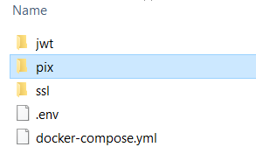

* ***docker-compose.yaml*** – this is the main Docker Compose configuration file which describes the environment.
  + ***Choose your flavour*** – you will see the “image:” details, with an obvious choice between Linux or Windows 2019 for each instance. Comment in/out the appropriate lines to make your choice. There are also some small differences in the way volumes are mounted. Again comment in/out the appropriate lines to make your choice
  + ***Confirm ports*** – default port settings are configured, however this is easy to change if desired. Be careful to make sure that the ports in this file are aligned with those in the .env file
* ***.env*** – configuration file for the FHIR Appliance.
  + This file will need working through carefully and appropriate settings making. Further detailed comments and instructions can be found in the configuration file itself.
  + It is useful to look at the “quickstart” example files for “typical” settings which you may wish to copy
  + See also ***FHIR Appliance Install 03 - Quickstart Install*** for further details

1. **Check internal firewalls**

* You will need to make sure that any internal and/or server firewalls are open for the necessary connections – eg to access the FHIR Appliance ports, and for the FHIR Appliance to connect to the database. (For example Windows Firewall will block all of these by default)

1. **Run up the system**

* Ensure your current directory is the “prod” directory where the “docker-compose.yml” file is located
* Enter the command to spin up the installation: ***docker-compose up***. (On Linux this may need to be prefixed with sudo).
  + As usual, the first time will be slow as it downloads all of the docker images. Subsequent runs will be much faster

1. **Smoke Test**

* The most obvious basic test is to try ***<http://localhost:8300/fhir/stu3/metadata>****.* (NB: If you plan to configure API authorisation, then you may want to temporarily turn it off to try this initial smoke-test)
* You can also try[***http://localhost:3000/fhir/stu3/metadata***](http://localhost:3000/fhir/stu3/metadata) – which should return an Operation Outcome stating “Unauthorised request”
* You can also try just [***http://localhost:8300***](http://localhost:8300) and [***http://localhost:3000***](http://localhost:3000) – both of which should return simply “Ping”. This can be useful for healthchecks - as this check is not affected by JWT verification.
* See ***FHIR Appliance Install 03 - Quickstart Install*** for more details of initial testing and troubleshooting

1. **Configure Autostart**

The FHIR Appliance needs to autostart when the server reboots.

* **On Linux**

1. Ensure the Docker Compose file is configured with ***restart: always*** for the containers which you want to autostart. (This is already the case in the provided docker compose files)
2. Set the service running in the background with docker-compose up -d
3. Nothing else is necessary on Linux – the docker daemon and containers will autostart when the server boots.
4. Test to make sure – eg reboot and check ***docker ps***

* **On Windows Server**

The steps above do not appear to be sufficient on Windows Server. It appears to be necessary to run a script on system startup.

1. Use Control Panel / Services to check that the Windows docker service itself is configured to autostart (by default it should be)
2. Create a start up script eg a .bat file containing:

***cd*** *<the “prod” directory containing the prod docker-compose file>*

***docker-compose down***

***docker-compose up -d***

(The ***docker-compose down*** line was added based on experience that sometimes debris can remain when the server is switched off. Startup was found to be more reliable with this precaution)

***See also example script in the “misc” folder of the installation***

1. Test the script by running it manually to make sure that it works.
2. This script then needs to be scheduled on system startup – there are several ways to do this and you may have your own preferences. One method which the author tested successfully was using Windows Task Scheduler:
   * Create a new task
     + Needs to run whether a user is logged on or not (but does not seem to require a password)
     + Configure for the correct operating system

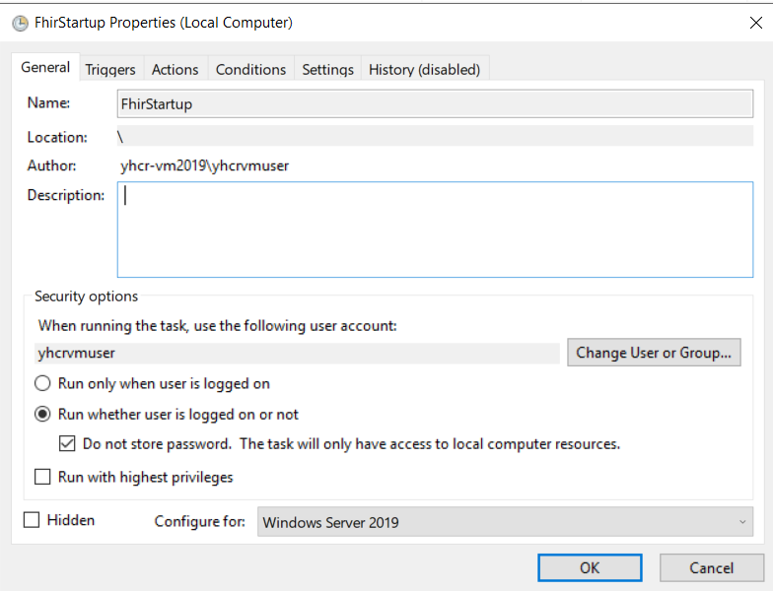

* + Trigger “At startup”
    - **The 1 minute delay appears to be very important**. If the task attempts to run too soon – eg before other services have started, then it will fail.

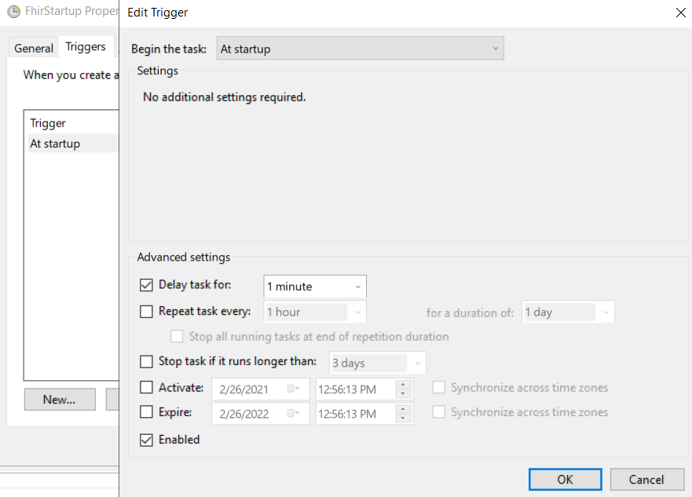

* + Action - to run your start-up script

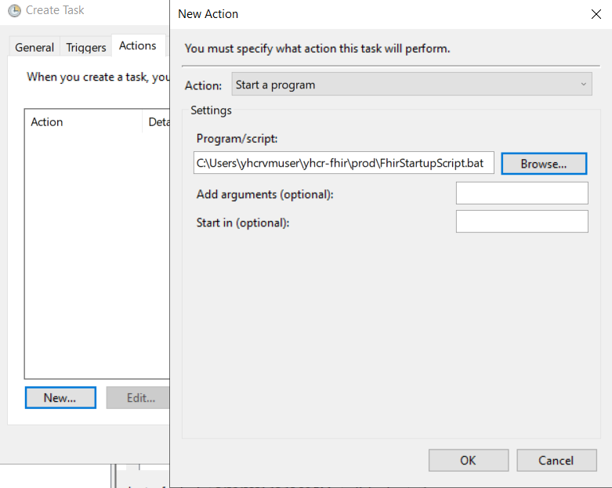

1. Test this configuration – eg reboot and check ***docker ps*** to confirm the services are running

## Applying Updates

There are two reasons why updates to the FHIR Appliance will be issued:

1. **Functional enhancements** (including bugfixes) – these will be notified via the normal release process. To-date the FHIR Appliance has been stable and these have been rare.
2. **Regular security patching** – a docker image encapsulates a “full stack” including operating system. Therefore the images need to be regularly rebuilt to incorporate any operating system patches. This will be done monthly (aligned with Microsoft Patch Tuesday) for both Windows and Linux. No additional announcements will be made about this.

In either case you will need to upgrade to get the new image

**Upgrade scripts (for both Linux and Windows) are provided in the “misc” folder**

**It is recommended to schedule these scripts to run at least monthly - to ensure you have the latest, fully patched, version of the image.**

# Technical Onboarding

**Once you are satisfied with your installation from an internal perspective then it is time to move to the final step of connecting to the messaging exchange via the Onboarding process.**

The Onboarding Suite website is provided to assist with these technical onboarding steps. In essence the process involves registering for an account, and providing various information – including contact details, plus technical details such as IP addresses. You are then provided with details of the relevant messaging exchange endpoints, plus credentials to connect. This document is not intended to be a user guide for the Onboarding Suite itself – but rather to highlight the local technical configuration needed as part of using this tool.

The two main activities are:

1. **Configuring IP addresses, endpoints and firewalls**
   * You will provide your environment’s IP address to the Onboarding Suite – which will be used for routing and/or to open any necessary firewalls on messaging exchange side
   * The Onboarding Suite will provide details of the messaging exchange’s IP address and endpoints – which will similarly need to be used to open relevant firewalls for the messaging exchange to gain access into your organisation’s infrastructure.
2. **Obtaining certificates, keys, and credentials**

Essentially this involves replacing any self-signed credentials which you may have used for the “quickstart” exercise with properly signed certificates from the central exchange.

* + Screens are provided to guide you through this process – downloading configuration templates (cnf) and using OpenSSL to generate private keys (key), and then submit certificate signing requests (csr) to obtain the corresponding signed certificates (crt or pem)
  + Note that the cnf and csr files are temporary artefacts, and no longer needed once you have key and certificate which they help you to generate
  + You can also download the relevant public root certificates

For the most part, this will provide the information needed to populate the “jwt” and “pix” folders, plus to complete the configuration settings in your .env file. The exception is the SSL keys and certificates - which will most likely need to be installed on a separate web proxy server.

Once configuration is complete then the Onboarding Suite can also help test the connection.