

FHIR Appliance Installation

3rd Party Technologies

Version 1 – February 2021

Table of Contents

1 Introduction 4

1.1 Purpose of this Document 4

2 Postgres 5

2.1 Installation 5

2.2 FHIR Store Database Setup 6

2.3 Backups and High Availability 7

2.4 Enterprise Support 7

3 IIS 8

3.1 Install IIS (including security options , plus ARR) 8

3.2 Manage Certificates 9

3.3 Configure SSL 11

3.4 Configure IIS Load Balancing (Server Farm) 12

3.5 Configure Mutual Authentication 15

3.6 IIS Reverse Proxy option 19

4 Other Web Proxies 20

4.1 NGINX 20

4.2 Traefik 20

**Version Control**

|  |  |  |  |
| --- | --- | --- | --- |
| **Version** | **Release Date** | **Released By** | **Reason for Release** |
| 1 | 22/02/2021 | Tim Davey | Preliminary Draft |
|  |  |  |  |

**Reviewers**

|  |  |  |  |
| --- | --- | --- | --- |
| **Initials** | **Name** | **Role** | **Organisation** |
|  |  |  |  |
|  |  |  |  |
|  |  |  |  |
|  |  |  |  |
|  |  |  |  |
|  |  |  |  |
|  |  |  |  |
|  |  |  |  |
|  |  |  |  |
|  |  |  |  |
|  |  |  |  |
|  |  |  |  |
|  |  |  |  |
|  |  |  |  |
|  |  |  |  |
|  |  |  |  |
|  |  |  |  |
|  |  |  |  |
|  |  |  |  |
|  |  |  |  |
|  |  |  |  |
|  |  |  |  |

# Introduction

## Purpose of this Document

This document is part of a set which walks through the entire process of installing the FHIR Proxy and connecting to YHCR. It is assumed that the preceding document(s) have already been read, and material already covered will not be repeated.



This document provides additional guidance on some of the 3rd party technologies which are anticipated to be needed around the YHCR FHIR Proxy itself in a production deployment. For example, databases and web proxies.

***Note that this paper is entirely concerned with industry-standard technologies which are not directly provided by the YHCR.***

***Considerable research has been put into preparing the notes and they have been carefully tested – the aim is to help get your installation working as quickly and easily as possible.***

***However ultimately the YHCR cannot be responsible for configuration of these 3rd party technologies, and you may need to supplement these notes with your own expertise and with knowledge of your own specific environment and organisational standards.***

# Postgres

In this section we cover the basics of installing and configuring a standalone (non-docker) Postgres database server for use with the FHIR Proxy.

***The aim is to provide enough information to help you get started and to point out any specifics relevant to this installation. However it is beyond the scope of these documents to provide Postgres DBA training. You will need to supplement these notes with your own learning if you are planning a production deployment and Postgres is new to you.***

***Note: Another option would be to use a cloud service. Most of the major cloud providers offer a fully managed Postgres database-as-a-service, so if your organisation is already using the cloud then this option may be attractive.***

## Installation

Note: For a test system it is possible for the database to be co-located on the same server as the FHIR Proxy. For a production system then it is best-practice to host the database on a dedicated server.

1. **Run installation (including pgAdmin client)**

* From the Postgres website, follow the download link and install Postgres v11.x <https://www.postgresql.org/>
* On Windows, the installation wizard also includes by default the pgAdmin client. Or otherwise install from the website: <https://www.pgadmin.org/>

The pgAdmin client is exposed (by default) on <http://127.0.0.1:50198/browser/>, or on Windows a link is also added under the “Postgres” folder in the Start Menu

* The Windows installation wizard also offers a link to the “Stack Builder” tool which is worth looking at for various additional tools and utilities which may be useful

1. **Open server firewalls**

* After installation, please check that any firewall software running on the server allows inbound TCP/IP and UDP from necessary sources (eg the FHIR Proxy server) to the PostGreSQL Server service (port 5432).

*Note: This may be necessary to configure even on a test server where the database and FHIR Proxy are running on the same box.*

1. **Enable database connections from the FHIR Proxy**

Connections to the database are controlled by the Postgres configuration file ***pg_hba.conf***, which you will need to edit to allow a connection from the FHIR Proxy:

* Stop the PostGreSQL Server Service
* Open [PostGres Installation Path]\PostGreSQL\11\data\pg_hba.conf in a text editor.
* Under the section called "IPv4 local connections" add a new entry

***host all all [FHIR PROXY IP]/32 password***

For example: ***host all all 10.1.4.5/32 password***

* Save the file and restart the PostGreSQL Server Service.

## FHIR Store Database Setup

1. **Connect to the database server using the pgAdmin client**

* Right click on “Servers”, select “Create >”, “Server…” and fill out the dialog box.
* Give it a name (eg fhirstoredb)
* On the “Connection” tab then the Host is the name or ip address of the server, the Username is by default “postgres” and the password is whatever you set as the master password on database creation

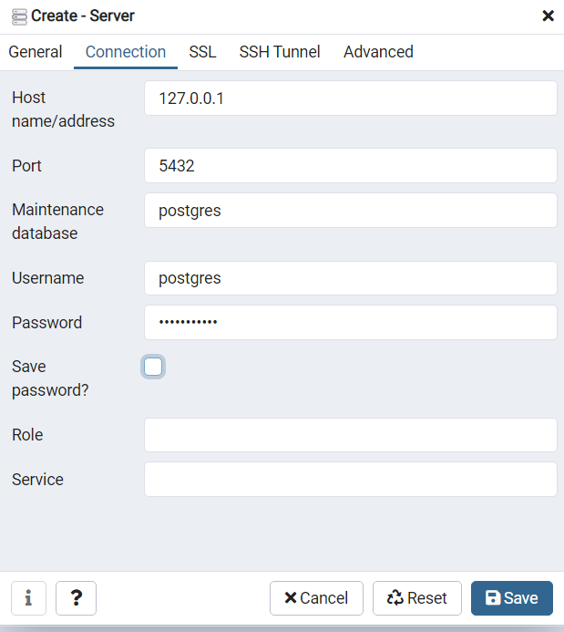

1. **Create a new database named fhirstore**

* (Right click on databases, “Create >”, “Database…”)

1. **Create a new login/group role for the FHIR Proxy User, and make owner of the fhirstore database.**

* Right click on the Sever (eg fhirstoredb), “Create >”, “Login/Group Role…”
* Enter a user name (eg iamonfhir) in the name field (General tab)
* Enter a password field (Definition tab)
* Switch all the options in the Privileges tab to Yes
* Select the fhirstore database and change the owner to iamonfhir (Right click on the data, “Properties…”, General tab

This username and password are what the FHIR Appliance will use when connecting to the database. For example it will need to be configured in the FHIR Proxy .env files as part of the database connection string.

1. **Create the database tables needed by the FHIR Proxy**

* In the fhirstore data, right click on Schemas, “Query Tool”
* Paste in and run the database initialisation script provided in the FHIR Proxy installation (ie ***pg_init.sql***)
* Refresh the view, and check that FHIR Store and also Audit tables have been created

## Backups and High Availability

For a production server it is important to configure backups and high availability

1. **Configure backups**

* Information about configuring backups can be found here:

<https://www.postgresql.org/docs/current/backup.html>

* Postgres offers several backup options, and further guidance can be found online – for example:

<https://www.enterprisedb.com/blog/postgresql-database-backup-recovery-what-works-wal-pitr>

* It is worth noting that the two schemas created for the FHIR Proxy have significantly different characteristics
  + The main “public” schema contains the FHIR Resources, and will be critical to restore quickly to get running again in the event of a disaster
  + The “audit” schema is vital to archive securely to preserve an audit trial. However it has potential to grow large, and it would not be vital to immediately restore the historical audit trail to restart operations after a disaster

There may therefore be benefit in separate backups of the two schemas.

1. **Configure high availability**

* Information about configuring high availability can be found here:

<https://www.postgresql.org/docs/current/high-availability.html>

* Again there is further guidance available online, for example:

<https://www.enterprisedb.com/postgres-tutorials/how-implement-repmgr-postgresql-automatic-failover>

* There are also various replication tools available (some free and others licensed) which may relevant.

## Enterprise Support

Whilst Postgres is free, several companies offer enterprise support agreements if this is desired. For example, the Postgres download page is sponsored, and other companies offer similar services. As noted above, most cloud providers also offer a fully managed Postgres database-as-a-service.

# IIS

In this section covers the basics of installing and configuring Microsoft Internet Information Server on Windows Server 2019 - to provide reverse proxy and load balancing services. We also look at installing certificates for TLS including Mutual Authentication

***The aim is to provide enough information to help you get started and to point out any specifics relevant to this installation. However IIS is a complex product and configuring it in a correct and security-hardened manner is non-trivial. You will need to supplement these notes with your own learning if you are planning a production deployment and IIS is new to you.***

***Tip: If any of the following steps are unfamiliar then it is highly recommended to do a practice-run using your own self-signed certificates***.

Self-signed certificates are easy to generate using OpenSSL (see Appendix of ***YHCR FHIR Proxy Install 03 - Quickstart Install*** for details), and also a full set for testing are provided in the “***misc***” folder of the install. Taking this approach of experimenting with your own certificates lets you test everything in isolation, before adding the additional complexity of external connections to the YHCR. It also means that you have all of the private and public keys available to fully test– whereas with the actual YHCR configuration then some of the private keys will obviously be withheld.

## Install IIS (including security options , plus ARR)

1. **Install IIS**

* In Server Manager, “Add roles and features”, and add the “Web Server (IIS)” feature
* Under “Security”, make sure that the following options are ticked, as they may be needed for configuring TLS Mutual Authentication:
  + Client Certificate Mapping Authentication
  + IIS Client Certificate Mapping Authentication
  + URL Authorization

1. **Install the Application Request Routing (ARR)**

* This enables reverse-proxy features, and can be got from: <https://www.iis.net/downloads/microsoft/application-request-routing>

1. **Check it is working**

* Browse to <http://localhost> where you should see the IIS home page

## Manage Certificates

*Note: In IIS all certificates are managed at the server level. Once all necessary certificates are installed on the server then specific certificates are referenced as required to enable SSL on particular “Site”*

1. **Open the IIS Server Certificates tool**

* Open IIS Manager
* Select the top-level node representing the entire Server, and then select “Server Certificates”

Here there are many options to work with certificates

1. **Create an IIS Generated Certificate for SSL (optional)**

If you just want to get SSL working quickly, you can simply take the option to “Create Self Signed Certificate”.

* Give the certificate a “Friendly Name”, and select the “Web Hosting” store
* You can now use this self-signed certificate to enable SSL for a website (see next section)

Whilst this is very easy, it is not so helpful for our purposes - as we will want to enable SSL by importing specific certificates (eg YHCR provided, or our own self-signed certificates for testing).

1. **Importing a Certificate for SSL**

Importing a certificate is more useful for our purposes, and is also straightforward:

* Select “Import…”
* Browse to the pfx file that you wish to import
* Enter a password (if necessary), and select the “Web Hosting” store

Whilst this is simple enough, the challenge is where to get a pfx file from - as this is not what you get back from the YHCR Onboarding process.

1. **Generating a pfx file**

A pfx file is a “bundle” which combines together:

* The **public certificate** (crt or pem – these file types are interchangable)
* The **private key** (key)
* If necessary, the **root certificate** (crt or pem) which proves the bone-fides of the public certificate

You can easily demonstrate this for yourself using Open SSL:

* First generate a self-signed key pair for testing:

***openssl req -x509 -newkey rsa:4096 -sha256 -keyout testSSL.key -out testSSLl.crt -subj "/CN=yourservernamehere" -days 600 -nodes***

* Then combine the key and crt files into a single pfx file:

***openssl pkcs12 -export -out testSSL.pfx -inkey testSSL.key -in testSSL.crt name MyTestSSLCertificate***

This will prompt for a password to secure the pfx file – and it is good practice to provide one, or alternatively just press “enter”

* Your pfx file can now be imported as a Certificate into IIS

However our goal is to achieve this feat with the SSL certificate provided by YHCR. To understand how this will work, it is worth remembering the steps of the onboarding process which are (you do not necessarily need to actually do this now):

1. Use OpenSSL to generate a private key (key) and certificate signing request (csr)
2. The csr is uploaded to YHCR, gets signed, and comes back as an SSL Server Certificate (crt)
3. You will also need the YHCR Root CA Certificate, which is used to verify the signature on the cert

* These three ingredients are then combined in a similar way as the previous example to create the pfx file:

***openssl pkcs12 -export -out YHCRServerSSL.pfx -inkey YHCRServerSSL.key -in YHCRServerSSL.crt -certfile YHCRRootCA.crt name YHCRServerSSLCertificate***

(NB: the actual filenames of the key and crt or pem files will be different – the above is illustrative)

* As before, the resulting pfx file can now be imported as a Certificate into IIS

## Configure SSL

*Note: Before beginning it is worth noting that in IIS the SSL settings are per “Site”. Therefore if the IIS server is shared with other websites and applications, it is likely that you will want to configure a new “Site” to manage the specific TLS settings and certificates required for the YHCR.*

Once the certificates are imported (see above) then configuring SSL is straightforward:

1. **Edit the site Bindings**

* Open IIS Manager
* Right click on the Site and select “Bindings”
* Select “Add”, choose “https” from the dropdown, select the correct certificate from the dropdown – then press “OK”. (This assumes you have already followed the steps above to load the certificate into IIS. It will then appear in the dropdown on this screen)
* To enforce HTTPS only - in the list of bindings, select the http Binding, and click “Remove”
* Finally click “Close”

1. **Enable SSL**

* Now go back and select the Site, and select “SSL Settings” (the padlock icon)
* Tick the box for “Require SSL”, and press “Apply”

Traffic to the website is now secured using SSL with your chosen certificate. For more details and screenshots, see (for example) <https://techexpert.tips/iis/enable-https-iis/>

## Configure IIS Load Balancing (Server Farm)

1. **Create a Server Farm**

* Open IIS Manager
* Right click on Server Farms, and select “Create Server Farms”
* Give the farm a name
* Add server(s) to the farm – enter the IP address(es) of the FHIR Proxy server(s)

NB: You may wish to change the backend port – for example the FHIR Proxy “secured” endpoint (with JWT token verification) listens by default on port 3001. This can be done when adding the server by clicking on “Advanced Settings…”. As far as the author can see there is no other way to ever view or edit this setting if you miss this opportunity!

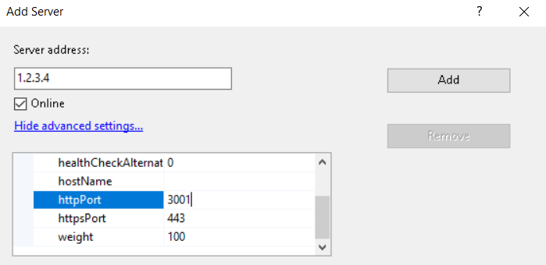

* Say “yes” to the suggestion of a rewrite rule

1. **Configure a Health Test**

It is possible to configure a “URL Test” using the root url of the FHIR Proxy (ie https://<host>) . This returns a “Ping” response – and this works even if JWT validation is enabled for requests to the FHIR Server itself. This is therefore useful for a URL health test:

* Try it for yourself in a browser – enter the url https://<webhost> , and see the response “Ping”
* Back in IIS Manager, click on the Web Farm, and then on the Health Check icon
* Configure the URL as https://<webhost>, and the Response match as “Ping”
* Press “Verify URL Test” to check it is working

***Note that this is a single URL for the “frontend” website. IIS does not appear to offer a way to direct healthchecks at specific “backend” servers.***

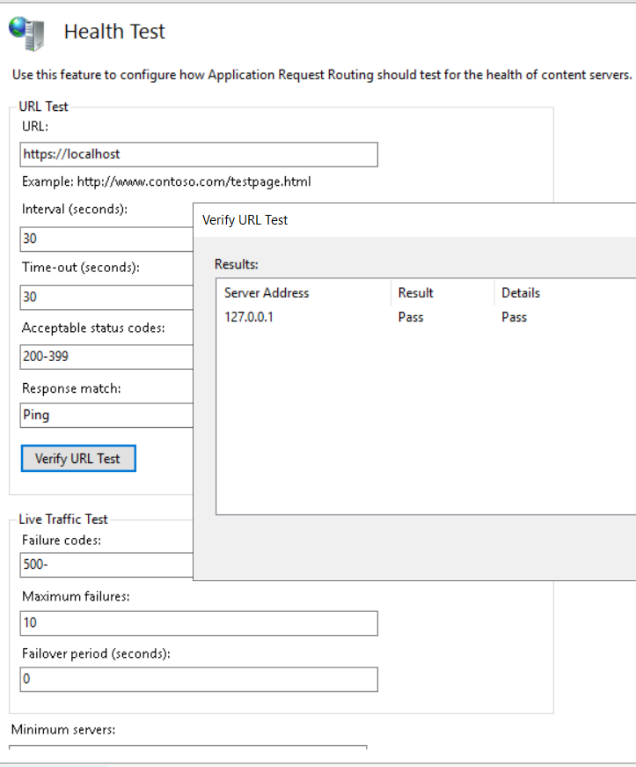

Notice that there is also an option for a “Live Traffic Test”, however this is more problematic. The FHIR Proxy currently seems to be quite enthusiastic in its use of HTTP 500 responses – for example a 500 is returned if JWT verification fails. Therefore the Live Traffic Test may be better left on the default, disabled, settings.

The following link provides useful further details of these IIS healthcheck features: <https://blogs.iis.net/richma/application-request-routing-health-check-features>

1. **Review other Server Farm Settings**

The other options for a Server Farm are reasonably self-explanatory and covered by Microsoft documentation, however a few points of note are:

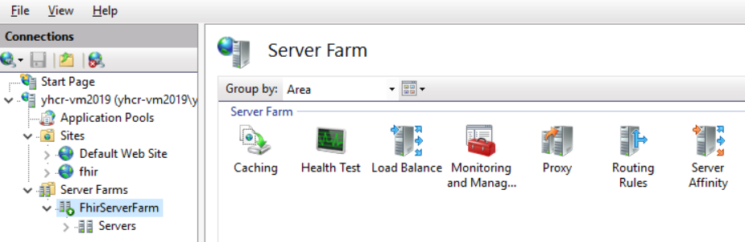

* **Load Balance**

Contains a choice of algorithms for distributing requests

* **Monitoring and Management**

Shows some useful statistics, and is also the place where you can right-click on a server to adjust its healthy / unhealthy status

* **Routing Rules**

Contains the tickbox for “***SSL Offloading***”.

If ticked it will forward requests to the backend (eg FHIR Proxy) on http, which is the default and simplest option. This also allows the possibility of configuring just an IP address for the back end servers – ie a host name is also possible but not necessary.

If not ticked it will use https, which does provide an extra layer of security (if required) whilst traversing the internal network – but will require additional SSL configuration of the FHIR Proxy backend. It will also require a proper host name – ie with either DNS or “hosts” routing configured. IIS does check the backend certificate against the hostname in the configured URL, and will error on a mismatch.

There is also an option for “***Advanced routing***” - where this http/https choice for the backend connection can be seen and edited more directly, along with many other advanced settings. This includes a “***Conditions***” option which can be used to control which type of requests (eg by host, path, etc) come through to this server farm. This may be useful if, for example if there are multiple sites and applications on the IIS Server. For more details see also:

<https://improve.dk/setting-up-multiple-iis-application-request-routing-farms-on-the-same-server/>

* **Server Affinity**

The FHIR Proxy is stateless – so there should be no need to configure server affinity

## Configure Mutual Authentication

***NB: Before starting on this activity, it is worth noting a couple of characteristics of IIS which make TLS Mutual Authentication more complicated to configure than might otherwise be expected:***

1. **Server-wide Trusted Root CA certificate store**

Trusted Root CA certificates are imported to the Windows server-wide store. This means that a “simple” implementation of TLS-MA on IIS may be easily configured to require a certificate, but that this will accept a certificate from ANY of the many Trusted Root CAs in the Windows certificate store! Thus the site is not, by default, locked down to enforcing credentials from only, say, the YHCR CA.

1. **Single Healthcheck URL**

IIS Web Farms do not allow configuration of healthchecks directly to the backend servers. Rather there is a single URL to check the frontend website. There is also no way for this URL to present any credentials. This means that if the website is locked down with TLS-MA, then the healthchecks will be unable to get through – and the entire site will go “unhealthy” and take itself down!

The steps below suggest a workaround to these IIS limitations which is based on:

* Requiring not just any trusted certificate, but a specific certificate. This extra check can be done in IIS by mapping that certificate to represent a “user” identity, and then locking the site to prevent “anonymous” access
* Leaving the root of the website open - to allow the “Ping” healthcheck response to continue. Additional configuration is instead used to apply the TLS-MA lockdown only to the “/fhir” subdirectory

The remaining steps go into more detail around these basic ideas. The author would welcome comments from any IIS experts if a neater solution can be proposed.

**Note on testing:**

In order to test the configuration at each step, it is useful to have the following three tests prepared:

1. https://<webhost> - this is the basic “Ping” test, to be run in a client with no certificates (eg a simple browser tab). This should always work
2. https://<webhost>/fhir/stu3/metadata - to be run in a client with certificate credentials configured (eg Postman). This should always work
3. https://<webhost>/fhir/stu3/metadata - to be run in a client with no certificates (eg a simple browser). This should work at the start, but NOT work by the end of the exercise

(Note that “work” in this context may mean returning an Operation Outcome to inform that the JWT token is invalid. The key point being that this is a response from the FHIR Proxy, as opposed by an authentication / authorisation rejection from IIS)

1. **Import Root CA to Trusted Store**

* Open the Windows Certificate Manager Tool (ie NOT in IIS)
* Navigate to the Trusted Root Certification Authority folder, and “Import” the certificate

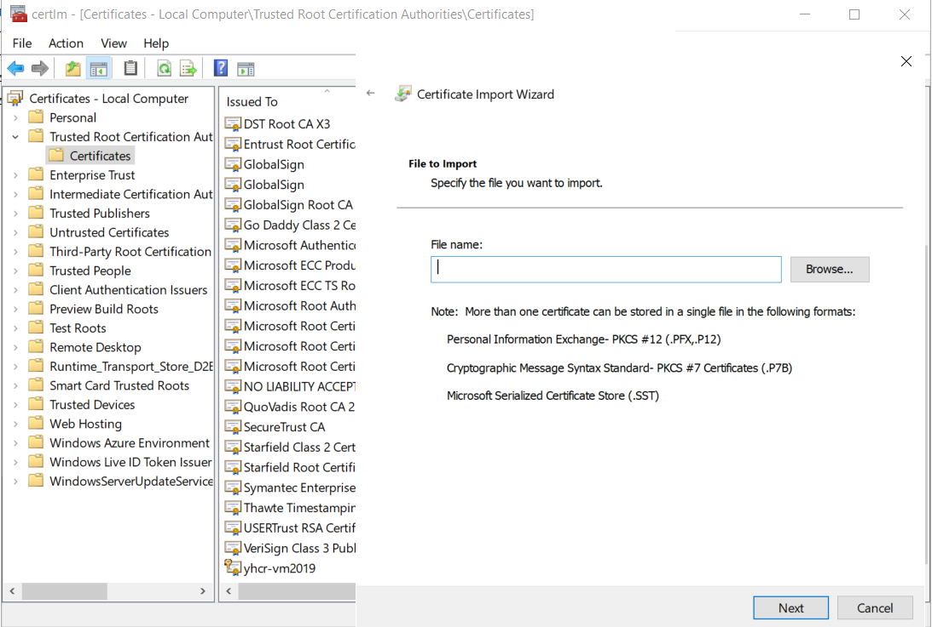

This step is very straightforward, but points to note include:

* Notice the long list of trusted roots in the store – by default ANY of these would unlock the site! (We will lock this down shortly)
* If you have a “.pem” file then, although not listed, this will also work. Just change the options to “All Files” and select it
* If you are testing with self-signed certificates then you may not have a root CA. Just import the Self-Signed certificate itself.

1. **Enable (but do not enforce) Mutual Authentication for the site**

* Back in IIS Manager, select the site, and then SSL Settings (the padlock icon)
* On Client Certificates, choose the option for “Accept”

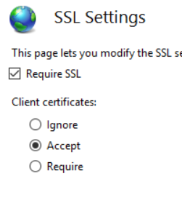

This choice merits some discussion. At this point we have changed very little, and all 3 of the test cases should still work. All that is happening is that IIS is now “looking” for a certificate and processing it if it finds one. However nothing is enforced.

(You could try experimenting with “Require” to see what happens. As you might expect the test case which presents a certificate continues to work for a short while, whilst the other tests should fail. However this failure includes the “Ping” Health Check – and once the Web Farm notices then the site will go down entirely! You will need to reset it to “healthy” from within the Web Farm “Monitoring” option).

1. **Create a user account**

This is just a normal Windows user account – for example in Computer Management, Local Users and Groups. You may want to make sure that the password does not expire. This is the user which we will map to the certificate.

1. **Map Certificate to User**

* In IIS Manager, on the Site, select “***Configuration Editor***” (the icon of a piece of paper)
* Select the setting “*webserver/security/authentication/iisClientCertificateMappingAuthentication*”, and make sure it is “enabled” (This assumes that the feature is installed – see the first step of installing IIS).
* In the details, make sure that “*oneToOneCertificateMappingsEnabled*” is true, then click on the “…” to the right of “(Count=1)”
* In the properties dialogue enter the username and password of the user you have created, plus paste in the relevant certificate. (This is a bit fiddley – you need to remove any “--- BEGIN CERTIFICATE ---“, “--- END CERTIFICATE---” statements, plus remove all newlines. So just one long string of characters)

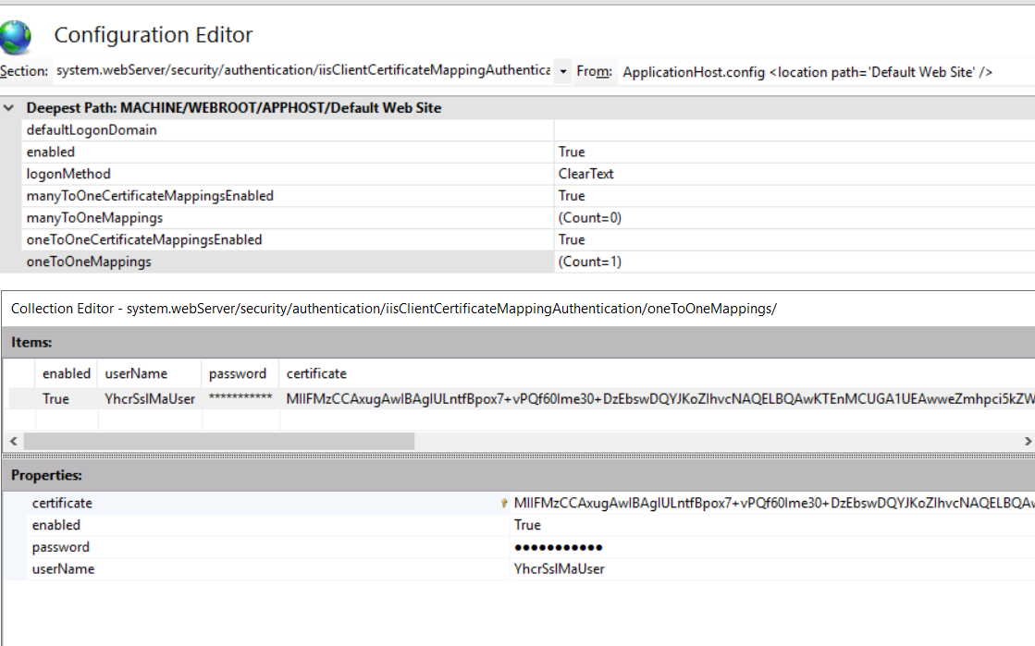

*At this point all 3 tests should still work, however there is now a subtle difference. The two tests without credentials are still running as the “anonymous” user. However the test with the credentials has now had its certificate inspected and verified (via the “SSL Settings = Accept” choice), and has been mapped to a user (via the above configuration). It is no longer anonymous, but is running as this user.*

1. **Lock down the /fhir directory with a Location Tag**

With all of the preparations in place, finally we are ready to lock down the site. The goal is to leave the top-level open (for the “Ping” healthchecks), but lock down the “/fhir” directory. There does not appear to be a way to do this from the IIS Manager user interface – it is necessary to edit the IIS configuration files manually.

* Edit ***applicationHost.config*** – this can be found in ***Windows/System32/inetsrv/config***
* The file is large, but you are looking for a section like this (probably at the bottom). It is fairly easy to see how this encodes the settings that we have just been making in the UI.

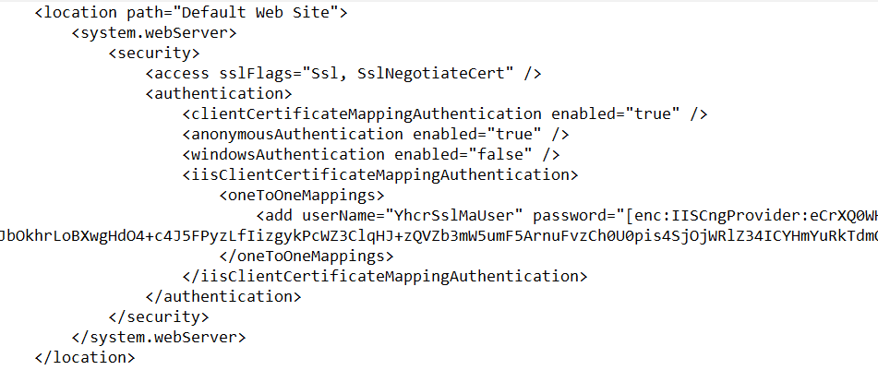

* Leave this section alone, but make a second copy immediately underneath and edit it as follows (you can also find an example in the “misc” folder of the install)

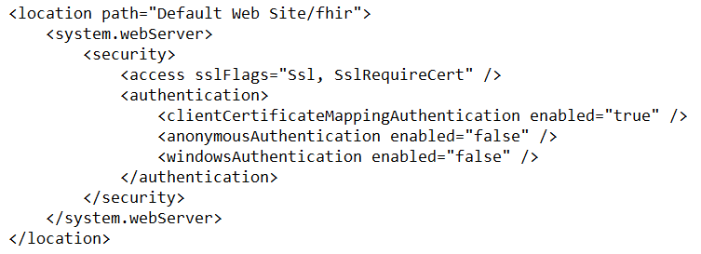

* Important points in this configuration are:
  + ***location path*** – states that this configuration applies to the “fhir” directory only
  + ***sslFlags – SslRequreCert*** means that a valid certificate (albeit from ANY of the trusted CAs) must be presented to get in.

*Note: the author has had some difficulties with this setting mysteriously locking out even when a valid certificate is presented. It would be possible to “turn it down” to SslNegotiateCert and still be protected by the other authentication settings.*

* + ***authentication*** – most important is that anonymousAuthentication is “false” - so anonymous users are locked out. And clientCertificateMappingAuthentication is “true” – and so the only way to acquire an identity and get in here is by matching with the certificate configured in the previous section.

At this point the task should be complete, and you should rerun the 3 tests to confirm. Ping should still be working, the metadata query with a certificate should still be working, but the metadata query without a certificate should be blocked.

To be extra sure, you could edit the applicationHost.config file and temporarily “sabotage” the certificate string (eg change a character). This should cause even the test presenting a “valid” certificate to be locked out – because it does not match the one-and-only certificate configured to access this site.

1. **Further Reading**

The following links have been useful in researching this section, and may be of interest:

<https://www.lucadentella.it/en/2018/04/18/iis-mutua-autenticazione-con-certificati-ssl/>

<https://hafizmohammed.medium.com/configuring-client-certificates-on-iis-95aef4174ddb>

<https://medium.com/@yildirimabdrhm/configuring-iis-for-client-certificate-mapping-authentication-d7f707506a97>

<https://hostadvice.com/how-to/how-to-configure-iis-user-authentication/>

<https://docs.microsoft.com/en-us/iis/get-started/planning-your-iis-architecture/deep-dive-into-iis-configuration-with-iis-7-and-iis-8>

## IIS Reverse Proxy option

Finally, it is worth mentioning that IIS can also be configured as a reverse proxy. This is a somewhat simpler configuration – it could be seen as an alternative to the Web Farm and it just passes traffic through to a single backend with no load balancing.

This might be relevant if IIS is being used in a “simpler” way to offer SSL termination – for example maybe just used with self-signed certificates to provide encryption of network traffic across an internal network link.

Further details can be found here:

<https://techcommunity.microsoft.com/t5/iis-support-blog/setup-iis-with-url-rewrite-as-a-reverse-proxy-for-real-world/ba-p/846222>

# Other Web Proxies

## NGINX

Very similar topics as for IIS will need to be considered for NGINX – ie configuring SSL, Mutual Authentication, and Load Balancing. However this should be a simpler – given NGINX’s more straightforward design in terms of probing backend servers and assigning client certificates to services.

The following links cover installing NGINX:

<https://www.digitalocean.com/community/tutorials/how-to-install-nginx-on-ubuntu-18-04>

<http://nginx.org/en/docs/windows.html>

The following links cover configuring SSL, Mutual Authentication, and Load Balancing:

<http://nginx.org/en/docs/http/configuring_https_servers.html>

<https://docs.nginx.com/nginx/admin-guide/security-controls/terminating-ssl-http/>

<https://smallstep.com/hello-mtls/doc/server/nginx>

<https://docs.nginx.com/nginx/admin-guide/load-balancer/http-load-balancer/>

More time could be spent fleshing out further examples on request.

## Traefik

Again, similar topics would apply for Traefik.

One obvious possibility would be to use a modified version of the “quickstart” Traefik configuration if an internal SSL layer is required to connect the FHIR Proxy to the “main” external-facing web proxy. On Linux this could be copied from the quickstart docker-compose file almost as-is. On Windows a standalone installation would be necessary, plus some slight modification to the config files. (In the future it is hoped that the FHIR Proxy might offer an SSL option “out of the box”)

The following link covers installing Traefik:

<https://doc.traefik.io/traefik/getting-started/install-traefik/#use-the-binary-distribution>

* Copy the configuration files into the installation folder
* From the installation folder type ***./traefik*** to run

To setup the standalone equivalent of the quickstart configuration would involve transposing the startup commands from docker-compose into a (static) traefik.toml something like:

[entryPoints]

[entryPoints.web-secure]

address = ":443"

[providers]

[providers.file]

filename="dynamic_conf.toml"

watch = true

[api]

insecure = true

And transposing the router configuration from docker lables into a dynamic_conf.toml would look something like:

[http]

[http.routers]

[http.routers.rtr-fhir-secured]

rule="Host(`<hostnamehere>`) && PathPrefix(`/fhir`)"

service="svc-fhir-secured"

entryPoints=["web-secure"]

[http.routers.proxy.tls]

[http.services]

[http.services.svc-fhir-secured.loadBalancer]

[[http.services.svc-fhir-secured.loadBalancer.servers]]

url=<urlhere:port>

Settings for TLS would also need adding – probably configuring based on a specific “host” rather than global defaults.

The following link covers all aspects of TLS configuration for Traefik (including Mutual Authentication)

<https://doc.traefik.io/traefik/https/tls/>

And load balancing is covered here:

<https://doc.traefik.io/traefik/routing/services/>

Again, more time could be spent fleshing out further examples on request.