## Purpose of the Program

Position Converter’s purpose is to convert Fanuc TP program points from XYZWPR representation to Joint representation and vice versa. The program does this by opening a full MD: backup and parsing all .ls files contained along with a number of various files for the robot’s arm type, user tools, and user frames in order to do the conversion properly.

## Requirements

This program was written with .Net Framework 4.6.1, so that has to be present on your machine. If it is not, you can get it from this link: <https://www.microsoft.com/en-us/download/details.aspx?id=49981>

## How to use

1. Start by opening a full MD: robot backup from the File Open menu. The program will parse the robot backup and then display a list of programs with motion.

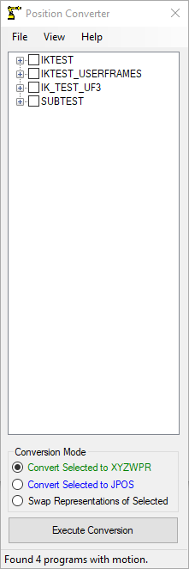

1. Check the program, or positions in a program that you would like to convert and press the ‘Execute Conversion’ button.

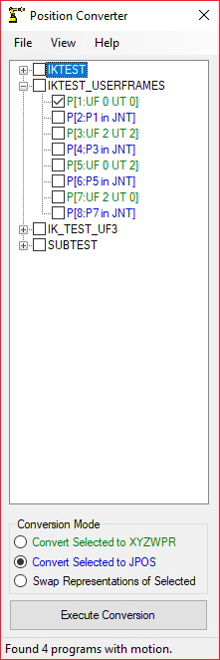

1. If the conversion was successful, the point will change color to match its current representation.

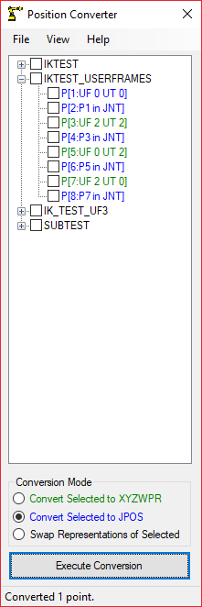

1. Once the conversion is complete, right click on the program name, and click either save as to save the program in a separate directory, or click on copy to copy the program unto the clipboard.
2. You’re done!

## Program tips

1. Hovering over a point will display its contents in a tooltip.
2. Hovering over a program will display its comment in a tooltip.
3. Points are color coded by their point representation. Green for XYZWPR, and blue for Joint.
4. If a conversion fails, the point will be colored red, and the tooltip will be updated on why the conversion failed.
5. You can view the parsed in robot type, user frames and robot model under the view tab.

## Known issues

1. The math will have slight differences from a conversion done on the Fanuc controller vs a conversion done by this program. Typically the differences are in the order of hundredths to thousandths of a millimeter (far below the repeatability of a typical arm).
2. Only NUT or FUT point configurations are supported. I plan on adding support for NDT, FDT, NDB, and FDB at a later date.
3. Only the following arms are supported, more to be added in the future:
   1. R-1000iA/80F with and without insulation plate.
   2. R-1000iA/100F with and without insulation plate.
   3. R-2000iA/165F,/200F with and without insulation plate.
   4. R-2000iB/125L,165F,/210F with and without insulation plate.
   5. R-2000iC/125L,165F,/210F with and without insulation plate.
   6. Arc Mate 120iC or M20iA
   7. M710iC/12L
   8. M710iC/20L - Untested
   9. M710iC/20M - Untested
   10. M710iC/45M - Untested
   11. M710iC/50 - Untested
   12. M710iC/70 - Untested
4. Multiple groups are not supported.
5. Remote TCP is not supported.
6. Extended Axes are not supported.

## Legal

Synaptic Robotics LLC makes no warranties, expressed or implied, with respect to the software, and/or documentation, and specifically disclaims the implied warranties of merchantability and fitness for particular purposes. Synaptic Robotics LLC does not warrant that the operation of the software will be error free. To the maximum extent permitted by law, in no event shall Synaptic Robotics LLC be liable for any special, incidental, consequential or punitive damages whatsoever, including claims of lost profits, business interruptions, lost information, or other damages arising out of the use or inability to use the software.