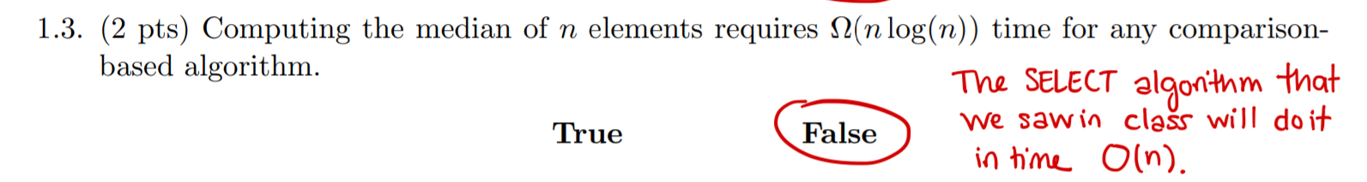

Always O(n)



As long as a fixed n, all o(1)?

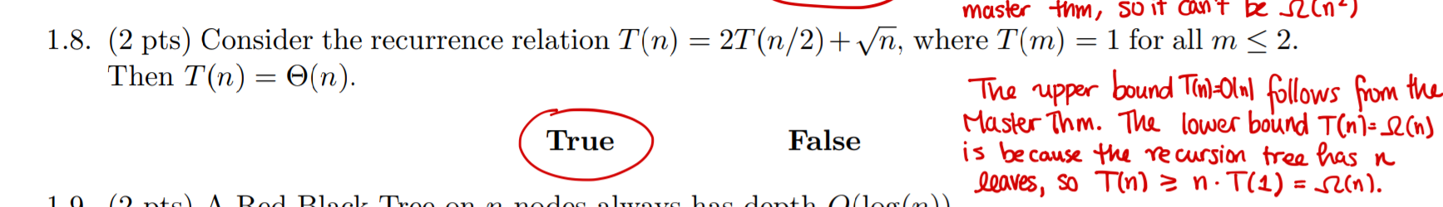

Because the recursion tree has n leaves??

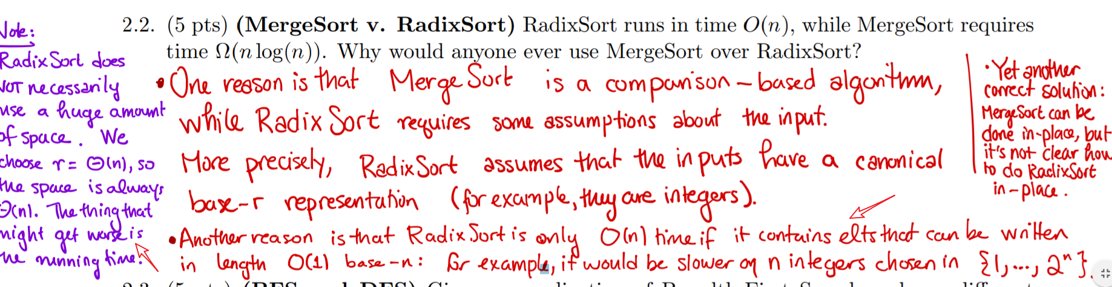why radixsort radix sort is slower for a large integers, if n is large n<n\*log(n)

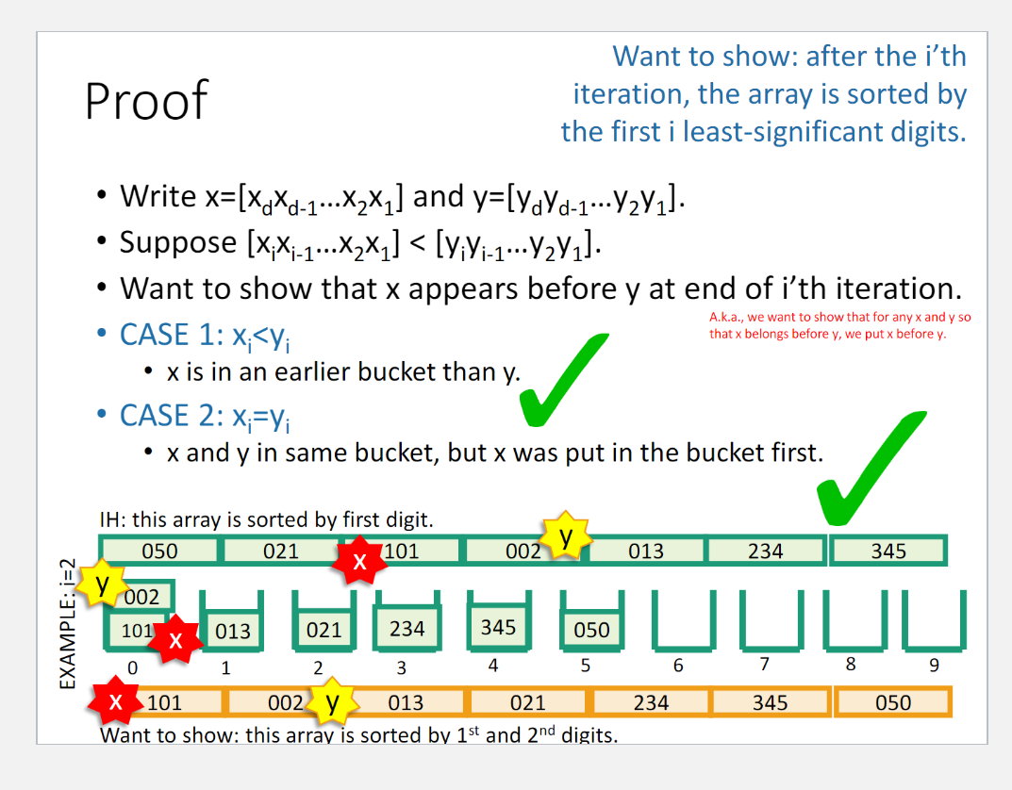

How to prove the radixrort is correct using induction?

P39

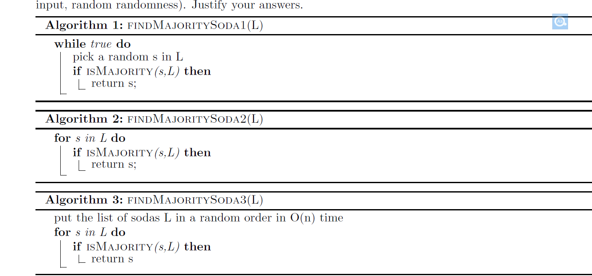



Use the bucket for sorting the month

Use two month for the