**ELEC352**

**Task One Answer Template**

|  |  |
| --- | --- |
| **Group number: 3** | |
| **Project Manager: Dequn Teng** | **Secretary: Haohan Niu** |

1. Using the template below, perform a **SWOT** analysis on your project. You need to write **8-10** bullet points for each area.

|  |  |
| --- | --- |
| **Strengths**   * Strong Implementation and Execution Ability * Rich Project Management Experience * High Delivery Efficiency * High Level of Product Quality * Advanced Group Communication Skills * Experienced Risk Management * Quality process and procedures * From similar cultural backgrounds and collaborate well | **Weaknesses**   * Lack of mechanical engineering * Expensive in Cost * New: Without High Reputation, Capital * Low Supply chain management Efficiency * New Master Degrees of Engineering lack of industry training. * Lack of marketing expertise * New product or service lack of market evaluation * Constraint access to natural resources |
| **Opportunties**   * Available and enthusiastic labour * Reasonable prices for raw materials * Helicopter Available for fast delivery * Abundant forest resources supporting construction * Impressive Product as the core of the whole project * Successful negotiation with Local tribes and protest groups for construction without interference * A solution in reducing negative consequences of the high temperature and humidity on working * Specialized workforce on the market available for use. * Fixtures, fittings and specialist equipment are brought with shipping fee covered | **Threats**   * Hard to recruit a specialized workforce, satisfying the requirement * Raw materials and tools from Ecuador are out of stock. * Transport Links are broken due to vehicle’s flaw. * Transport Links are broken due to bad weather * International workforce suffers from harsh environment, influencing the productivity. * Disagreement with local tribes and protest groups * Harms and injuries caused during the deforestation * Water scarcity due to geographical factors (i.e. no rainfall). * Glass is broken in Safety Violation (i.e. attack from the Tyrannosaurus Rex). |

1. In the space below; devise a **SMART** objective for your project.

“To design, simulate, fabricate and test an Tyrannosaurus Rex Enclosure with a walkway for visitors which should be completely enclosed with viewing windows (20m long, 4m high and 2m wide) (windows are 1m x 3m), Electric fencing around the perimeter (1km*1km fencing with 10 m high), Thermal cameras to be installed to monitor t-rex movement (minimum of 4 cameras), A feeding lift for the pen using Cranes, Steel reinforced concrete, Wood, Glass, A Water supply, Plumbing, Towers, Data relay system, Plants, Excavator, Electric circuitry , to enable a Tyrannosaurus Rex Enclosure, where people may go on the walk way in seeing the Tyrannosaurus Rex eating and playing as the premier exhibition in the park with impressive but incredibly secure characteristics. Thus, it is built with a be highly secure with a concealed walkway through the enclosure containing a feeding mechanism for the dinosaur and era specific foliage and terrain, by February 26 2021”

1. In no more than **200 words**, analyse and discuss the findings of your SWOT analysis.

As a high standard construction building company, even if at the early stage of our professional careers, we are all professional engineers with a master of engineering degree. Additionally, we are equipped with Project Risk Management Experience, in training the engineering disciplinaries from electronic to computer engineering. Furthermore, we are a group with high Delivery Efficiency, indicating that we will finish every deadline the moment they occurred with our full efforts. What is more, we guaranteed a high Level of Product Quality inherited from our high standard of academic integrity of the University of Liverpool. Moreover, we have been equipped with Advanced Group Communication Skills via Microsoft Teams, Project, and Visio for well-understood group planning.

However, we also have some limitations due to our electronic engineering background. There is a lack of mechanical engineering training. Additionally, as the industry-leading company, our service is expensive. What is more, as a start-up company, we are capable of limited to global recognitions. Furthermore, since construction is a system engineering, but there are limited supply chain management skills for professional industries. Moreover, as a company whose founders are all engineering background, there is a lack of marketing expertise for promoting our products.

## Appendix 1 – Team Roles Document

**Team Roles**

* The table below is to be filled in with the person’s name who will be taking each position for each task (i.e a different person for each two week period).
* Roles are to be rotated on a fortnightly basis.
* All members of the group must be Chairman / PM at least once. If your team has six members, you will need to specify two people as co-chairman for one task.
* The Chairman/PM has responsibility for completing the task deliverables. His/her version will be marked. All other team members must submit the same deliverables and if they do so will receive the same mark as the chairman.

|  |  |  |
| --- | --- | --- |
| Weeks | Chairman/ Project Manager | Secretary |
| Task 1 | Dequn Teng (D.Teng@student.liverpool.ac.uk) | Haohan Niu |
| Task 2 | Haohan Niu (h.niu2@student.liverpool.ac.uk) | Qiyang Ding |
| Task 3 | Qiyang Ding (Q.Ding4@student.liverpool.ac.uk) | Gan Fang |
| Task 4 | Gan Fang (G.Fang@student.liverpool.ac.uk) | Wenhan Hu |
| Task 5 | Wenhan Hu (w.hu10@student.liverpool.ac.uk) | Dequn Teng |

**You also need to make a note of everybody’s email address in your group and their telephone numbers. Additionally you need to arrange your first meeting.**

If somebody from your group is missing you need to contact them as soon as possible telling them where and when each meeting is. If a designated chairman does not turn up to a meeting, the members present should elect a new chairman, and record this in their minutes.

## Appendix 2 – Agenda and Minutes

*Project Management Module*

Group 03 Virtual Project Management Committee

|  |
| --- |
| **Minutes of the meeting on the 23/10/20** |

1. Replace the red text with your own words.
2. Log all agreed points and key events in the minutes.
3. The minutes should then be submitted with each task, and also put in the file share folder for the benefit of the rest of the group.

|  |  |  |  |
| --- | --- | --- | --- |
| **Group Name/Number:** | **Group 3** | **Meeting Date and time :** | **23/10/20** |
| **Meeting Topic:** | **Weekly Review Meeting** | **Location:** | **Teams** |

|  |  |
| --- | --- |
| **Attendees:** | (Project Manager) Dequn Teng |
|  | (Secretary) Haohan Niu |
|  | Qiyang Ding |
|  | Wenhan Hu |
|  | Gan Fang |
|  |  |
| **Apologies:** |  |
|  |  |
|  |  |
| **Absences:** |  |
|  |  |
|  |  |

1. **Project Discussion, Agreement and Consensus**

**Outline**

* Project agreement
  + reading
  + discussion
  + questions
  + possible solutions
* Task 1 agreement
  + reading
  + discussion
  + questions
  + possible solutions
* meeting minutes
  + I'm not sure how to do this.

**Subsections**

The project is divided into five tasks.

* Situation analysis and goal-setting
* Planning and organization of the work programme
* Critical path analysis
* Risk analysis and management
* Cost analysis and management

**Global Constrainsts**

Your team is running the program, but you need to recruit an employee. A dedicated workforce to provide it.

1. there is a ready supply of enthusiastic labour, but most people will need to Training and transportation to the island.
   1. All raw materials and tools needed can be purchased from Ecuador. Competitive prices. 4.
2. many fixtures, accessories and specialized equipment must be purchased. from other cities in South America, Europe or North America.
   1. Poor transport links to the island: deliveries must be planned as early as possible. And carefully managed. (The island is only accessible by boat twice a week.) The ship can carry a volume of 50 cubic metres)
3. there is also a helicopter at your disposal at a much higher cost. Shorter transport time. (It can only carry a volume of 10 cubic meters.)
4. Severe weather will affect all transportation to the island, and hurricanes and storms will affect transportation to the island. Storms are common. This weather will also affect high Cranes and heavy construction equipment.
5. international staff may be exposed to high temperatures and humidity.
6. local tribes and protest groups may make it difficult and obstruct the construction The park. ELEC 352 - Engineering Management
7. Most of the islands are overgrown and have inadequate trails, roads and infrastructure. None exist. Deforestation is required.
8. all construction times given are for a team of workers.

**Hypothesis.**

We have only one team for construction

**dependency**

This will be the premier exhibition in the park. It needs to be appropriately Impressive, but very.

keywords: security,

Your job. Your job is to build a Proper TRex housing.

It should be highly stable and steady secret passage The shell. It requires Includes dinosaur feeding mechanisms and era-specific foliage and. Terrain. Enclosure requirements.

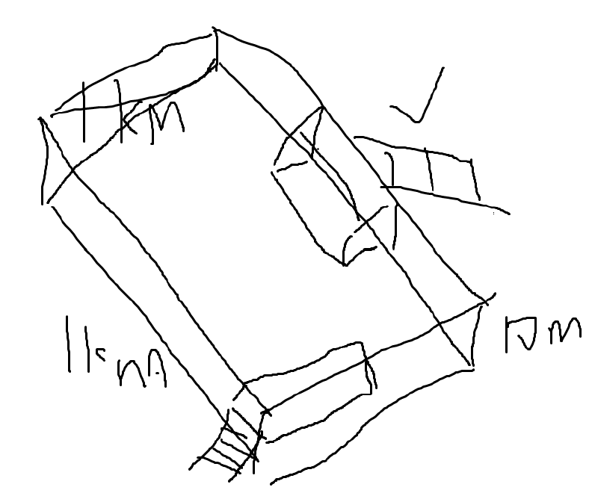

* An access road for visitors. It should be completely closed. Observation window (20m long, 4m high, 2m wide) (window is 1m X 1m) 3m)

--

* + The 1-meter sidewalk would take a day to build.
  + A window takes half a day to install.
* Tyrannosaurus rex is the largest of the Tyrannosauridae family. The body length is about 11.5-14.7 meters. The average hip height is about 4 meters. The maximum hip height can reach about 5.2 meters and the maximum head height is nearly 6 meters. The average weight was about 9 tons.
* Electric fence around the perimeter (4km of fence) done
  + The 1 meter long fence takes 2 hours to build.
* Water supply
* The fence will be 1x1 km large and 10 m high.
  + The 1m long fence will take 2 hours to erect.
* Thermal cameras will be installed to monitor the activity of the t-rex (minimum). (4 cameras).
  + It takes 2 days to install a camera.

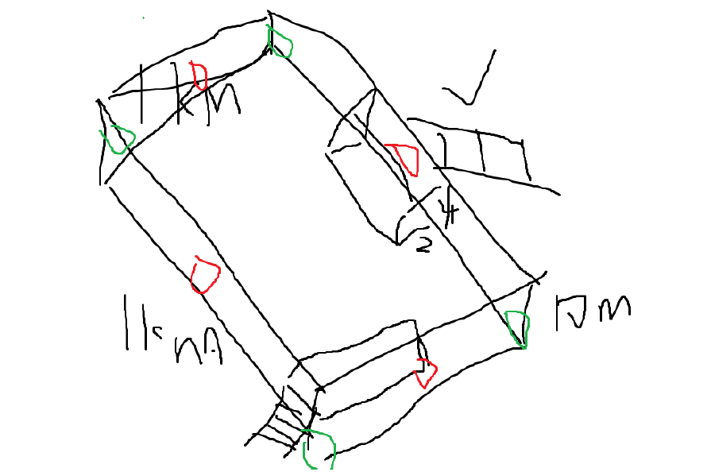

* Feeding lifts at the bar
  + Feed elevator installation takes 4 days
  + Input: food outside the human fence
  + Output: food inside the fence
  + specific location remain unknown
  + possible location
  + 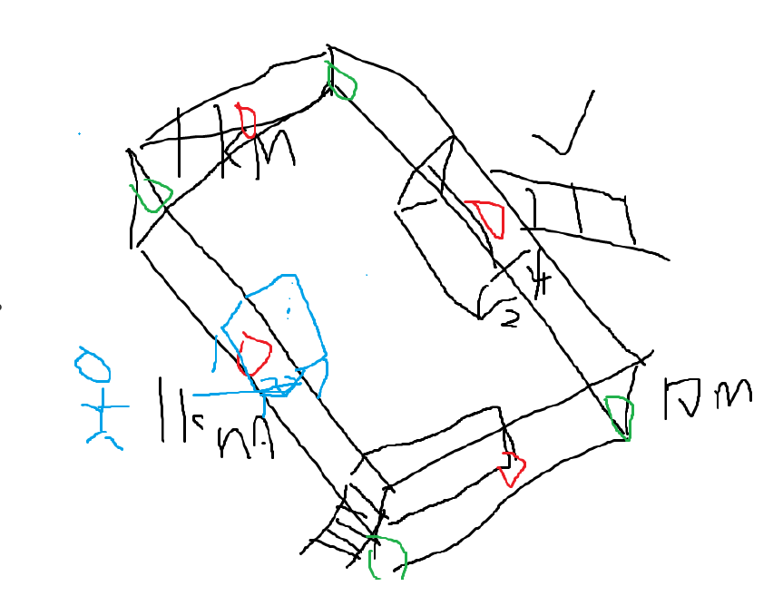
* time
  + A 1 meter fence takes 2 hours to build.
  + 1 meter of pavement takes a day to build.
  + A window takes half a day to install.
  + A camera takes 2 days to install.
  + Feed elevator installation takes 4 days
  + 4+8+
* goods
  + cranes
  + reinforced concrete
  + lumber
  + glassware
  + water supply
  + plumbing
  + pagoda
  + thermal imaging camera
  + Data Relay System
  + plants
  + Feed elevator
  + excavators
  + circuits

**Questions**

* How many works can I train?
* How many works can I train?
* There is a ready supply of enthusiastic labour but most people require training and transport to the island.
* There is a ready supply of enthusiastic labour but most people require training and transport to the island. transformed to workers

1. **Brainstorm and devise a SMART objective**

* Discussion
* Dequn Teng and Haohan Niu suggested that the SMART objective should be To design, simulate, fabricate and test an Tyrannosaurus Rex Enclosure with a walkway for visitors which should be completely enclosed with viewing windows
* This was agreed and the SMART objective refined so that it fulfilled the SMART format.

1. **Brainstorm and do project SWOT analysis**

* Discussion
* Brainstorming
* 10 points were found for each sections among Strengths, Weaknesses, Opportunities and Threats.

1. **Allocation of future tasks**

* Haohan and Dequn to write up minutes and brainstorms.
* All members to read through SWOT analysis to derive conclusion points.

1. **Confirm the next Chairperson/Project Manager and Secretary.**

* Hanhan Niu and Qiyang Ding to remain Chairperson and Secretary respectively.

1. **Agree the date, time and place for the next meeting**

* The next meeting to be held on the 30th of October at 10am in the ETC

1. **Any Other Business**

* N/A

|  |  |  |
| --- | --- | --- |
| ACTIONS SUMMARY – For review at next meeting | | |
| Future agreed Actions | **Initials** | **Due date** |
| 1. **Discussion of Submission** | **ALL** | **Oct 30** |
| 1. **SWOT of the submission** | **ALL** | **Oct 30** |
| 1. SMART of the submission | **ALL** | **Oct 30** |
| 1. **Weekly Report of the submission** | **ALL** | **Oct 30** |
|  |  |  |
|  |  |  |
|  |  |  |
|  |  |  |
|  |  |  |
|  |  |  |

*Project Management Module*

Group 03 Virtual Project Management Committee

|  |
| --- |
| **Minutes of the meeting on the 23/10/20** |

1. Replace the red text with your own words.
2. Log all agreed points and key events in the minutes.
3. The minutes should then be submitted with each task, and also put in the file share folder for the benefit of the rest of the group.

|  |  |  |  |
| --- | --- | --- | --- |
| **Group Name/Number:** | **Group 3** | **Meeting Date and time :** | **30/10/20** |
| **Meeting Topic:** | **Weekly Review Meeting** | **Location:** | **Teams** |

|  |  |
| --- | --- |
| **Attendees:** | (Project Manager) Dequn Teng |
|  | (Secretary) Haohan Niu |
|  | Qiyang Ding |
|  | Wenhan Hu |
|  | Gan Fang |
|  |  |
| **Apologies:** |  |
|  |  |
|  |  |
| **Absences:** |  |
|  |  |
|  |  |

1. **Project Discussion, Agreement and Consensus**
2. **Brainstorm and devise a SMART objective**

* Discussion

- Haohan contributes to the specific goal

- Gan suggests the measureable goal

- Qiyang recommends the achievable goal

- Wenhan contributes to the relevant goal

- Dequn proposes to the time-based constraints

1. **Brainstorm and do project SWOT analysis**

* Discussion
* Brainstorming
* 10 points were updated and reached a consensus for each sections among Strengths, Weaknesses, Opportunities and Threats.

1. **Allocation of future tasks**

* The next task will be done by Qiyang, Gan, Wenhan

1. **Confirm the next Chairperson/Project Manager and Secretary.**

* Hanhan Niu and Qiyang Ding to remain Chairperson and Secretary respectively.

1. **Agree the date, time and place for the next meeting**

* The next meeting to be held on the 6th of November at 10am in the ETC

1. **Any Other Business**

* N/A

|  |  |  |
| --- | --- | --- |
| ACTIONS SUMMARY – For review at next meeting | | |
| Future agreed Actions | **Initials** | **Due date** |
| 1. **Resilience Questionnaire** | **ALL** | **Nov 6** |
| 1. **Peer Assessment** | **ALL** | **Nov 6** |
|  |  |  |
|  |  |  |
|  |  |  |
|  |  |  |
|  |  |  |
|  |  |  |