Created with a trial version of Syncfusion Word library or registered the wrong key in your application. Click here to obtain the valid key.
Template

Adventure Works Cycles
Adventure Works Cycles, the fictitious company on which the AdventureWorks sample databases are based, is a large, multinational manufacturing company. The company manufactures and sells metal and composite bicycles to North American, European and Asian commercial markets. While its base operation is located in Bothell, Washington with 290 employees, several regional sales teams are located throughout their market base.
In 2000, Adventure Works Cycles bought a small manufacturing plant, Importadores Neptuno, located in Mexico. Importadores Neptuno manufactures several critical subcomponents for the Adventure Works Cycles product line. These subcomponents are shipped to the Bothell location for final product assembly. In 2001, Importadores Neptuno, became the sole manufacturer and distributor of the touring bicycle product group.

Product Overview
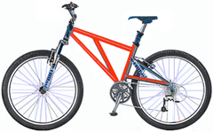 | Mountain-200  Product No: BK-M68B-38  Size: 38  Weight: 25  Price: $2,294.99
Mountain-300  Product No: BK-M47B-38  Size: 35  Weight: 22  Price: $1,079.99 | 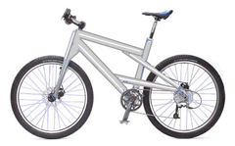
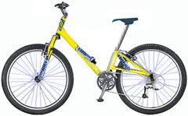 | Road-150  Product No: BK-R93R-44  Size: 44  Weight: 14  Price: $3,578.27

Tiny Cubs
An infant giant panda cub is about the size of a croissant, weighs less than a teacup and is about 900 times smaller than its mother. An average adult mother weighs around 91 kilograms (200 pounds) while newborn weighs only 83 to 190 grams (3 to 4 ounces).

Other Fun Giant Panda Facts
- Researchers have recently discovered that the gene responsible for tasting savory or umami flavors, such as meat, is inactive in giant pandas.
- For many centuries, giant pandas were thought to be a mythical creature, like a dragon or unicorn.
- Unlike other bears in the region, giant pandas don’t hibernate.
- Giant pandas can stand erect on their hind legs but rarely walk.

Created with a trial version of Syncfusion Word library or registered the wrong key in your application. Click here to obtain the valid key.

