Adventure Works Cycles^{Trademark}
Adventure Works Cycles, the fictitious company on which the Adventure Works sample databases are based, is a large, multinational manufacturing company. The company manufactures and sells metal and composite bicycles to North American, European and Asian commercial markets. While its base operation is located in Bothell, Washington with 290 employees, several regional sales teams are located throughout their market base.

Explore:
- precision-engineered frames with lightweight alloys like Al_{CeramicBlend},
- touring bikes^{MexicoBuilt} designed for long-distance comfort,
- Final assembly at our Bothell HQ_{AssemblyBase},

Product Overview
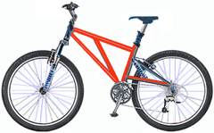 | Mountain-200^{New model}  Product No: BK-M68B-38  Size: 38 cm_{SurfaceArea}  Weight: 25  Price: $2,294.99
Mountain-300^{New model}  Product No: BK-M47B-38  Size: 35 cm_{SurfaceArea}  Weight: 22  Price: $1,079.99 | 