Created with a trial version of Syncfusion Word library or registered the wrong key in your application. Click here to obtain the valid key.

Adventure Works Cycles
Adventure Works Cycles, the fictitious company on which the AdventureWorks sample databases are based, is a large, multinational manufacturing company. The company manufactures and sells metal and composite bicycles to North American, European and Asian commercial markets. While its base operation is located in Bothell, Washington with 290 employees, several regional sales teams are located throughout their market base.
In 2000, Adventure Works Cycles bought a small manufacturing plant, Importadores Neptuno, located in Mexico. Importadores Neptuno manufactures several critical subcomponents for the Adventure Works Cycles product line. These subcomponents are shipped to the Bothell location for final product assembly. In 2001, Importadores Neptuno, became the sole manufacturer and distributor of the touring bicycle product group.

Product Overview
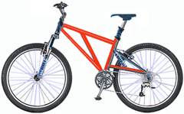 | Mountain-200  Product No: BK-M68B-38  Size: 38  Weight: 25  Price: $2,294.99
Mountain-300  Product No: BK-M47B-38  Size: 35  Weight: 22  Price: $1,079.99 | 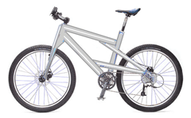
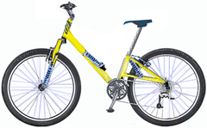 | Road-150  Product No: BK-R93R-44  Size: 44  Weight: 14  Price: $3,578.27

It contains the following detailed information:
- Suppliers/Vendors of Northwind – who supply to the company.
- Customers of Northwind – who buy from Northwind
- Employee details of Northwind traders – who work for Northwind
- Invoices – details of the invoice raised against the order.

Information About the Suppliers of Adventure Works Cycles:
Please find the supplier list as follows,
Supplier ID | Company Name | Contact Name | Address | City | Country
1 | Exotic Liquids | Charlotte Cooper | 49 Gilbert St. | London | UK
2 | New Orleans Cajun Delights | Shelley Burke | P.O. Box 78934 | New Orleans | USA
3 | Grandma Kelly's Homestead | Regina Murphy | 707 Oxford Rd. | Ann Arbor | USA
4 | Tokyo Traders | Yoshi Nagase | 9-8 Sekimai  Musashino-shi | Tokyo | Japan
5 | Cooperativa de Quesos 'Las Cabras' | Antonio del Valle Saavedra | Calle del Rosal 4 | Oviedo | Spain

Created with a trial version of Syncfusion Word library or registered the wrong key in your application. Click here to obtain the valid key.

