Stock Market exchange report.
Trade No | Company name | Cost Price of a Share | Number of Shares | Sales Price of a Share | Net Profit/Loss
1 | A.H. Belo Corp. | $70 | 50 | $75 | $ 250.00
2 | Abercrombie & Fitch Company | $69 | 200 | $71 | $ 400.00
3 | Abm Industries Incorporated | $101 | 120 | $112 | $1,320.00
4 | ACA CAPITAL HOLDINGS | $170 | 20 | $172 | $ 40.00
5 | Accretive Health | $120 | 53 | $135 | $ 795.00
6 | Ace Limited | $90 | 73 | $85 | ($ 365.00)
7 | Advanced Micro Devices | $98 | 22 | $101 | $ 66.00
8 | Agco Corp. | $120 | 43 | $135 | $ 645.00
9 | Agl Resources | $130 | 84 | $132 | $ 168.00
10 | Agrium Inc. | $140 | 28 | $175 | $ 980.00
11 | Cabot Oil & Gas Corp. | $230 | 17 | $273 | $ 731.00
12 | Calix Inc | $354 | 35 | $343 | ($ 385.00)
13 | F.N.B. Corp. | $293 | 34 | $273 | ($ 680.00)
14 | Forestar Group Inc | $65 | 23 | $73 | $ 184.00
15 | Gabelli Utility Trust | $342 | 65 | $354 | $ 780.00
16 | Gamco Investors | $345 | 26 | $234 | ($2,886.00)
17 | Gannett Co. | $240 | 23 | $275 | $ 805.00
18 | Goodrich Corp. | $720 | 45 | $610 | ($4,950.00)
19 | M&F Worldwide Corp. | $470 | 83 | $435 | ($2,905.00)
20 | Macerich Company | $534 | 93 | $640 | $9,858.00
21 | Magna International | $843 | 27 | $820 | ($ 621.00)
22 | Mohawk Industries | $992 | 38 | $832 | ($6,080.00)
23 | Nabors Industries | $342 | 83 | $349 | $ 581.00
24 | Nalco Holding Company | $930 | 20 | $843 | ($1,740.00)
25 | Panhandle Royalty Company | $934 | 29 | $930 | ($ 116.00)
26 | Parkway Properties | $493 | 52 | $535 | $2,184.00
27 | Patriot Coal Corp. | $433 | 73 | $343 | ($6,570.00)
28 | Polo Ralph Lauren Corp. | $483 | 55 | $530 | $2,585.00
29 | Polyone Corp. | $918 | 44 | $958 | $1,760.00
30 | Post Properties | $281 | 83 | $332 | $4,233.00

Northwind Database
Database Diagram
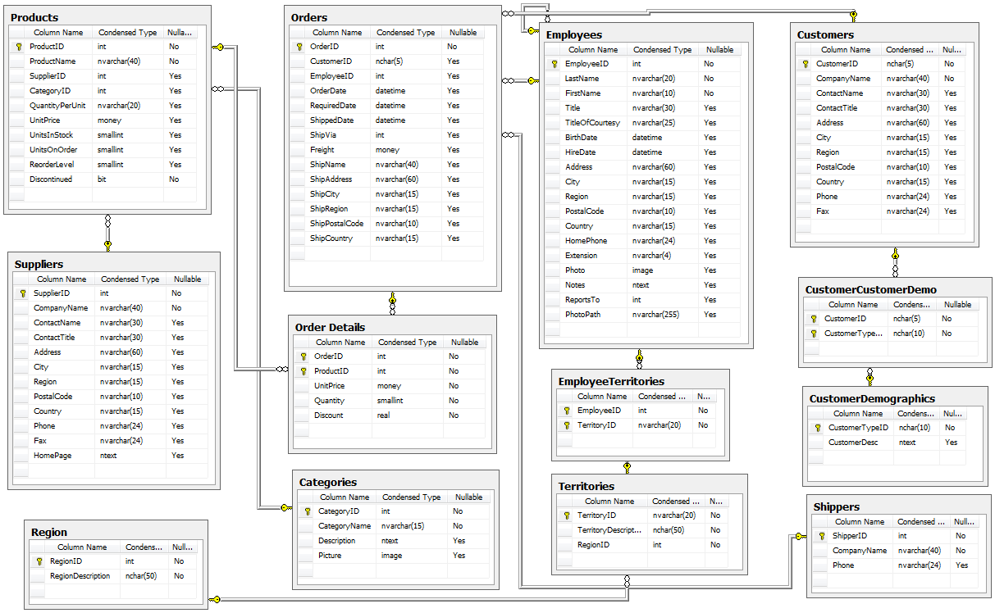
Figure(i) Database diagram of Northwind
The Northwind sample database (Northwind.mdb) is included with all versions of Access. It provides data you can experiment with and database objects that demonstrate features you might want to implement in your own databases.
It contains the following detailed information :
i). Suppliers/Vendors of Northwind – who supply to the company.
ii). Customers of Northwind – who buy from Northwind.
Suppliers
Supplier_ID | Company Details
 | Company Name | Contact Name | Address
4 | Exotic Liquids | Charlotte Cooper | 49 Gilbert St.
5 | New Orleans Cajun Delights | Shelley Burke | P.O. Box 78934
6 | Grandma Kelly's Homestead | Regina Murphy | 707 Oxford Rd.
7 | Tokyo Traders | Yoshi Nagase | 9-8 Sekimai  Musashino-shi  Calle del Rosal 4
8 | Cooperativa de Quesos 'Las Cabras' | Antonio del Valle Saavedra

Tables Details
Northwind Database contains the following table:
S.No. | Table name | Count
9. | Suppliers | 1
10. | Customers | 1
11. | Employees | 3
12. | Products | 1
13. | Inventory | 2
14. | Shippers | 1

