TIFF Image Test Document
Sample content for identifying WPicture image formats
Purpose: This document contains an embedded TIFF image and a non-TIFF image. It can be used to test a DocIO routine that reads WPicture.ImageBytes and checks the TIFF byte signature.
Expected result: 2 picture objects are present. Only the first picture should return true from IsTiff.

1. Embedded TIFF Image
The image below is stored as a TIFF file and embedded in the Word document.
Figure 1. TIFF image used for DocIO validation

2. Related Image Content
The following PNG image provides comparison content. It should not match either TIFF header signature.
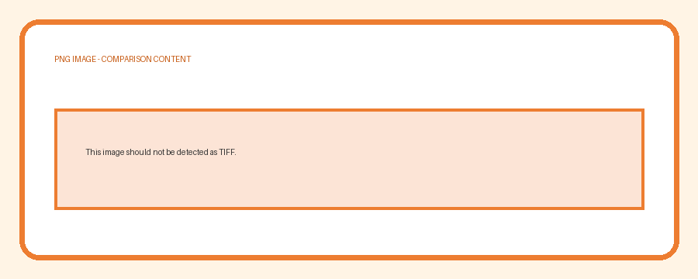
Figure 2. PNG image used as a non-TIFF comparison

3. Expected Validation Results
Picture | Format | Header bytes | IsTiff result
Figure 1 | TIFF | 49 49 2A 00 or 4D 4D 00 2A | true
Figure 2 | PNG | 89 50 4E 47 | false

4. Test Notes
- Load this DOCX file using WordDocument.
- Traverse the document entities and obtain each WPicture.
- Pass each WPicture to the IsTiff method.
- Confirm that the TIFF image returns true and the PNG image returns false.
Note: Some Word-processing applications may convert unsupported image formats when resaving the document. Use the original generated file for byte-signature testing.

