DocIO SVG Image Test Document
Sample content for identifying SVG pictures
Purpose: This document contains an SVG image with a PNG fallback and a separate PNG comparison image. It can be used to test SVG detection from WPicture image data.
Expected result: The first displayed picture has SVG vector data. The comparison picture is PNG.

1. Embedded SVG Image
The image below is displayed using a PNG fallback. The DOCX package also contains the original SVG vector image associated with this picture.
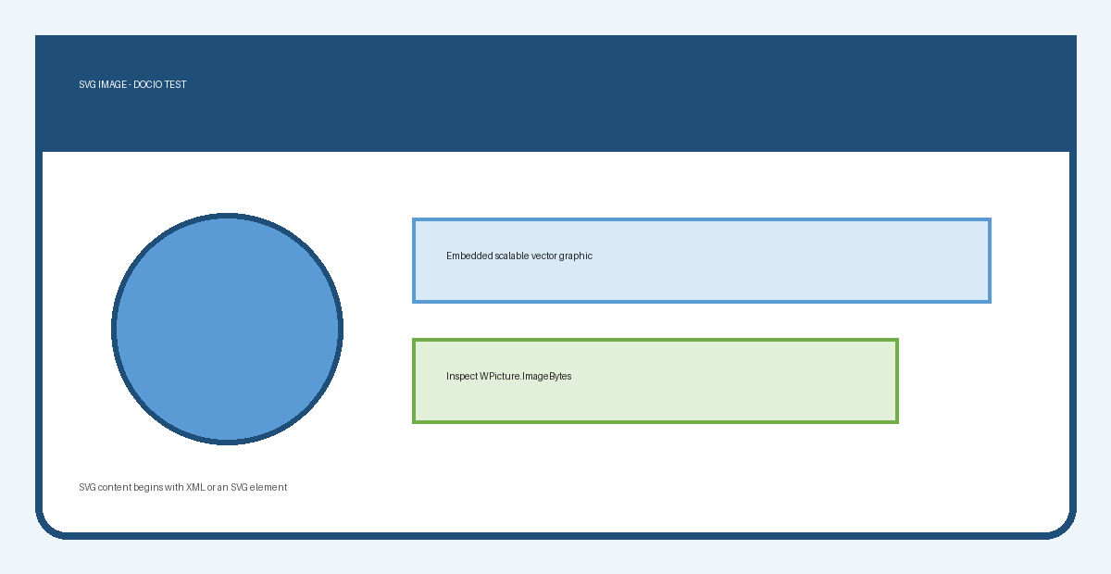
Figure 1. SVG image with a raster fallback

2. Related Raster Content
The following PNG image provides comparison content and should not be identified as SVG.

Figure 2. PNG image used as a non-SVG comparison

3. Expected Validation Results
Picture | Format | Typical content | Expected result
Figure 1 | SVG | <svg ...> or XML declaration | true
Figure 2 | PNG | 89 50 4E 47 | false

4. Test Notes
- Load the document using WordDocument.
- Obtain the WPicture objects from the document.
- Read the picture image data and check for SVG content.
- Confirm that the SVG picture is detected and the PNG comparison is not.
Note: Modern DOCX files can store an SVG together with a raster fallback for compatibility with applications that cannot render SVG directly.

