Adventure Works Cycles
Adventure Works Cycles, the fictitious company on which the Adventure Works sample databases are based, is a large, multinational manufacturing company. The company manufactures and sells metal and composite bicycles to North American, European and Asian commercial markets. While its base operation is located in Bothell, Washington with 290 employees, several regional sales teams are located throughout their market base.

Product Overview
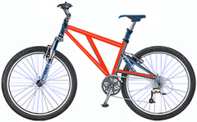 | Mountain-200  Product No: BK-M68B-38  Size: 38  Weight: 25  Price: $2,294.99
Mountain-300  Product No: BK-M47B-38  Size: 35  Weight: 22  Price: $1,079.99 | 