Platform | Diagram Node Template | Diagram Annotation Template | User handle Template
JS – TS | Define function:  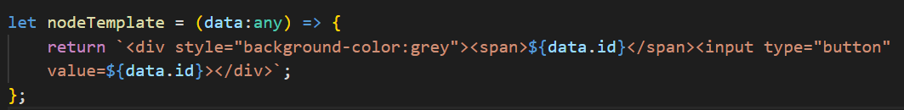  Assign it to diagram:  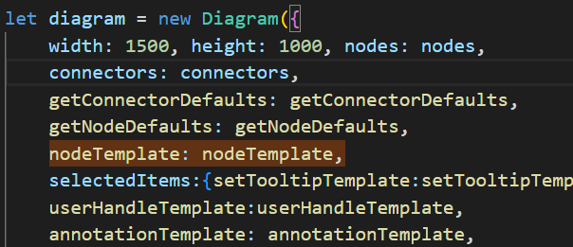  -----------------------------------------------------------------------------------------  Node HTML Content:  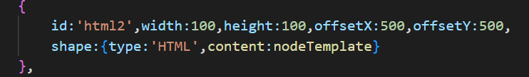 | Define function:  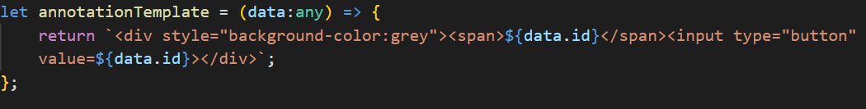  Assign it to diagram:  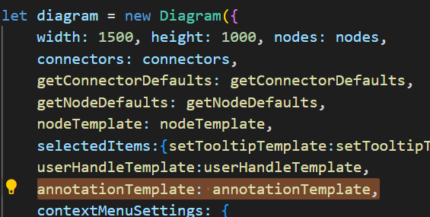  -----------------------------------------------------------------------------  Node / Connector Annotation template:  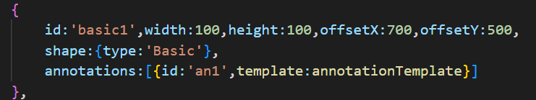 | Define function:  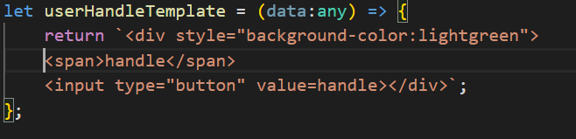  Assign it to diagram:  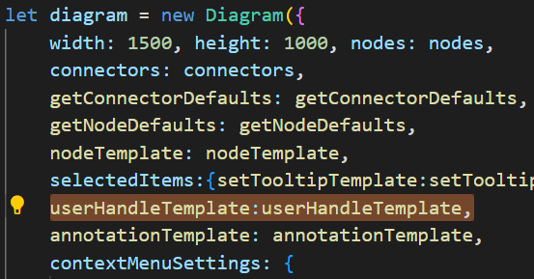
Angular | Assign inside diagram tag:  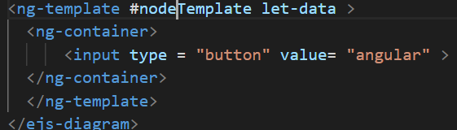  Node HTML Content:  NA | Assign inside diagram tag:  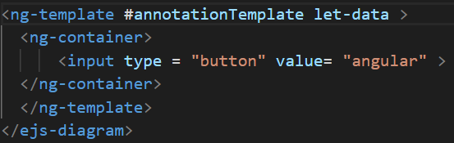  Node / Connector Annotation template:  NA | Assign inside diagram tag:  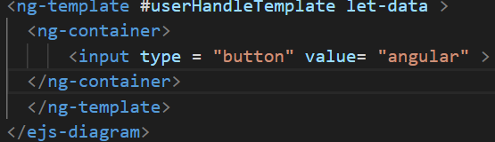
React | Define function template:  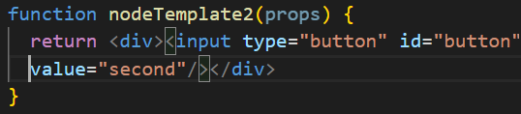  Assign it to diagram:  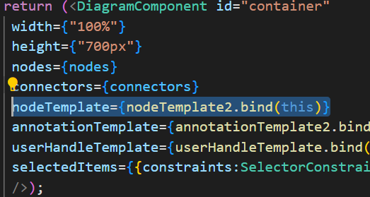  Node HTML Content:  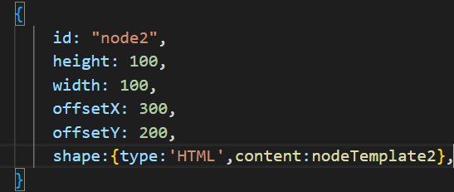 | Define function template:  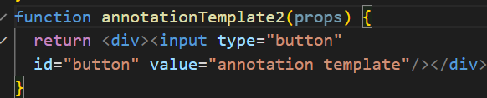  Assign it to diagram:  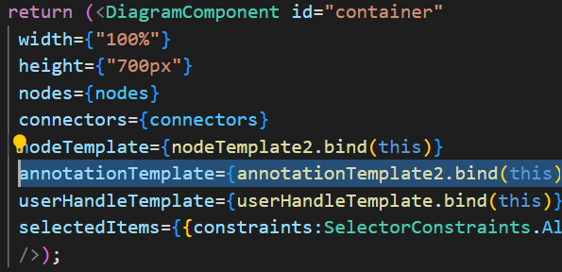  Node / Connector Annotation template:  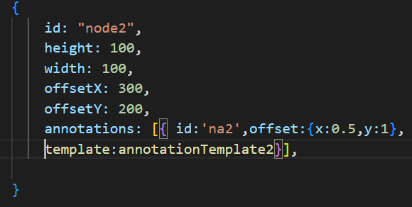 | Define function template:  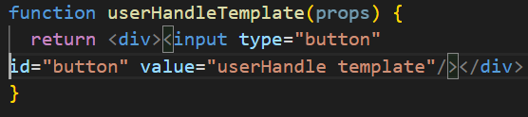  Assign it to diagram:  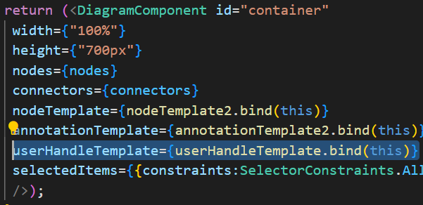
Vue | Assign v-slot template:  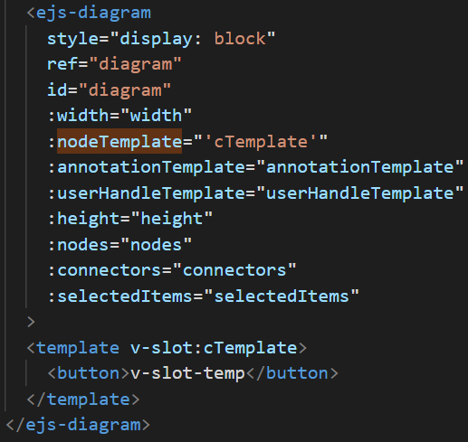 | Assign v-slot template:  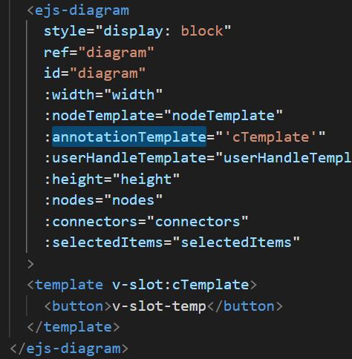 | Assign v-slot template:  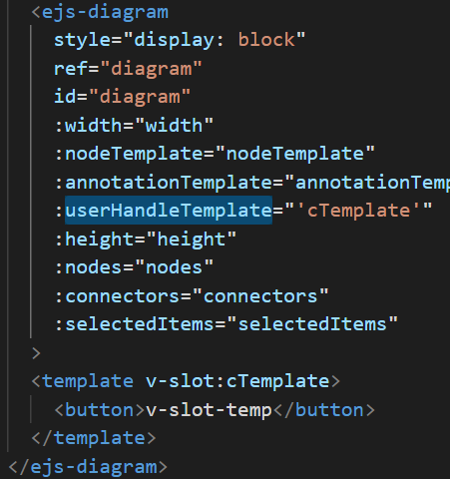
Assign External template:

- The template elements can be defined in an external file (single-file component)

- Import that file in sample App.vue file:

- Refer that file for nodeTemplate, annotation, userhandle

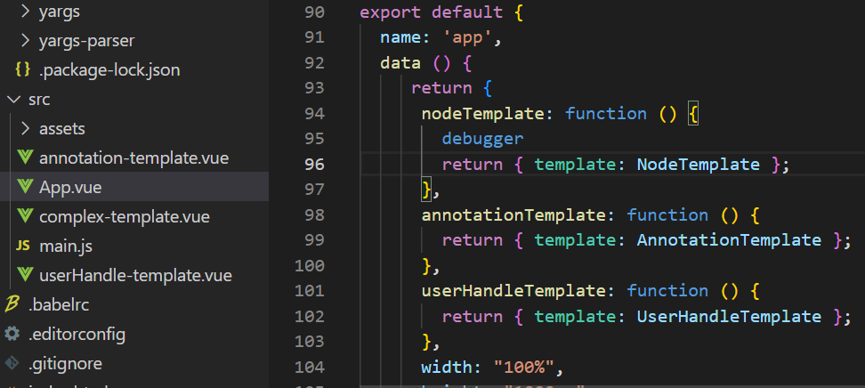

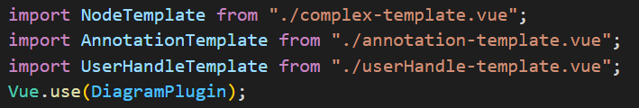

Node HTML Content:

NA

Node / Connector Annotation template:

NA

Without CSP:

Platform | Diagram Node Template | Diagram Annotation template | User handle template
JS-TS | Define template in html file:  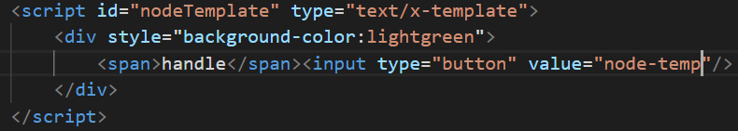  Define in diagram: (Same for all):  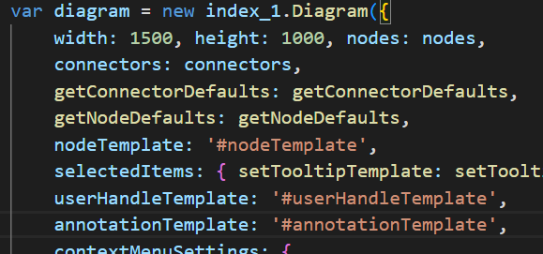  Node Content:  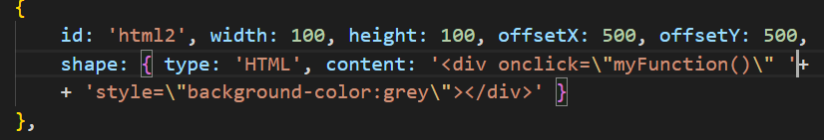 | Define template in html file:  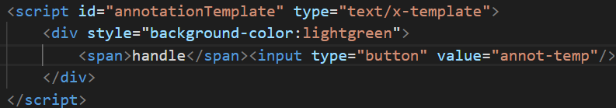  Node/Connector Annotation template:  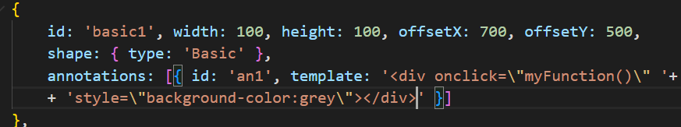 | Define template in html file:  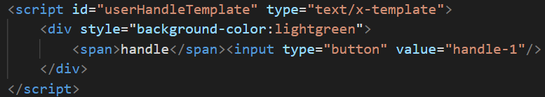
Angular | Same NG Template, additionally we can use string templates for shape content and annotation template as string. | Same | Same
React | Same we can use both functional template as mentioned in (With CSP) and additionally we can use string templates for shape content and annotation template as string. | Same | Same
Vue | 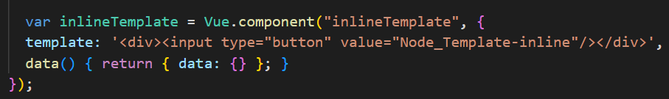  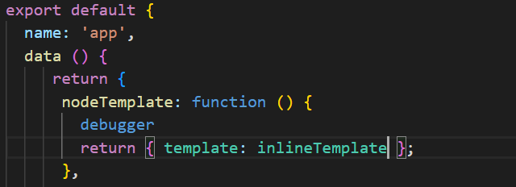  Similar for annotation and userhandle template.  Same we can use v-slot template, external template, inline template as mentioned in (With CSP) and additionally we can use string templates for shape content and annotation template as string. | Same | Same

