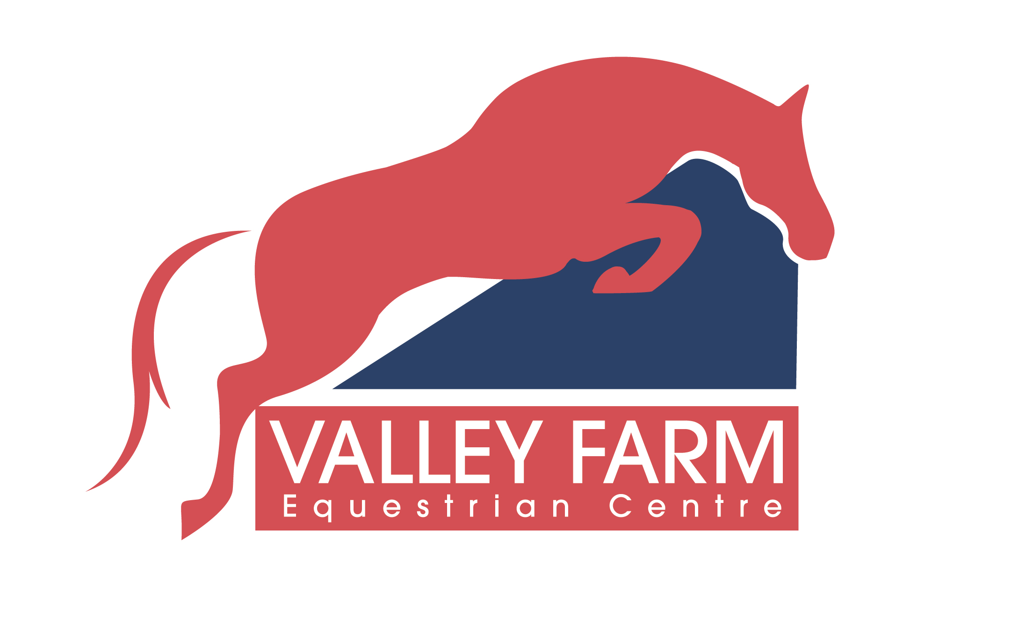 VALLEY FARM

EQUESTRIA EQUESTRIAN CENTRE LTD

SHOTTESWELL

NR BANBURY

OXON

OX17 1HZ

TEL: 01295 730576

CHILDREN

½ Hour Class £21.00

¾ Hour Class £27.00

20 Min Lead Rein £14.00

ADULTS

½ Hour Class £26.00

¾ Hour Class £32.00

PRIVATE DAYTIME SHARED

½ Hour £34.00 £28.00

¾ Hour £40.00 £32.00

1 Hour £45.00 £36.00

PRIVATE EVENING – 5.30PM ONWARDS

½ Hour £40.00 £32.00

¾ Hour £45.00 £36.00

1 Hour £50.00 £40.00

PRIVATE WEEKEND

½ Hour £41.00 £32.00

¾ Hour £47.00 £36.00

1 Hour £52.00 £40.00

PRIVATE HACKS

1 Hour £45.00 £35.00

BHS APPROVED

HIRE OF HAT - £1.00

NO WELINGTONS OR TRAINERS TO BE WORN WHEN RIDING

LESSONS CANCELLED WITHOUT 24HRS NOTICE MUST BE PAID FOR