
M2 MLDS 2017/2018

Data Visualization
Visualization of gene expression in patients for the identification of types of cancer

REN Kexin
PIAT Guilhem
Table of Contents
I. Objective 3
II. Data Description 3
III. Analysis 3
1 Preprocessing 3
2 Gordon dataset 4
3 Pomeroy dataset 8
IV. Discussion 10
V. References 10

Objective
The data sets in this project (pomeroy and gordon) are genetic data. The observations correspond to patients that are affected by a certain (known) type of tumor and the variables correspond to genes. Each cell contains the gene expression level of the corresponding gene for the corresponding patient. Interestingly, we have very few observations for many variables. Our task here will thus be to identify a group of genes that can allow us to discriminate between various types of tumors. Therefore, the objective here is feature selection rather than feature extraction. We will visualize our data as it is, attempt to select the pertinent variables and then use various techniques to visualize our data after the right genes have been selected.

Data Description
The basic descriptive statistics of the pomeroy dataset are shown in Table 1. They were obtained by first calculating the statistics for each patient, and then averaging the statistics for each type of tumor. Table 1 illustrates that the DNA data values stretch across a wide range, from 10 to 104. However, half data locates in the interval [10,20], and most data (i.e. 75%) concentrates in the interval from 10 to 100~200. The data of all types of tumors skews to right.

 | Max | 3rd Quartile | Mean | Median | 1st Quartile | Min | Skew | Standard  Deviation
MD | 11407 | 103 | 152 | 14 | 10 | 10 | 14 | 596
Mglio | 15689 | 158 | 277 | 10 | 10 | 10 | 9 | 1044
Rhab | 15403 | 140 | 288 | 19 | 10 | 10 | 9 | 1133
Ncer | 16000 | 264 | 282 | 20 | 10 | 10 | 7 | 1490
PNET | 14059 | 169 | 273 | 11 | 10 | 10 | 11 | 949
Table 1: Descriptive Statistics of Pomeroy Data
Aside from the fact that it has only two types of tumors (AD and MPM), the gordon dataset is extremely similar to the pomeroy dataset.

Analysis

Preprocessing
Since the data is originally laid out such that columns represent patients, whilst rows represent genes, the data first needs to be transposed so that different patients are represented by rows and their genes are represented by columns. After transposition, the first column includes the labels of the tumor types (e.g. “MD”, “Ncer”, etc.), thus, the first column was removed and used as the label for each patient. The data then needed to be converted to numeric format to be exploitable.

Gordon dataset
Before we do anything with the data, let us try viewing the raw data with PCA (Figure 2.1), LDA (Figure 2.2), MDS (Figure 2.3) and ISOMAP (Figure 2.4) in order to acquire a feel for the data.
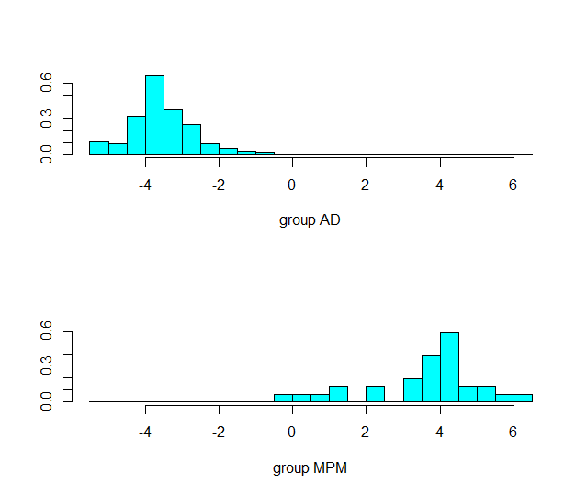Figure 2.2: One-dimensional result of LDA on Gordon dataset. Each plot is the histogram of one of the classes.
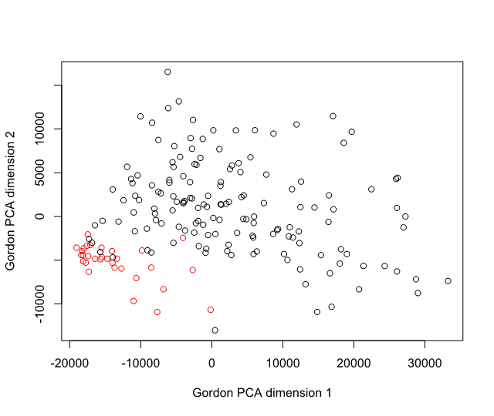Figure 2.1: Two first principal components of PCA on Gordon dataset. The colors correspond to the classes of the observations.

In Figure 2.1, we can see that the data is almost linearly separable. Given that we have the classes of the data points, not only can we color them, but we can also see if LDA can separate our data.
In figure 2.2, we can see that LDA cannot quite separate the data, although it comes close. It is also noteworthy that LDA only finds one dimension, and executes with a warning stating that some variables are collinear. This indicates that most variables must be highly correlated, which is an indicator of the genes being related, possibly being involved in the same biological function.
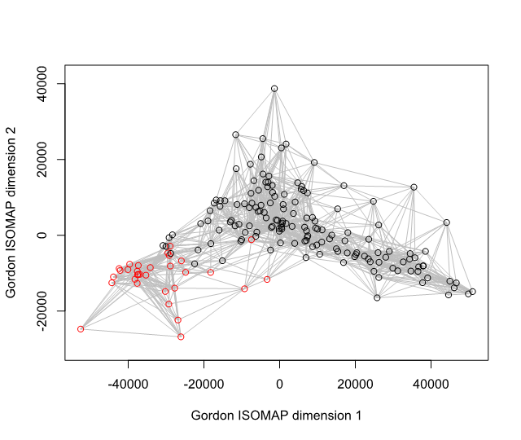Figure 2.4: 2-dimensional ISOMAP on Gordon dataset. The colors correspond to the classes of the observations.
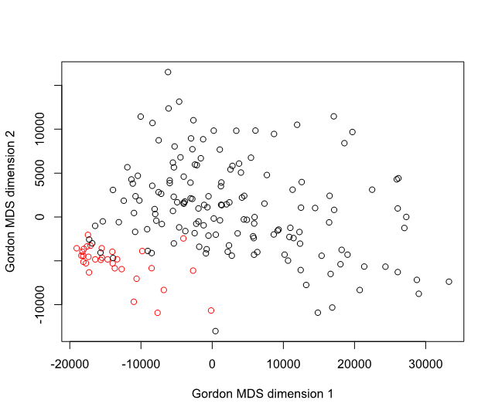Figure 2.3: 2-dimensional MDS on Gordon dataset. The colors correspond to the classes of the observations.
Interestingly, as seen in Figure 2.3, MDS gives nearly identical results to PCA. This is an indicator that the relationship between classes and variables is linear, since nonlinearity doesn’t seem to introduce much information.
In Figure 2.4, once again, we may notice how little the nonlinearity introduced by the method helps in separating the data. We can thus assume that simply selecting variables that are correlated with the classes may yield good data separability. We thus sorted the variables by their degree of correlation with the classes. We tried visualizing data separability with a few different numbers of selected dimensions, and selecting approximately 75 dimensions seemed to work best.

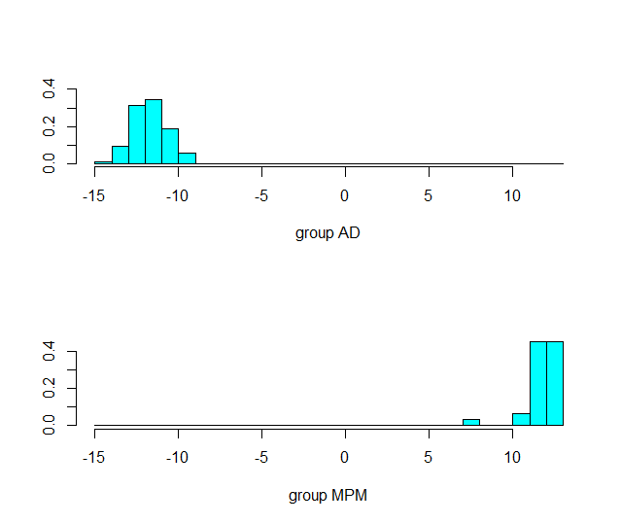Figure 2.6: One-dimensional result of LDA on Gordon dataset after variable selection. Each plot is the histogram of one of the classes.
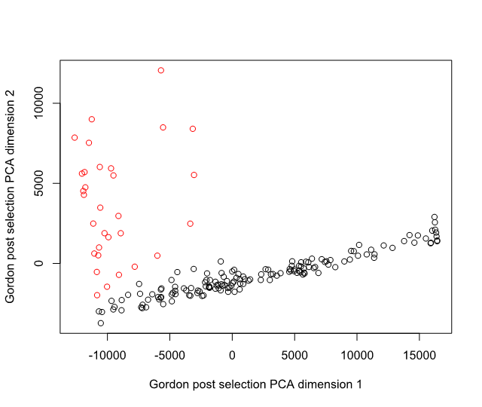Figure 2.5: Two first principal components of PCA on Gordon dataset after variable selection. The colors correspond to the classes of the observations.

In figure 2.5, we see that the data is linearly separable in the selected subspace. Once again, MDS gave seemingly identical results, however the second dimension was flipped. Although we do not show this here, you may view the results by executing the attached R code.
In Figure 2.6, we can see that LDA perfectly separates the two classes. Given these results, we know that any linear classification technique such as linear regression or linear SVM will yield perfect results on this dataset. Assuming these results are representative of the entire population, the 75 genes we’ve selected would be sufficient to tell whether a patient has a tumor of type AD or MPM (adenocarcinoma or malignant pleural mesothelioma) with great accuracy.

Pomeroy dataset
As with the Gordon dataset, we applied PCA as the first visualization method (see Figures 3.1 and 3.2). Points with different colors represent the 5 types of tumours. The plot reveals a separation tendency among the points, but there still exist some mixed points of different classes. It demonstrates that further processing needs to be done before applying PCA in order to distinguish different types of the tumours.

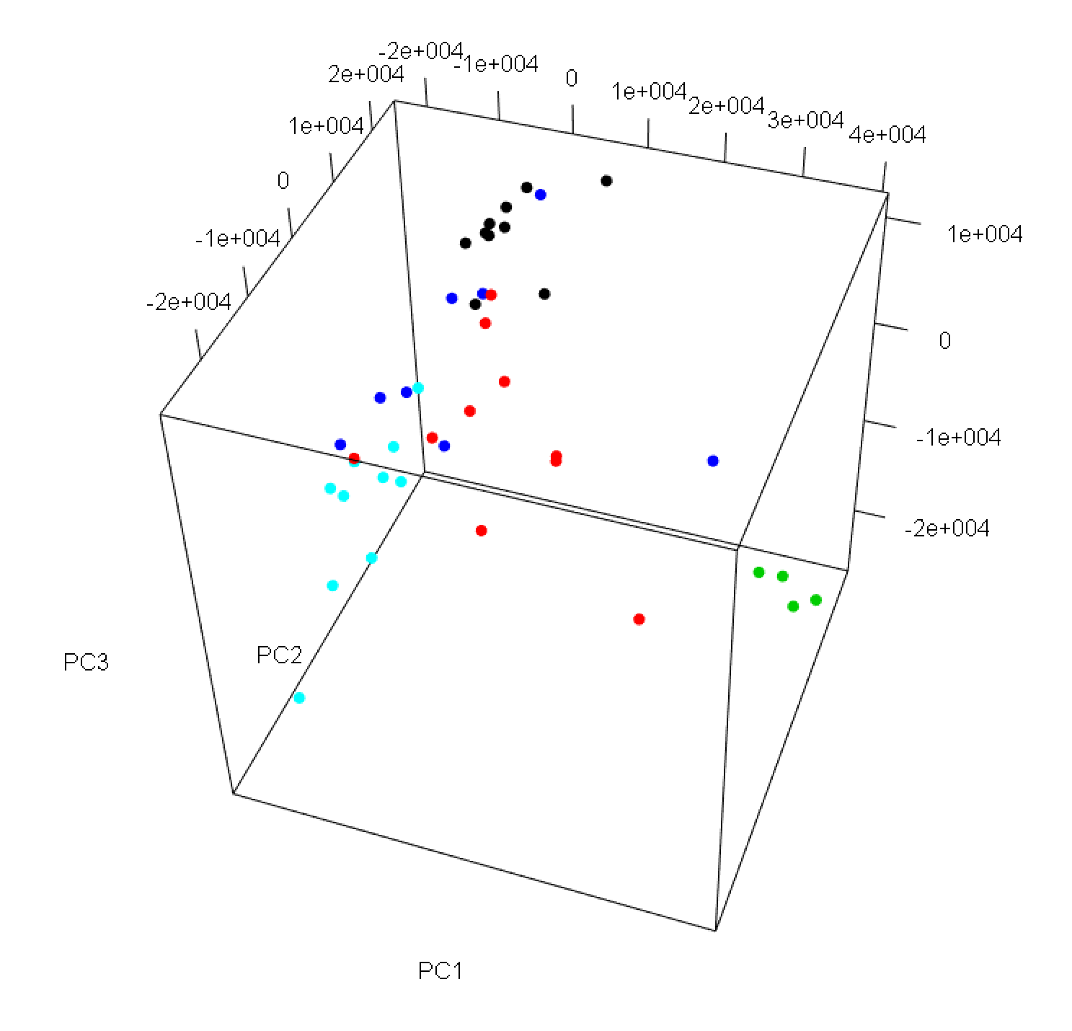Figure 3.2: Three first principal components of PCA on Pomeroy dataset. The colors correspond to the classes of the observations.
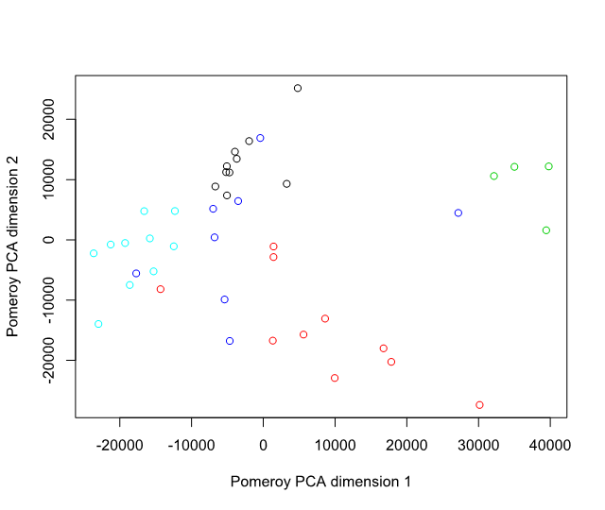Figure 3.1: Two first principal components of PCA on Pomeroy dataset. The colors correspond to the classes of the observations.

Figure 3.3: Four-dimensional result of LDA on Pomeroy dataset, represented as a scatterplot matrix. Each color corresponds to a label.
We then applied LDA to the Pomeroy dataset. Figure 3.3 shows scatter plot matrix of the LDA. Different tumour types are labeled with their names in different colors. The plots illustrate that the groups in the data cannot be distinguished well. We observe the same warning we did with the Gordon dataset as well as a big reduction in number of dimensions. We can make the same conclusion as above: it is likely that correlation between gene expressions translates to involvement in the same biological functions.
Figure 3.4: 2-dimensional ISOMAP on Pomeroy dataset. The colors correspond to the classes of the observations.

Again, we attempted nonlinear dimensionality reduction techniques. Just like for the Gordon dataset, MDS yielded virtually indistinguishable results from PCA. However, ISOMAP achieved excellent separability of the Rhab and Ncer tumor types (cyan and green classes). This indicates that the relationship between the classes may be nonlinear.

Nevertheless, nonlinear feature extraction being complex, let us first attempt the same process as with the Gordon dataset. We ranked the variables by their correlation to tumour types, and visualized the top 75 variables by PCA (Figure 3.5), LDA (Figure 3.6) and MDS, like with the Gordon dataset. PCA and MDS, once again, had seemingly perfectly mirrored results.
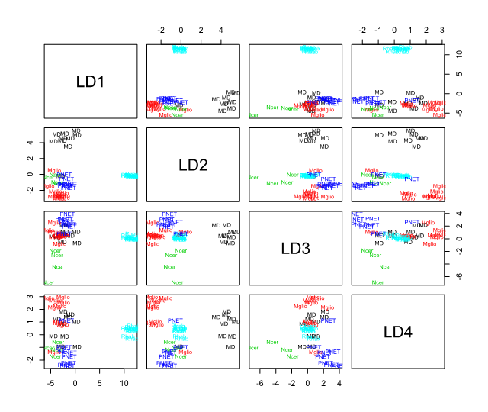Figure 3.6: Four-dimensional result of LDA on Pomeroy dataset after variable selection, represented as a scatterplot matrix. Each color corresponds to a label.
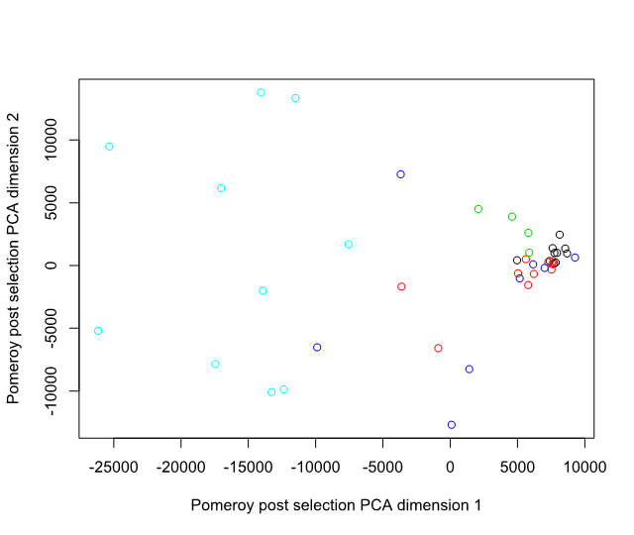Figure 3.5: Two first principal components of PCA on Pomeroy dataset after variable selection. The colors correspond to the classes of the observations.
The PCA fails to provide a significant improvement on the visualization, indicating that variance does not account for separability of this dataset due to the very different sizes of the classes. However, LDA, using the information of the labels, created a four-dimensional space that made almost any two classes linearly separable. Figure 3.6 shows the LDA plot after feature selection. It illustrates that Rhab (cyan) and MD (black) are successfully separated from other points with the dimensions LD1 and LD2 respectively, and Ncer (green) is linearly separable from the rest mainly thanks to LD3. PNET (blue) and Mglio (red), though not perfectly separable, are quite isolated when plotting LD2 as a function of LD4 (or vice-versa) with only one Mglio in the PNET cluster.

Discussion
In this project, we deal with labeled gene data – Gordon and Pomeroy, both of which have collinear or quasi-collinear variables, have many more variables than observations, but have different numbers of classes (2 and 5 respectively). In our analysis, we firstly noticed that comparing with Gordon, for the data with more classes – Pomeroy, the introduction of non-linearity to the data analysis would improve the visualization results significantly. Secondly, PCA showed good results for Gordon data, while it worked not well for Pomeroy data, revealing that variance doesn't account for separability much for data with many classes (i.e. Pomeroy), because the clusters may have very different sizes. Thirdly, we found that for the high-dimensional labeled data, the correlation between the variables and classes may be a useful tool for conducting feature selection, and reducing the data dimensionality by feature selection could help the further data mining (e.g. feature extraction in this report) in next steps. In summary, by applying the data processing and visualization methods we have learned in class, we obtained obviously contrasted and improved results in each step, and finally visualized the high-dimensional data with extracted dimensions successfully.
For the discussion, I think we can talk about the features of the dataset (# classes, # variables vs. samples) and the linearity of the method. What else do you think?
Oh and for the discussion, another point beyond dataset feature & linear/nonlinear, could be the effect of correlation analysis
PCA looks worse after, but that's not necessarily unexpected. We'll have to mention it in the Discussion, but it just means that variance doesn't account for separability because the clusters have very different sizes

References
Pomeroy, S. L., Tamayo, P., Gaasenbeek, M., Sturla, L. M., Angelo, M., McLaughlin, M. E., Golub, T. R. (2002). Prediction of central nervous system embryonal tumour outcome based on gene expression. Nature, 415, 436.
Gordon, G. J., Jensen, R. V., Hsiao, L.-L., Gullans, S. R., Blumenstock, J. E., Ramaswamy, S., Bueno, R. (2002). Translation of microarray data into clinically relevant cancer diagnostic tests using gene expression ratios in lung cancer and mesothelioma. Cancer Research, 62(17), 4963–4967.

Appendix

R Code for Gordon dataset

R Code for Pomeroy dataset

